Supplementary Information for
Ultrahigh-rate quasi-solid-state Zn-air batteries enabled by atomically dispersed Co site electrocatalyst and organhydrogel electrolyte
Qichen Wang^{1,2,7}, Qingguo Feng^{3,7}, Shuaihao Tang⁴, Yongpeng Lei^{1,2},
Liang Xu⁴, Yu Xiong², Guozhao Fang⁵, Yuchao Wang¹, Peiyao Yang¹, Jingjing Liu², Wei Liu⁶, Xiang Xiong¹

In generally, battery polarization at low temperature includes the following three aspects: activation polarization, ohmic polarization, and concentration polarization. As known, the battery voltage is mainly affected by both polarization and internal resistance. Both of polarization and internal resistance are severely restricted by working temperature. In the low-potential window that just over the equilibrium potential, the electrochemical reaction is mainly in a state where the molecules are activated to allow the reaction to proceed. The overpotential is mainly used to overcome the activation energy of the reaction, causing the activation polarization. The decrease of electrolyte ionic conductivity, the electron transport in the electrode and interface also decreases at low temperatures, which result in huge increase in the Ohmic polarization. At high applied potential, the ion diffusion rate of electrolyte is slower than the electrochemical reaction rate due to the mass transport limitation, resulting in the concentration polarization.
The output voltage is a critical parameter in electrochemical batteries. Based on the second law of thermodynamics, low temperate undoubtedly lower the charge (ion and electron) transport in electrode and electrolyte, leading to a considerable resistance enhancement.
From the point of thermodynamics factor:
ΔG = -nEF
Where ΔG is the Gibbs free energy, n is the of transferred electron number, E is the battery voltage and F is the Faraday constant. Nernst equation describes the relationship between battery voltage and working temperature could be established as follow:$E=E^{ø}-\frac{RT}{nF}In\frac{{[C]}^{c}{[D]}^{d}}{{[A]}^{a}{[B]}^{b}}$
In this equation, E stands for the actual measured voltage, $E^{ø}$ represents the battery voltage at the standard state, T is the working temperature and R, n, and F are all constants. In general, the delivered voltage conforms to the Nernst equation. When the battery is discharging by electrochemical reactions, $\frac{{[C]}^{c}{[D]}^{d}}{{[A]}^{a}{[B]}^{b}}$ < 0, $-\frac{RT}{nF}In\frac{{\left[C\right]}^{c}{\left[D\right]}^{d}}{{\left[A\right]}^{a}{\left[B\right]}^{b}}$> 0 would be obtained. The decrease in T leads to a decrease in$-\frac{RT}{nF}In\frac{{\left[C\right]}^{c}{\left[D\right]}^{d}}{{\left[A\right]}^{a}{\left[B\right]}^{b}}$, which will cause a decrease in the E. Consequently, the decrease in delivered voltage result in the energy efficiency loss of battery.
From the point of kinetic factor:
The ionic conductivity is another dominant aspect in an electrochemical battery kinetics. The ionic diffusivity (D_{i}) is commonly used to quantitatively assess the movement of ions. The connection between the Arrhenius parameter and the ionic diffusivity are as follow:
$D_{i}= D_{0}\exp\left(-\frac{ΔG^{θ}}{k_{B}T}\right)= \frac{ζ^{2}}{t}$
where D₀ is the estimated pre-factor, ΔG^{θ} is the energy barrier, k_{B} is the Boltzmann constant, and ζ is the diffusion length. The D_{i} is also related to the diffusion time (t).
Supplementary Figures
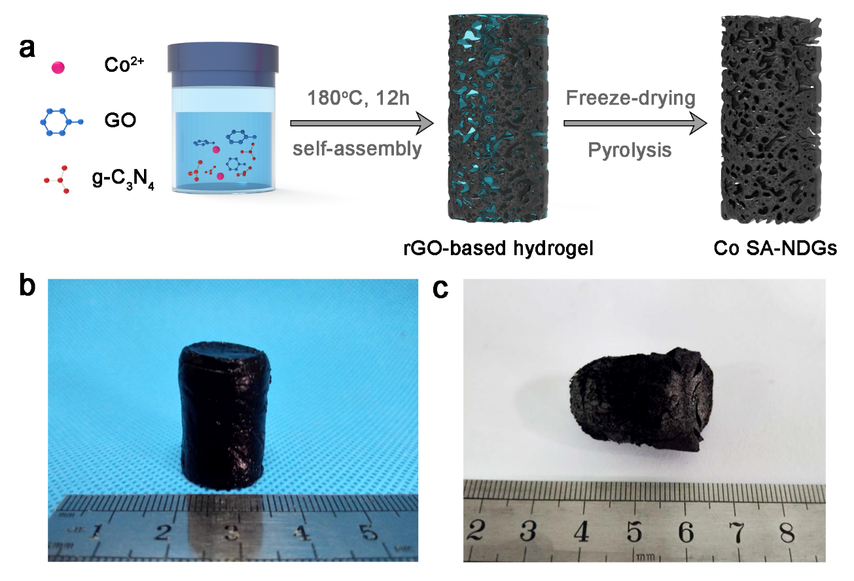
Supplementary Figure 1. (a) Schematic illustration of the fabrication process for Co SA-NDGs. Optical photograph of (b) rGO-based hydrogel and (c) Co SA-NDGs.

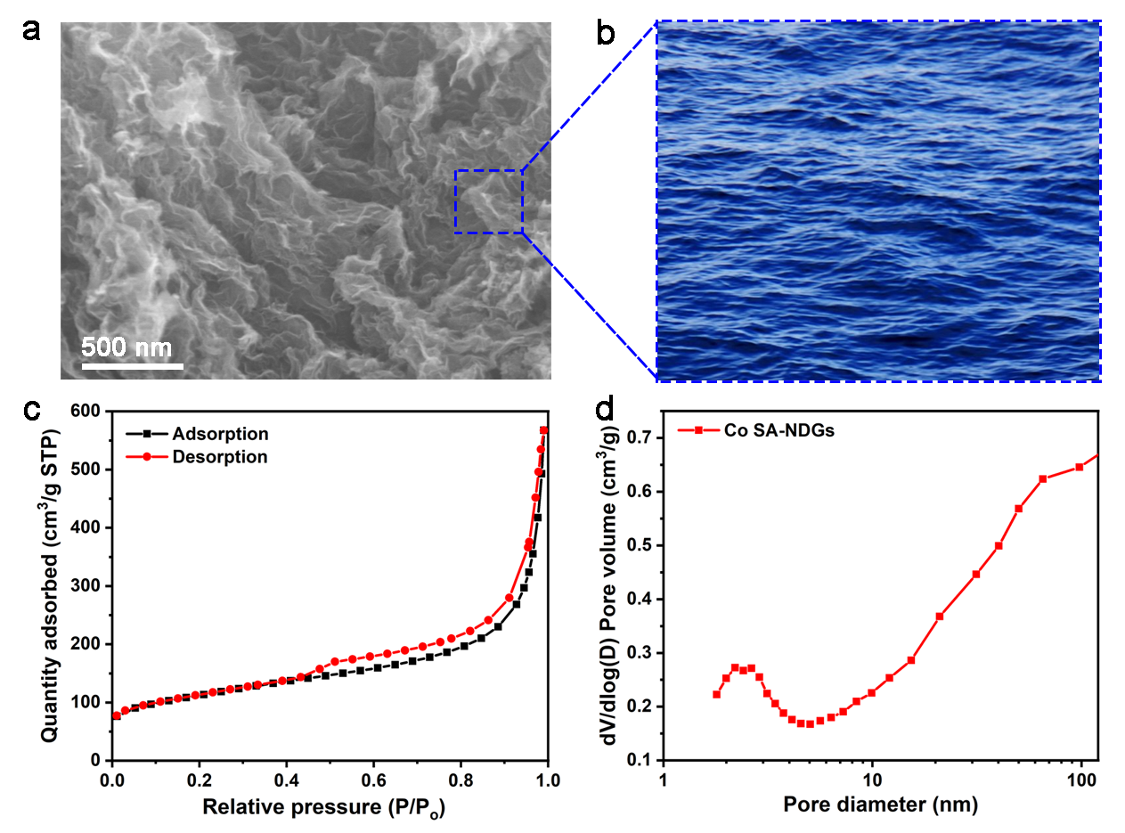
Supplementary Figure 2. (a) SEM image of Co SA-NDGs. (b) Fluctuating sea level. (c) N₂ adsorption/desorption isotherms and (d) corresponding pore size distribution of Co SA-NDGs.
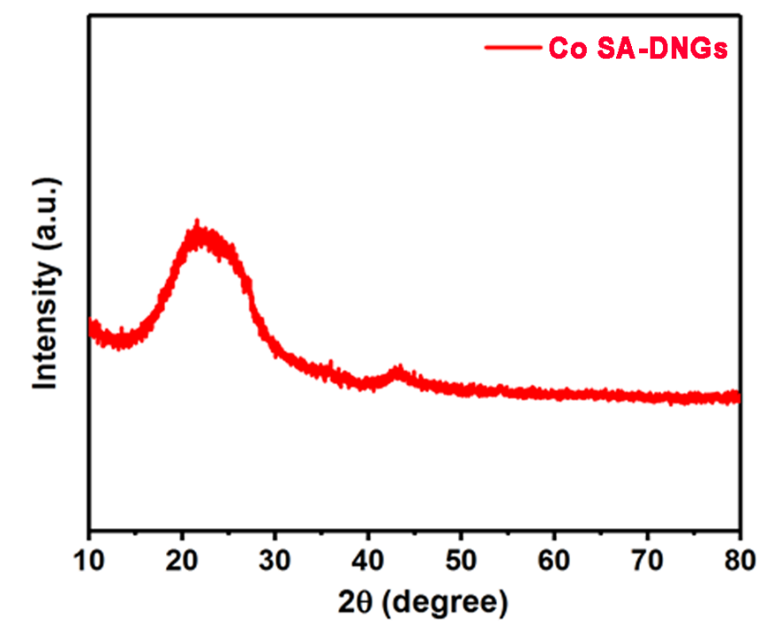
Supplementary Figure 3. XRD pattern of Co SA-NDGs.

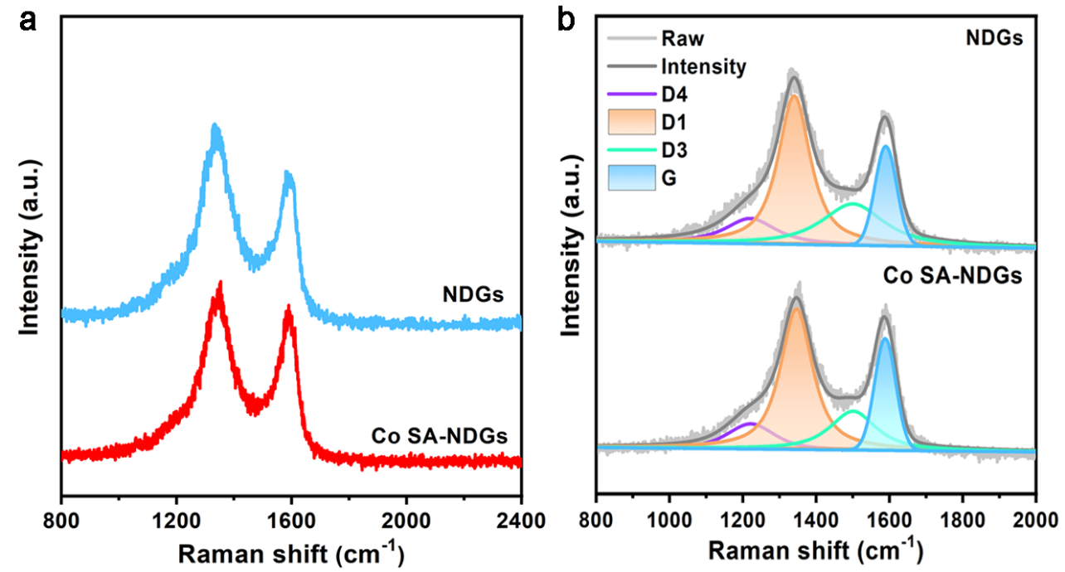
Supplementary Figure 4. (a) Raman spectra and (b) Curve fitting results of NDGs and Co SA-NDGs.
Two broad peaks (about 1350 and 1580 cm⁻¹) were observed, corresponding to the D-band and G-band, respectively. To obtain valuable information of the structural defects, the Raman spectra have been fitted with four bands (D1, D3, D4, and G). Specifically, the G band corresponds to the defect-free sp² carbon. The D1 band is associated with the small crystallite sizes, grains, or edge plane defects of graphite domains. The D3 band is assigned to amorphous carbon, while the presence of D4 band has been tentatively related to the existence of polyene-like structures or ionic impurities. The intensity ratio of D1 and G band of Co SA-NDGs is high up to 3.13, suggesting the abundant structural defects (e.g., edge and in-plane atomic vacancy, etc).

Supplementary Figure 5. EPR spectra of Co SA-NDGs.

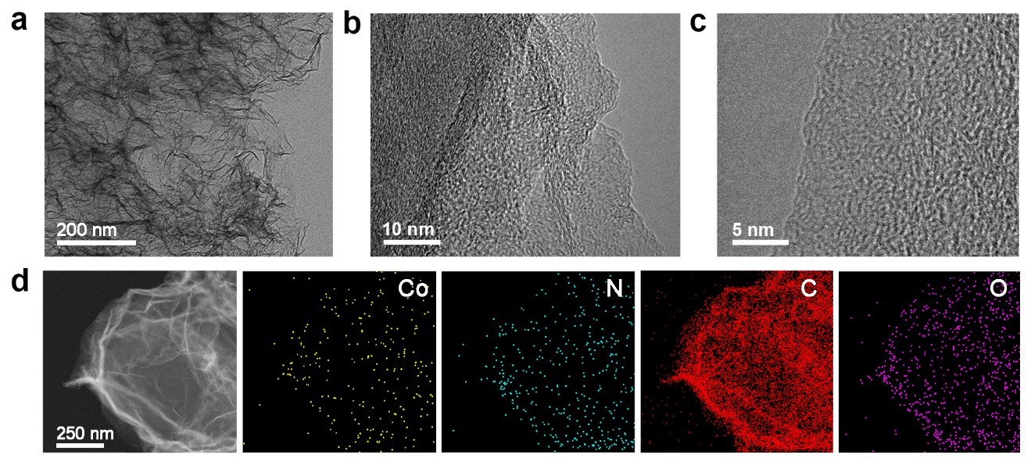
Supplementary Figure 6. (a-c) TEM and HRTEM images and (d) element mapping images of Co SA-NDGs.

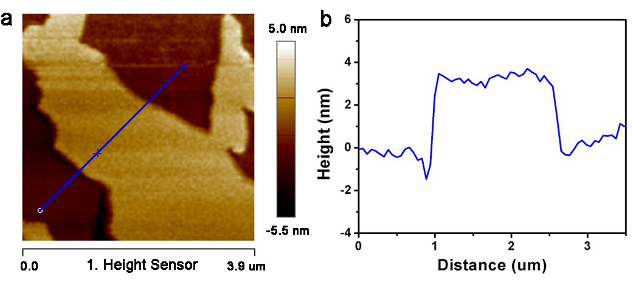
Supplementary Figure 7. (a) AFM image of Co SA-NDGs. (b) The corresponding thickness measurement.

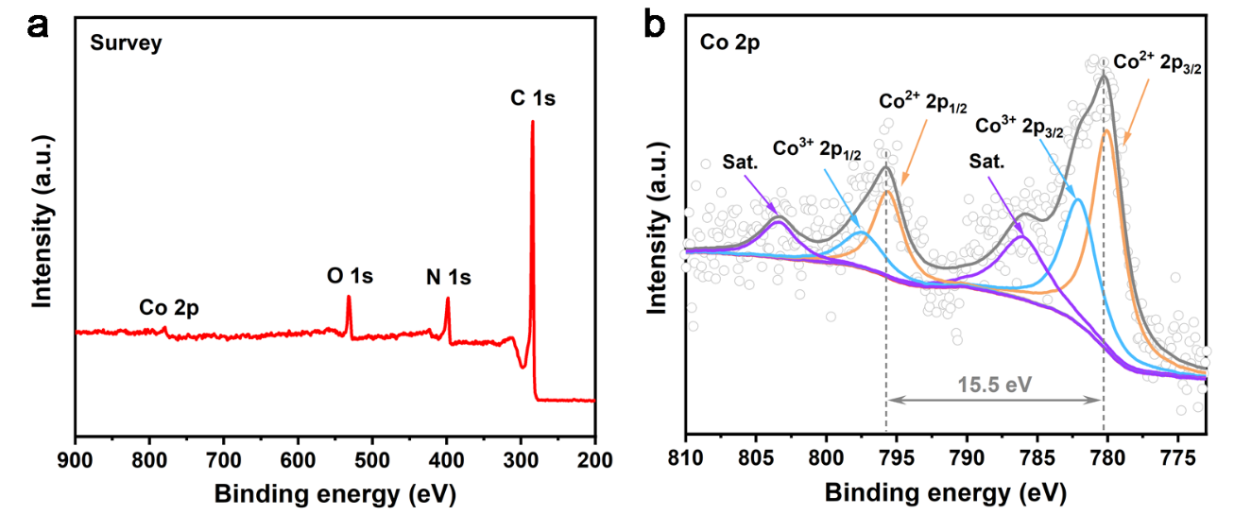
Supplementary Figure 8. (a) XPS survey spectrum and (b) Co 2p spectrum for Co SA-NDGs.

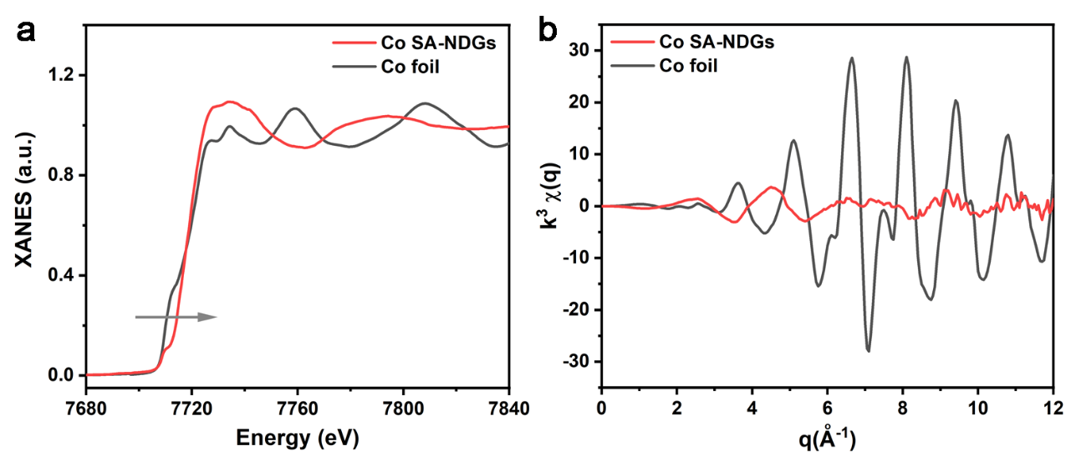
Supplementary Figure 9. (a) Normalized XANES spectra at the Co K-edge and (b) Corresponding EXAFS fitting curves of Co SA-NDGs and Co foil at k space.

Supplementary Figure 10. (a) CV curves of Co SA-NDGs at N₂/O₂-saturated 0.1 M KOH. (b) Tafel slopes for NDGs, Co SA-NDGs and Pt/C.

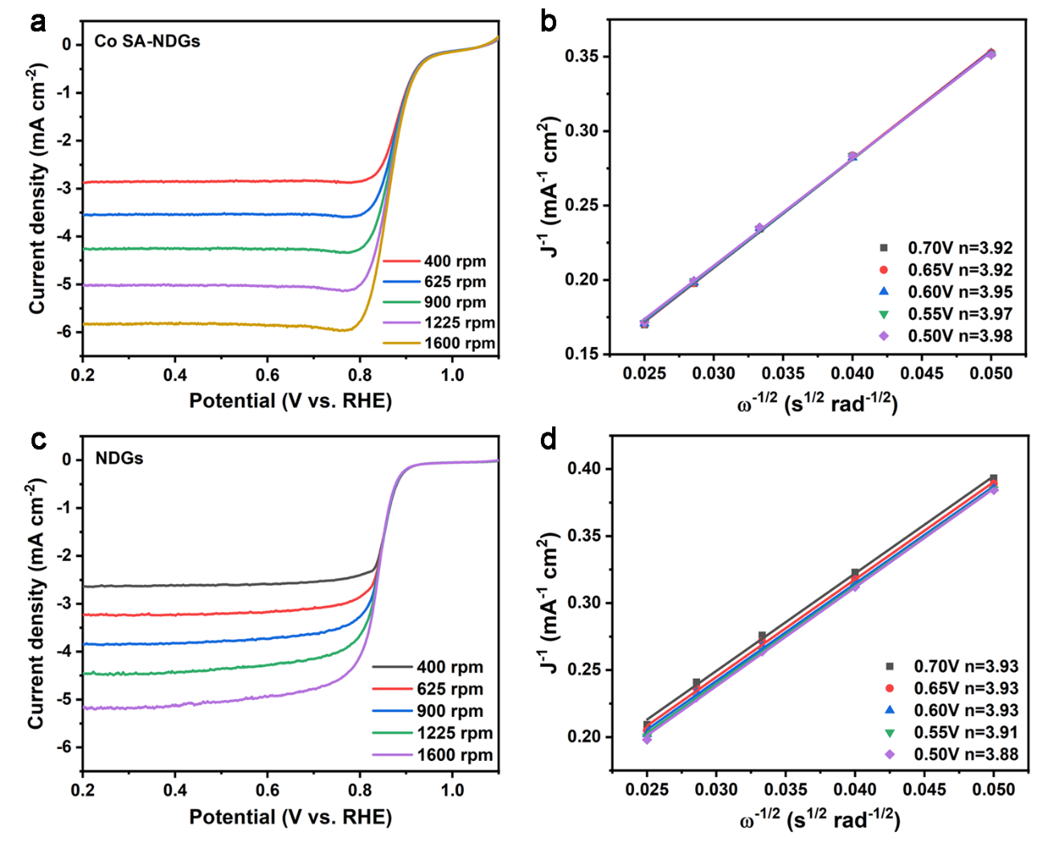
Supplementary Figure 11. LSV curves recorded at various rotation rates and Koutecky-Levich (K-L) plots (J⁻¹ vs. ω^{-1/2}) at different potentials for (a,b) Co SA-NDGs and (c,d) NDGs.

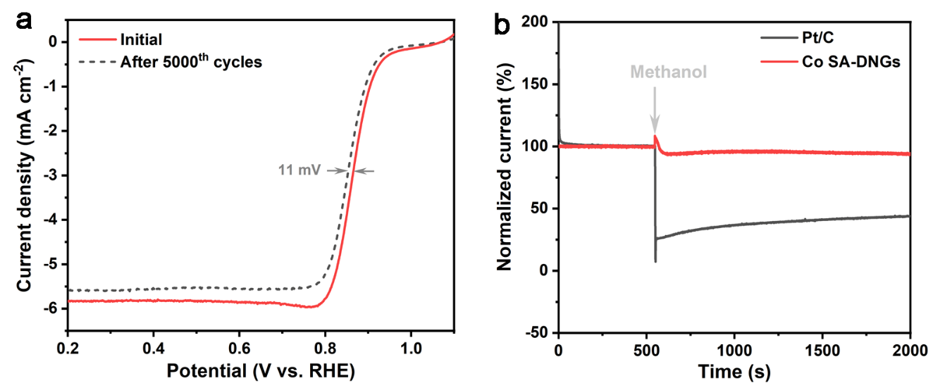
Supplementary Figure 12. (a) ORR polarization curves of Co SA-NDGs before and after accelerated degradation measurement. (c) I-t curves for Co SA-NDGs and Pt/C in O₂-saturated 0.1 M KOH without and with methanol.

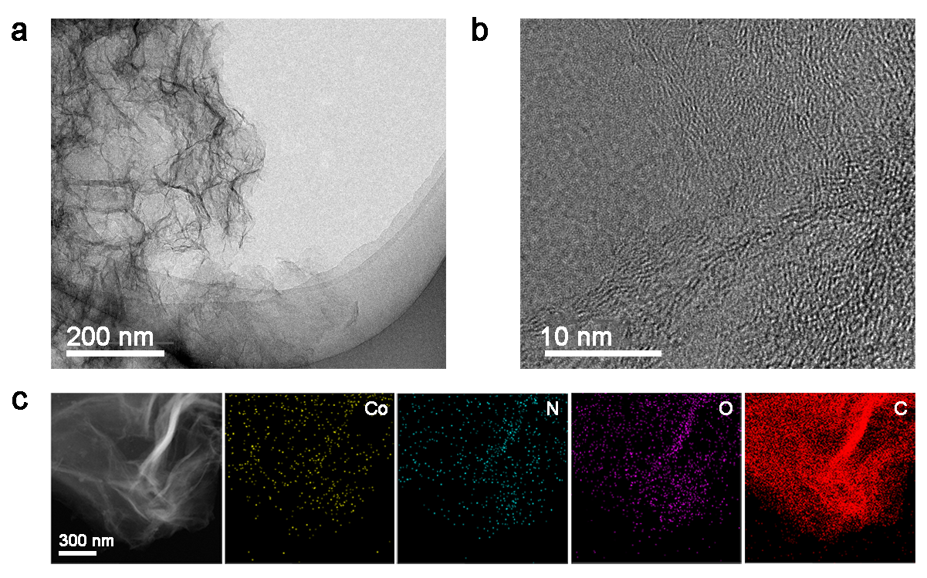
Supplementary Figure 13. (a) TEM, (b) HRTEM image and (c) element mapping images of Co SA-NDGs after ORR stability measurement.

Supplementary Figure 14. (a) Tafel slopes of Co SA-NDGs, NDGs, Ir/C and RuO₂ for OER. (b) EIS results of Co SA-NDGs and NDGs.
Supplementary Figure 15. LSV curves of (a) Co SA-NDGs and (b) NDGs measured at different temperature.
The electrochemical activation energy (E_{a}) of OER can be estimated by the Arrhenius relationship:
$$\text{logj=}\frac{\text{-}{\text{E}}_{\text{a}}}{\text{ln10*R*T}}\text{+cons}\text{an}\text{t}$$
where j is the current density at the overpotential of 350 mV, R is the universal gas constant (8.314 J K⁻¹ mol⁻¹), T is the temperature. The E_{a} could be calculated from the slope of the fitted Arrhenius plot.

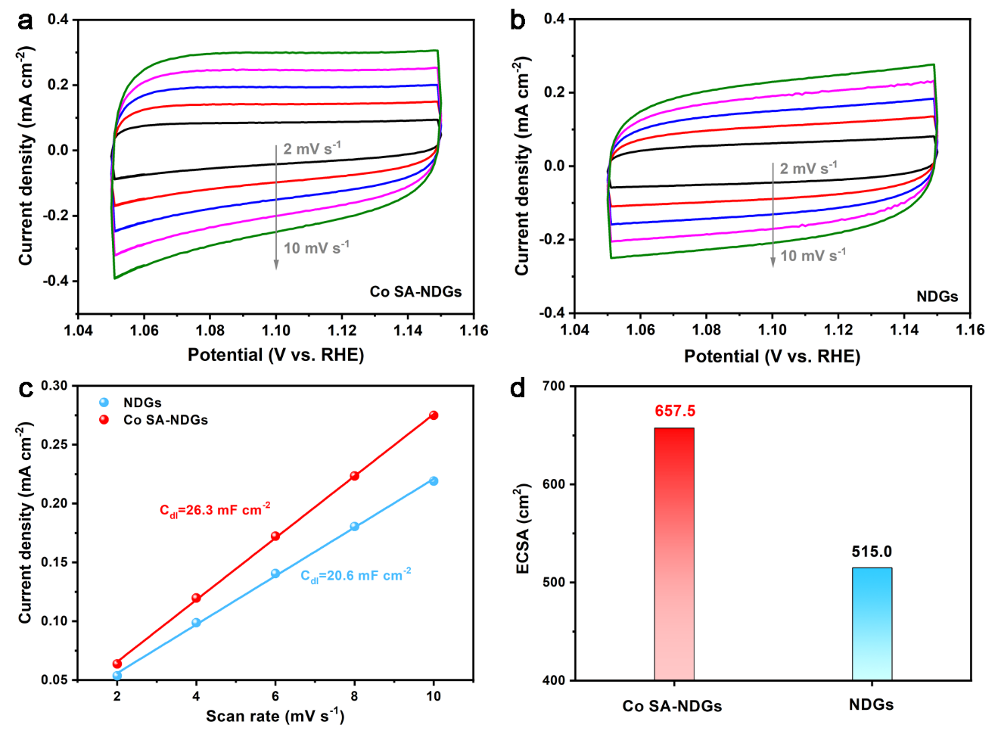
Supplementary Figure 16. CV curves of (a) Co SA-NDGs and (b) NDGs at 2, 4, 6, 8 and 10 mV s⁻¹. (c) The capacitive current measured at 1.15 V plotted as a function of scan rate. (d) Comparison of ECSA of Co SA-NDGs and NDGs. A specific capacitance of 1 cm² flat surface-area (C_{s}) generally corresponds to 40 μF cm⁻². Therefore, the ECSA can be obtained from ECSA = C_{dl} of catalyst (mF cm⁻²)/0.04 (mF cm⁻²).

Supplementary Figure 17. Free energy diagram of the ORR on planar Co-N₄ site and curved Co-N₄ site in alkaline media.

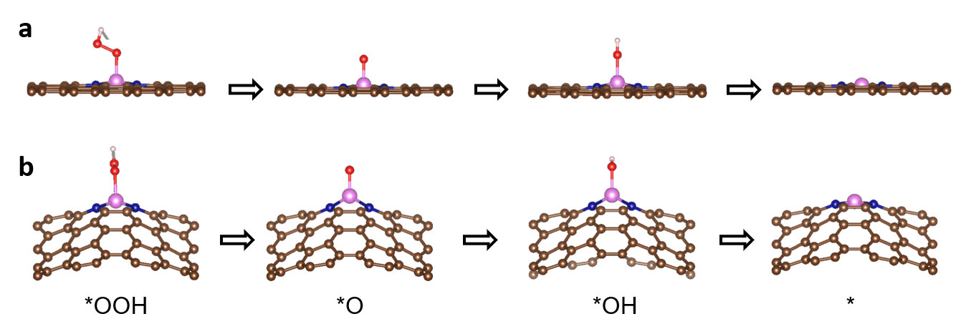
Supplementary Figure 18. The optimized intermediate species along the reaction pathway of ORR on (a) planar Co-N₄ and (b) curved Co-N₄.

Supplementary Figure 19. (a) Schematic diagram of aqueous ZABs. (b) Optical photograph of the assembled ZABs.

Supplementary Figure 20. (a) OCV curves of the aqueous ZABs with Co SA-NDGs and Pt/C. Inset shows the photograph of practical application of the aqueous ZABs. (b) Galvanostatic discharge curves and the corresponding power density curves of aqueous ZABs using Co SA-NDGs and Pt/C. (c) Specific capacities at 10 mA cm⁻². (d) Rate performance. (e) Galvanostatic discharge curves of the aqueous ZABs with Co SA-NDGs at 100 mA cm⁻². (f) In situ optical visualization observations of the interface change of the Zn/electrolyte under the discharge at 20 mA cm⁻² in 6M KOH + 0.2M Zn(Ac)₂.

Supplementary Figure 21. (a,b) SEM images, (c) N₂ adsorption/desorption isotherms of the control Co SA-NDGs. Inset shows the corresponding pore size distributions. (d) Galvanostatic discharge curves and the corresponding power density curves of the aqueous ZABs with the control Co SA-NDGs.

Supplementary Figure 22. Charging/discharging cycling performance of aqueous ZABs at current density of 10 mA cm⁻².

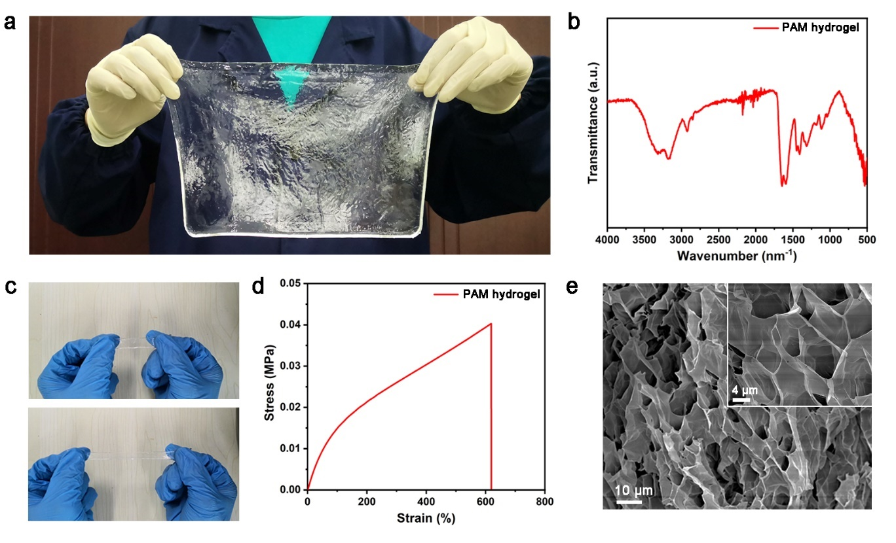
Supplementary Figure 23. (a) Photograph of the amplification-synthesized PAM hydrogel. (b) Fourier transform infrared spectra of the PAM hydrogel. (c) Photographs of the PAM hydrogel in stretched state. (d) Tensile stress-strain curve of PAM hydrogel. (e) SEM images of the freeze-dried PAM hydrogel.
The stretchable PAM hydrogel electrolyte by free radical polymerization approach, followed by soaking in 6M KOH + 0.2M Zn(Ac)₂ solution to absorb significant salt electrolyte via solvent exchange. It is noted that this method can amplify production. The PAM chains form porous network structure via covalent cross-links and hydrogen bonds. Several absorption bands (e.g., N-H stretching/bending vibration and C-O stretching vibration) are detected in Fourier transform infrared spectrum. The PAM hydrogel displays a good tensile strength and excellent stretchability (up to 780%).
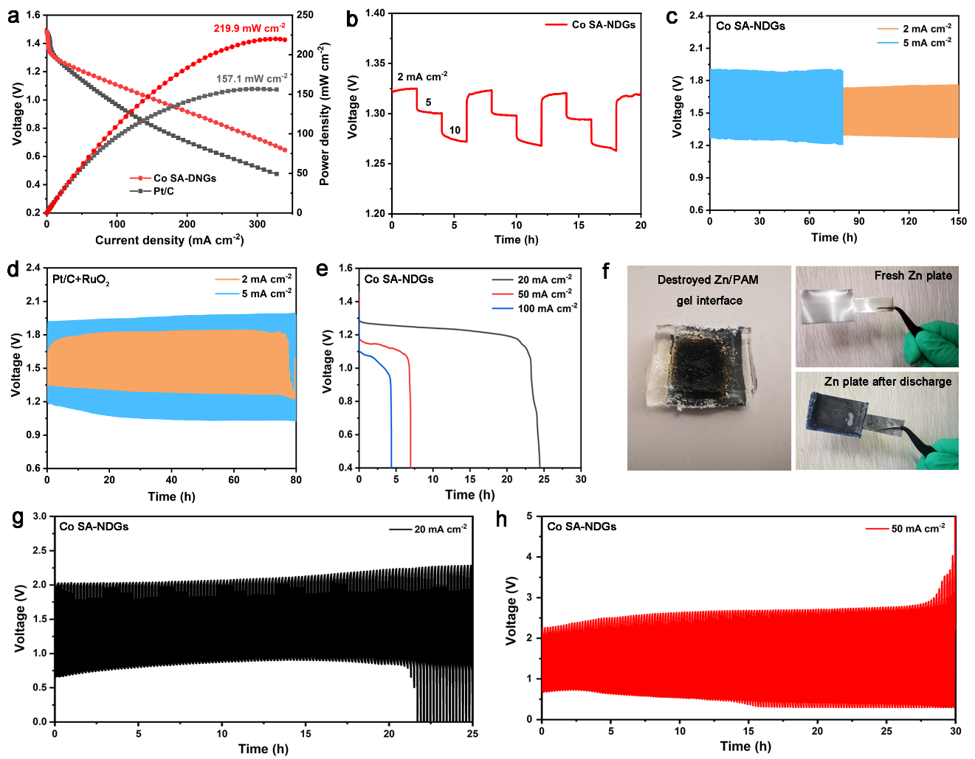
Supplementary Figure 24. (a) Galvanostatic discharge curves and the corresponding power density curves of the quasi-solid-state ZABs using PAM hydrogel electrolyte. (b) Rate performance. Charging/discharging performance of quasi-solid-state ZABs with (c) Co SA-NDGs and (d) Pt/C+RuO₂. (e) Galvanostatic discharge voltage platforms of the quasi-solid-state ZABs with Co SA-NDGs. (f) Photographs of PAM hydrogel electrolyte and Zn plate after discharge. Charging/discharging cycling performance of the Co SA-NDGs-based quasi-solid-state ZABs at (g) 20 and (h) 50 mA cm⁻² measured at room temperature.

The charging/discharging plateaus with the small overpotential are recorded at 2 and 5 mA cm⁻² for the quasi-solid-state ZABs with Co SA-NDGs, by contrast to that of quasi-solid-state Pt/C+RuO₂-based ZABs, validating the outstanding reversibility and robustness. The main component of Zn dendrites after cycling test is identified as ZnO (Supplementary Fig. 25).
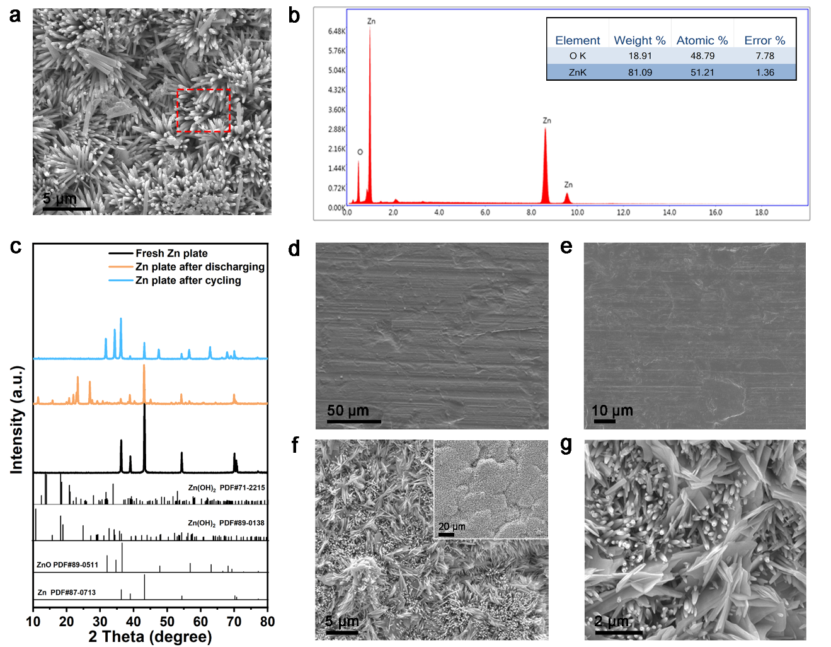
Supplementary Figure 25. (a) SEM image of Zn anode after cycling test. (b) The corresponding EDS results of the cycled Zn plate. (c) XRD patterns of various Zn samples. It suggests that the discharging and charging/discharging products are Zn(OH)₂ and ZnO, respectively. (d,e) SEM images of fresh Zn plate. (f,g) SEM images of Zn plate after discharging.
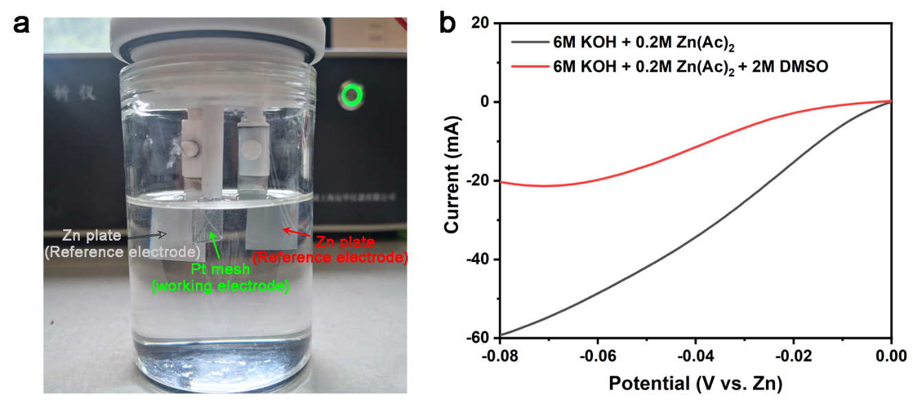
Supplementary Figure 26. (a) The optical photograph of three electrode system. (b) Hydrogen evolution reaction (HER) activity of Pt mesh in different electrolyte.

Supplementary Figure 27. (a) Schematic illustration of PAM organhydrogel electrolyte synthesized in binary solvent systems of DMSO/H₂O. (b) Tensile stress-strain curve for PAM organhydrogel.

Supplementary Figure 28. Ex situ XRD patterns of Zn plates after cycling tests under the different charging-discharging time at 20 mA cm⁻²: (a) 1h; (b) 2h; (c) 4h; (d) 6h; (e) 8h and (f) 10h.
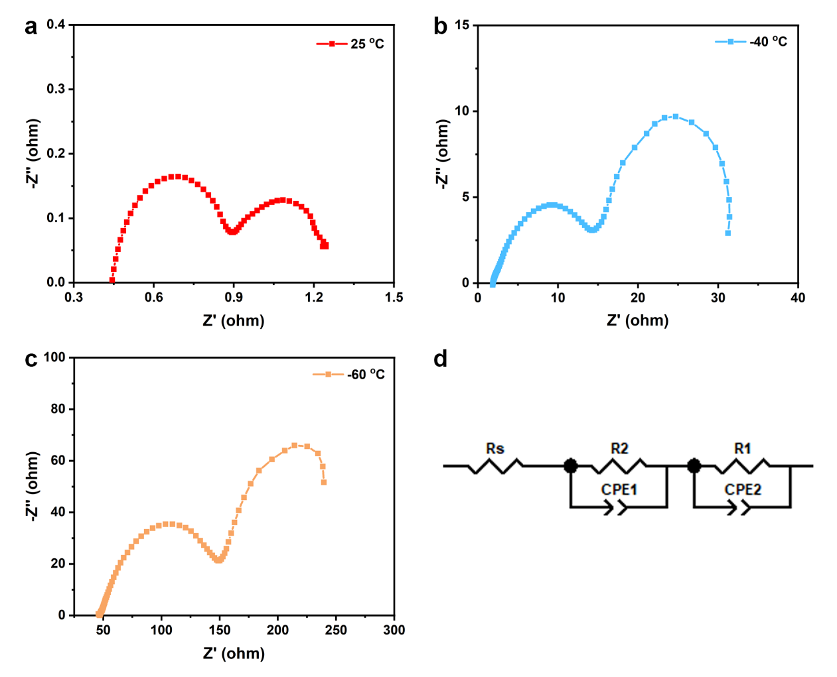
Supplementary Figure 29. EIS results of the quasi-solid-state ZABs with Co SA-NDGs measured at (a) 25ºC, (b) -40ºC and (c) -60ºC. (d) Equivalent circuit diagram.

Supplementary Figure 30. (a) Cycling performance (@0.5 mA cm⁻²) of the symmetric Zn||Zn battery employing the PAM organhydrogel electrolyte at -60 ºC. (b) EDS result of Zn plate after 500 h cycling test. Inset shows the corresponding SEM image.
Supplementary Figure 32. DMA analysis of PAM organhydrogel under temperatures ranges from 25 to 200 ºC.

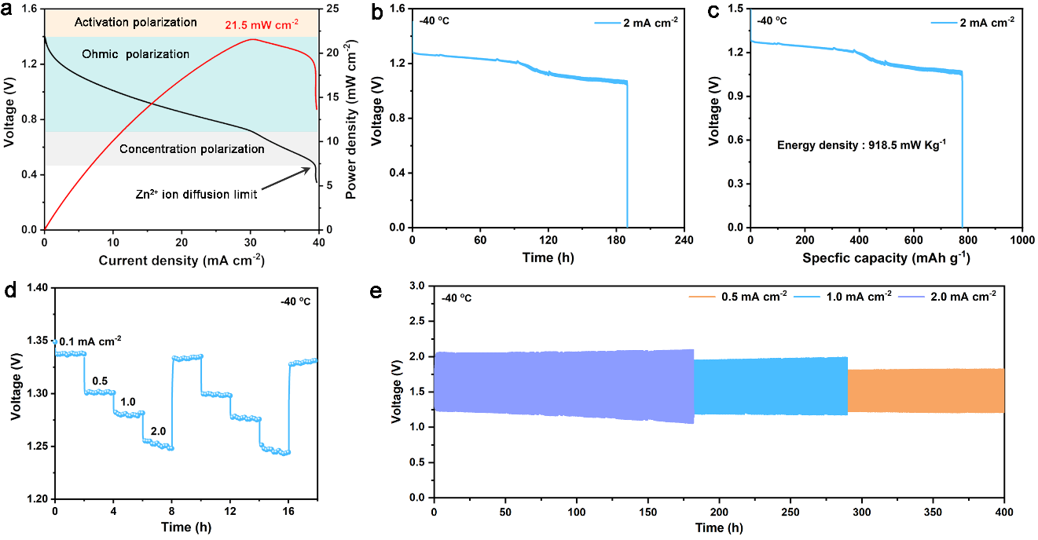
Supplementary Figure 32. (a) Galvanostatic discharge curves and the corresponding power density curves of the quasi-solid-state ZABs with Co SA-NDGs at -40 ºC. (b) Galvanostatic discharge voltage platform and (c) specific capacity of the quasi-solid-state ZABs with Co SA-NDGs at 2 mA cm⁻². (d) Rate performance of the Co SA-NDGs-based quasi-solid-state ZABs. (e) Charging/discharging cycling performance of quasi-solid-state ZABs with Co SA-NDGs at -40 ºC.
As shown in Supplementary Fig. 32a, the dominant factor of discharge behavior changes from ohmic polarization to concentration polarization with the increase of voltage at -40 °C. The quasi-solid-state ZABs using Co SA-NDGs delivers a maximum power density of 21.9 mW cm⁻². Therefore, a large voltage driving force is required in ultra-low-temperature environment to reach similar current density level measured in ambient condition. Supplementary Fig. 32d shows the rate performance of quasi-solid-state ZABs with Co SA-NDGs at -40 °C. After twice current density fluctuation tests, the discharging voltage hardly decays. The exceptional charging/discharging cycling performance with high-capacity retention over 90% are recorded at different current density in Supplementary Fig. 32e.
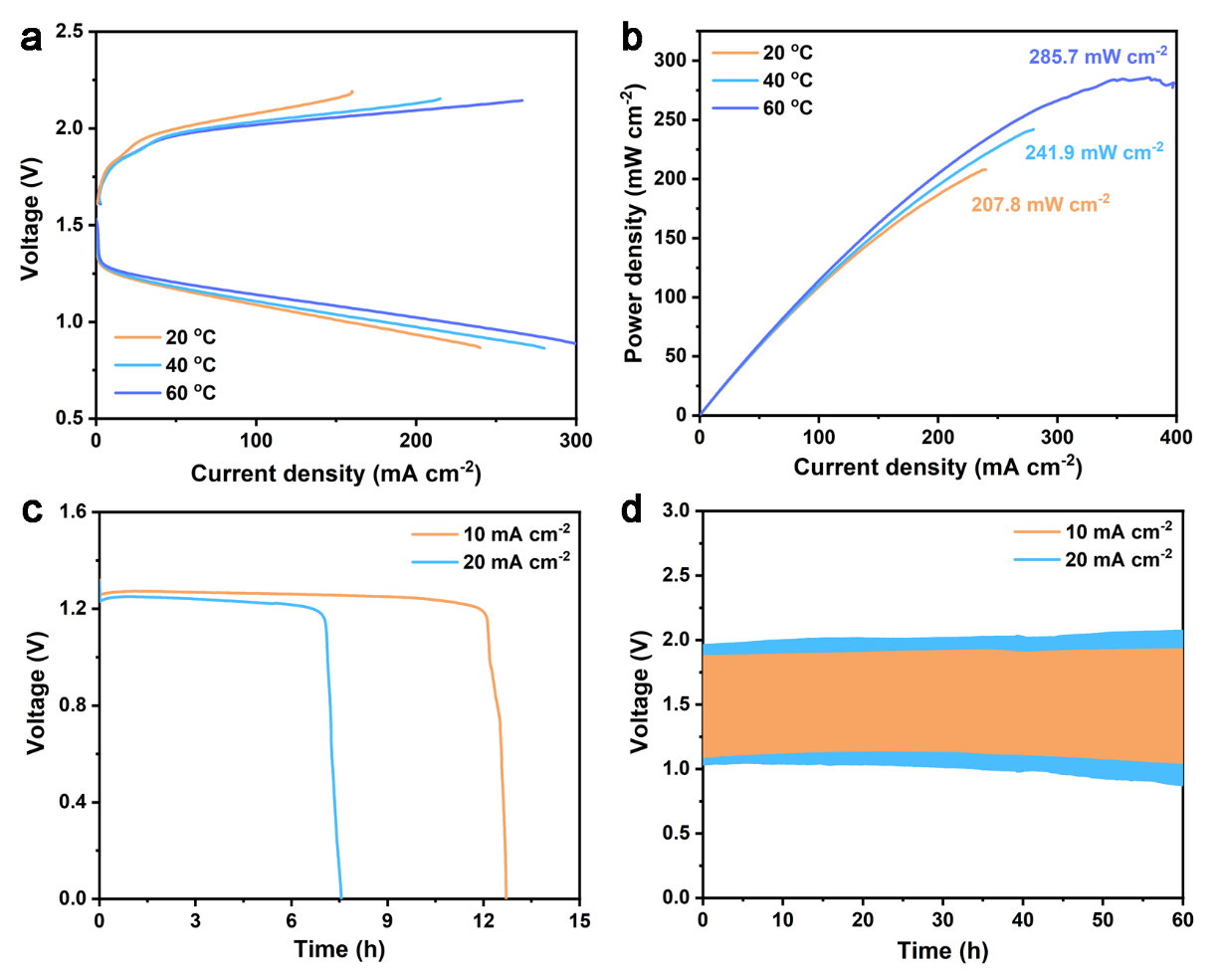
Supplementary Figure 33. (a) Charging/discharging curves and (b) power density curves of quasi-solid-state ZABs with Co SA-NDGs at different temperatures. (c) Galvanostatic discharge voltage platforms at 10 and 20 mA cm⁻². (d) Charging/discharging cycling performance of quasi-solid-state ZABs with Co SA-NDGs measured at 60 ºC.

Supplementary Table S1. EXAFS fitting parameters at the Co K-edge.
Samples | Shell | N ª | R (Å) ^{b} | σ² (Å²·10⁻³) ^{c} | ΔE₀ (eV) ^{d} | R factor (%)
Co SA-NDGs | Co-N | 3.8 | 1.83 | 3.1 | -8.7 | 0.4
Co SA-NDGs | Co-C | 1.6 | 2.53 | 9.9 | -9.7 | 0.4
ª N: coordination numbers; ^{b} R: bond distance; ^{c} σ²: Debye-Waller factors; ^{d} ΔE₀: the inner potential correction. R factor: goodness of fit.

Supplementary Table 2. Performance comparison of bifunctional oxygen catalysts.
Catalysts | E_{onset}  (V) | E_{1/2}  (V) | E_{j=10} (V) | △E  (V) | Reference
Co SA-NDGs | 1.03 | 0.87 | 1.58 | 0.71 | This work
CNT@CoSA-Co/NCP | 1.00 | 0.87 | 1.61 | 0.74 | Adv. Funct. Mater.  2021, 31, 2103360.
NGM-Co | 0.92 | 0.8 | 1.75 | 0.95 | Adv. Mater.  2017, 29, 1703185.
H-Co@FeCo/N/C | 1.03 | 0.91 | 1.61 | 0.70 | Appl. Catal. B: Environ.  2020, 278, 119259.
Fe/Ni-N_{x}/OC | 1.05 | 0.94 | 1.67 | 0.73 | Adv. Mater.  2020, 32, 2004670.
Fe/N-G-SAC | 0.99 | 0.89 | 1.6 | 0.71 | Adv. Mater.  2020, 32, 2004900.
Co-N₄/NC | 0.93 | 0.81 | 1.60 | 0.79 | Nano-Micro Lett.  2021, 13, 60.
FeN_{x}-PNC | 0.997 | 0.85 | 1.63 | 0.78 | ACS Nano  2018, 12, 1949.
Fe-NC SAC | 1.02 | 0.88 | 1.68 | 0.80 | J. Mater. Chem. A  2020, 8, 9981.
Co SA@NCF/CNF | 1.01 | 0.88 | 1.63 | 0.75 | Adv. Mater.  2019, 31, 1808267.
Co-C₃N₄/CNT | 0.9 | 0.85 | 1.61 | 0.76 | J. Am. Chem. Soc.  2017, 139, 3336.
S,N-Fe/N/C-CNT | 0.97 | 0.85 | 1.60 | 0.75 | Angew. Chem. Int. Ed.  2017, 56, 610.
CoN₄/NG | 0.98 | 0.87 | 1.61 | 0.74 | Nano Energy  2018, 50, 691.
CoSA/N,S-HCS | 0.96 | 0.85 | 1.56 | 0.71 | Adv. Energy Mater.  2020, 10, 2002896.
UNT Co SAs/N-C | 0.97 | 0.89 | 1.61 | 0.72 | Nano Energy  2019, 61, 245.
SCoNC | 1.05 | 0.91 | 1.54 | 0.63 | Adv. Energy Mater.  2019, 9, 1900149.
Co-N,B-CSs | 0.96 | 0.83 | 1.66 | 0.83 | ACS Nano  2018, 12, 1894.
Co-POC | 0.94 | 0.83 | 1.70 | 0.87 | Adv. Mater.  2019, 31, 1900592.
Co-SAs@NC | 0.96 | 0.82 |  |  | Angew. Chem. Int. Ed.  2019, 58, 5359.
NC-Co SA | 1.0 | 0.87 | 1.59 | 0.72 | ACS Catal.  2018, 8, 8961.
Fe-N₄ SAs/NPC | 0.972 | 0.88 | 1.66 | 0.78 | Angew. Chem. Int. Ed.  2018, 57, 8614.
Fe-N/P-C-700 | 0.94 | 0.87 | 1.66 | 0.79 | J. Am. Chem. Soc.  2020, 142, 2404.
Fe-N_{x}-C | 1.08 | 0.91 | 1.83 | 0.92 | Adv. Funct. Mater.  2019, 29, 1808872
NCA_{C-Zn}/Fe | 1.10 | 0.89 | 1.60 | 0.71 | Research  2019, 6813585, 1.
FePc-GO | 0.99 | 0.89 | 1.65 | 0.76 | ACS Nano  2020, 14, 13279.
MnSAC | 1.04 | 0.91 | 1.58 | 0.67 | Nano Lett.  2020, 20, 5443.
Ni-N₄/GHSs/Fe-N₄ | 0.93 | 0.83 | 1.62 | 0.79 | Adv. Mater.  2020, 32, 2003134.
CoNi-SAs/NC | 0.88 | 0.76 | 1.57 | 0.81 | Adv. Mater.  2019, 31, 1905622.
FeCo-N_{x}-CN | 0.95 | 0.89 | 1.67 | 0.78 | Angew. Chem. Int. Ed.  2018, 57, 1856.
G@POF-Co | 0.87 | 0.81 | 1.66 | 0.85 | Adv. Funct. Mater.  2019, 29, 1901301.
Fe₃C-Co/NC | 0.94 | 0.88 | 1.60 | 0.72 | Adv. Funct. Mater.  2019, 29, 1901949.
N-CoS₂ YSSs | 0.95 | 0.81 | 1.51 | 0.79 | Adv. Sci.  2020, 7, 2001178.
Co@hNCTs-800 | 0.99 | 0.87 | 1.63 | 0.76 | Nano Energy  2020, 71, 104592.
CoFe/N-HCSs | 0.90 | 0.79 | 1.52 | 0.73 | Chem. Eng. J  2021, 407, 127961.
FeCo/Co₂P@NPCF | 0.85 | 0.79 | 1.56 | 0.77 | Adv. Energy Mater.  2020, 10, 1903854.
MnO/Co/PGC | 0.95 | 0.78 | 1.54 | 0.82 | Adv. Mater.  2019, 31, 1902339.
FeP/Fe₂O₃@NPCA | 0.98 | 0.78 | 1.57 | 0.79 | Adv. Mater.  2020, 32, 2002292
Pd/FeCo | 0.98 | 0.84 | 1.55 | 0.71 | Adv. Energy Mater.  2020, 11, 2002204.
Co₂FeO₄/NCNTs | 0.94 | 0.8 | 1.65 | 0.85 | Angew. Chem. Int. Ed.  2019, 58, 13291.
Co/N@CNTs@CNMF | 0.99 | 0.86 | 1.54 | 0.68 | Adv. Funct. Mater.  2020, 30, 2003407.
Co-Co₃O₄@NAC | 0.94 | 0.8 | 1.61 | 0.81 | Appl. Catal.B: Environ.  2020, 260, 118118.
Ni@N-HCGHF |  | 0.87 | 1.49 | 0.62 | Adv. Mater.  2020, 32, 2003313.
f-FeCo-CNT | 0.96 | 0.87 | 1.71 | 0.85 | Nano Res.  2020, 13, 1090.
CoFe20@CC | 1.02 | 0.86 | 1.52 | 0.66 | Adv. Mater.  2019, 31, 1904689.
CoNC | 0.97 | 0.87 | 1.55 | 0.68 | Chem. Eng. J  2021, 404, 121112.
Co₃O_{4-x}/NG | 0.96 | 0.84 | 1.53 | 0.66 | Appl. Catal. B: Environ.  2020, 278, 119300.
FeCo@MNC | 0.96 | 0.86 | 1.47 | 0.61 | Appl. Catal. B: Environ.  2019, 244, 150.
CoDNG900 | 0.94 | 0.86 | 1.61 | 0.75 | Appl. Catal. B: Environ.  2021, 281, 119514.
ZOMC | 0.96 | 0.85 | 1.56 | 0.71 | Adv. Mater.  2020, 32, 2002170.
N-NiSe₂/CC | 0.80 | 0.73 | 1.5 | 0.76 | Chem. Eng. J  2020, 401, 126088.
CoNi/BCF | 0.91 | 0.80 | 1.60 | 0.80 | Appl. Catal. B: Environ.  2019, 240, 193.
ZIF@HMCS | 0.92 | 0.82 | 1.63 | 0.81 | Nat. Sci. Rev.  2020, 7, 609.
f-FeCo-CNT | 0.96 | 0.87 | 1.71 | 0.84 | Nano Res.  2020, 13, 1090.
Co₃O₄-Co@NC | 0.97 | 0.86 | 1.58 | 0.72 | Nano Res.  2021, 14, 2353.
CuCo₂O₄@C | 0.95 | 0.85 | 1.56 | 0.71 | Nano Lett.  2017, 17, 7989.
GNCNTs | 0.92 | 0.85 | 1.60 | 0.75 | Adv. Funct. Mater.  2019, 30, 1906081.
C-MOF-C2-900 | 0.94 | 0.82 | 1.58 | 0.76 | Adv. Mater.  2018, 30, 1705431.
Fe_{0.5}Ni_{0.5}@N-GR | 0.94 | 0.83 | 1.43 | 0.70 | Adv. Funct. Mater.  2018, 28, 1706928.
CMO/S | 0.92 | 0.76 | 1.7 | 0.94 | Adv. Energy Mater.  2018, 8, 1800612.
CNF@Zn/CoNC | 0.91 | 0.82 | 1.7 | 0.88 | Small  2018, 14, 1704207.
CoS_{x}/Co-NC-800 | 0.95 | 0.80 | 1.54 | 0.74 | Adv. Funct. Mater.  2019, 29, 1904481.

Supplementary Table 3. The performance comparison of reported aqueous ZABs.
Catalysts | OCV  (V) | Peak Power density (mW cm⁻²) | Specific capacity (mAh g⁻¹) | Cycling stability  (h) | Reference
Co SA-NDGs | 1.53 | 251.4 | 757.4 | 300 | This work
CNT@SAC-Co/NCP | 1.45 | 172 |  | 33 | Adv. Funct. Mater. 2021, 2021, 31, 2103360.
Fe/Ni-N_{x}/OC | 1.52 | 148 | 712 | 315 | Adv. Mater.  2020, 32, 2004670.
PFN | 1.45 | 175 | 816 | 500 | J. Am. Chem. Soc.  2021, 143, 11595.
Fe-NC SAC |  | 180 | 786 | 53 | J. Mater. Chem. A  2020, 8, 9981.
Co-N,B-CSs | 1.4 | 100.4 |  | 14 | ACS Nano  2018, 12, 1894.
Fe_{AC}@Fe_{SA}-N-C | 1.41 | 115 |  |  | ACS Nano  2019, 13, 11853.
Cu ISAS/NC |  | 280 | 736 | 50 | Nat. Commun.  2019, 10, 3734.
MnSAC |  | 258 | 675 |  | Nano Lett.  2020, 20, 5443.
Co-N₄/NC | 1.36 | 101.6 | 762.8 | 16.7 | Nano-Micro Lett.  2021, 13, 60.
Fe/N-G-SAC |  | 120 |  | 240 | Adv. Mater.  2020, 32, 2004900.
Co SANC-850 | 1.48 |  | 860.95 | 44 | J. Mater. Chem. A  2020, 8, 2131.
Cu-SA/SNC |  | 220 |  |  | Energy Environ. Sci.  2019, 12, 3508.
Fe SAs/N-C |  | 225 |  | 260 | ACS Catal.  2019, 9, 2158.
Co₂FeO₄/NCNTs | 1.43 | 90.1 |  | 100 | Angew. Chem. Int. Ed.  2019, 58, 13291.
(Mg,Co)₃O₄@NGC | 1.45 | 125 |  | 200 | ACS Energy Lett.  2017, 2, 2706.
NCA_{C-Zn}/Fe | 1.50 | 231 | 780 | 122 | Research  2019, 6813585, 1-13.
Fe-SAs/NP-C | 1.45 | 195 |  |  | Nat. Commun.  2018, 9, 5422.
S,N-Fe/N/C-CNT | 1.35 | 102.7 |  | 33 | Angew. Chem. Int. Ed.  2017, 56, 610.
Mo SACs/N-C | 1.47 | 78 | 750 | 120 | Nano Energy  2020, 67, 104288.
Fe,Mn,N-FGC | 1.41 | 220 |  | 12.8 | Inorg. Chem.  2020, 59, 5194.
N-CoS₂ YSSs | 1.41 | 81 | 744 | 165 | Adv. Sci.  2020, 7, 2001178.
Fe/N-CNRs |  | 181.8 | 771.77 |  | Adv. Funct. Mater.  2020, 31, 2008085.
Co-POC |  | 78 |  | 79 | Adv. Mater.  2019, 31, 1900592.
SilkNC/KB | 1.43 | 91.2 | 614.7 | 33 | Chem. Mater.  2019, 31, 1023.
Co-SAs@NC | 1.46 | 105.3 | 897.1 |  | Angew. Chem. Int. Ed. 2019, 58, 5359.
CoNi/BCF | 1.44 | 155.1 | 710.9 | 30 | Appl. Catal. B: Environ.  2019, 240, 193.
CoN₄/NG | 1.51 | 115 | 730 | 100 | Nano Energy  2018, 50, 691.
CoSA/N,S-HCS | 1.50 | 173.1 | 781 | 333 | Adv. Energy Mater.  2020, 10, 2002896.
CuSA@HNCN_{x} | 1.51 | 212 | 806 | 300 | Appl. Catal. B: Environ.  2020, 268, 118746.
N-Co₃O₄@NC | 1.344 | 174.1 |  | 50 | Adv. Funct. Mater.  2019, 29, 1902875.
Cu₁/NC-900 | 1.48 | 223 |  | 100 | Nano Res.  2021, 14, 998.
Fe-Zn-SA/NC |  | 167.2 | 756.6 | 120 | Nano Res.  2021, 14, 1374.
f-FeCo-CNT | 1.484 | 195.8 | 754 | 180 | Nano Res.  2020, 13, 1090.
Co-Co₃O₄@NAC | 1.45 | 164 | 721 | 35 | Appl. Catal. B: Environ.  2020, 260, 118118.
(Co,Fe)₃N_R |  | 234 |  | 300 | Nat. Commun.  2020, 11, 1952.
Fe-N_{x}-C | 1.51 | 96.4 | 641 |  | Adv. Funct. Mater.  2019, 29, 1808872.
Fe-N/P-C-700 | 1.42 | 133.2 | 723.6 | 40 | J. Am. Chem. Soc.  2020, 142, 2404.
pfSAC-Fe | 1.41 | 123.4 | 732 |  | Sci. Adv.  2019, 5, eaaw2322.
FeCo-IA/NC |  |  |  |  | J. Mater. Chem. A  2020, 8, 4369.
SCoNC | 1.49 | 194 |  | 20 | Adv. Energy Mater.  2019, 9, 1900149.
A-Co@CMK-3-D |  | 162 | 765 | 45 | Small Methods  2019, 3, 1800450.
CoFe20@CC | 1.50 | 190.3 | 787.0 | 132 | Adv. Mater.  2019, 31, 1904689.
Mn-SAS/CN |  | 220 |  |  | Adv. Energy Mater. 2021, 11, 2002753.
AlNiCoRuMo | 1.48 | 146.5 |  | 500 | ACS Materials Lett.  2020, 2, 1698.
Co₃O_{4-x}/NG | 1.49 | 166 | 700.6 | 62 | Appl. Catal. B: Environ.  2020, 278, 119300.
H-Co@FeCo/N/C | 1.45 | 125.2 |  | 200 | Appl. Catal. B: Environ.  2020, 278, 119259.
Co₃O₄-Co@NC |  | 158 | 758 | 200 | Nano Res.  2021, 14, 2353.
FePc@N,P-DC | 1.45 | 120 | 585 | 50 | Appl. Catal. B: Environ.  2020, 265, 118198.
NPSC-Co₂Fe₁ | 1.44 | 174.6 |  | 70 | Appl. Catal. B: Environ.  2020, 260, 118594.
CoFe@NC-AS | 1.58 | 102 |  | 48 | J. Power Sources  2020, 455, 227975.
NPMC/CoFe | 1.49 | 146.3 |  | 75 | J. Power Sources  2019, 441, 227177.
ZIF/HMCS | 1.38 | 120.2 |  | 80 | Nat. Sci. Rev.  2020, 7, 609.
CoFe/N-HCSs | 1.39 | 96.5 | 774.5 |  | Chem. Eng. J  2021, 407, 127961.
PdMo bimetallene | 1.48 | 154.2 | 798 | 500 | Nature  2019, 574, 81.
SA-PtCoF |  | 125 | 808 | 240 | Energy Environ. Sci.  2020, 13, 884.
FeP/Fe₂O₃ @NPCA |  | 130 | 717 | 200 | Adv. Mater.  2020, 32, 2002292.
ZOMC | 1.49 | 221.1 | 697.9 | 165 | Adv. Mater.  2020, 32, 2002170.
Co/N@CNTs@  CNMF | 1.52 | 133 |  | 190 | Adv. Funct. Mater.  2020, 30, 2003407.
N-NiSe₂/CC |  |  |  |  | Chem. Eng. J  2020, 401, 126088.
CoO_{x}/NMC | 1.48 | 195.3 |  | 400 | Energy Storage Mater.  2020, 29, 156.
CoFe@N-GCNCs | 1.45 | 132.5 |  | 100 | J. Power Sources  2020, 480, 229107.
FeCo/Co₂P@  NPCF | 1.44 | 154 |  | 107 | Adv. Energy Mater.  2020, 10, 1903854.
Ni|MnO/CNF | 1.56 | 138.6 |  | 120 | Adv. Funct. Mater.  2020, 30, 1910568.
CoFe/N-GCT | 1.43 | 203 |  | 267 | Angew. Chem. Int. Ed.  2018, 57, 16166.
Mo-N/C@MoS₂ | 1.46 | 196.4 |  | 48 | Adv. Funct. Mater.  2017, 27, 1702300.
f-FeCo-CNT | 1.484 | 195.8 | 754 | 180 | Nano Res.  2020, 13, 1090-1099.
Co-NC-800 | 1.44 | 109.5 | 657.2 | 36 | Chem. Eng. J  2021, 404, 121112.
CoDNG900 | 1.45 | 207 | 669 | 666 | Appl. Catal. B: Environ.  2021, 281, 119514.
FeCo@MNC | 1.41 | 115 |  | 24 | Appl. Catal. B: Environ.  2019, 244, 150.
Ni_{0.2}Co_{0.8}Se | 1.44 | 223.5 | 698.6 | 50 | Nano-Micro Lett.  2019, 11, 28.
Meso-CoNC@GF | 1.51 | 154.4 |  | 105 | Adv. Mater.  2017, 30, 1704898.
Fe_{0.5}Ni_{0.5}@N-GR | 1.48 | 85 | 765 | 40 | Adv. Funct. Mater.  2018, 28, 1706928.
C-MOF-C2-900 | 1.46 | 105 | 741 | 120 | Adv. Mater.  2018, 30, 1705431.
CNF@Zn/CoNC | 1.46 | 140.1 | 680.2 | 150 | Small  2018, 14, 1704207.
CoS_{x}/Co-NC-800 | 1.40 | 103 | 770.4 | 200 | Adv. Funct. Mater.  2019, 29, 1904481.
N, S-CC | 1.36 | 42 |  |  | Adv. Sci.  2018, 5, 1800760.
o-CC-H₂ |  | 91.4 | 707 | 30 | Energy Storage Mater.  2018, 15, 124.
CNT@POF |  | 237 | 772.7 | 67 | Energy Environ. Sci.  2018, 11, 1723.
N-GQDs/NiCo₂S₄/  CC |  | 75.2 |  | 200 | Small  2019, 15, 1903610.
NGM-Co |  | 152 | 750 | 60 | Adv. Mater.  2017, 29, 1703185.
Co-N-CNT | 1.37 | 101 |  | 15 | Adv. Funct. Mater.  2017, 28, 1705048.

Supplementary Table 4. Performance comparison of reported quasi-solid-state ZABs.
Catalysts | Gel electrolyte | OCV  (V) | Peak Power density (mW  cm⁻²) | Cycling time (h)  @current density (mA cm⁻²) | Reference
Co SA-NDGs | PAM | 1,43 | 219.9 | 50@100  100@50 | This work
Co SA@NCF/CNF | PVA | 1.41 |  | 9@3 | Adv. Mater.  2019, 31, 1808267.
NiCo_{2.148}O₄ PNS | PVA | 1.30 |  | 20@1 | Adv. Mater.  2020, 32, 2001651.
Ce-LaCoO₃ | PVA | 1.33 | 31 | 8@2 | Nano Energy  2020, 50, 691.
CoN₄/NG | PVA |  | 28 | 6@3 | Nano Energy  2018, 50, 691.
C-Co SA | PAA | 1.41 | 20.9 | 41@ | ACS Catal.  2018, 8, 8961.
CoSA/N,S-HCS | PVA | 1.48 |  | 17@5 | Adv. Energy Mater.  2020, 10, 2002896.
Fe-NC SAC | PVA | 1.424 | 45 | 1@2 | J. Mater. Chem. A  2020, 8, 9981.
Mn-CoN | PAAm | 1.37 | 48 | 20@2 | Sci. China Chem.  2020, 63, 7.
Mn₃O₄/NiCo₂S₄ | PVA-PEO | 1.427 |  | 16.8@1 | J. Power Sources  2020, 462, 228162.
NiCo₂O₄/MXene | PVA | 1.40 | 55.1 | 33@1 | ACS Appl. Mater. Interfaces 2020, 12, 44639.
NPF@CNF-800 | PVA | 1.33 | 64 | 20@5 | ACS Appl. Mater. Interfaces  2021, 13, 13328.
CoS/CoO@NGNs | PVA | 1.3 | 39.3 | 10@1 | Nano-Micro Lett.  2021, 13, 3.
NCNTM | PAAs | 1.49 | 176 | 30@1 | J. Energy Chem.  2021, 55, 183.
FeCo/Se-CNT | PVA | 1.41 | 37.5 | 20@5 | Nano Lett.,  2021, 21, 2255.
CoFe/N-HCSs | PVA | 1.4 |  | 10@2 | Chem. Eng. J  2021, 407, 127961.
N-Mo-holey G | PANa | 1.37 | 83 | 88@2 | Appl. Catal.B: Environ.  2020, 276, 119172.
AlFeCoNiCr | PANa | 1.38 | 100 | 60@2 | Appl. Catal. B: Environ. 2020, 268, 118431.
FePc@N,P-DC | PVA | 1.33 |  | 8@2 | Appl. Catal. B: Environ.  2020, 260, 118198.
S-Ni₃FeN/NSG | PAAs | 1.38 | 140.1 | 35@1 | Appl. Catal. B: Environ.  2020, 274, 119086.
Fe_{0.5}Ni_{0.5}@N-GR | PVA | 1.352 |  | 18@10 | Adv. Funct. Mater.  2018, 28, 1706928.
N-NiSe₂/CC | PVA |  | 27 | 30@1 | Chem. Eng. J  2020, 401, 126088.
FeP/Fe₂O₃@NPCA | PVA | 1.42 | 40.8 | 8@5 | Adv. Mater.  2020, 32, 2002292.
FeCo/Co₂P@NPCF | PVA | 1.26 |  | 15@2 | Adv. Energy Mater.  2020, 10, 1903854.
Co₃O₄@x HoNPs@HPNCS | PVA | 1.459 | 94.1 | 18@3 | Angew. Chem. Int. Ed.  2019, 58, 13840.
GNCNTs | PAA | 1.54 | 223 | 24@1 | Adv. Funct. Mater.  2019, 30, 1906081.
Co-NC@Al₂O₃ | PAM | 1.41 | 72.4 | 10@20 | Adv. Mater.  2018, 30, 1805268.
N-GQDs/  NiCo₂S₄/CC | PVA | 1.406 | 26.2 | 12@20 | Small  2019, 15, 1903610.
Meso-CoNC@GF | PVA | 1.40 | 85.6 | 12@20 | Adv. Mater.  2017, 30, 1704898.
NC-Co₃O₄-90 | PAM | 1.44 | 82 | 21@5 | Adv. Mater.  2017, 29, 1704117.
N, S-CC | PVA-PEO | 1.247 | 47 | 8@5 | Adv. Sci.  2018, 5, 1800760.
CNT@POF | PVA | 1.39 | 22.3 | 4@1 | Energy Environ. Sci.  2018, 11, 1723.
Co₃O₄/CC | PVA-SiO₂ | 1.27 | 62.6 | 48@3 | Nano Energy  2019, 56, 454.
CMO/S | PVA-PEO | 1.32 |  | 10@1 | Adv. Energy Mater.  2018, 8, 1800612.
NGM-Co | PVA | 1.439 | 28 | 1@1 | Adv. Mater.  2017, 29, 1703185.
NP-Co₃O₄/CC | PVA | 1.349 | 99.8 | 20@5 | Energy Storage Mater.  2020, 26 , 157.
Ni_{0.2}Co_{0.8}Se | PVA | 1.428 | 41 | 8@2 | Nano-Micro Lett.  2019, 11, 28.
Co₃O₄/N-CNT | PVA | 1.31 |  | 20@2 | Small  2017, 13, 1700518.
SilkNC/KB | PVA |  | 32.3 | 10@1 | Chem. Mater.  2019, 31, 1023.
Co/ZnCo₂O₄@NC-CNTs | PVA | 1.30 | 151 | 21@5 | Nano Energy  2021, 82, 105710.
D-CMO | PANa | 1.46 | 149 | 34@2 | Nano Energy  2021, 85, 106020.
Co₃O₄/Mn₃O₄/CN_{x}@CNFs | PVA | 1.51 | 191 | 9@1 | Electrochimica Acta  2020, 344, 136145.
HCA-Co | PAA | 1.40 | 44.8 | 40@1 | Chem. Eng. J.  2019, 369, 988.
CoNC | PAAS | 1.33 | 117 | 21@2 | Chem. Eng. J.  2021, 404, 127112.
Fe-N-C-700 | PAA | 1.42 | 70 |  | Chem. Eng. J.  2021, 405, 125956.
NiFe@N-CFs | PVA | 1.18 |  | 10@1  mA cm⁻² | J. Mater. Chem. A  2020, 8, 13725.
Co-Fe-S@NSRPC | PAM-PAA | 1.42 | 78 | 50@5 | Nanoscale  2020, 12, 11746.
Mn₃O₄/NiCo₂S₄ | PVA/PEO | 1.43 |  | 16.8@1 | J. Power Sources  2020, 462, 228162.
Co/Co-N-C | PVA | 1.41 |  | 10@2 | Adv. Mater.  2019, 31, 1901666.
Co-NCNT | PANa | 1.45 | 144.6 | 75@2 | Energy Storage Mater.  2019, 20, 234.
Co-N_{x}-YSC-600 | PVA | 1.35 | 55.3 | 4@5 | Nano Energy  2021, 89, 106314.
WN-Ni@N,P-CNT | PVA | 1.57 | 100.4 | 10@1 | Appl. Catal. B: Environ.  2021, 298, 120511.
Fe₁Co₁-CNF | PVA |  |  | 3@2 | Nano Energy  2021, 87, 106147.
Co/CoO@NSC | PANa | 1.43 | 82.7 | 143@2 | J. Energy Chem.  2022, 64, 385.
NiFe/N-CNT | PVA | 1.41 | 105.4 | 10@1 | Nano Energy  2020, 68, 104293.
OCNT | PAA | 1.39 | 103 | 17@5 | Energy Storage Mater.  2020, 30, 138.
FeCo/N-CNTs@CC | PVA | 1.40 | 127 | 8@20 | ACS Sustainable Chem. Eng. 2021, 9, 4498.
FeS₂-CoS₂/NCFs | PVA | 1.39 | 69 | 20@1 | J. Power Sources  2021, 482, 228955.
CoNC-MOG | PVA | 1.41 | 63 | 12@2 | Appl. Surface Sci.  2021, 537, 147818.
NBSCF | CNF-based membranes | 1.44 |  | 15@1 | J. Mater. Chem. A  2019, 7, 24231.
CoFe@NCNT/  CFC | PVA | 1.43 | 37.7 | 15@1 | J. Mater. Chem. A  2020, 8, 18162.
Ni_{5.7}Ru_{0.3} | PVA | 1.33 | 98.3 | 68@2 | Chem. Commun.  2020, 56, 13615.
NC-Co/CoNx | PAA | 1.40 | 41.5 | 25@1 | Energy Storage Mater.  2019, 16, 243.
NO-G@CP | PVA | 1.33 | 65.1 | 6@5 | J. Mater. Chem. A  2020, 8, 11202.
CoO-NSC | PAA |  | 65 | 35@1 | ACS Appl. Mater. Interfaces 2019, 11, 16720.
P-O/FeN₄-CNS | PVA | 1.41 | 109 | 20@10 | ACS Appl. Mater. Interfaces 2019, 11, 33054.
CoFe/FeNC | PAA | 1.47 | 108.6 | 18@2 | ACS Sustainable Chem. Eng. 2020, 8, 9009.
FeCo-N-C-700 | PVA | 1.43 |  | 62@10 | J. Mater. Chem. A  2020, 8, 9355.
FeN_{x}/N,S-C | PANa |  | 70.6 | 52@5 | Carbon  2020, 166, 64.
Fe-NC SAC | PVA | 1.42 | 45 | 1@1 | J. Mater. Chem. A  2020, 8, 9981.
N-CuCoS_{1.97} NWs | PVA | 1.36 |  | 8@1 | J. Energy Chem.  2019, 34, 1.
CoFeP@C | PVA |  | 72.6 | 20@1 | ACS Appl. Mater. Interfaces 2021, 13, 22282.
CoIn₂Se₄ | PVA | 1.37 | 107 | 68@10 | ACS Appl. Mater. Interfaces 2020, 12, 8115.
V-Co₃O₄ | PVA | 1.39 | 40.6 | 32@7 | ACS Catal. 2021, 11, 8097.
N-doped NiCo₂O₄ | PVA |  | 23 | 53@5 | ACS Appl. Energy Mater. 2019, 2, 2296.
h-FeCo alloy/NCNFs | PAA | 1.34 | 12.6 | 19@1 | Sustainable Energy Fuels 2020, 4, 1747
BFC-FC-0.2 | PAA | 1.49 | 160 | 110@2 | Angew. Chem. Int. Ed.  2020, 59, 4793.
FeNi SAs/NC | PAA | 1.45 | 42.2 | 9@3 | Adv. Energy Mater.  2021, 11, 2101242.
Fe/Fe₃C@  NdC-NCs | P-(AM-co-AA) | 1.43 | 60 | 40@5 | J. Mater. Chem. A  2019, 7, 17581
FeCu-N-HC- | PVA | 1.41 | 113 | 110@10 | Adv. Funct. Mater.  2020, 31, 2006533.
Fe-N-C | PANa-cellulose | 1.48 | 108.6 | 110@5 | Adv. Energy Mater.  2019, 9, 1803046.
CoNCNTF/CNFs | PVA | 1.30 | 63 | 11@0.5 | Carbon  2019, 142, 379e387
NiS₂/CoS₂ | PVA |  | 101 | 33@10 | J. Power Sources  2019, 437, 226893.
Pt/RuO₂/CF | PAM-CNF/KOH/KI | 1.45 | 65 | 75@2 | Energy Storage Mater.  2021, 42, 88.
Co₃O₄/CC | KI-PVAA-GO GPE |  | 78.6 | 200@2 | Adv. Mater.  2020, 32, 1908127.
Ni-Co9S8/rGN | PAA | 1.37 | 110 | 25@1 | Appl. Catal. B: Environ.  2021, 298, 120539.
NiCo₂O₄@N-CNWs | PVA-PEO | 1.28 |  | 45@1 | Electrochim. Acta  2019, 319, 1e9.
CoSe₂-NCNT NSA | PAA | 1.37 | 51.1 | 5@2 | Nanoscale 2021,13, 3019.
P-CoSe₂/N-C FAs | PAA | 1.30 |  | 20@1 | Adv. Funct. Mater.  2018, 28, 1804846.
PdNi/Ni@N-C | PAA | 1.40 | 66.5 | 15@1 | Energy Storage Mater.  2021, 42, 118.
ODAC-CoO-30 | PVA | 1.41 | 42 | 12@2 | Adv. Funct. Mater.  2021, 31, 2101239.
Co-NDC | PVA |  | 45.9 | 3.3@2 | Sci. Bull.  2018, 63, 548.

Supplementary Table 5. Performance comparison of low-temperature electrochemical device.
Energy devices | Electrolyte | Working tempera-ture (ºC) | Performance | Reference
Zinc-air battery | PAM-based organohydrogel electrolyte | -60 | 300h@0.5 mA cm⁻²  100h@1.0 mA cm⁻² | This work
Zinc-air battery | PAM-based organohydrogel electrolyte | -40 | 21.9 mW cm⁻²; Specific capacity of 778.4 mAh g⁻¹; Energy density of 918.5 Wh kg⁻¹; 160h@1.0 mA cm⁻² | This work
Zinc-air battery | CsOH-based electrolyte | -10 | 57.9 mW cm⁻²; 160 cycles@5.0 mA cm⁻²; 65 cycles@10.0 mA cm⁻² at -10 °C; 6.5 mW cm⁻² at -40 °C | Angew. Chem. Int. Ed. 2021, 60, 15281.
Zinc-air battery | PAA hydrogel electrolyte | -20 | 80.5 mW cm⁻²; Specific capacity of 691 mAhg⁻¹; Energy density of 798 Wh kg⁻¹ | Angew. Chem. Int. Ed.  2020, 59, 4793.
Zinc-air battery | CBCs super-ion conductors | -20 | 2h of discharge at -20 °C | Nat. Energy  2021, 6, 592.
Zinc-air battery | PAM/PAA  organohydrogel electrolyte | -20 | 1.44V of OCV for 0.5h at -20 °C; 10h@1 mA cm⁻² | ACS Sustainable Chem. Eng. 2020, 8, 11501
Zinc-air battery | PAMC | -20 | 35.8 mW cm⁻²; 190 cycles@2 mA cm⁻² at -30 °C | Chem. Eng. J.  2021, 417, 129179.
Zinc-air battery | A-PAA hydrogel electrolyte | -30 | 63.6 mW cm⁻²; Specific capacity of 699 mAhg⁻¹; Energy density of 789 Wh kg⁻¹; 500 cycles@2 mA cm⁻² at -30 °C | Energy Environ. Sci. 2021, 14, 4926.
Zinc-air battery | PVA organohydrogel electrolyte | -35 | 1.25V of OCV for 120h at -35 °C; 8.2 mW cm⁻²; | Adv. Mater.  2020, 32, 2001651.
Zinc-air battery | PAM-CNF/KOH/KI-based hydrogel | -40 | 10 mW cm⁻²  Specific capacity of 743 mAhg⁻¹; 45h@2 mA cm⁻² | Energy Storage Mater.  2021, 42, 88.
Zinc-air battery | SP-DN hydrogel electrolyte | -50 | 1.38V of OCV; 97 mW cm⁻²; Specific capacity of 620 mAhg⁻¹ | Energy Environ. Sci.  2021,14, 4451.
Zn/LiFePO₄ hybrid battery | ZL-PAAm hydrogel electrolyte | -20 | 98% capacity retention upon cooling down to -20 °C; near 100% capacity retention with >99.5%; Coulombic efficiency over 500 cycles at -20 °C | Adv. Funct. Mater.  2019, 30, 1907218.
Strain sensors | MXene nanocomposite organohydrogel | -40 | a relatively broad strain range (up to 350% strain) and a high gauge factor of 44.85 at -40 °C | Adv. Funct. Mater.  2019, 29, 1904507.
Super-capacitors | PVA organohydrogel | -40 | 70.6% capacitance retained at -40 °C and 11.7% capacitance decay over 5000 charge/discharge cycles at -20 °C | Adv. Energy Mater.  2018, 8, 1801967
Li metal battery | 1M LiFSI DEE | -60 |  | Nat. Energy  2021, 6, 303.
Li metal battery | 5M LiTFSI/EA + DCM | -70 | High energy (178 Wh kg⁻¹ and power (2877 W kg⁻¹) at @70 ºC | Angew. Chem. Int. Ed.  2019, 58, 5623.
Li-ion batteries | EA-based electrolyte | -70 | capacity of 20 mAh g⁻¹ at low rate of 0.2C; 70% of capacity at room temperature | Joule, 2018, 2, 902.
Zn ion hybrid capacitors | Zn(ClO₄)₂ salty ice | -50 | 74.1% of the room temperature capacity at -60 °C; 280 days at 1 A g⁻¹ at -30 °C | Adv. Funct. Mater.  2021, 31, 2101277.
PANI|LTE|Zn battery | ZnCl₂-based electrolyte | -70 | 84.9 mA h g⁻¹ and stable during over 2000 cycles with ~100% capacity retention | Nat. Commun.  2020, 11, 4463
Li-CO₂ battery | DOL-based electrolyte | -60 | Discharge capacity of 8976 mAh g⁻¹ and long lifespan of 150 cycles (1500 h) with a fixed 500 mAh g⁻¹ capacity per cycle at -60 °C | Adv. Funct. Mater.  2020, 30, 2001619
Proton battery | 62 wt% (9.5 M) H₃PO₄ | -78 | Stable cycle life for  450 cycles, high round-trip efficiency of 85% | Adv. Energy Mater., 2020, 10, 2000968.
Zn batteries | 2M Zn(CF₃SO₃)₂ | -30 | Specific capacity of 285.0 mAh g⁻¹ at -30 °C and capacity retention of 81.7% after 1000 cycles | ACS Energy Lett.,  2021, 6, 2704.

