Supplementary Materials
Age-Standardized Disability-Adjusted Life Years (DALYs) of Colorectal Cancer in Brunei Darussalam, 2002–2020: A Population-Based Burden-of-Disease Study
Ummi Salwa Suhaimei^{1*}, Hein Minn Tun^{1,2}, Elvynna Leong³, Sok King Ong^{1,4}, Hanif Abdul Rahman¹, Lin Naing¹
- PAPRSB Institute of Health Sciences, Universiti Brunei Darussalam, Bandar Seri Begawan, Brunei Darussalam
- School of Digital Sciences, Universiti Brunei Darussalam, Bandar Seri Begawan, Brunei Darussalam
- Faculty of Science, Universiti Brunei Darussalam, Bandar Seri Begawan, Brunei Darussalam
- Department of Policy and Planning, Ministry of Health, Bandar Seri Begawan, Brunei Darussalam
Corresponding author: Ummi Salwa Suhaimei, 23h1801@ubd.edu.bn, PAPRSB Institute of Health Sciences, Universiti Brunei Darussalam, Jalan Tungku Link, Bandar Seri Begawan, Brunei Darussalam

Supplementary Table S1. One-way sensitivity analysis of total DALYs to disability-weighting method and phase-duration assumptions, colorectal cancer, Brunei Darussalam, 2002–2020.
Scenario | Total DALYs | Change vs. base case | YLD (%)
Base case: stage/phase-specific DW, 6-month phases, fixed 31-Dec-2021 censoring | 17,234.3 | 0% (reference) | 4.9%
Phase duration: 3 months | 17,162.7 | -0.4% | 4.5%
Phase duration: 12 months | 17,351.9 | +0.7% | 5.5%
Generic flat DW (0.288), fixed 31-Dec-2021 censoring | 18,246.7 | +5.9% | 10.1%
DW = disability weight. The floating-censoring scenario uses the current system date rather than a fixed follow-up cutoff for still-living patients and is included only to show the magnitude of this data-handling issue; it is not a valid basis for reporting and is not reproducible.
Referenced in the main text at: Methods §2.4 (Sensitivity Analysis), Discussion §4.1 (Burden Relative to Global and Regional Estimates), and the Conclusions.

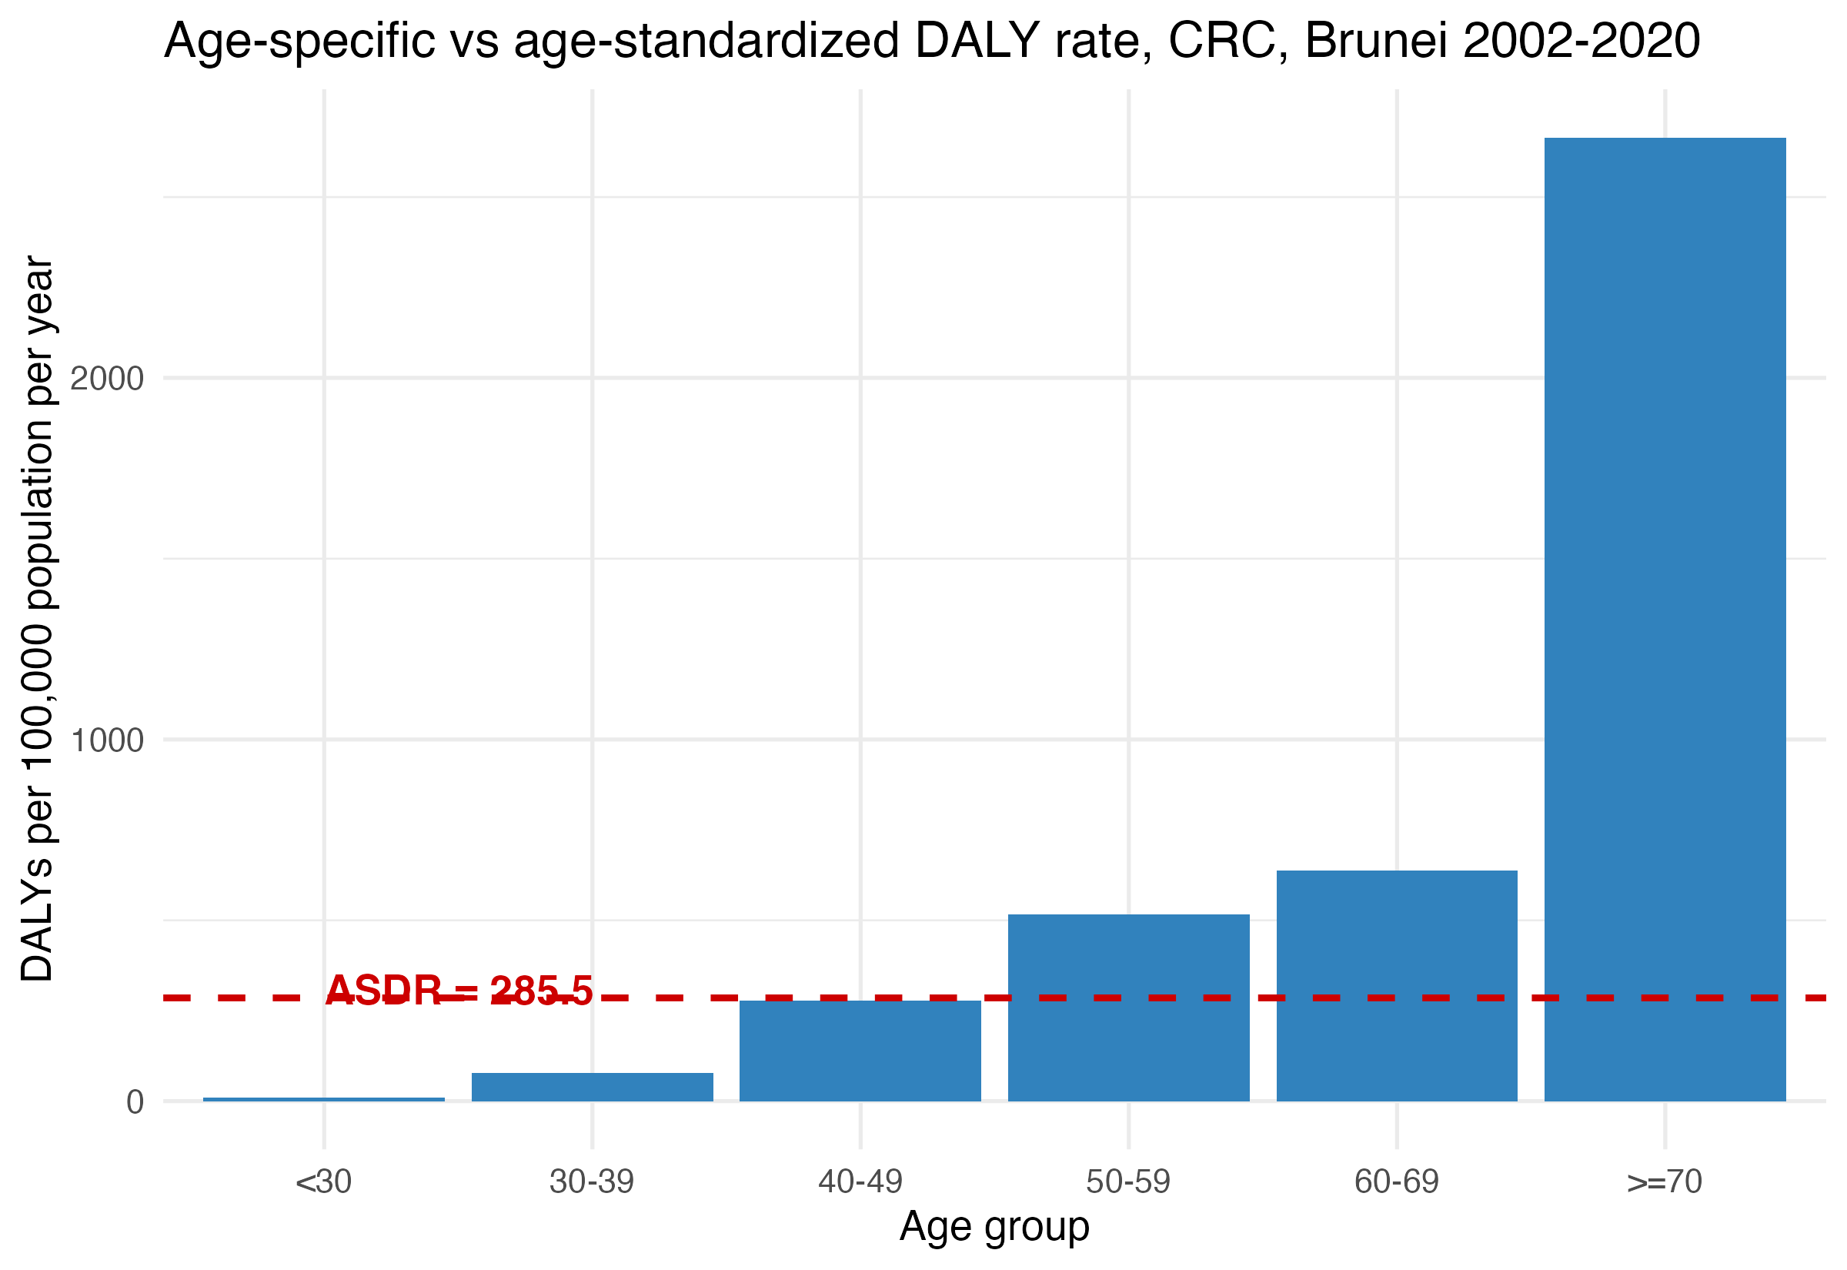
Supplementary Fig. S1. Age-specific DALY rates (per 100,000 population per year) for colorectal cancer by age group, with overall age-standardized DALY rate (285.5 per 100,000 per year), Brunei Darussalam, 2002–2020. Relocated from the main text (formerly Fig. 3 in Section 3.6) as part of merging Section 3.6 (Burden by Age Group) into Section 3.4 (Burden by Age Group and Age at Onset).
Referenced in the main text at: Results §3.4 (Burden by Age Group and Age at Onset).

Supplementary Table S2. Statistical comparison of DALY burden metrics between early-onset (<50 years) and common-onset (≥50 years) colorectal cancer, Brunei Darussalam, 2002–2020.
Metric | Early-onset  (n=295) | Common-onset  (n=1078) | Test | Statistic | p-value
Case-fatality, % (deaths/cases) | 41.0% (121/295) | 44.8% (483/1078) | Fisher's exact | OR = 0.86 | 0.261
DALYs per case, mean | 19.5 | 10.6 | Mann-Whitney U | U = 183,549.5 | <0.001
YLL per death, mean (decedents only) | 45.9 (n=121) | 22.4 (n=483) | Mann-Whitney U | U = 58,071.0 | <0.001
OR = odds ratio (early-onset relative to common-onset). Case-fatality was compared using Fisher’s exact test on the 2×2 onset-group × vital-status table (χ² = 1.20, p = 0.273, Yates-corrected, concordant with the exact test). DALYs per case and YLL per death were compared using Mann-Whitney U tests, given right-skewed, zero-inflated distributions unsuited to a t-test. The YLL share of total DALYs (96.4% vs. 94.5%) is a group-level composition ratio rather than an independent per-patient outcome and was not formally tested.
Referenced in the main text at: Results §3.4 (Burden by Age Group and Age at Onset).

