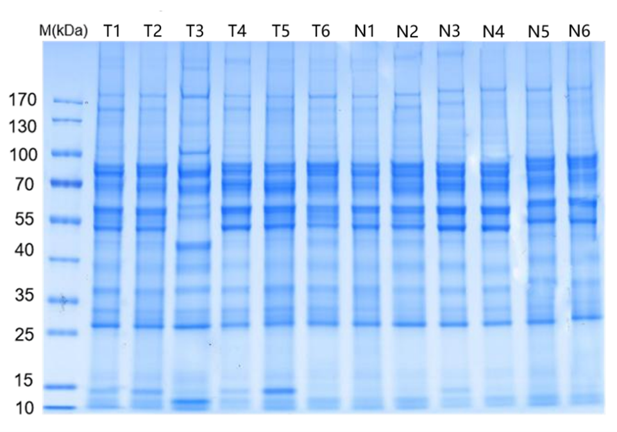
Figure S1 Results of SDS-PAGE electrophoresis.

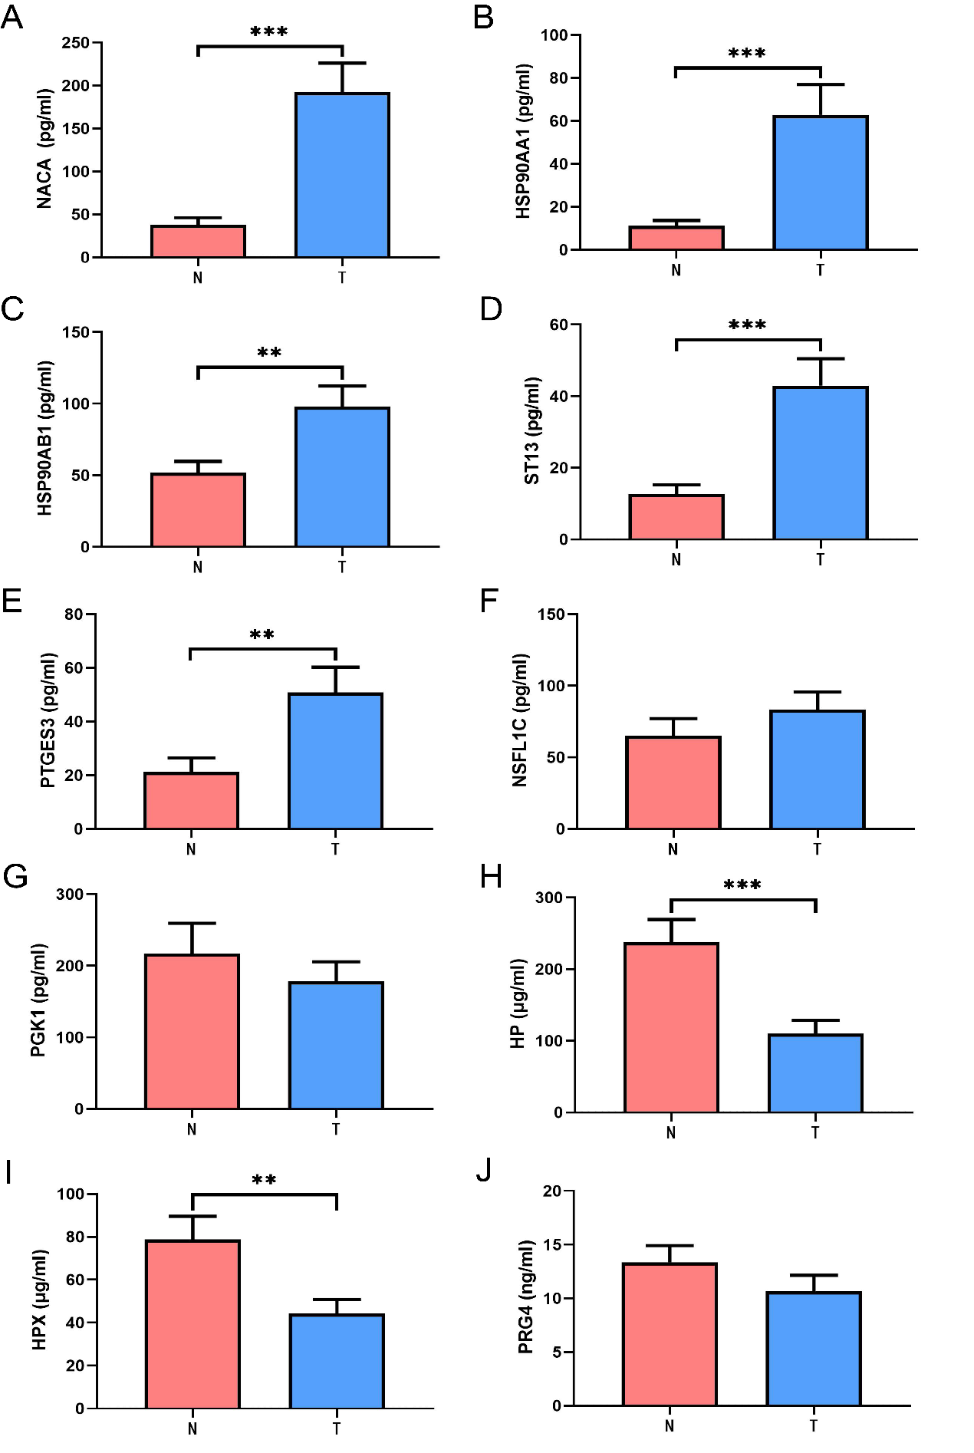
Figure S2: Quantitative analysis of 10 candidate differential proteins by ELISA(A：NACA；B：HSP90AA1；C：HSP90AB1；D：ST13；E：PTGES3；F：NSFL1C；G：PGK1；H：HP；I：HPX；J：PRG4. * P<0.05，**P<0.01，***P<0.001.)
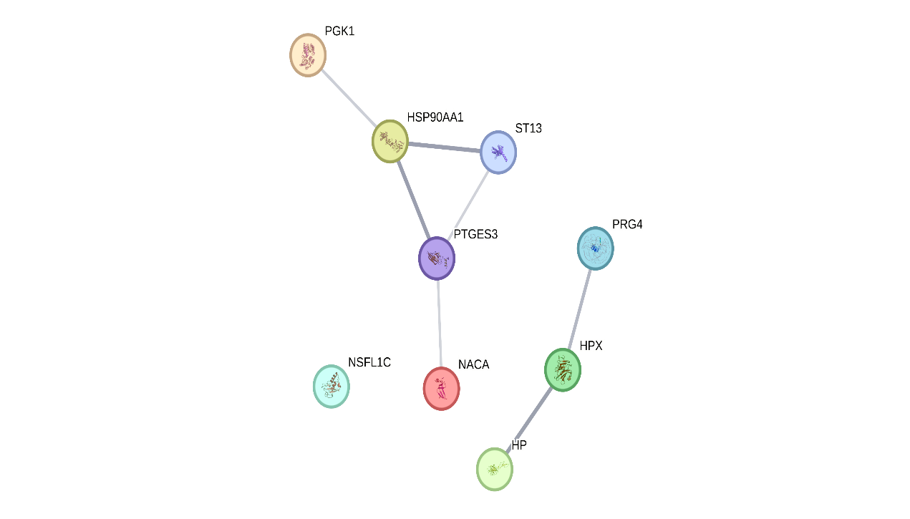
Figure S3 Interaction network diagram of 10 candidate differential proteins
Table S1 clinical information of participants
Sample | Age  (years) | Gender | Genotype | Hemoglobin （g/L） | Ferritin （ng/mL） | Blood transfusion | Liver and spleen size
T1 | 5 | Male | αCSα/--SEA | 77 | 281.53 | No | Untouched
T2 | 8 | Female | αCSα/--SEA | 87 | 197.17 | No | Untouched
T3 | 5 | Female | αCSα/--SEA | 42 | 245.53 | Yes& | Splenomegaly
T4 | 6 | Male | αCSα/--SEA | 67 | 217.24 | Yes & | Splenomegaly
T5 | 11 | Male | αCSα/--SEA | 77.5 | 296.3 | No | Splenomegaly
T6 | 5 | Female | αCSα/--SEA | 80 | 161.1 | No | Untouched
N1 | 4 | Female |  | 129 | 34.9 | No | Untouched
N2 | 5 | Male |  | 126 | 46.8 | No | Untouched
N3 | 10 | Female |  | 139 | 25.6 | No | Untouched
N4 | 5 | Female |  | 139 | 80.4 | No | Untouched
N5 | 13 | Male |  | 137 | 59.2 | No | Untouched
N6 | 8 | Male |  | 132 | 37.3 | No | Untouched
Note: & indicates a history of blood transfusion but no transfusion therapy within the past three months.

Table S2 Isotope labeling design table
Sample | Experiment Label |  | Marking Information
T1 |  | T1 | 126
T2 |  | T2 | 127N
T3 |  | T3 | 127C
T4 |  | T4 | 128N
T5 |  | T5 | 128C
T6 |  | T6 | 129N
N1 |  | N1 | 129C
N2 |  | N2 | 130N
N3 |  | N3 | 130C
N4 |  | N4 | 131N
N5 |  | N5 | 131C
N6 |  | N6 | 134N

Table S3 Separation gradient of fractionation treatment
Time (minutes) | Mobile Phase B Ratio（%）
0 | 5
5 | 8
40 | 18
62 | 32
64 | 95
68 | 95
72 | 5
Table S4 Search database retrieval parameter Settings
Parameters | Value
Enzyme | Trypsin
Static Modification | Carbamidomethyl(C)
Dynamic Modification | M Oxidation（15.995Da）；TMT-16plex（K，N-terminal）  Acetyl (Protein N-terminal)；
Precursor ion mass tolerance | ± 15 ppm
Fragment ion mass tolerance | ± 0.02 Da
Max Missed Cleavages | 2
Table S5 Comparison of general information between the two groups
Characteristics | Group T（n=6） |  | Group N（n=6） | P
Age(years) # |  | 6.67±2.422 | 7.50±3.507 | 0.642
Gender (e.g.) |  |  |  | 1.000
Male |  | 3 | 3
Female |  | 3 | 3
Note:# denotes mean ± standard deviation.
Table S6 Quantitative results of protein
Sample Name | Protein concentration（μg/μL） | Sample volume（μL） | Total Protein Weight（μg） | Sample Rating | Rubber consumption（μg） | Remaining samples in the original sample
T1 | 1.33 | 80 | 106.23 | A1 | 5 | 0
T2 | 1.61 | 80 | 128.70 | A1 | 5 | 0
T3 | 0.55 | 80 | 43.62 | A1 | 5 | 0
T4 | 1.50 | 80 | 119.87 | A1 | 5 | 0
T5 | 1.46 | 80 | 116.69 | A1 | 5 | 0
T6 | 1.19 | 80 | 95.18 | A1 | 5 | 0
N1 | 1.74 | 80 | 139.26 | A1 | 5 | 0
N2 | 0.99 | 80 | 79.13 | A1 | 5 | 0
N3 | 1.69 | 80 | 135.46 | A1 | 5 | 0
N4 | 1.64 | 80 | 131.05 | A1 | 5 | 0
N5 | 1.31 | 80 | 104.44 | A1 | 5 | 0
N6 | 1.40 | 80 | 112.32 | A1 | 5 | 0
Sample Grade Description:A1: Sample protein quantity is greater than or equal to the requirement for two experiments, with clear gel images and abundant bands, but lacking high abundance.
Table S7 Details of differential proteins
 | ID | name | log2FC | P | regulated
 | E9PAV3 | NACA | 0.875881579664838 | 0.0039354026519439 | up
 | P23528 | CFL1 | 0.549540442472916 | 0.00624491818881856 | up
 | Q9UNZ2 | NSFL1C | 1.04187314519766 | 0.00750938642424797 | up
 | P50502 | ST13 | 0.926679814242179 | 0.007625740714907791 | up
 | P62258 | YWHAE | 0.48097381573710607 | 0.0100009197575586 | up
 | P07900 | HSP90AA1 | 1.41486736258415 | 0.0106849928488418 | up
 | P01019 | AGT | 0.420184833099533 | 0.0113970774169156 | up
 | Q02818 | NUCB1 | 0.802775461208455 | 0.0116462502610593 | up
 | Q9UNW1 | MINPP1 | 0.397719848541883 | 0.0144627898819895 | up
 | P62081 | RPS7 | 0.669443651940991 | 0.017151313216218 | up
 | P08238 | HSP90AB1 | 0.8564139207428941 | 0.0180613810385994 | up
 | P13727 | PRG2 | 0.709839771978817 | 0.0195974222960142 | up
 | P04217 | A1BG | 0.43308299086885793 | 0.0202987914404395 | up
 | P62979 | RPS27A | 0.823868939988005 | 0.0211631411083288 | up
 | P59190 | RAB15 | 0.7344867360977819 | 0.0212503631038749 | up
 | O75563 | SKAP2 | 0.668459197494505 | 0.022797338636617995 | up
 | Q15185 | PTGES3 | 1.23670413990077 | 0.0248453306825107 | up
 | P40227 | CCT6A | 1.1273754551351398 | 0.0307317789545533 | up
 | Q99832 | CCT7 | 1.08415236044359 | 0.0321536682124966 | up
 | P69892 | HBG2 | 1.7490269277888602 | 0.0329109556844804 | up
 | P29692 | EEF1D | 1.25537949450575 | 0.0346602349343261 | up
 | A0A0C4DH38 | IGHV5-51 | 0.49254803682927795 | 0.0347323049793236 | up
 | Q6B0K9 | HBM | 2.6317210016709303 | 0.0369923701085139 | up
 | P28072 | PSMB6 | 0.774262972921023 | 0.0381603034508363 | up
 | O43242 | PSMD3 | 0.695423863836186 | 0.0399208222246657 | up
 | P50991 | CCT4 | 1.4882139713182199 | 0.0399892395236027 | up
 | P19320 | VCAM1 | 0.46423733355842606 | 0.0412237886924961 | up
 | P02786 | TFRC | 1.6461757535149801 | 0.041242906668917 | up
 | Q06830 | PRDX1 | 0.8912207201408059 | 0.0426413770048042 | up
 | P21912 | SDHB | 0.514790648152265 | 0.0426611496054863 | up
A0A087WW87 |  | IGKV2-40 | 0.286309116839106 | 0.0437332967677729 | up
P30613 |  | PKLR | 0.5859898110157359 | 0.0441092004252957 | up
P05388 |  | RPLP0 | 0.5581089626718381 | 0.0442630639183818 | up
P02763 |  | ORM1 | 0.6925540922557231 | 0.0471345718182547 | up
P61586 |  | RHOA | 0.657302430921376 | 0.0480767115641884 | up
P07225 |  | PROS1 | -0.533004539 | 0.00214757214894344 | down
Q92954 |  | PRG4 | -0.907276396 | 0.0033502178390821197 | down
P04003 |  | C4BPA | -0.357775013 | 0.00391919568131758 | down
Q9HCB6 |  | SPON1 | -0.416222464 | 0.00471673788460699 | down
P01833 |  | PIGR | -0.391137491 | 0.00496189209933502 | down
Q15166 |  | PON3 | -0.646186281 | 0.0062634762193786 | down
P04070 |  | PROC | -0.615788526 | 0.007669780415773 | down
P80108 |  | GPLD1 | -0.694523614 | 0.00882379344862709 | down
P08709 |  | F7 | -0.324076861 | 0.01335448802308 | down
Q9NQ79 |  | CRTAC1 | -0.680798602 | 0.0205233355106863 | down
Q9UHG3 |  | PCYOX1 | -0.395309696 | 0.0205407670925791 | down
P00558 |  | PGK1 | -1.314274066 | 0.024467873798579 | down
Q9UK55 |  | SERPINA10 | -0.401465921 | 0.0251720290143689 | down
P00738 |  | HP | -1.13405511 | 0.0280264220020122 | down
P49747 |  | COMP | -0.538297133 | 0.0311521978145627 | down
P20700 |  | LMNB1 | -0.276346334 | 0.033695494592104 | down
Q8NI99 |  | ANGPTL6 | -0.403710064 | 0.0339460578847077 | down
O00602 |  | FCN1 | -0.536242588 | 0.043339354732863995 | down
P24593 |  | IGFBP5 | -0.633365278 | 0.0440438207165982 | down
Q99969 |  | RARRES2 | -0.418255922 | 0.0461693536170893 | down
 | P02790 | HPX | -1.587847197 | 9.12767037588275e-07 | down

Table S8 Comparison of clinical data between the two groups
 | Total (n=90, %) | Group T (n=45, %) | Group N (n=45, %) | P
Gender |  |  |  | 0.389
Female | 54(60.0) | 25(55.6) | 29(64.4)
Male | 36(40.0) | 20(44.4) | 16(35.6)
Age (years)# | 16.00±11.77 | 16.33±12.12 | 15.69±11.54 | 0.798
Hemoglobin (g/L)# | 106.37±29.43 | 79.77±13.31 | 132.98±11.25 | ＜0.001***
Blood transfusion |  |  |  | 0.001***
No | 80(88.9) | 35(77.8) | 45(100.0)
Yes& | 10(11.1) | 10(22.2) | 0(0.0)
Hepatosplenomegaly |  |  |  | ＜0.001***
No | 73(81.1) | 28(62.2) | 45(100.0)
Yes | 17(18.9) | 17(37.8) | 0(0.0)
Note: # denotes mean ± standard deviation; &denotes prior history of blood transfusion but no transfusion therapy within the past three months. *P < 0.05, **P < 0.01, ***P < 0.001

Table S9 Univariate analysis
proteins | B | HR (95%CI) | P
NACA | 0.022 | 1.022(1.021-1.098) | 0.001**
HSP90AA1 | 0.057 | 1.059(1.009-1.034) | 0.002**
HSP90AB1 | 0.014 | 1.014 (1.003-1.025) | 0.013*
ST13 | 0.035 | 1.036 (1.010-1.062) | 0.005**
PTGES3 | 0.016 | 1.016 (1.002-1.030) | 0.022*
NSFL1C | 0.003 | 1.003 (0.998-1.008) | 0.290
PGK1 | -0.001 | 0.999 (0.998-1.001) | 0.443
HP | -0.005 | 0.995 (0.991-0.998) | 0.005**
HPX | -0.011 | 0.989 (0.980-0.998) | 0.014*
PRG4 | -0.027 | 0.974 (0.934-1.015) | 0.213
*P < 0.05, **P < 0.01, ***P < 0.001

Table S10 Comparison of clinical data in subgroup analysis
 | Total (n=45，%) | Hb≤80g/L (n=23，%) | Hb＞80g/L (n=22，%) | P
Gender |  |  |  | 0.300
Female | 24(53.3) | 14(60.9) | 10(45.5)
Male | 21(46.7) | 9(39.1) | 12(54.5)
Age (years)# | 16.56±12.13 | 15.78±11.21 | 17.36±13.25 | 0.668
Hemoglobin (g/L)# | 79.63±13.40 | 69.85±8.86 | 89.86±8.91 | ＜0.001***
Blood transfusion |  |  |  | 0.071
No | 35(77.8) | 15(65.2) | 20(90.9)
Yes& | 10(22.2) | 10(43.5) | 0(0)
Hepatosplenomegaly |  |  |  | 0.088
No | 27(60.0) | 11(47.8) | 16(72.7)
Yes | 18(40.0) | 12(52.2) | 6(27.3)
Note: # denotes mean ± standard deviation; &denotes prior history of blood transfusion but no transfusion therapy within the past three months. *P < 0.05, **P < 0.01, ***P < 0.001

