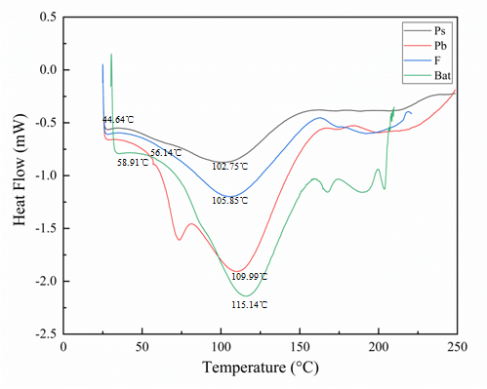

Fig S1 Thermogravimetric analysis curve top: Ps: Small molecule type I collagen in pigskin; Pb: Large-molecule type I collagen from pigskin F: Type I collagen from fish skin Bat: Type I collagen of bovine Achilles tendon, down: type I collagen of yak skin.
Table S1 The amino acid composition and content of type I collagen from different sources
Amino acids | mg/g |  |  |  |  | %
Amino acids | Ps | P_{b} | F | Bat | Yak | Ps | Pb | F | Bat | Yak
Asp | 19.542 | 18.769 | 22.566 | 22.020 | 48.135 | 3.967 | 4.015 | 4.781 | 4.279 | 6.320
Thr | 7.008 | 4.597 | 9.475 | 7.591 | 14.853 | 1.423 | 0.983 | 2.007 | 1.474 | 1.950
Ser | 11.116 | 6.410 | 12.130 | 12.645 | 20.841 | 2.257 | 1.371 | 2.570 | 2.455 | 2.736
Glu | 34.228 | 33.454 | 40.757 | 37.008 | 85.853 | 6.949 | 7.156 | 8.635 | 7.185 | 11.272
Gly | 42.052 | 42.708 | 41.344 | 44.724 | 191.218 | 8.537 | 9.135 | 8.759 | 8.684 | 25.107
Ala | 24.295 | 26.582 | 25.458 | 30.965 | 86.865 | 4.932 | 5.686 | 5.393 | 6.012 | 11.405
Cys | 5.164 | 4.511 | 5.830 | 5.341 | 4.077 | 1.048 | 0.965 | 1.235 | 1.037 | 0.535
Val | 24.894 | 29.524 | 31.066 | 32.573 | 21.429 | 5.054 | 6.315 | 6.582 | 6.324 | 2.814
Met | 48.963 | 45.830 | 39.912 | 46.186 | 7.359 | 9.940 | 9.803 | 8.456 | 8.967 | 0.966
Ile | 38.346 | 21.497 | 33.578 | 33.087 | 13.706 | 7.785 | 4.598 | 7.114 | 6.424 | 1.800
Leu | 48.009 | 36.457 | 40.366 | 44.390 | 26.512 | 9.746 | 7.798 | 8.545 | 8.619 | 3.481
Tyr | 8.592 | 4.020 | 8.920 | 5.559 | 3.335 | 1.744 | 0.860 | 1.890 | 1.079 | 0.438
Phe | 9.319 | 7.618 | 10.827 | 11.202 | 15.588 | 1.892 | 1.629 | 2.294 | 2.175 | 2.047
His | 2.545 | 2.210 | 4.805 | 2.839 | 13.741 | 0.517 | 0.473 | 1.018 | 0.551 | 1.804
Lys | 11.672 | 13.931 | 12.148 | 13.218 | 32.812 | 2.370 | 2.980 | 2.574 | 2.566 | 4.308
Arg | 21.103 | 18.516 | 20.749 | 21.880 | 65.888 | 4.284 | 3.960 | 4.396 | 4.248 | 8.651
Pro | 135.74 | 150.888 | 112.119 | 143.798 | 109.412 | 27.556 | 32.274 | 23.753 | 27.920 | 14.366
Total | 492.589 | 467.523 | 472.019 | 515.044 | 761.624 | 100.000 | 100.000 | 100.000 | 100.000 | 100.000
Since the crystal structure of the collagen from yak skin has not been reported yet, its three-dimensional structure needs to be constructed through homology modeling. The protein structure was constructed using the homology modeling software MODELLER in combination with the SWISS-MODEL and CCBuilder 2.0 servers.
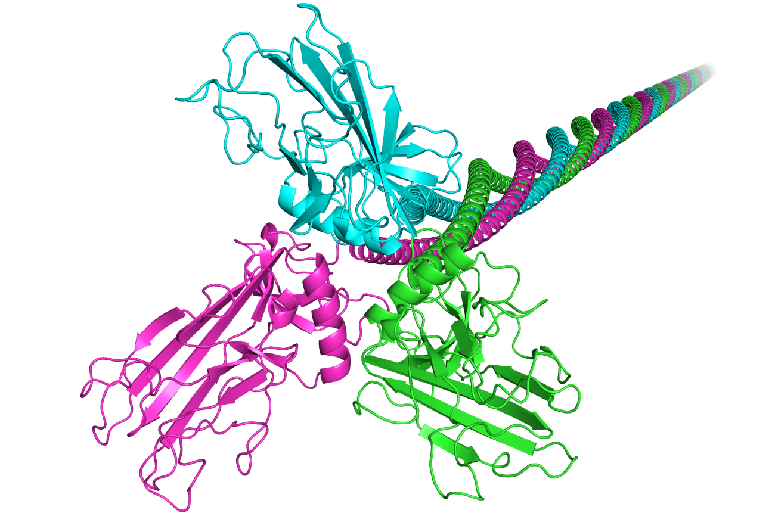
Fig S2 Full-length structure model of collagen from yak skin
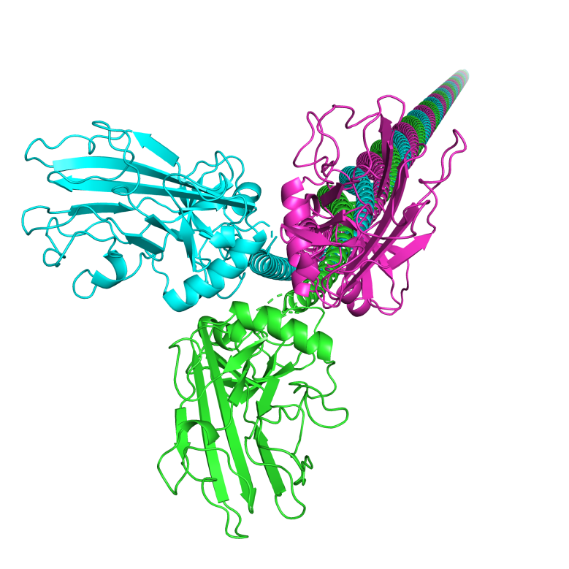
Fig S3 Full-length model of collagen alpha-2 (I) chain
The three-colored cartoon models in the figure represent the three subunits of bovine collagen. From near to far, the models are shown from the C-terminus to the N-terminus of the collagen protein.

Table S2 Analysis of variance (ANOVA)
Source | Sum of squares | df | Mean square | F | P | Significance
Model | 0.52 | 9 | 0.058 | 5.46 | 0.0179 | significant
A | 7.526E-003 | 1 | 7.526E-003 | 0.71 | 0.4259
B | 3.773E-003 | 1 | 3.773E-003 | 0.36 | 0.5684
C | 0.031 | 1 | 0.031 | 2.98 | 0.1281
AB | 0.19 | 1 | 0.19 | 18.30 | 0.0037
AC | 0.013 | 1 | 0.013 | 1.28 | 0.2960
BC | 0.038 | 1 | 0.038 | 3.62 | 0.0989
A² | 6.013E-003 | 1 | 6.013E-003 | 0.57 | 0.4746
B² | 0.20 | 1 | 0.20 | 18.73 | 0.0034
C² | 1.677E-003 | 1 | 1.677E-003 | 0.16 | 0.7018
Residual | 0.074 | 7 | 0.011
Lack of fit | 0.031 | 3 | 0.010 | 0.97 | 0.4893 | not significant
Pure Error | 0.043 | 4 | 0.011
Cor Total | 0.59 | 16

