Supplementary file
Table S1. Structure, PIC50 and docking scores of the dataset
S/N | STRUCTURE | IC50(nm) | PIC50 | Docking
 |  |  |  | score
1 | 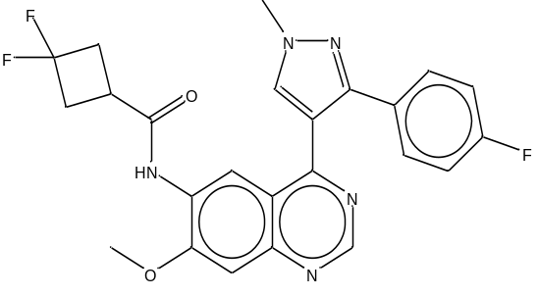 | 0.2 | 9.69897 | -7.361
2 | 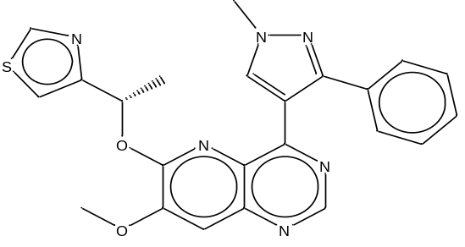 | 0.5 | 9.30103 | -3.169
3 | 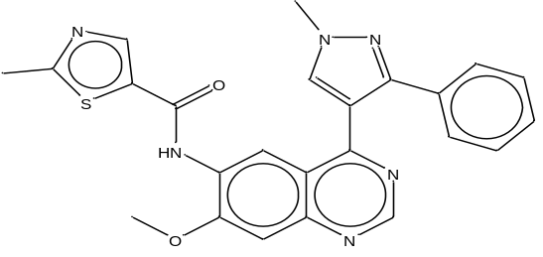 | 0.4 | 9.39794 | -3.226
4 | 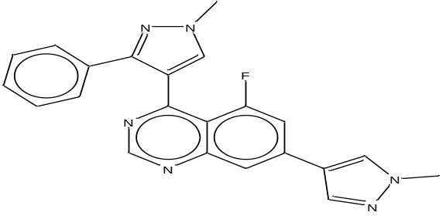 | 0.7 | 9.154902 | -9.857
5 | 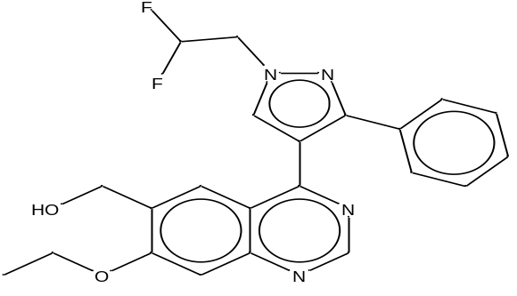 | 0.9 | 9.045757 | -9.462
6 | 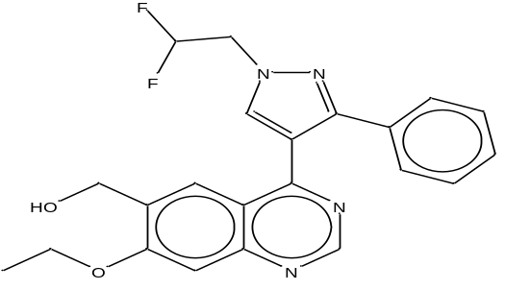 | 1 | 9.000 | -10.41
7 | 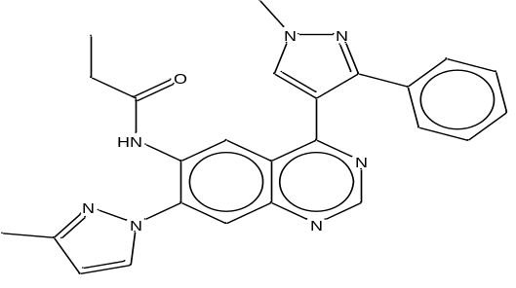 | 1.2 | 8.920819 | -4.544
8 | 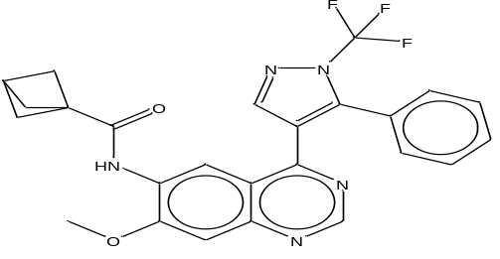 | 121 | 6.917215 | -2.843
9 | 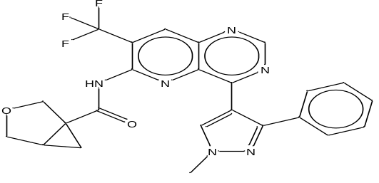 | 126 | 6.899629 | -2.046
10 | 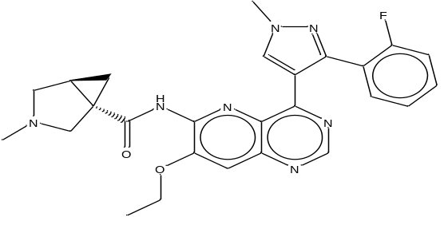 | 141 | 6.850781 | -8.532
11 | 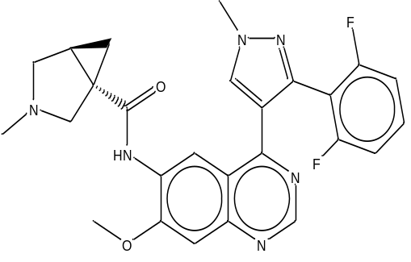 | 145 | 6.838632 | -2.658
12 | 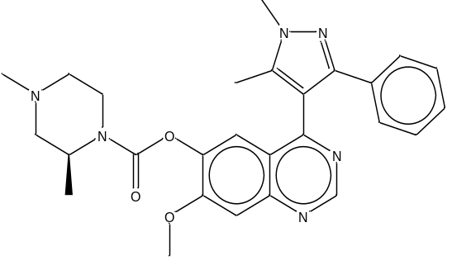 | 207 | 6.68403 | -2.268
13 | 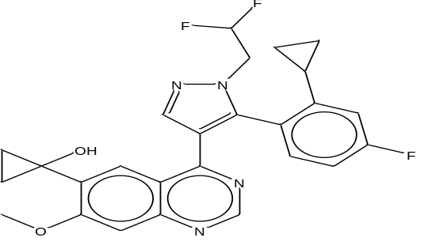 | 237 | 6.625252 | -7.672
14 | 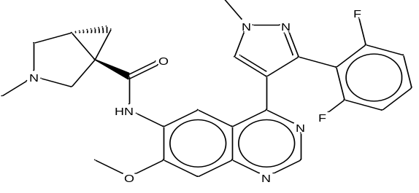 | 277 | 6.55752 | -4.876
15 | 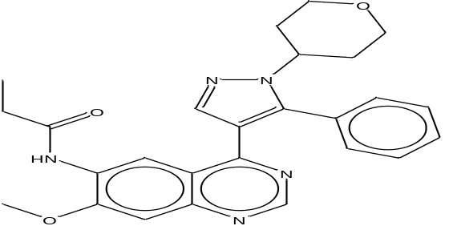 | 349 | 6.457175 | -4.876
16 | 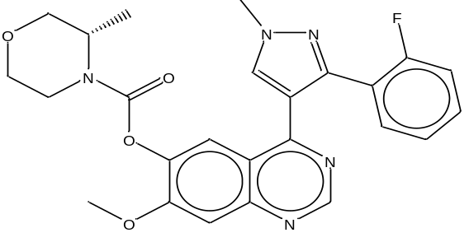 | 829 | 6.081445 | -3.5
17 | 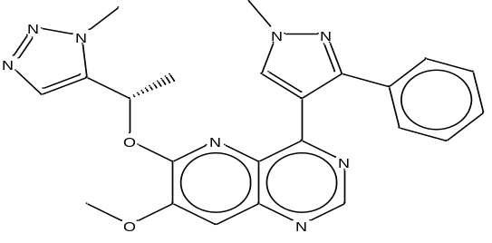 | 9.6 | 8.017729 | -7.025
18 | 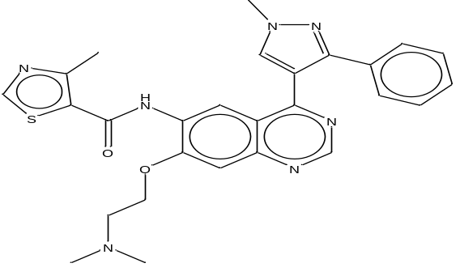 | 11 | 7.958607 | -6.564
19 | 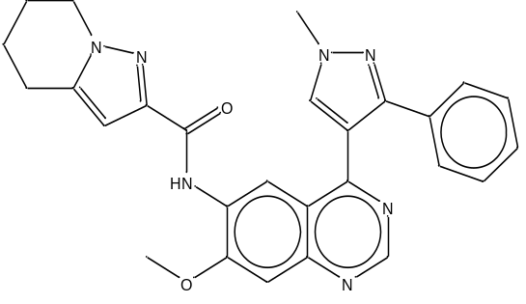 | 14 | 7.853872 | -3.282
20 | 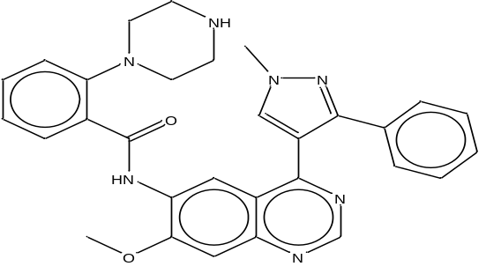 | 15.2 | 7.818156 | -4.446
21 | 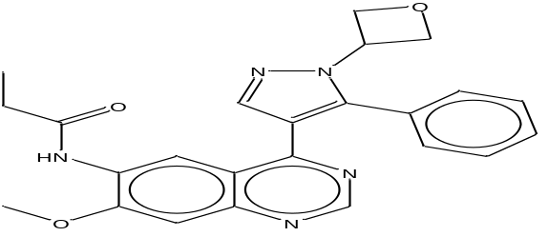 | 17 | 7.769551 | -8.38
22 | 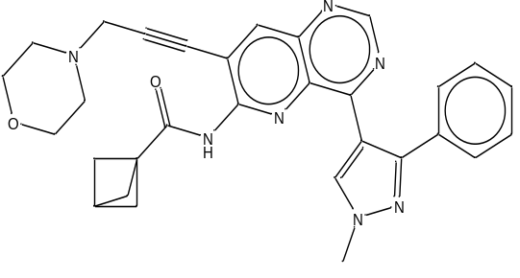 | 18.1 | 7.742321 | -3.01
23 | 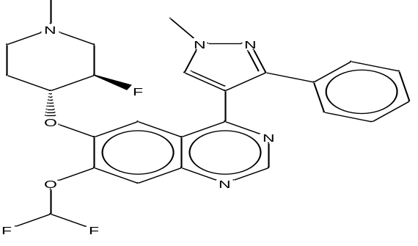 | 21 | 7.677781 | -5.625
24 | 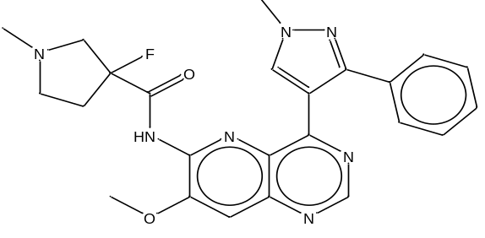 | 24.9 | 7.603801 | -4.961
25 | 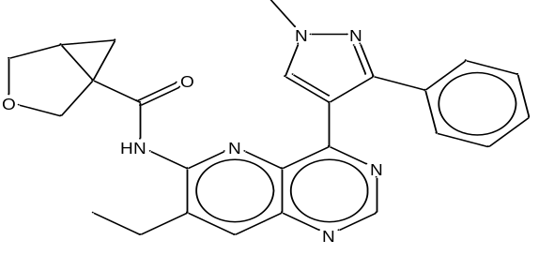 | 28.9 | 7.539102 | -4.961
26 | 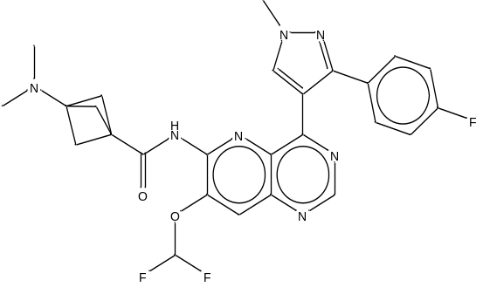 | 39 | 7.408935 | -3.627
27 | 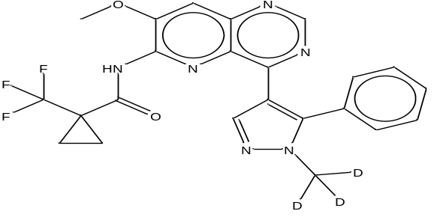 | 43.3 | 7.363512 | -5.063
28 | 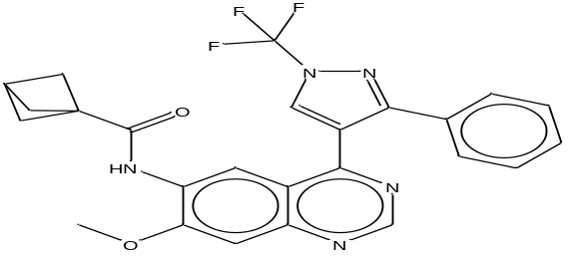 | 48.7 | 7.312471 | -1.427
29 | 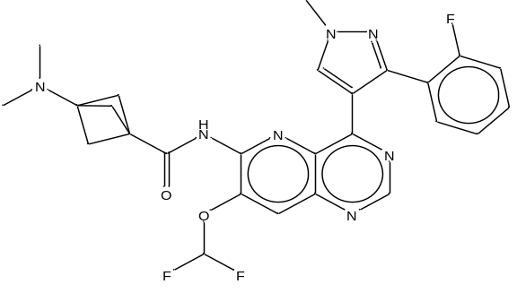 | 60 | 7.221849 | -5.451
30 | 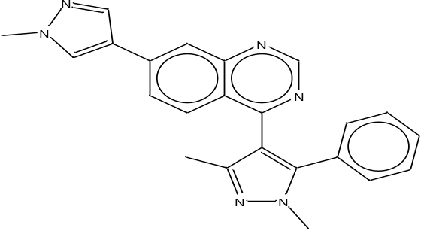 | 70.5 | 7.151811 | -7.127
31 | 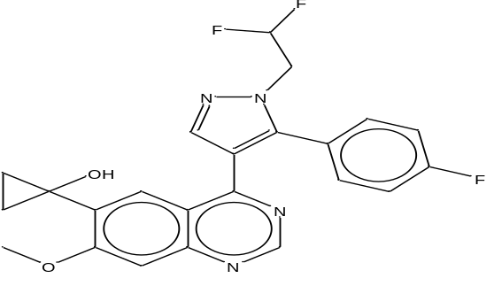 | 82 | 7.086186 | -8.557
32 | 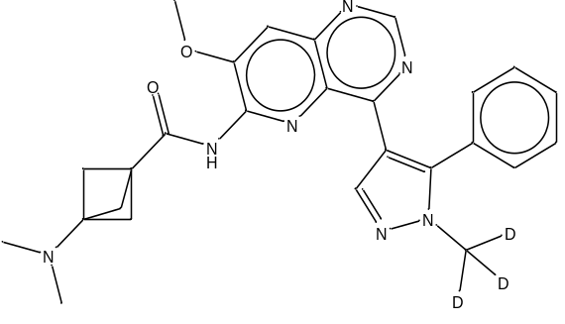 | 92.4 | 7.034328 | -3.437
33 | 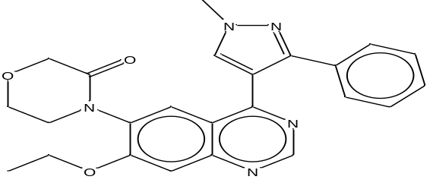 | 109 | 6.962574 | -9.63
34 | 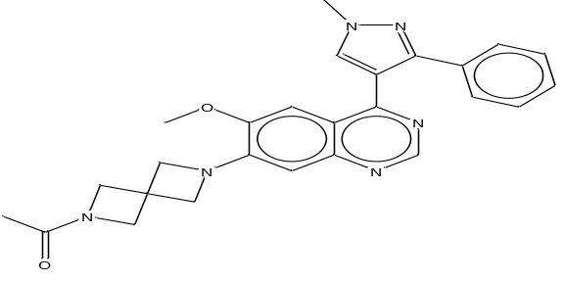 | 1.6 | 8.79588 | -4.919
35 | 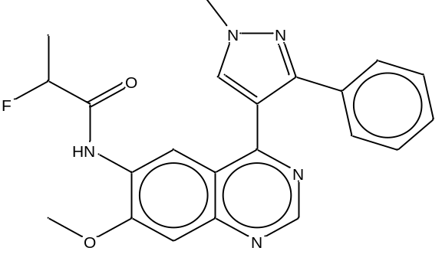 | 1.8 | 8.744727 | -4.978
36 | 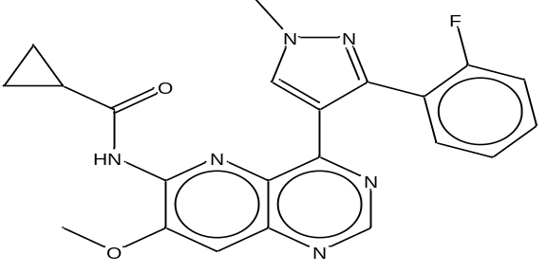 | 1.9 | 8.721246 | -3.434
37 | 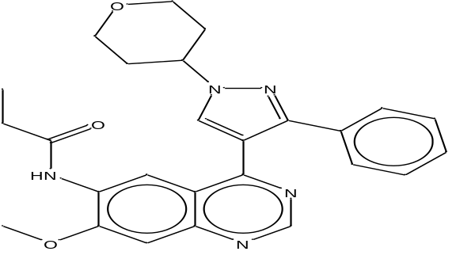 | 2 | 8.69897 | -6.123
38 | 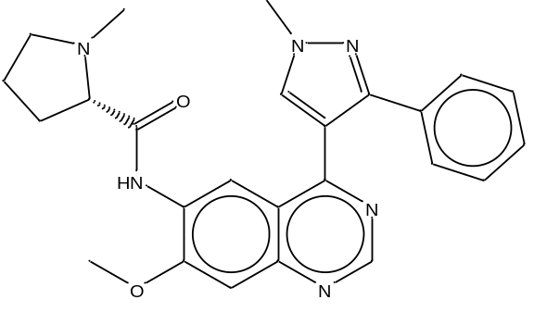 | 2.4 | 8.619789 | -6.428
39 | 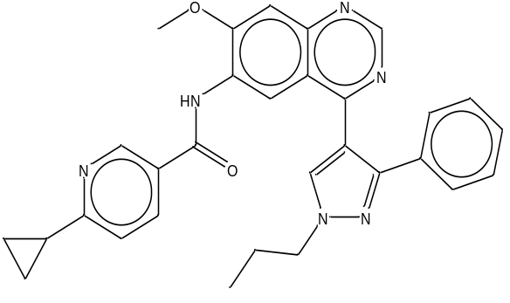 | 2.7 | 8.568636 | -0.286
40 | 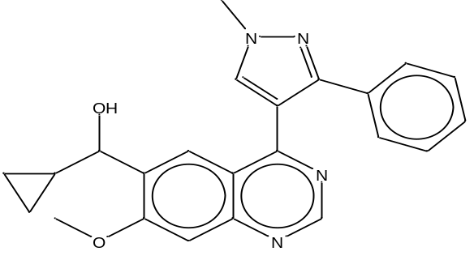 | 2.5 | 8.60206 | -5.34
41 | 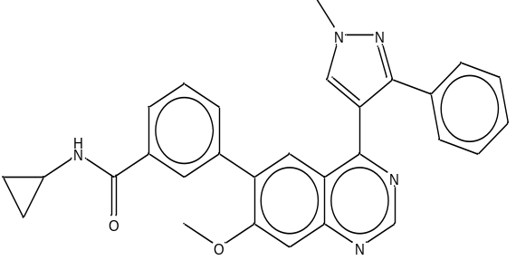 | 2.8 | 8.552842 | -4.596
42 | 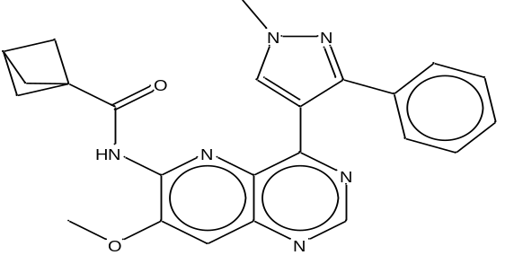 | 3.1 | 8.508638 | -8.868
43 | 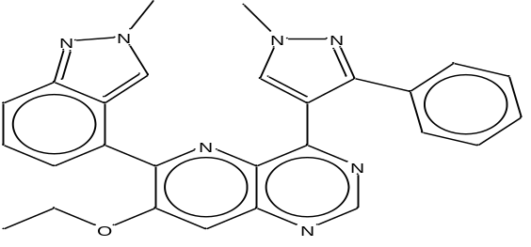 | 3.2 | 8.49485 | -4.074
44 | 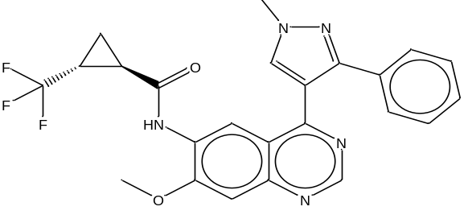 | 3.5 | 8.455932 | -8.657
45 | 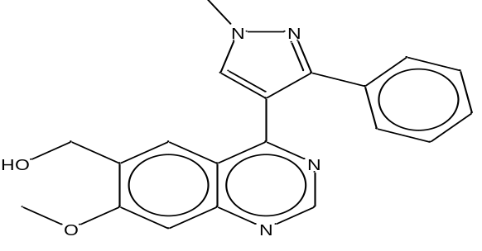 | 3.9 | 8.408935 | -10.012
46 | 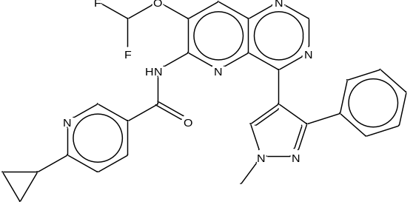 | 4.5 | 8.346787 | -3.929
47 | 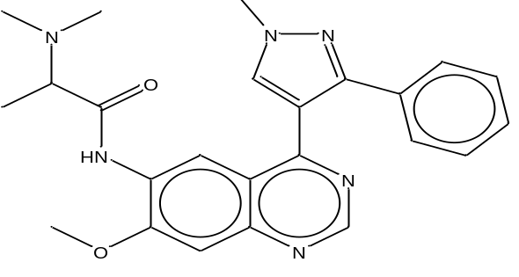 | 5 | 8.30103 | -8.472
48 | 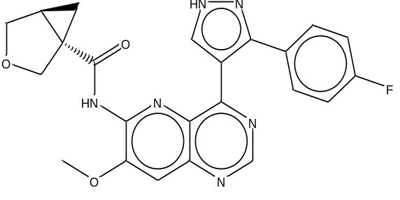 | 5.5 | 8.259637 | -9.235
49 | 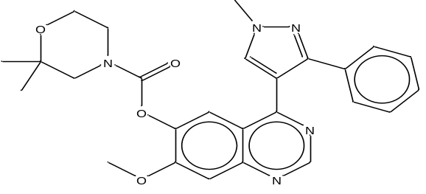 | 6 | 8.221849 | -3.641
50 | 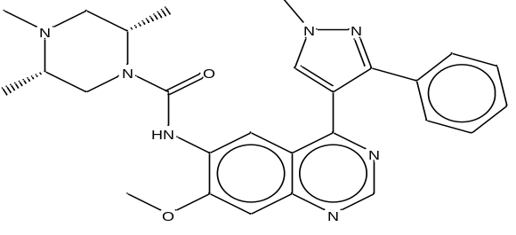 | 6.2 | 8.207608 | -1.793
51 | 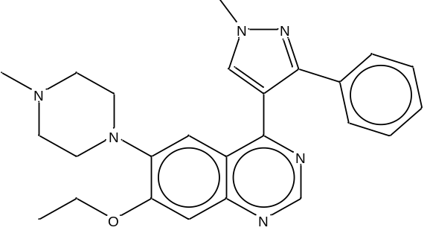 | 7 | 8.154902 | -3.696
52 | 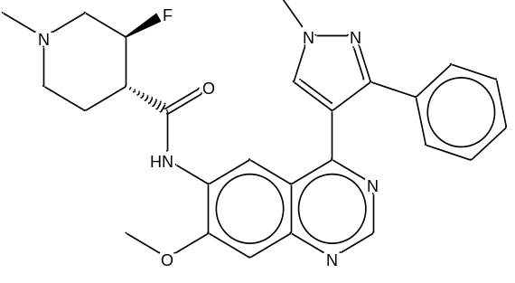 | 8.7 | 8.060481 | -2.296

Table 2. MLR Y-randomization model parameter
MODEL TYPE | R | R² |  | Q²(LOO)
Original | 0.883804 | 0.781109 |  | 0.708751
Random 1 | 0.421925 | 0.178021 |  | -0.19184
Random 2 | 0.376874 | 0.142034 |  | -0.23107
Random 3 | 0.256808 | 0.06595 |  | -0.34106
Random 4 | 0.318941 | 0.101723 |  | -0.27583
Random 5 | 0.310882 | 0.096648 |  | -0.17725
Random 6 | 0.229689 | 0.052757 |  | -0.41549
Random 7 | 0.436358 | 0.190408 |  | -0.16608
Random 8 | 0.438247 | 0.192061 |  | -0.10307
Random 9 | 0.315304 | 0.099417 |  | -0.25956
Random 10 | 0.370349 | 0.137158 |  | -0.34003
Random 11 | 0.429254 | 0.184259 |  | -0.22839
Random 12 | 0.391788 | 0.153498 |  | -0.21818
Random 13 | 0.463731 | 0.215046 |  | -0.11346
Random 14 | 0.203835 | 0.041549 |  | -0.3666
Random 15 | 0.198843 | 0.039539 |  | -0.43851
Random 16 | 0.202875 | 0.041158 |  | -0.30729
Random 17 | 0.407412 | 0.165985 |  | -0.12904
Random 18 | 0.515588 | 0.265831 |  | 0.044536
Random 19 | 0.373641 | 0.139607 |  | -0.25915
Random 20 | 0.545362 | 0.297419 |  | 0.030174
Random 21 | 0.392351 | 0.153939 |  | -0.15758
Random 22 | 0.416766 | 0.173694 |  | -0.06919
Random 23 | 0.495687 | 0.245705 |  | -0.26945
Random 24 | 0.234037 | 0.054773 |  | -0.38924
Random 25 | 0.303045 | 0.091836 |  | -0.3615
Random 26 | 0.269605 | 0.072687 |  | -0.32551
Random 27 | 0.189404 | 0.035874 |  | -0.26461
Random 28 | 0.31271 | 0.097788 |  | -0.22239
Random 29 | 0.400839 | 0.160672 |  | -0.13708
Random 30 | 0.312752 | 0.097814 |  | -0.2967
Random 31 | 0.412598 | 0.170237 |  | -0.143
Random 32 | 0.35062 | 0.122934 |  | -0.20945
Random 33 | 0.388258 | 0.150744 |  | -0.15597
Random 34 | 0.448571 | 0.201216 |  | -0.1055
Random 35 | 0.326378 | 0.106523 |  | -0.28635
Random 36 | 0.472997 | 0.223726 |  | -0.03409
Random 37 | 0.402357 | 0.161891 |  | -0.10501
Random 38 | 0.221584 | 0.0491 |  | -0.27604
Random 39 | 0.355141 | 0.126125 |  | -0.1696
Random 40 | 0.528485 | 0.279296 |  | 0.022039
Random 41 | 0.310781 | 0.096585 |  | -0.24592
Random 42 | 0.437335 | 0.191262 |  | -0.158
Random 43 | 0.239076 | 0.057158 |  | -0.42565
Random 44 | 0.234486 | 0.054984 |  | -0.24542
Random 45 | 0.289238 | 0.083659 |  | -0.26636
Random 46 | 0.406206 | 0.165003 |  | -0.2045
Random 47 | 0.346051 | 0.119751 |  | -0.31541
Random 48 | 0.207173 | 0.042921 |  | -0.5184
Random 49 | 0.306127 | 0.093714 |  | -0.34932
Random 50 | 0.349929 | 0.12245 |  | -0.23672
Random Models | Parameters
Average R | 0.361806
Average R² | 0.144809
AverageQ²(LOO) | -0.20981
cR²p | 0.716727

Table S3. Drug likeness predictions of the newly designed inhibitors base on Lipinski, veber, Egan and Goose
 | Lipinnski | Veber | Egan | Ghoose | Muegge
D1 | YES | YES | YES | YES | YES
D2 | YES | YES | YES | NO | YES
D3 | YES | YES | YES | NO | YES
D4 | YES | YES | YES | NO | YES
Co-crystalize | YES | YES | YES | YES | YES
Osimertinib | YES | NO | YES | NO | YES

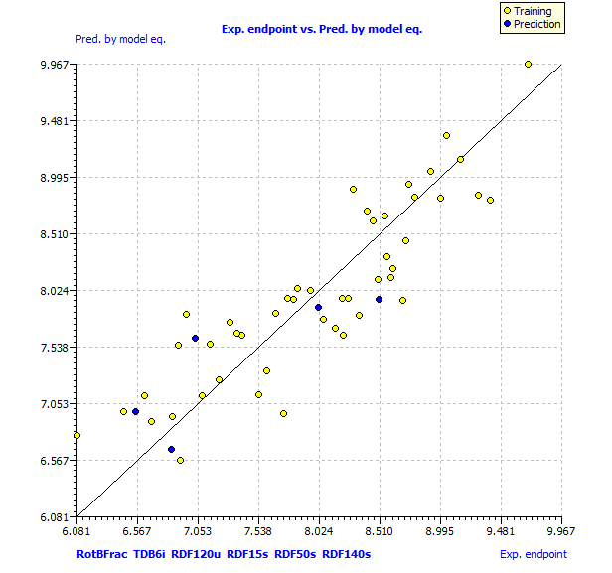
Fig.S1 scatter plot of experimental activities and predicted activity for the data set compounds

