Supplementary Figures and Tables

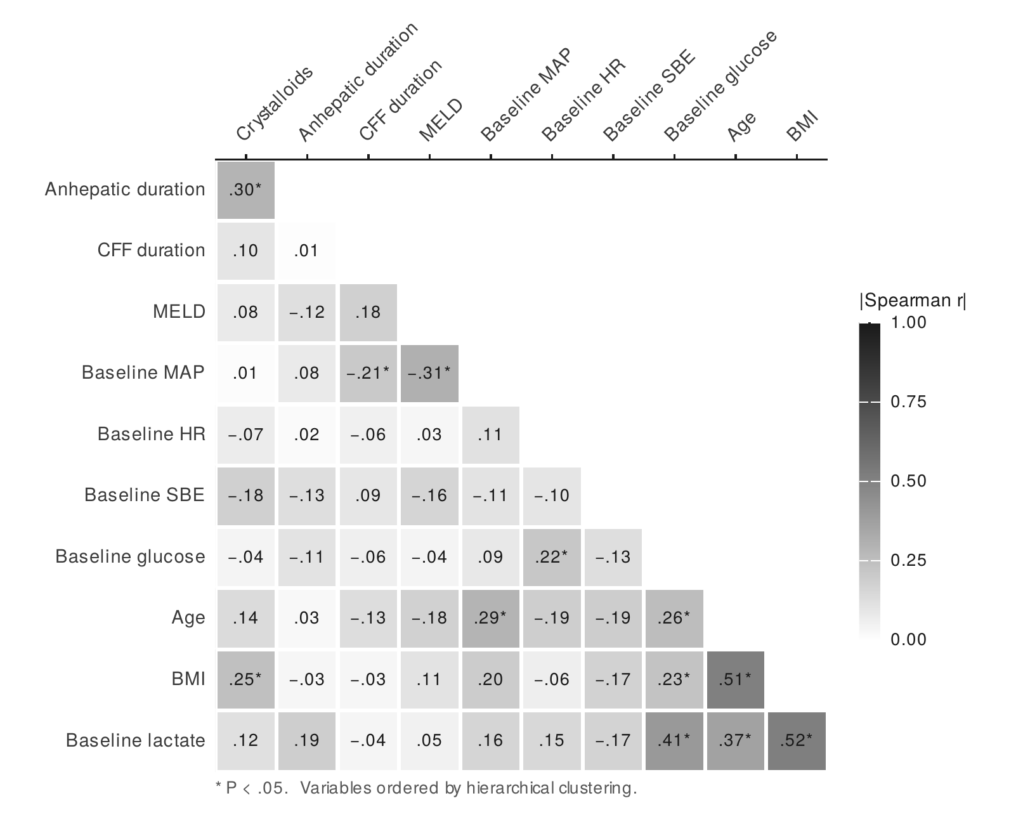
Figure S1. Spearman rank correlations among baseline and intraoperative variables. Lower-triangular matrix of pairwise Spearman rank-correlation coefficients (pairwise-complete observations). Cell shading encodes the magnitude of the coefficient from white (0) to black (1); the signed coefficient is printed in each cell and an asterisk flags significance at P < .05. Variables are ordered by hierarchical clustering (correlation distance) so that related blocks sit together, and the trivial unit diagonal is omitted. Coefficients are shown without a leading zero.
Abbreviations: CFF, clear fluid fasting; BMI, body mass index; MELD, Model for End-stage Liver Disease; MAP, mean arterial pressure; HR, heart rate; SBE, standard base excess.
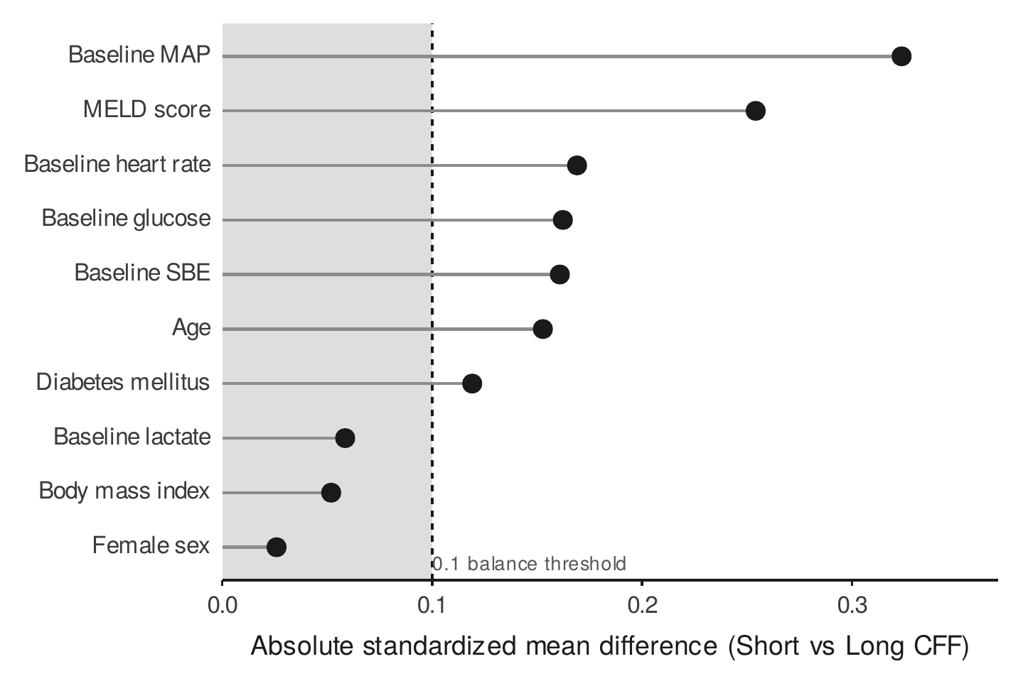
Figure S2. Baseline covariate balance between clear fluid fasting groups. Absolute standardized mean differences between the shorter- and longer-fasting groups for baseline covariates, ordered by magnitude (Love plot). The dashed line and shaded region mark the conventional 0.1 threshold below which imbalance is regarded as negligible: baseline mean arterial pressure and MELD exceed it modestly, as expected of an unadjusted observational comparison, whereas the remaining covariates are well balanced. These differences motivate the a priori covariate set used in the adjusted models.
Abbreviations: CFF, clear fluid fasting; MAP, mean arterial pressure; MELD, Model for End-stage Liver Disease; SBE, standard base excess.

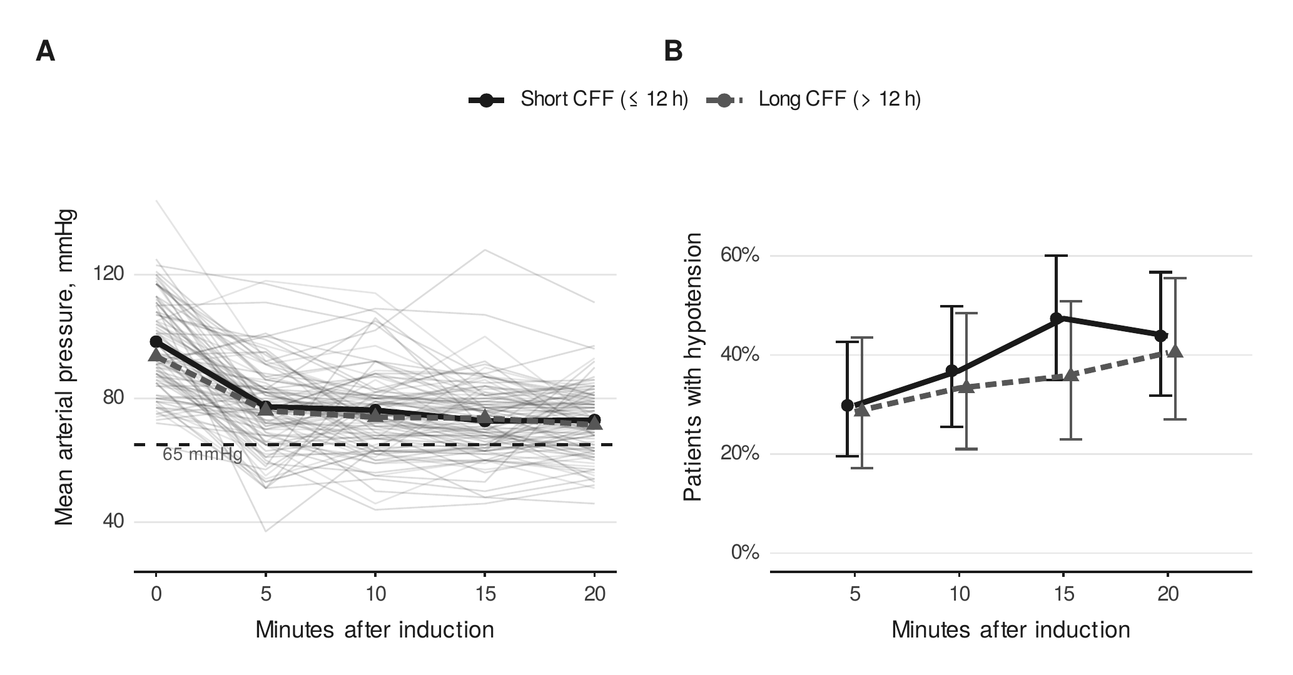
Figure S3. Post-induction hypotension dynamics by clear fluid fasting group. (A) Individual mean arterial pressure trajectories (thin grey lines, one per patient) with the group means overlaid (Short CFF, black solid line with circles; Long CFF, grey dashed line with triangles) and the 65 mmHg hypotension threshold (dashed); mean arterial pressure falls sharply within the first 5 minutes and then plateaus, while individual traces disclose the recipients who cross the threshold. (B) Prevalence of post-induction hypotension at each time point (mean arterial pressure below 65 mmHg or a decrease exceeding 30% from the first reading) with Wilson 95% confidence intervals, laterally offset to prevent overlap. The groups follow a broadly parallel course, with a modestly higher prevalence in the short-fasting group between 10 and 20 minutes (peak 47% versus 36% at 15 minutes); confidence intervals overlap at every time point. A scalar area under the mean arterial pressure–time curve is deliberately not shown, as over the raw trace it is monotonically equivalent to the time-averaged pressure.
Abbreviations: CFF, clear fluid fasting; CI, confidence interval.
Table S1. Participant flow per endpoint and missing-data inventory
Item | n | %
Eligible or analytic cohort, n
Hypotension (whole cohort) | 99
De novo hyperglycemia | 40
De novo hyperlactatemia | 71
De novo base deficit | 47
Events (of eligible)
Hypotension | 64 | 64.6
De novo hyperglycemia | 28 | 70.0
De novo hyperlactatemia | 68 | 95.8
De novo base deficit | 27 | 57.4
Missing measurements
Baseline glucose | 2 | 2.0
Baseline lactate | 3 | 3.0
Baseline standard base excess | 4 | 4.0
Anhepatic glucose | 24 | 24.2
Anhepatic lactate | 25 | 25.3
Anhepatic standard base excess | 25 | 25.3
Note. Percentages are relative to n = 99 (missingness) or to the eligible cohort (events). Metabolic ineligibility (abnormal baseline): hyperglycemia 46, hyperlactatemia 5, base deficit 31; a further 3 patients with severe hemorrhage and 2 receiving hemodialysis were excluded on clinical grounds.

Table S2. Post-induction hypotension at alternative clear fluid fasting cut-points (exploratory)
Cut-point, h | Shorter group, n | Longer group, n | OR | 95% CI | P
6 | 20 | 79 | 0.39 | 0.10–1.17 | .12
8 | 33 | 66 | 0.37 | 0.13–0.92 | .04
10 | 43 | 56 | 0.46 | 0.19–1.07 | .08
12 (median) | 57 | 42 | 0.47 | 0.20–1.09 | .08
Note. Odds ratios compare the longer group (> cut-point) with the shorter group (≤ cut-point), unadjusted. Cut-points were examined jointly to assess stability of effect direction; not corrected for multiplicity. OR, odds ratio.

Table S3. Sensitivity analysis: composite endpoint (post-induction hypotension or ephedrine use)
Model | OR | 95% CI | P | EPV
Per 1-h increase, unadjusted | 0.92 | 0.86–0.99 | .038 | 33.0
Long vs Short, unadjusted | 0.48 | 0.20–1.11 | .09 | 33.0
Note. Composite endpoint: post-induction hypotension or initiation of ephedrine rescue at induction (66 of 99; 66.7%). Ephedrine was given to 22 patients, of whom only 2 had not already met the hypotension threshold; norepinephrine (Levonor) is an anhepatic-phase vasopressor and is not part of this endpoint. Unadjusted (limiting count 33). The estimate is concordant with the primary hypotension analysis. OR, odds ratio; EPV, events per variable.

Table S4. De novo hyperglycemia by clear fluid fasting group within diabetes strata (descriptive)
Diabetes | CFF group | n | Events, n (%) | 95% CI, %
No | Short | 15 | 10 (66.7) | 41.7–84.8
No | Long | 15 | 10 (66.7) | 41.7–84.8
Yes | Short | 4 | 4 (100.0) | 51.0–100.0
Yes | Long | 6 | 4 (66.7) | 30.0–90.3
Note. Eligible cohort n = 40. The pre-specified CFF-by-diabetes interaction was not evaluable (diabetic subgroup n = 10); only observed proportions with Wilson 95% CI are shown. CFF, clear fluid fasting.

