Supplement 1: Icon Array depicting outcomes for infant born at 23 weeks EGA receiving intensive care
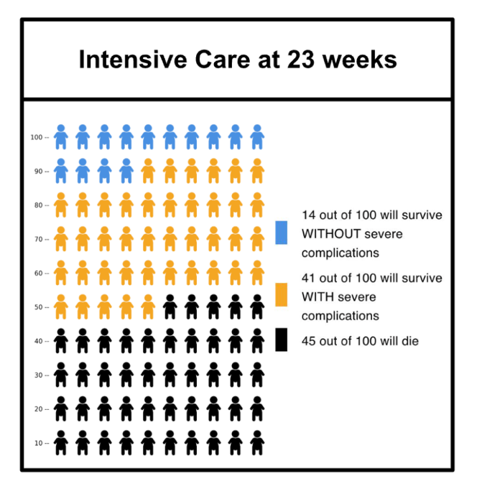

Supplement 2: Descriptions of Intensive Care and Comfort care used in the interview guide
Intensive care involves a breathing tube, feeding tube, and special IV lines to deliver medications and draw blood. Some babies will need invasive procedures like placing chest tubes, abdominal drains, and could require one or more surgeries. While the babies receive intensive care, parents may be able to touch, interact with, or hold their baby, but may be limited in doing so after procedures or during more critical times of the baby's care. While we do everything we can to save the baby's life, most babies that survive will have some sort of long term complication(s).
Comfort care focuses on keeping a baby comfortable instead of doing everything to keep them alive. We give the baby medications so they don’t have pain and we avoid painful pokes or invasive procedures. This allows the family to hold and spend time with their baby until the baby passes.

Supplement 3: Interview image from published preclinical trial of AWT
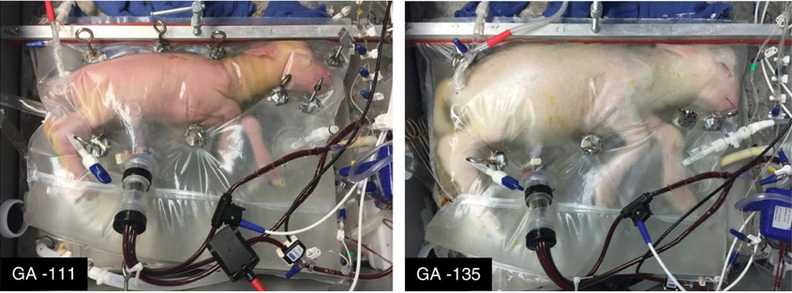
Supplement 4: AI-Generated Interview image depicting human fetus in AWT
