Supplementary Information

Bioinspired IDO1-loaded Cu/ZIF for alopecia areata therapy via remodeling immune privilege
Mingzhu Jin^{1†}, Jiahao Ma^{2,3†}, Zhenhua Liu^{4†}, Yaoyao Li^{5†}, Yuqi Wang⁴, Xiaolei Su⁴, Haoran Song⁵, Bingquan Zong⁵, Yajie Lv¹, Da Zhai¹, Yongquan Qu^{2*}, Zhimin Tian^{2,3*}, Yiting Lin^{1*}, Ling Liu^{1*}
¹ Department of Dermatology, Tangdu Hospital, The Fourth Military Medical University, Xi’an, Shaanxi 710000, China
² Key Laboratory of Special Functional and Smart Polymer Materials of Ministry of Industry and Information Technology, School of Chemistry and Chemical Engineering, Northwestern Polytechnical University, Xi’an, Shaanxi 710072, China
³ Shenzhen Research Institute of Northwestern Polytechnical University, Shenzhen, Guangdong 518057, China
⁴ Department of Dermatology, Xijing Hospital, The Fourth Military Medical University, Xi’an, Shaanxi 710032, China
⁵ School of Basic Medicine, The Fourth Military Medical University, Xi’an, Shaanxi, China
*Corresponding authors: Yongquan Qu (yongquan@nwpu.edu.cn), Zhimin Tian (zhimintian@nwpu.edu.cn), Yiting Lin (linyiting@fmmu.edu.cn) and Ling Liu (liuling_derm@163.com)
† These authors contributed equally to this work: Mingzhu Jin, Jiahao Ma, Zhenhua Liu and Yaoyao Li

Supplementary Methods

Materials and reagents
Unless otherwise specified, all chemicals were used as received without further purification, and all aqueous solutions were prepared using deionized water with a resistivity of 18.2 MΩ·cm. Zinc nitrate hexahydrate (Zn(NO₃)₂·6H₂O), copper nitrate trihydrate (Cu(NO₃)₂·3H₂O), 2-methylimidazole (2-MIM), and other general chemical reagents were purchased from Aladdin. IDO1 was purchased from MedChemExpress (MCE). RPMI-1640 medium (PM150110) and fetal bovine serum (FBS) (164210) were purchased from Procell. Penicillin/streptomycin solution (P1400) and red blood cell lysis buffer (R1010) were obtained from Solarbio. Recombinant human IFN-γ (91207ES20) and the DHE fluorescent probe (50102ES25) were purchased from Yeasen Biotechnology Co., Ltd. The total superoxide dismutase assay kit with WST-8 (S0101M, 250T), BCA protein assay kit (P0012), DCFH-DA reactive oxygen species probe (S0034S), Hoechst (C1027), and poly-L-lysine (ST509) were purchased from Beyotime Biotechnology Co., Ltd. The One-step TUNEL Cell Apoptosis Detection Kit (CX107) was purchased from Epizyme Biotech. 7-AAD (420404), Zombie UVTM Fixable Viability Kit (432108), Cell Activation Cocktail with Brefeldin A (423304), and some flow cytometry antibodies were purchased from BioLegend. The anti-Foxp3 antibody (MA5-16224) and TRIzol reagent (15596026CN) were obtained from Invitrogen. The FOXP3/Transcription Factor Staining Buffer Set (00-5523-00) was purchased from eBioscience, and the reverse transcription kit (TSK314) was purchased from Tsingke. The human Trp ELISA kit (CB13053-Hu), human Kyn ELISA kit (CB11195-Hu), mouse Trp ELISA kit (CB11412-Mu), and mouse Kyn ELISA kit (CB11300-Mu) were purchased from COIBO BIO. Collagenase P (11213857001) and DNase I (10104159001) were purchased from Merck. 70 μm cell strainers were purchased from Corning. 4% paraformaldehyde solution was purchased from Leagene. Goat serum was purchased from BOSTER. Triton X-100 and mounting medium containing DAPI (F6057) were purchased from Sigma-Aldrich. IMQ cream was purchased from Mingxin Pharmaceutical Co., Ltd. (Sichuan, China), and baricitinib was purchased from Aladdin (B127687). Primary antibodies used for immunofluorescence staining were obtained from Abcam and Proteintech. Coralite® Plus 488-conjugated phalloidin (PF00001) and the corresponding fluorophore-conjugated secondary antibodies (SA00003-11/RGAM004/RGAR004) were purchased from Proteintech.

Synthesis of ZIF-8 and Cu-doped ZIF
ZIF-8 and Cu-doped ZIF samples were synthesized by an aqueous coordination precipitation method. The obtained samples were denoted as ZIF-8, Cu_{0.5}/ZIF, Cu₁/ZIF, and Cu₂/ZIF, where Cu_{0.5}, Cu₁, and Cu₂ refer to nominal Cu feeding fractions of 5, 10, and 20 mol% relative to the total metal precursors, respectively. The nominal Cu contents described here represent precursor feeding ratios, while the actual Cu/Zn ratios in the final products were determined by inductively coupled plasma analysis.
In a typical synthesis, an aqueous metal precursor solution (10 mL) with a total metal concentration of 40 mM was prepared by dissolving Zn(NO₃)₂·6H₂O and Cu(NO₃)₂·3H₂O in deionized water. For ZIF-8, only Zn(NO₃)₂·6H₂O was used. For Cu_{0.5}/ZIF, Cu₁/ZIF, and Cu₂/ZIF, the Cu fraction in the total metal precursors was adjusted to 5, 10, and 20 mol%, respectively, while maintaining the total concentration of Zn and Cu precursors at 40 mM. Separately, 2-MIM was dissolved in deionized water (10 mL) to obtain a 2400 mM ligand solution. The metal precursor solution was added to the 2-MIM solution under magnetic stirring, and the reaction mixture was stirred at room temperature for 4 h. The resulting precipitate was collected by centrifugation, washed with deionized water three times, and dried under vacuum to obtain the corresponding ZIF-based samples.

Preparation of IDO@Cu₁/ZIF
IDO@Cu₁/ZIF was prepared using an IDO1-assisted aqueous coordination precipitation procedure. Briefly, IDO1 was added to the 2400 mM 2-MIM aqueous solution (10 mL) and stirred at room temperature for 10 min. A Cu₁/ZIF metal precursor solution containing Zn(NO₃)₂·6H₂O and Cu(NO₃)₂·3H₂O in deionized water (10 mL; total metal concentration, 40 mM; Cu fraction in total metal precursors, 10 mol%) was then added to the IDO1-containing 2-MIM solution under magnetic stirring. The mixture was stirred at room temperature for 4 h. The precipitate was collected by centrifugation, washed with deionized water three times, and dried under vacuum to obtain IDO@Cu₁/ZIF. The IDO1 loading content was determined using a BCA Protein Assay Kit (Beyotime, P0012) according to the manufacturer’s protocol.

In Vitro Kyn Assay
The catalytic activity of IDO1 in IDO@Cu1/ZIF was evaluated using a cell-free enzymatic assay. The amount of free IDO1 was matched to the actual IDO1 content in IDO@Cu₁/ZIF according to the experimentally determined loading content. Cu₁/ZIF, free IDO1, and IDO@Cu₁/ZIF were dispersed in 50 mM potassium phosphate buffer (16.9 mM K₂HPO₄ and 33.1 mM KH₂PO₄, pH 6.5). The enzymatic reaction was initiated by adding ascorbic acid, methylene blue, L-tryptophan (Trp), and catalase to final concentrations of 10 mM, 10 μM, 2 mM, and 100 μg mL⁻¹, respectively. The reaction mixtures were incubated at 37 °C for 60 min. Trichloroacetic acid was then added to a final concentration of 7% (v/v), followed by incubation at 70 °C for 30 min to terminate the enzymatic reaction and facilitate conversion of N-formylkynurenine to kynurenine (Kyn). An equal volume of freshly prepared 2% (w/v) p-dimethylaminobenzaldehyde (p-DMAB) in glacial acetic acid was subsequently added. The absorbance was measured at 492 and 650 nm using a microplate reader.
Relative activity is calculated according to the following formula:
Relative IDO1 activity (%) = (A₄₉₂ - A₆₅₀) _{sample} ÷ (A₄₉₂ - A₆₅₀) _{free IDO1} × 100%

Isolation and culture of human peripheral blood mononuclear cells
Peripheral blood samples were collected from healthy donors at the Physical Examination Center of Tangdu Hospital. The donors had no history of inflammatory or autoimmune skin diseases, including AA, psoriasis, vitiligo or atopic dermatitis, and had no acute or chronic infection, malignancy or systemic immune disease. None of the donors had received systemic glucocorticoids, immunosuppressants or biologics within 3 months before blood collection. All procedures involving human samples were conducted in accordance with the Declaration of Helsinki and were approved by the Ethics Committee of Tangdu Hospital (approval number: K202505-26). Written informed consent was obtained from all donors before sample collection.
Human PBMCs were isolated by density-gradient centrifugation. The mononuclear cell layer was collected, washed three times with PBS, and resuspended in complete RPMI-1640 medium. The medium was supplemented with 10% fetal bovine serum and 1% (v/v) penicillin/streptomycin. Cells were cultured at 37 ℃ in a humidified incubator containing 5% CO₂ and were used for subsequent IFN-γ-induced inflammatory modelling and material intervention experiments.

Cellular uptake assay
Cy5.5-labelled IDO@Cu₁/ZIF was used to evaluate cellular uptake. PBMCs were seeded into 96-well plates. After the cells had stabilized, Cy5.5-IDO@Cu₁/ZIF was added at a final concentration of 50 μg/mL and incubated for 24 h. Cells were then fixed with 4% paraformaldehyde for 15 min and permeabilized with 0.1% Triton X-100 for 10 min. To visualize the cytoskeleton, cells were stained with Coralite Plus 488-conjugated phalloidin for 30 min at room temperature in the dark. Nuclei were subsequently counterstained with Hoechst for 10 min at room temperature in the dark.
Because PBMCs are non-adherent cells, the stained cells were transferred to confocal dishes pretreated with poly-L-lysine to promote cell attachment to the dish surface. Fluorescence images were acquired using a confocal laser scanning microscope.

Intracellular ROS detection
After the indicated treatments, intracellular ROS levels in PBMCs were detected using the DCFH-DA fluorescent probe. Nuclei were counterstained with Hoechst. Fluorescence images were acquired using a confocal laser scanning microscope.

Flow cytometric analysis of PBMCs
To evaluate the cytoprotective effect of IDO@Cu₁/ZIF on PBMCs under IFN-γ-induced inflammatory conditions, cells from each group were collected after the indicated treatments and stained with 7-AAD. Cell viability was assessed by flow cytometry and expressed as the percentage of 7-AAD-negative cells.
To further evaluate the effects of IDO@Cu₁/ZIF on CD8⁺T cells and Tregs in PBMCs, treated cells were collected and stained with Zombie UV™ Fixable Viability Kit together with fluorophore-conjugated surface antibodies. The antibodies used included anti-CD8 (BioLegend, 388809), anti-CD44 (BioLegend, 103029), anti-CD4 (BioLegend, 300526) and anti-CD25 (BioLegend, 302655). Cells were incubated at 4 ℃ for 30 min in the dark. After surface staining, cells were fixed and permeabilized using the FOXP3/Transcription Factor Staining Buffer Set according to the manufacturer’s instructions. Cells were then stained with anti-Foxp3 (Invitrogen, MA5-16224) overnight at 4 ℃ in the dark. After washing, cells were resuspended in PBS and analyzed by flow cytometry.

Measurement of Trp and Kyn in cell culture supernatants
To evaluate the effect of IDO@Cu₁/ZIF on Trp/Kyn metabolism, culture supernatants were collected from each group of PBMCs. Trp and Kyn levels were measured using human Trp ELISA and human Kyn ELISA kits, respectively, according to the manufacturer’s instructions. Absorbance was measured at 450 nm using a microplate reader, and concentrations were calculated from standard curves.

Recurrence-prevention study in AA mice
To evaluate the preventive effect of IDO@Cu₁/ZIF on AA recurrence, mice were randomly assigned to the Control, Relapse + PBS, Relapse + ZIF, Relapse + Cu₁/ZIF, Relapse + IDO@Cu₁/ZIF, and Relapse + baricitinib groups. Except for the Control group, all mice were first subjected to IMQ induction and the corresponding treatments according to the therapeutic protocol: AA-like lesions were induced by topical IMQ application for 3 weeks, followed by 3 weeks of the indicated treatments. Mice were then allowed to recover during a 5-week resting phase. After hair regrowth was observed in all groups, the dorsal skin was re-shaved and re-challenged with topical IMQ alone, without further treatment, to induce relapse. Dorsal skin photographs were collected on D0, D7, D14, and D21 after relapse induction, and hair coverage and body weight were recorded. At the indicated sampling time points, dorsal skin tissues were harvested for H&E staining, immunofluorescence staining, and hair follicle quantification.

Preparation of single-cell suspensions from skin tissues
After mice were euthanized, dorsal treatment-area skin tissues were collected and placed in cold PBS. After removal of subcutaneous fat, tissues were minced into small pieces and digested in RPMI-1640-based digestion buffer containing collagenase P (1 mg/mL) and DNase I (100 μg/mL). Tissues were digested in a 37 ℃ shaking incubator for 2 h. Digestion was terminated by adding medium containing 10% FBS. The cell suspension was filtered through a 70 μm cell strainer and finally resuspended in PBS for flow cytometric staining.

Immune cell analysis of spleens and draining lymph nodes
To determine whether IDO@Cu₁/ZIF induced systemic immune perturbation, spleens and draining lymph nodes were collected at the experimental endpoint. Tissues were placed in cold PBS, mechanically dissociated and filtered through a 70 μm cell strainer to obtain single-cell suspensions. Splenocytes were treated with red blood cell lysis buffer and resuspended in PBS. Cells were stained with Zombie UVTM Fixable Viability Kit, anti-CD4 (BioLegend, 100431), anti-CD8 (BioLegend, 100729), anti-CD25 (BioLegend, 113707) and anti-Foxp3 (BioLegend, 118903). Intracellular Foxp3 staining for Tregs was performed according to the instructions for the fixation/permeabilization kit. Samples were analyzed by flow cytometry.

Supplementary Figures
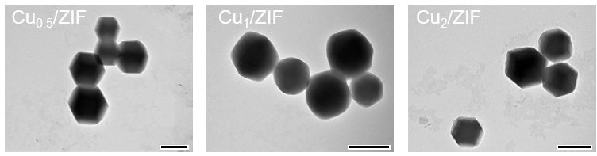
Supplementary Fig. 1 | Representative TEM images of different Cu-doped ZIF-8. Scale bar, 200 nm.

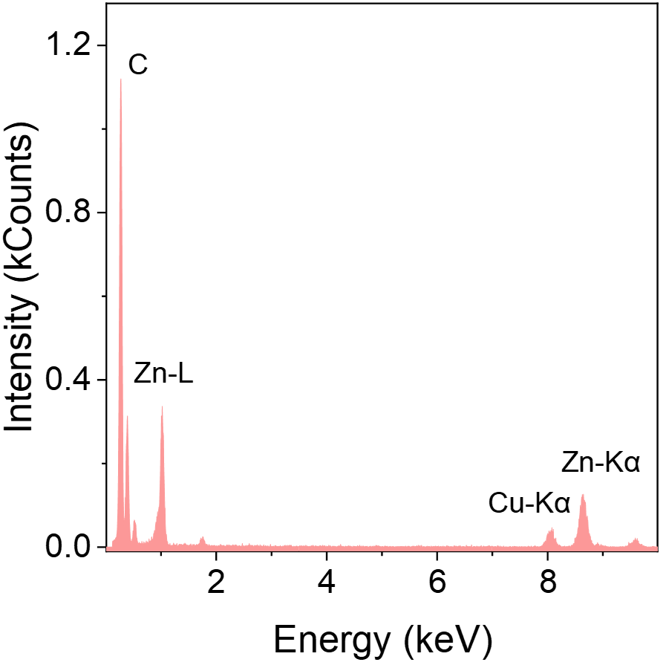
Supplementary Fig. 2 | Energy-dispersive X-ray spectroscopy of Cu₁/ZIF.

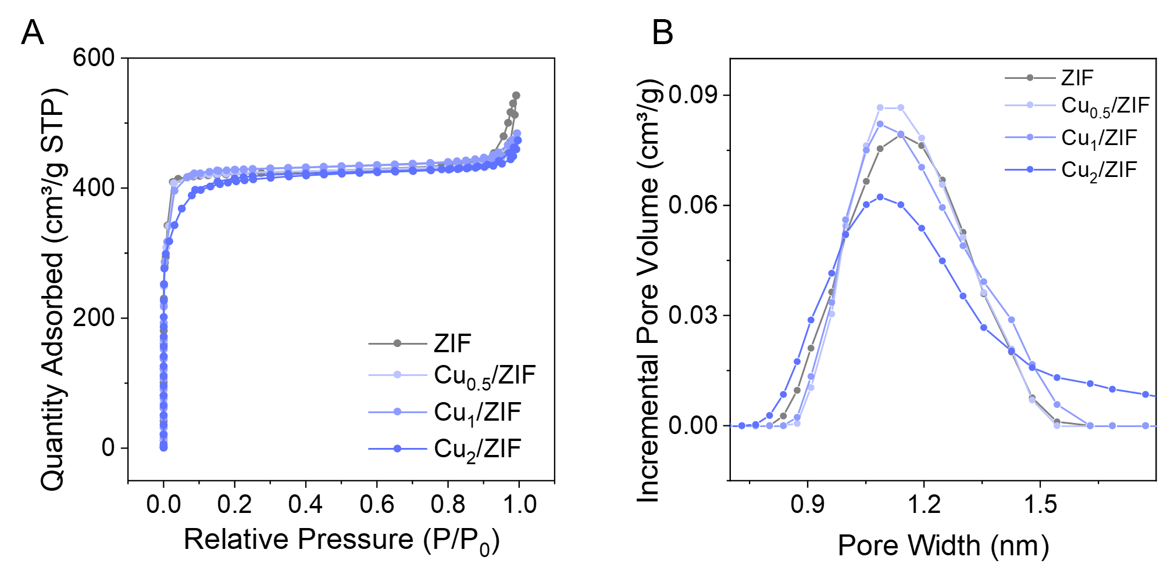
Supplementary Fig. 3 | Porosity characterization of ZIF-8 and Cu-doped ZIF-8. (A) N₂ adsorption-desorption isotherms of ZIF-8, Cu_{0.5}/ZIF, Cu₁/ZIF, and Cu₂/ZIF. (B) Corresponding pore size distributions.

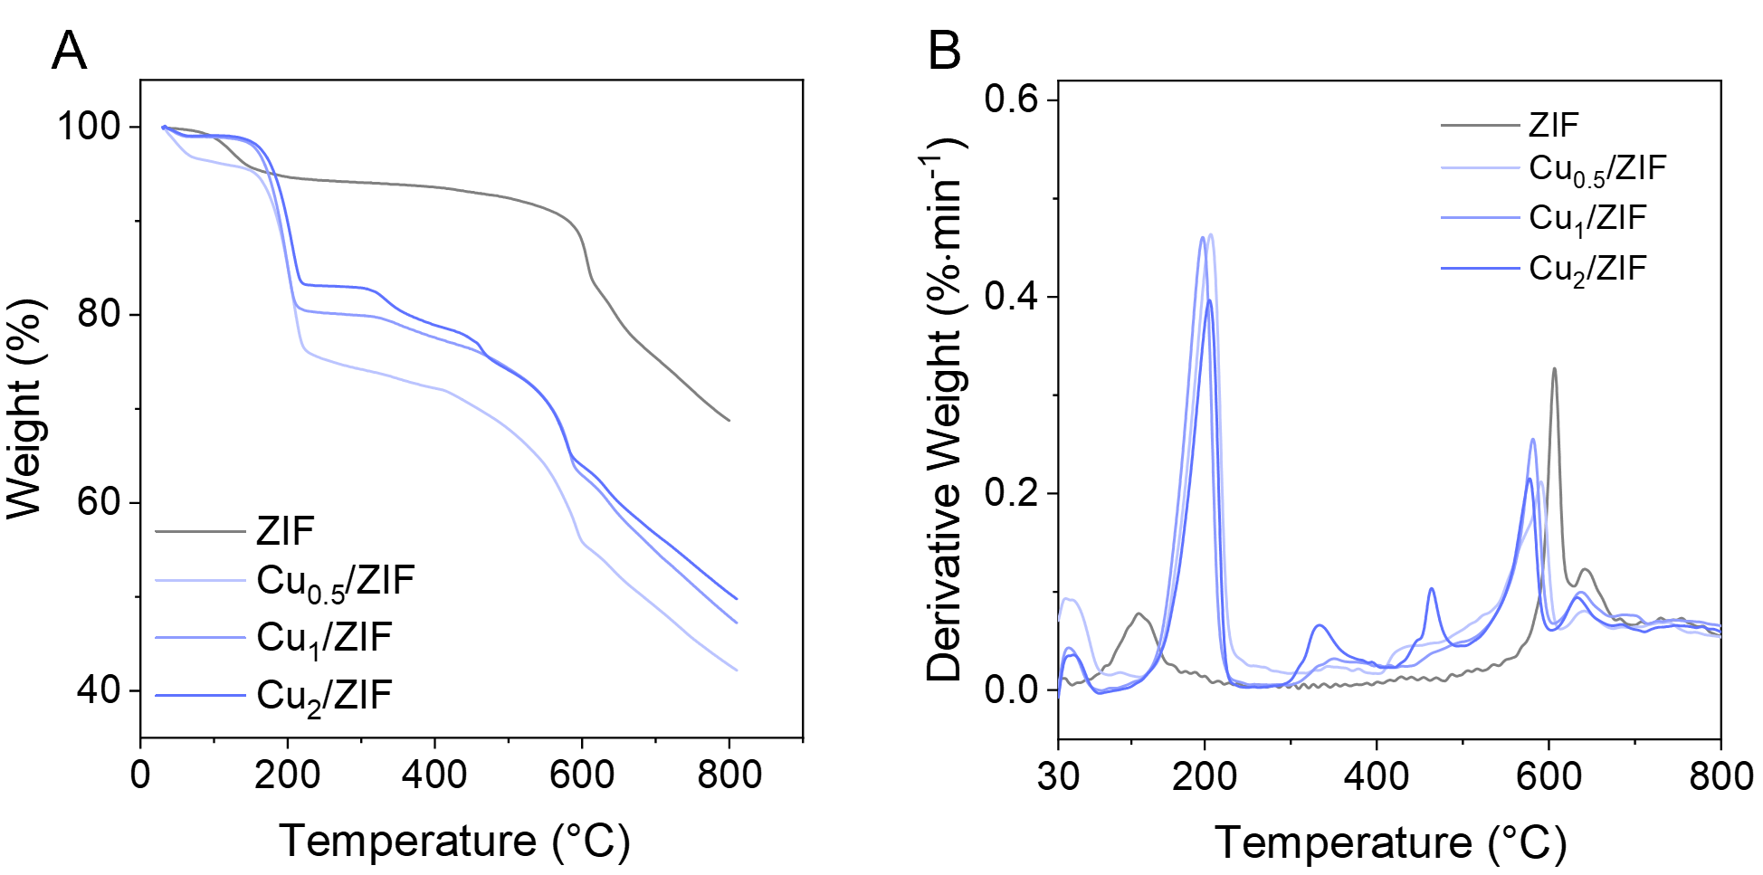
Supplementary Fig. 4 | Thermogravimetric analysis of ZIF-8 and Cu-doped ZIF-8. (A) TGA and (B) derivative thermogravimetric curves of ZIF-8, Cu_{0.5}/ZIF, Cu₁/ZIF, and Cu₂/ZIF recorded under the indicated atmosphere.

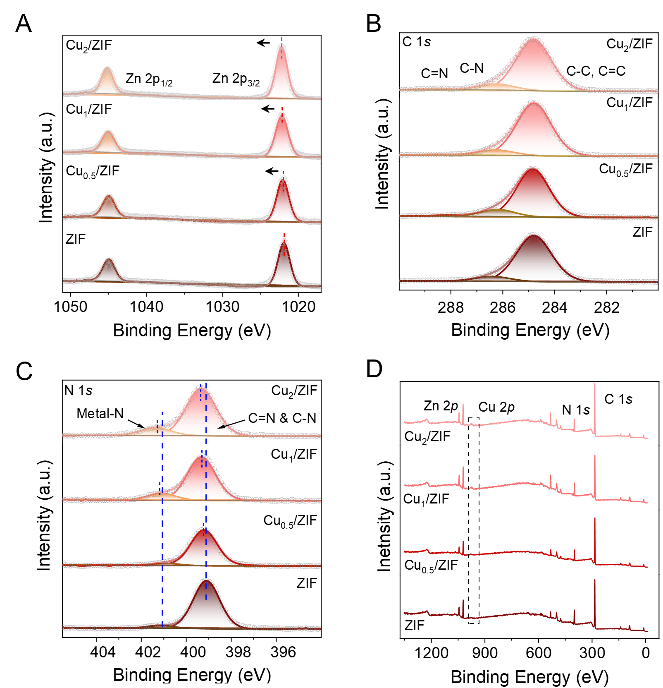
Supplementary Fig. 5 | XPS characterization of ZIF-8 and Cu-doped ZIF-8. (A) High-resolution Zn 2p spectra. (B) High-resolution C 1s spectra. (C) High-resolution N 1s spectra. (D) XPS survey spectra of ZIF-8 and Cu-doped ZIF-8 samples.

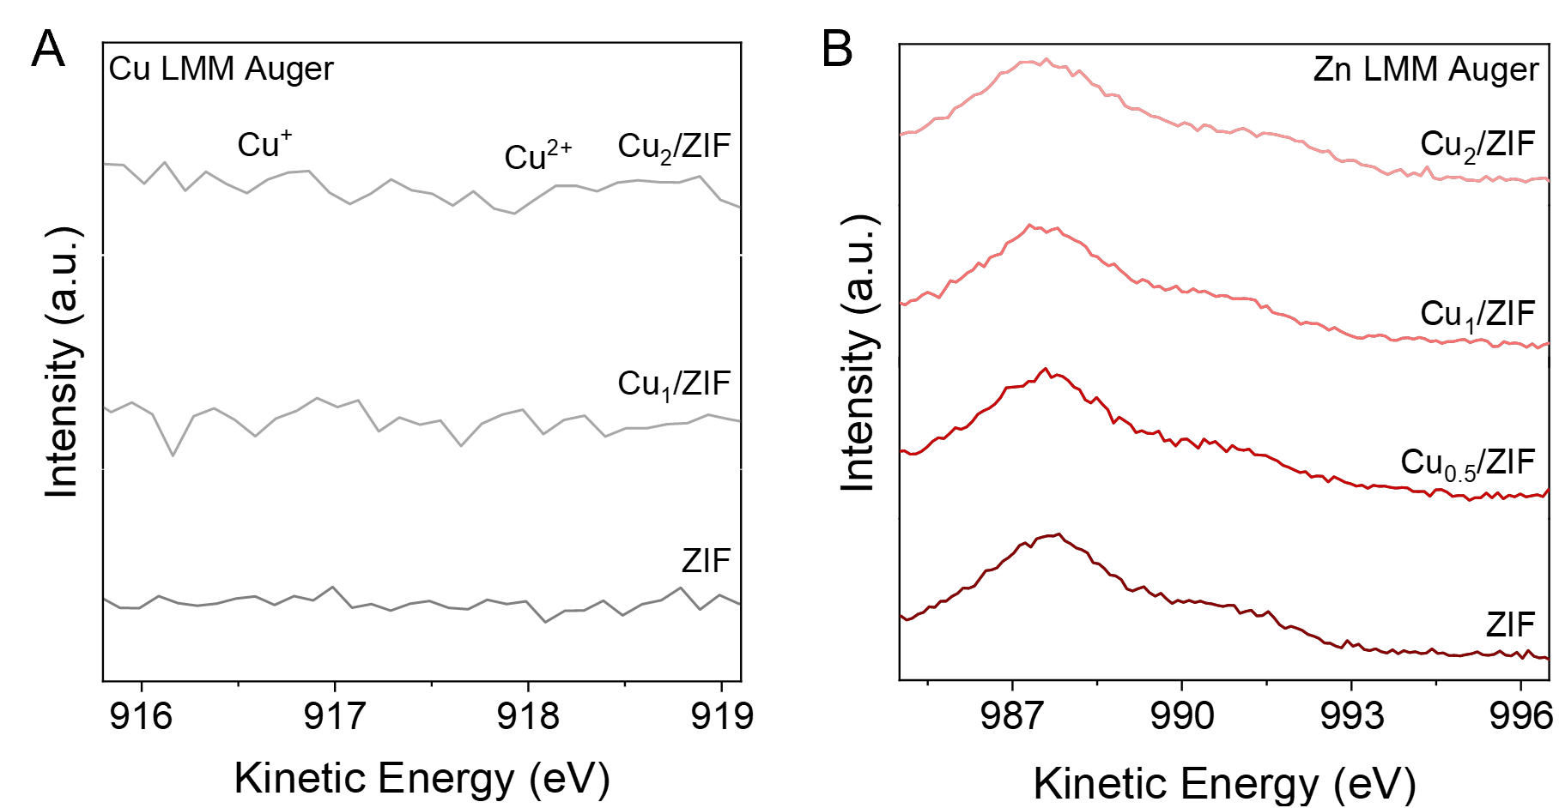
Supplementary Fig. 6 | Auger spectra of Cu-doped ZIF-8. (A) Cu LMM and (B) Zn LMM Auger spectra of Cu-doped ZIF-8 samples.

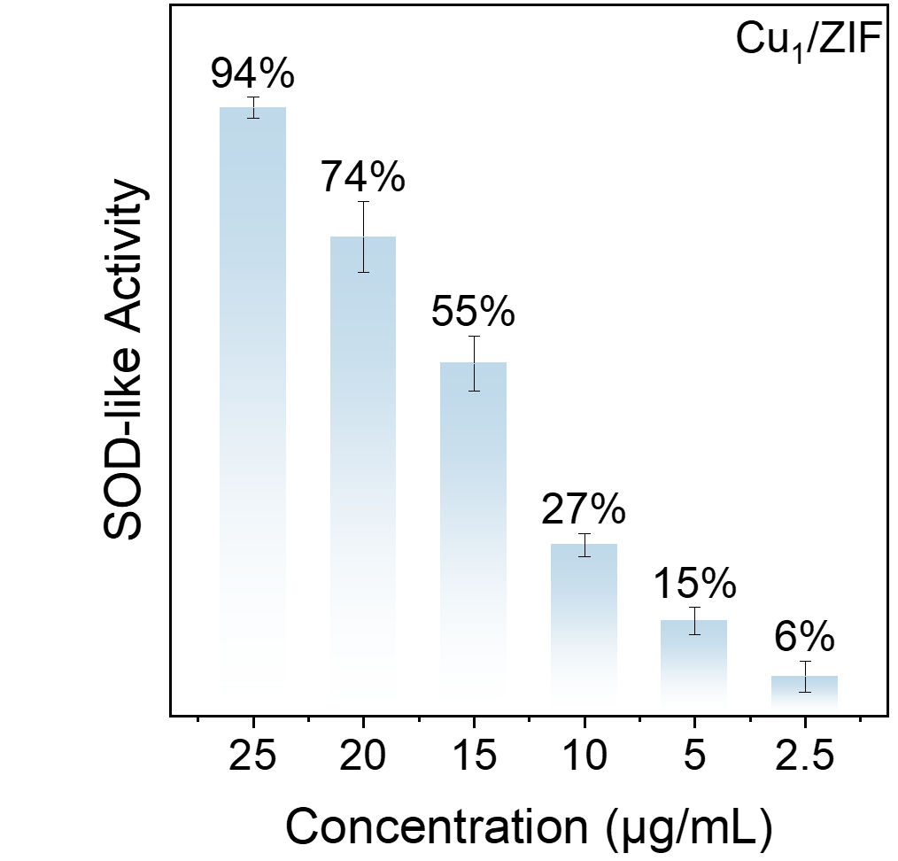
Supplementary Fig. 7 | Concentration-dependent SOD-like activity of Cu₁/ZIF.

Supplementary Fig. 8 | BCA standard curve for quantification of IDO1 loading in IDO@Cu₁/ZIF.

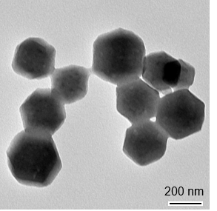
Supplementary Fig. 9 | TEM images of IDO@Cu1/ZIF.

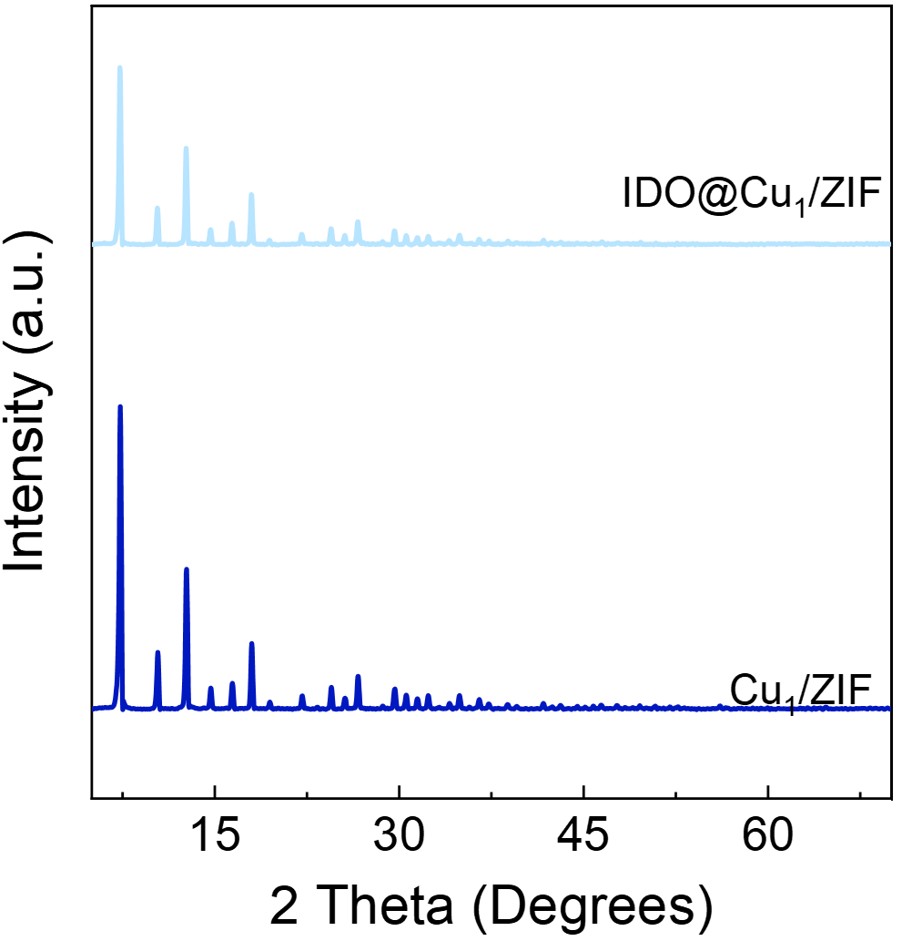
Supplementary Fig. 10 | XRD patterns of IDO@Cu1/ZIF.

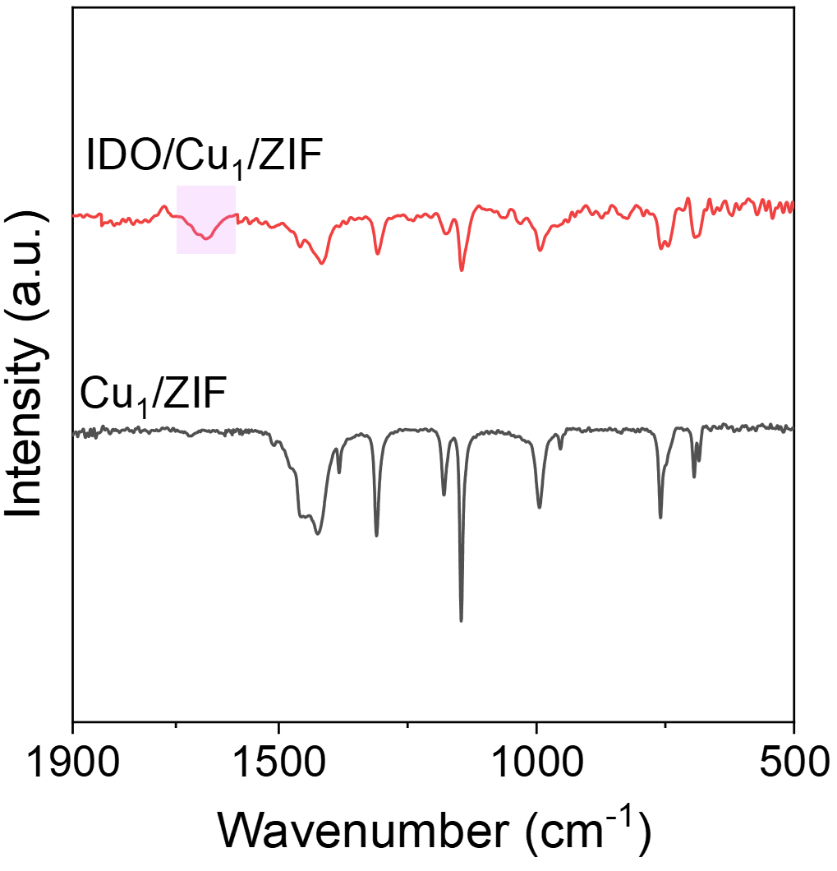
Supplementary Fig. 11 | FT-IR spectrum of IDO@Cu1/ZIF and Cu1/ZIF.

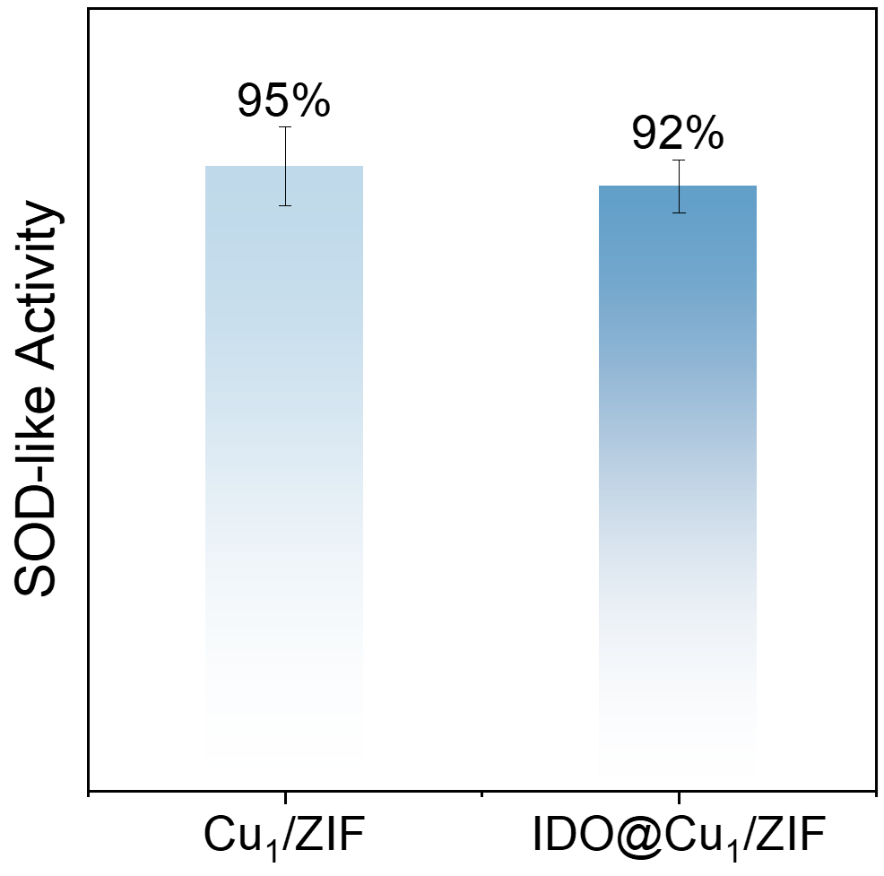
Supplementary Fig. 12 | SOD activity of IDO@Cu1/ZIF and Cu1/ZIF evaluated by WST-8 assay.

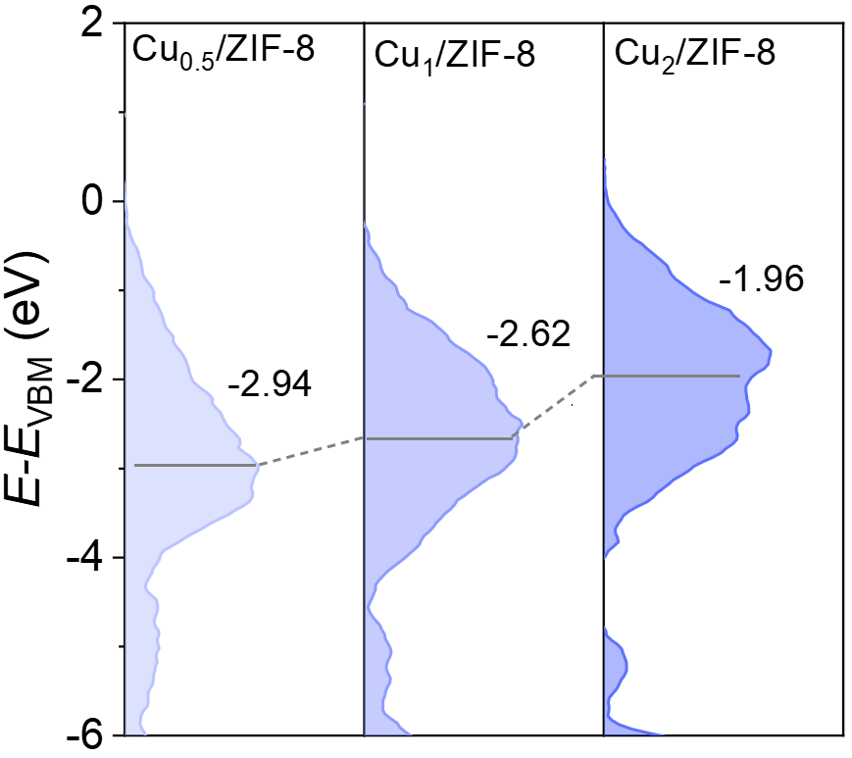
Supplementary Fig. 13 | Surface valence band photoemission spectra of different catalysts.

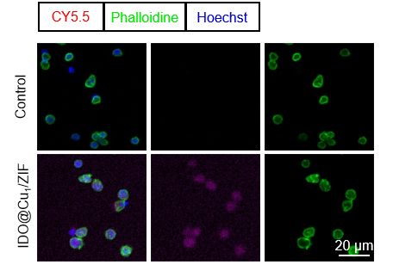
Supplementary Fig. 14 | Intracellular distribution of Cy5.5-labeled IDO@Cu₁/ZIF. Confocal fluorescence images showing the intracellular localization of Cy5.5-labeled IDO@Cu₁/ZIF (red). The actin cytoskeleton was stained with phalloidin (green), and nuclei were counterstained with Hoechst (blue). Scale bar, 20 μm.

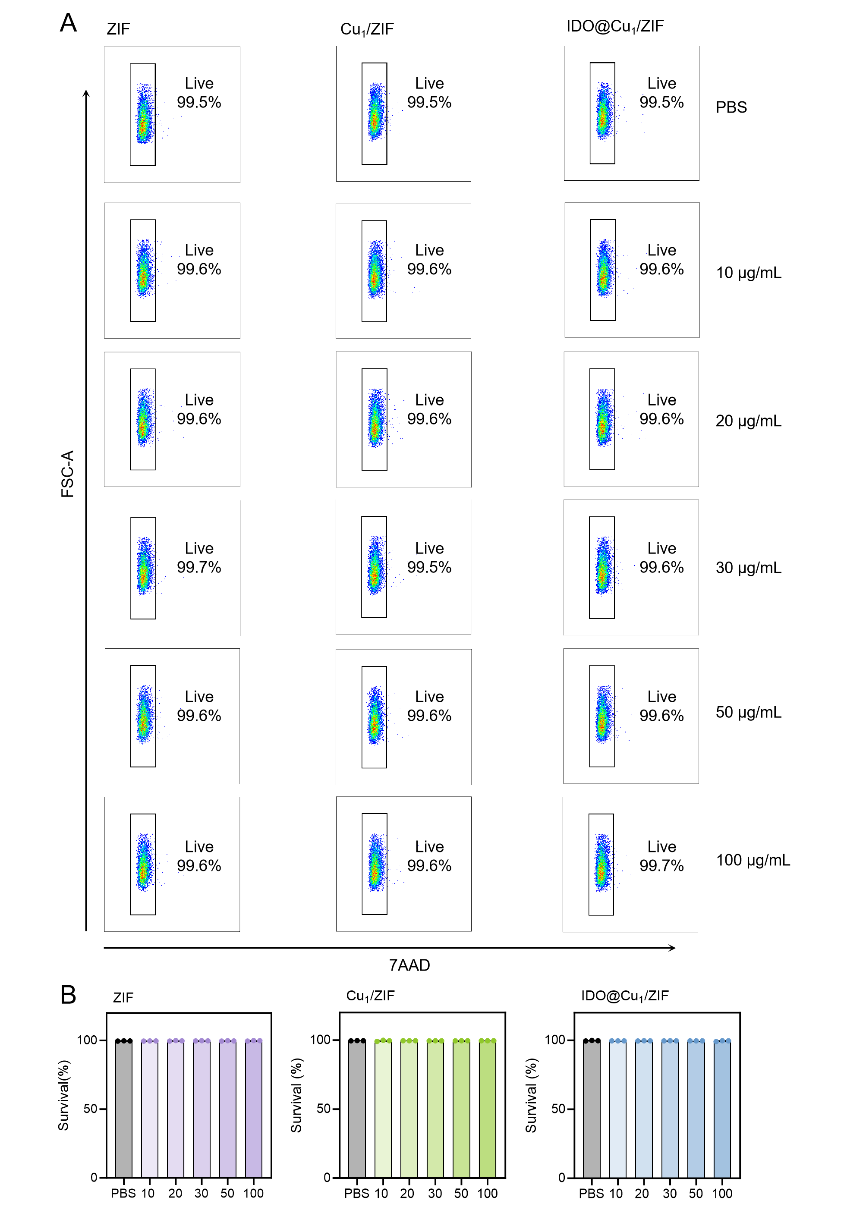
Supplementary Fig. 15 | In vitro cytocompatibility of ZIF-based formulations. Flow cytometric analysis of cell viability following treatment with ZIF, Cu₁/ZIF, and IDO@Cu₁/ZIF at the indicated concentrations using 7-AAD staining. (A) Representative contour plots. (B) Quantification of viable cells. Data are presented as mean ± SD. n = 3 independent experimental replicates per group. Statistical significance for the indicated pairwise comparisons was determined using unpaired two-tailed Student’s t-tests.
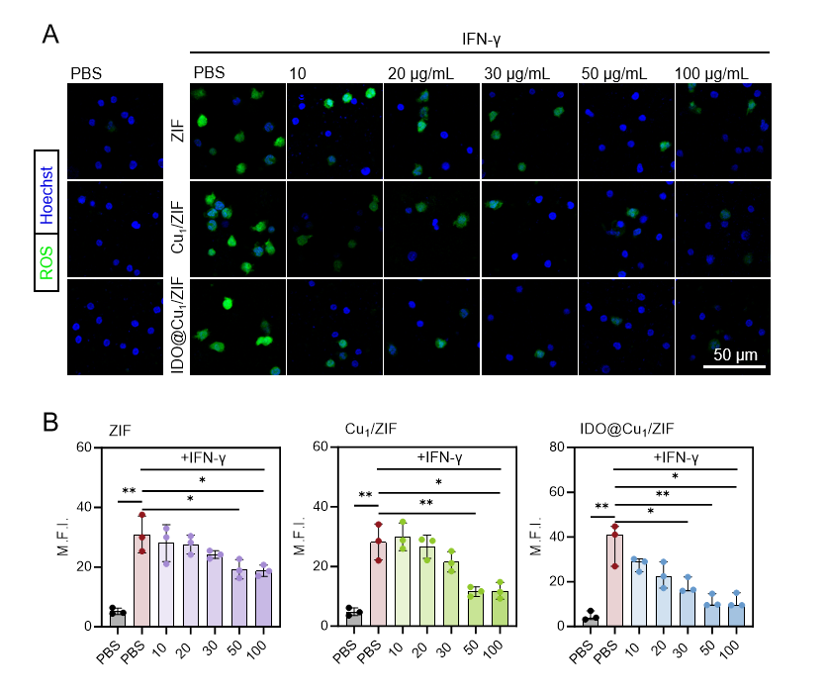
Supplementary Fig. 16 | Effects of ZIF-based materials at different concentrations on intracellular ROS under IFN-γ stimulation. (A) Representative confocal fluorescence images of intracellular ROS detected by DCFH-DA (green) in IFN-γ-stimulated cells treated with the indicated concentrations of ZIF, Cu₁/ZIF, or IDO@Cu₁/ZIF. Nuclei were counterstained with Hoechst (blue). (B) Quantification of ROS fluorescence intensity. Scale bar, 50 μm. Data are presented as mean ± SD. n = 3 independent experimental replicates per group. Statistical significance for the indicated pairwise comparisons was determined using unpaired two-tailed Student’s t-tests.

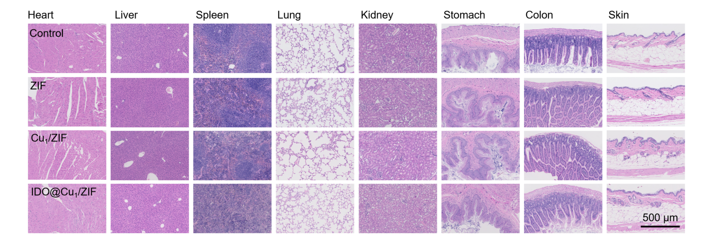
Supplementary Fig. 17 | Histological evaluation of systemic biosafety following treatment with IDO@Cu₁/ZIF. Representative H&E-stained sections of the heart, liver, spleen, lung, kidney, stomach, colon, and skin from mice receiving the indicated treatments. Scale bar, 500 μm.

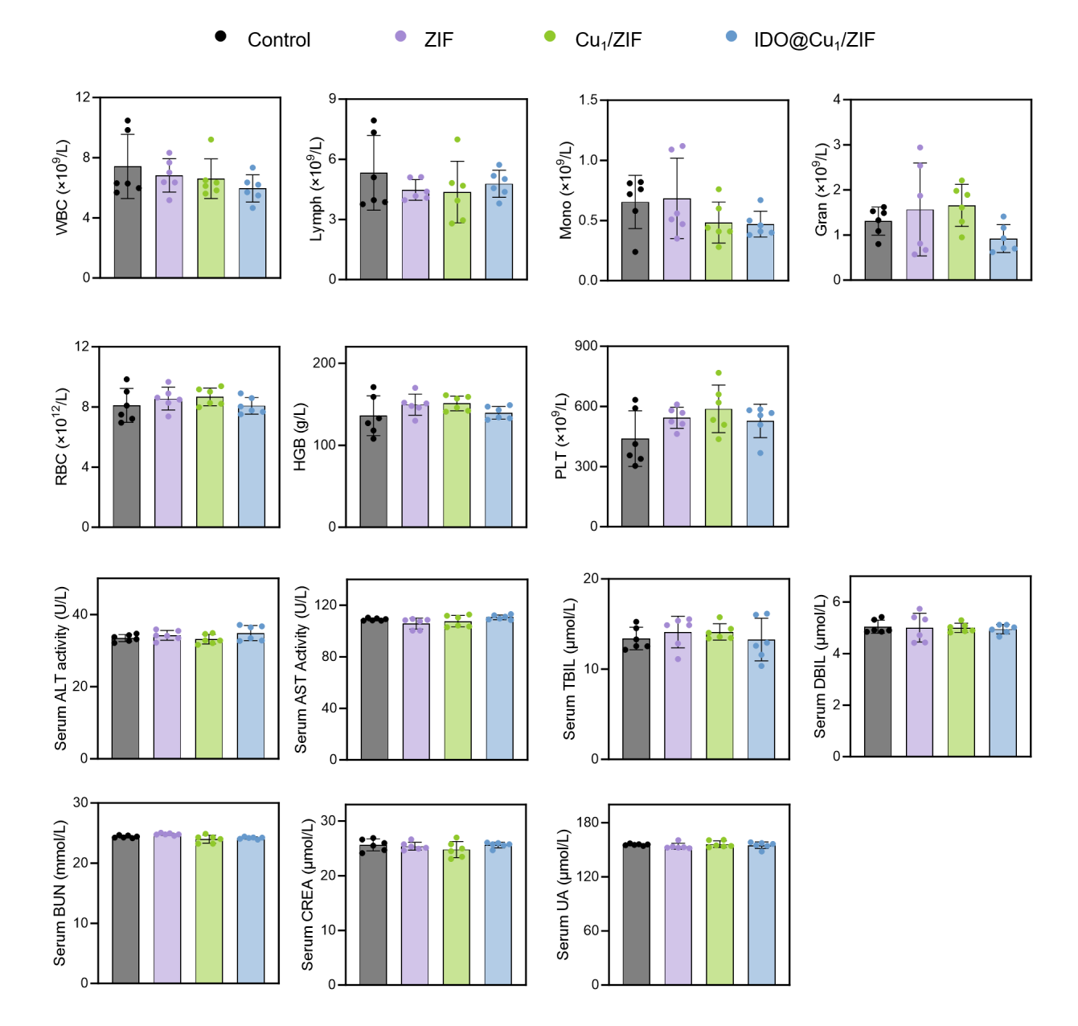
Supplementary Fig. 18 | Hematological and serum biochemical evaluation of systemic safety. Complete blood count (CBC) parameters and serum biochemical indices were measured in mice from the indicated groups. Data are presented as mean ± SD. n = 5 biologically independent mice per group. Statistical significance for the indicated pairwise comparisons was determined using unpaired two-tailed Student’s t-tests.

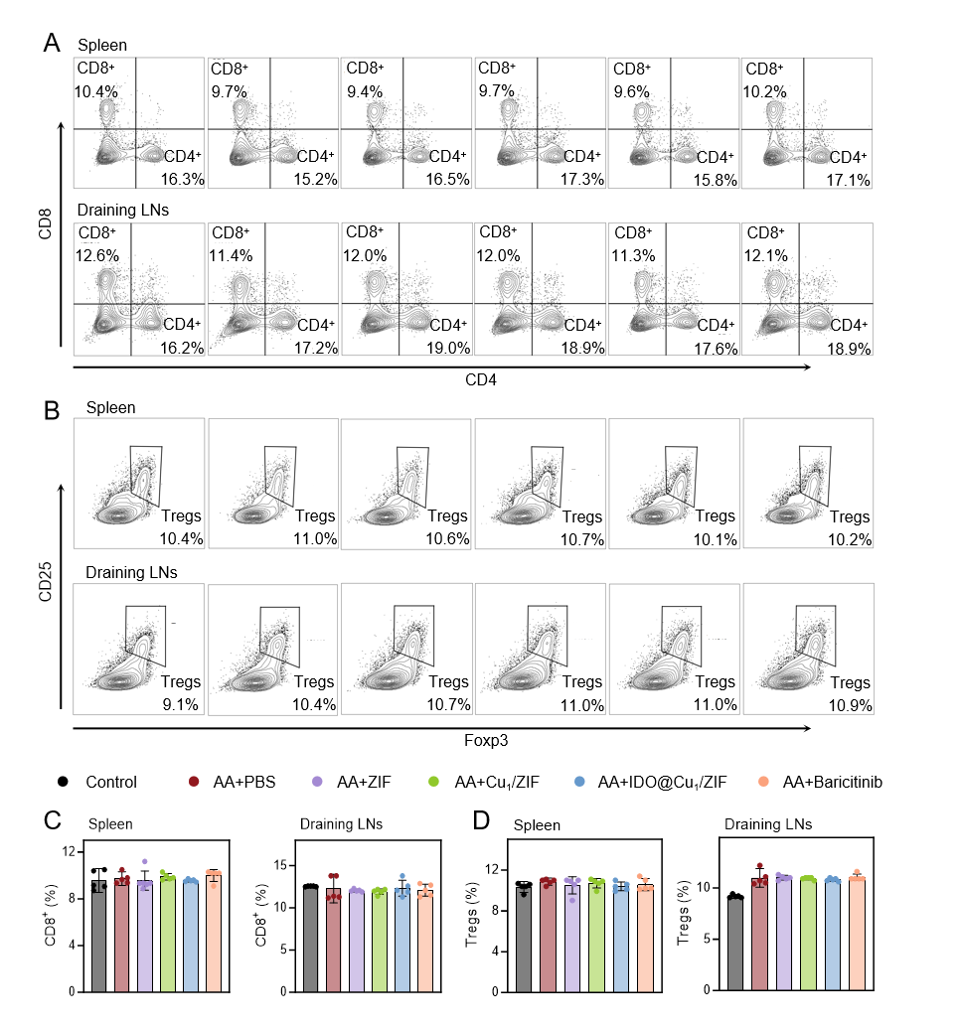
Supplementary Fig. 19 | Flow cytometric analysis of T cell subsets in spleens and draining lymph nodes during therapeutic treatment of AA mice. (A) Representative flow cytometry plots showing the distribution of CD4⁺T and CD8⁺T cells in the spleen and draining lymph nodes. Percentages of the indicated populations are shown in each panel. (B) Representative flow cytometry plots showing CD25 and Foxp3 staining for identification of Tregs in the spleen and draining lymph nodes. (C, D) Quantification of immune cell subsets in the spleen and draining lymph nodes. (C) Frequencies of CD8⁺T cells. (D) Frequencies of Tregs. Data are presented as mean ± SD. n = 5 biologically independent mice per group. Statistical significance for the indicated pairwise comparisons was determined using unpaired two-tailed Student’s t-tests.
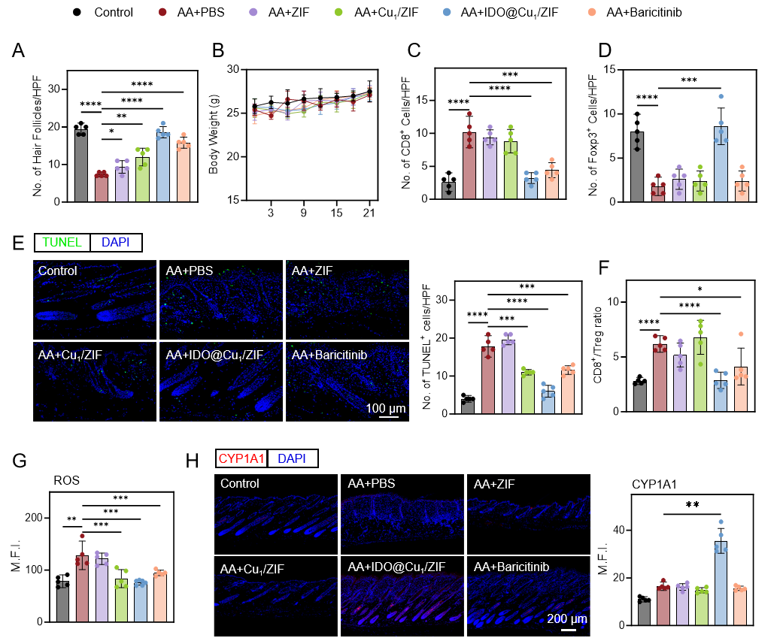
Supplementary Fig. 20 | Quantitative analyses associated with therapeutic treatment of AA mouse model. (A) Quantification of hair follicle numbers corresponding to Fig. 6E. (B) Body weight changes during therapeutic treatment. (C, D) Quantification of immune cell infiltration in skin lesions. (C) Number of CD8⁺T cells per high-power field corresponding to Fig. 7A. (D) Number of Foxp3⁺ cells per high-power field corresponding to Fig. 7B. (E) Representative TUNEL staining (green) and quantification of TUNEL-positive cells per high-power field in skin sections. Scale bar, 100 μm. (F) Quantification of CD8⁺T/Treg ratio corresponding to Fig. 7D. (G) Quantification of ROS fluorescence intensity corresponding to Fig. 7G. (H) Immunofluorescence staining and quantitative analysis of CYP1A1 in skin sections. Scale bar, 200 μm. Data are presented as mean ± SD. n = 5 biologically independent mice per group. Statistical significance for body weight curves was determined by two-way ANOVA, whereas the remaining comparisons were analyzed using unpaired two-tailed Student’s t-test. *P < 0.05, **P < 0.01, ***P < 0.001, ****P < 0.0001.

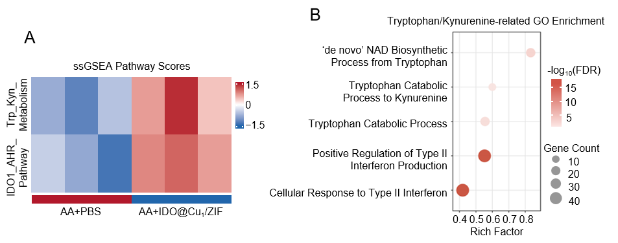
Supplementary Fig. 21 | Supplementary transcriptomic analyses associated with Trp-Kyn signaling. (A) Heatmap of ssGSEA pathway scores showing relative changes in Trp-Kyn metabolism and the IDO1-AHR axis. (B) GO enrichment analysis of biological processes associated with Trp-Kyn metabolism. RNA-seq analyses in (A, B) were performed using three samples per group.

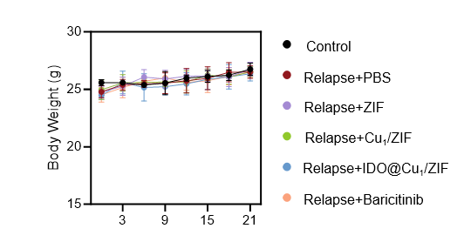
Supplementary Fig. 22 | Body weight changes during imiquimod re-challenge in the AA relapse model. Data are presented as mean ± SD. n = 5 biologically independent mice per group. Statistical significance was determined by two-way ANOVA.

Supplementary Tables
Supplementary Table 1 | BET surface area, pore volume, and Zn/Cu contents of different samples.
 | Surface Area  (m² g⁻¹) | Pore Volume  (cm³ g⁻¹) | Zn Content  (wt.%) | Cu Content  (wt.%)
ZIF | 1860 | 0.839 | 19.93 | /
Cu_{0.5}/ZIF | 1738 | 0.749 | 21.04 | 1.25
Cu₁/ZIF | 1710 | 0.749 | 21.86 | 2.42
Cu₂/ZIF | 1558 | 0.732 | 20.43 | 3.92

Supplementary Table 2. Primer sequences for RT-qPCR.
Species | Gene | Direction | Sequence (5′→3′)
Human | IFNG | fw | TGCAGAGCCAAATTGTCTCCTTT
Human | IFNG | rev | TGTATTGCTTTGCGTTGGACATT
Human | TNF | fw | CTCAGCCTCTTCTCCTTCCTGAT
Human | TNF | rev | GTTTGCTACAACATGGGCTACAG
Human | IL10 | fw | TGCTGGAGGACTTTAAGGGTTAC
Human | IL10 | rev | TTGATGTCTGGGTCTTGGTTCTC
Human | TGFB1 | fw | TACAGCAACAATTCCTGGCGATA
Human | TGFB1 | rev | CAGTGTGTTATCCCTGCTGTCAC
Human | AHRR | fw | GCCGCCACAGCTCCTG
Human | AHRR | rev | ACGGCGGGCCTCTGTTTC
Human | CYP1A1 | fw | CAGCTCAGTACCTCAGCCAC
Human | CYP1A1 | rev | CATGGCCCTGGTGGATTCTT
Human | CYP1B1 | fw | GCTCCTCCTCTTCACCAGGTAT
Human | CYP1B1 | rev | TGGTCACCCATACAAGGCAG
Human | GAPDH | fw | TGACAACAGCCTCAAGATCATCA
Human | GAPDH | rev | GGTCATGAGTCCTTCCACGATAC

Supplementary Table 3. List of abbreviations used in this study.
Abbreviation | Full term
AA | Alopecia areata
Tregs | Regulatory T cells
IFN-γ | Interferon-γ
JAK | Janus kinase
IDO1 | Indoleamine 2,3-dioxygenase 1
Trp | Tryptophan
Kyn | Kynurenine
AHR | Aryl hydrocarbon receptor
ROS | Reactive oxygen species
MOF | Metal-organic framework
SOD | Superoxide dismutase
GO | Gene Ontology
DEGs | Differentially expressed genes
ssGSEA | Single-sample gene set enrichment analysis
TEM | Transmission electron microscopy
HAADF-STEM | High-angle annular dark-field scanning transmission electron microscopy
EDS | Energy-dispersive X-ray spectroscopy
XRD | X-ray diffraction
FTIR | Fourier-transform infrared spectroscopy
TGA | Thermogravimetric analysis
XPS | X-ray photoelectron spectroscopy
EPR | Electron paramagnetic resonance
XAFS | X-ray absorption fine structure
XANES | X-ray absorption near-edge structure
FT-EXAFS | Fourier-transformed extended X-ray absorption fine structure
PDOS | Projected density of states
PBMCs | Peripheral blood mononuclear cells
RT-qPCR | Reverse-transcription quantitative PCR
IMQ | Imiquimod
SEM | Scanning electron microscopy
H&E | Hematoxylin and eosin
DHE | Dihydroethidium
KEGG | Kyoto Encyclopedia of Genes and Genomes
GSEA | Gene set enrichment analysis
DFT | Density functional theory
NLDFT | Nonlocal density functional theory
XAS | X-ray absorption spectroscopy
GEO | Gene Expression Omnibus
GSA | Genome Sequence Archive
ANOVA | Analysis of variance

