SUPPLEMENTARY INFORMATION
Online Resource 1
A Pressure-Aware Pedestrian Routing Service for Tourism Data Spaces
Information Technology & Tourism
This file contains Figs. S1-S9 and Tables S1-S2.
POI tourism values, expected visit times and nodal pressure scores are prototype inputs. The controlled experiments reported in the manuscript use a uniform 5-minute visit time unless stated otherwise.

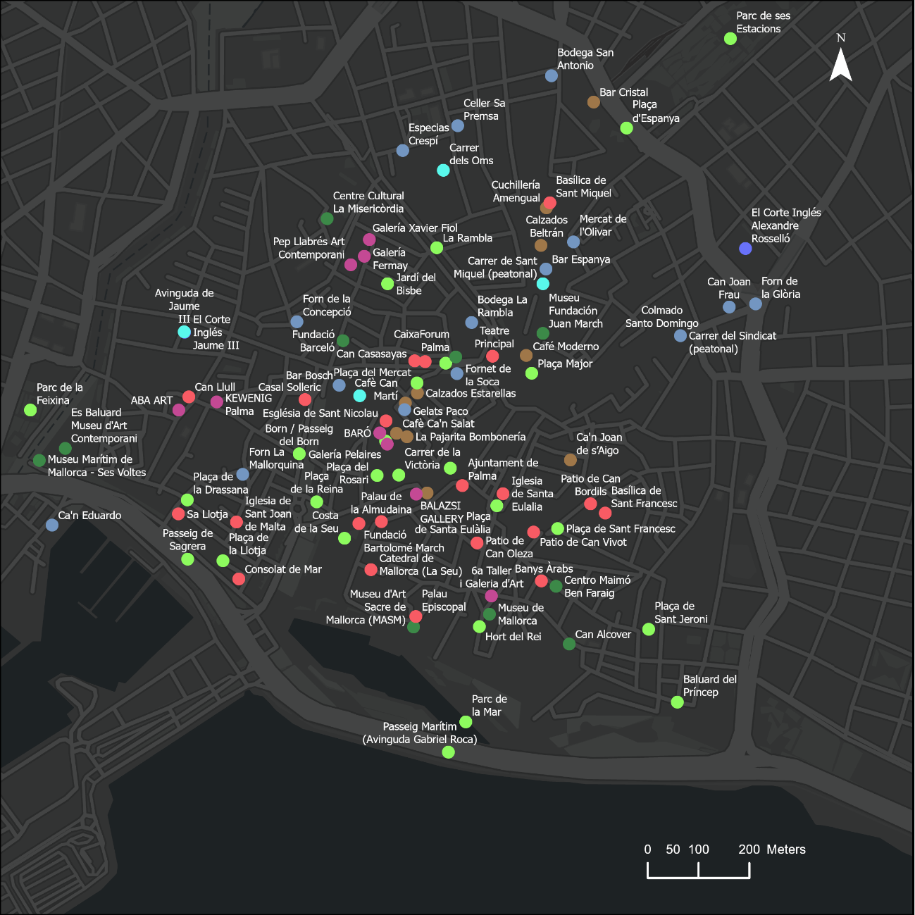
Fig. S1 Georeferenced inventory of the 105 points of interest used by the framework in Palma's historic centre. Each POI is labelled and classified by thematic category, allowing the spatial distribution of heritage, museums, galleries, gastronomy, commerce and urban-space resources to be compared across the study area

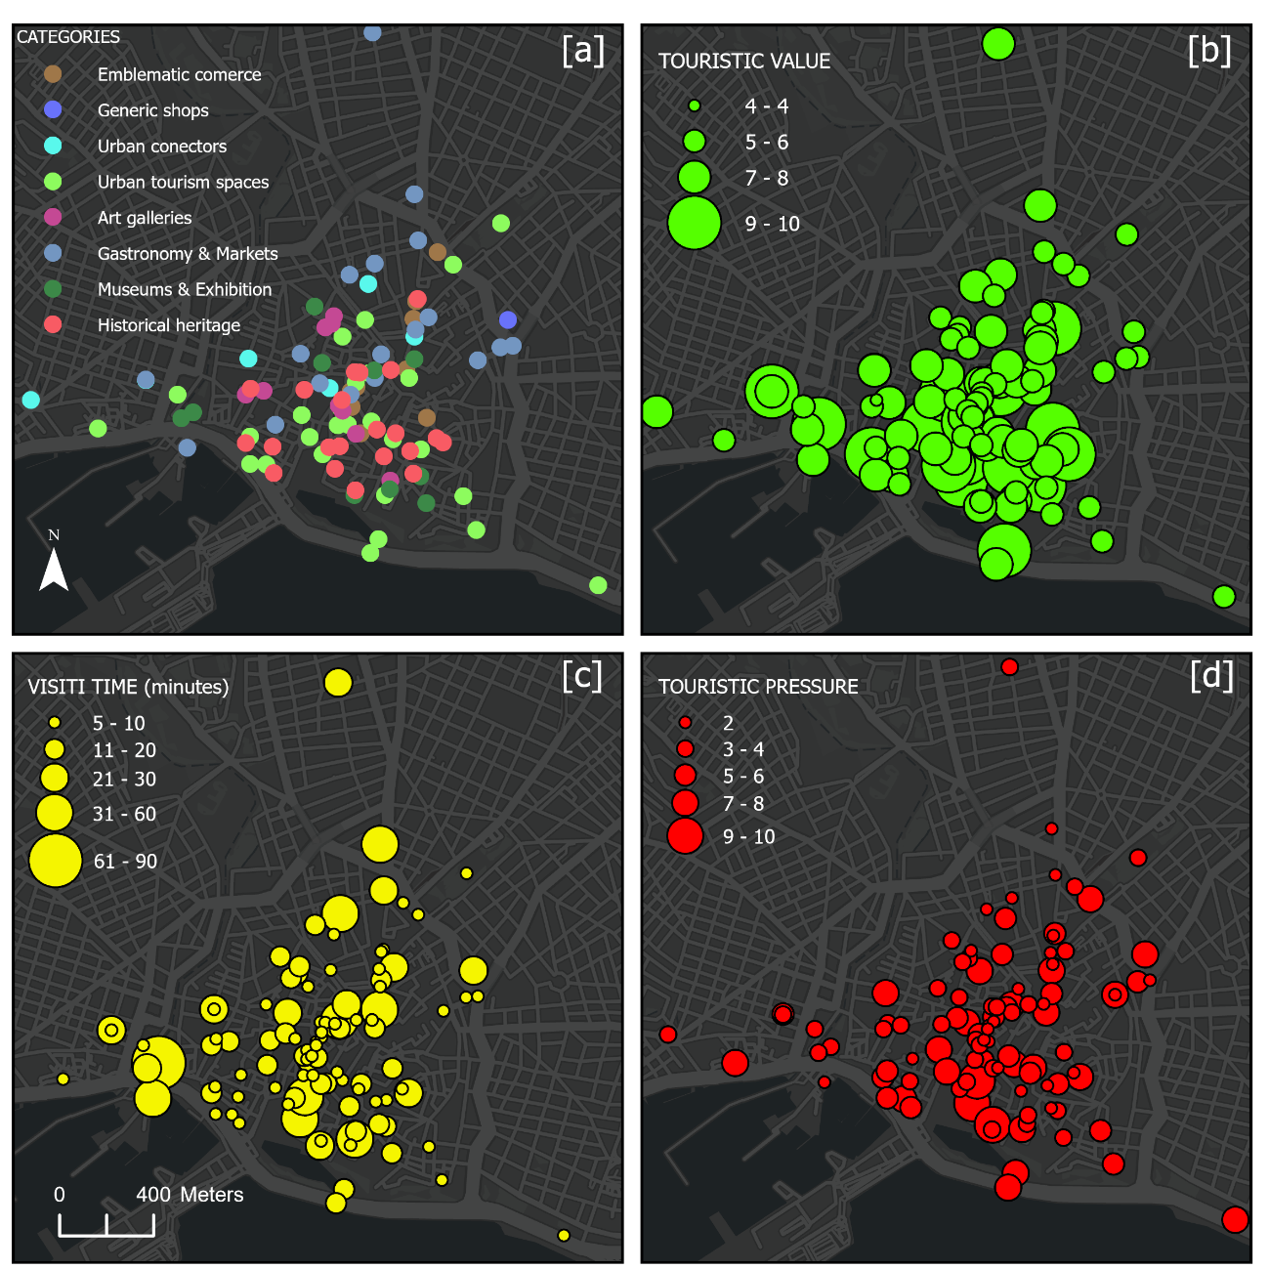
Fig. S2 Attributes of the POI inventory: thematic category, tourism value, expected visit time and nodal pressure. All panels use the same spatial extent. Symbol size in panels (b)-(d) is proportional to the mapped attribute. Tourism value, expected visit time and nodal pressure are prototype inputs used to define and test the framework

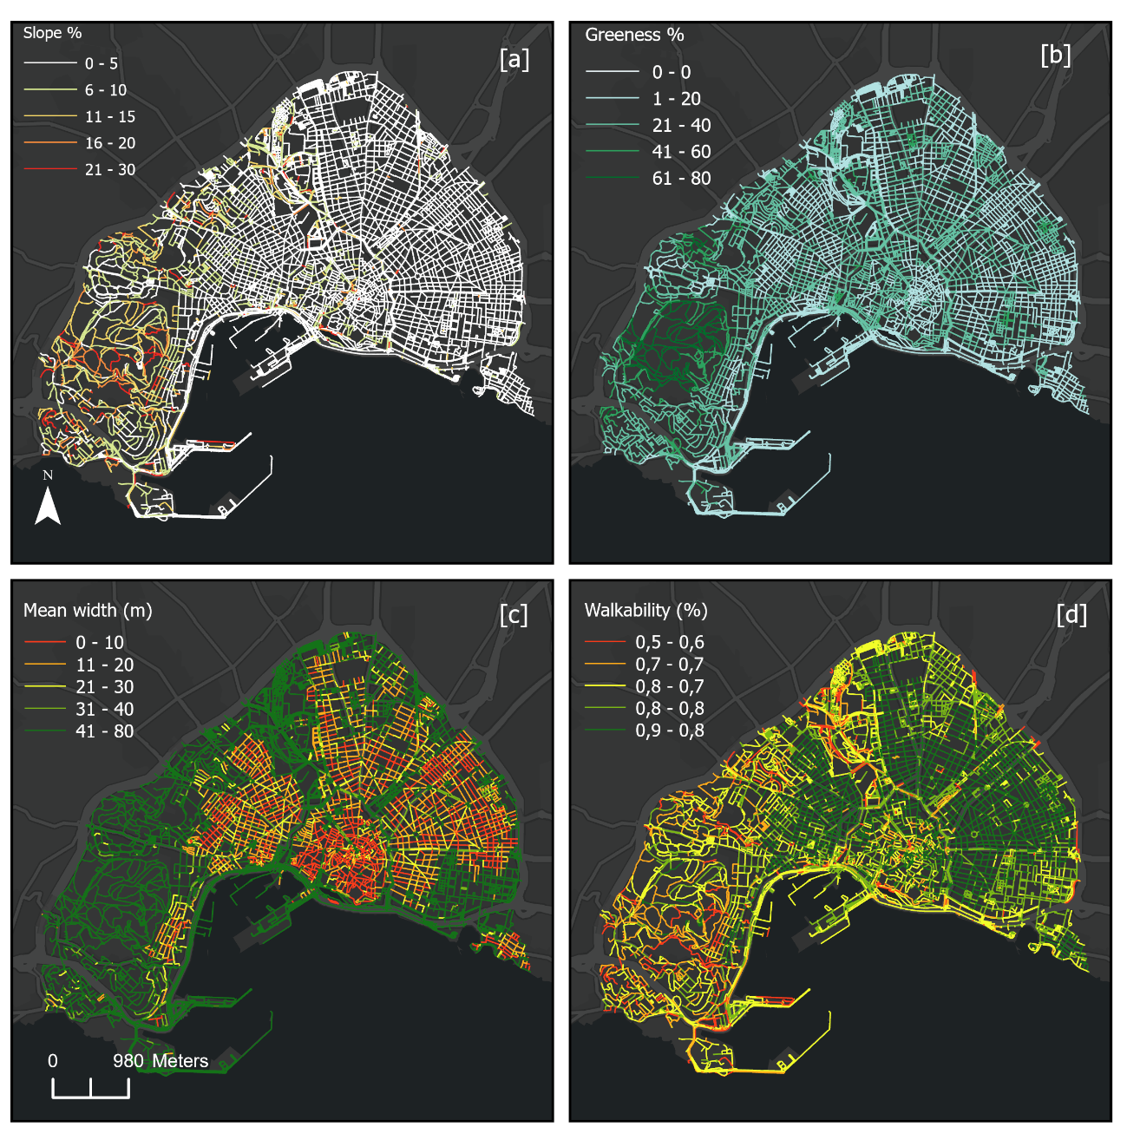
Fig. S3 Morphological attributes of the pedestrian network and the resulting walkability index. Panel (a) shows longitudinal slope, panel (b) tree-canopy coverage, panel (c) mean effective street width, and panel (d) the composite walkability index derived from the morphological penalties described in Sect. 3.2

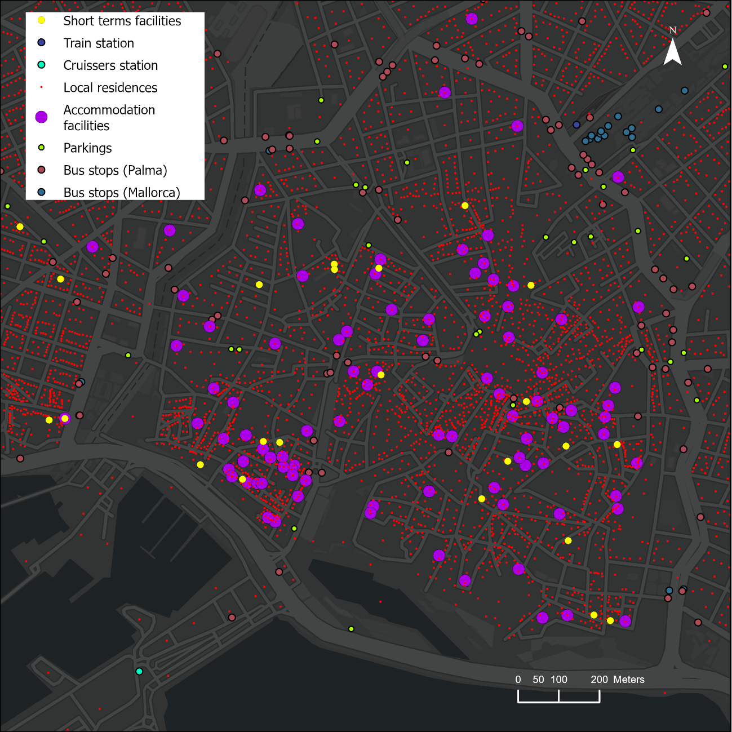
Fig. S4 Spatial distribution of the eight demand-generator layers used in the gravity model of pedestrian flow: short-term rentals, rail, cruise terminal, resident population, registered accommodation, public parking, EMT bus stops and TIB bus stops

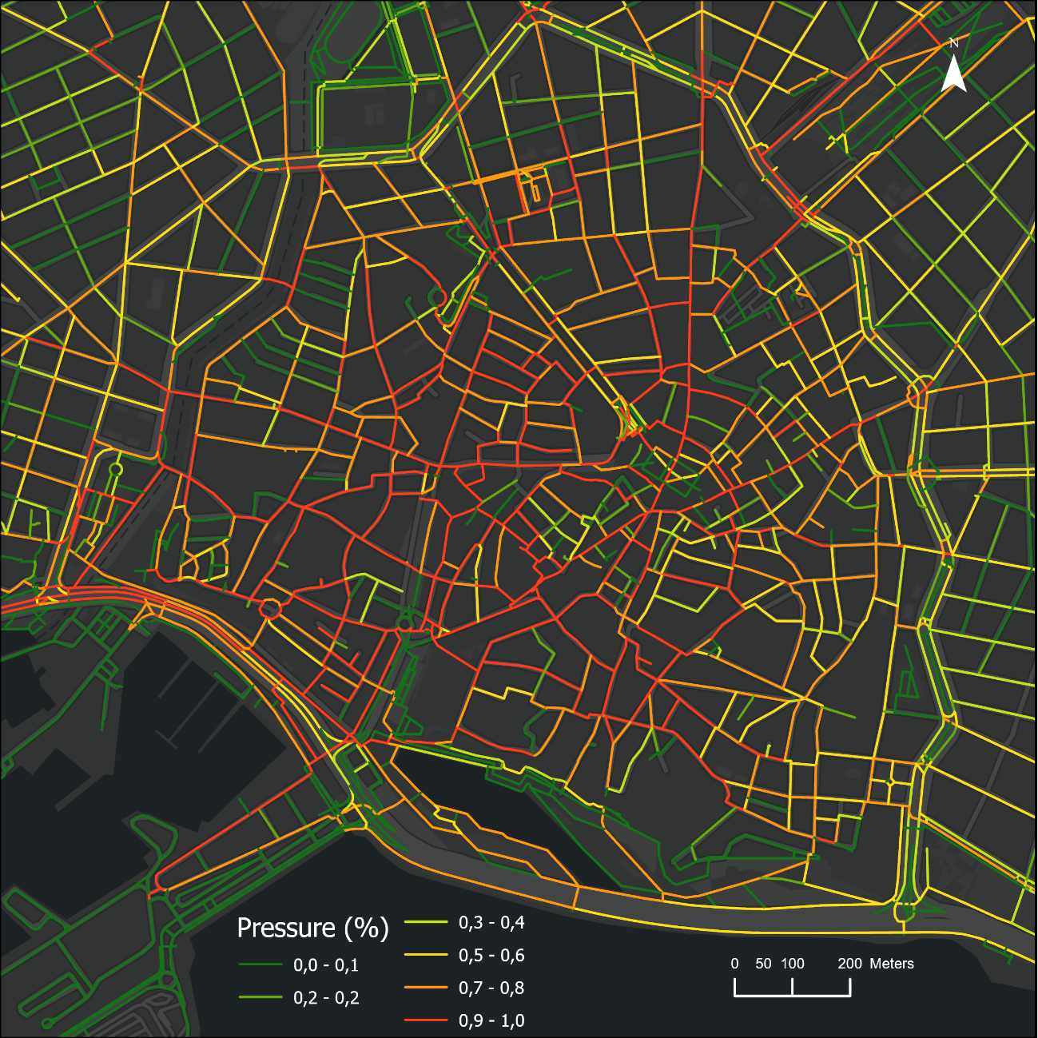
Fig. S5 Normalised tourism pressure on the pedestrian network. Segment pressure is derived from the gravity-based flow model and scaled to the 0-1 range. High values form connected corridors through the historic core, while nearby secondary streets can carry substantially lower modelled pressure

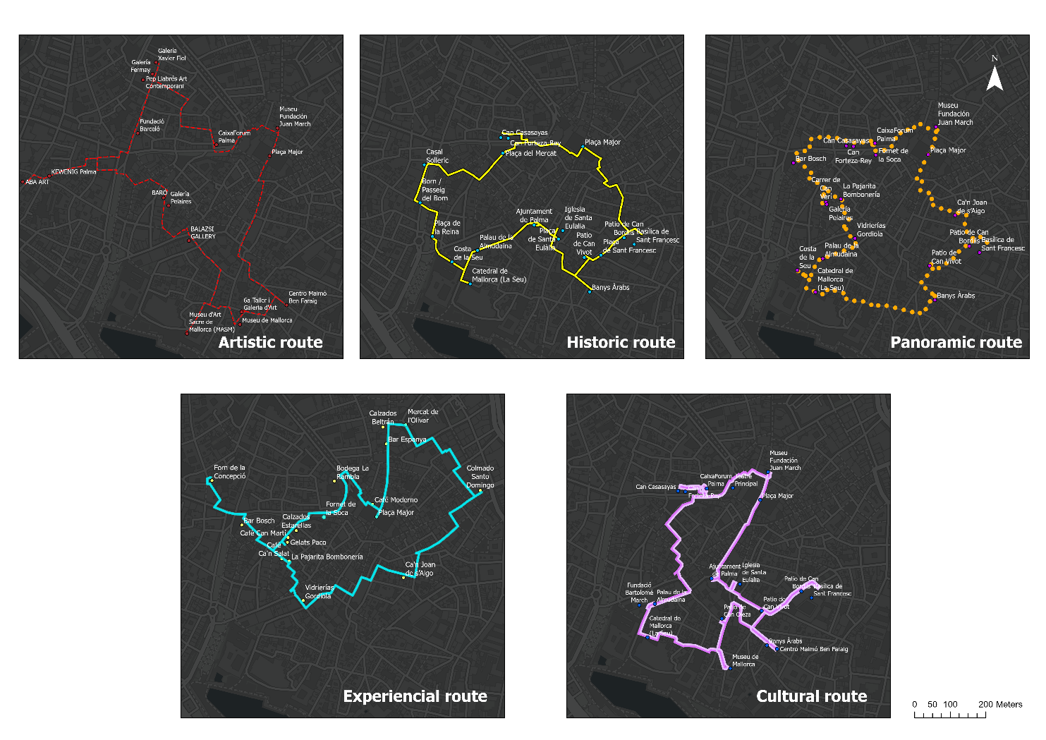
Fig. S6 Five thematic baseline routes optimised from the central origin at Plaça Major with a 120-minute budget, a closed route structure, uniform 5-minute visits and no candidate cap. The panels correspond to Art Route, Historic Walk, Panoramic, Local Experience and Classic Cultural

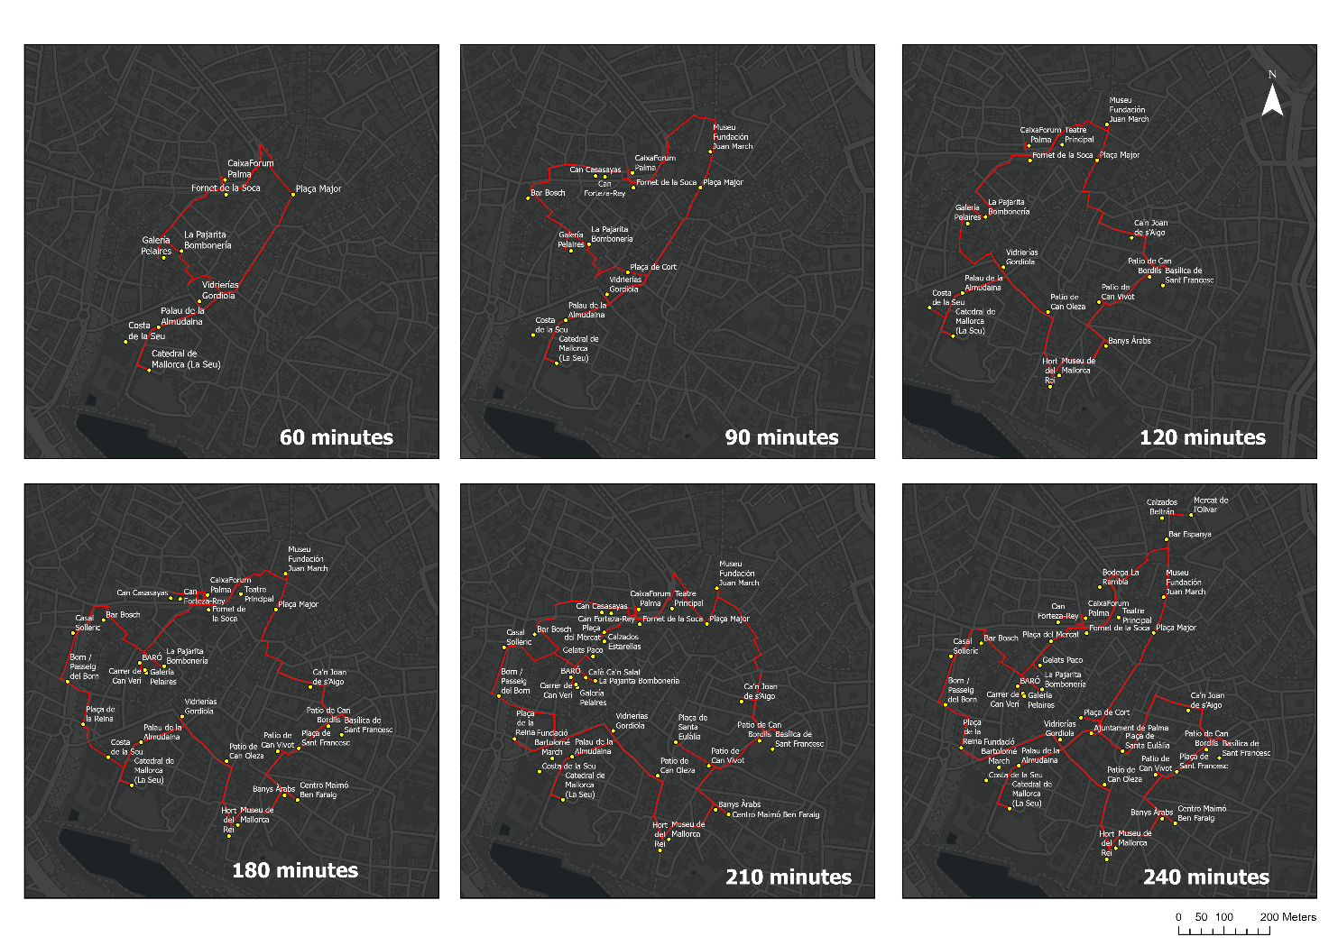
Fig. S7 Effect of the time budget on the Panoramic route. The montage shows six selected solutions at 60, 90, 120, 180, 210 and 240 minutes; the 150-minute solution is omitted from the montage for readability. Increasing the budget adds stops mainly within the same central corridor structure

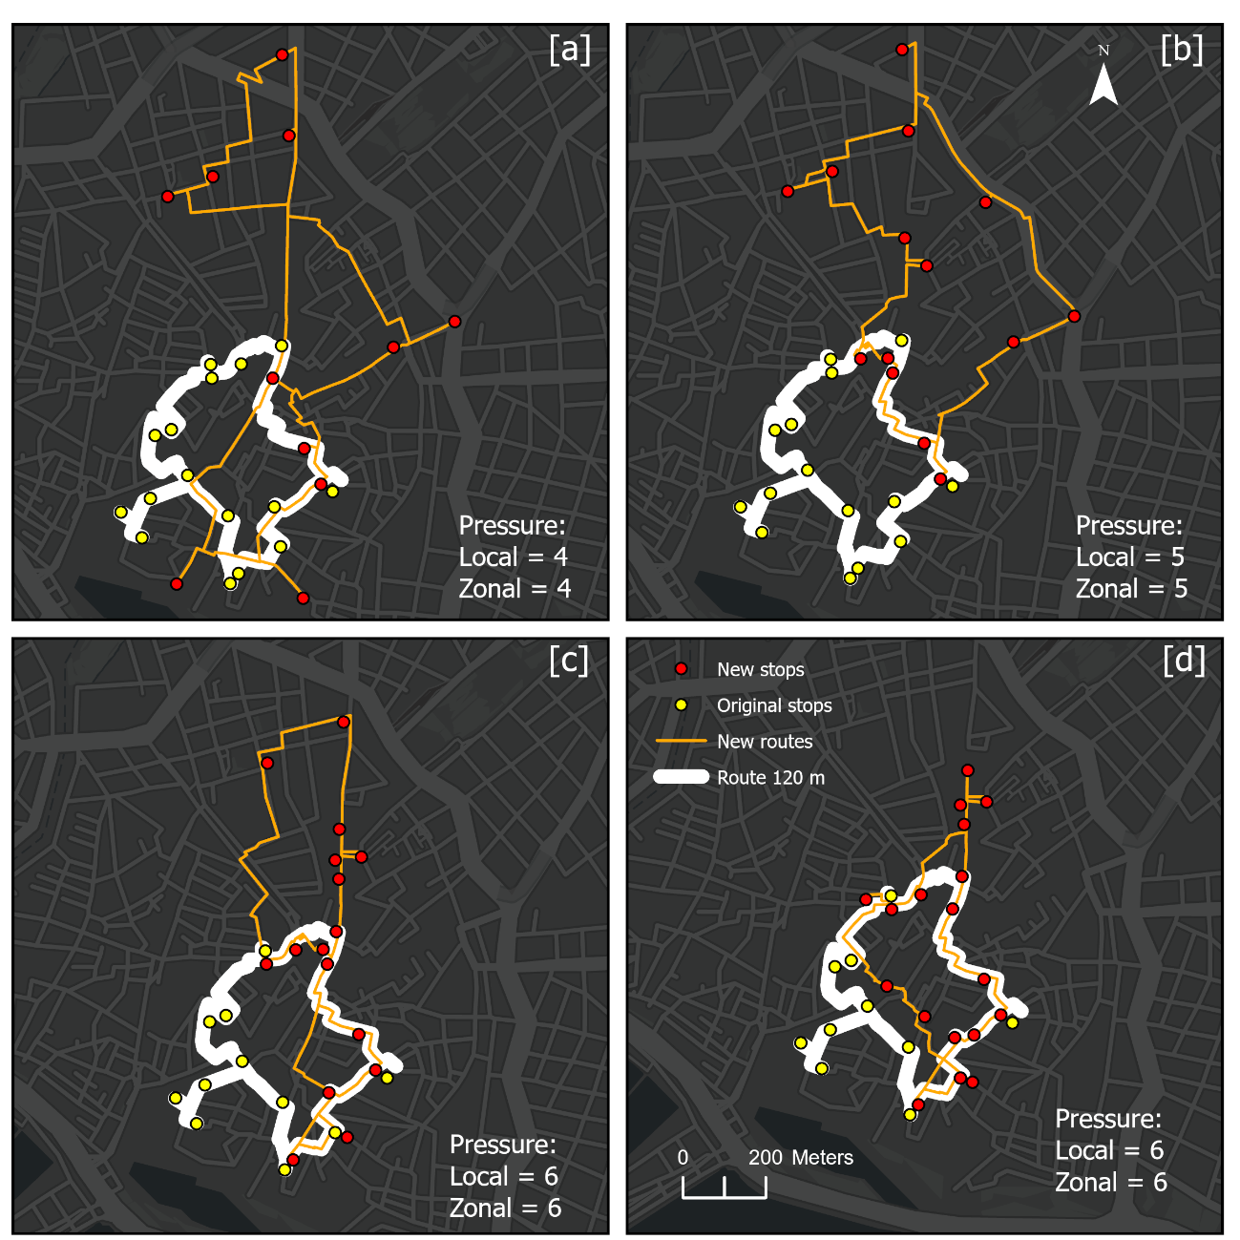
Fig. S8 Effect of progressive dual pressure filtering on route geometry. Panels (a)-(d) apply common nodal and zonal thresholds of 4, 5, 6 and 7, respectively. The white band represents the unfiltered 120-minute route, and the filtered solution shows how changing the admissible POI set affects both selected stops and the walked trajectory

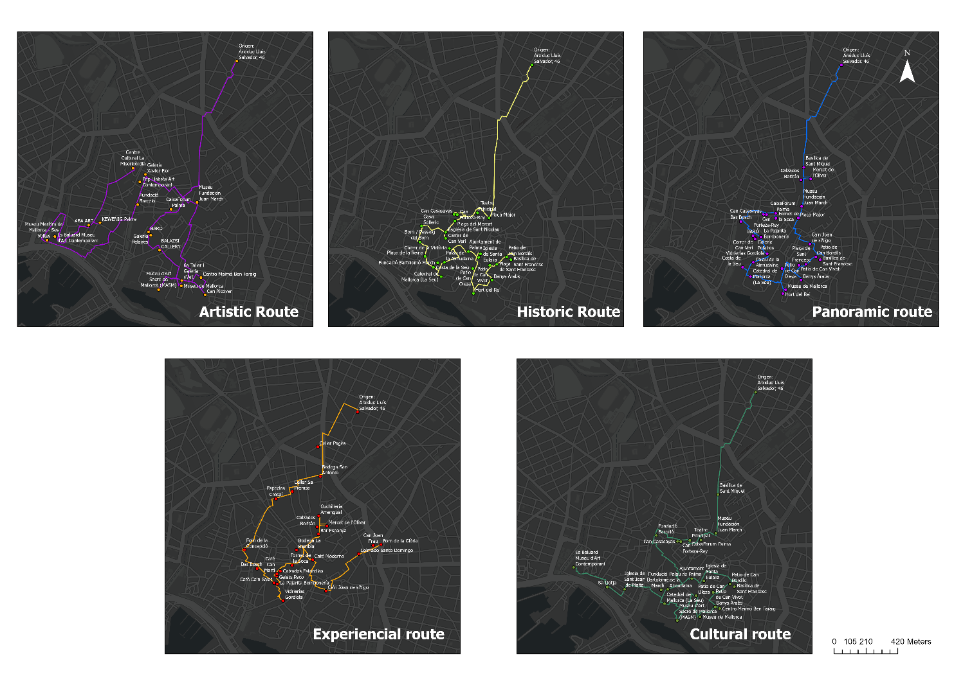
Fig. S9 Five thematic routes optimised from the peripheral accommodation origin used in Experiment 4 with an open route structure. The panels use the same thematic definitions as Fig. S6: Art Route, Historic Walk, Panoramic, Local Experience and Classic Cultural

Table S1 Complete POI inventory catalogue
The catalogue contains 105 georeferenced records in six visitable thematic categories and two auxiliary, non-visitable categories. Tourism value and nodal pressure are prototype scores on 0-10 scales. Zonal pressure is model-derived and rescaled to 0-10. Expected visit time is reported as an inventory attribute; the controlled experiments use a uniform 5-minute visit time unless stated otherwise. Coordinates are given in WGS84 (EPSG:4326).
Table S1 (continued) Monumental and historical heritage (22 POIs)
Code | POI | Tourism value | Nodal pressure | Zonal pressure | Expected visit (min) | Description | Value rationale | Coordinates
MH-01 | Catedral de Mallorca (La Seu) | 9.8 | 10 | 3 | 60 | Gothic cathedral (13th-16th c.) built over an Almohad mosque; a 44 m central nave, a 12 m rose window and a Gaudí baldachin, its south façade rising directly above the sea. | Major monumental landmark of Palma and the Balearic Islands, defining the city's Mediterranean skyline for centuries. 98/100. | 39.5679°N, 2.6481°E
MH-02 | Sa Llotja | 8.8 | 6 | 8 | 15 | Flamboyant-Gothic 15th-c. merchants' exchange by Guillem Sagrera, a notable example of Spanish civil-Gothic architecture; an open hall of helicoidal columns, facing the sea. | A major example of Spanish civil-Gothic architecture, in a privileged seafront setting. 88/100. | 39.5689°N, 2.6437°E
MH-03 | Banys Àrabs · Archaeology & Arab heritage | 8.8 | 2 | 6 | 20 | The only surviving Arab baths in Mallorca (10th c.): a domed central chamber with star-shaped skylights and columns of mismatched capitals, in the Gothic quarter. | The most important Arab architectural vestige and the only one open to visitors in Palma; singular within the Balearic context. 88/100. | 39.5677°N, 2.6520°E
MH-04 | Palau de la Almudaina | 8.7 | 9 | 10 | 45 | Royal palace of Islamic origin (10th c.) and official residence of the Spanish Crown in Mallorca; the Santa Ana chapel, the Tinell courtyard and the keep stand out. | Forms the great south monumental front with the Cathedral; an active royal palace with visitable historic collections. 87/100. | 39.5688°N, 2.6483°E
MH-05 | Castell de Bellver | 8.5 | 7 | 6 | 60 | Circular 14th-c. Gothic castle-notable for its unusual circular plan-set in pinewoods 112 m above the sea, with a municipal museum, moat and panoramic bay views. | A monument notable for its circular typology and panoramic views, despite its peripheral location. 85/100. | 39.5671°N, 2.6249°E
MH-06 | Basílica de Sant Francesc | 8.2 | 7 | 2 | 30 | 14th-c. Gothic-Baroque church and convent with a notable double-galleried Gothic cloister, the tomb of Ramon Llull and a monumental Baroque façade. | A major monument of the old town, housing the tomb of Mallorca's major medieval philosopher; heavily visited. 82/100. | 39.5689°N, 2.6534°E
MH-07 | Patio de Can Oleza · Civil architecture · seigneurial courtyard | 8.2 | 2 | 7 | 15 | A well-known courtyard in Palma (15th-16th c., Gothic-Renaissance): an arcaded gallery of round arches with wells and an interior garden, on Carrer de la Moreneta. | A well-preserved courtyard of the old town for its scale, composition and conservation; a reference point of the courtyard routes. 82/100. | 39.5684°N, 2.6505°E
MH-08 | Patio de Can Vivot · Civil architecture · seigneurial courtyard | 7.8 | 2 | 5 | 10 | Grand 18th-c. Baroque courtyard on Carrer de Can Savellà, with a double arcaded gallery, an interior garden and fine decorative elements-a well-preserved example of civil-Baroque architecture in Palma. | A well-preserved Baroque courtyard of the old town; complements Can Oleza on the seigneurial-courtyard route. 78/100. | 39.5686°N, 2.6518°E
MH-09 | Casal Solleric | 7.6 | 4 | 10 | 20 | 18th-c. Baroque palace on the Passeig del Born, now a municipal cultural centre; an arcaded courtyard with imperial staircase hosting exhibitions and the tourist office. | Combines high-quality seigneurial Baroque architecture with an active free-access cultural programme at the heart of the Born. 76/100. | 39.5709°N, 2.6465°E
MH-10 | Can Casasayas | 7.2 | 3 | 7 | 10 | Modernista building of 1908 on the Plaça del Mercat by Gaspar Bennàssar; together with Can Forteza-Rey it forms Palma's only pair of twin Modernista buildings. Much photographed. | An unusual example of a twin Modernista pair, with excellent access at the Plaça del Mercat-Born node. 72/100. | 39.5716°N, 2.6490°E
MH-11 | Can Forteza-Rey | 7.2 | 3 | 6 | 10 | Modernista building of 1909 on the Plaça del Mercat, twin of Can Casasayas; a façade of floral motifs, wrought iron and eclectic ornament, now in commercial use. | Key, with its twin, to understanding Palma's urban transformation in the early 20th century. 72/100. | 39.5716°N, 2.6493°E
MH-12 | Patio de Can Bordils · Civil architecture · seigneurial courtyard | 7.2 | 2 | 2 | 10 | 16th-c. Renaissance courtyard, home of the Palma Municipal Archive; an arcaded gallery of round arches with a central well, accessible during archive hours. | A Renaissance courtyard of high architectural value that adds a documentary, historical dimension to the courtyard route. 72/100. | 39.5691°N, 2.6531°E
MH-13 | Fundació Bartolomé March | 7 | 3 | 10 | 20 | Palau March, a 20th-c. residence on Carrer del Palau Reial, housing sculpture by Rodin, Moore, Dalí and Chillida; the outdoor terrace is freely visitable. | A combination of Novecento architecture and an internationally recognised sculpture collection; the free Rodin/Moore terrace is much photographed. 70/100. | 39.5687°N, 2.6478°E
MH-14 | Teatre Principal | 6.8 | 4 | 4 | 10 | 19th-c. Neoclassical theatre, the oldest active in the Balearics; a columned portico on the Riera, staging opera, dance and a stable programme since 1860. | A cultural and historic landmark with over 160 years of unbroken activity; one of the most recognisable façades of the centre. 68/100. | 39.5717°N, 2.6508°E
MH-15 | Ajuntament de Palma | 6.5 | 7 | 6 | 10 | 17th-c. city hall on the Plaça de Cort, with a Baroque façade, a great wooden clock and a famed olive tree over 700 years old. Interior visitable at set times. | An institutional building of great symbolic value; the ancient olive and the façade are much photographed, completing the central urban node. 65/100. | 39.5694°N, 2.6502°E
MH-16 | Iglesia de Santa Eulalia | 6.2 | 7 | 5 | 15 | The first parish church raised after the Christian conquest of 1229; a lofty Gothic nave with side chapels and notable altarpieces, on the Plaça de Santa Eulàlia. | High historic value as Palma's first parish; well integrated into the Gothic-quarter and Call circuit. 62/100. | 39.5693°N, 2.6511°E
MH-17 | Basílica de Sant Miquel | 5.8 | 6 | 4 | 10 | The first church consecrated after the 1229 conquest; an 18th-c. classicist exterior with bell tower over original Gothic elements, on the pedestrian Sant Miquel axis. | Singular historic value as Palma's first consecrated church, with a recognisable façade on the main pedestrian axis. 58/100. | 39.5744°N, 2.6521°E
MH-18 | Consolat de Mar | 5.5 | 6 | 7 | 5 | Historic seat of the Maritime Trade Tribunal (17th c.), today the Presidency of the Balearic Government; a Renaissance façade with arcaded loggia facing the Passeig de Sagrera. | A historic building of notable architectural interest, selected for its role in the seafront monumental ensemble beside Sa Llotja. 55/100. | 39.5677°N, 2.6450°E
MH-19 | Palau Episcopal | 5.2 | 9 | 2 | 10 | 17th-c. Baroque palace, historic seat of the bishopric of Mallorca; a monumental portal and interior courtyard, housing the Museu d'Art Sacre, adjoining the Cathedral. | Considerable heritage interest that completes the episcopal ensemble beside the Cathedral; access depends on museum hours. 52/100. | 39.5671°N, 2.6491°E
MH-20 | Església de Sant Nicolau | 5 | 6 | 9 | 10 | 14th-c. Gothic church with a characteristic octagonal tower, on Carrer de Sant Nicolau, the pedestrian axis between the Born and the Plaça Major. | Heritage interest for its Gothic architecture and strategic position, enriching the reading of the historic centre. 50/100. | 39.5706°N, 2.6484°E
MH-21 | Iglesia de Sant Joan de Malta | 4.8 | 4 | 8 | 5 | 13th-c. church of the Order of the Hospitallers of St John; a sober Romanesque exterior housing the Aljub contemporary-art space, beside the Llotja front. | Heritage interest for its age and Order-of-Malta link; its dual church/art-space use enriches the seafront circuit. 48/100. | 39.5688°N, 2.6450°E
MH-22 | Can Llull | 3.8 | 4 | 5 | 5 | 14th-c. Gothic house linked to the family of the philosopher Ramon Llull; a façade with a pointed arch and Gothic windows near Sa Llotja, now in private residential use. | Historic interest through its Llull connection, though hard to access; included to complete the civil-Gothic circuit. 38/100. | 39.5710°N, 2.6439°E
Table S1 (continued) Museums, foundations and exhibition spaces (10 POIs)
Code | POI | Tourism value | Nodal pressure | Zonal pressure | Expected visit (min) | Description | Value rationale | Coordinates
MU-01 | Es Baluard Museu d'Art Contemporani | 8.7 | 4 | 6 | 90 | Museum of modern and contemporary art built into the 16th-c. Renaissance walls, with a permanent collection (Picasso, Miró, Tàpies) and a terrace overlooking the port. | A major museum with a high-quality collection, architecture integrated into the historic walls and broad harbour views. 87/100. | 39.5701°N, 2.6411°E
MU-02 | CaixaForum Palma | 7.8 | 7 | 4 | 45 | La Caixa exhibition venue in the Gran Hotel (1903), Palma's first Modernista building by Domènech i Montaner; rotating international temporary shows, free entry. | The Gran Hotel adds architectural value to a venue with rotating international exhibitions. 78/100. | 39.5717°N, 2.6500°E
MU-03 | Museu de Mallorca | 7.8 | 4 | 3 | 60 | Island museum in the 16th-c. Palau de la Gran Cristiana, spanning Talayotic prehistory to the 20th c.: Islamic bronzes, Mallorcan Gothic painting and historic ceramics. | Important for interpreting Mallorca's long-term history; a noble old-town building with a broad, well-documented collection. 78/100. | 39.5671°N, 2.6508°E
MU-04 | Museu Fundación Juan March | 7.5 | 5 | 3 | 45 | Museum of 20th-c. Spanish art in an 18th-c. mansion, with a permanent collection (Picasso, Miró, Dalí, Saura, Millares); free entry, on Carrer de Sant Miquel. | Free access to a substantial collection of 20th-century Spanish art, in a fine building on the main pedestrian axis. 75/100. | 39.5721°N, 2.6520°E
MU-05 | Fundació Barceló | 7.2 | 3 | 9 | 30 | Foundation of the Mallorcan artist Miquel Barceló in an 18th-c. palazzetto on Carrer de Sant Jaume; a permanent display of his work, visited by guided groups with booking. | A direct link to Barceló, an internationally recognised Spanish artist; a historic building and high-quality collection. 72/100. | 39.5720°N, 2.6474°E
MU-06 | Museu d'Art Sacre de Mallorca (MASM) | 6.5 | 3 | 1 | 30 | Diocesan museum in the Palau Episcopal beside the Cathedral: Mallorcan Gothic painting, medieval altarpieces, liturgical goldwork and religious sculpture from across the island. | A high-quality, internationally little-known Gothic-painting collection in a location next to the Cathedral. 65/100. | 39.5669°N, 2.6491°E
MU-07 | Museu Marítim de Mallorca - Ses Voltes | 6.2 | 4 | 6 | 30 | Maritime museum in the medieval vaults of Ses Voltes beneath the Renaissance walls: historic vessels, nautical cartography and Balearic maritime heritage. | A distinctive theme in a singular historic space, adding the maritime dimension relevant to Palma as a port city. 62/100. | 39.5698°N, 2.6405°E
MU-08 | Centre Cultural La Misericòrdia | 6 | 3 | 5 | 20 | Consell de Mallorca cultural centre in a 17th-c. former hospital; a large free-access arcaded courtyard, exhibition halls and a permanent programme. | One of Palma's larger historic courtyards, free to enter, with an active cultural programme. 60/100. | 39.5741°N, 2.6470°E
MU-09 | Centro Maimó Ben Faraig | 5.8 | 4 | 5 | 20 | Interpretation centre for Palma's Jewish heritage in the former Call (medieval Jewish quarter), explaining the Sephardic presence and the history of the Xuetes. | A unique resource for understanding the Mallorcan Jewish diaspora, at the heart of the Call. 58/100. | 39.5676°N, 2.6523°E
MU-10 | Can Alcover | 5.2 | 3 | 1 | 15 | 20th-c. Modernista house, seat of the Llorenç Villalonga House-Museum, linked to the author of 'Bearn'; a permanent display and interior garden. | Literary and identity interest for connoisseurs of Mallorcan culture; the Modernista building has value in its own right. 52/100. | 39.5666°N, 2.6526°E
Table S1 (continued) Art galleries (9 POIs)
Code | POI | Tourism value | Nodal pressure | Zonal pressure | Expected visit (min) | Description | Value rationale | Coordinates
GA-01 | Galería Pelaires | 8.2 | 3 | 9 | 20 | One of Palma's most historic and prestigious galleries, founded 1968 on Carrer de Can Verí; it has shown Miró, Tàpies and Barceló-a benchmark of Balearic gallery life. | Palma's longest-running and most prestigious gallery, with Barceló's first shows and Miró collaborations to its name. 82/100. | 39.5701°N, 2.6484°E
GA-02 | KEWENIG Palma | 7.8 | 3 | 9 | 20 | International gallery with venues in Berlin, Cologne and Palma; a space on Carrer de Sant Feliu showing top global-circuit artists, with high-quality interiors. | The Balearic branch of a major European gallery, raising island gallery life to an international level. 78/100. | 39.5709°N, 2.6445°E
GA-03 | BARÓ | 6.8 | 3 | 10 | 15 | International contemporary-art gallery on Carrer de Can Verí, representing artists active on the international circuit-one of Palma's most internationally projected galleries. | A consolidated international-profile gallery with artists shown at fairs like Art Basel and ARCO. 68/100. | 39.5703°N, 2.6483°E
GA-04 | Galería Xavier Fiol | 5.8 | 2 | 6 | 15 | Contemporary-art gallery on Carrer de Sant Jaume with a cross-generational programme spanning figurative and abstract painting; a recognised Balearic-circuit track record. | A consolidated gallery of more classic-contemporary profile that adds continuity to the Palma art scene. 58/100. | 39.5738°N, 2.6480°E
GA-05 | Galería Fermay | 5.5 | 3 | 6 | 15 | Contemporary-art gallery on Carrer de Sant Jaume combining Mallorcan and mainland artists, with an emphasis on painting and sculpture and a stable, accessible programme. | A gallery with a solid track record on the Sant Jaume axis, adding a more regional, accessible profile to the circuit. 55/100. | 39.5735°N, 2.6479°E
GA-06 | Pep Llabrés Art Contemporani | 5.5 | 3 | 7 | 15 | Contemporary-art gallery on Carrer de Sant Jaume focused on Mallorcan and island artists, with an emphasis on painting and drawing and a more local profile. | A reference for understanding the local Mallorcan art scene, complementing the more international galleries. 55/100. | 39.5733°N, 2.6476°E
GA-07 | ABA ART | 5.2 | 3 | 4 | 15 | Contemporary-art gallery and project rooms on Costa de Santa Creu, backing emerging local and international artists with short exhibition cycles and experimental proposals. | A dynamic gallery on the Born axis whose emerging profile sets it apart from the more established circuit. 52/100. | 39.5707°N, 2.6437°E
GA-08 | BALAZSI GALLERY | 4.8 | 3 | 7 | 15 | Contemporary-art gallery on Carrer de la Victòria with a mixed programme of national and international artists; a mid-sized space with good access from the Born. | A gallery of growing interest, well placed on the Born-galleries axis, chiefly of interest to collectors. 48/100. | 39.5693°N, 2.6491°E
GA-09 | 6a Taller i Galeria d'Art | 4.5 | 3 | 6 | 15 | A hybrid artist's workshop and exhibition space on Carrer de Puresa, deep in the Gothic quarter, with a locally produced craft and visual-art programme. | Interesting for its hybrid function and off-circuit location, adding authenticity and urban texture to the route. 45/100. | 39.5675°N, 2.6508°E
Table S1 (continued) Urban spaces of tourist interest (27 POIs)
Code | POI | Tourism value | Nodal pressure | Zonal pressure | Expected visit (min) | Description | Value rationale | Coordinates
US-01 | Born / Passeig del Born | 9 | 8 | 10 | 15 | Palma's most emblematic promenade: a tree-lined boulevard of ancient elms, terraces, galleries and historic architecture, linking the Cathedral front to the shopping district. | The city's reference urban axis, with the greatest concentration of historic architecture, galleries and terraces; an important pedestrian axis. 90/100. | 39.5700°N, 2.6464°E
US-02 | Costa de la Seu | 8.5 | 4 | 7 | 10 | A promenade at the foot of the Cathedral's south wall between the Parc de la Mar and the Almudaina-Palma's most photographed image: cathedral, Gothic wall and lake reflection. | A well-known pedestrian route; the view of the Cathedral from here is a prominent view of Palma's waterfront. 85/100. | 39.5685°N, 2.6475°E
US-03 | Parc de la Mar | 8.2 | 7 | 0 | 15 | Urban park at the foot of the Cathedral and walls, with an artificial lake mirroring the south façade, a Miró sculpture, an amphitheatre and access to the seafront promenade. | One of Palma's well-known public spaces; the Cathedral reflected in the lake is a frequently photographed view of the city. 82/100. | 39.5652°N, 2.6503°E
US-04 | Plaça Major | 8 | 7 | 3 | 15 | Great arcaded square of the historic centre, porticoed on every side, with artisan markets, street performers and direct access to the Gothic quarter and pedestrian axes. | The busiest, most recognised square of the old town and a gateway to the Gothic quarter; a major node. 80/100. | 39.5714°N, 2.6517°E
US-05 | Plaça de Cort | 7.2 | 6 | 4 | 10 | Institutional square of the historic centre with the City Hall and the 700-year-old olive tree; a stage for civic events and markets and an entry point to the Gothic quarter. | Palma's central urban node, heavily frequented; the ancient olive is a much-photographed city symbol. 72/100. | 39.5697°N, 2.6499°E
US-06 | Plaça de la Llotja | 7.2 | 7 | 9 | 10 | Square beside Sa Llotja with views of the seafront and summer restaurant terraces-one of the liveliest meeting points on the waterfront, animated day and night. | A strong interplay of public space, the Gothic Sa Llotja and the seafront; very busy in high season. 72/100. | 39.5681°N, 2.6447°E
US-07 | La Rambla | 7.2 | 6 | 4 | 10 | Tree-lined promenade of the historic centre with a permanent florists' market beneath century-old plane trees, linking the Plaça d'Espanya to the old town. Lively and colourful. | A singular space thanks to its permanent flower market; an important connector between the station area and the old town. 72/100. | 39.5736°N, 2.6496°E
US-08 | Hort del Rei | 7 | 8 | 2 | 10 | Historic garden of Islamic origin below the Palau de l'Almudaina, with the Arab Jia fountain, ancient palms and an Alexander Calder sculpture, linking the monuments to the sea. | An Islamic garden of great heritage value; the Calder sculpture adds a contemporary dimension. Very photogenic. 70/100. | 39.5669°N, 2.6506°E
US-09 | Plaça de Sant Francesc | 6.8 | 6 | 3 | 10 | Medieval square fronted by the Baroque façade of the Basílica de Sant Francesc, with a statue of Ramon Llull, a quiet atmosphere and access to the Gothic cloister. | A high-quality square-basilica ensemble and one of the most photogenic corners of the old town. 68/100. | 39.5687°N, 2.6524°E
US-10 | Carrer de Can Verí · Pedestrian axis · galleries | 6.8 | 3 | 10 | 10 | A Born-quarter street concentrating three of Palma's leading galleries-Pelaires, Baró and Tube Gallery-in restored seigneurial houses with high-quality interiors. | Palma's densest, highest-quality gallery axis: 200 m gathering the city's most international galleries. 68/100. | 39.5702°N, 2.6484°E
US-11 | Plaça de la Reina | 6.8 | 7 | 8 | 5 | Transition square between the Born and the Cathedral front, with a fountain, palms and direct views of the Almudaina's south façade-a starting point for routes to the sea. | A key articulation node between the Born and the Cathedral-Almudaina front, heavily frequented and scenic. 68/100. | 39.5691°N, 2.6468°E
US-12 | Plaça de Santa Eulàlia | 6.5 | 6 | 6 | 10 | One of Palma's oldest squares, presided over by the Gothic church of Santa Eulàlia; a quiet atmosphere with terraces and access to the Call and the medieval fabric. | The historic heart of Palma's oldest quarter, between the Cathedral and the Call; human-scaled and authentic. 65/100. | 39.5691°N, 2.6509°E
US-13 | Passeig de Sagrera | 6.5 | 5 | 10 | 10 | Historic seafront promenade facing Sa Llotja and the Consolat de Mar-one of Palma's oldest urban fronts, with harbour views and the atmosphere of the Llotja quarter. | A seafront of great historic and urban value, linking the Llotja ensemble to the port; a fine pedestrian stretch. 65/100. | 39.5681°N, 2.6439°E
US-14 | Passeig Marítim (Avinguda Gabriel Roca) | 6.5 | 7 | 3 | 15 | A grand coastal boulevard tracing Palma's waterfront, giving access to Es Baluard, the Parc de la Mar and the whole harbour front, with high-quality walking and cycling. | A fundamental structuring element of the seafront, important for understanding Palma's relationship with the sea. 65/100. | 39.5647°N, 2.6499°E
US-15 | Plaça de Weyler | 6 | 6 | 3 | 5 | Square where CaixaForum (the 1903 Modernista Gran Hotel) and the Teatre Principal meet, at the start of the Passeig del Born-a lively reference node of the historic centre. | Concentrates three major resources-CaixaForum, Teatre Principal and the start of the Born-at a manageable scale. 60/100. | 39.5716°N, 2.6498°E
US-16 | Plaça del Mercat | 5.8 | 5 | 7 | 5 | Square fronting the twin Modernista buildings Can Casasayas and Can Forteza-Rey; a transition space between the Born and the Sant Miquel axis, with busy café terraces. | Its value lies in staging Palma's two most singular twin Modernista buildings; a through-node on the Born-Plaça Major axis. 58/100. | 39.5712°N, 2.6491°E
US-17 | Baluard del Príncep | 5.8 | 5 | 0 | 10 | 16th-c. Renaissance bastion at the south-east end of Palma's walls, a viewpoint over the seafront and the Calatrava quarter, part of the Dalt Murada walk. | A defensive element of high historic value with excellent sea and old-town views, complementing the Dalt Murada walk. 58/100. | 39.5656°N, 2.6551°E
US-18 | Passeig del Moll Vell | 5.8 | 7 | 0 | 10 | Promenade fronting the historic marina (Moll Vell), with views of sailing boats and yachts, linking the old town to the seafront promenade towards Santa Catalina. | An interesting maritime connector with marina views, of good walking quality though slightly off the core. 58/100. | 39.5635°N, 2.6612°E
US-19 | Plaça de la Drassana | 5.5 | 5 | 8 | 5 | Historic square on the site of Palma's medieval shipyards (14th c.); a quiet space between Sa Llotja and the Maritime Museum, with access to the seafront. | Historic value through its shipyard link; a calm through-space on the Llotja and historic-port circuit. 55/100. | 39.5691°N, 2.6439°E
US-20 | Parc de la Feixina | 5.5 | 4 | 5 | 10 | Public park on the edge of the historic centre and Santa Catalina, beside the Renaissance bastion of the same name; trees, a monument and access to the seafront promenade. | A good-quality transition park between the centre and Santa Catalina, offering shade on the coastal route. 55/100. | 39.5707°N, 2.6403°E
US-21 | Plaça d'Espanya | 5.5 | 7 | 2 | 5 | Large multimodal transport square (metro, train, bus) ringed by early-20th-c. buildings-the northern gateway to the historic centre from the transport stations. | A major mobility node; interesting chiefly as an arrival and distribution point rather than a destination in itself. 55/100. | 39.5758°N, 2.6539°E
US-22 | Carrer de la Victòria · Pedestrian axis | 5.5 | 4 | 8 | 5 | Pedestrian street between the gallery area (Can Verí, BALAZSI) and the Passeig del Born; restored historic architecture with shops and cafés, a busy Born connector. | A heavily used pedestrian connector between the gallery axis and the Born, avoiding the narrow old-town alleys. 55/100. | 39.5696°N, 2.6487°E
US-23 | Jardí del Bisbe | 5.2 | 8 | 8 | 10 | Historic bishopric garden between the Palau Episcopal and the Almudaina, with a 19th-c. neo-Gothic arcaded gallery linking the two palaces. Access is very restricted. | A space of great architectural beauty but very limited access; the neo-Gothic gallery is very photogenic. 52/100. | 39.5730°N, 2.6484°E
US-24 | Passeig des Born de Santa Catalina | 5.2 | 7 | 0 | 10 | A small boulevard between the historic centre and Santa Catalina, beside the seafront promenade, with fashionable bars and restaurants-a link to Palma's trendiest quarter. | A connector to Palma's most dynamic leisure and dining quarter; of growing interest as Santa Catalina regenerates. 52/100. | 39.5694°N, 2.6363°E
US-25 | Plaça del Rosari | 4.8 | 3 | 10 | 5 | A small square on the Born-Cathedral axis, backed by the Rosari church; a quiet, frequently used through-space on the Born-monumental-front circuit. | Valuable chiefly as a through-space on the Born-Cathedral circuit, with a pleasant human scale. 48/100. | 39.5696°N, 2.6482°E
US-26 | Plaça de Sant Jeroni | 4.5 | 6 | 1 | 5 | A small square deep in the Gothic quarter, presided over by the 14th-c. enclosed convent of Sant Jeroni; very authentic and quiet, away from the main tourist circuit. | Valued for its authenticity and distance from the mass circuit, adding urban texture and medieval quiet. 45/100. | 39.5669°N, 2.6544°E
US-27 | Parc de ses Estacions | 4.2 | 3 | 2 | 5 | Urban park between the Plaça d'Espanya and the Fortí quarter, beside the railway station; trees and seating, a through-point between the station and the historic centre. | Functional interest as a green transition space on the approach from the station; moderate tourist value. 42/100. | 39.5774°N, 2.6563°E
Table S1 (continued) Gastronomy and markets (18 POIs)
Code | POI | Tourism value | Nodal pressure | Zonal pressure | Expected visit (min) | Description | Value rationale | Coordinates
GM-01 | Mercat de l'Olivar | 8.5 | 4 | 4 | 30 | Palma's central municipal market (1951): stalls of vegetables, fish, meat and charcuterie plus a tapas-bar zone-the largest, busiest market of the historic centre. | A high-value resource combining market diversity, local food products and an active urban setting. 85/100. | 39.5737°N, 2.6527°E
GM-02 | Mercat de Santa Catalina | 8.2 | 5 | 0 | 30 | Historic market of the Santa Catalina quarter (1920): traditional fish and produce stalls alongside a booming tapas and market-cuisine zone. | Palma's most dynamic market in gastronomic regeneration terms, in the quarter most popular with young locals and international residents. 82/100. | 39.5713°N, 2.6387°E
GM-03 | Fornet de la Soca | 8.2 | 4 | 5 | 15 | Artisan bakery devoted to reviving historic Mallorcan pastry-ensaïmada, crespells, robiols and panades to traditional recipes-on the Plaça de Weyler. | A first-line gastronomic reference for its recovery of the Mallorcan repertoire, widely praised in specialist guides. 82/100. | 39.5714°N, 2.6500°E
GM-04 | Bar Bosch | 8.2 | 5 | 10 | 20 | Historic bar founded in 1936, the most emblematic in Palma; a terrace on the Plaça del Rei Joan Carles I, at the heart of the Born-a classic local meeting point. | An institution of Palma: a well-known and frequently visited bar, its Born terrace a showcase of daily city life. 82/100. | 39.5712°N, 2.6473°E
GM-05 | Celler Sa Premsa | 8 | 2 | 2 | 60 | Mallorcan celler founded in 1958, one of the largest and well-known in Palma; seating 400 amid bullfight posters and demijohns, serving frit mallorquí, porcella and soups. | A well-established reference for traditional Mallorcan dining in Palma. 80/100. | 39.5758°N, 2.6500°E
GM-06 | Especias Crespí | 7.2 | 2 | 2 | 15 | Historic shop of Mallorcan spices, herbs and artisan products on Carrer dels Oms: island spices, paprika, aromatic herbs and local goods, with an unmistakable aroma. | A singular sensory experience; its spices and herbs are representative of Balearic Mediterranean agriculture and cuisine. 72/100. | 39.5754°N, 2.6488°E
GM-07 | Forn de la Concepció | 6.5 | 3 | 9 | 10 | Historic bakery on Carrer de la Concepció, close to the Passeig del Born; artisan Mallorcan pastry specialising in ensaïmada-a well-known bakery in the centre. | An excellent location by the Born and high marks for its ensaïmada, Mallorca's most emblematic pastry. 65/100. | 39.5723°N, 2.6464°E
GM-08 | Mercado Gastronómico San Juan | 6.5 | 3 | 0 | 30 | Contemporary food hall in Palma's Eixample, with local-produce stalls, quality international cuisine and an informal atmosphere-a modern alternative to the traditional markets. | Represents the contemporary evolution of the urban market in Palma; appealing for quality food in an informal format. 65/100. | 39.5846°N, 2.6499°E
GM-09 | Bodega La Rambla | 6.5 | 2 | 7 | 30 | Historic bodega with a terrace on La Rambla, the promenade of flowers; Mallorcan wines, tapas and simple cooking beneath the century-old plane trees. | An attractive pairing of setting (leafy, flower-lined La Rambla) and local-wine offer; a fine stop on the Rambla route. 65/100. | 39.5723°N, 2.6504°E
GM-10 | Ca'n Eduardo | 6.5 | 2 | 7 | 60 | Historic Mallorcan seafood restaurant beside the port's Contramoll, founded in 1927-one of the oldest restaurants still active in Palma. | A historic reference of Palma's seafaring cuisine with almost a century of activity and a hard-to-match harbourside authenticity. 65/100. | 39.5687°N, 2.6408°E
GM-11 | Forn La Mallorquina | 6.2 | 2 | 10 | 10 | Historic bakery beside Sa Llotja on the seafront edge; an artisan bakery in one of the quietest corners of the historic centre, specialising in ensaïmada. | Well placed near the Llotja, a heavily frequented tourist area; a good food stop on the historic maritime route. 62/100. | 39.5696°N, 2.6451°E
GM-12 | Celler Pagès | 6.2 | 2 | 1 | 60 | Traditional Mallorcan celler in Palma's northern quarter: home cooking with soups, frit and carn i xulla, family atmosphere and a mostly local clientele. | An authentic celler of more local than tourist profile, complementing Sa Premsa with a genuine neighbourhood feel. 62/100. | 39.5785°N, 2.6520°E
GM-13 | Bar Espanya | 6.2 | 2 | 5 | 15 | Historic bar on Carrer de Sant Miquel facing the Basílica de Sant Miquel; a long-standing establishment with original wooden interiors and a loyal local clientele. | Heritage value for its preserved historic interior and its continuity on the main pedestrian axis. 62/100. | 39.5733°N, 2.6521°E
GM-14 | Gelats Paco | 6 | 2 | 9 | 10 | Historic ice-cream shop on the Plaça del Mercat, a reference for artisan gelato in Palma, specialising in Mallorcan flavours: ensaïmada, sobrassada and toasted almond. | Renowned for unique Mallorcan flavours, in a prominent position on the Plaça del Mercat facing the Modernista buildings. 60/100. | 39.5708°N, 2.6488°E
GM-15 | Forn de la Glòria | 5.8 | 2 | 0 | 10 | Historic bakery in the Sant Antoni quarter; traditional bread and pastry with ensaïmadas, Mallorcan coques and artisan baking-a long-standing neighbourhood establishment. | A neighbourhood oven representative of Palma's historic baking fabric, adding authenticity and local scale to the food route. 58/100. | 39.5727°N, 2.6569°E
GM-16 | Bodega San Antonio | 5.5 | 2 | 1 | 30 | Historic bodega on Carrer de Sant Miquel with traditional Mallorcan cooking and island wines; a classic interior frequented by residents of the northern quarter. | A neighbourhood bodega with good historic continuity on the main pedestrian axis, complementing Sa Premsa. 55/100. | 39.5767°N, 2.6522°E
GM-17 | Colmado Santo Domingo | 5.5 | 2 | 1 | 10 | Historic grocer on Carrer del Sindicat: local products, artisan preserves and Mallorcan wines, with a classic interior and a largely local clientele. | A traditional grocer representative of the Sindicat's commercial fabric, of a more neighbourhood profile. 55/100. | 39.5721°N, 2.6551°E
GM-18 | Can Joan Frau | 5.2 | 6 | 1 | 10 | Historic food shop on Carrer del Sindicat; a family establishment with local produce, nuts and artisan preserves-one of the last active historic corner shops. | Valued for its continuity as a historic proximity shop on a busy old-town street; a vanishing type of commerce. 52/100. | 39.5726°N, 2.6563°E
Table S1 (continued) Emblematic shops and establishments (10 POIs)
Code | POI | Tourism value | Nodal pressure | Zonal pressure | Expected visit (min) | Description | Value rationale | Coordinates
ES-01 | Ca'n Joan de s'Aigo | 8.8 | 3 | 3 | 20 | Chocolate and ice-cream house founded in 1700, the oldest active in Palma; historic interiors of Mallorcan ceramics, marble and period cabinets. Ensaïmada with chocolate. | Palma's oldest emblematic establishment (300+ years); its interiors are living heritage-a relevant stop for local food culture. 88/100. | 39.5699°N, 2.6526°E
ES-02 | La Pajarita Bombonería · Historic establishment | 8 | 2 | 8 | 15 | 18th-c. historic confectioner on Carrer de Sant Nicolau, with 19th-c. interiors and period display cases; artisan chocolates, turrón and traditional Mallorcan sweets. | With Ca'n Joan de s'Aigo, one of Palma's longest-running historic shops; its interiors and product are living food heritage. 80/100. | 39.5703°N, 2.6489°E
ES-03 | Vidrierías Gordiola · Historic establishment | 7.5 | 2 | 7 | 20 | Museum-shop of hand-blown Mallorcan glass on Carrer de la Victòria; Gordiola is Spain's oldest active glassworks (1719), with a display of historic and collector pieces. | Living industrial heritage-Spain's oldest glassworks-whose central museum-shop extends that legacy with unique pieces. 75/100. | 39.5693°N, 2.6494°E
ES-04 | Calzados Beltrán | 6.2 | 2 | 5 | 10 | Historic artisan shoemaker on Carrer de Sant Miquel, making and selling traditional Mallorcan footwear-notably the 'avarca'-active since the early 20th century. | A reference of Mallorcan artisan commerce; the avarca is a characteristic island product and this a recognisable Sant Miquel fixture. 62/100. | 39.5737°N, 2.6519°E
ES-05 | Calzados Estarellas | 5.8 | 2 | 8 | 10 | Historic shoe shop on the Plaça del Mercat specialising in artisan Mallorcan footwear-one of the square's oldest businesses, complementing Calzados Beltrán. | Provides artisan-footwear continuity alongside Calzados Beltrán, in a prominent position on the Plaça del Mercat. 58/100. | 39.5710°N, 2.6491°E
ES-06 | Cuchillería Amengual | 5.5 | 2 | 4 | 10 | Historic artisan cutler on Carrer de Sant Miquel, making and selling knives and tools-one of the few surviving cutlery trades in Palma. | A singular artisan trade whose rarity gives it value; the Mallorcan knife is a specific island cultural object. 55/100. | 39.5744°N, 2.6521°E
ES-07 | Cafè Can Martí | 5.2 | 2 | 8 | 10 | Historic café on the Plaça del Mercat facing the twin Modernista buildings; a traditional establishment with a prominent terrace on one of the centre's liveliest squares. | Valued for its prominent location facing the Modernista buildings and its long-standing traditional-café character. 52/100. | 39.5709°N, 2.6488°E
ES-08 | Cafè Ca'n Salat | 5 | 2 | 9 | 10 | Historic café on Carrer de Sant Nicolau, the pedestrian axis between the Born and the Plaça Major; a classic interior with regulars and an authentic neighbourhood feel. | Interesting for its continuity as a traditional café on a busy pedestrian axis in the Born's fabric. 50/100. | 39.5703°N, 2.6486°E
ES-09 | Café Moderno | 4.8 | 2 | 4 | 10 | Historic café on the Plaça Major, with a terrace on the busiest square of the old town-a long-standing establishment at the heart of Palma's urban centre. | Its Plaça Major location gives it high visibility and footfall; valued for historic continuity at the busiest node. 48/100. | 39.5717°N, 2.6516°E
ES-10 | Bar Cristal | 4.2 | 4 | 1 | 10 | Historic bar on the Plaça d'Espanya, the arrival point from the intermodal station; a long-standing local establishment with a terrace on the great northern gateway square. | Interesting for its historic continuity and Plaça d'Espanya position; a useful stop on the route from the station. 42/100. | 39.5751°N, 2.6543°E
Table S1 (continued) Retail (auxiliary, non-visitable) (2 POIs)
Code | POI | Tourism value | Nodal pressure | Zonal pressure | Expected visit (min) | Description | Value rationale | Coordinates
RT-01 | El Corte Inglés Jaume III · Department stores & malls | 6.2 | 7 | 2 | 30 | Department store on Avinguda de Jaume III, Palma's most elegant boulevard: premium fashion, perfumery and a gourmet supermarket-anchor of the most exclusive luxury axis. | The more tourism-relevant of the two stores for its prominent boulevard setting amid luxury boutiques. 62/100. | 39.5721°N, 2.6438°E
RT-02 | El Corte Inglés Alexandre Rosselló · Department stores & malls | 5.5 | 7 | 0 | 30 | Department store on Avinguda Alexandre Rosselló: supermarket, fashion, electronics and a gourmet food hall with local produce-a commercial reference of Palma's Eixample. | The gourmet supermarket and food hall are of particular tourist interest; a commercial anchor of non-historic Palma. 55/100. | 39.5736°N, 2.6566°E
Table S1 (continued) Proposed urban connectors (auxiliary, non-visitable) (7 POIs)
Code | POI | Tourism value | Nodal pressure | Zonal pressure | Expected visit (min) | Description | Value rationale | Coordinates
UC-01 | Mirador Es Jonquet (molinos) · Viewpoint | 8 | 3 | 0 | 15 | A viewpoint over the port and Bay of Palma beside the medieval windmills of Es Jonquet, with wide views of the marina, the bay and the city, particularly at sunset. | The Es Jonquet windmills are a well-known Palma landmark absent from the original table; notable land-based views of the port. 80/100. | 39.5705°N, 2.6330°E
UC-02 | Avinguda de Jaume III · Emblematic boulevard | 7.2 | 7 | 2 | 10 | City-centre boulevard with El Corte Inglés, luxury boutiques, terraces and 1950s rationalist architecture, linking the Born to Santa Catalina-Palma's most elegant shopping axis. | An emblematic boulevard of high urban quality and footfall, enabling routing through one of 20th-c. Palma's signature axes. 72/100. | 39.5721°N, 2.6438°E
UC-03 | Barri de Santa Catalina - Plaza · Public space | 6.5 | 4 | 0 | 10 | A node in Palma's most dynamic quarter, around the Mercat de Santa Catalina, with reference bars, restaurants and terraces-the city's liveliest leisure and dining district. | Lets routes capture the atmosphere of Santa Catalina-Palma's most popular nightlife and dining quarter-beyond just its market. 65/100. | 39.5713°N, 2.6387°E
UC-04 | Carrer de Sant Miquel (peatonal) · Pedestrian axis | 6.2 | 7 | 4 | 5 | The main north-south pedestrian artery of the old town, linking the Plaça Major to the Mercat de l'Olivar past the Basílica de Sant Miquel; intense commerce and buzz. | The old town's most important pedestrian axis by length and connectivity; without it, long northern routes lack articulation. 62/100. | 39.5730°N, 2.6520°E
UC-05 | Carrer de l'Unio · Pedestrian axis | 5.5 | 7 | 9 | 5 | Pedestrian street linking the Passeig del Born to the Plaça Major area and the Sant Miquel axis, with historic shops and access to Can Balaguer-an important north-south axis. | an important connector; without it the router would route through narrow medieval alleys between the Born and Plaça Major. 55/100. | 39.5710°N, 2.6478°E
UC-06 | Carrer del Sindicat (peatonal) · Pedestrian axis | 5 | 7 | 1 | 5 | Pedestrian street of the historic centre with traditional commerce, linking the Plaça Major to the markets and Santa Catalina-an everyday axis of historic proximity trade. | A mid-old-town connector that avoids alleys, linking the Plaça Major to the Olivar and the Oms/Sindicat axes. 50/100. | 39.5721°N, 2.6551°E
UC-07 | Carrer dels Oms · Pedestrian axis | 4.5 | 5 | 3 | 5 | A transition street between La Rambla and Carrer del Sindicat, with varied commerce and intense pedestrian flow-a necessary connector between the Rambla and the old town. | A necessary connecting street to link La Rambla with the Sindicat and Olivar axes; without it the router lacks a natural path. 45/100. | 39.5750°N, 2.6497°E

Table S2 Rank association between nodal and zonal POI pressure
Spearman rank correlation was calculated across the 105 POIs used in the main analysis. The table reports the two-sided p value and a 95% percentile-bootstrap confidence interval based on 10,000 resamples.
Sample | n | Spearman rho | Two-sided p | 95% bootstrap CI
All 105 POIs | 105 | -0.148 | 0.133 | [-0.339, 0.054]
Interpretation. The estimated association is weak and non-significant, and the confidence interval includes zero. The result does not support treating nodal and zonal pressure as interchangeable measures; it does not establish statistical independence.

