Supplementary Material
Supplementary Text S1. Development of Gastric and Esophageal Tumor Segmentation Models
Two independent nnU-Net models were developed to segment the gastric and esophageal components of adenocarcinoma of the esophagogastric junction (AEG).
For gastric-component segmentation, a manually annotated CT dataset consisting of 250 patients with AEG was collected from Peking University Cancer Hospital. Experienced radiologists delineated the gastric-side tumor extent according to standardized annotation protocols. The dataset was subsequently used for training and validation of the gastric-component segmentation model.
For esophageal-component segmentation, a dedicated dataset consisting of 76 patients was constructed, including 35 patients from Peking University Cancer Hospital and 41 patients from Changzhi People's Hospital of Shanxi Province. Experienced radiologists manually delineated the esophageal-side tumor extent using the same annotation criteria. All annotations were reviewed in axial, coronal, and sagittal planes to ensure volumetric consistency and boundary accuracy.
Both models were trained using the 3D full-resolution configuration of the nnU-Net framework. The framework automatically determined image preprocessing, network architecture, training schedule, and data augmentation strategies according to dataset characteristics. Model development was performed using the default five-fold cross-validation strategy implemented in nnU-Net. Training was conducted in Python and executed on NVIDIA Tesla V100 GPUs. The resulting segmentation masks served as candidate anatomical structures for subsequent structure selection, path modeling, and interface reasoning within the FACET framework.
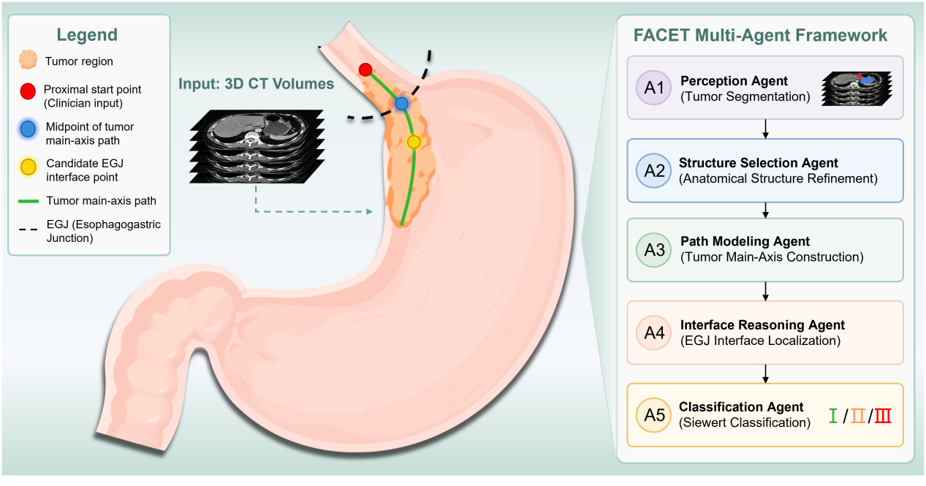
As shown in Fig. 2, the framework begins with the perception agent, which identifies candidate gastric and esophageal tumor regions from CT images. The extracted candidates are subsequently processed by the structure selection agent, which refines and selects anatomically plausible components for downstream analysis, thereby filtering out segmentation noise and resolving ambiguities in complex tumor presentations. The path modeling agent then constructs a mucosal-surface-guided search space, generates the continuous three-dimensional tumor main-axis path, and determines the tumor midpoint. This path provides a quantitative representation of longitudinal tumor extent along the gastric wall and reflects the anatomical orientation considered during endoscopic and surgical evaluation. Subsequently, the interface reasoning agent localizes a representative EGJ interface point through a hierarchical reasoning strategy integrating structural overlap, spatial relationship analysis, and lumen-based anatomical cues.

Structure Selection and Path Modeling
The structure selection agent and path modeling agent, as functional units within FACET, refine candidate structures and construct the tumor main-axis path, forming the quantitative basis for Siewert classification. In contrast to the perception stage, which prioritizes comprehensive candidate generation, this stage explicitly introduces anatomical constraints to ensure structural plausibility and measurement consistency.
Following the initial perception stage, candidate anatomical structures are first processed by the structure selection agent, which applies anatomical constraints to eliminate disconnected or spatially implausible components and to resolve multiple candidate regions generated during automated segmentation. This module performs anatomy-guided structure selection based on spatial continuity and anatomical coherence. A clinician-provided tumor starting point is used as a spatial anchor to identify the proximal tumor region and guide subsequent path exploration. Candidate tumor structures are further evaluated according to their spatial relationship with the anchor region, ensuring selection of anatomically plausible structures for downstream analysis (Supplementary Figure 1).

Using the refined candidates, the path modeling agent constructs a mucosal-surface-constrained search space along the gastric wall, enabling exploration of the tumor’s spatial extent. This constraint restricts the search to anatomically feasible regions, preventing shortcuts through non-physiological paths (e.g., across lumen or outside the organ boundary). A three-dimensional breadth-first search (BFS) algorithm is performed within this search space, starting from a spatial anchor provided by the clinician, to generate the continuous tumor main-axis path (Supplementary Algorithm 1). The system generates a clear path that mirrors the tumor's progression along the gastric wall, providing surgeons with an easily interpretable guide for planning surgical intervention or evaluating tumor resection. The cumulative geodesic path length along this trajectory is computed, and the point situated at half of this length is defined as the tumor midpoint, which serves as a spatial reference for downstream interface reasoning (Supplementary Figure 2). Defining the midpoint along the geodesic path, rather than in Euclidean space, ensures consistency with curved anatomical structures and improves robustness under irregular tumor morphology.
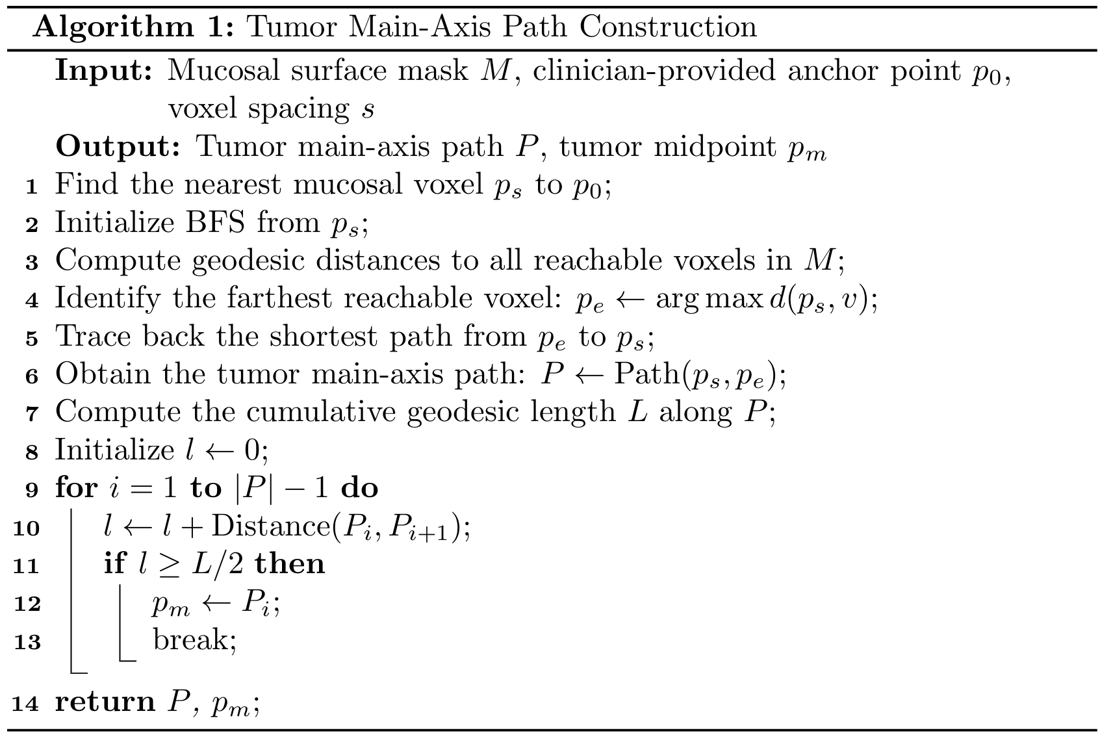
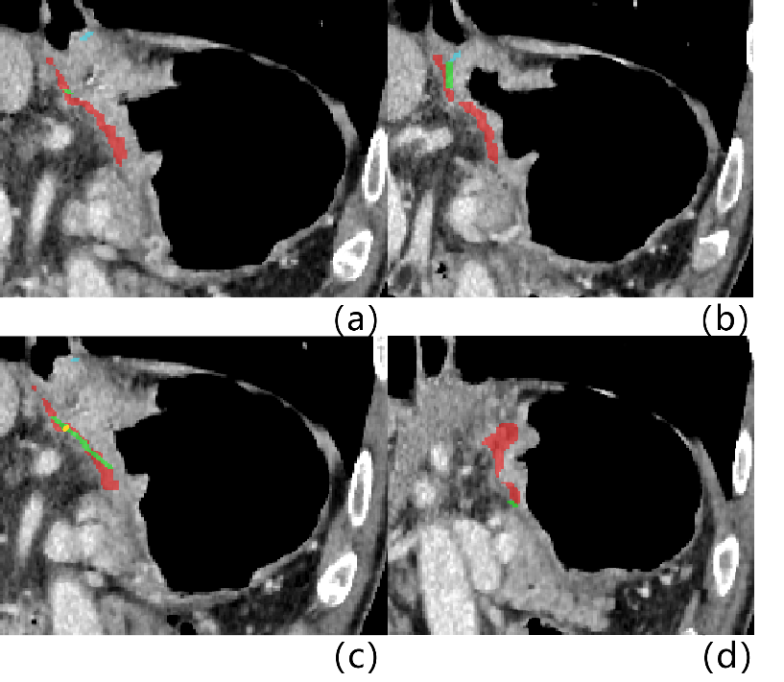
Supplementary Figure 2. Schematic illustration of tumor main-axis path construction and tumor midpoint localization
Note: (a) The blue path represents the straight-line segment from E_{start} to the mucosal-surface connection point E_{m}. Its starting point is the clinician-annotated starting point of the esophageal tumor, E_{start}, and the red region represents the mucosal-surface-constrained search space of the gastric tumor; (b) the intersection of the blue and green paths is E_{m}; (c) the green path represents the mucosal-surface path from E_{m} to E_{end} obtained by searching within the mucosal-surface VOI, and the yellow point indicates the path midpoint; (d) the distal end of the green path is E_{end}, the distal endpoint of the complete tumor main-axis path.

Interface Reasoning and Siewert Classification
The interface reasoning agents and classification module are responsible for localizing the EGJ interface point and determining the Siewert classification based on path-level measurements. Using the refined candidate structures and the tumor main-axis path generated in the preceding stage, the interface reasoning agent localizes a representative EGJ interface point corresponding to the anatomical transition between the esophageal and gastric compartments along the tumor trajectory, while accounting for variable tumor morphology, imaging artifacts, and segmentation uncertainties.
The reasoning process integrates multiple complementary strategies that are organized as an evidence-driven decision hierarchy and automatically orchestrated according to the availability of structural evidence (Supplementary Figure 3):
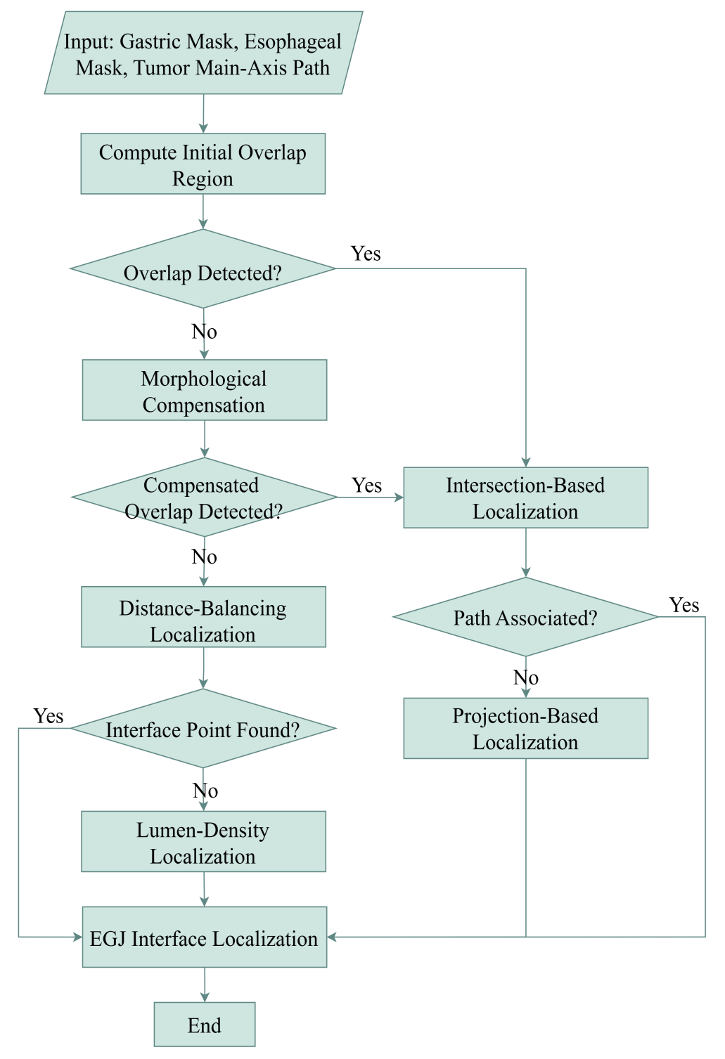
Clinical Software Implementation
To facilitate clinical implementation of the proposed FACET framework, we developed a dedicated CT-based AEG analysis software platform (Fig. 3). The platform integrates volumetric CT visualization, automated tumor segmentation, anatomy-constrained tumor path reconstruction, EGJ interface localization, Siewert classification, three-dimensional rendering, and standardized result export within a unified workflow. Intermediate outputs generated by each functional agent, including tumor masks, the tumor main-axis path, the path-defined tumor midpoint, and the inferred EGJ interface point, can be displayed and interactively reviewed during the analysis process. For cases with complex anatomy, segmentation uncertainty, or ambiguous tumor boundaries, the platform allows optional manual mask refinement and clinician verification, thereby supporting anatomical plausibility, measurement reliability, and traceability of the final classification.
