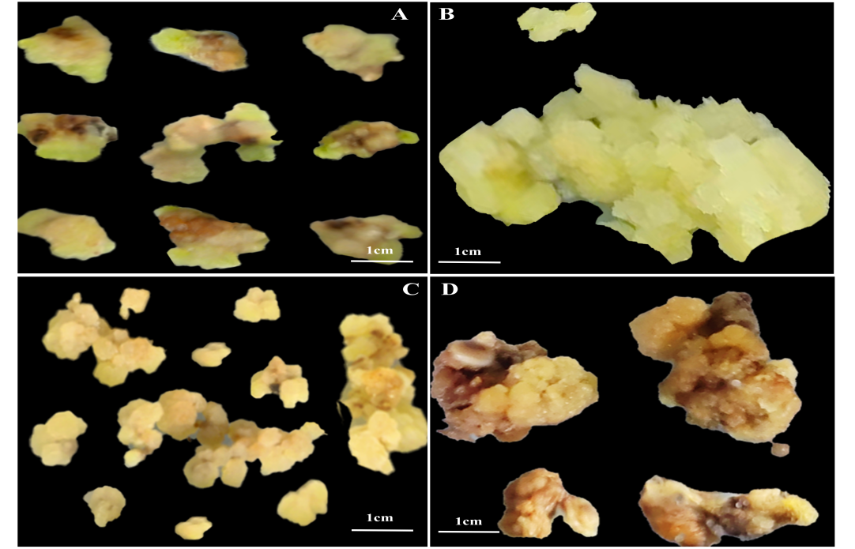
Fig.S1 TDZ and IBA under different concentration combinations for callus growth state. (A) Callus growth status with 2.0 mg·L⁻¹ TDZ and 0.05 mg·L⁻¹ IBA; (B) Callus growth state induced by 2.0 mg·L⁻¹ TDZ and 0.10 mg·L⁻¹ IBA; (C) Callus growth induced by 2.0 mg·L⁻¹ TDZ and 0.15 mg·L⁻¹ IBA; (D) Growth status of callus induction with 2.0 mg·L⁻¹ TDZ and 0.20 mg·L⁻¹ IBA.

