Appendix C
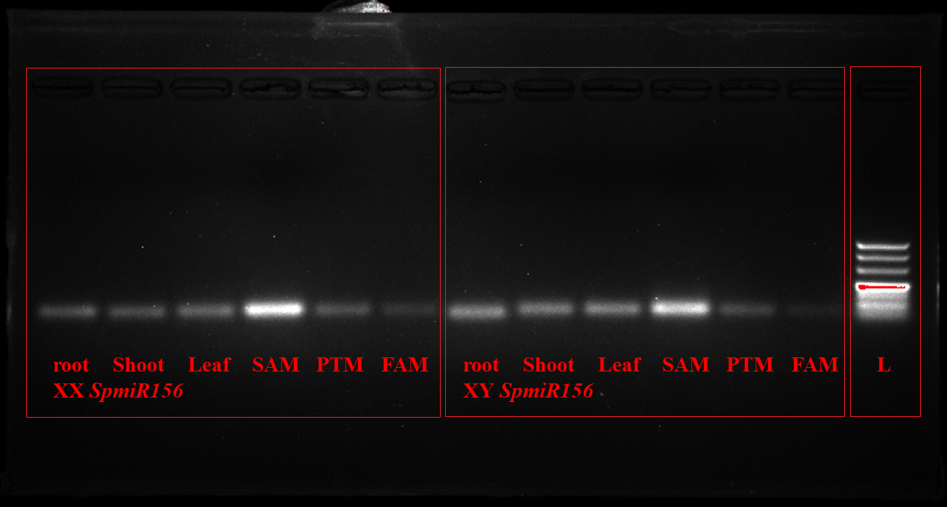
Supplementary Figure 7S (a) Full-length, un-cropped agarose gel (3%) showing end-point PCR products of stem-loop RT-qPCR for SpmiR156. The red rectangle indicates the region of the gel used for Figure 7b in the main manuscript for male and female tissues (root; shoot; leaf; SAM; PTM; FAM) SpmiR156 expression. L: 500 bp ladder.
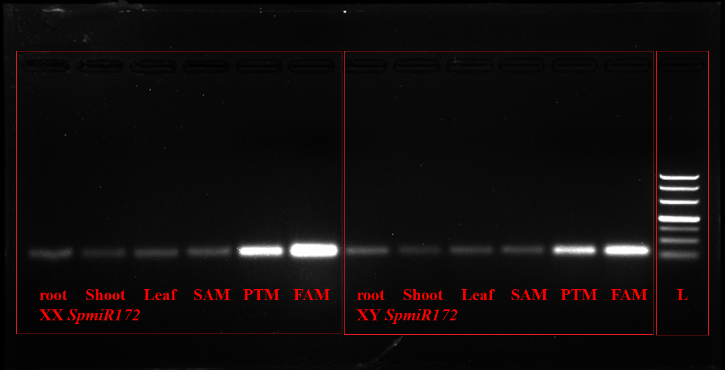
Supplementary Figure 7S (b) Full-length, un-cropped agarose gel (3%) showing end-point PCR products of stem-loop RT-qPCR for SpmiR172. The red rectangle indicates the region of the gel used for Figure 7b in the main manuscript for male and female tissues (root; shoot; leaf; SAM; PTM; FAM) SpmiR172 expression. L: 500 bp ladder.
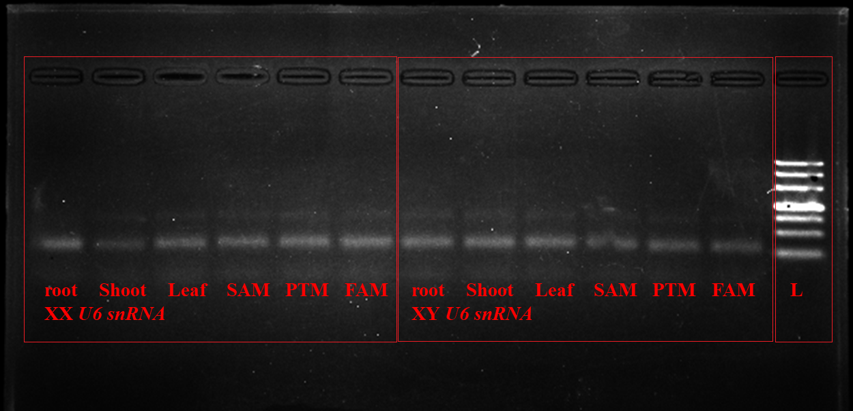
Supplementary Figure 7S (c) Full-length, un-cropped agarose gel (3%) showing end-point PCR products of stem-loop RT-qPCR for U6 snRNA. The red rectangle indicates the region of the gel used for U6 snRNA expression in the main manuscript for male and female tissues (root; shoot; leaf; SAM; PTM; FAM). L: 500 bp ladder.

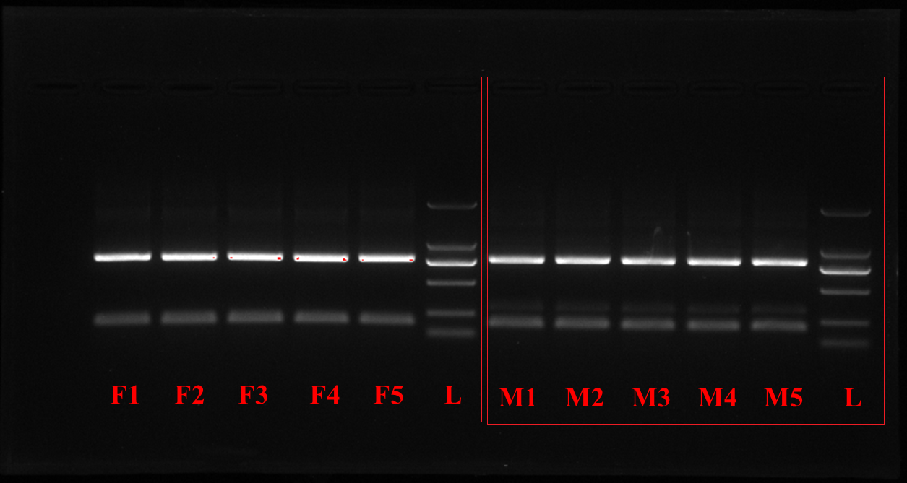
Supplementary Figure S1 (a) Full-length, uncropped agarose gel (1.5%) showing PCR amplification products of the X-linked SpSpoX molecular marker (F1 to F5) and Y-linked SpT11A marker (M1 to M5). L: 2000 bp ladder; F1–F5, female biological replicates; M1–M5, male biological replicates. The red rectangle indicates the region used for Figure S1.

