Supplemental Information for

Sinking particle fluxes and nitrogen loss in the eastern tropical North Pacific oxygen deficient zone measured using incubating sediment traps
Duffy, Megan E.¹
Fuchsman, Clara A.²
Palevsky, Hilary I.³
Neibauer, Jacquelyn A.⁴
Ruef, Wendi⁴
Rocap, Gabrielle⁴
Devol, Allan H.⁴
Keil, Richard G.⁴

- University of Vermont, Rubenstein School of Environment and Natural Resources, Burlington, VT, USA
- University of Maryland Center for Environmental Science, Horn Point Laboratory, Cambridge, MD, USA
- Boston College, Department of Earth and Environmental Sciences, Chestnut Hill, MA, USA
- University of Washington, School of Oceanography, Seattle, WA, USA

Contents of this file:

Figure S1. CTD depth profiles
Figure S2. N-deficit, NO₃⁻, and NO₂⁻ depth profiles
Figure S3. Station mixed layers
Figure S4. Sinking POC flux vs NPP linear regression fitting
Figure S5. Unadjusted in situ N₂ production rates
Figure S6. Beam transmittance profiles
Supplemental Methods and Figures S7-S9, additional information on incubations
Figure S10. Additional sediment trap-incubator design information
Figure S11. Trap-incubator EXO sensor deployment data
Figure S12. N₂ production rate adjustment conceptual diagram
Table S2. Results from replicate sediment trap-incubator deployments

Additional Supporting Materials not in this file:

Supplemental Table 1 (Excel file), all sediment trap deployment data
Supplemental Table 3 (Excel file), oxygen deficient zone POC flux literature comparison
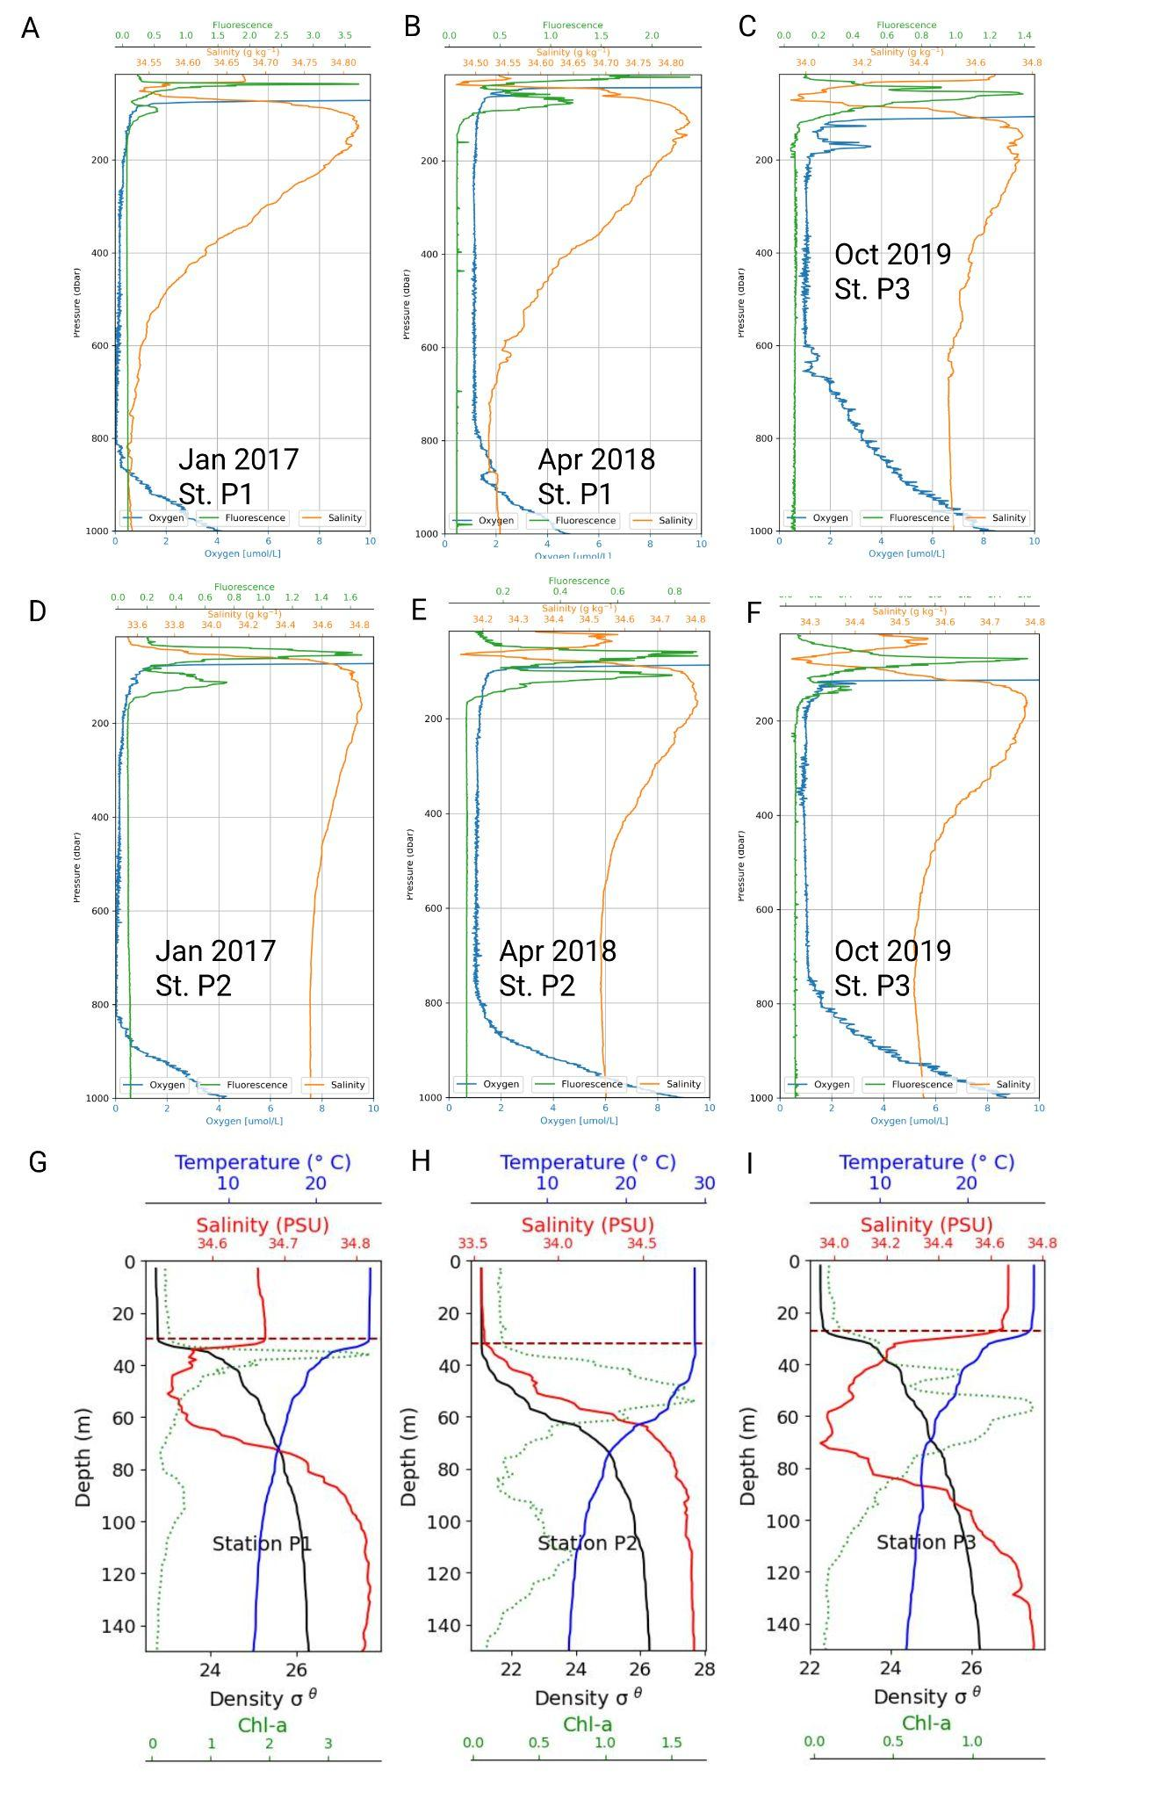

Figure S1. CTD profiles: Depth profiles of chlorophyll-a fluorescence (green), salinity (orange), and dissolved oxygen (blue) for eastern tropical North Pacific (ETNP) oxygen deficient zone (ODZ) slope Station P1 (A-B), northern Station P3 (C), and offshore Station P2 (D-F) in January 2017, April 2018, and October 2019. The upper oxygen deficient zone profiles (0-150 m depth) are shown with the mixed layer depth indicated (dashed orange lines) for slope Station P1 in 2017 (G), offshore Station P2 in 2017 (H), and northern Station P3 in 2019 (I).

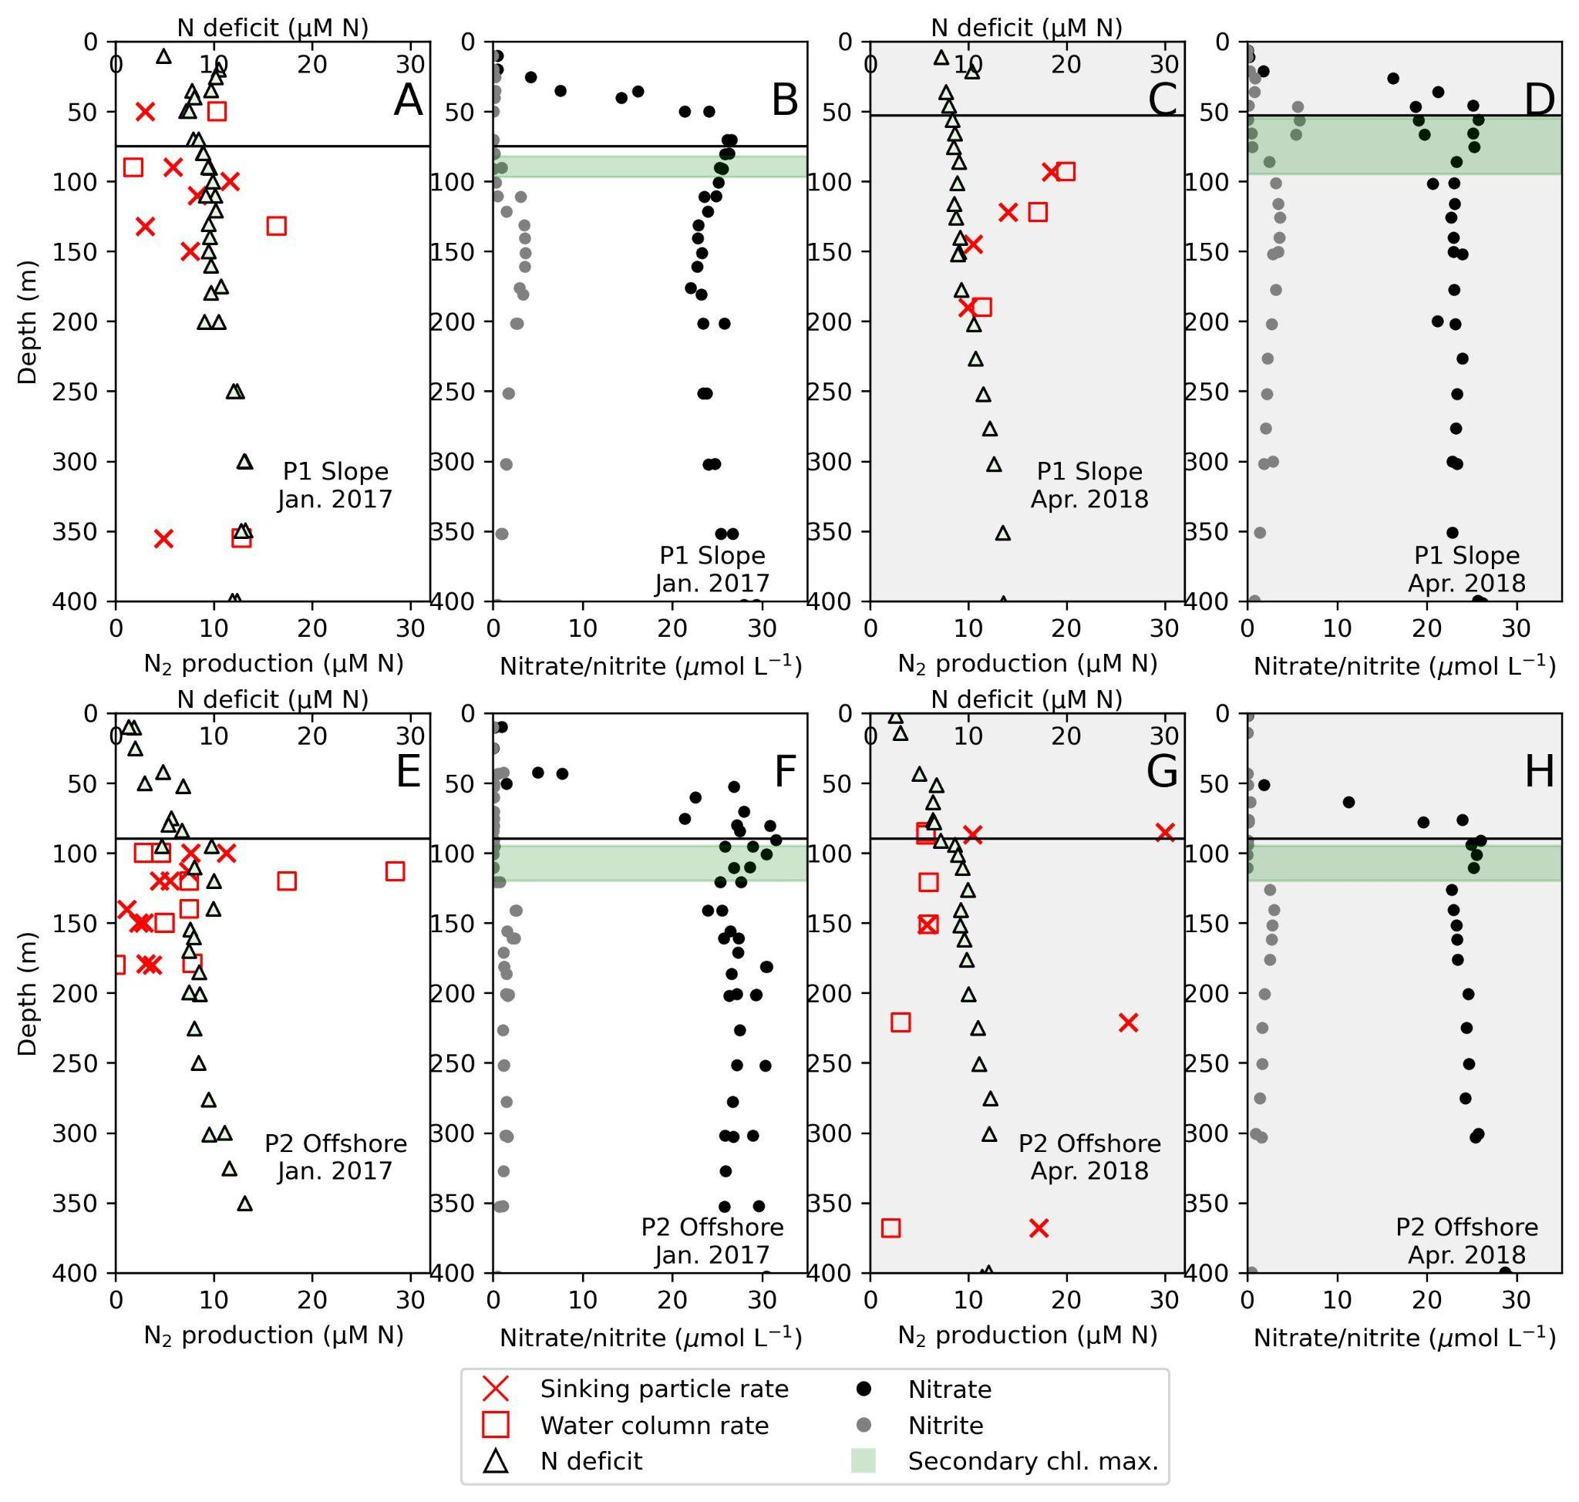Figure S2. N-deficit (black triangles), N₂ production rates in the water column (red squares) and due to sinking particles (red crosses), nitrate (black circles) and nitrite (grey circles) profiles for eastern tropical North Pacific (ETNP) oxygen deficient zone (ODZ) slope Station P1 in January 2017 (A-B) and April 2018 (C-D); offshore Station P2 in January 2017 (E-F) and April 2018 (G-H). The approximate onset depth of anoxia is with a black horizontal line in each plot. The approximate secondary chlorophyll maximum (SCM) depth range for each station is shown in green shading.

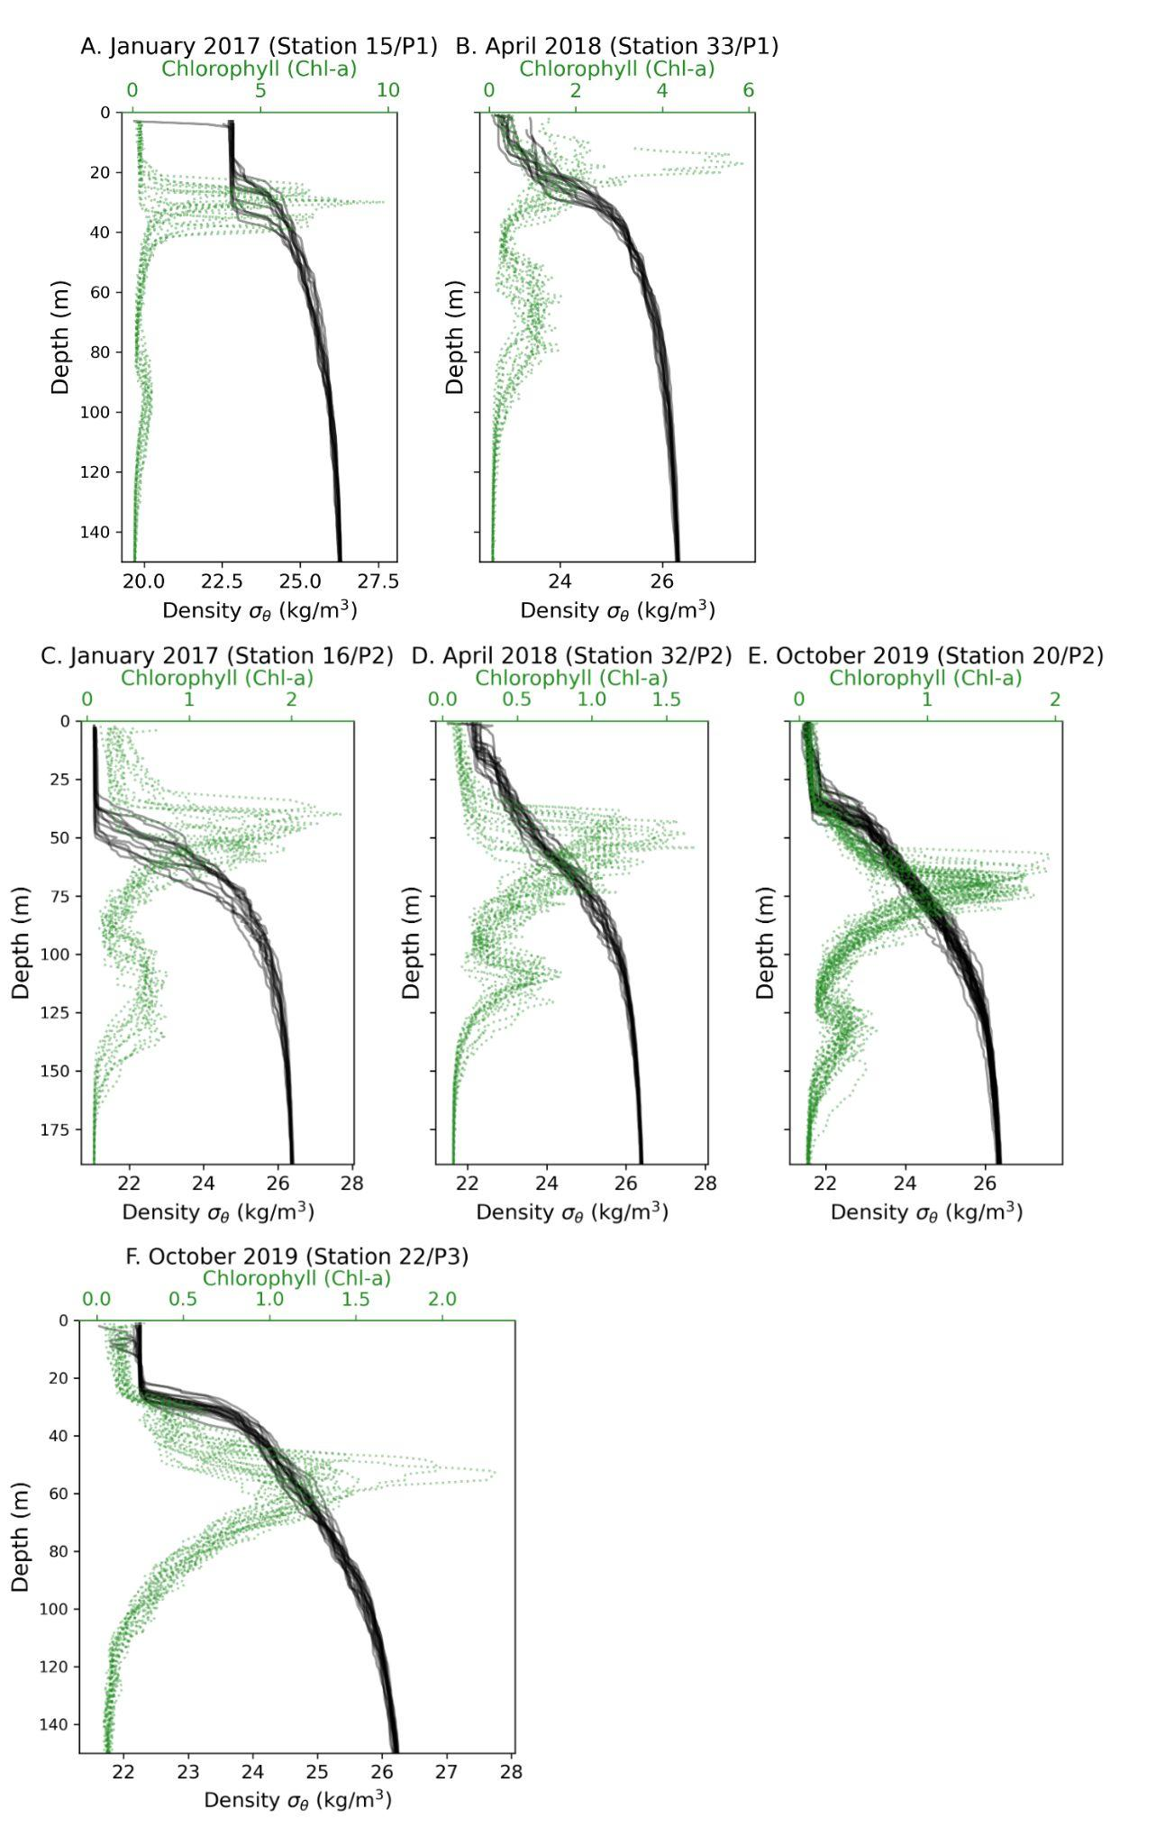
Figure S3. Density and chlorophyll-a fluorescence at eastern tropical North Pacific (ETNP) oxygen deficient zone (ODZ) Stations P1, P2, and P3 in January 2017, April 2018, and October 2019. All station casts combined for station occupations lasting 5-10 days.
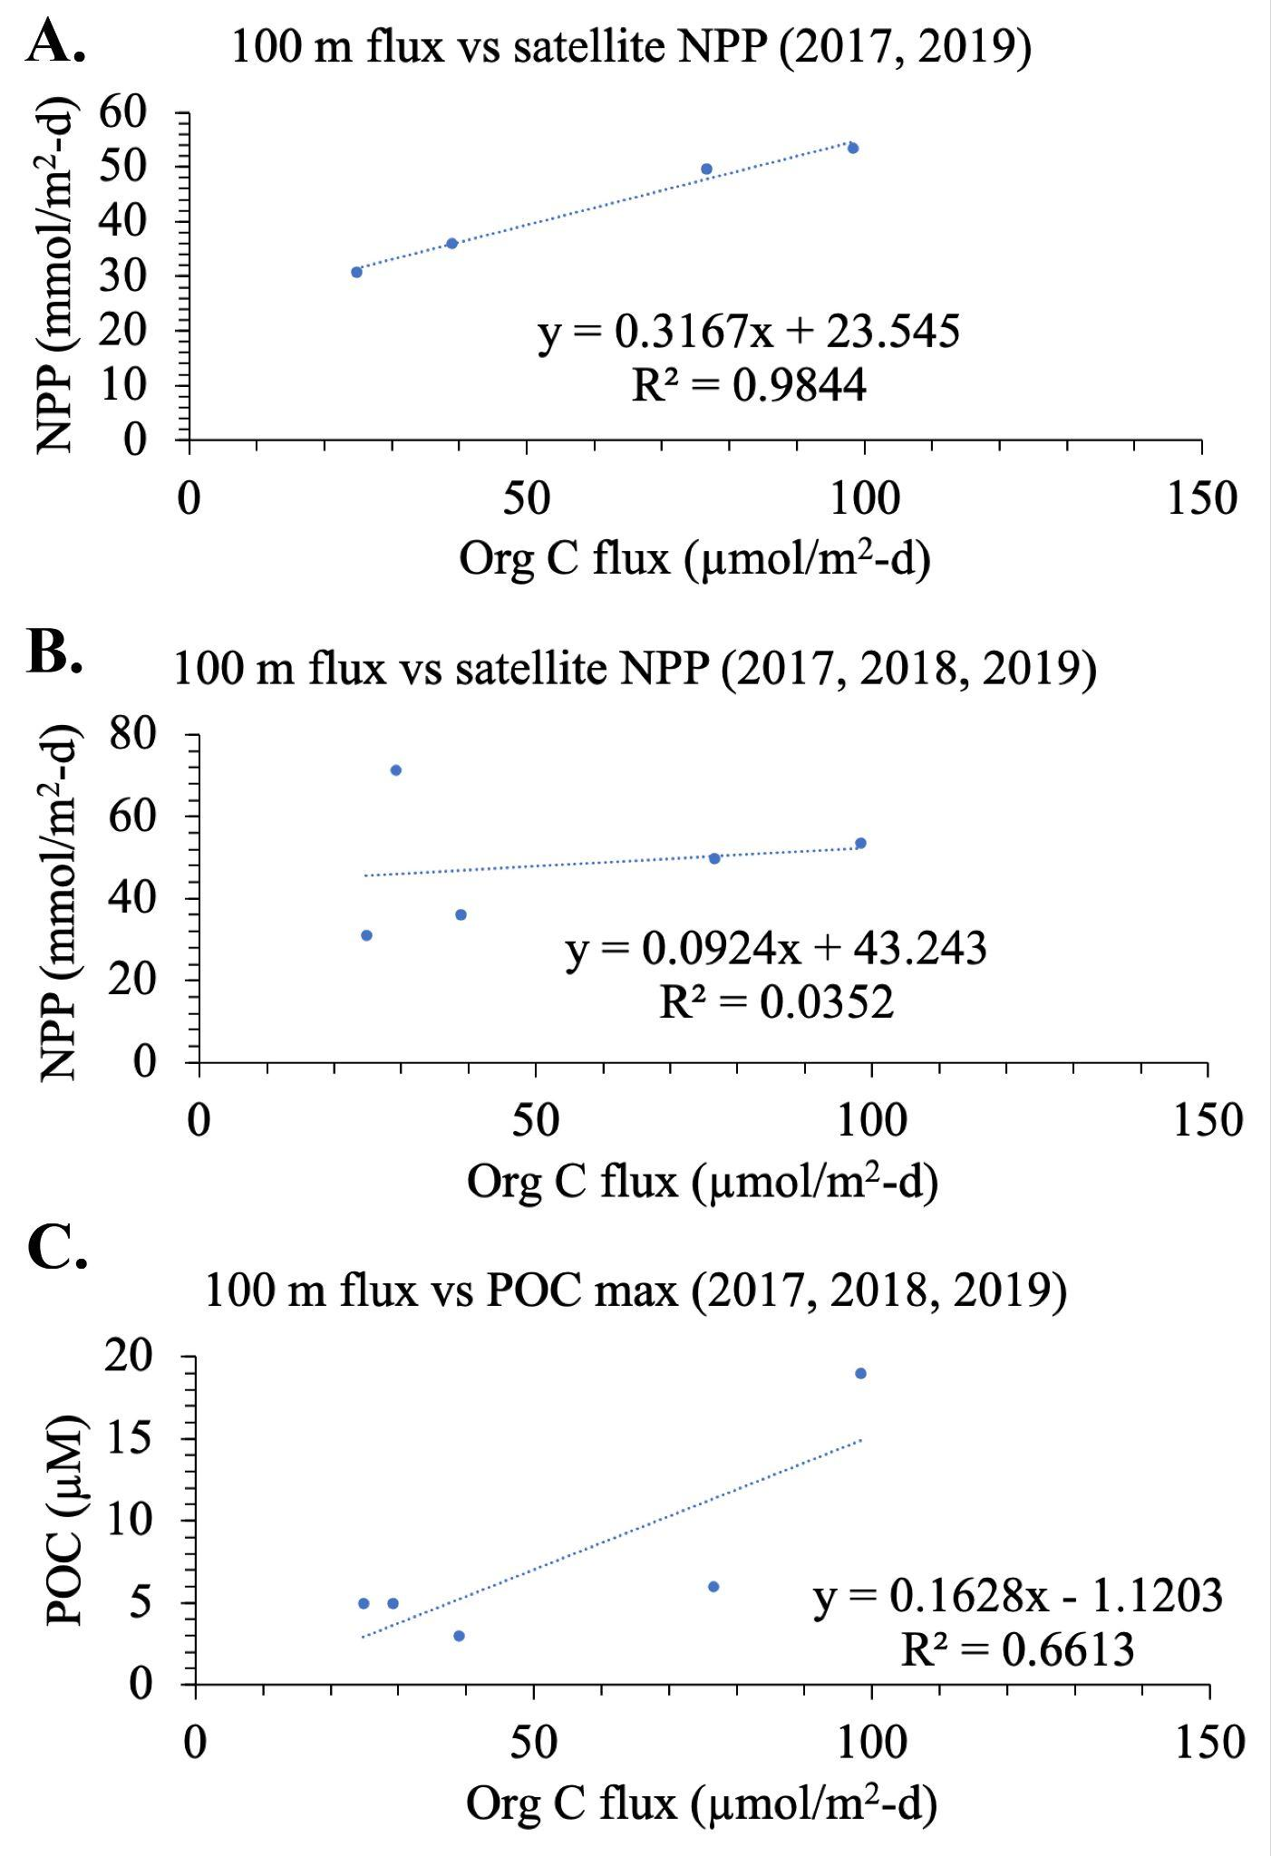
Figure S4. Regressions between sinking particulate organic C (POC) flux and (A) satellite-derived net primary productivity (NPP) rate at eastern tropical North Pacific (ETNP) oxygen deficient zone (ODZ) slope Station P1 in January 2017 and October 2019; (B) the same dataset as (A) but including sinking POC flux vs NPP rate from April 2018 at St P1; and C) suspended POC concentrations from January 2017, April 2018, and October 2019 at St P1.
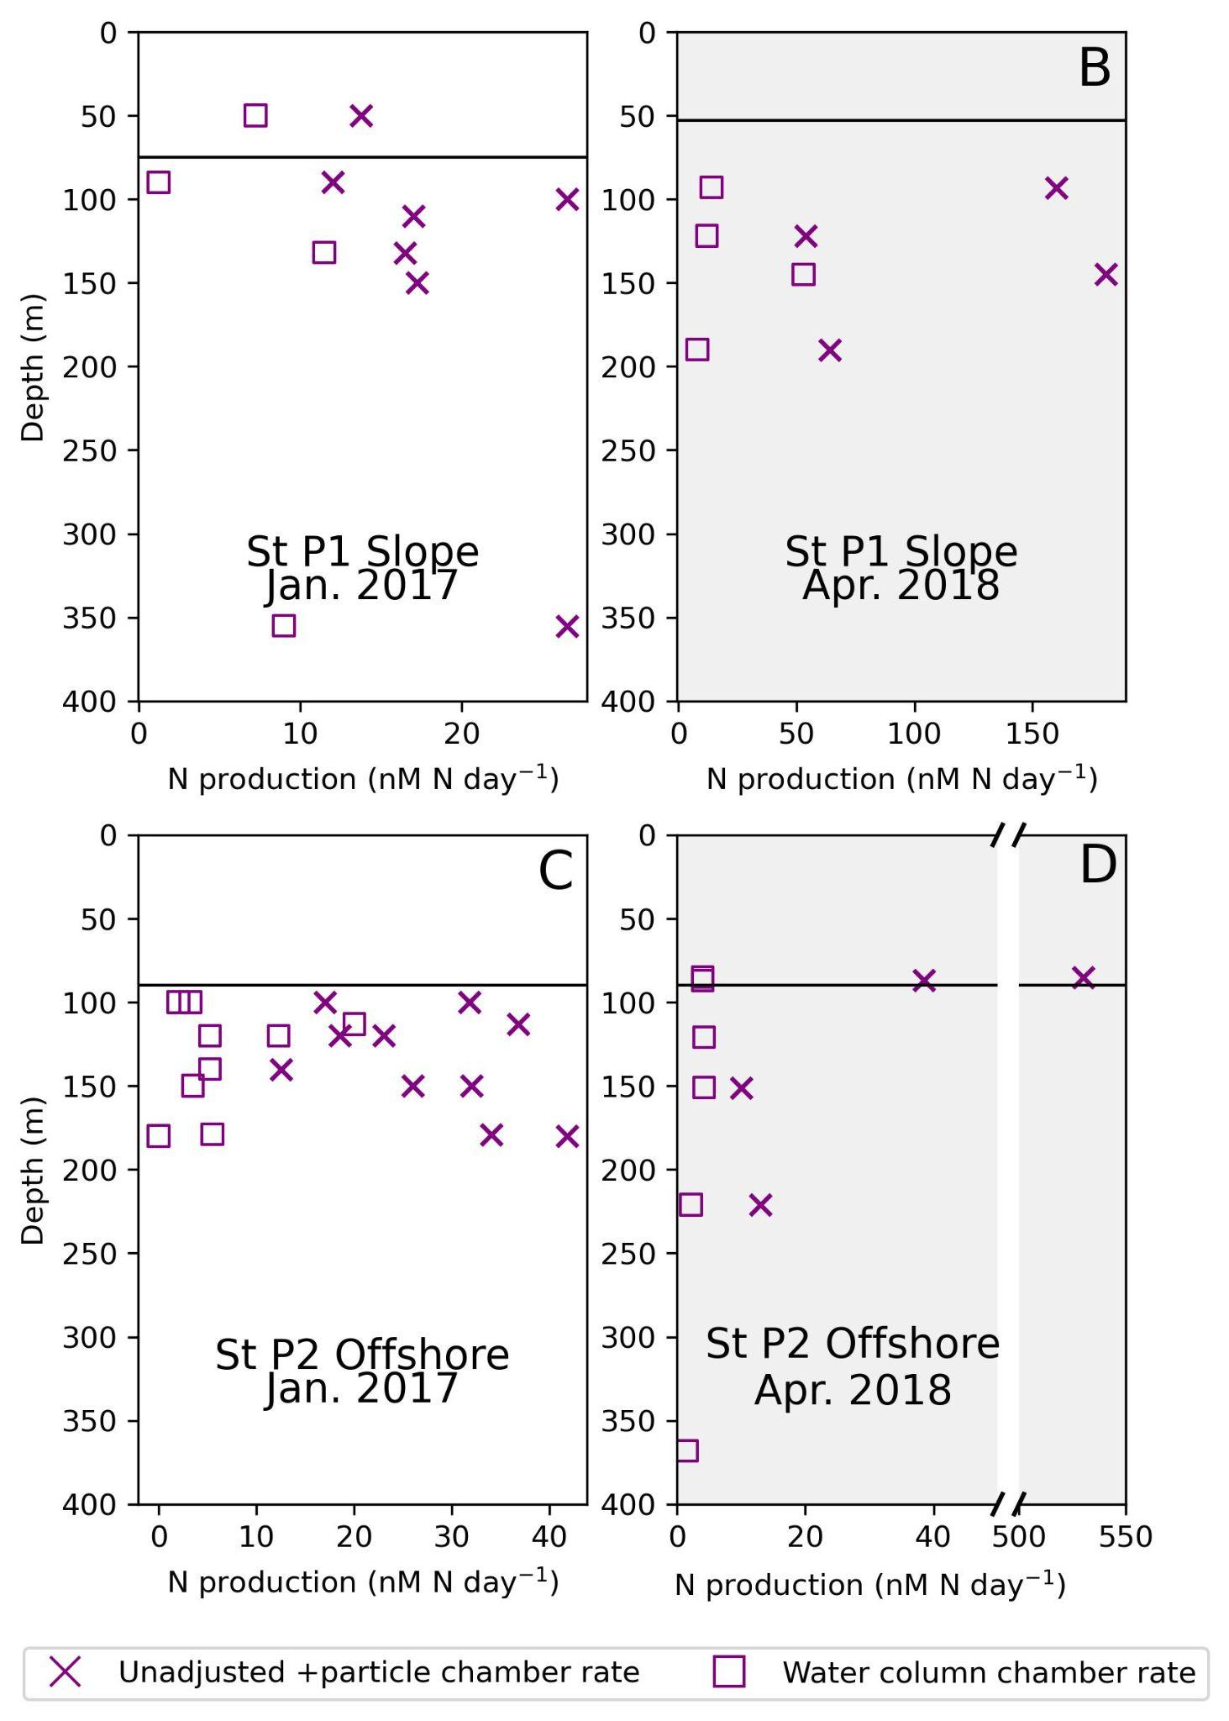
Figure S5. Unadjusted rates of N₂ production as measured in situ incubations in +particle chamber (concentrated sinking particles) and water column chambers in the eastern tropical North Pacific (ETNP) oxygen deficient zone (ODZ) at slope station P1 in January 2017 (A) and April 2018 (B) and offshore St P2 in 2017 (C) and 2018 (D). Horizontal black lines denote the onset of anoxia.
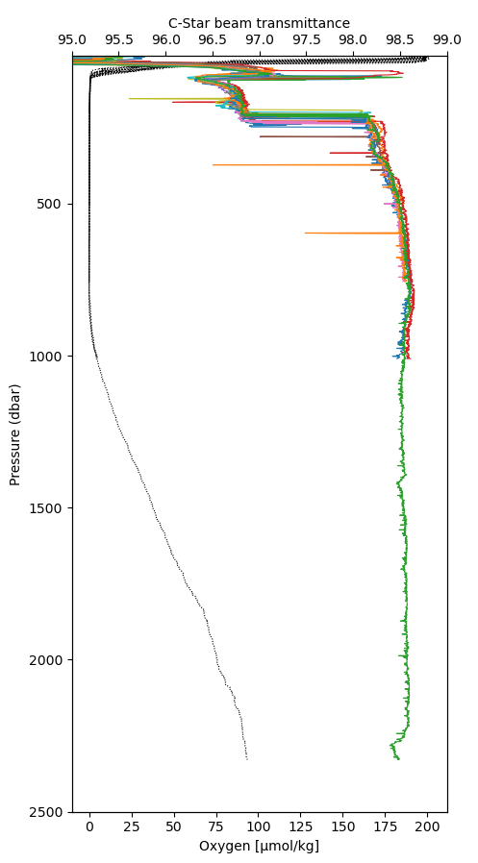
Figure S6. Beam transmittance (C-Star Beam Transmissometer, Seabird) from all CTD casts at eastern tropical North Pacific (ETNP) oxygen deficient zone (ODZ) slope Station P1 in January 2017 shown as colored lines. Black lines show O₂ profiles. The beam transmissometer was not functional for the 2018 expedition.
Supplemental Discussion

The purpose of this supplemental discussion section is to compare incubations using ¹⁵N-NH₄⁺ to those using ¹⁵N-NO₂⁻. In July of 2013, in situ trap incubators were deployed from the RV Nathaniel B. Palmer in the Eastern Tropical South Pacific Oxygen Deficient Zone (ETSP ODZ) at two stations: BB1 (14.00°S 81.20°W) and BB2 (20.54°S 20.71°W). For ¹⁵N-NH₄⁺ incubations, the concentration of labeled ammonium in the incubation was 10 µM and for ¹⁵N-NO₂⁻ incubations, ¹⁵N-NO₂⁻ in the incubation was 15 µM. The in situ trap incubators used were net traps, similar to those described in the main text. The incubation set up was the same, but the sinking material collected above the incubation chamber during the incubation had no closing mechanism for the end of the deployment. Additionally, the nets were washed into the collector. That means that material that could be used for sinking flux calculations included both what fell into the trap and what was attached to and filtered by the net, while incubations only included organic matter that fell into the trap. Therefore, we do not use this flux information to modify our particle rate calculations and show raw rates here.
¹⁵N-NH₄⁺ was used during two trap deployments: 235 m at BB1 and 160 m at BB2. The majority of ¹⁵N-NO₂⁻ experiments were performed at BB2, except for one deployment at 155 m at BB1. ¹⁵N-NH₄⁺ addition did not stimulate N₂ production in particles (Figure 1). However, ¹⁵N-NO₂⁻ indicated high N₂ production rates on particles (Figure 2). A comparison ¹⁵N-NH₄⁺ addition at 160 m at BB2 and ¹⁵N-NO₂⁻ addition at 155 m at BB1 indicates that N₂ producers on particles were using nitrite and not ammonium (Figure 1, 2). We believe that these data indicate that the N₂ production on particles was mediated by denitrifiers not anammox bacteria. This conclusion is also consistent with microbial data that indicates that denitrifiers are enriched in particles and anammox bacteria are enriched in the water column (Fuchsman et al., 2012, 2017; Ganesh et al., 2014). The data from this 2013 cruise informed our decision to only use ¹⁵N-NO₂⁻ in the 2017 and 2018 ETNP cruises.
Additionally, we can compare our in situ rates to shipboard rates measured at the same cruise and station (Babbin et al., 2020). The water column in situ incubations with nitrite were consistently higher than those from shipboard experiments. This is likely due to the fact that medium and large particles sink below the nozzle of Niskin bottles (Gardner, 1977; Suter et al., 2017; Fuchsman and Cram, 2025) and so would not be included in rate measurements where water was obtained from Niskin bottles.

References
Babbin, A.R., Buchwald, C., Morel, F.M.M., Wankel, S.D., and Ward, B.B. (2020) Nitrite oxidation exceeds reduction and fixed nitrogen loss in anoxic Pacific waters. Mar Chem 224: 103814.
Fuchsman, C.A. and Cram, J.A. (2025) Zooplankton and Picocyanobacteria Contribute Characteristic Size Ranges of Organic Particles to Different Layers of the Anoxic Water Column. Global Biogeochem Cycles 39: e2024GB008397.
Fuchsman, C.A., Devol, A.H., Saunders, J.K., McKay, C., and Rocap, G. (2017) Niche Partitioning of the N cycling microbial community of an offshore Oxygen Deficient Zone. Front Microbiol 8: 2384.
Fuchsman, C.A., Staley, J.T., Oakley, B.B., Kirkpatrick, J.B., and Murray, J.W. (2012) Free-living and aggregate-associated Planctomycetes in the Black Sea. FEMS Microbiol Ecol 80: 402–416.
Ganesh, S., Parris, D.J., DeLong, E.F., and Stewart, F.J. (2014) Metagenomic analysis of size-fractionated picoplankton in a marine oxygen minimum zone. ISME J 8: 187–211.
Gardner, W.D. (1977) Incomplete extraction of rapidly settling particles from water samplers. Limnol Oceanogr 22: 764–768.
Suter, E.A., Scranton, M.I., Chow, S., Stinton, D., Medina Faull, L., and Taylor, G.T. (2017) Niskin bottle sample collection aliases microbial community composition and biogeochemical interpretation. Limnol Oceanogr 62: 606–617.

Figures
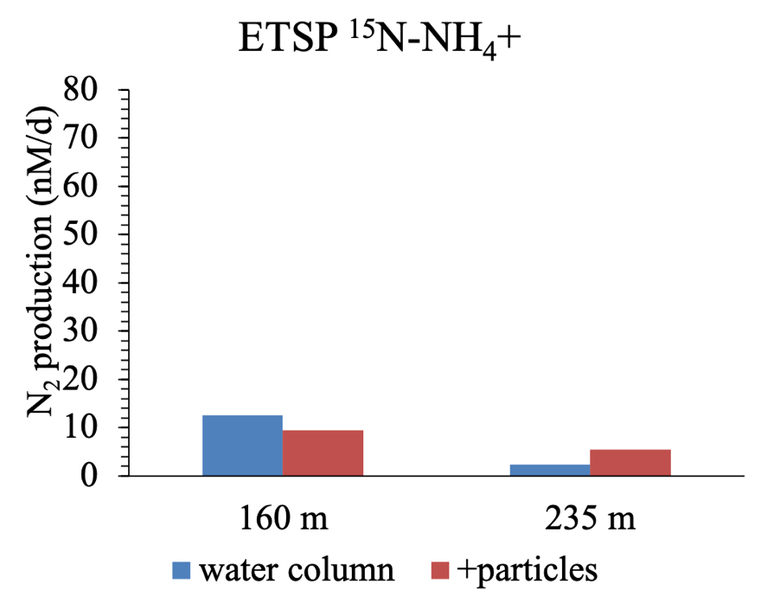
Figure S7. ETSP N₂ production rates from ¹⁵N-NH₄⁺ experiments.

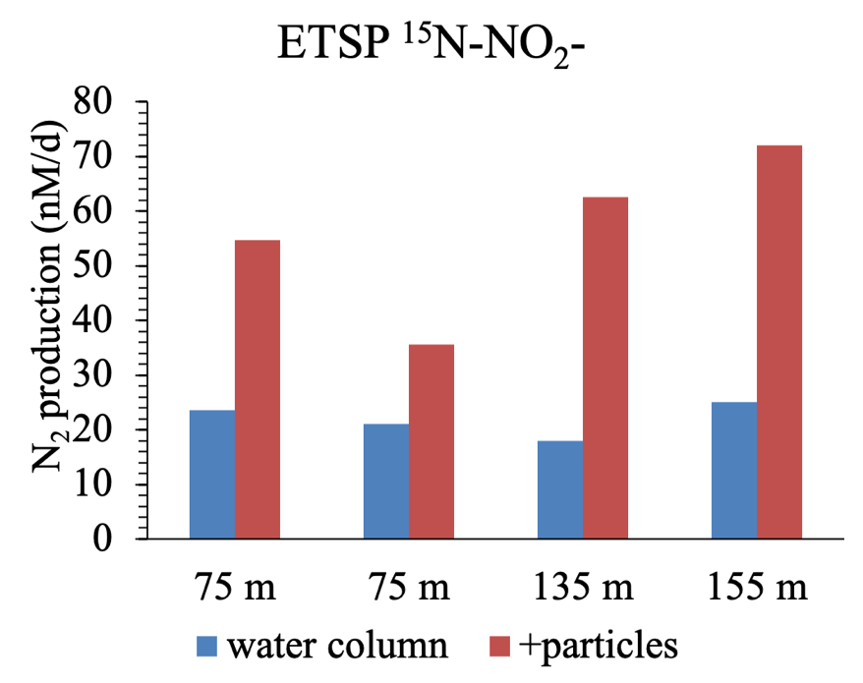
Figure S8. ETSP N₂ production rates from ¹⁵N-NO₂⁻ experiments.

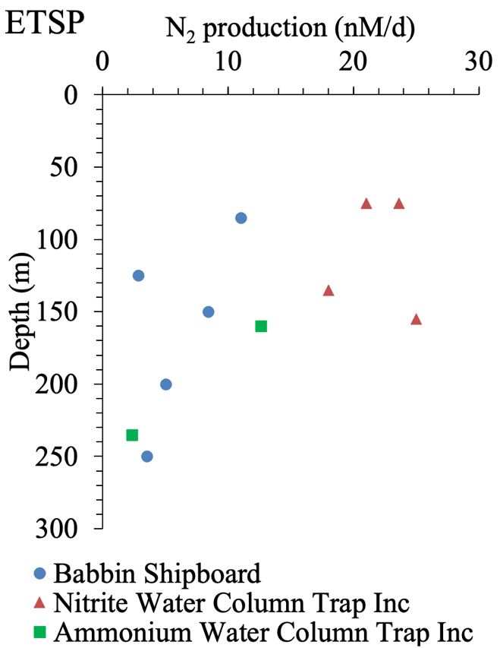

Figure S9. Comparison of shipboard water column rate experiments from station BB2 (Babbin et al., 2020) and water column in situ trap incubation data.

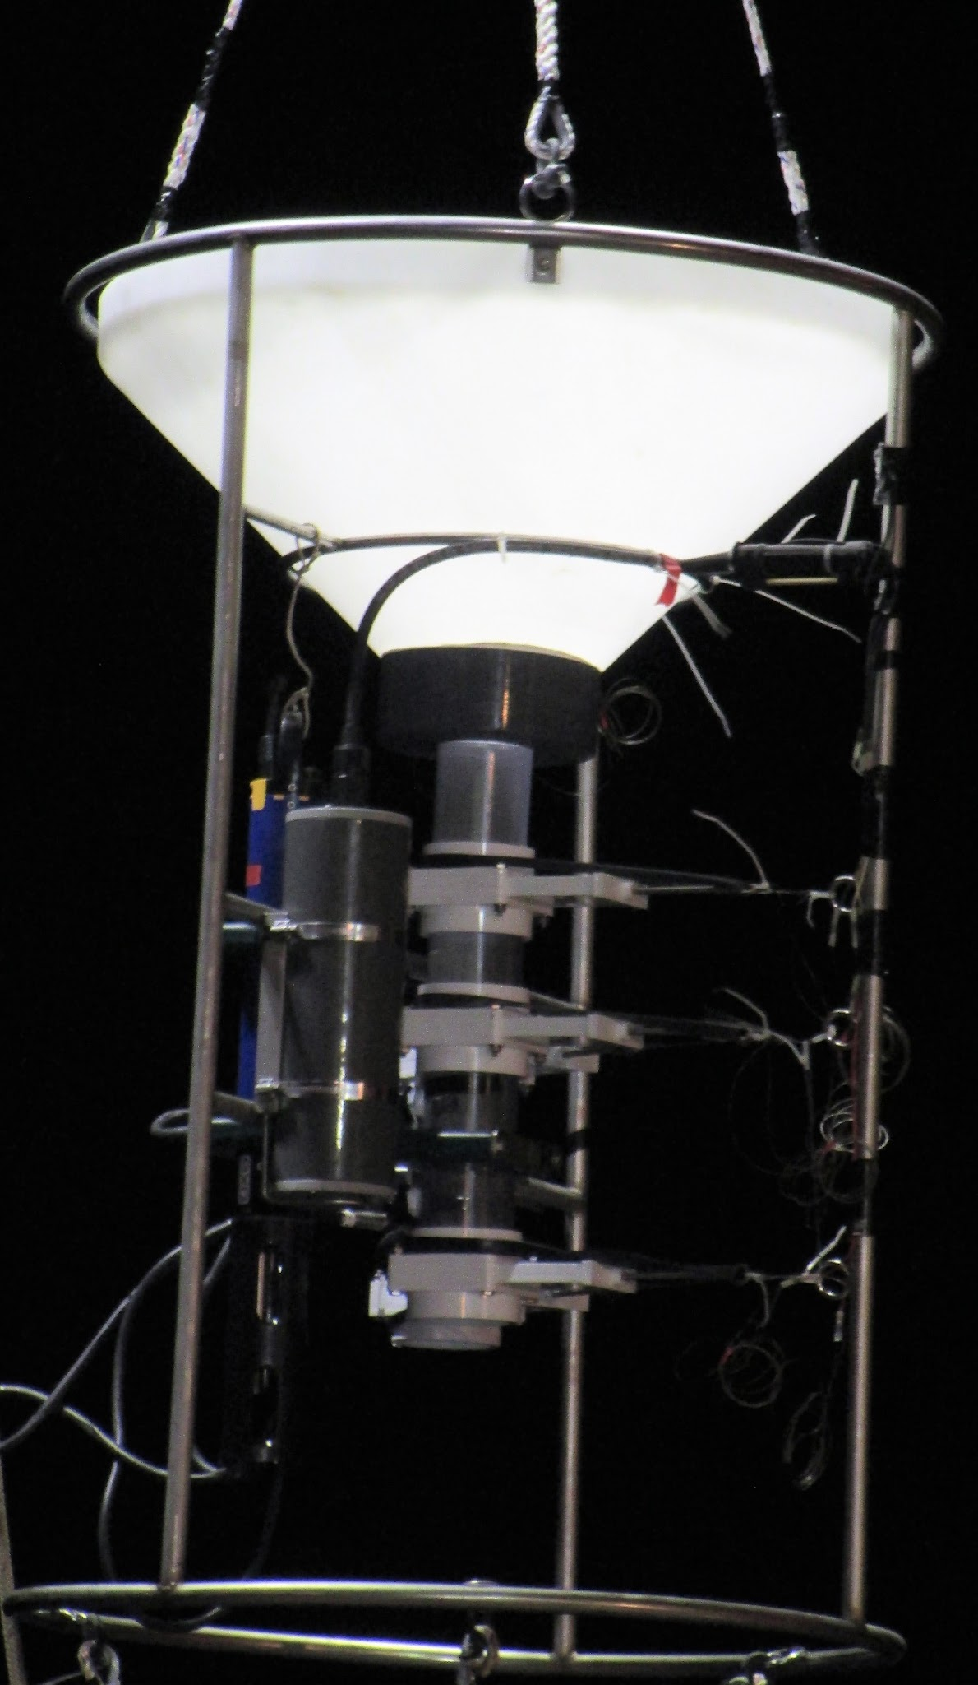
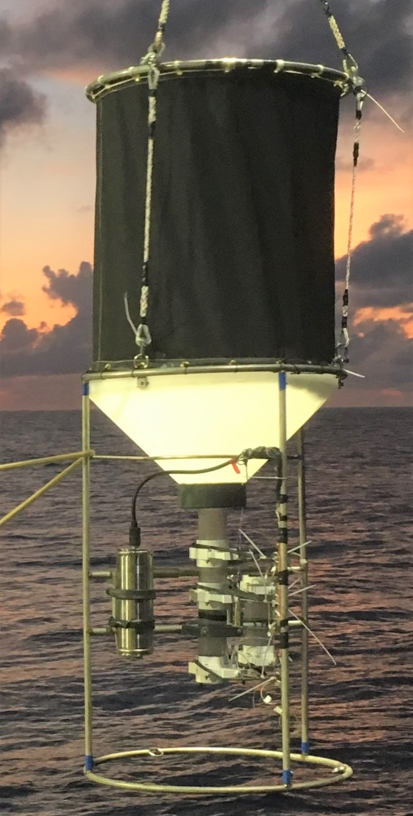
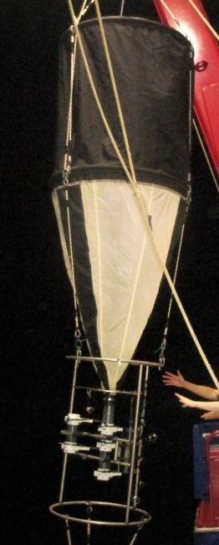
- Cone trap (Gen 4) B. Net trap (Gen 5) C. Net-cone hybrid trap (Gen 6)

Figure S10. Design evolution of sediment trap-in situ incubation systems and deployment history. One reason for the trap design progression from the cone and net traps (2017 and 2018 ETNP campaigns) to the hybrid and net traps (2019 ETNP campaign) was to increase the aspect ratio, adding 36’’ to the original cone trap’s design length. The trap aspect ratio, A = H/D where H is the trap height and D is the inside diameter of the trap mouth. The plastic cone trap (A): in the cone trap (Gen 4) design, particles are caught in a sampling funnel cone constructed from a 60 gallon polyethylene inductor tank, purchased from tankdepot.com (Norwesco 31 Inch Long 60 Gallon 45 Degree Plastic Cone Bottom Inductor Tank in White, Part number N-62205; Manufacturer Part 62205). In the trap design, the original tank is trimmed so that only 3’’ of the vertical side wall remains. The length of the angled funnel (perpendicular to the opening) is 13’’. An attachment collar is machined to allow for a smooth connection between the funnel opening and the +particles experimental chamber, adding 2’' for a total funnel length of 18’’. The cone trap aspect ratio is 0.58. The mesh net trap (B): the net trap (Gen 5) is sewn in house to make a black canvas cylinder (1.25 m length, 1.25 m width) that attaches a funnel made of 0.53 um white mesh netting (1.9 m length) with a collar that attaches to the +particles chamber with clamps. The net trap has an aspect ratio of 2.5. The hybrid cone-funnel extension trap (C): in the latest cone-net hybrid trap design (Gen 6), a canvas cylinder (30” diameter, 36” height), with grommet holes at the top and bottom, is coupled loosely to the top of the sampling funnel cone (13’’ length with 2’’ attachment collar as in Gen 4) using bungee cord tied in continuous half-hitch knots around the top ring of the incubator frame. A separate stainless steel ring supports the top of the canvas extension, also tied with bungee cord through the grommet holes and around the ring. There is a small gap at the base of the canvas/top of the funnel that allows water to flow out during trap recovery. There are three polydac sidelines that attach to the top stainless ring and the top of the incubator frame. These sidelines support the weight of the incubator frame, so the canvas is not weight-bearing. The canvas cylinder serves to concentrate particles into the funnel cone, where they can settle into the +particles incubation chamber. Such an extension allows for the increased particle concentration ability of a net with a higher aspect ratio, without the fragility of the mesh that exists on a typical net trap. The aspect ratio of the hybrid trap is 1.7.

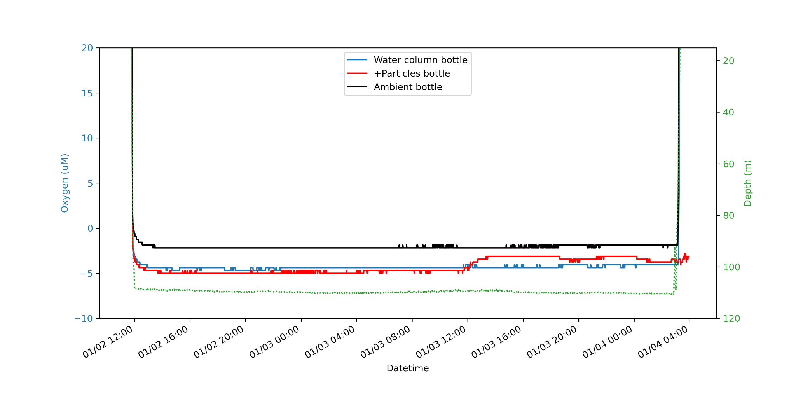
Figure S11. Example trap-incubator system deployment to 100 m depth at slope Station P1 in the eastern tropical North Pacific (ETNP) oxygen deficient zone (ODZ) in January 2017. Plotted for the system deployment are ambient, water column incubation chamber, and particle collection/incubation chamber (+P) O₂ data from YSI EXO² optical oxygen sensors. The O₂ sensors were at their detection limit, and their relative values during the deployment did not indicate contamination from air bubbles during the collection and incubation periods within the ODZ.
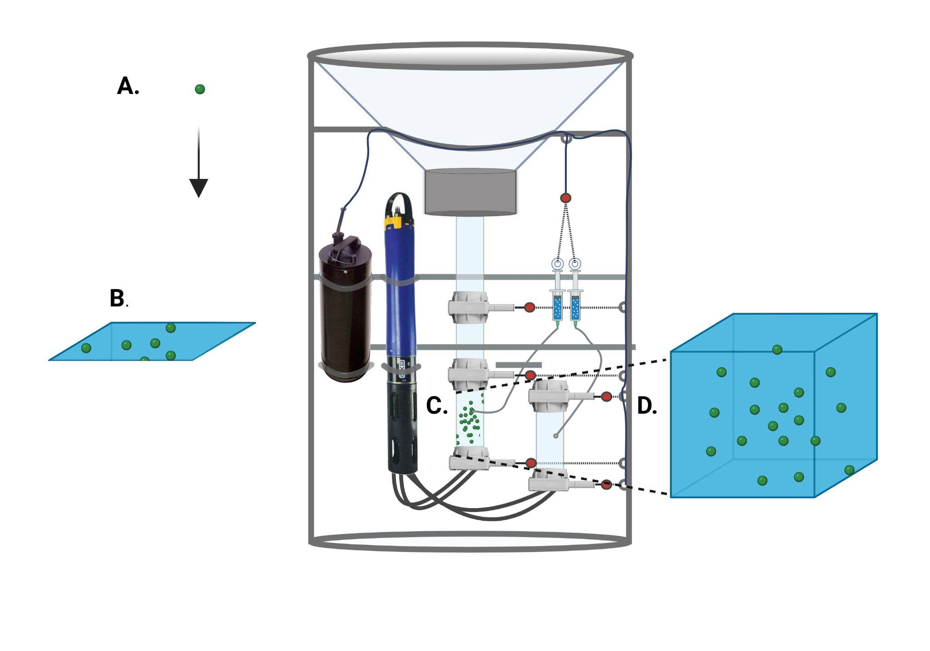
Figure S12. N₂ production rate adjustment to account for particle concentration in sediment trap-incubators. In our schema, we use (A) P_{sinking} , the particle sinking rate (m day⁻¹); (B) P_{flux} , the sinking particle flux ($μ$mol C m⁻² day⁻¹); (C) OC_{+P} , the mass concentration of organic carbon in +particles chamber of the incubator ($μ$mol C m⁻³); and (D) OC_{sinking particles} , the mass concentration of organic carbon in sinking particles in the water column (𝜇mol C m⁻³), derived from P_{flux}/P_{sinking} , to arrive at F_{conc} , the particle concentration factor and thus adjust NP_{+P} , the unadjusted rate of N₂ production in +particles chamber with concentrated sinking particles (nmol N day⁻¹) to arrive at NP_{sinking particles} , the adjusted rate of N₂ production in the water column due to sinking particles (nmol N day⁻¹). The basic calculations are thus:
P_{flux} $÷$ P_{sinking} = OC_{sinking particles} ; OC_{sinking particles} $÷$ OC_{+P} = F_{conc}; and NP_{+P} $×$ F_{conc} = NP_{sinking particles}. For example, for the incubation at 100 m St P2 2017 (2-17_100m): 115.67 𝜇mol C m⁻² day⁻¹ $÷$ 8.45 m day⁻¹ = 13.68 𝜇mol C m⁻³; 13.68 $μ$mol C m⁻³ $÷$ 75.75 $μ$mol C m⁻³ = 0.180; and 31.8 nmol N day⁻¹ $×$ 0.180 = 5.7 nmol N day⁻¹.

Supplementary Table 2. Results of sinking particle collection and incubations at duplicate depths at offshore Station P2 in January 2017.

Date | Station | Depth | Trap type | +particles collection time (hr) | Incubation time (hrs) | Particle flux (umol C/m2 day) | N₂ production rate (nM/day) | Adjusted N₂ production rate (nM/day)
01/09/17 | P2 | 100 | cone | 12 | 24 | 37.58 | 15 | 6.99
01/11/17 | P2 | 100 | cone | 12 | 23 | 115.68 | 29 | 8.8
01/13/17 | P2 | 119 | cone | 27 | 27 | 120 m flux used | 21 | 3.54
01/11/17 | P2 | 120 | cone | 12 | 23 | 165.80 | 16 | 2.69
01/09/17 | P2 | 150 | net | 12 | 24 | 2nd 150 m flux used | 30 | 1.89
01/11/17 | P2 | 150 | net | 12 | 23 | 22.80 | 24 | 1.51
01/09/17 | P2 | 179 | net | 12 | 23 | 180 m flux used | 31 | 1.95
01/11/17 | P2 | 180 | net | 12 | 24 | 86.97 | 39 | 2.46

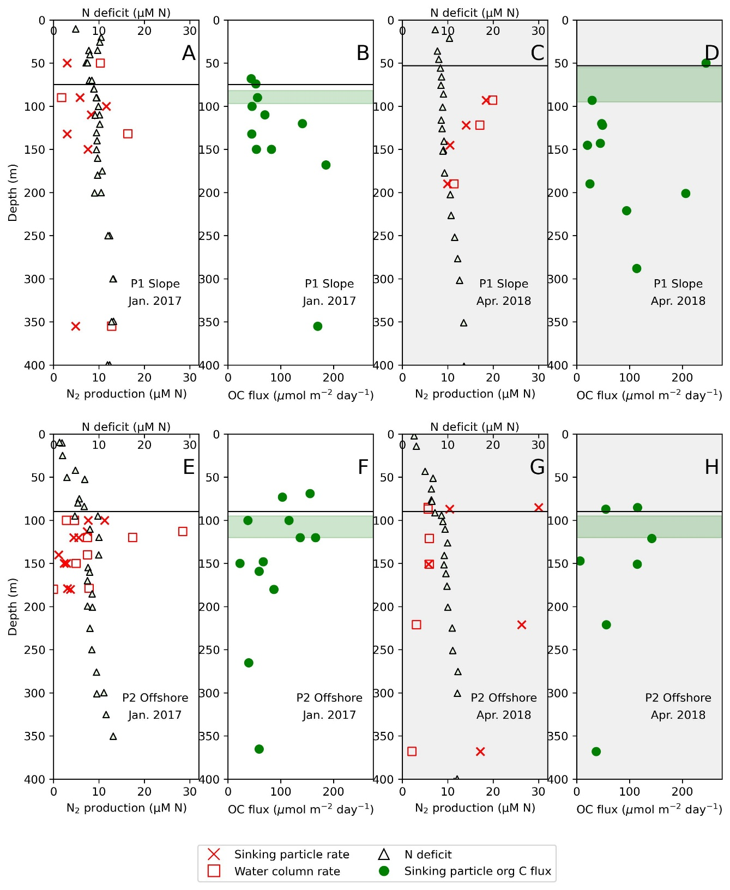
Figure S13. Comparison of N-deficit (black triangles), N₂ production rates in the water column (red squares) and due to sinking particles (red crosses), nitrate (black circles) sinking particulate organic carbon (POC) flux (green circles) profiles for eastern tropical North Pacific (ETNP) oxygen deficient zone (ODZ) slope Station P1 in January 2017 (A-B) and April 2018 (C-D); offshore Station P2 in January 2017 (E-F) and April 2018 (G-H). The approximate onset depth of anoxia is with a black horizontal line in each plot. The approximate secondary chlorophyll maximum (SCM) depth range for each station is shown in green shading.

