Supplementary Information
An intelligent sensing platform integrating YOLOv8-Seg with paper-based microfluidic chips for multi-component sweat biomarker analysis
Yuhan Gou¹ ·Chenglin Li² ·Ruiqi Yang¹ ·Borun Li¹ ·Hai Tan^{2, *} ·Jinyi Wang^{1, *} ·Shu-Wei Chen^{1, *}
¹ College of Chemistry & Pharmacy, Northwest A&F University, Yangling, Shaanxi 712100, China
² College of Mechanical and Electronic Engineering, Northwest A&F University, Yangling, Shaanxi 712100, China
E-mail addresses: tanhai@nwafu.edu.cn (H. Tan); jywang@nwsuaf.edu.cn (J. Wang); chenshuwei2011@nwsuaf.edu.cn (S.-W. Chen)

Chemicals and instrumentation
Horseradish peroxidase (HRP, 250 U/mg), 2,4,6-tris(2-pyridyl)-s-triazine (TPTZ), methyl red, 2,2’-azino-bis(3-ethylbenzothiazoline-6-sulfonic acid) diammonium salt (ABTS), mercury (II) sulfate (HgSO₄), iron (II) sulfate (FeSO₄), glucose, sodium hydroxide, chitosan, citric acid and methanol were purchased from Shanghai Aladdin Biochemical Technology Co., Ltd. (China). Lactate, trehalose, bromothymol blue, potassium iodide, sodium chloride, sodium citrate and Tween-80 were provided by Energy Chemical (Shanghai, China). Glucose oxidase (GOD, 180 U/mg) and lactate oxidase (LO_{X}, 100 U/mg) were purchased from Shanghai Macklin Biochemical Co., Ltd. (China) and Beijing Solarbio Science & Technology Co., Ltd. (China). Whatman No.1 filter paper and hydrochloric acid were purchased from GE Healthcare (Shanghai, China) and Chengdu Kelong Chemical Co., Ltd. (China). All the reagents used were at the analytical purity level.
Inkjet printing was performed using an Epson R330 inkjet printer (Epson, Japan). UV-vis absorption spectra were recorded on Shimadzu-UV-1800 spectrophotometer (Shimadzu, Japan). Ultrasonic treatment was carried out using the SB-100DT ultrasonic bath (XJ Biotechnology Instrument, Zhejiang, China). The structure and morphology of the materials were characterized by scanning electron microscope (SEM, Nano SEM-450, USA). Surface wettability of ﬁlter paper was evaluated using a DropMeter A-100 optical contact angle analyzer (Maist Testing Technology, Ningbo, China). The housing of the portable image acquisition device was fabricated using a HORI Z560 3D printer (HORI Technology, Beijing, China), and the integrated camera was a F1080p model (Zhongwei Aoke, China) with a resolution of 2 megapixels.
Fig. S1 Reaction mechanisms of colorimetric detection for lactate, Cl⁻, glucose and pH.

Fig. S2 UV-vis absorption spectra validation of each colorimetric reaction system. (A) For the Cl⁻ detection system, an enhancement of the characteristic absorption peak was observed at 595 nm, corresponding to the formation of the Fe²⁺-TPTZ complex. (B) As the glucose concentration increased, the characteristic absorption peak of the I₂ at approximately 350 nm gradually intensified, indicating the successful formation of the iodine oxidation product. (C) In the mixed indicator system, the position and intensity of the absorption peaks changed significantly under different pH conditions, with the acidic and alkaline characteristic peaks exhibiting a reciprocal increase and decrease. (D) For the lactate system, a clear absorption enhancement was observed at λ = 414-417 nm, confirming that ABTS was oxidized to ABTS_{OX}. These results indicate that each colorimetric reaction occurred successfully, providing a mechanistic basis for colorimetric quantitative analysis.

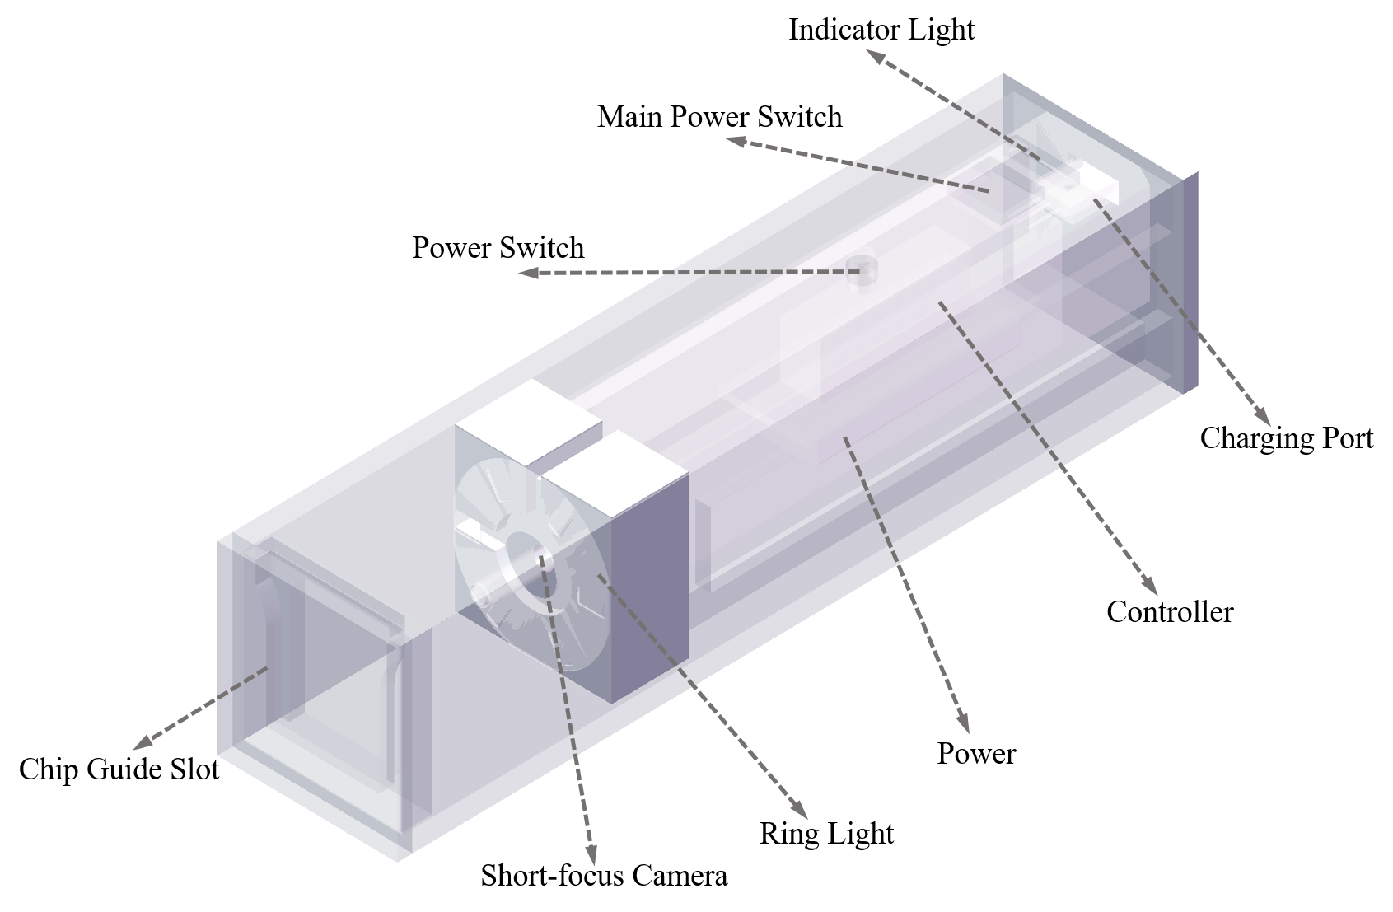
Fig. S3 Detailed structural diagram, dimensional drawing and photograph of the semi-enclosed portable image acquisition device. The outer shell was made by 3D printing with resin material.

Fig. S4 Training convergence and recognition performance evaluation of the YOLOv8-Seg model under small-sample training data conditions. The training set consisted of 56 images, while the validation set contained 24 images. The ratio of the two sets was 7:3. (A) Variation of mAP@0.5 and mAP@0.5:0.95 with training epochs in the mask segmentation task. During the first 50 epochs of training, the model performance improved rapidly, with a significant increase in mAP values. After approximately 80-100 epochs, the performance stabilized and reached convergence. Ultimately, the mAP50 (Mask) approached 1.0, and the mAP50-95 (Mask) remained stable at a high level, indicating that the model achieved high segmentation accuracy across different IoU thresholds. Moreover, the curve fluctuations were small in the later stage of training, demonstrating that the training process was stable without obvious overfitting phenomenon. (B) Precision-Recall curve of the model. The PR curve was tightly aligned with the upper-right corner of the coordinate space, indicating that the model maintained high precision and recall across different confidence thresholds. The model achieved mAP of 0.995 at IoU = 0.5, demonstrating its excellent detection accuracy and segmentation stability for image targets.

Table S1 Age and gender of volunteers
Participant | Age | Gender
1 | 21 | Male
2 | 24 | Male
3 | 28 | Male
4 | 25 | Female
5 | 23 | Female
6 | 26 | Female

Table S2 Typical concentration ranges of major analytes in real human sweat (summary from literature)
Analyte | Concentration Range | Reference
Cl⁻ | 25-100 mM | [1]
 | 10-100 mM | [2]
 | 1-100 mM | [3]
Glucose | 0.001-0.2 mM | [4]
 | 0.03-1 mM | [5]
 | 0.05-0.40 mM | [6]
pH | 4.5-7.5 | [7]
 | 5.5-8.5 | [8]
 | 5.0-9.0 | [9]
Lactate | 0-25 mM | [10]
 | 1-50 mM | [11]
 | 3-25 mM | [12]

Supplementary Equations
Equation S1
$$\text{Response Retention} \text{(\%)} \text{=} \frac{{\text{RGB}}_{\text{t}}\text{-}{\text{RGB}}_{\text{blank}}}{{\text{RGB}}_{\text{0}}\text{-}{\text{RGB}}_{\text{blank}}}\text{×100\%}$$
Among them, ${\text{RGB}}_{\text{t}}$ represents the RGB values of the paper-based chip at time t, ${\text{RGB}}_{\text{blank}}$ represents the blank background of the paper-based chip, and ${\text{RGB}}_{\text{0}}$ represents the RGB values of the paper-based chip at time 0.
Equation S2
$$\text{Relative signal} \text{(\%)} \text{=} \frac{\text{Mean of }\text{interfence}\text{ group}}{\text{Mean of control group}}\text{×100\%}$$

References
1. Reeder JT, Choi J, Xue Y, Gutruf P, Hanson J, Liu M, Ray T, Bandodkar AJ, Avila R, Xia W, Krishnan S, Xu S, Barnes K, Pahnke M, Ghaffari R, Huang Y, Rogers JA (2019) Waterproof, electronics-enabled, epidermal microfluidic devices for sweat collection, biomarker analysis, and thermography in aquatic settings. Sci Adv 5: eaau6356. https://doi.org/10.1126/sciadv.aau6356
2. Parrilla M, Ortiz-Gómez I, Cánovas R, Salinas-Castillo A, Cuartero M, Crespo GA (2019) Wearable potentiometric ion patch for Oon-body electrolyte monitoring in sweat: toward a validation strategy to ensure physiological relevance. Anal Chem 91:8644-8651. https://doi.org/10.1021/acs.analchem.9b02126
3. Kassal P, Steinberg MD, Horak E, Steinberg IM (2018) Wireless fluorimeter for mobile and low cost chemical sensing: a paper based chloride assay. Sens. Actuators, B 275:230-236. https://doi.org/10.1016/j.snb.2018.07.170
4. Hou Z, Gao T, Liu X, Guo W, Bai L, Wang W, Yang L, Yang H, Wei D (2023) Dual detection of human motion and glucose in sweat with polydopamine and glucose oxidase doped self-healing nanocomposite hydrogels. Int J Biol Macromol 252:126473. https://doi.org/10.1016/j.ijbiomac.2023.126473
5. Zhou L, Menon SS, Li X, Zhang M, Malakooti MH (2024) Machine learning enables reliable colorimetric detection of pH and glucose in wearable sweat sensors. Adv Mater Technol 10: 2401121. https://doi.org/10.1002/admt.202401121
6. Liu D, Liu Z, Feng S, Gao Z, Chen R, Cai G, Bian S (2023) Wearable microfluidic sweat chip for detection of sweat glucose and pH in long-distance running Exercise. Biosensors 13:157. https://doi.org/10.3390/bios13020157
7. Jiang Y, Gao B, Dong Y, An W, Lv J, Kang Z, Zhang Y, Zhang D (2026) A smart wearable microfluidic colorimetric sweat sensing system for concurrent, wireless monitoring of sweat biomarkers and sweat rate. Chem Eng J 533:174786. https://doi.org/10.1016/j.cej.2026.174786
8. Koh A, Kang D, Xue Y, Lee S, Pielak RM, Kim J, Hwang T, Min S, Banks A, Bastien P, Manco MC, Wang L, Ammann KR, Jang K, Won P, Han S, Ghaffari R, Paik U, Slepian MJ, Balooch G, Huang Y, Rogers JA (2016) A soft, wearable microfluidic device for the capture, storage, and colorimetric sensing of sweat. Sci Transl Med 8 https://doi.org/10.1126/scitranslmed.aaf2593
9. Andrea CD, Banchelli M, Amicucci C, Polykretis P, Micheletti F, de Angelis M, Hwang B, Matteini P (2024) Development of a wearable surface enhanced raman scattering sensor chip based on silver nanowires for rapid detection of urea, lactate and pH in sweat. J Eur Opt Soc Rapid Publ 20:10. https://doi.org/10.1051/jeos/2024013
10. Promphet N, Rattanawaleedirojn P, Siralertmukul K, Soatthiyanon N, Potiyaraj P, Thanawattano C, Hinestroza JP, Rodthongkum N (2019) Non-invasive textile based colorimetric sensor for the simultaneous detection of sweat pH and lactate. Talanta 192:424-430. https://doi.org/10.1016/j.talanta.2018.09.086
11. Shitanda I, Ozone Y, Morishita Y, Matsui H, Loew N, Motosuke M, Mukaimoto T, Kobayashi M, Mitsuhara T, Sugita Y, Matsuo K, Yanagita S, Suzuki T, Mikawa T, Watanabe H, Itagaki M (2023) Air-bubble-insensitive microfluidic lactate biosensor for continuous monitoring of lactate in sweat. ACS Sens 8:2368-2374. https://doi.org/10.1021/acssensors.3c00490
12. Komkova MA, Eliseev AA, Poyarkov AA, Daboss EV, Evdokimov PV, Eliseev AA, Karyakin AA (2022) Simultaneous monitoring of sweat lactate content and sweat secretion rate by wearable remote biosensors. Biosens Bioelectron 202:113970. https://doi.org/10.1016/j.bios.2022.113970

