Supplementary Figure S1. Feature selection, data integration, and dimensionality assessment of retinal single-cell transcriptomic data. (A) Heatmaps showing representative genes associated with the major principal components. (B) Top genes contributing to PC1 and PC2. (C) Optimization of single-cell data integration across iterative integration steps. (D) Elbow plot showing the standard deviations of the first 20 principal components.
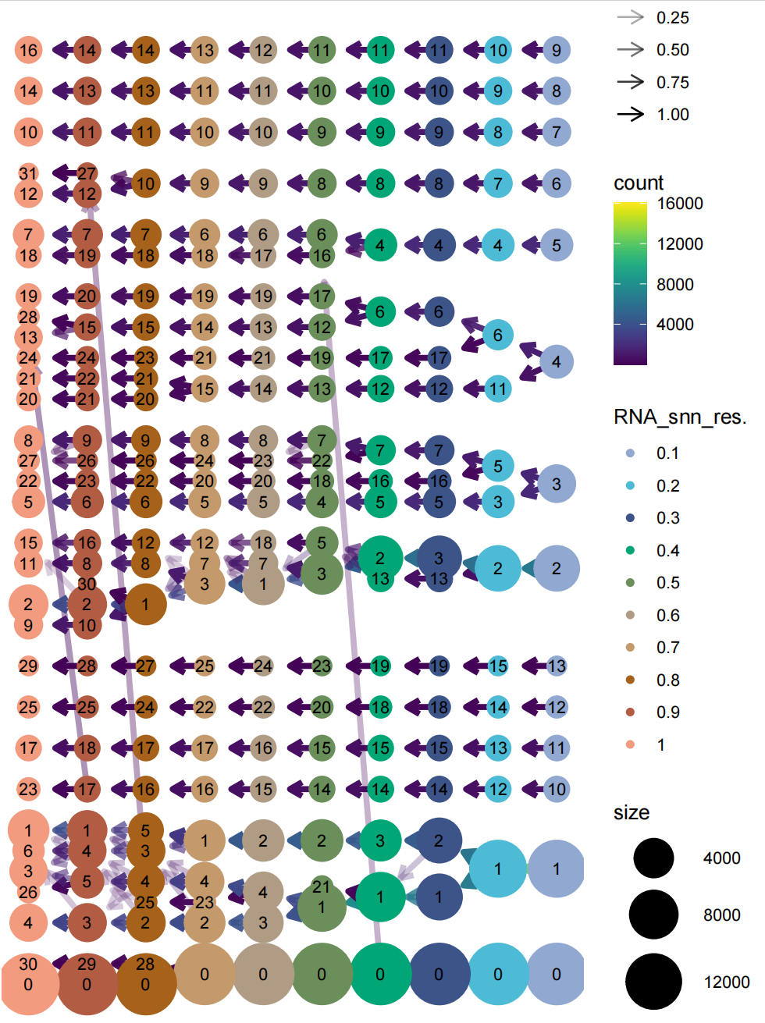
Supplementary Figure S2. Clustering stability across different resolutions in retinal single-cell data. Clustree visualization showing the relationships among cell clusters across clustering resolutions from 0.1 to 1.0. A resolution of 0.4 was selected for subsequent cell clustering and annotation.

Supplementary Figure S3. Outgoing and incoming signaling patterns across retinal cell types in the Control and IR groups. (A) Heatmaps showing outgoing signaling strength. (B) Heatmaps showing incoming signaling strength. The left and right panels represent the Control and IR groups, respectively.
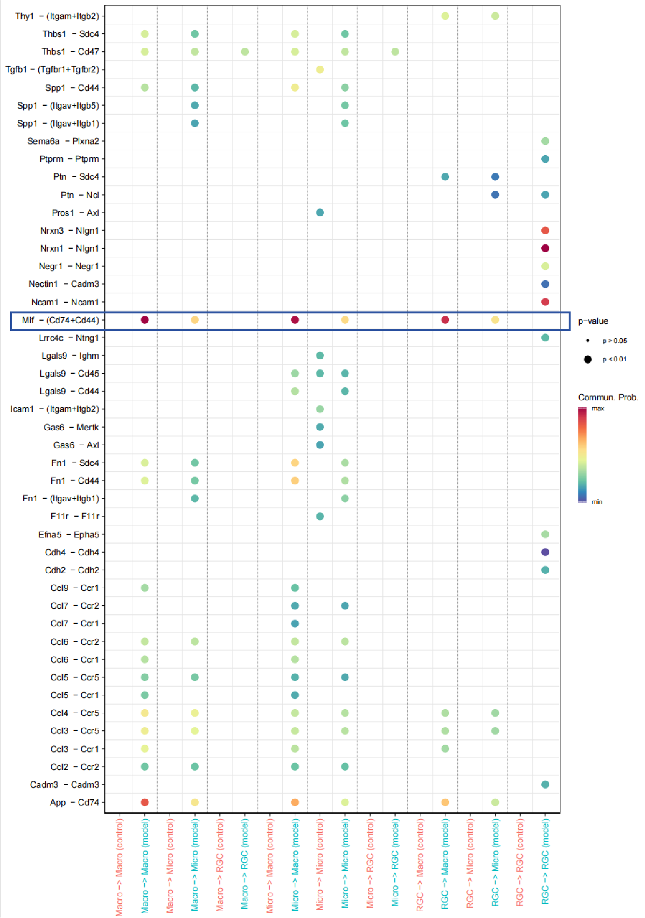
Supplementary Figure S4. Comparison of ligand–receptor interactions among macrophages, microglia, and RGCs between the Control and IR groups. Dot plot showing predicted communication probabilities of ligand–receptor interactions across different sender–receiver pairs. Dot color represents communication probability, and dot size indicates statistical significance.

Supplementary Figure S5. Original Western blots corresponding to the immunoblots shown in Fig. 1E
Supplementary Figure S6. Original Western blots corresponding to the immunoblots shown in Fig. 7A

