SUPPLEMENTARY FILE 2
Detailed Reflexive Thematic Analysis Process
Manuscript 2: Community Health Cadres as Community Mediators in Supporting Families at Risk of Stunting: A Qualitative Study within Maternal and Child Health Services In Indonesia
The qualitative data were analysed using Braun and Clarke’s six-phase reflexive thematic analysis. The process below provides a concise audit trail showing how the qualitative data were developed into the final themes and subthemes reported in the manuscript. NVivo 15 was used to support data organisation, coding, retrieval, and management.
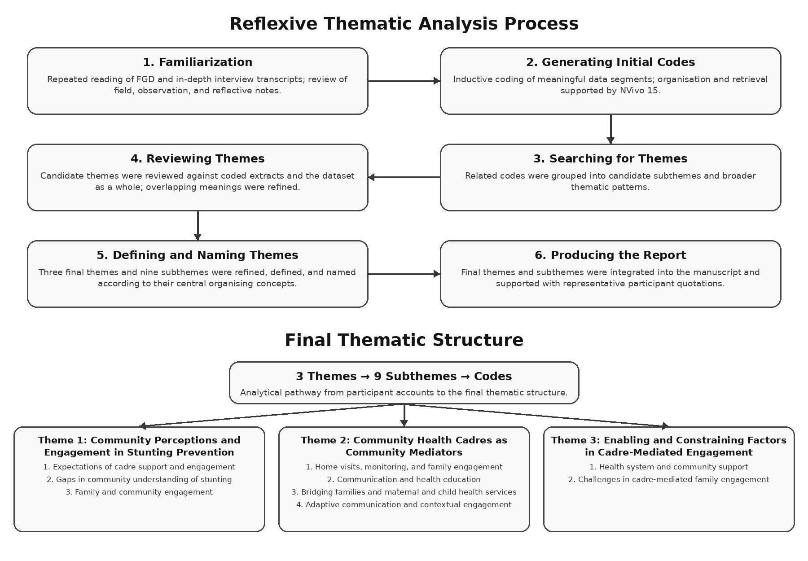
Figure 1. Reflexive thematic analysis process used for Manuscript 2.
- Familiarization with the Data

The researcher repeatedly read the verbatim transcripts from the focus group discussions (FGDs) and in-depth interviews to become familiar with the dataset. Audio recordings were reviewed when necessary to verify transcription accuracy. Field notes, observation notes, and reflective notes were also reviewed to capture contextual observations and initial analytical ideas. Familiarization focused on participants’ accounts of community health cadre roles, communication with families, family engagement, home visits, health education, community participation, and interactions with maternal and child health services.
2. Generating Initial Codes
Relevant segments of the transcripts were coded inductively according to the meanings expressed by participants. Coding focused on statements describing community perceptions of stunting prevention, expectations of cadre support, family and community engagement, home visits, growth monitoring, communication and health education, linkages with health services, adaptive communication strategies, community and health-system support, and challenges encountered by cadres. NVivo 15 was used to organise and retrieve coded data. Codes were reviewed iteratively to ensure that they remained grounded in participants’ accounts.
3. Searching for Themes
Related codes were grouped according to shared meanings and patterns across the dataset. Through this process, codes were organised into candidate subthemes concerning community perceptions and engagement, cadre-mediated family engagement, communication and health education, home visits and monitoring, connections between families and maternal and child health services, and factors enabling or constraining cadre-mediated practices. The candidate subthemes were then considered in relation to the broader pattern of community health cadres functioning as community mediators in stunting prevention.
4. Reviewing Themes
Candidate subthemes were reviewed against the coded extracts and the dataset as a whole. The researcher examined whether each subtheme had internal coherence, was sufficiently distinct from the others, and remained relevant to the study aim. Interpretations were compared across the different participant groups and between FGD and in-depth interview data. Particular attention was given to whether the emerging themes adequately captured the processes through which cadres engaged families, adapted communication, conducted home visits, and connected families with maternal and child health services. Overlapping meanings were clarified and related codes were consolidated where appropriate.
5. Defining and Naming Themes
The subthemes were refined and clearly defined to capture their central organising concepts. Three final themes were identified: (1) Community Perceptions and Engagement in Stunting Prevention; (2) Community Health Cadres as Community Mediators; and (3) Enabling and Constraining Factors in Cadre-Mediated Engagement. These themes and their associated subthemes were integrated into an analytical framework describing how community health cadres mediate between families, communities, and maternal and child health services.
6. Producing the Report
The final themes and subthemes were organised into a coherent analytical narrative. Participant quotations were selected to illustrate and support the interpretation of each subtheme. The final thematic structure was presented in Table 2 of the manuscript and illustrated in the coding tree. The analysis emphasised how community health cadres functioned as community mediators through communication, family engagement, home visits, health education, and linkages with maternal and child health services, while also identifying community and health-system factors that enabled or constrained these practices.
Final Thematic Structure
Theme | Subtheme | Codes
Community Health Cadres as Community Mediators in Supporting Families at Risk of Stunting | Community Perceptions and Engagement in Stunting Prevention | 1. Expectations of cadre support and engagement  2. Gaps in community understanding of stunting  3. Family and community engagement
 | Community Health Cadres as Community Mediators | 1. Home visits, monitoring, and family engagement  2. Communication and health education  3. Bridging families and maternal and child health services  4. Adaptive communication and contextual engagement
 | Enabling and Constraining Factors in Cadre-Mediated Engagement | 1. Health system and community support  2. Challenges in cadre-mediated family engagement
Note. The codes should be populated using the original NVivo coding output for Manuscript 2. No codes have been inferred or created where the source material provided only themes and subthemes.
Figure 2. Coding tree illustrating the development of the themes, subthemes, and codes.
Analytic Output
The analysis resulted in three interconnected themes and nine subthemes. The coding structure illustrates how participants’ accounts developed from initial codes into subthemes and broader themes. The final thematic structure highlights the role of community health cadres as community mediators who facilitate family engagement and connections with maternal and child health services within community-based stunting prevention.

