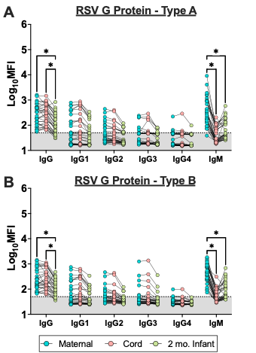
Supplemental Figure 1. RSV G Protein-specific immunoglobulin responses were measured for both (A) RSV Type A and (B) Type B in serum from maternal blood (MB), cord blood (CB) and 2-month infant blood by systems serology and reported as log₁₀ mean fluorescence intensity. Each line connects a matched maternal-cord sample from the same dyad. Relative abundance of immunoglobulin isotypes (IgG, IgG1-4, IgM) were measured for all samples. Linear mixed effects regression analysis with Bonferroni post-hoc. Asterisks indicate p < 0.05. The stippled line and gray shading indicate the limit of background (LOB), defined as the log₁₀MFI of a defined negative control.
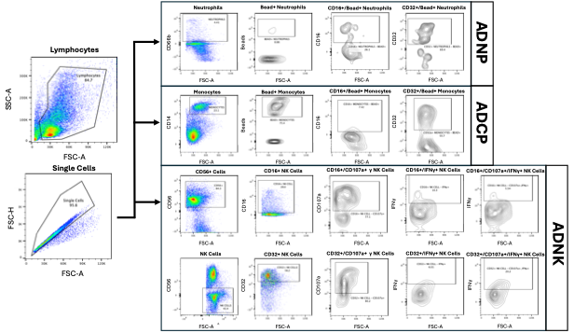
Supplemental Figure 2. Representative gating strategy for multiplexed non-neutralizing antibody assay including antibody dependent neutrophil phagocytosis (ADNP), antibody dependent cellular phagocytosis (ADCP), and antibody dependent NK cell cytotoxicity (ADNK).

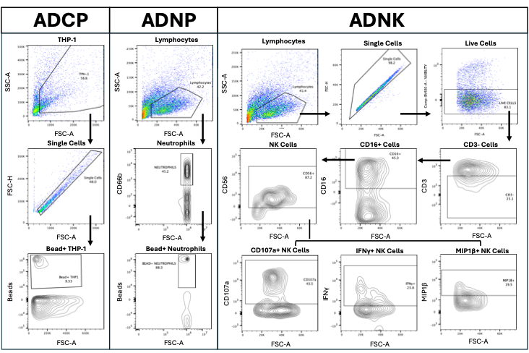
Supplemental Figure 3. Representative gating strategy for singleplex non-neutralizing antibody assay including antibody dependent neutrophil phagocytosis (ADNP), antibody dependent cellular phagocytosis (ADCP), and antibody dependent NK cell cytotoxicity (ADNK).
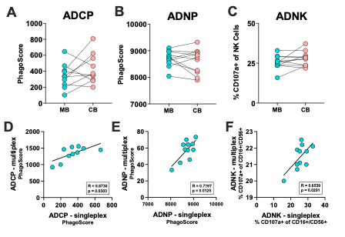
Supplemental Figure 4. RSV PreF-specific antibody functions were measured in serum from maternal blood (MB), cord blood (CB) and 2-month infant blood. Cellular non-neutralizing functions were measured by singleplex or multiplexed flow cytometry analysis. Each line connects a matched maternal-cord sample from the same dyad. (A) Antibody dependent neutrophil phagocytosis (ADNP) and (B) antibody dependent cellular phagocytosis (ADCP) were reported as PhagoScore, calculated as (% bead-positive monocytes/neutrophils) × (geometric MFI of each cell). (C) Antibody dependent NK cell cytotoxicity was measured as CD107a+/CD16+ NK cells. (A-C) Data were analyzed by paired t-test. (D-F) Singleplex data was correlated to multiplex data with Pearson correlations with R values, p values, and simple linear regression lines shown on each individual comparison.
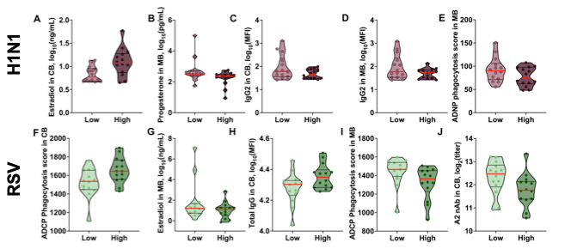
Supplemental Figure 5. Sparse partial least squares discriminant analysis (sPLS-DA) integrating MB and CB immune and steroid features to classify high versus low 2-month infant RSV PreF-specific (green) or H1N1 HA-specific (plum) IgG1 levels (n=28 maternal-cord pairings with complete data). Plots represent each model-selected feature used to predict high or low transfer for each antigen. For H1N1 HA, features include (A) Estradiol in CB, (B) progesterone in MB (C) IgG2 in CB and MB, (D) and (E) ADNP in MB. RSV PreF features include (F) ADCP in CB, (G) estradiol in MB, (H) total IgG in CB, (I) ADCP in MB, and (J) RSV Type A neutralizing antibody in CB. Red lines represent the median values of each group.

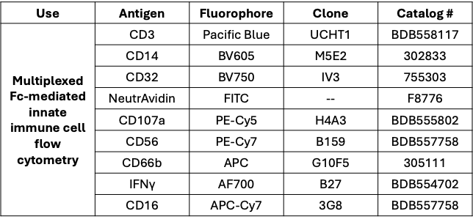
Supplemental Table 1. Antibody used for flow cytometry.

Supplemental Methods
Luminex Antigen-Bead Coupling
Antigens were covalently coupled to distinct Luminex MagPlex bead regions via carboxylate modification. Antigens included RSV Pre-F (Eenzyme #RSV-F0-30p), RSV G-Type A (Eenzyme #RSV-GP-10Ap), RSV G-Type B (Eenzyme #RSV-GP-30Bp) and Influenza A H1 protein (Eenzyme #IA-H1-V19WP). Beads were activated using activation buffer (0.1 M NaH2PO4, pH 6.2) supplemented with 50 mg/mL EDC and 50 mg/mL Sulfo-NHS. Activated beads were coupled to 25 µg of antigen in coupling buffer (0.05 M MES, pH 5.0), blocked with PBS containing 0.1% BSA, 0.02% Tween-20, and 0.05% sodium azide (pH 7.4), and washed with PBS containing 0.05% Tween-20. Beads were stored at 4°C in PBS until use.
Luminex-Based Isotyping and Fc Receptor Binding
Plasma samples (5 µL, diluted 1:25) were incubated with antigen-coupled bead solution (20 µL per bead region) in Luminex Assay Buffer (PBS, 0.1% BSA, 0.05% Tween-20) for 2 hours on a plate shaker. Plates were placed on a magnet and washed with Procartaplex Wash Buffer (Thermo Fisher). Isotype/subclass detection was performed using PE-conjugated secondary antibodies (Southern Biotech) targeting IgM, IgG (subclasses IgG1–4), and IgA (subclasses IgA1–2). For Fc receptor (FcR) profiling, recombinant FcR proteins (Duke Vaccine Institute Protein Production Facility) were biotinylated using a BirA biotin-ligation kit (Avidity) and conjugated to PE-Streptavidin (BioLegend) for 15 minutes on a rotor prior to use. FcRs assessed included FcγRIIAR, FcγRIIB, FcγRIIIA-V, FcγRIIIAF, FcγRIIIB, FcRn, and FcαR. Mean fluorescence intensity (MFI) was measured on a Luminex Intelliflex (FlexMap 3D instrument, low PMT; doublet discrimination range 7,000–17,000; minimum 100 events per antigen). PBS served as a negative control, and positive controls were included in each run to ensure assay integrity.
Antibody-Dependent Complement Deposition (ADCD)
Biotinylated antigen-coated beads were incubated with serum samples (1:25) to form immune complexes, then washed three times with 1% BSA. Lyophilized Low-Tox Guinea Pig Complement (Cedarlane) was reconstituted in ice-cold dH2O, diluted 1:25 in GVB++ (Gelatin Veronal buffer with Mg²⁺ and Ca²⁺; Boston Bio), and added to each well for incubation at 37°C. Complement deposition was detected using goat anti-guinea pig C3 IgG (1:500; MP Biomedicals) followed by donkey anti-goat IgG-PE secondary antibody (1:200; Thermo Fisher). Beads were resuspended and acquired on the Luminex Intelliflex as described above. Antigens included RSV Pre-F and H1.
Multiplexed Non-Neutralizing Antibody Assay
A multiplex assay was performed to evaluate antigen-specific non-neutralizing antibody functions mediated through FcR activity across innate immune cell populations, including natural killer (NK) cells, monocytes, and neutrophils. Biotinylated antigen was generated using a 20-fold molar excess of biotin reagent and purified using spin columns to remove unbound biotin. The biotinylated antigen was coupled to fluorescent neutravidin-coated beads by incubation overnight at 4°C, followed by washing and resuspension in PBS containing 0.1% BSA. Serum samples were thawed and diluted 1:100 in PBS, then incubated with antigen-coated beads for 2 hours at 37°C to allow immune complex formation. Fresh whole blood–derived leukocytes were isolated from donor leukopaks using ammonium chloride lysis, washed, and resuspended in RPMI supplemented with 10% fetal bovine serum and 1% penicillin-streptomycin (R10 Media). Cells were counted, adjusted to 1.5 × 10⁶ cells/mL, and stimulated overnight with IL-15 (1 ng/mL) at 37°C. Following immune complex formation, beads were washed and incubated with effector cells at a density of 1 × 10⁵ cells per well. An inhibitor cocktail containing anti-CD107a and Golgi transport inhibitor was added, and plates were incubated for 5 hours at 37°C. Cells were then stained for extracellular markers to identify NK cells (CD3⁻CD56⁺), neutrophils (CD66b⁺), and monocytes (CD14⁺), as well as Fc receptors (CD16 and CD32). Following surface staining, cells were fixed, permeabilized, and stained intracellularly for cytokines. NK cell function was assessed by degranulation (CD107a) and intracellular cytokine production (IFNγ) Phagocytic activity in neutrophils and monocytes was quantified based on bead uptake (bead⁺ cells). Samples were acquired on an BD Symphony A3 flow cytometer, and functional responses were analyzed within Fc receptor–expressing (CD16⁺ and/or CD32⁺) populations
Singleplex Antibody-Dependent NK Cell Activation (ADNK)
Peripheral blood mononuclear cells (PBMCs) were isolated by density gradient centrifugation using Ficoll-Paque (GE Healthcare). NK cells were enriched using the MagniSort Human NK Cell Enrichment Kit (Thermo Fisher Scientific) per manufacturer's instructions and resuspended at 1.5 × 10⁶ cells/mL in R10 medium (RPMI 1640, 10% FBS, 1% penicillin-streptomycin, 2 mM L-glutamine). NK cells were rested overnight at 37°C with 1 ng/mL IL-15 (Abcam). ELISA plates were coated overnight at 4°C with 3 µg/mL biotinylated antigen-bead solution (RSV Pre-F and H1N1 HA), blocked with 5% BSA, and washed. Serum samples (1:100 in R10) were added to antigen-coated wells to allow immune complex formation. An inhibitor cocktail (CD107a-PeCy5 [BD Biosciences], brefeldin A [Millipore Sigma], and Golgi Stop [BD Biosciences] in R10) was added to wells prior to the addition of 50,000 NK cells per well. Cells were incubated for 5 hours at 37°C. Following stimulation, cells were surface stained (CD3-Pacific Blue, CD56-PE-Cy7, CD16-APC-Cy7; BD Biosciences), fixed and permeabilized with Perm A (Thermo Fisher Scientific), and intracellularly stained for IFN-γ-APC, CCL4-PE (BD Biosciences), and Perm B (Thermo Fisher Scientific). Samples were acquired on a BD Symphony A3 flow cytometer (Bloomberg Flow Cytometry and Immunology Core). NK cells were gated as CD3⁻CD16⁺CD56⁺, and functional readouts reported as frequencies of IFN-γ⁺, CD107a⁺, and CCL4⁺ cells.
Singleplex Antibody-Dependent Cellular Phagocytosis (ADCP)
Biotinylated antigen-coated beads were incubated with serum (1:150), washed with PBS, and centrifuged at 2,000 × g for 10 minutes. THP-1 monocytic cells (provided by Dr. Andrea Cox, Johns Hopkins School of Medicine) were plated at 25,000 cells/well in R10 and co-cultured with immune complexes overnight at 37°C. Cells were fixed with 4% paraformaldehyde (PFA), washed, and resuspended in PBS for acquisition on an Attune NxT flow cytometer. Phagocytic activity was quantified as a PhagoScore: (% bead-positive THP-1 cells) × (geometric MFI of bead uptake). Antigens included RSV Pre-F and H1.
Singleplex Antibody-Dependent Neutrophil Phagocytosis (ADNP)
RSV PreF and H1N1 HA were biotinylated (BirA kit, Avidity) and coupled to FluoSpheres NeutroAvidin-Labeled Microspheres (1.0 µm, yellow-green; Thermo Fisher). Serum (1:100 in PBS) was incubated with antigen-coated beads. Neutrophils were isolated from donor blood collected in CPT tubes, separated from granulocytes, and red blood cells were lysed with ACK Lysis Buffer. Neutrophils (5 × 10⁶ cells/well) were plated, incubated with immune complexes, and surface stained with APC-conjugated anti-CD66b antibody (BioLegend, #305117) for 15 minutes at room temperature. Cells were fixed with 4% PFA and acquired on an Attune NxT flow cytometer. Neutrophils were gated as CD66b⁺, and the PhagoScore was calculated as described for ADCP.
RSV Plaque Reduction Neutralization Test (PRNT)
Serum samples were heat-inactivated at 56°C for 1 hour and serially diluted (1:40 to 1:2560) in OptiMEM (Thermo Fisher) supplemented with 2% FBS, 1% PenStrep, and 1% GlutaMax. RSV A2 or RSV B1 (100 PFU) was added to each diluted sample and incubated for 1 hour at room temperature. Vero cells, seeded to confluency in 24-well plates, were inoculated with 150 µL of virus-serum mixture for 2 hours at 37°C with intermittent agitation. An overlay of 0.5% agarose in supplemented OptiMEM was applied, and plates were incubated at 37°C for 7 days. Plaques were fixed with 10% neutral buffered formalin (5–6 hours) and stained overnight with Naphthol Blue Black. ATCC reference sera (High [#NR-4021], Medium [#NR-4022], Low [#NR-4023], and IgG-depleted [#NR-49447]) were included as controls. IC50 values were calculated from plaque counts across the dilution series.
H1N1 Microneutralization Assay
H1N1 microneutralization assays were performed as previously described ⁹². Briefly, plasma samples were diluted with receptor destroying enzyme (RDE, Denka Seiken) at 1:3 ratio and incubated overnight at 37 °C followed by heat inactivation RDE at 56 °C for 35 min. Samples were 2-fold serially diluted in infection media (1% Penicillin/Streptomycin, 1% Glutamax, 0.5% BSA, 5 µg/ml of N-acetyl-trypsin in Dulbecco’s Modified Eagle’s Medium), and mixed with 100 TCID50 of A/Victoria/4897/2022 (H1N1) vaccine strain vaccine strain, and incubated at room temperature for 1 h. The virus/serum mixture was transferred in duplicate into the 96-well cell culture plates containing confluent Madin-Darby Canine Kidney (MDCK) cells and incubated at 32 °C. After a 24 h incubation, plates were washed once with 1X PBS, fresh infection media was added, and cells were incubated for 7 days. Plates were fixed with 4% formaldehyde, stained with naphthol blue black solution. The neutralizing antibody titer was calculated as the highest plasma dilution that eliminated virus cytopathic effects in 50% of the wells.
Steroid Hormone Assays
Steroid hormones were extracted from serum by acetonitrile precipitation (2:3 v/v serum:acetonitrile), followed by centrifugation and vacuum drying. Dried extracts were reconstituted in assay buffer and analyzed using the MILLIPLEX MAP Multi-Species Hormone Magnetic Bead Panel (Millipore MSHMAG-21K) according to manufacturer's instructions. Cortisol, estradiol, and progesterone were quantified. Samples were incubated overnight with antibody-conjugated beads and detection reagents and read on a Luminex Intelliflex. Steroid concentrations were determined by five-parameter logistic curve fit against standard concentrations.
Multiplex Cytokine Profiling
Cytokine concentrations were measured using the Human Cytokine Magnetic 25-Plex Panel Kit (Invitrogen, #LHC0009M). Serum samples were diluted as needed in assay diluent, and a fresh standard curve was generated for each run using serial dilutions of lyophilized standards. Capture antibody-coated magnetic beads were incubated with samples, standards, and blanks for 2 hours at room temperature or overnight at 4°C with shaking. Biotinylated detection antibodies and streptavidin-phycoerythrin were added sequentially with appropriate wash steps. Plates were acquired on a Luminex Intelliflex, and concentrations were determined by five-parameter logistic standard curve fitting. All steps were performed in the dark to prevent photobleaching.
Machine Learning
Systems serology and immunological data were log₁₀-transformed to approximate Gaussian distributions. 2-month-old infant IgG1 levels (low and high) were defined using the median value as a cutoff for H1 (cutoff: 3.022 log₁₀[MFI]) and RSV PreF-specific data (cutoff: 3.894 log₁₀[MFI]). Complete (i.e., non-missing) data, including steroids, systems serology, neutralizing antibody, and phagocytosis scores, were available for n=28 maternal-cord pairings. Z-scaled maternal and cord blood data were used for sparse partial least squares discriminant analysis (sPLS-DA), which includes a lasso penalization step for feature selection, to predict subsequent 2-month-old IgG1 levels (high or low) separately for each antigen. 7-fold cross-validation with 100 repeats was used to tune the number of components and variables within each component necessary for each model. The final models were determined based on the parameters that yielded the lowest overall error rates and balanced error rates. All supervised machine learning modeling was performed in RStudio v4.5.1 and the mixOmics package⁹³.
Statistical Analyses
For each antigen, average percentile ranks of systems serology, cytokine, and steroid hormone data were calculated for each measure and then visualized with polar plots by sample type (maternal blood, cord blood, or 2-month-old infant blood) with ggplot2 v4.0.3⁹⁴ in RStudio v4.5.1. Statistical analyses were performed in GraphPad Prism (v10.6.1). Unpaired or paired two-tailed t-tests were used for pairwise comparisons, as appropriate. Pearson correlation was used for bivariate analyses. Comparisons across multiple conditions or time points were made using two-way ANOVA, repeated-measures one-way ANOVA, or mixed-effects models, with Bonferroni correction applied for multiple comparisons. A p-value < 0.05 was considered statistically significant. Significant results are indicated by asterisks on figures or bold text in tables.

