Supplementary material

Lower miRNA-155-5p expression in pancreatic β cells than in α cells is associated with higher susceptibility to innate immune pathway activators
Celine Yvonne Shaw¹, Bettina Rosa Højfeld Pedersen^{1,2}, Louise Torp Dalgaard², Karsten Buschard³, Mathias Høj Jensen^{1*}, Martin Haupt-Jorgensen¹

¹The Bartholin Institute, Department of Pathology, Rigshospitalet, Copenhagen University Hospital, Denmark.
²Department of Science and Environment, Roskilde University, Denmark.
³Veterinary and Animal Sciences, Faculty of Health and Medical Sciences, University of Copenhagen, Frederiksberg Campus, Denmark
*Corresponding author: Mathias Høj Jensen, The Bartholin Institute, Department of Pathology, Rigshospitalet, Copenhagen University Hospital, Ole Maaløes Vej 5, 2200 Copenhagen N, Denmark. Email: mathias.hoej.jensen.01@regionh.dk

Supplementary Figures
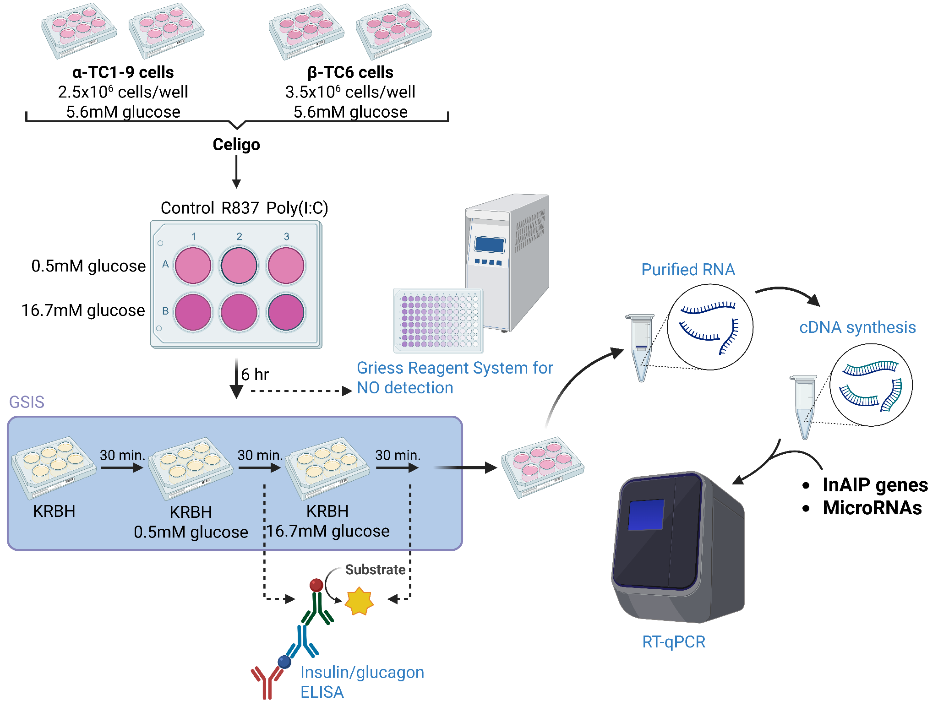
SFig 1 Overview of stimulation experiment protocol Murine α-TC1-9 and β-TC6 cell lines were subjected to glucose and innate immune agonist treatments as control DMSO, Imiquimod R837, or polyinosinic:polycytidylic acid Poly(I:C), followed by functional and molecular analyses. Nitric oxide (NO) secretion was measured using the Griess reagent system. Hormone section was assessed by glucose-stimulated insulin secretion (GSIS) or glucagon secretion assays using Krebs-Ringer Bicarbonate HEPES buffer (KRBH) containing low (0.5mM) or high (16.7mM) glucose. Insulin and glucagon concentrations were quantified by enzyme-linked immunosorbent assay (ELISA). Following stimulation, RNA was isolated, reverse transcribed to cDNA, and InAIP gene and miRNA expression were analyzed by reverse transcription quantitative polymerase chain reaction (RT-qPCR). Created in BioRender. Høj Jensen, M. (2026) https://BioRender.com/6ahyvm5

Supplementary Tables
Table S1. Primer list for target InAIP genes
Target | Forward Sequence | Reverse Sequence
IFNα | GCTCTGTGCTTTCCTGATGG | GCTCACTCAGGACAGGGATG
ISG15 | CGCAGACTGTAGACACGCTT | AGGCACACTGGTCCCCTC
MDA5 | AGGAAGTACAACGAAGCCCTAC | CCTCGTCATCACTCTTGTCG
OAS1 | ATCAGCCGTCAATGTCGTGT | CTTGAGTGTGGTGCCTTTGC
OAS3 | GCCAGCCTTTGATGCTCTCG | CCTTGATGGTCTTGTTACACTGTT
PDE12 | GTTGCTAATACCCATCTCTACTGG | GCTAAAGAAAACCTACCTTTTGGG
RNaseL | TAGGCGAACACATCAATGAGGA | CTGCCTCTGGAACGCTGAG
TLR3 | CCTCTTGAACAACGCCCAAC | TCGAGCTGGGTGAGATTTGTC
TLR7 | GATCGTGGACTGCACAGACA | TGGACCCCAGTAGAACAGGT
GAPDH | GTCGTGGAGTCTACTGGTGTC | GAGCCCTTCCACAATGCCAAA
YWHAZ | TGCGTGACATCTGCAACGAT | TGACTGGTCCACAATTCCTTTCT
Table S2. Primer list for target miRNAs
Target | Forward primer | Looped reverse transcription sequence | Reverse primer
miR-29a-3p | ACACTCCAGCTGGGTAGCACCATCTGAAAT | CTCAACTGGTGTCGTGGAGTCGGCAATTCAGTTGAGTAACCGAT
miR-21-5p | ACACTCCAGCTGGGTAGCTTATCAGACTGA | CTCAACTGGTGTCGTGGAGTCGGCAATTCAGTTGAGTCAACATC
miR-146a-5p | ACACTCCAGCTGGGTGAGAACTGAATTC | CTCAACTGGTGTCGTGGAGTCGGCAATTCAGTTGAGAACCCATG
miR-155-5p | ACACTCCAGCTGGGTTAATGCTAATTGTGAT | CTCAACTGGTGTCGTGGAGTCGGCAATTCAGTTGAGACCCCTAT
miR-92a-5p | ACACTCCAGCTGGGAGGTTGGGATCGGTTG | CTCAACTGGTGTCGTGGAGTCGGCAATTCAGTTGAG AGCATTGC
miR-34a-5p | ACACTCCAGCTGGGTGGCAGTGTCTTAGCT | CTCAACTGGTGTCGTGGAGTCGGCAATTCAGTTGAGTCAACCAG
URP universal  Reverse |  |  | TGGTGTCGTGGAGT  CG
RNU6B (U6) | CTCGCTTCGGCAGCACA |  | ​​AACGCTTCACGAATTTGCGT
Cel-miR-39 | ACACTCCAGCTGGGTCACCGGGTGTAAATC

