Additional file 1. Supplementary tables and figures

Supplementary Results
Before propensity score adjustment, the largest imbalances were observed for the age at index date, residential area, smoking status, income level, alcohol consumption, and sex. After 1:1 propensity score matching, all measured covariates had maximum absolute standardized mean differences <0.10. After inverse probability of treatment weighting, covariate balance was substantially improved for most variables; however, age remained marginally above the conventional threshold of 0.10 (maximum absolute SMD = 0.1001; Fig. S1 and Table S1).
The original stabilized IPTW had a mean ± standard deviation of 0.999 ± 0.205 (range 0.320–8.099). After truncation at the 1st and 99th percentiles, the mean weight was 0.994 and the standard deviation decreased to 0.162 (range 0.503–1.771). The reduction in skewness from 5.117 to 1.057 indicated improved stability of the weighting distribution after truncation (Table S2).
In the 1-year lag sensitivity analysis, 1,746 participants were excluded because they entered long-term care insurance (LTCI) or died before LTCI entry within the first year after the index date. After re-starting follow-up on January 1, 2016, the association remained nearly unchanged in the fully adjusted Fine–Gray model (sHR, 0.69; 95% CI, 0.63–0.76; p < 0.001; Table S3).
The scaling-by-log-time interaction was not statistically significant in the fully adjusted Fine–Gray model (exp[β], 1.09; 95% CI, 0.96–1.24; p = 0.177), suggesting no clear evidence that the association between dental scaling and LTCI entry varied over follow-up. The results of the Schoenfeld residual-based assessment was consistent with this finding for dental scaling status, without significant correlation between the dental scaling residual and either follow-up time (ρ = 0.00894; p = 0.455) or log-transformed follow-up time (ρ = 0.01513; p = 0.206) (Table S4).
Fig. S1. Covariate balance before and after the application of propensity score methods
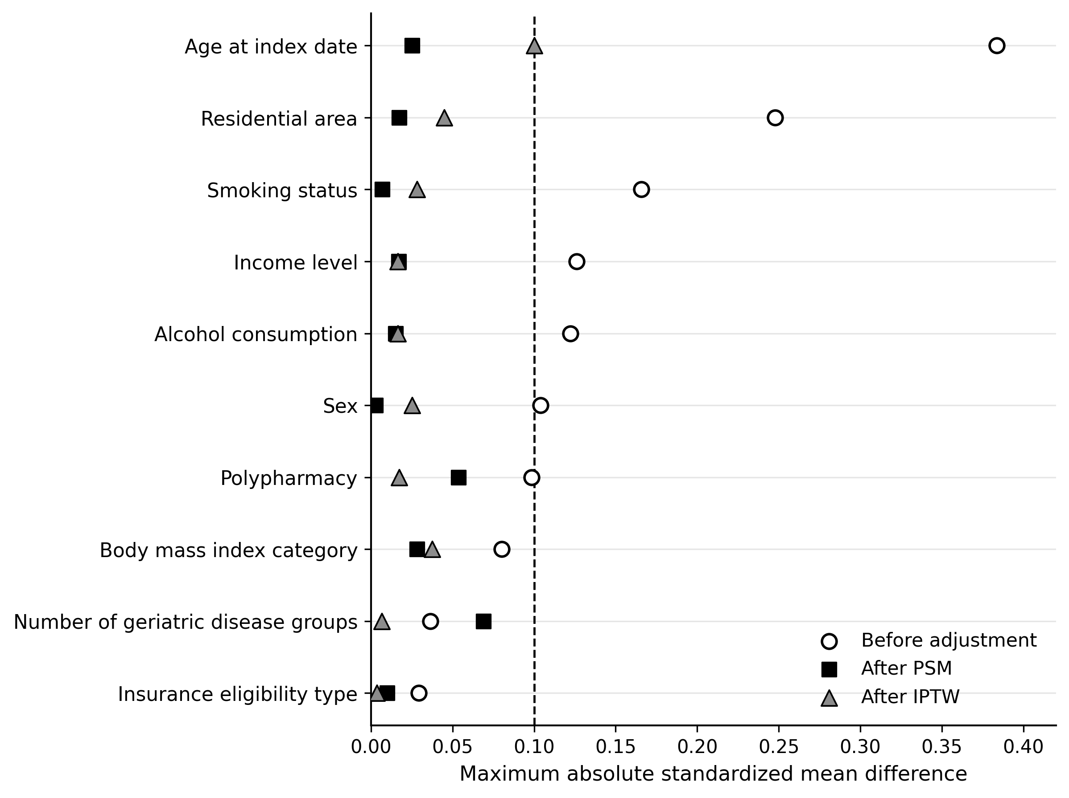
Fig. S1. Points indicate absolute standardized mean differences before propensity score adjustment, after 1:1 propensity score matching, and after inverse probability of treatment weighting. For categorical variables with more than two levels, the maximum absolute standardized mean difference across category-specific indicators is shown. The dashed vertical line indicates an absolute standardized mean difference of 0.10. IPTW, inverse probability of treatment weighting; PSM, propensity score matching; SMD, standardized mean difference.
Table S1. Covariate balance after propensity score methods
Covariate | Before adjustment | After PSM | After IPTW
Age at index date | 0.3838 | 0.0253 | 0.1001
Sex | 0.1040 | 0.0027 | 0.0252
Residential area | 0.2479 | 0.0173 | 0.0448
Insurance eligibility type | 0.0294 | 0.0098 | 0.0036
Income level | 0.1260 | 0.0171 | 0.0163
Number of geriatric disease groups | 0.0363 | 0.0691 | 0.0066
Polypharmacy | 0.0984 | 0.0538 | 0.0173
Body mass index category | 0.0802 | 0.0282 | 0.0375
Smoking status | 0.1658 | 0.0068 | 0.0283
Alcohol consumption | 0.1223 | 0.0152 | 0.0165
Absolute standardized mean differences were calculated before propensity score adjustment, after 1:1 propensity score matching, and after inverse probability of treatment weighting. For categorical variables with more than two levels, the maximum absolute standardized mean difference across category-specific indicators is shown. An absolute standardized mean difference <0.10 indicated adequate covariate balance. IPTW, inverse probability of treatment weighting; PSM, propensity score matching; SMD, standardized mean difference.
Table S2. IPTW weight distribution
Statistic | Original stabilized IPTW | Truncated stabilized IPTW
N | 99218 | 99218
Mean | 0.999 | 0.994
Standard deviation | 0.205 | 0.162
Median | 0.980 | 0.980
Interquartile range | 0.117 | 0.117
25th percentile | 0.930 | 0.930
75th percentile | 1.047 | 1.047
1st percentile | 0.503 | 0.503
5th percentile | 0.735 | 0.735
95th percentile | 1.221 | 1.221
99th percentile | 1.771 | 1.771
Minimum | 0.320 | 0.503
Maximum | 8.099 | 1.771
Skewness | 5.117 | 1.057
Kurtosis | 74.997 | 6.986
Weights are stabilized inverse probability of treatment weights that were estimated from the propensity score model. Truncation was performed at the 1st and 99th percentiles of the original stabilized weights. The original and truncated weights ranged from 0.320 to 8.099 and 0.503 to 1.771, respectively. IPTW, inverse probability of treatment weighting.
Table S3. One-year lag sensitivity analysis for LTCI entry
Analysis | N | sHR | 95% CI | P-value | E-value, point estimate | E-value, CI limit closest to null
One-year lag fully adjusted Fine–Gray model | 97472 | 0.692 | 0.630–0.760 | <0.001 | 2.25 | 1.96
The 1-year lag cohort excluded participants who entered LTCI (n=679) or died before LTCI entry (n=1067) within the first year after the index date. Follow-up was re-started on January 1, 2016. The model was adjusted for age, sex, residential area, insurance eligibility type, income level, number of geriatric disease groups, polypharmacy, body mass index category, smoking status, and alcohol consumption. Death before LTCI entry was treated as a competing event. CI, confidence interval; LTCI, long-term care insurance; sHR, sub-distribution hazard ratio.
Table S4. Fine–Gray proportionality assessment
Assessment | Statistic | Estimate | 95% CI | P value | Interpretation
Scaling × log-time interaction | exp(β) | 1.09 | 0.96–1.24 | 0.177 | No clear evidence of non-proportionality for scaling
Scaling Schoenfeld residual vs. follow-up time | ρ | 0.00894 | NA | 0.455 | No significant correlation
Scaling Schoenfeld residual vs. log follow-up time | ρ | 0.01513 | NA | 0.206 | No significant correlation
The interaction term between dental scaling status and log-transformed follow-up time was added to the fully adjusted Fine–Gray model. The Schoenfeld residuals were obtained from the Fine–Gray proportional sub-distribution hazards model using STATUS = 0 as censored, STATUS = 1 as LTCI entry, and STATUS = 2 as death before LTCI entry as a competing event. Correlations between the Schoenfeld residuals and follow-up time are shown among LTCI entry events. CI, confidence interval; LTCI, long-term care insurance.
Table S5. Five-year RMTL to LTCI entry
Measure | Estimate, days | Lower 95% CI, days | Upper 95% CI, days
No scaling | 54.49 | 52.97 | 56.08
Scaling | 24.93 | 22.62 | 27.58
Difference, No scaling minus Scaling | 29.56 | 26.62 | 32.32
RMTL was calculated as the area under the cumulative incidence function for LTCI entry up to 5 years (tau = 1825 days), treating death before LTCI entry as a competing event. The difference was calculated as No scaling minus Scaling; positive values indicate greater restricted mean time lost in the no-scaling group. Bootstrap percentile 95% confidence intervals are shown. CI, confidence interval; LTCI, long-term care insurance; RMTL, restricted mean time lost.

