Supporting information
S1 Fig. Anti-SEn OAg (A), anti-STm OAg (B) and anti-Vi polysaccharide (C) IgG antibody responses in mice after immunization with iNTS-TCV toxicology lot stored at 2-8°C for 18 months, compared with a freshly formulated potency standard.
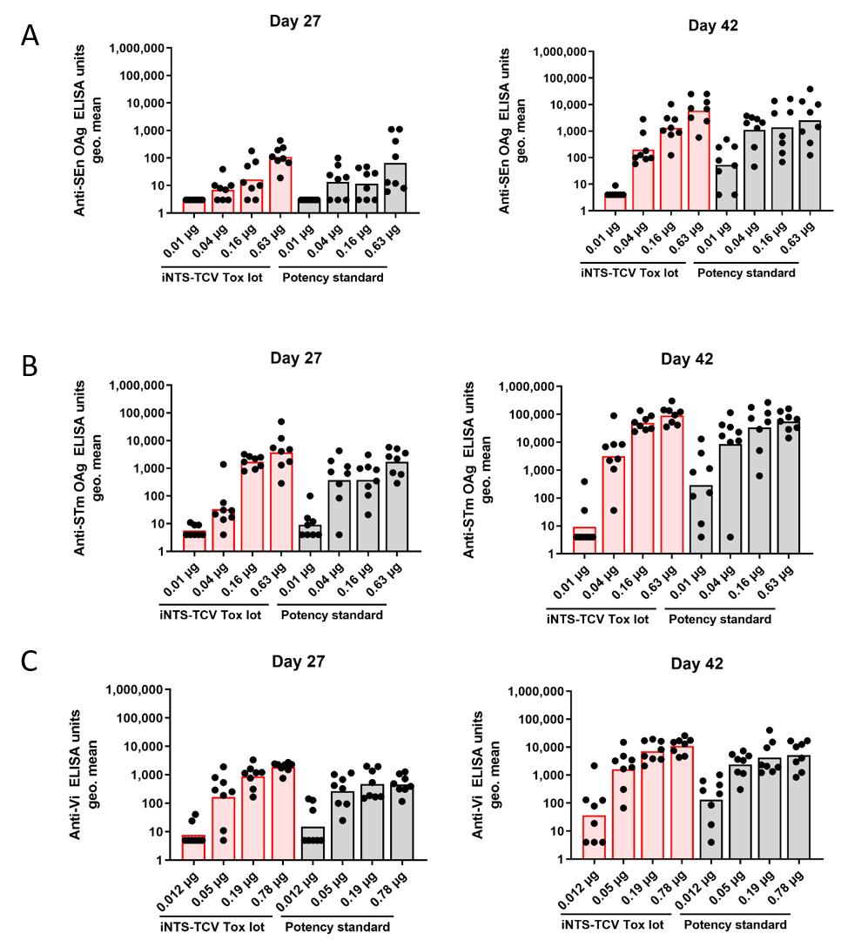
- Anti-SEn OAg IgG ELISA units in individual mice immunized with 0.01 µg, 0.04 µg, 0.16 µg and 0.63 µg OAg (SEnGMMA) of the iNTS-TCV toxicology lot (red bars) or the iNTS-TCV potency standard (grey bars) on Days 27 and 42. (B) Anti-STm OAg IgG ELISA units in individual mice immunized with 0.01 µg, 0.04 µg, 0.16 µg and 0.63 µg OAg (STmGMMA) of the iNTS-TCV toxicology lot (red bars) and the iNTS-TCV potency standard (grey bars) on Days 27 and 42. (C) Anti-Vi polysaccharide IgG ELISA units in individual mice immunized with 0.012 µg, 0.05 µg, 0.19 µg and 0.78 µg Vi polysaccharide of the iNTS-TCV toxicology lot (red bars) and the iNTS-TCV potency standard (grey bars) on Days 27 and 42. Black circles represent individual mice; bars represent group geometric mean ELISA units. Mice were immunized intraperitoneally on Days 0 and 28 with the iNTS-TCV toxicology lot or the iNTS-TCV potency standard. A single intraperitoneal immunization of groups of eight mice with sera analyzed on Day 27 was selected for vaccine potency assessment at release and as part of stability testing. STm: Salmonella enterica serovar Typhimurium; SEn: Salmonella enterica serovar Enteritidis; OAg: O-antigen.

S2 fig. Immunogenicity of the iNTS-TCV toxicology lot after storage at 2-8°C for 18 months, against (A) SEn OAg, (B) STm OAg and (C) Vi polysaccharide, compared with a freshly formulated potency standard.

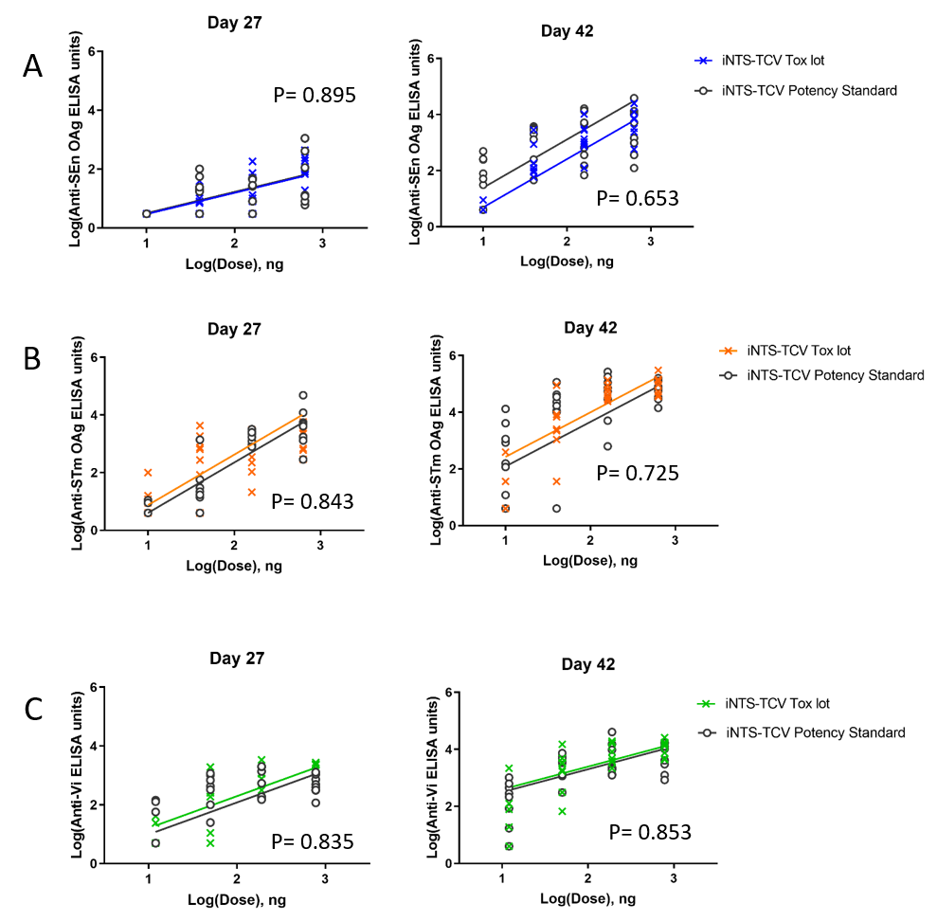

Scatter plots show the log-transformed individual anti-SEn OAg (blue), anti-STm OAg (orange), anti-Vi polysaccharide(green) IgG responses in sera obtained on Days 27 and 42 from mice immunized with the iNTS-TCV toxicology lot stored for 18 months at 2-8°C and a freshly formulated Potency Standard (grey).
Parallel-line analysis (PLA) of the log-transformed dose-response curves showed no significant differences in slopes and Y-intercepts between the specific antigenic responses elicited by the Tox lot or the Potency Standard. Absence of statistical significance is reported by P value in the scatter plots. STm: Salmonella enterica serovar Typhimurium; SEn: Salmonella enterica serovar Enteritidis; OAg: O-antigen.

Table S1 GMP lot manufactured with single-use bioreactor at a CMO.
- STmGMMA Drug Substance
Test | Method | GMP run  (SU fermentation)  #21I7408
O-Antigen identification | Dot blot | positive
Total protein (μg/mL) | MicroBCA (μg/mL) | 3478.4
Soluble protein (μg/mL) | MicroBCA (μg/mL) | 230.6
Soluble protein/total protein (w/w) | calculation (%) | 6.60
OAg quantification (μg/mL) | HPAEC-PAD (μg/mL) | 3088
OAg/total protein w/w | calculation  (OAg/total protein) | 0.9
OAg molecular size distribution | HPLC-SEC  (Kda) | Molar ratio Peak1:Peak2 01:11
OAg molecular size distribution | HPLC-SEC  (Kda) | Peak 1: 36
OAg molecular size distribution | HPLC-SEC  (Kda) | Peak 2: 2
O-Acetyl content | Hestrin-Dische  (% molar ratio O-Acetyl/Rhamnose) | 93%
Lipid A structure | MALDI-TOF | Sum of the peak intensities related to WT or species with similar IL-6 release in MAT, lower than 1% of the sum of the peak intensities related to species with reduced IL-6 release in MAT compared to WT
Lipid A quantification | HPLC-RP QQQ  (nmol/mL) | 1160.6
Lipid A/OAg ratio | Calculation  (nmol/μg) | 0.38
Lipid A/total protein | Calculation  (nmol/μg) | 0.33
Particle size determination (nm) | Dynamic light scattering | Z-average : 114 nm  PDI : 0.163
Appearance | Visual inspection | Whitish, free of precipitates
pH | Potentiometry | 6.7
Osmolality (mOsm/kg) | Osmometry (mOsm/kg) | 285
PPG | HPTLC  (Weight ratio PPG/total protein %) | <0.4
PPG / STm OAg w/w | Calculation (%) | <0.45
Residual DNA | Threshold (μg/mL) | <LOQ
DNA / OAg | Calculation  (μg DNA/mg OAg) | <0.001

B) SEnGMMA Drug Substance
Test | Method | GMP run  (SU fermentation)  #21L7601
O-Antigen identification | Dot blot | positive
Total protein (μg/mL) | MicroBCA (μg/mL) | 2753
Soluble protein (μg/mL) | MicroBCA (μg/mL) | 86.1
Soluble protein/total protein (w/w) | calculation (%) | 3
OAg quantification (μg/mL) | HPAEC-PAD (μg/mL) | 6612
OAg/total protein | calculation  (OAg/total protein) | 2.4
OAg molecular size distribution | HPLC-SEC  (Kda) | 01:04
OAg molecular size distribution | HPLC-SEC  (Kda) | Peak 1: 32
OAg molecular size distribution | HPLC-SEC  (Kda) | Peak 2: 3
Colanic Acid | Colanic acid by quantification of fucose (µg Acido colanico / µg OAg) | 3
Lipid A structure | MALDI-TOF | Sum of the peak intensities related to WT or species with similar IL-6 release in MAT, lower than 1% of the sum of the peak intensities related to species with reduced IL-6 release in MAT compared to WT
Lipid A quantification | HPLC-RP QQQ  (nmol/mL) | 1241.4
Lipid A / OAg ratio | Calculation  (nmol/μg) | 0.19
Lipid A/total protein | Calculation  (nmol/μg) | 0.45
Particle size determination (nm) | Dynamic light scattering | Z-average : 93nm
Appearance | Visual inspection | confirmed
pH | Potentiometry | 6.8
Osmolality (mOsm/kg) | Osmometry (mOsm/kg) | 289
PPG | HPTLC  (Weight ratio PPG/total protein %) | <0.4
PPG/SEn OAg | Calculation (%) | <0.16
Residual DNA | Threshold (μg/mL) | <LOQ
DNA / OAg | Calculation  (μg DNA/mg OAg) | <0.0047

Table S2 Long-term stability data for two iNTS-TCV GMP lots manufactured at the same CMO at different times (2021 and 2023) and stored at 5°C
- GMP lot BK0121 (manufactured in 2021)
Test | BK0121 Storage in months at 5°C |  |  |  |  |  |  |  |  |  | T-test for slope different from 0  (p-value)
Test | Release | 3 | 6 | 9 | 12 | 18 | 24 | 36 | 42
Quantification of SEn OAg (µg/mL) | 41 | NT | NT | 46 | NT | 30 | 37 | 29 | 34 | 0.142
Quantification of STm OAg  (µg/mL) | 53 | NT | NT | 49 | NT | 57 | 60 | 54 | 43 | 0.583
Quantification of Vi polysaccharide  (µg/mL) | 44 | NT | NT | 47 | 48 | 39 | 46 | 44 | 46 | 0.975
Free Vi (unconjugated) in the drug product  (%) | 9 | 9 | 11 | 9 | 9 | 10 | 12 | 12 | 12 | 0.006
GMMA not adsorbed to Alhydrogel measured by Lipid A in drug product supernatant  (nmol/mL) | 0.4 | 0.3 | 0.6 | 0.4 | 0.5 | 0.8 | 0.6 | 0.9 | 1.2 | 0.001
Total Vi not adsorbed to Alhydrogel measured by 2-aminogalacturonic acid in drug product supernatant (%) | 72 | 58 | 76 | 62 | 63 | 62 | 71 | 65 | 63 | 0.694
NT: Not tested
- GMP lot BK0123 (manufactured in 2023)
Test | BK0123 Storage in months at 5°C |  |  |  |  |  |  |  |  | T-test for slope different from 0  (p-value)
Test | Release | 3 | 6 | 9 | 12 | 18 | 24 | 36 | 42* | T-test for slope different from 0  (p-value)
Quantification of SEn OAg  (µg/mL) | 35 | 30 | 37 | 50 | 38 | 40 | 32 | 31 | - | 0.557
Quantification of STm OAg  (µg/mL) | 48 | 56 | 57 | 59 | 60 | 55 | 48 | 48 | - | 0.279
Quantification of Vi polysaccharide  (µg/mL) | 40 | 43 | 42 | 34 | 41 | 38 | 43 | 45 | - | 0.336
Free Vi (unconjugated) in the drug product  (%) | 8 | 9 | 12 | 10 | 11 | 12 | 11 | 12 | - | 0.066
GMMA not adsorbed to Alhydrogel measured by Lipid A in drug product supernatant  (nmol/mL) | 1.2 | 1.1 | 1.1 | 0.7 | 1.0 | 1.2 | 1.1 | 1.3 | - | 0.373
Total Vi not adsorbed to Alhydrogel measured by 2-aminogalacturonic acid in drug product supernatant (%) | 69 | 78 | 86 | 74 | 75 | 74 | 67 | 78 | - | 0.813
*not performed yet

Table S3 Results of the modified pyrogenicity test in rabbits following intramuscular administration of the iNTS-GMMA bivalent vaccine and the iNTS-TCV trivalent vaccine.
Administered vaccines | Group average initial temp. [°C] | Group mean maximum temperature [°C] | Group mean temperature [°C] at end of measurement [5 hours after vaccination] | Time of mean peak temperature after vaccination [minutes] | Mean peak temperature rise [°C]
iNTS-GMMA  (STmGMMA/Alhydrogel batch BJ0121 + SEnGMMA/Alhydrogel batch BH0121)  20 μg OAg + 20 μg OAg | 38.6 | 40.2 | 39.4 | 180-210 | 1.6
iNTS-TCV (batch BK0121)  20 μg OAg + 20 μg OAg + 25 μg Vi | 38.7 | 39.9 | 39.7 | 180-240 | 1.4

