Supporting Information

Comprehensive GC×GC-MS-based Non-Target Screening to Unveil Chemical Profiles of Indoor Dust from Seven European Countries

Andriy Rebryk ^{1,2}, Lisa Melymuk ³, Linda Schenk ⁴, Eva Sugeng ², Pim Leonards ², Marta Gabriel ⁵, Anna Maria Ingelido ⁶, Kristina Aidla ⁷, Stamatina Violaki ², Joana Azeredo ⁵, Rok Novak ⁸, Neža Palir ⁸, Valentina Marra ⁶, Marco Inglessis ⁶, Anna-Sofia Preece ⁹, Konstantin Kislitsõn ⁷, Riin Tarto ⁷, Hans Orru ¹⁰, Ene Indermitte ¹⁰, and Peter Haglund ^{1*}

¹ Department of Chemistry, Umeå University, Linnaeus väg 6, 901 87 Umeå, Sweden
² Amsterdam Institute for Life and Environment (A-LIFE), Faculty of Science, Vrije Universiteit Amsterdam, De Boelelaan 1108, 1081 HZ Amsterdam, The Netherlands
³ RECETOX, Faculty of Science, Masaryk University, Kotlarska 267/2, 611 37 Brno, Czechia
⁴ Institute of Environmental Medicine, Karolinska Institutet, Nobels väg 13, 17177 Stockholm, Sweden
⁵ INEGI, Institute of Science and Innovation in Mechanical and Industrial Engineering, Campus da FEUP, Rua Dr. Roberto Frias 400, 4200-465 Porto, Portugal
⁶ ISS, Italian National Institute of Health, Viale Regina Elena 299, 00161 Rome, Italy
⁷ Republic of Estonia Health Board, Paldiski mnt 81, 10614 Tallinn, Estonia
⁸ Jožef Stefan Institute, Jamova 39, 1000 Ljubljana, Slovenia
⁹ Department of Health Sciences, Karlstad University, Universitetsgatan 2, 651 88 Karlstad, Sweden
¹⁰ Institute of Family Medicine and Public Health, University of Tartu, Ravila 19, 50411 Tartu, Estonia

* Corresponding author at: Department of Chemistry, Umeå University, Linnaeus väg 6, 901 87 Umeå, Sweden.
E-mail address: peter.haglund@umu.se.
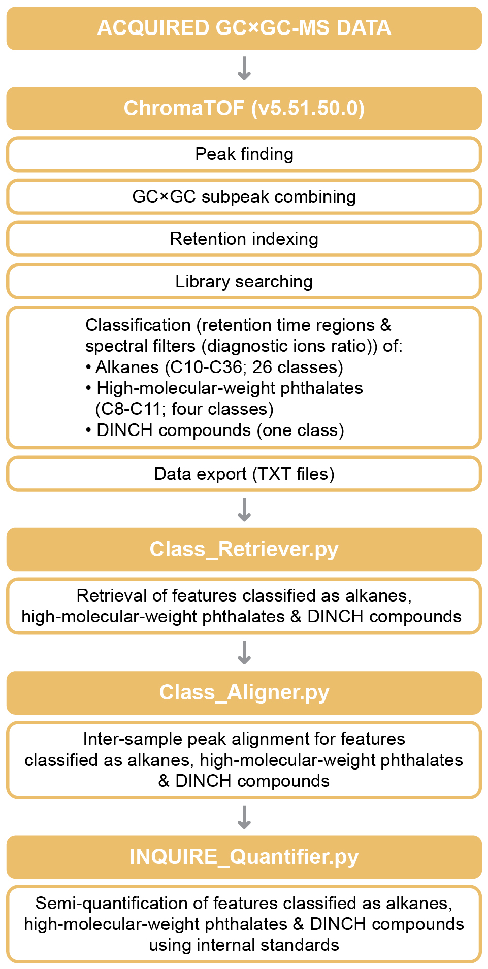

Figure S1. Schematic workflow for features treated as chemical classes, not individual compounds. Abbreviations: GC×GC, two-dimensional gas chromatography; DINCH, 1,2-cyclohexane dicarboxylic acid diisononyl ester and derivative compounds.

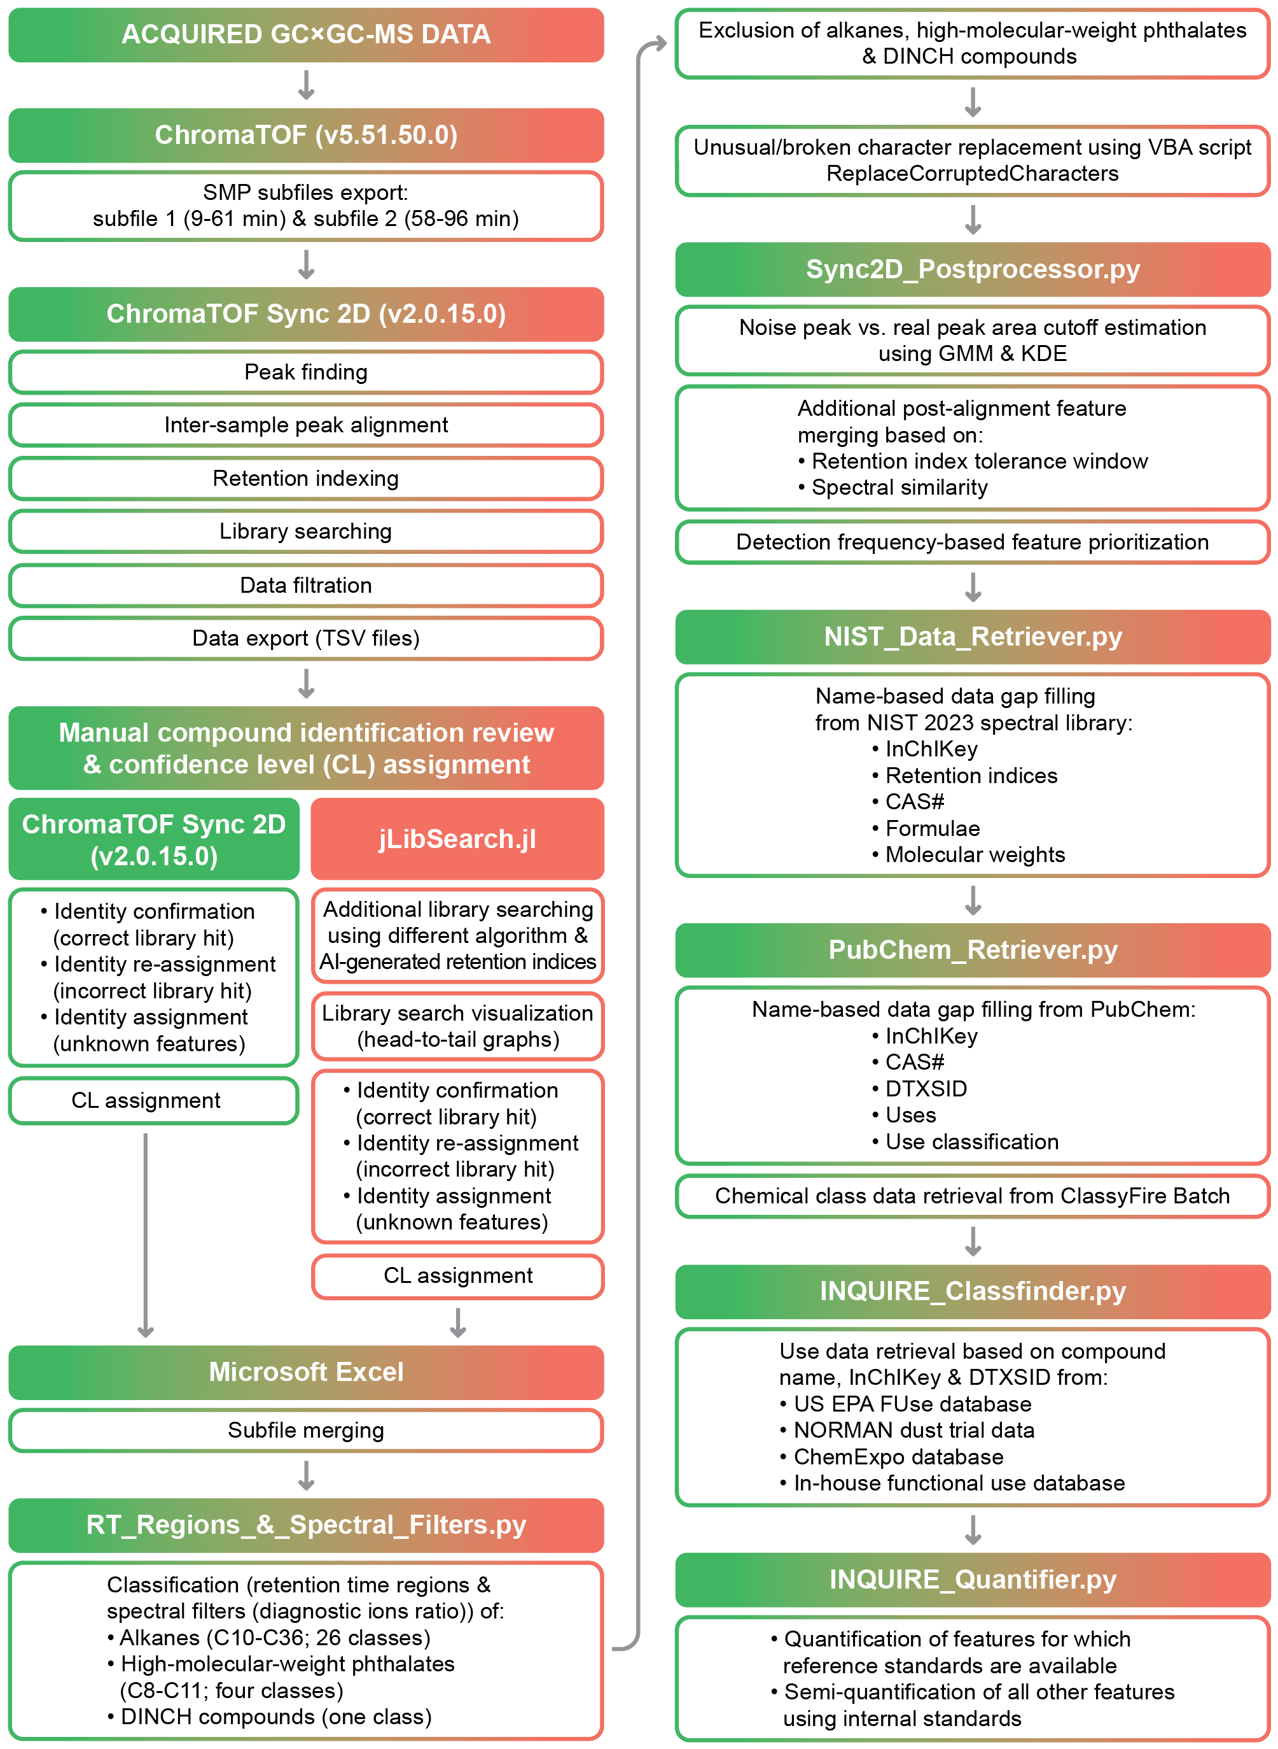

Figure S2. Schematic non-target screening workflow for individual features. Abbreviations: GC×GC, two-dimensional gas chromatography; CL, identification confidence level; DINCH, 1,2-cyclohexane dicarboxylic acid diisononyl ester and derivative compounds; GMM, Gaussian mixture model; KDE, kernel density estimation.

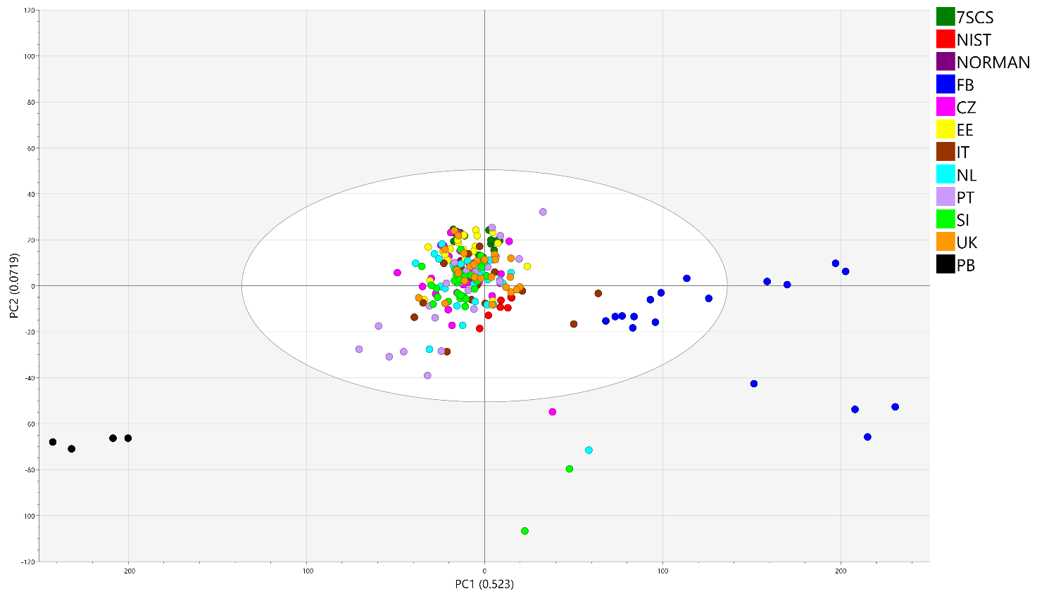
Figure S3. Initial PCA score plot. Abbreviations: 7SCS, seven-state composite sample (QC); NIST, NIST SRM 2585 sample (QC); NORMAN, composite sample from the NORMAN Network dust trial; FB, field blank; CZ, sample from Czechia; EE, sample from Estonia; IT, sample from Italy; NL, sample from the Netherlands; PT, sample from Portugal; SI, sample from Slovenia; UK, sample from the United Kingdom; PB, procedural blank. NB: The same abbreviations are used in all other MVA plots. The white ellipse corresponds to the 95% confidence limit based on Hotelling’s T² statistics. Points outside this ellipse are considered outliers with respect to the model.

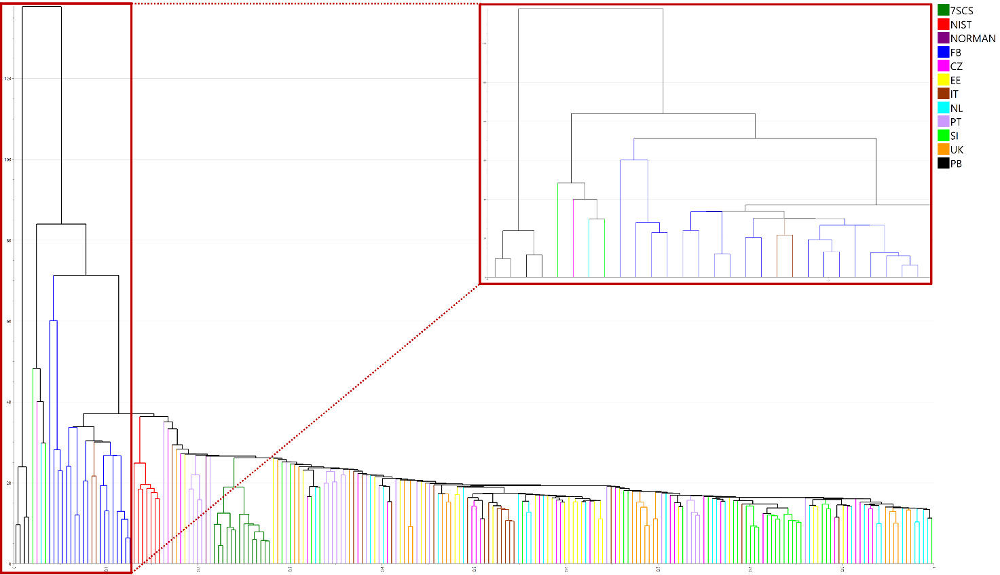
Figure S4. Initial HCA dendrogram with closeup of the blanks and samples that cluster with blanks.

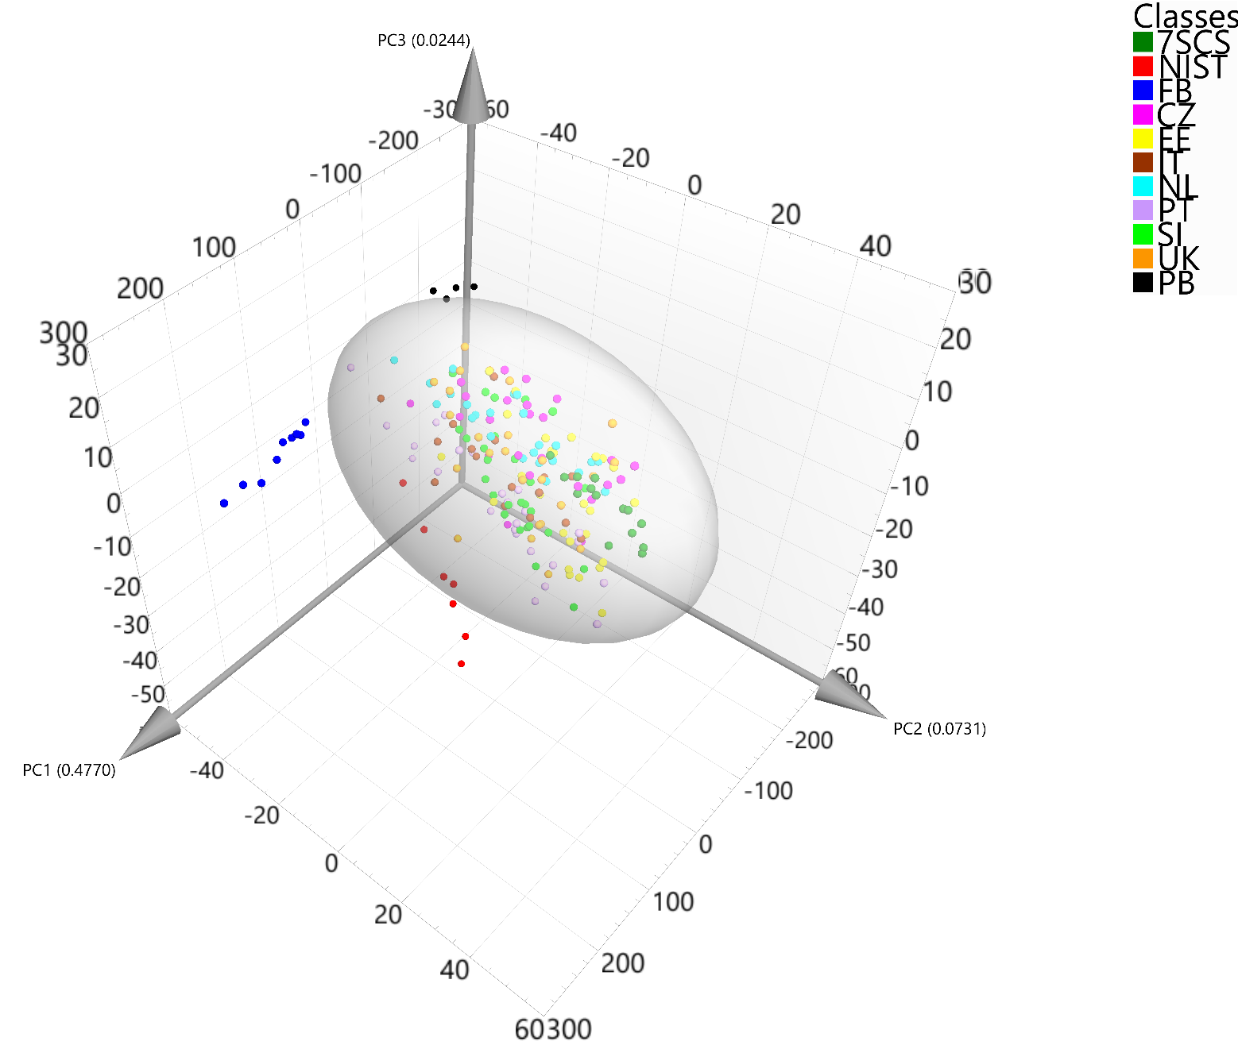

Figure S5. PCA 3D score plot of the filtered dataset (145 features abundant in PBs and 219 features abundant in the remaining FBs were removed along with additional 77 unknown features that were present in at least 30 % of FBs at the log(concentration) ratio samples vs. FBs < 5).

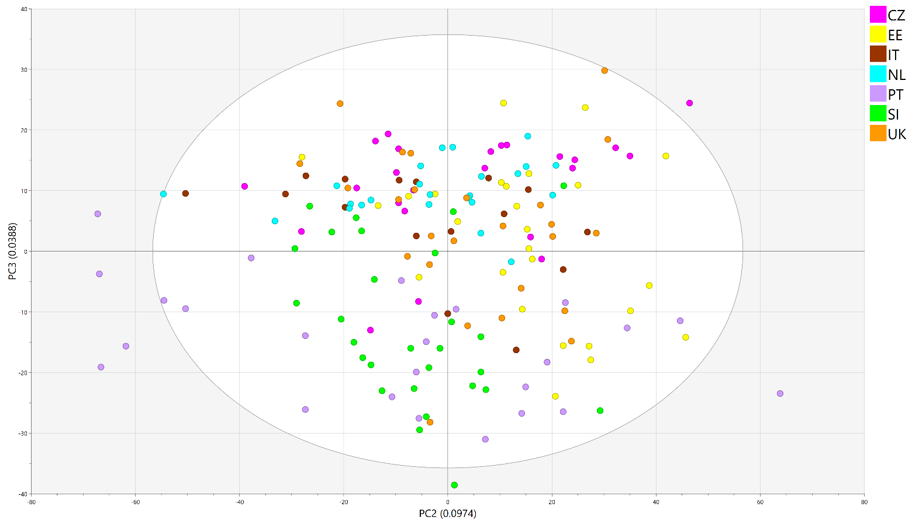
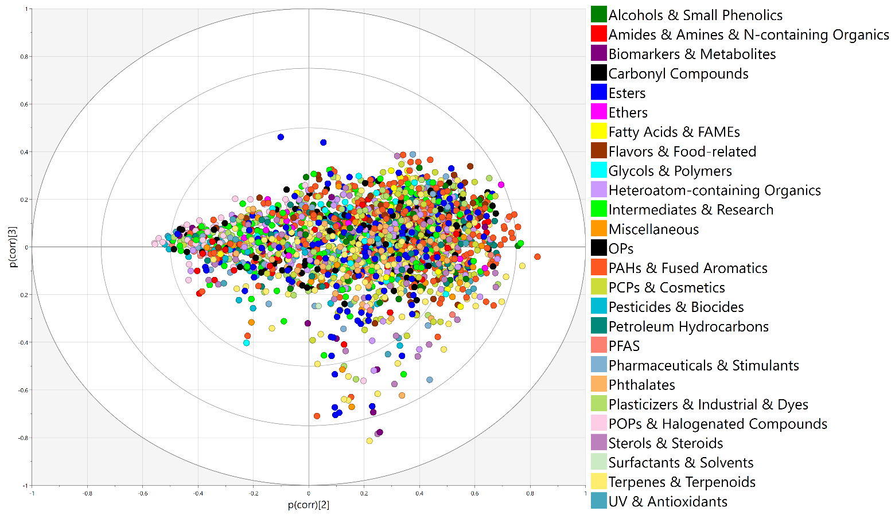
Figure S6A. PCA score (upper panel) and loading (lower panel) plots for country samples (including unknown features and alkanes (both not shown in the figure)).

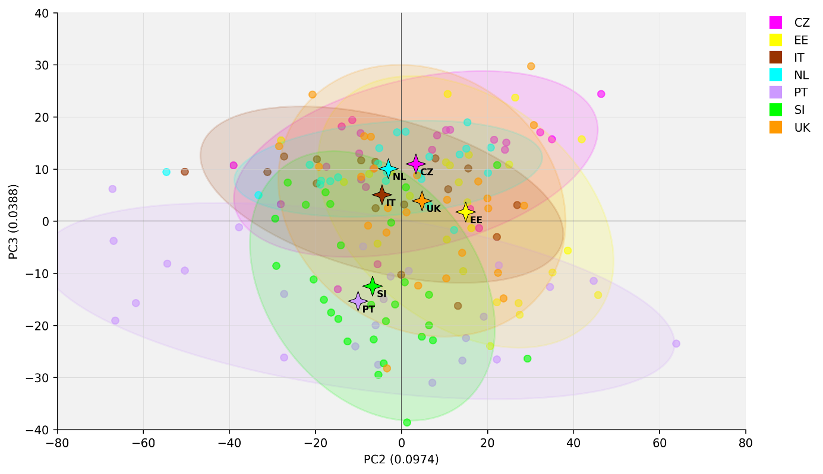
Figure S6B. PCA score plot for country samples (including unknown features and alkanes (both not shown in the figure)) with country centroids (four-point stars).

Workflow S1. Important details and settings for data processing workflow.

- To use the workflow, several pieces of software must be installed/available
- LECO ChromaTOF Software for Pegasus BT (version 5.51.50.0)
- LECO ChromaTOF Sync 2D (version 2.0.15.0)
- Python 3 (version 3.13.5): https://www.python.org/downloads
- Anaconda (Conda) environment: https://www.anaconda.com/download
- Julia (version 1.11.6): https://julialang.org/downloads/
- Visual Studio Code notebook: https://code.visualstudio.com/download
- Class_Retriever.py: https://github.com/r3bryk/Class_Retriever
- Class_Aligner.py: https://github.com/r3bryk/Class_Aligner
- INQUIRE_Quantifier.py: https://github.com/r3bryk/INQUIRE_Quantifier
- RT_Regions_&_Spectral_Filters.py: https://github.com/r3bryk/RT_Regions_and_Spectral_Filters
- Sync2D_Postprocessor.py: https://github.com/r3bryk/Sync2D_Postprocessor
- NIST_Data_Retriever.py: https://github.com/r3bryk/NIST_Data_Retriever
- PubChem_Retriever.py: https://github.com/r3bryk/PubChem_Retriever
- INQUIRE_Classfinder.py: https://github.com/r3bryk/INQUIRE_Classfinder
- PLSDA_Interpreter.py: https://github.com/r3bryk/PLSDA_Interpreter
- JLibSearch.jl: https://github.com/r3bryk/jLibSearch
- VBA script: https://github.com/r3bryk/ReplaceCorruptedCharacters

- Library search, classification, and result export in ChromaTOF
NB: The settings for this workflow were chosen based on authors’ experience and do not necessarily reflect default settings of the ChromaTOF software.
- Open ChromaTOF and create data processing (DP) method for library search
  - Settings for “Peak Finding”
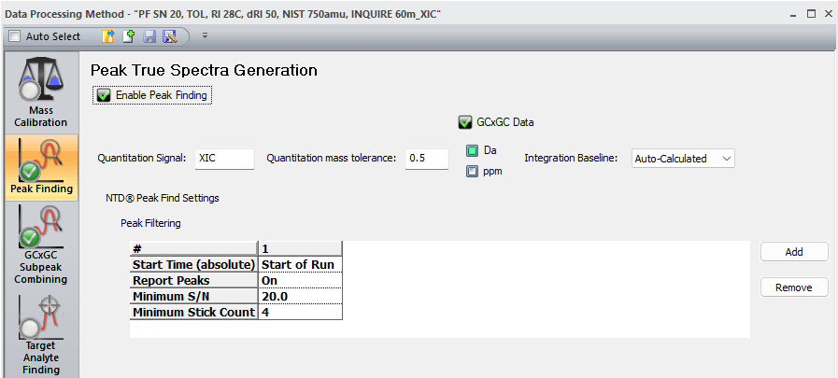

- Settings for “GC×GC Subpeak Combining”
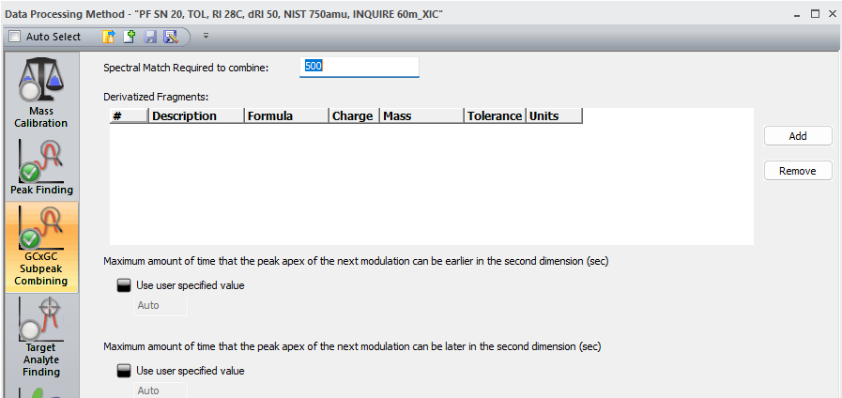

- Settings for “Retention Index”. The respective file with retention data can be prepared by, e.g., acquiring saturated alkane mixture chromatogram in respective solvent; for the RI data used in this work, see Table S3
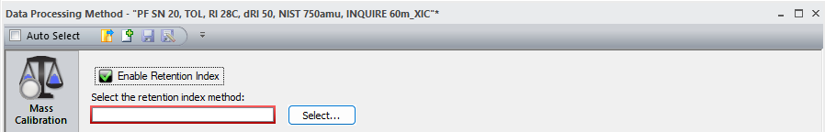

  - Settings for “Library Search Options”. Any other appropriate value can be used instead of proposed values used in this work
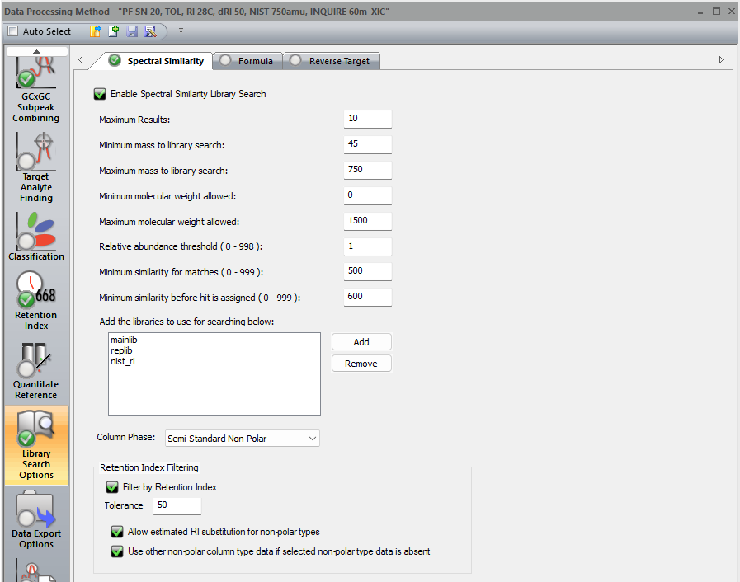
  - Save and name method by pressing “Save as”

- Create DP method for feature classification
  - Settings for Classification. Add class data in “Classes to use to classify the peaks” by pressing “Add” and navigating to the respective file
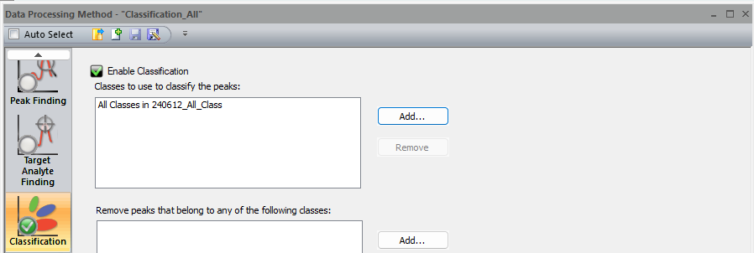

  - The classification file is created using “Create Regions” option in “Classifications” tab. Then, classes are created using “Create New Class” option and regions are assigned to classes using “Assign Region To Class” functionality in “Classifications” tab
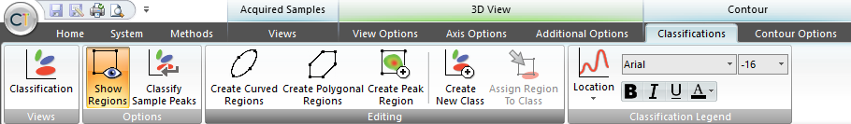

  - Chromatographic regions used in this study
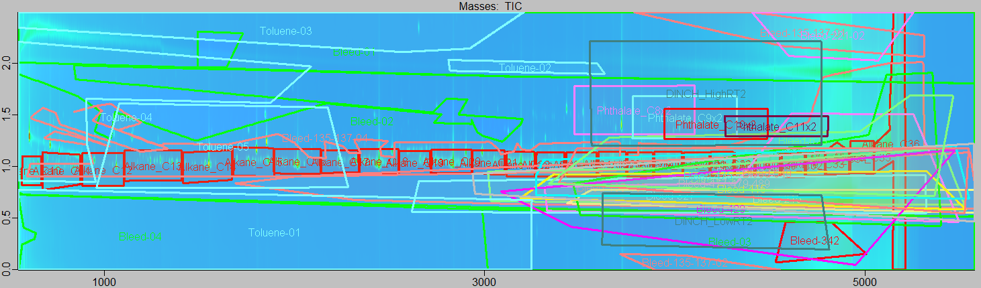

  - Additionally, spectral peak filters are added to classes as follows: “Classification – “Class file name” tab → Press on any class name in “Class” column → Choose filter from a drop-down menu → Press “OK”
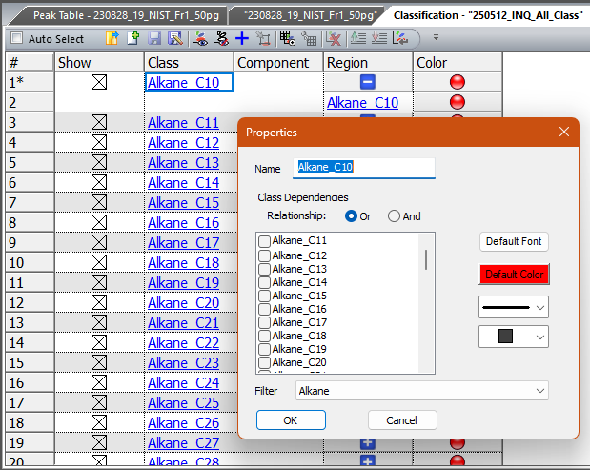

  - Peak filters are created as follows: “Peak Table – Sample name” tab → Press on “Filter” (filtration funnel icon) → Choose “Spectral” tab → Create spectral peak filter using statements → Save and name the filter by pressing “Save Filter Set” → Press “OK”
  - Example peak filter – Alkanes
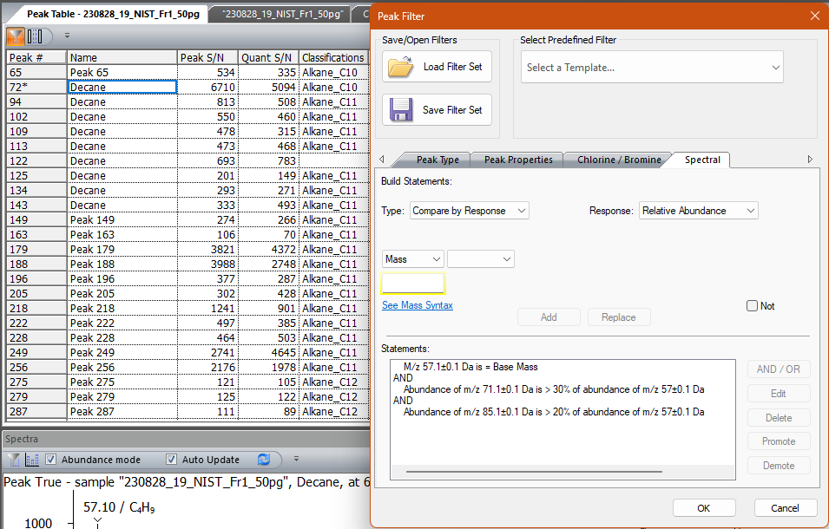

  - Example peak filter – DINCH
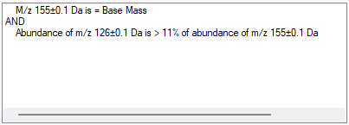

  - Example peak filter – Phthalates C8
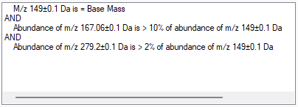

  - Example peak filter – Phthalates C9
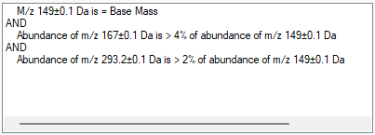

  - Example peak filter – Phthalates C10
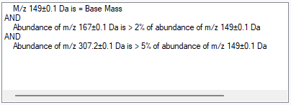

  - Example peak filter – Phthalates C11
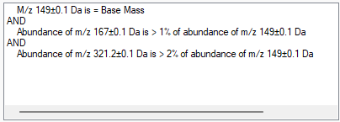
  - For more information about regions and filters, see “Classifications Overview” and “Working with Peak Filters – Spectral” sections and any other related section of the ChromaTOF manual.
  - Save and name DP classification method by pressing “Save as”

- Go to “Acquired Samples” and select all sample files to be processed. To begin DP, right mouse click on the selected samples → Data Processing. The new window will be called to the sample files location where the samples to be processed are highlighted; any additional samples can be added to the DP list at this point. Press “Select” → Select DP method, e.g., library search or classification → Press “Select”

- Create data export method
- In “Peak Data ASCII Export Options”:
  - Tick off “Export peak information in ASCII CSV format” and specify export directory
  - Set “Field Separator” to “Tab”
  - Tick off “Add Not Found Analytes”
- In “Columns”, select which information columns to be exported by highlighting them and pressing “Add >>”. For the next steps of the workflow, at least the following data columns should be included: “Name”, “R.T. (s)”, “Retention Index”, “Lib. RI”, Synonyms”, “Synonyms List”, “Observed Ion m/z”, “Expected Ion m/z”, “Formula”, “CAS”, “InChIKey”, “Actual Masses”, “Base Mass”, Quant Masses”, “FWHH (s)”, “Probability” “Similarity”, “Reverse”, “Area”, “Height”, “Classifications”, “Spectrum”
  - In “Spectra”, tick off “Export the peak true spectrum as part of the information for each peak” and set “Format of Intensity values” to “Relative”
- Save and name method by pressing “Save as”

- Go to “Acquired Samples” and select all sample files to be exported. To begin export, right mouse click on the highlighted samples → Data Processing. The new window will be called to the sample files location where the samples to be exported are highlighted; any additional samples can be added to the list at this point. Press “Next” → Select DP file export method → Press “OK”

- Inter-sample peak alignment and quantification of alkanes, phthalates, and DINCH compounds
- Retrieval of the class data (including retention index (RI) range, ranges for retention times in the 1st (RT1) and in the 2nd dimensions (RT2), formulae, base masses, and class total areas) is done by Class_Retriever.py; more information on how to use the script can be found in README file at https://github.com/r3bryk/Class_Retriever

- Inter-sample peak alignment of the class data into single alignment result table (ART) is done using Class_Aligner.py; more information on how to use the script can be found in README file at https://github.com/r3bryk/Class_Aligner

- Semi-quantification for the classes is done using INQUIRE_Quantifier.py; more information on how to use the script can be found in README file at https://github.com/r3bryk/INQUIRE_Quantifier

- Inter-sample peak alignment in ChromaTOF Sync 2D
NB: The settings for this workflow were chosen based on authors’ experience and do not necessarily reflect default settings of the ChromaTOF Sync 2D software.
  - Open ChromaTOF Sync 2D and press “Begin new alignment”
- In “Alignment name”, specify resulting file name
- In “Alignment type”, pick “GCxGC”
- In “Sample set”:
  - Choose desired database by double-clicking on its name
  - Choose desired sample folder by double-clicking on its name
  - Choose samples to be aligned by highlighting them and dragging to “Samples to compare” pane
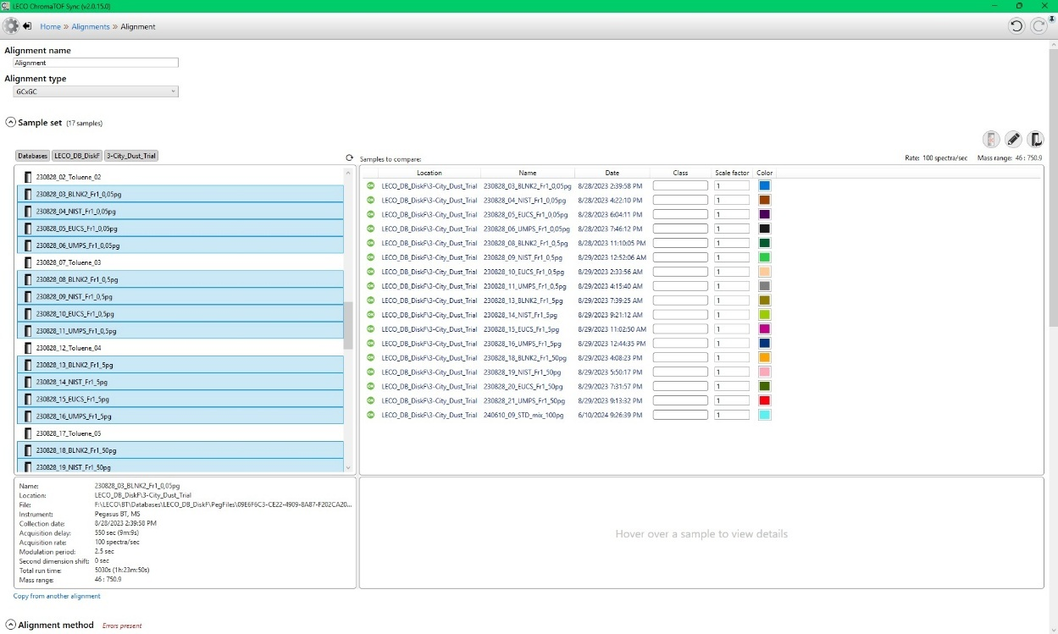

- Settings for “Alignment method” and “Library search”. Any other appropriate value can be used instead of proposed values used in this work
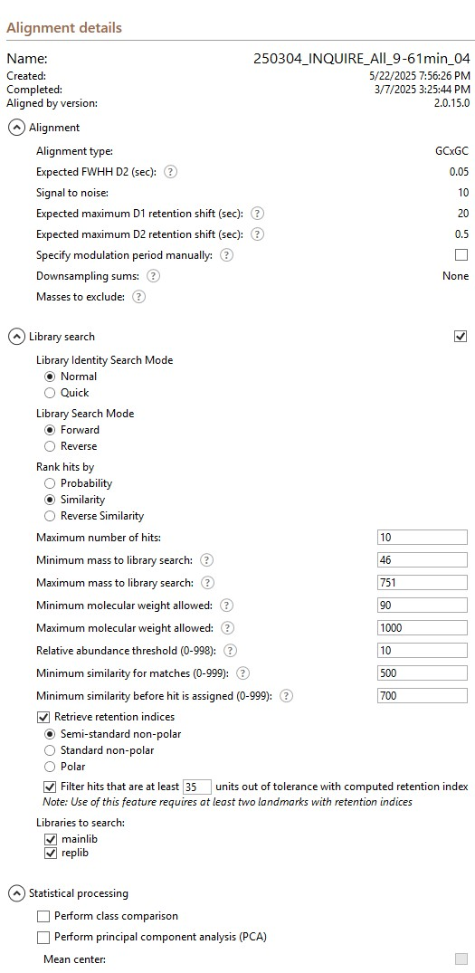

  - In “Landmarks”, specify name, retention times (R.T. (sec)), and retention indices (R.I.) for compounds that will be used for retention indexing; preferably, use the same landmark table as for library search in ChromaTOF (section 1b)
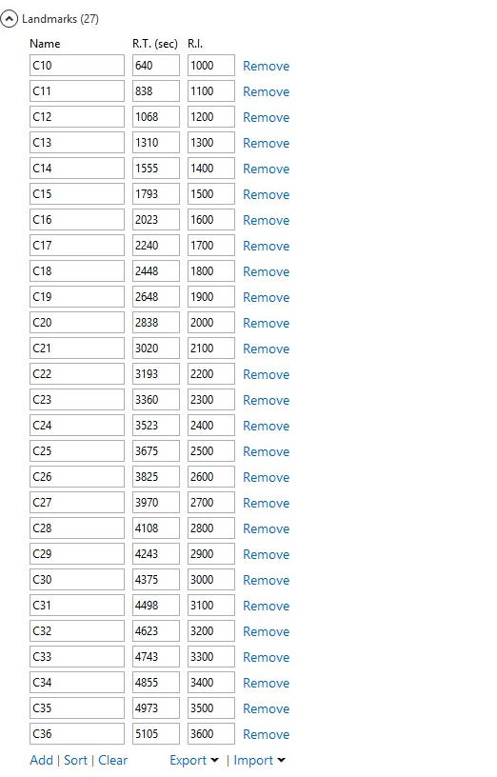

  - Press “Begin GCxGC alignment”

- Additional library search with different algorithms
- The ARTs were exported as TSV (tab-separated values) files and additional library searching was done using JLibSearch.jl; more information on how to use the script can be found in README and manual files at https://github.com/r3bryk/jLibSearch

- Removing alkanes, phthalates, and DINCH compounds from the ART
- Since alkanes, phthalates, and DINCH compounds were semi-quantified based on ChromaTOF classification, they must be removed from the ART. This is done using RT_Regions_&_Spectral_Filters.py, based on the use of chromatographic retention time regions and spectral peak filters like functionalities available in ChromaTOF software; more information on how to use the script can be found in README file at https://github.com/r3bryk/RT_Regions_and_Spectral_Filters
- Corrupted character replacement
- Compound names in the ART that contained any unusual or corrupted characters from the list, such as a German letter “ß” (Eszett or scharfes S) or “Î²” instead of a Greek letter “β” (beta), were replaced with Latin analogues using a VBA script in Microsoft Excel; more information on how to use the script can be found in README file at https://github.com/r3bryk/ReplaceCorruptedCharacters

- External postprocessing for ChromaTOF Sync 2D alignment data
- Because of the nature of the alignment algorithm that ChromaTOF Sync 2D uses, all the features are usually “found” in all the samples, however, with very small areas, e.g., 226.38, instead of 0.00. This creates problems when it comes to detection frequency (DF) calculation, which was needed in this study for DF-based compound/feature prioritization
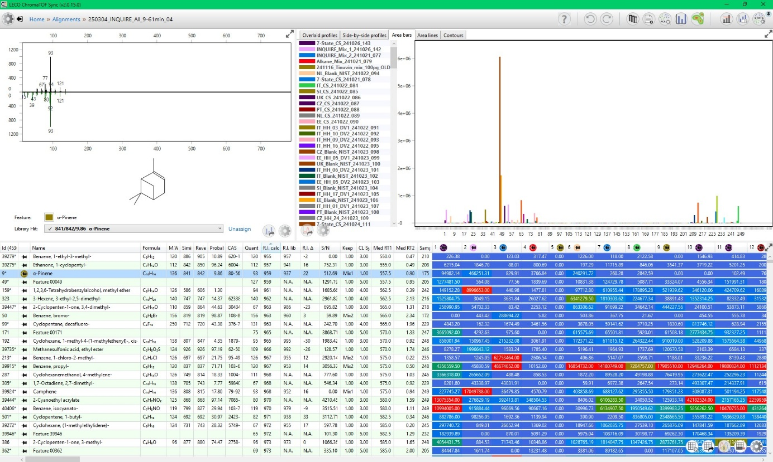

- Python script Sync2D_Postprocessor.py was used to distinguish between real peaks and peaks potentially with area values of 0. Histogram plot for distribution of log₁₀-transformed peak areas was created and modeling methods, such as the Gaussian mixture model (GMM; a probabilistic unsupervised machine learning (ML) model) and the kernel density estimation (KDE; a non-parametric method used for the probability density function estimation), were used to estimate the intersect of the two clusters as an area cutoff (~4.26). Then, antilog of the mean intersect was taken, giving an area cutoff of antilog₁₀(4.26) = 10^{4.26} = 18250. Then, all the area values under 18250 were replaced with -18250 (-LOD in peak area units)
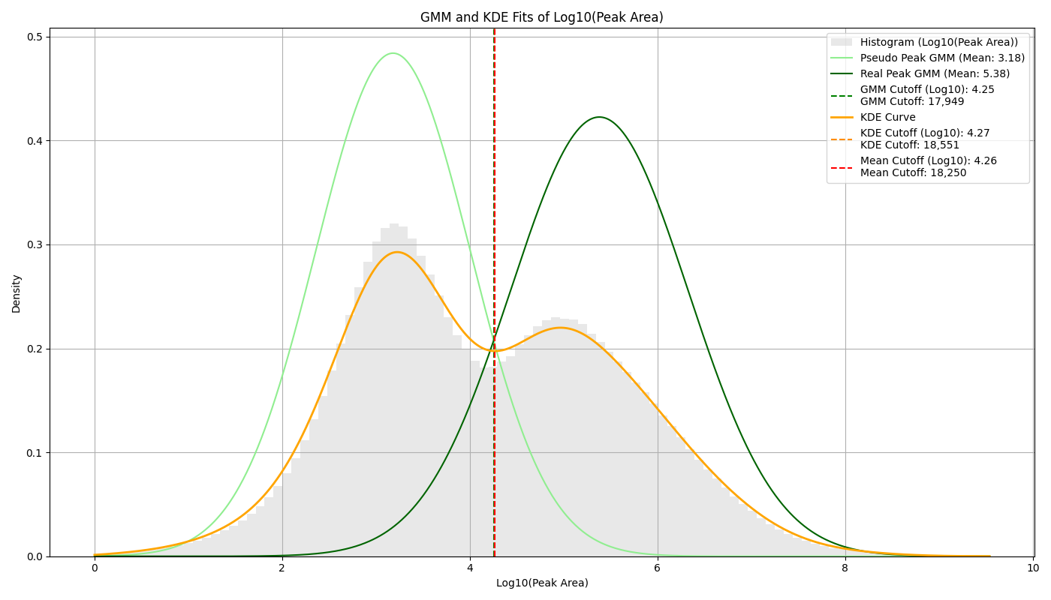
- Sync2D_Postprocessor.py is also used to merge duplicates based on the specified RI tolerance window and spectral similarity as well as to calculate DF and conduct DF-based feature prioritization using a hierarchical rule-based approach integrating DF, signal-to-blank relationships, and contextual annotations. Each feature is assigned a priority score from 0 (low) to 2 (high), which is subsequently translated into a ranking category
  - Features annotated as IS or RS, reference standard mixtures, compounds identified at CLs 1-2, or those with confirmed database matches (e.g., target or NORMAN dust trial compounds) are automatically assigned high priority (Priority = 2)
  - For all other features, prioritization is based on i) the ratio between sample signal intensities (above a predefined cutoff) and ii) the mean signal of procedural (UMU) blanks:
    - Features detected in at least 10% of samples, with at least 50% of sample-to-blank ratios ≥ 5, are assigned high priority (Priority = 2)
    - Otherwise, features are assigned low priority (Priority = 0)
  - For unknown features, an additional filtering step based on DF applies:
    - Features with DF < 2.5% are assigned low priority (Priority = 0) unless previously elevated
    - Features not yet prioritized are further evaluated for regional consistency, and those with DF ≥ 25% in any country are assigned high priority (Priority = 2)
    - Remaining features are assigned intermediate priority (Priority = 1)
  - Priority scores are translated into three ranking categories:
    - Ranking = 2 (retain): Priority = 2
    - Ranking = 1 (borderline, manual review/curation): Priority = 1, or unknown features with DF ≥ 2.5%
    - Ranking = 0 (discard): Priority = 0
- More information on how to use the script can be found in README file at https://github.com/r3bryk/Sync2D_Postprocessor
- Data gaps filling and classification
- NIST_Data_Retriever.py is used to retrieve InChIKey, CAS#, formulae, molecular weights, and retention indices from NIST 2023 library (exported as SDF file and converted to Excel) based on compound names. More information on how to use the script can be found in README file at https://github.com/r3bryk/NIST_Data_Retriever
- PubChem_Retriever.py is used to retrieve InChIKey, SMILES, CAS#, DTXSID (Distributed Structure-Searchable Toxicity Substance Identifier), uses, and use classification values from PubChem database using compound names and existing NIST InChIKey values as input. In addition, it retrieves chemical class data from ClassyFire Batch. More information on how to use the script can be found in README file at https://github.com/r3bryk/PubChem_Retriever
- INQUIRE_Classfinder.py is used to retrieve functional use data from various databases based on compound name, InChIKey, and DTXSID in a stepwise manner. More information on how to use the script can be found in README file at https://github.com/r3bryk/INQUIRE_Classfinder

- (Semi-)quantification
- INQUIRE_Quantifier.py is used to i) quantify features based on availability of reference standards were available and/or ii) semi-quantify features using internal standards. The calculations are made using total component areas computed by the script and the final concentrations are normalized to 1 g of dust. More information on how to use the script can be found in README file at https://github.com/r3bryk/INQUIRE_Quantifier

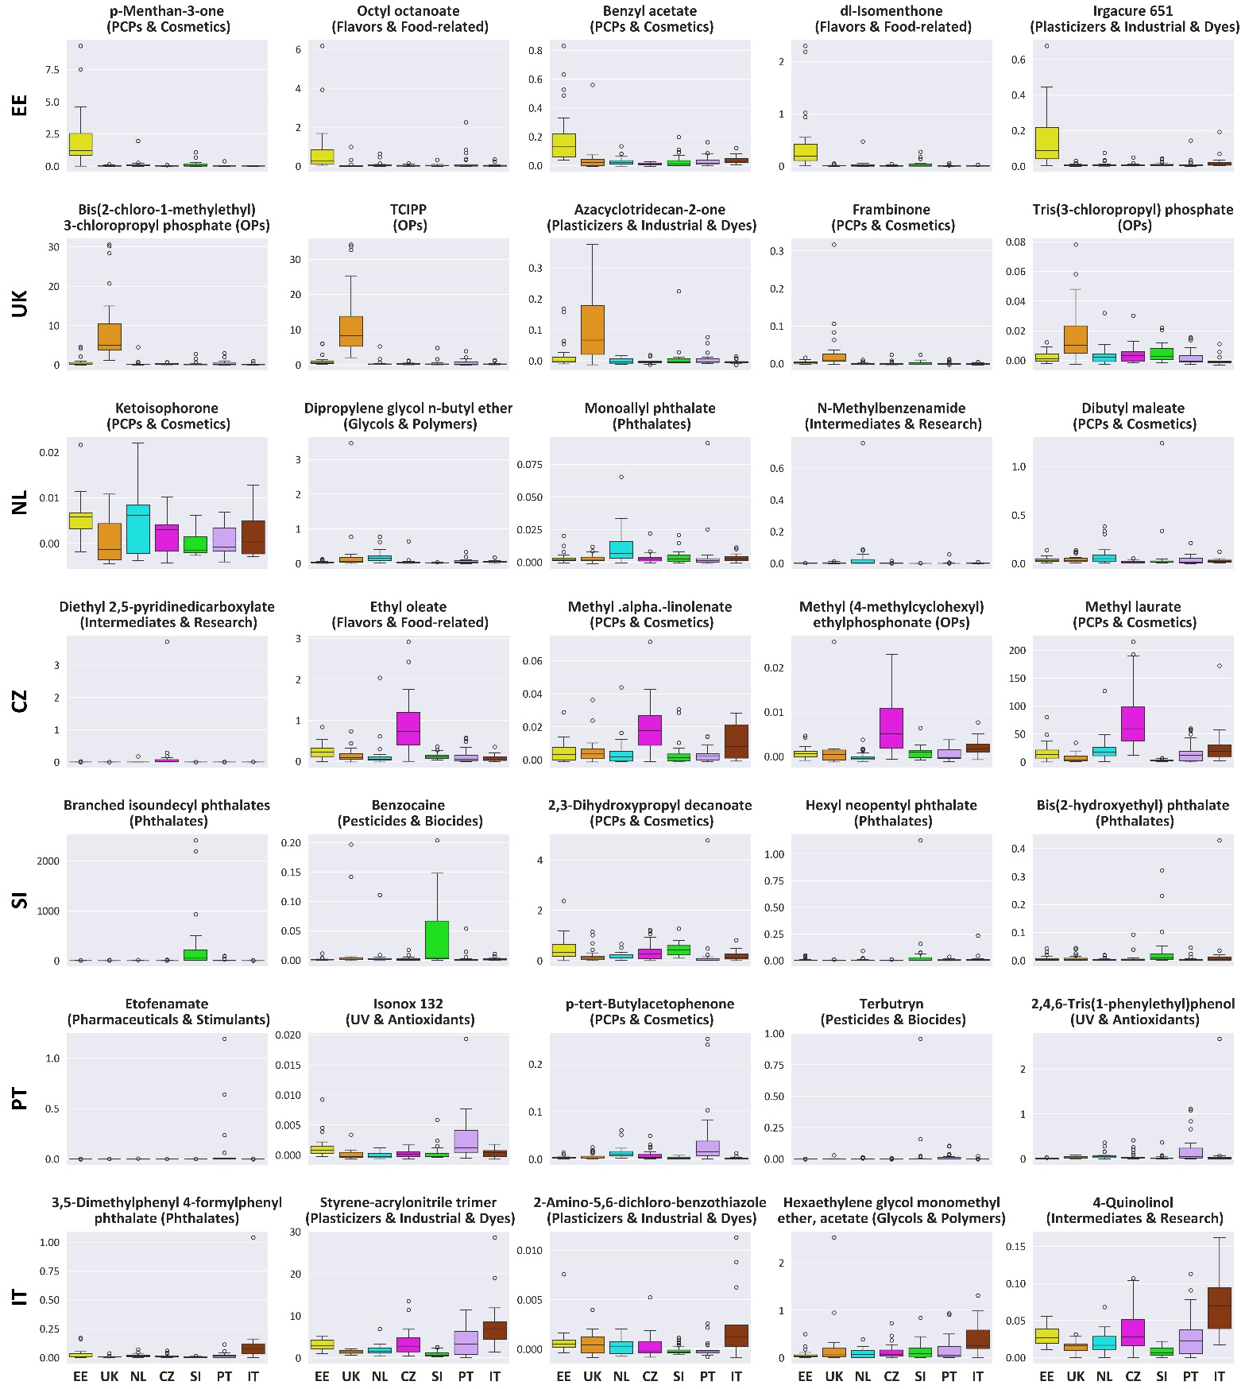

Figure S7. Box-and-whisker plot for concentrations (µg/g dust) of signature compounds for the seven countries under study. Top 5 compounds are included for each country. The graphs are loosely organized according to geographic location (north-to-south), from top row to bottom row: Estonia, the UK, the Netherlands, Czechia, Slovenia, Portugal, and Italy.

