SUPPLEMENTAL INFORMATION
Supplementary Figure and Legends S1-S4
Supplementary Tables S1-S4
Extended Data to Supplementary Figures

Supplementary Figures:
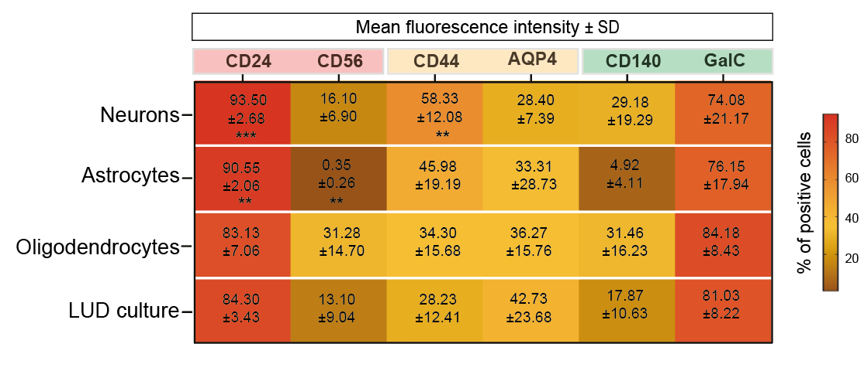
Supplementary Figure S1
Heatmap depicting mean florescence intensity of cells immunoreactive for early and late neuronal (CD24, CD56), astrocytic (CD44, AQP4) and oligodendrocytic (CD140, GalC) differentiation markers (Data represent mean ± SEM from 3 biological replicates). Statistical significance was assessed by unpaired t-test, **p < 0.01, ***p < 0.001.
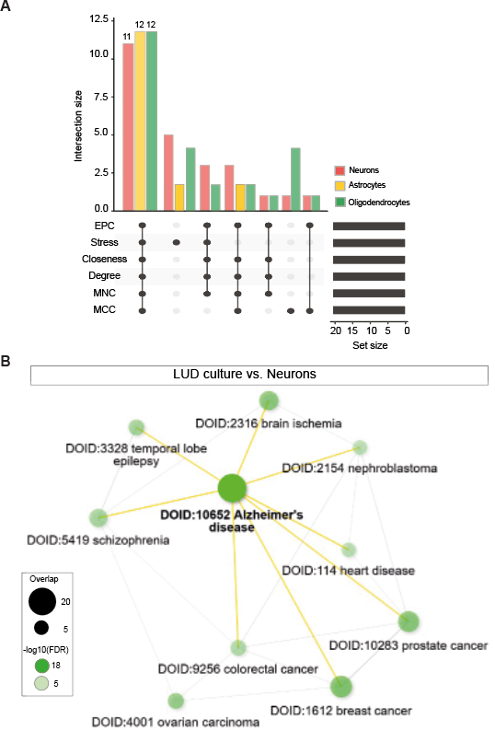
Supplementary Figure S2
A) The UpSet plot shows the overlap of hub genes identified using individual CytoHubba algorithms in individual PPI networks of DEG genes (in neurons, astrocytes, and oligodendrocytes when compared to LUD culture).
B) Network analysis using the Disease Alliance database identified top significantly enriched disease pathways among genes upregulated in the LUD culture compared with neuron-only cultures.

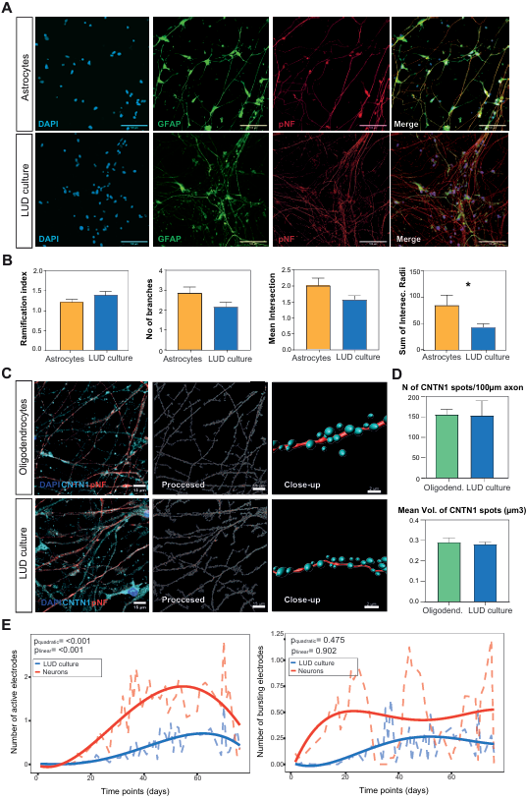
Supplementary Figure S3
A) Representative images of LUD cell cultures and astrocytes culture stained for glial fibrillary acidic protein (GFAP) and for the axonal projections with an antibody against the phosphorylated neurofilament heavy chain (pNF) and DAPI (scale bar 15 μm and 2 μm).
B) Sholl analysis of astrocytes showing number of branches, ramification index, mean intersection and sum of intersecting radii in LUD culture vs. astrocytes. Data represent mean ± SEM from 3 biological replicates (each with 3 technical replicates). Statistical significance was assessed by unpaired t-test, *p<0.05).
C) Representative Imaris processed confocal Z-stack images of cell populations stained for the axonal projections with an antibody against the phosphorylated neurofilament heavy chain (pNF) and Contactin-1 (CNTN1) responsible for the establishment of axon-myelin junctions at paranodes.
D) Quantification of CNTN1 intensity. Graph showing number of spots per axonal projections in NSCs differentiated using LUD versus discriminate approach (n=3 experiments per condition, unpaired t-test, *p<0.05).
E) MEA recordings showing network activity in LUD cultures compared with neuron-only cultures. Metrics include number of active and bursting electrodes. Dashed lines indicate means from three biological replicates (32 technical replicates per time point); solid lines represent smoothed fourth-degree polynomial regression fits. Linear and quadratic growth trends were assessed using Welch’s t-test.

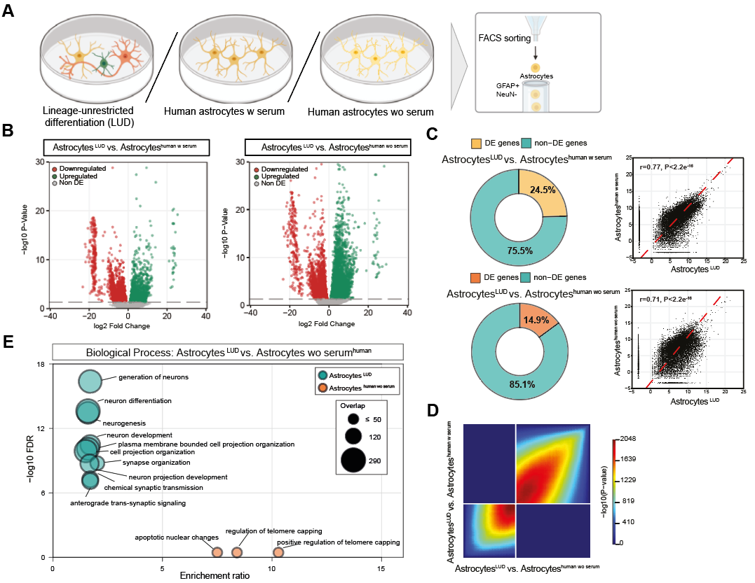
Supplementary Figure S4
A) Workflow diagram. Schematic of the experimental protocol whereby differentiated NSCs were first sorted and then the RNA of individual astrocytic cell populations sequenced. Considering significant effect of serum on the astrocytes, astrocytes generated using the LUD approach were compared with astrocytes harvested from week 20 human fetal cortex grown with or without serum.
B) Volcano plots showing downregulated and upregulated differentially expressed genes in astrocytes differentiated using LUD approach compared with human fetal cortical astrocytes grown with or without serum.
C) The percentage overlap in cell culture transcriptomes. Proportions of identical and differentially expressed genes and the respectful correlations between astrocytes differentiated using LUD approach (A^{id}) compared with human fetal cortical astrocytes grown with (A^{ws}) or without serum (A^{wos}). Scatterplots show Spearman's correlation of average gene expressions between A^{id} and A^{ws} and between A^{id} and A^{wos}.
D) Heatmaps showing log₂-transformed odds ratios of rank–rank hypergeometric overlap analysis of concordance of DE RNAs between A^{id} (LUD culture astrocytes) versus A^{ws} (human fetal astrocytes grown with serum) and A^{id} versus A^{wos} (human fetal astrocytes grown without serum).
E) Gene ontology analysis of the significant top ranking biological processes in DEGs upregulated in astrocytes differentiated using LUD approach compared with human fetal cortical astrocytes grown without serum.

