Supplemental Table 1. The variants profiles of enrolled 30 patients.
Patient screening number | Patient randomization number | Group | Gene | Variants | Parental validation | Pathogenic classification
1 | 1 | PEG-rhGH | PTPN11 | c.922A>G,p.Asn308Asp | de novo | P
2 | 2 | Daily GH | PTPN11 | c.1504T>G,p.Ser502Ala | de novo | LP
3 | 8 | Daily GH | PTPN11 | c.182A>G,p.Asp61Gly | de novo | P
4 | 16 | Daily GH | PTPN11 | c.854T>C,p.Phe285Ser | de novo | LP
5 | 17 | PEG-rhGH | PTPN11 | c.1471C>T,p.Pro491Ser | de novo | P
7 | 27 | PEG-rhGH | PTPN11 | c.218C>T,p.Thr73Ile | de novo | P
8 | 20 | Daily GH | PTPN11 | c.181G>A,p.Asp61Asn | de novo | P
9 | 7 | PEG-rhGH | PTPN11 | c.794G>A,p.Arg265Gln | de novo | P
10 | 26 | Daily GH | PTPN11 | c.1507G>C,p.Gly503Arg | de novo | P
13 | 4 | Daily GH | SHOC2 | c.4A>G,p.Ser2Gly | de novo | P
14 | 12 | Daily GH | PTPN11 | c.317A>C,p.Asp106Ala | de novo | P
15 | 10 | Daily GH | PTPN11 | c.853T>C,p.Phe285Leu | de novo | P
16 | 23 | PEG-rhGH | SHOC2 | c.4A>G,p.Ser2Gly | de novo | P
22 | 13 | PEG-rhGH | PTPN11 | c.179G>C,p.Gly60Ala | de novo | P
23 | 9 | PEG-rhGH | PTPN11 | c.215C>G,p.Ala72Gly | de novo | P
24 | 28 | Daily GH | PTPN11 | c.1507G>A,p.Gly503Arg | de novo | P
26 | 11 | PEG-rhGH | PTPN11 | c.1529A>G,p.Gln510Arg | F | P
27 | 22 | Daily GH | PTPN11 | c.317A>C,p.Asp106Ala | de novo | P
28 | 3 | PEG-rhGH | PTPN11 | c.794G>A,p.Arg265Gln | de novo | P
29 | 30 | Daily GH | SHOC2 | c.4A>G,p.Ser2Gly | de novo | P
30 | 15 | PEG-rhGH | PTPN11 | c.188A>G,p.Tyr63Cys | de novo | P
31 | 24 | Daily GH | PTPN11 | c.182A>G,p.Asp61Gly | de novo | P
33 | 19 | PEG-rhGH | SOS1 | c.1649T>C,p.Leu550Pro | de novo | P
34 | 21 | PEG-rhGH | PTPN11 | c.922A>G,p.Asn308Asp | de novo | P
35 | 5 | PEG-rhGH | PTPN11 | c.922A>G,p.Asn308Asp | de novo | P
36 | 18 | Daily GH | PTPN11 | c.218C>T,p.Thr73Ile | de novo | P
37 | 6 | Daily GH | PTPN11 | c.1510A>G,p.Met504Val | de novo | P
38 | 29 | PEG-rhGH | PTPN11 | c.236A>G,p.Gln79Arg | F | P
39 | 32 | Daily GH | PTPN11 | c.922A>G,p.Asn308Asp | de novo | P
40 | 31 | PEG-rhGH | PTPN11 | c.794G>A,p.Arg265Gln | de novo | P
PEG-rhGH, polyethylene glycol-conjugated recombinant human growth hormone; GH, growth hormone; P, Pathogenic; LP, Likely Pathogenic; F, paternal inheritance; Pathogenicity classification for all identified variants was determined in accordance with the American College of Medical Genetics and Genomics (ACMG) guidelines.

Supplemental Table 2. Changes in metabolic and thyroid profiles over 52 weeks of treatment.
Parameter & Visit | Daily GH (n = 15) | PEG-rhGH (n = 15) | P value (Between groups)
Fasting Blood Glucose (mmol/L)
Baseline | 4.76 ± 0.64 | 4.65 ± 0.54 | 0.612
Week 26 | 4.99 ± 0.55 | 4.87 ± 0.24 | 0.449
Week 52 | 4.92 ± 0.44 | 4.98 ± 0.31 | 0.672
P value (within-group: 0 vs 52w) | 0.448 | 0.061 | -
HbA1c (%)
Baseline | 4.81 ± 0.36 | 4.94 ± 0.20 | 0.252
Week 26 | 4.94 ± 0.45 | 5.09 ± 0.23 | 0.274
Week 52 | 4.89 ± 0.37 | 5.08 ± 0.26 | 0.116
P value (within-group: 0 vs 52w) | 0.54 | 0.084 | -
Total Cholesterol (TC, mmol/L)
Baseline | 4.03 ± 0.68 | 4.17 ± 0.93 | 0.638
Week 26 | 3.58 ± 0.74 | 4.01 ± 0.86 | 0.155
Week 52 | 4.05 ± 0.73 | 4.41 ± 1.22 | 0.347
P value (within-group: 0 vs 52w) | 0.941 | 0.463 | -
Triglycerides (TG, mmol/L)
Baseline | 1.28 ± 0.75 | 1.06 ± 0.64 | 0.395
Week 26 | 1.15 ± 0.39 | 0.79 ± 0.15 | 0.003**
Week 52 | 1.20 ± 0.58 | 0.64 ± 0.22 | 0.004**
P value (within-group: 0 vs 52w) | 0.671 | 0.038* | -
TSH (uIU/mL)
Baseline | 3.23 ± 1.63 | 2.50 ± 1.28 | 0.187
Week 26 | 3.42 ± 1.54 | 2.50 ± 0.96 | 0.062
Week 52 | 3.03 ± 1.15 | 2.50 ± 1.06 | 0.203
P value (within-group: 0 vs 52w) | 0.58 | 0.999 | -
Free T3 (pmol/L)
Baseline | 5.37 ± 1.10 | 5.00 ± 0.51 | 0.245
Week 26 | 5.38 ± 0.81 | 5.48 ± 0.67 | 0.716
Week 52 | 5.34 ± 0.61 | 5.56 ± 0.60 | 0.334
P value (within-group: 0 vs 52w) | 0.902 | 0.003** | -
Free T4 (pmol/L)
Baseline | 16.59 ± 2.66 | 15.52 ± 2.53 | 0.267
Week 26 | 14.54 ± 2.37 | 15.50 ± 1.93 | 0.239
Week 52 | 15.82 ± 1.83 | 14.92 ± 2.21 | 0.244
P value (within-group: 0 vs 52w) | 0.37 | 0.407 | -
Between-group differences at each time point were analyzed using independent samples t-tests. Within-group changes from baseline to Week 52 were analyzed using paired t-tests. *P < 0.05, **P < 0.01.
Data are presented as mean ± standard deviation (SD).PEG-rhGH, polyethylene glycol-conjugated recombinant human growth hormone; GH, growth hormone; HbA1c, glycated hemoglobin; TC, total cholesterol; TG, triglycerides; TSH, thyroid-stimulating hormone; FT3, free triiodothyronine; FT4, free thyroxine.

Supplemental Table 3. Multiple linear regression analysis of baseline factors affecting the change in Height SDS over 52 weeks of treatment.
Variable | β Coefficient | Standard Error  (SE) | 95% Confidence Interval | t-value | P-value
PEG-rhGH (n = 15)
Constant | 1.086 | 0.254 | [0.533, 1.639] | 4.276 | 0.001
Baseline Age (Years) | -0.062 | 0.029 | [-0.125, 0.001] | -2.150 | 0.052
Baseline Height SDS | -0.041 | 0.097 | [-0.252, 0.170] | -0.418 | 0.683
Daily GH (n = 15)
Constant | 1.532 | 0.650 | [0.116, 2.948] | 2.357 | 0.036
Baseline Age (Years) | -0.106 | 0.074 | [-0.267, 0.055] | -1.430 | 0.179
Baseline Height SDS | 0.038 | 0.217 | [-0.435, 0.511] | 0.175 | 0.864

This table presents the outcomes of multiple linear regression models, fitted using Ordinary Least Squares (OLS), to evaluate the independent effects of baseline age and baseline height SDS on the 52-week catch-up growth (Δ Height SDS) in both long-acting and short-acting treatment groups. The unstandardized regression coefficients (β) represent the estimated absolute change in Δ Height SDS per unit increase in the respective predictor variable, holding the other variable constant. The statistical significance of each predictor was evaluated using the t-statistic (the ratio of β to its standard error, SE).
In the long-acting group, baseline age demonstrated a marginally significant negative association with Δ Height SDS (β= -0.062, t= -2.150, P= 0.052), suggesting a trend where younger age at treatment initiation may independently predict a greater magnitude of growth response. Baseline height SDS did not exert a statistically significant influence on catch-up growth in either treatment model (P > 0.05), confirming that the observed treatment effects were not heavily confounded by initial height deficits.
Overall model fit is described by the coefficient of determination (R²) and F-statistics. Model Summary for PEG-rhGH Group: R² = 0.286, Adjusted R² = 0.167, F-statistic = 2.40, P = 0.133. Model Summary for Daily GH Group: R² = 0.148, Adjusted R² = 0.006, F-statistic = 1.04, P = 0.384.
Δ Height SDS is defined as Height SDS at 52 weeks minus Baseline Height SDS. PEG-rhGH, polyethylene glycol-conjugated recombinant human growth hormone; GH, growth hormone.

Supplementary Figure 1. Comparison of long-term growth responses between PEG-rhGH and Daily GH after 52 weeks of treatment.
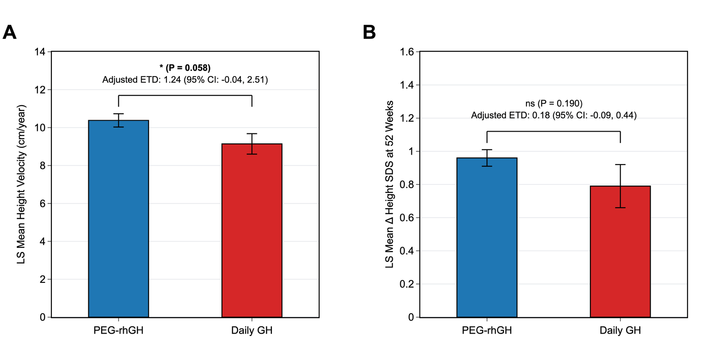
(A) Least Squares (LS) Mean height velocity at 52 weeks. (B) LS Mean change in height standard deviation score ($Δ$Height SDS) at 52 weeks. Both models were analyzed using an analysis of covariance (ANCOVA) adjusting for baseline age and baseline height SDS to account for potential initial imbalances. Error bars indicate standard error of the mean (SEM) based on robust HC3 standard errors due to heteroscedasticity. PEG-rhGH, polyethylene glycol-conjugated recombinant human growth hormone; GH, growth hormone; ETD, estimated treatment difference; CI, confidence interval.

Supplemental Figure 2. Changes in body mass index and metabolic profiles over 52 weeks of growth hormone treatment.
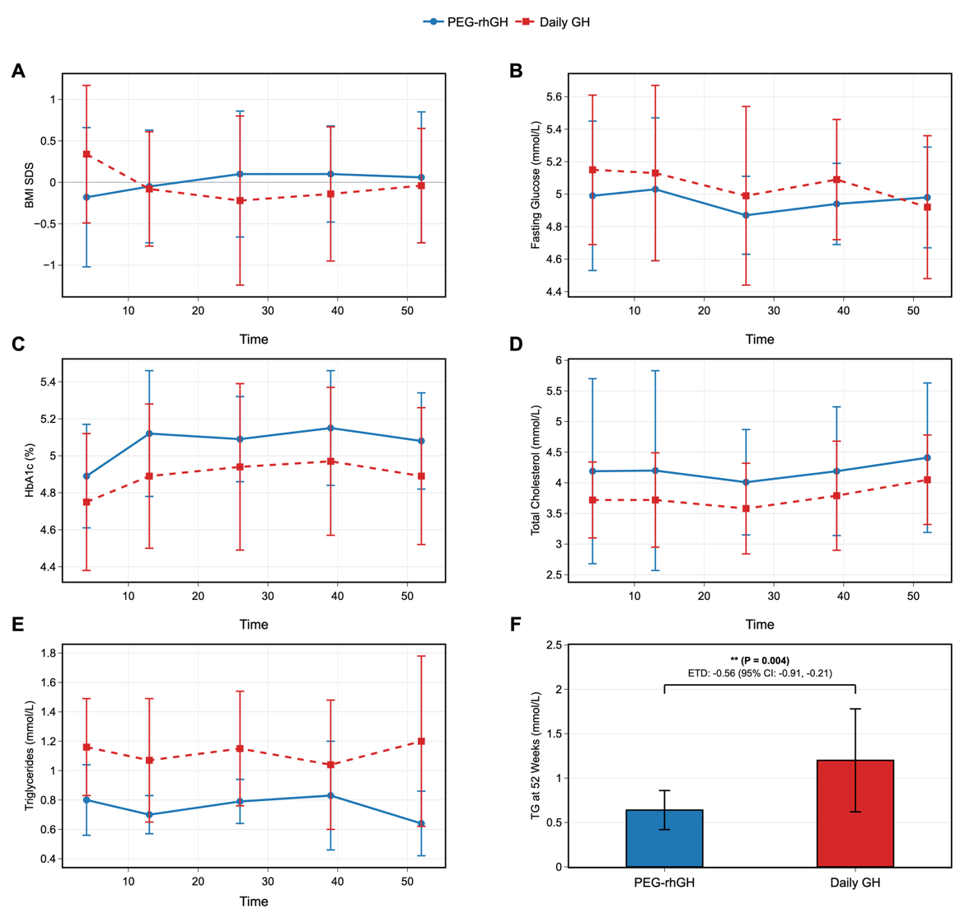
(A) Longitudinal trends of body mass index standard deviation score (BMI SDS). (B) Fasting glucose (mmol/L). (C) Glycated hemoglobin (HbA1c, %). (D) Total cholesterol (mmol/L). (E) Triglycerides (mmol/L). For panels A–E, the solid blue line with circles represents patients treated with once-weekly PEG-rhGH, and the dashed red line with squares represents patients receiving once-daily GH. Assessments were conducted from baseline through week 52. (F) Comparison of serum triglyceride (TG) levels at the 52-week endpoint. The PEG-rhGH group demonstrated significantly lower triglyceride levels compared to the Daily GH group at week 52 ( P = 0.004; ETD: -0.56, 95% CI: -0.91, -0.21). Data are presented as means, and error bars indicate standard deviations.
PEG-rhGH, polyethylene glycol-conjugated recombinant human growth hormone; GH, growth hormone; BMI, body mass index; SDS, standard deviation score; HbA1c, glycated hemoglobin; TG, triglycerides; ETD, estimated treatment difference; CI, confidence interval.

