Title:
Hierarchical drivers and ecological thresholds of shrub-to-forest transition in Mediterranean landscapes: implications for restoration
Galobart-Corominas M.¹, Vallbé-Mumbrú M.², Espírito Santo M.³, Nunes A.³, Branquinho C³.

Authors:
Marçal Galobart-Corominas¹ , ORCID: https://orcid.org/0009-0001-9399-6091
Marc Vallbé-Mumbrú² , ORCID: https://orcid.org/0000-0002-7518-8971
Maria Espírito Santo³ , ORCID: https://orcid.org/0009-0007-8837-622X
Alice Nunes³ , ORCID: https://orcid.org/0000-0002-6900-3838
Cristina Branquinho³ , ORCID: https://orcid.org/0000-0001-8294-7924
¹Department of Mining, Industrial and ICT Engineering (EMIT), Manresa School of Engineering (EPSEM), Universitat Politècnica de Catalunya (UPC), Av. Bases de Manresa 61-73, 08242 Manresa, Spain
²Department of Mining, Industrial and ICT Engineering (EMIT), Research Group on Intelligent and Sustainable Resources and Industries (RIIS), Manresa School of Engineering (EPSEM), Universitat Politècnica de Catalunya (UPC), Av. Bases de Manresa 61-73, 08242 Manresa, Spain
³cE3c – Center for Ecology, Evolution and Environmental Changes & CHANGE – Global Change and Sustainability Institute, Faculdade de Ciências da Universidade de Lisboa, 1749-016 Lisbon, Portugal

Corresponding Author: Marc Vallbé-Mumbrú
Pone number: +34 93 87 77 209
e-mail: marc.vallbe@upc.edu
Table S1. Summary of variables included in the analyses
Category | Code | Description | Unit | Data type | Resolution | Source
Vegetation productivity | NDVI_8687 | Mean NDVI value derived from Landsat 4–5 TM imagery (May 1986–1987) for each shrubland location | Index  (-1 to 1) | Raster | 30 m | USGS, 2025
Landscape context | Surr_LULC_500m | Percentage of each land-use class within a 500 m buffer around each initial shrub observation, calculated from the 1987 landscape configuration using a land-cover map | % | Vector | 30 m pixel size; 500 m analysis buffer | Author's calculations based on Generalitat de Catalunya, 2024
Topography | DEM | Elevation, from Digital elevation model | m | Raster | 15 m | ICGC, 2011
Topography | Slope | Slope, from Digital elevation model | º | Raster | 15 m | ICGC, 2011
Topography | TWI | Topographic wetnes index, derived from the DEM using SAGA GIS algorithms | - | Raster | 15 m | Conrad, 2014
Topography | PSR | Potential solar radiation | 10 kJ/(m²·day·µm) | Raster | 200 m | (Ninyerola et al., 2005)
Bioclimate | BIO01 | Annual Mean Temperature | ºC | Raster | 1 km | Wouters, 2021
Bioclimate | BIO02 | Mean Diurnal Range (Mean of monthly (max temp - min temp)) | ºC | Raster | 1 km | Wouters, 2021
Bioclimate | BIO03 | Isothermality (BIO2/BIO7) (×100) | ºC | Raster | 1 km | Wouters, 2021
Bioclimate | BIO04 | Temperature Seasonality (standard deviation ×100) | ºC | Raster | 1 km | Wouters, 2021
Bioclimate | BIO05 | Max Temperature of Warmest Month | ºC | Raster | 1 km | Wouters, 2021
Bioclimate | BIO06 | Min Temperature of Coldest Month | ºC | Raster | 1 km | Wouters, 2021
Bioclimate | BIO07 | Temperature Annual Range (BIO5-BIO6) | ºC | Raster | 1 km | Wouters, 2021
Bioclimate | BIO08 | Mean Temperature of Wettest Quarter | ºC | Raster | 1 km | Wouters, 2021
Bioclimate | BIO09 | Mean Temperature of Driest Quarter | ºC | Raster | 1 km | Wouters, 2021
Bioclimate | BIO10 | Mean Temperature of Warmest Quarter | ºC | Raster | 1 km | Wouters, 2021
Bioclimate | BIO11 | Mean Temperature of Coldest Quarter | ºC | Raster | 1 km | Wouters, 2021
Bioclimate | BIO12 | Annual Precipitation | mm | Raster | 1 km | Wouters, 2021
Bioclimate | BIO13 | Precipitation of Wettest Month | mm | Raster | 1 km | Wouters, 2021
Bioclimate | BIO14 | Precipitation of Driest Month | mm | Raster | 1 km | Wouters, 2021
Bioclimate | BIO15 | Precipitation Seasonality (Coefficient of Variation) | mm | Raster | 1 km | Wouters, 2021
Bioclimate | BIO16 | Precipitation of Wettest Quarter | mm | Raster | 1 km | Wouters, 2021
Bioclimate | BIO17 | Precipitation of Driest Quarter | mm | Raster | 1 km | Wouters, 2021
Bioclimate | BIO18 | Precipitation of Warmest Quarter | mm | Raster | 1 km | Wouters, 2021
Bioclimate | BIO19 | Precipitation of Coldest Quarter | mm | Raster | 1 km | Wouters, 2021
Bioclimate | ET | Potential Evapotranspiration | mm/year | Raster | 1 km | Zomer et al., 2022
Bioclimate | AI | Global Aridity index | - | Raster | 1 km | Zomer et al., 2022
Soil properties and lithology | AWC | Available Water Capacity | - | Raster | 500 m | Ballabio et al., 2016
Soil properties and lithology | Bulk_dens | Bulk density | - | Raster | 500 m | Ballabio et al., 2016
Soil properties and lithology | Clay | Clay content | % | Raster | 500 m | Ballabio et al., 2016
Soil properties and lithology | Coarse | Coarse fragments content | % | Raster | 500 m | Ballabio et al., 2016
Soil properties and lithology | Sand | Sand content | % | Raster | 500 m | Ballabio et al., 2016
Soil properties and lithology | Silt | Silt content | % | Raster | 500 m | Ballabio et al., 2016
Soil properties and lithology | CaCO3 | Calcium carbonates (CaCO3) | - | Raster | 500 m | Ballabio et al., 2019
Soil properties and lithology | CEC | Cation Exchange Capacity | - | Raster | 500 m | Ballabio et al., 2019
Soil properties and lithology | CN | C:N ratio | - | Raster | 500 m | Ballabio et al., 2019
Soil properties and lithology | P | Phosphorus (P) | - | Raster | 500 m | Ballabio et al., 2019
Soil properties and lithology | K | Potassium (K) | - | Raster | 500 m | Ballabio et al., 2019
Soil properties and lithology | N | Nitrogen (N) | - | Raster | 500 m | Ballabio et al., 2019
Soil properties and lithology | pH_CaCl | pH (n CaCl2 0.01 M solution) | - | Raster | 500 m | Ballabio et al., 2019
Soil properties and lithology | pH_H2O | pH (measured in H2O) | - | Raster | 500 m | Ballabio et al., 2019
Soil properties and lithology | pH_H2O_CaCl | pH in H2O minus pH in Cacl2 | - | Raster | 500 m | Ballabio et al., 2019
Soil properties and lithology | soil_org_30 | soil organic carbon concentration maps for the 0–30 cm | g/kg | Raster | 90 m | Durante et al., 2024
Soil properties and lithology | soil_org_100 | soil organic carbon concentration maps for the 30–100 cm | g/kg | Raster | 90 m | Durante et al., 2024
Soil properties and lithology | sil | siliceous rocks | - | Vector-polygons | n.a. | Derived from ICGC, 2006
Soil properties and lithology | carb | carbonated rocks | - | Vector-polygons | n.a. | Derived from ICGC, 2006
Soil properties and lithology | lim | limestone | - | Vector-polygons | n.a. | Derived from ICGC, 2006
Soil properties and lithology | cal_sed | calcareous sediments | - | Vector-polygons | n.a. | Derived from ICGC, 2006
Soil properties and lithology | sil_sed | siliceous sediments | - | Vector-polygons | n.a. | Derived from ICGC, 2006
Population influence | NTL_2013 | Night-time light intensity used as a proxy for human activities, extracted from the 2013 monthly cloud-free VIIRS DNB composite | nW/cm²/sr | Raster | 500 m | Elvidge et al., 2017
Population influence | Population_2015 | Human population from municipality level | Inhabitants | Vector | Municipality level | IDESCAT, 2015

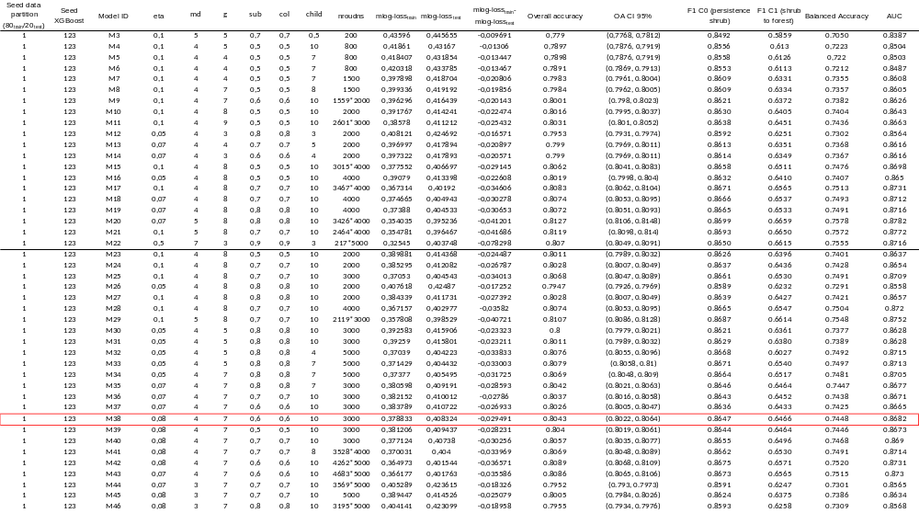
Table S2. Candidate XGBoost models evaluated during model selection. Several candidate models were tested using alternative hyperparameter combinations and predictor sets. Initial models (M3-M22) excluded evapotranspiration (ET) and aridity-related variables, whereas subsequent models (M23-M46) incorporated these predictors to better represent water-stress processes. The following hyperparameters were evaluated using the R package xgboost (Chen et al., 2024): eta, learning rate; g, gamma; md, maximum tree depth; child, minimum child weight; col, colsample by tree; sub, subsample by tree; and nrounds, number of boosting rounds. Model performance was assessed using test multiclass log-loss (mlog-loss), the difference between training and test mlog-loss as an indicator of overfitting, overall accuracy, balanced accuracy, F1 score, and area under the receiver operating characteristic curve (AUC). Early stopping was set to five rounds; models for which training stopped before reaching the maximum number of rounds are identified with an asterisk (*) in the nrounds column. Although some candidate models achieved marginally higher predictive performance, differences among the best-performing models were small (<1%). The final model (M38), highlighted with a red border, was selected because it combined high predictive performance with limited evidence of overfitting while retaining ecologically meaningful predictors directly related to shrub-to-forest transition and forest establishment processes. See Table S2 for a description of all predictor variables and their data sources.

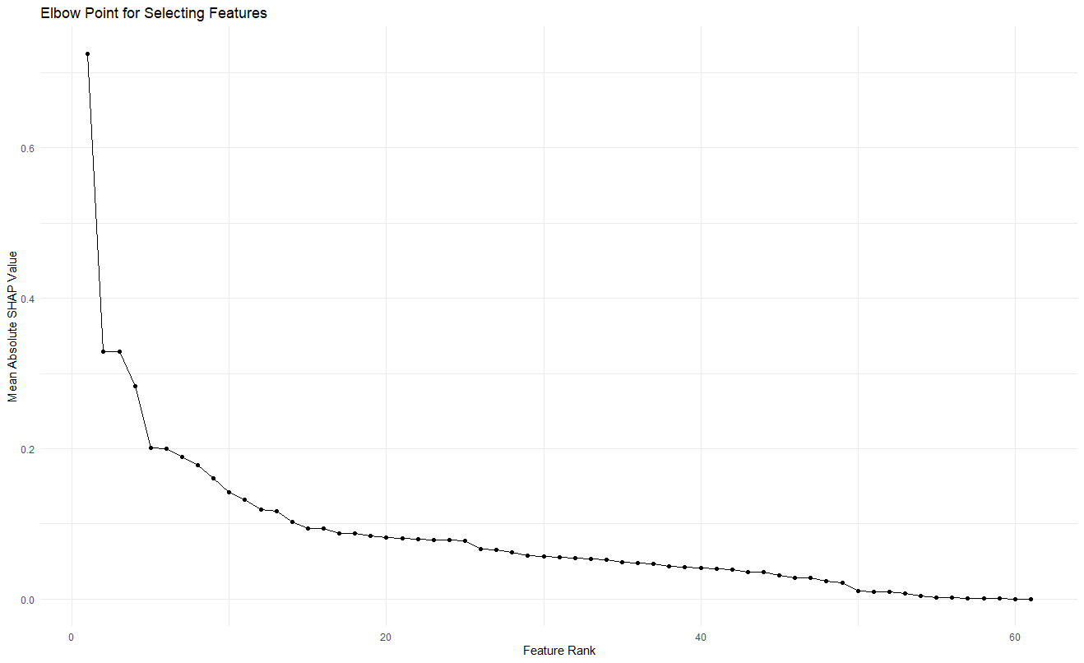
Figure S1. Elbow point plot for selecting top model predictors. Elbow point plot shows the mean absolute SHAP values for each predictor, ranked in a descending order. Mean SHAP values were plotted in decreasing order to visually identify a drop-off point for the selection of which variables to discuss.

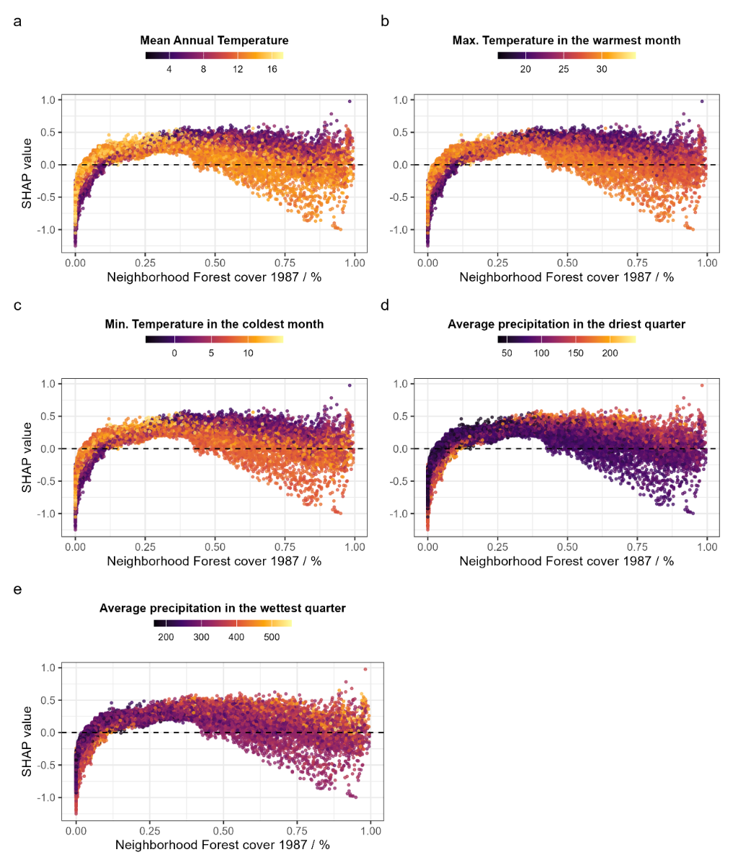
Figure S2. SHAP dependence plots showing the interaction between surrounding forest cover and climatic variables in the classification of shrub-to-forest transition.
The x-axis represents the percentage of surrounding forest cover in 1987, while the y-axis shows the corresponding SHAP values (i.e., the marginal contribution of forest cover to the model prediction). Positive SHAP values indicate higher probability of forest transition, whereas negative values indicate shrub persistence. Points are coloured according to the value of the interacting climatic variable in each panel. The dashed line represents a SHAP value of 0. (a) Mean annual temperature. Lower temperatures are more frequently associated with positive SHAP values at high forest cover, indicating more favourable conditions for forest transition. (b) Maximum temperature in the warmest month. Lower maximum temperatures favour transition at high forest cover, whereas higher temperatures reduce transition likelihood. (c) Minimum temperature in the coldest month. Lower temperatures are associated with higher transition probability, while warmer conditions reduce establishment success. (d) Precipitation in the driest quarter. Higher precipitation levels are associated with increased transition probability at high forest cover. (e) Precipitation in the wettest quarter. Similarly, higher precipitation is associated with positive SHAP values, indicating more favourable conditions for forest transition.

Supplementary references
Ballabio, C., Lugato, E., Fernández-Ugalde, O., Orgiazzi, A., Jones, A., Borrelli, P., Montanarella, L., Panagos, P. 2019. Mapping LUCAS topsoil chemical properties at European scale using Gaussian process regression. Geoderma 355, 113912. 10.1016/j.geoderma.2019.113912
Ballabio, C., Panagos, P., Monatanarella, L. 2016. Mapping topsoil physical properties at European scale using the LUCAS database. Geoderma 261, 110–123. 10.1016/j.geoderma.2015.07.006
Conrad, O. 2014. Topographic Wetness Index (One Step) [software]. SAGA 9.3.1 | Tool Library Documentation.
Durante, P., Requena-Mullor, J. M., Vargas, R., Guevara, M., Alcaraz-Segura, D., Oyonarte, C. 2024. Soil organic carbon maps and associated uncertainty at 90 m for peninsular Spain. Earth System Science Data Discussions 1–29. 10.5194/essd-2024-431
Elvidge, C. D., Baugh, K., Zhizhin, M., Hsu, F. C., Ghosh, T. 2017. VIIRS night-time lights. International Journal of Remote Sensing 38, 5860–5879. 10.1080/01431161.2017.1342050
Generalitat de Catalunya. 2024. Mapa d’usos i cobertes del sòl 1987 - 2022. Departament d’Acció Climàtica, Alimentació i Agenda Rural. https://agricultura.gencat.cat/ca/serveis/cartografia-sig/bases-cartografiques/usos-sol-subsol/usos-sol/ (accessed 20 June 2024).
ICGC. 2006. Mapa de grups litològics de Catalunya 1:250.000 (1a edició). Institut Cartogràfic i Geològic de Catalunya. https://www.icgc.cat/ca/Geoinformacio-i-mapes/Dades-i-productes/Geoinformacio-geologica-i-geofisica/Cartografia-geologica/Mapa-de-grups-litologics-de-Catalunya-1250000
ICGC. 2011. Modelo de elevaciones del terreno de 15x15 m. Institut Cartogràfic i Geològic de Catalunya. https://www.icgc.cat/es/Datos-y-productos/Bessons-digitals-Elevacions/Modelo-de-elevaciones-del-terreno-de-15x15-m
IDESCAT. 2015. Habitants per municipi del 2015. Institut d’Estadística de Catalunya. https://web.gencat.cat/ca/ciutadania/inici
Ninyerola, M., Pons, X., Roure, J. M. 2005. Atlas climático digital de la Peninsula Ibérica. Metodología y aplicaciones en bioclimatología y geobotánica. Universitat Autónoma de Barcelona, Barcelona.
USGS. 2025. Landsat 4-5 Thematic Mapper Collection 2 Level-2 Science Products. U.S. Geological Survey. https://earthexplorer.usgs.gov/
Wouters, H. 2021. Global bioclimatic indicators from 1979 to 2018 derived from reanalysis. Copernicus Climate Change Service (C3S) Climate Data Store (CDS).
Zomer, R. J., Xu, J., Trabucco, A. 2022. Version 3 of the Global Aridity Index and Potential Evapotranspiration Database. Scientific Data 9, 409. 10.1038/s41597-022-01493-1

