TITLE
Open Abdomen with Negative-Pressure Wound Therapy versus Primary Fascial Closure in Abdominal Septic Shock: A Propensity-Weighted Cohort Study

SUPPLEMENTARY FIGURES

- Conceptual directed acyclic graph for covariate selection and confounding by indication.
- Primary and sensitivity analyses of the association between initial open abdomen with negative-pressure wound therapy management and 30-day mortality.
- Exploratory treatment-effect modification at prespecified clinical evaluation points.
- Overlap-weighted mortality risk difference across quartiles of predicted baseline mortality risk.

Supplementary Figure 1. Conceptual directed acyclic graph for covariate selection and confounding by indication.
Conceptual directed acyclic graph illustrating the assumed relationships among preoperative disease severity and host factors, physiological and laboratory variables available before the treatment decision, operative context and procedure, unmeasured clinical judgment, initial abdominal management strategy, and clinical outcomes. Solid-outline nodes represent variables included in the primary propensity-score adjustment set. Preoperative procalcitonin is shown separately with a dashed outline because, although considered within the broader causal framework, it was excluded from the primary propensity-score model owing to extensive missingness (57.8%). Unmeasured clinical judgment represents a potential source of residual confounding.
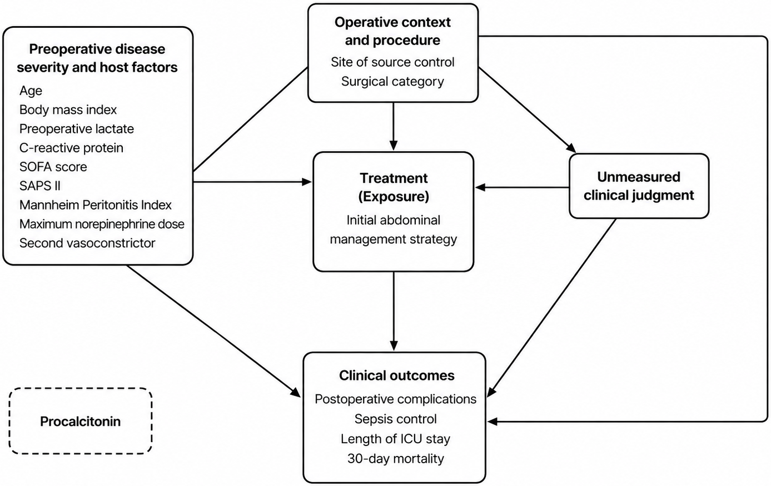

Supplementary Figure 2. Primary and sensitivity analyses of the association between initial open abdomen with negative pressure wound therapy management and 30-day mortality.
Forest plot showing the primary overlap-weighted estimate and prespecified sensitivity analyses for 30-day mortality. Sensitivity analyses included unadjusted comparison, overlap weighting with reintroduction of preoperative procalcitonin, conventional multivariable adjustment, 1:1 propensity-score matching, restriction to the empirical common-support population, and complete-case overlap weighting. The complementary weighted Cox model is reported as a hazard ratio; all other estimates are risk ratios. Points indicate effect estimates and horizontal lines indicate 95% confidence intervals. The sensitivity analysis including procalcitonin used multiple imputation rather than restriction to patients with observed procalcitonin values.
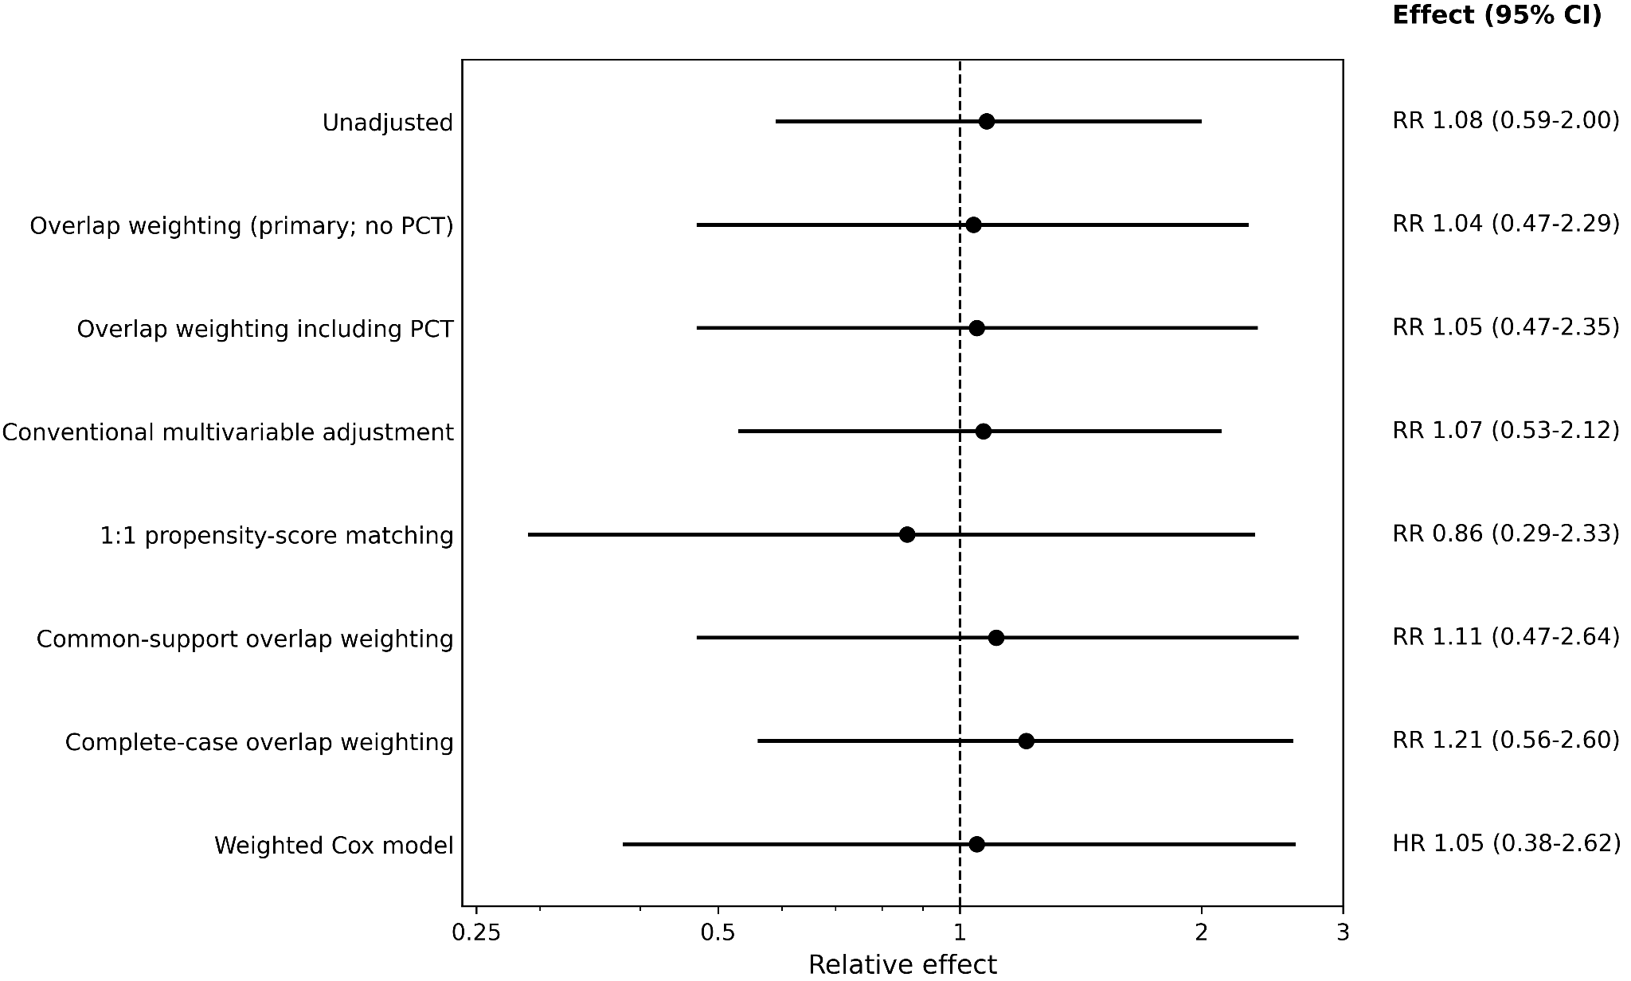

Supplementary Figure 3. Exploratory treatment-effect modification at prespecified clinical evaluation points.
Ridge-penalized estimates of the absolute difference in 30-day mortality between initial open abdomen with negative pressure wound therapy management and primary fascial closure across prespecified values of C-reactive protein, SOFA score, Mannheim Peritonitis Index, maximum intraoperative norepinephrine dose, operative duration, maximum intraoperative lactate, and second-vasoconstrictor use. Points represent estimated mortality risk differences and horizontal lines indicate 95% bootstrap confidence intervals. Positive values indicate higher estimated mortality with open abdomen with negative pressure wound therapy and negative values indicate lower estimated mortality with open abdomen with negative pressure wound therapy. Continuous modifiers were evaluated at prespecified distributional points and modeled without imposing arbitrary clinical thresholds. These analyses were exploratory; global interaction tests did not provide evidence of treatment-effect heterogeneity. For second-vasoconstrictor use, displayed point estimates and bootstrap confidence intervals are derived from the ridge-penalized prediction model; the formal interaction test was not estimable because of sparse treatment-by-modifier cells.
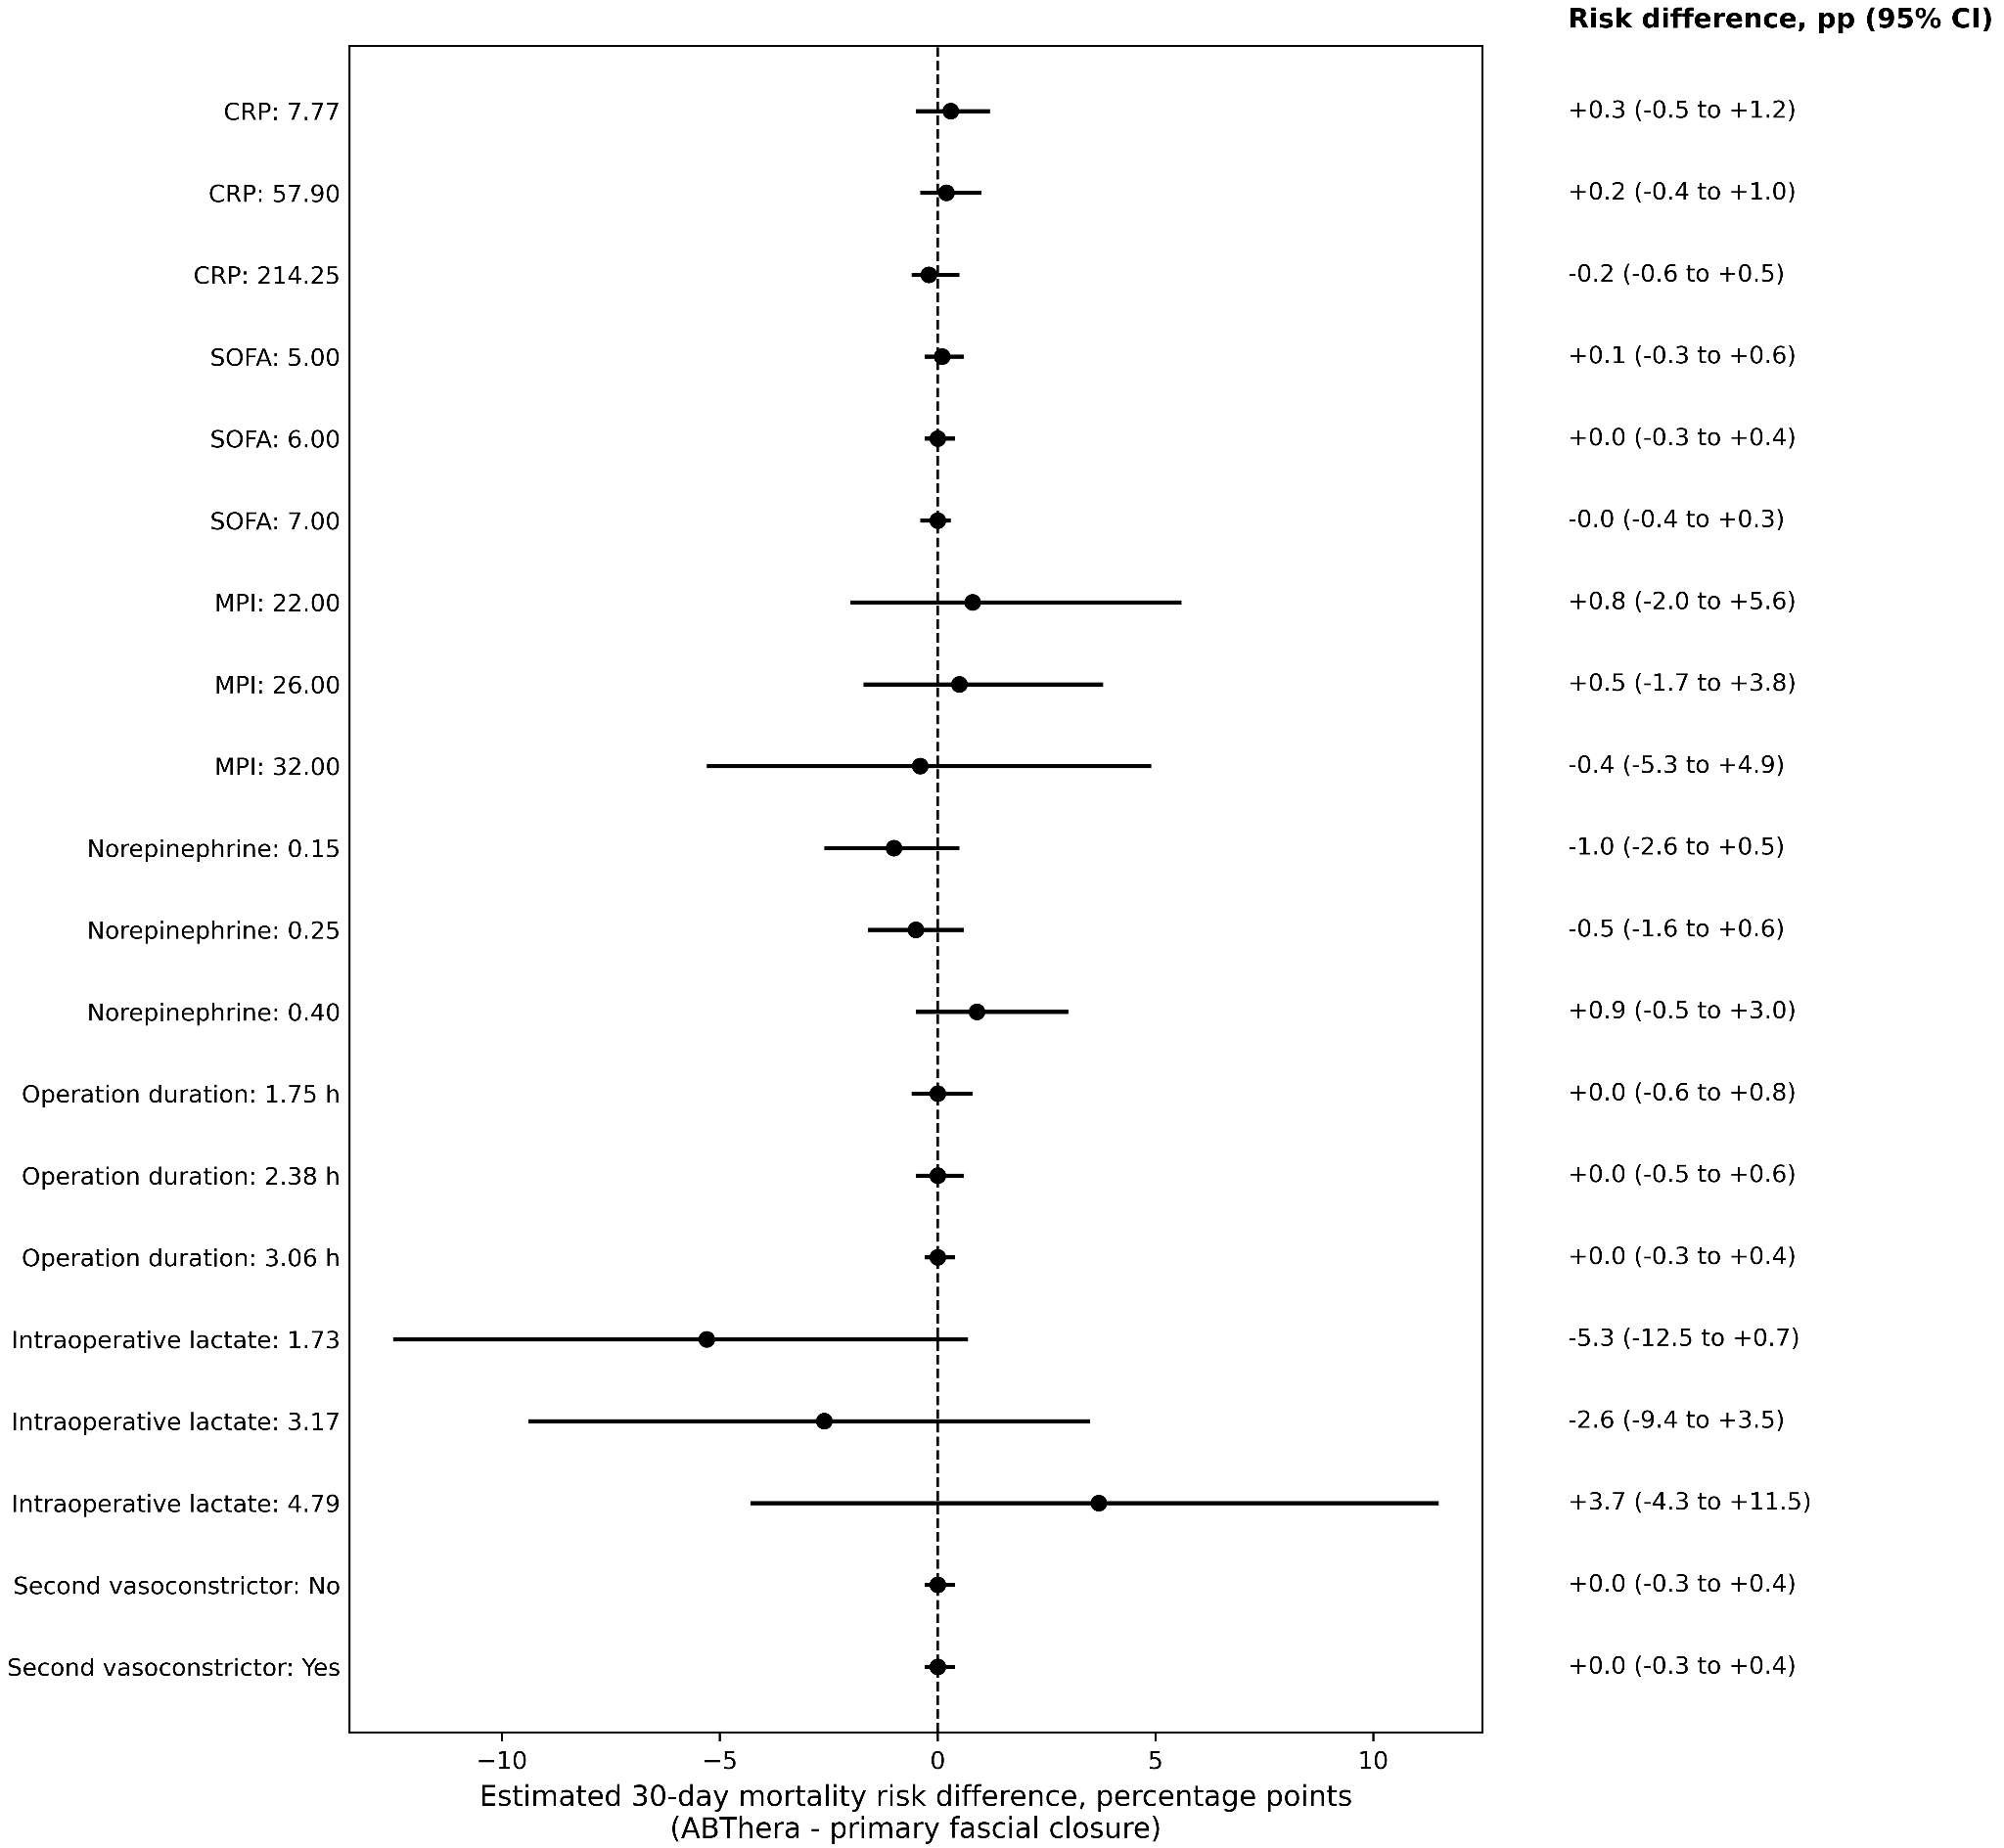
Supplementary Figure 4. Overlap-weighted mortality risk difference across quartiles of predicted baseline mortality risk.
Overlap-weighted absolute differences in 30-day mortality between initial open abdomen with negative pressure wound therapy management and primary fascial closure across quartiles of predicted baseline mortality risk under primary closure. Points represent estimated risk differences and horizontal lines indicate 95% confidence intervals. Positive values indicate higher estimated mortality with open abdomen with negative pressure wound therapy and negative values indicate lower estimated mortality with open abdomen with negative pressure wound therapy. Quartile-specific estimates were imprecise and showed no consistent monotonic pattern across increasing baseline risk; the continuous treatment-by-baseline-risk interaction was not statistically significant (P=.898).
