Supplementary Information

Stable Continuous-Wave Perovskite Lasers by Harvesting Triplet Excitons

Wenhui Zhao^{1,2 †}, Aohua Niu^{1 †}, Ying Shi^{3 †}, Yanjie Shao¹, Rong Wen¹, Hui Li¹, Fan Wu⁶, Jianjun Tian⁷, Wenyu Ji⁸, Tonu Pullerits⁶, Kaibo Zheng^{6,9}, Lining Sun^{2,4}, Guohui Li¹*, Qihua Xiong^{3*}, Yanxia Cui^{2,4,5*}

¹ College of Physics and Optoelectronics Engineering, Taiyuan University of Technology, Taiyuan 030024, China
² Harbin Institute of Technology Suzhou Research Institute, Suzhou 215104, China
³ State Key Laboratory of Low-Dimensional Quantum Physics and Department of Physics, Tsinghua University, Beijing, 100084, China
⁴ School of Mechatronics Engineering, Harbin Institute of Technology, Harbin 150001, China
⁵ QueenAI Embodied (Suzhou) Intelligent Technology Co., Ltd, Suzhou 215104, China
⁶ Chemical Physics Division and NanoLund Lund University Box 124, Lund 22100, Sweden
⁷ Institute for Advanced Materials and Technology, University of Science and Technology Beijing, Beijing 100083, China
⁸ Key Lab of Physics and Technology for Advanced Batteries (Ministry of Education), College of Physics, Jilin University, Changchun, China
⁹ Mathematics and Natural Science Department, Gulf University for Science and Technology (GUST), Mubarak Al-Abdullah 30000, Kuwait
† These authors contributed equally to this work.

email: liguohui@tyut.edu.cn, yanxiacui@hit.edu.cn, qihua_xiong@tsinghua.edu.cn

Methods
Coupled oscillator model
The polariton energies were fitted with a coupled harmonic oscillator model¹:
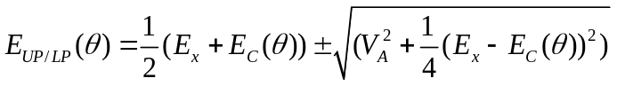 (1)
wwhere 𝐸_{C} is the cavity energy, E_{x} is the exciton energy, and 𝑉_{𝐴} is the coupling strength (corresponding to a Rabi splitting of ℏΩ_{𝑅} = 2𝑉_{𝐴} at resonance). 𝐸𝑐(𝜃) is the energy dispersion of the cavity and is described as follows:
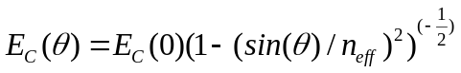 (2)
where 𝐸_{C}(0) is the cavity energy at angle zero, 𝜃 is the angle of incidence, and 𝑛_{𝑒𝑓𝑓} is the refractive index of the medium. Zero-angle cavity-exciton detuning is defined as follows:
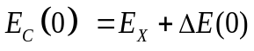 (3)
Laser characteristics
The far-field emission pattern of the laser was characterized under lasing conditions, as shown in Extended Data Fig. 11. The emission was well described by a fundamental Gaussian beam mode. The transverse divergence angle was determined from the measured beam diameters using the following relation²:
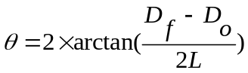 (4)
where Df and D0 are the beam diameters measured at the far and initial positions, respectively, and L is the propagation distance. For D_{f} = 1.0 mm and D₀ = 0.7 mm and L = 110 mm.
The degree of polarization (DOP) is fitted by eq^{3,4}:
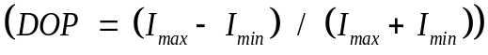 (5)
Calculation of Hopfield coefficients
Exciton-polaritons are hybrid quasi-particles formed by strong coupling between cavity photons and excitons, expressed as quantum superposition⁵:
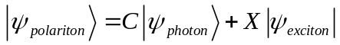 (6)
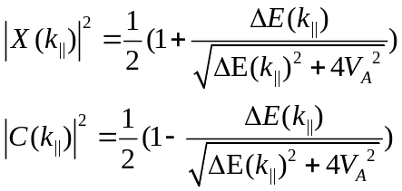 (7)
The squared Hopfield coefficients |C|² and |X|² quantitatively describe the photonic and excitonic fractions inside the polariton mode, satisfying |C|² + |X|² = 1. Their analytical formulas depend on the detuning ΔE(k‖) between bare exciton and cavity photon energies, as well as the coupling strength V_{A}. The Hopfield coefficients were calculated from the fitted cavity-exciton detuning and coupling strength. For the Ag-mirror Fabry–Pérot microcavity, the coupling strength V_{A} is 168 meV, corresponding to a vacuum Rabi splitting of 2V_{A} = 336 meV, and the calculated lower-polariton excitonic and photonic fractions are 23.42% and 76.58%, respectively. For the DBR-based polariton laser, the coupling strength corresponds to a vacuum Rabi splitting of 162 meV, the zero-angle detuning is -100 meV, and the Hopfield coefficients were calculated using the same coupled-oscillator formalism and the experimentally fitted zero-angle cavity-exciton detuning. The excitonic fraction reaches 30.1%.
Cavity fabrication and characterization
The glass substrates were cleaned sequentially by ultrasonic cleaning in deionized water, acetone, and ethanol for 15 min each and then dried with N₂ gas. After cleaning, all subsequent solution processes were carried out in a nitrogen-filled glove box (H₂O and O₂ concentrations of < 0.1 ppm). The P2F8 precursor was prepared by dissolving PEABr, FABr, and PbBr₂ (molar ratio of 0.094:0.376:0.376 mmol mL-1; Xi’an Yuri Solar Co., Ltd.) in DMF (Xi’an Yuri Solar Co., Ltd.). The films were spin-coated at 3000 rpm for 30 s (with the toluene antisolvent dripping at t = 18 s). The thickness was confirmed by AFM to be 70 nm. All optical cavities were fabricated on glass substrates (19 × 19 mm²). The substrates were sequentially ultrasonicated in deionized water (15 min), acetone (15 min), anhydrous ethanol (15 min) and isopropanol (15 min) and then dried with nitrogen. A semitransparent silver mirror (12 nm) was subsequently deposited onto the glass by thermal evaporation, followed by RF magnetron sputtering of SiO₂ layers with thicknesses of 23, 42, 59 and 65 nm onto the silver surface.
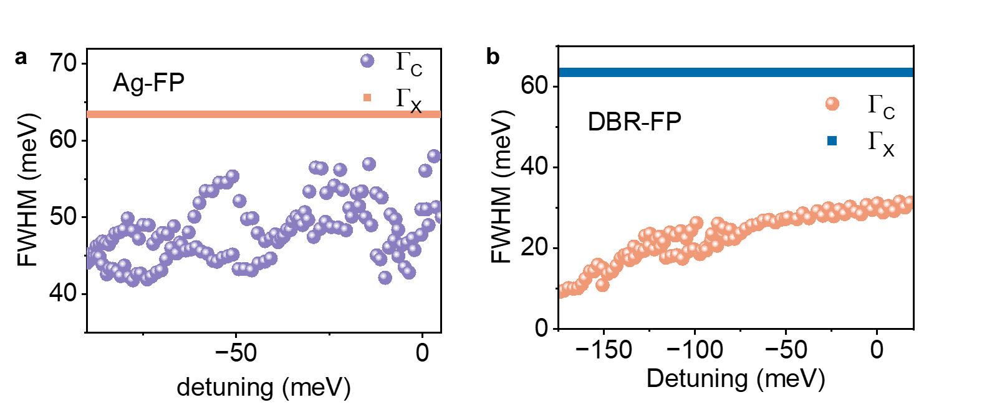
Extended Data Fig. 1 | Detuning-dependent cavity and exciton linewidths of the Ag-FP and DBR-FP microcavities. a, Cavity-mode linewidth Γ_{C} of the Ag-mirror Fabry–Pérot (Ag-FP) reference cavity as a function of detuning △ = E_{C} - E_{X}. The symbols represent the energy-domain full width at half maximum (FWHM) extracted by fitting the empty-cavity resonances. The horizontal line denotes the bare-exciton linewidth, Γ_{X} = 63.43 meV. Near zero detuning, the cavity linewidth is Γ_{C} = 48.36 meV, yielding an effective zero-detuning polariton loss of (Γ_{C} + Γ_{X})/2 = 55.90 meV. b, Corresponding cavity linewidths of the distributed Bragg reflector Fabry–Pérot (DBR-FP) reference cavity. The DBR cavity linewidth varies with detuning because of the wavelength- and angle-dependent DBR reflectivity. At approximately zero detuning, Γ_{C} ≈ 31.10 meV, corresponding to an effective loss of (Γ_{C} + Γ_{X})/2 = 47.27 meV. These zero-detuning linewidths are compared with the vacuum Rabi splitting to evaluate whether the systems operate in the strong-coupling regime.
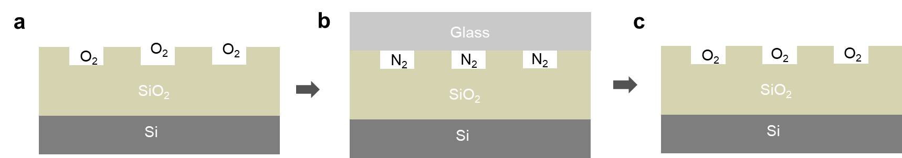
Extended Data Fig. 2 | DFB encapsulation device structure and lasing behavior under a controlled atmosphere. a, Before encapsulation, the laser threshold of the DFB in an oxygen environment is 15.5 W cm⁻². b, After encapsulation, the DFB is in a nitrogen atmosphere, and the lasing completely disappears. c, When the inert gas is removed and the DFB is returned to an oxygen environment, the lasing reappears.
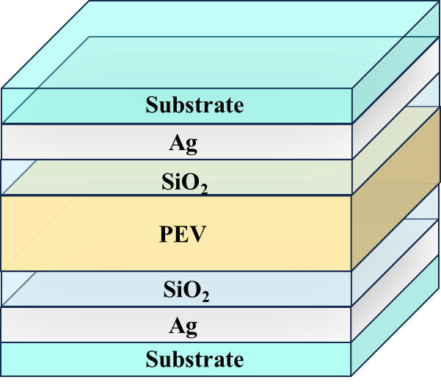
Extended Data Fig. 3 | Schematic of the semitransparent Fabry–Pérot cavity structure. The P2F8 film is sandwiched between two silver (Ag) mirrors. A SiO₂ layer is deposited between each Ag mirror and the emissive layer to prevent direct contact between the P2F8 film and the Ag mirrors.
Extended Data Table 1 | Fitted exciton energy E_{ex} and corresponding error △R_{E} for Devices 1–4 at normal incidence (0°). To confirm the coupling between the microcavity mode and the singlet (S₁) excitonic state of the quasi-2D perovskite, we performed energy-level fitting using the standard strong-coupling Hamiltonian for exciton–photon hybridization⁶. Here, the E_{UP/LP} was extracted from the angle-resolved reflectivity spectra, while the coupled-oscillator model was used to determine the exciton energy and coupling strength; E_{ex} is the exciton energy, E_{cav} is the cavity photon energy, and 2V_{A} is the vacuum Rabi splitting. E_{UP/LP,} E_{cav} and V_{A} were determined directly from the angle-resolved reflectivity measurements before fitting, and E_{ex} was the only free parameter. Fitting was carried out for Devices 1–4 using data taken at normal incidence (0°), yielding the exciton energy E_{ex} and associated fitting errors △R_{E} (summarized in the table below).
Device | 1 | 2 | 3 | 4
E_{ex} | 2.352 | 2.351 | 2.355 | 2.347
△R_{E} | 0.004 | 0.003 | 0.007 | 0.001
From these data, we determine a mean E_{ex} of 2.351 eV with a standard deviation of 0.0035 eV. This value (2.351 ± 0.004 eV) is in excellent agreement with the singlet state energy (S₁ ≈ 2.348 eV) of the quasi-2D perovskite but differs substantially from the triplet state energy (T₁ ≈ 2.328 eV). All the fitting errors for E_{ex} are less than 0.007 eV, confirming the robustness of our fitting procedure. These results clearly establish that the microcavity mode couples to the singlet (S₁) state rather than the triplet (T₁) state, supporting the central premise of our strong-coupling and triplet-management mechanism.
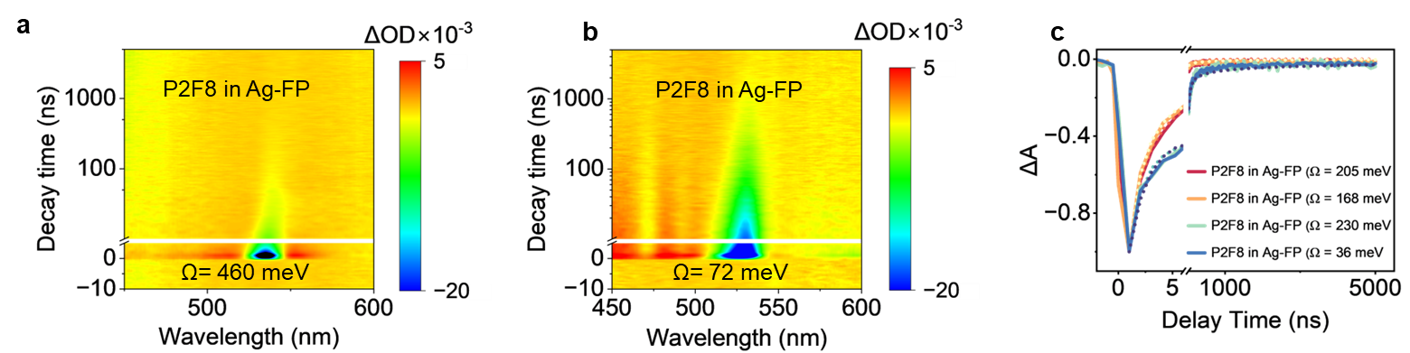
Extended Data Fig. 4 | Transient absorption (TA) spectra of the polariton-enhanced triplet harvester. a, P2F8 in a Ag-FP cavity (Ω = 230 meV) and a Ag-FP cavity (Ω = 36 meV). Photoexcitation at 380 nm (1 kHz repetition rate, 7.28 μJ cm⁻² fluence) and probing via a broadband white-light continuum. The 380 nm pump light matches the intrinsic absorption of the perovskite with the STA for efficient exciton excitation, and the low pump fluence prevents high-density exciton‒exciton interactions from isolating triplet dynamics. Nanosecond transient absorption signals for the perovskite with STA and polariton-enhanced triplet harvesters.
Extended Data Table 2 | Parameters extracted using a coupled harmonic oscillator model and the Hopfield coefficients of LP.
Device | E_{LP}  (eV) | E_{UP}  (eV) | E_{ex}  (eV) | E_{C}  (eV) | ΔE (eV) | 2V_{A}  (eV) | Exciton fraction  (X_{LP}) (%) | photon fraction  (C_{LP}) (%)
1 | 2.00 | 2.47 | 2.35 | 2.12 | -0.230 | 0.410 | 25.54 | 74.46
2 | 2.04 | 2.44 | 2.35 | 2.14 | -0.211 | 0.336 | 23.42 | 76.58
3 | 1.98 | 2.49 | 2.35 | 2.12 | -0.227 | 0.460 | 27.87 | 72.13
4 | 2.25 | 2.37 | 2.35 | 2.27 | -0.08 | 0.072 | 16.67 | 83.33
Extended Data Table 3 | Fitting parameters for P2F8 in the Ag-FP cavity (strong coupling). Triexponential analysis of the bleaching kinetics yields the singlet (A₁, ultrafast radiative recombination of spatially localized bound multiexcitons constructed from singlet excitons; A₂, originates from monomolecular radiative recombination of free band-edge singlet excitons) and triplet (A₃) exciton recombination amplitudes, revealing the depletion of the triplet reservoir under strong light–matter coupling. The three components correspond to distinct processes: two associated with molecular singlet exciton recombination (A₁, A₂) and one attributable to long-lived triplet exciton recombination (A₃).
 | A₁ (%) | τ₁ (ns) | A₂ (%) | τ₂ (ns) | A₃ (%) | τ₃ (ns)
Vac | 51.1 | 2.60 ± 0.24 | 37.7 | 44 ± 3 | 11.2 | 1312 ± 135
1 | 48.5 | 0.93 ± 0.04 | 48.2 | 5 ± 0.1 | 3.3 | 183 ± 16
2 | 40.1 | 0.89 ± 0.09 | 54.2 | 5 ± 0.2 | 5.7 | 75 ± 8
3 | 49.9 | 1.22 ± 0.09 | 33 | 27 ± 2 | 17.1 | 205 ± 18
4 | 51.7 | 1.48 ± 0.07 | 34.5 | 27 ± 1 | 13.8 | 298 ± 16
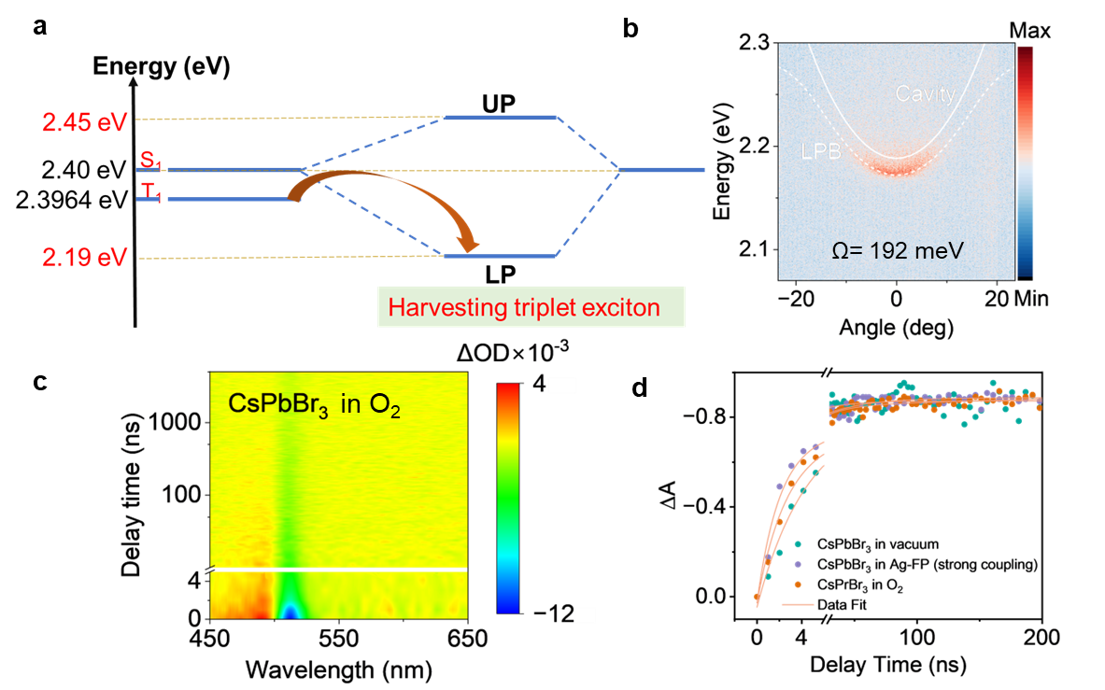
Extended Data Fig. 5 | Characteristics of the CsPbBr₃ film under different conditions. a, Schematic diagram of the cavity mode and exciton energy levels. b, Signature of strong coupling in microcavities. Angle-resolved reflection spectra (-25° to 25°) for the CsPbBr₃ film in the Ag-FP cavity (strong coupling), showing dispersion of the upper and lower polariton branches. The cavity-mode linewidth Γ_{C} of Ag-FP is 48.36 meV. The bare-exciton linewidth (Γ_{X}) of CsPbBr₃ is 97.12 meV, yielding an effective zero-detuning polariton loss of (Γ_{C} + Γ_{X})/2 = 72.74 meV. The Rabi splitting of the cavity is 192.3 meV. c, Broadband nanosecond transient absorption heatmaps acquired via transmission-mode transient absorption spectroscopy of CsPbBr₃ films in O₂. d, Pump fluence-dependent pump probe measurements for CsPbBr₃ in vacuum, O₂ and Ag-FP cavity (strong coupling).
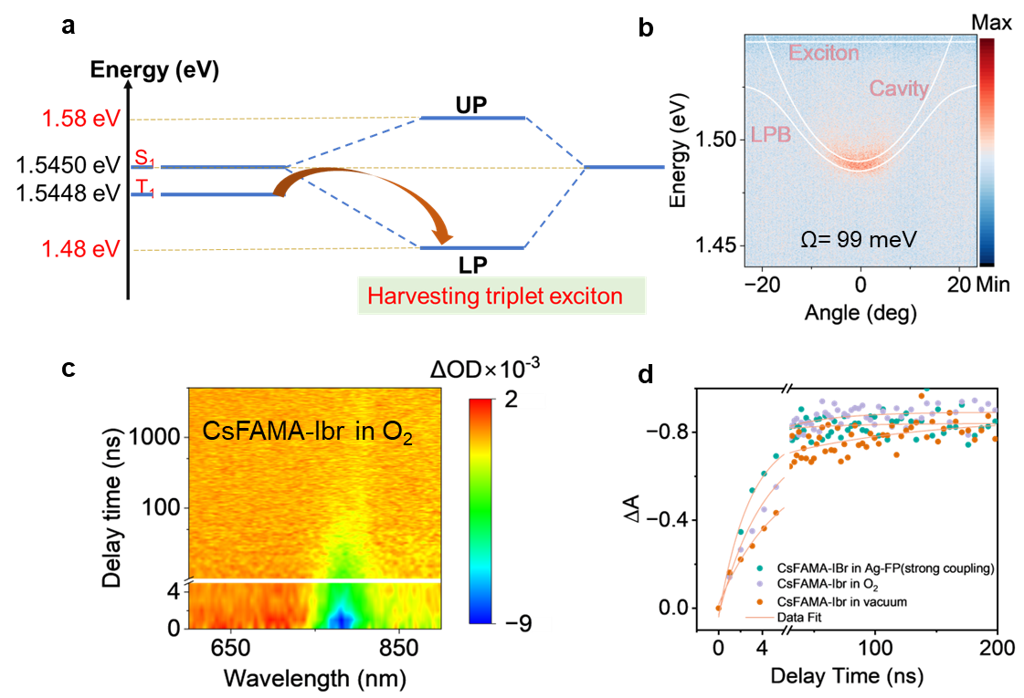
Extended Data Fig. 6 | Characteristics of the CsFAMA-IBr (Cs_{0.05}(FA_{0.95}MA_{0.05})_{0.95}Pb(I_{0.95}Br_{0.05})₃) film under different conditions. a, Schematic diagram of the cavity mode and exciton energy levels. b, Signature of strong coupling in microcavities. Angle-resolved reflection spectra (-25° to 25°) for the CsFAMA-IBr film in the Ag-FP cavity (strong coupling), showing dispersion of the upper and lower polariton branches. The cavity-mode linewidth Γ_{C} of Ag-FP is 48.36 meV. The bare-exciton linewidth (Γ_{X}) of CsFAMA-IBr is 76.80 meV, yielding an effective zero-detuning polariton loss of (Γ_{C} + Γ_{X})/2 = 62.58 meV. The Rabi splitting of the cavity is 99 meV. c, Broadband nanosecond transient absorption heatmaps acquired via transmission-mode transient absorption spectroscopy of CsFAMA-IBr films in O₂. d, Pump fluence-dependent pump probe measurements for CsFAMA-IBr in vacuum, CsFAMA-IBr in O₂ and CsFAMA-IBr in the Ag-FP cavity (strong coupling).
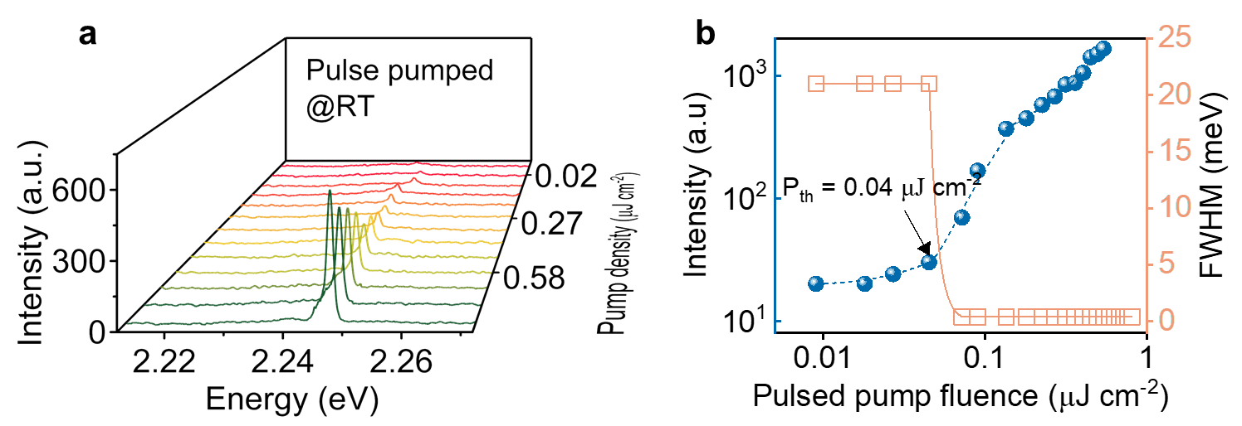
Extended Data Fig. 7 | a, Spectrum evolution under different pulsed pump fluences of the polariton-enhanced triplet harvester laser. b, Pulse-pumped laser emission intensity and FWHM as a function of the pump fluence of the polariton-enhanced triplet harvester laser.
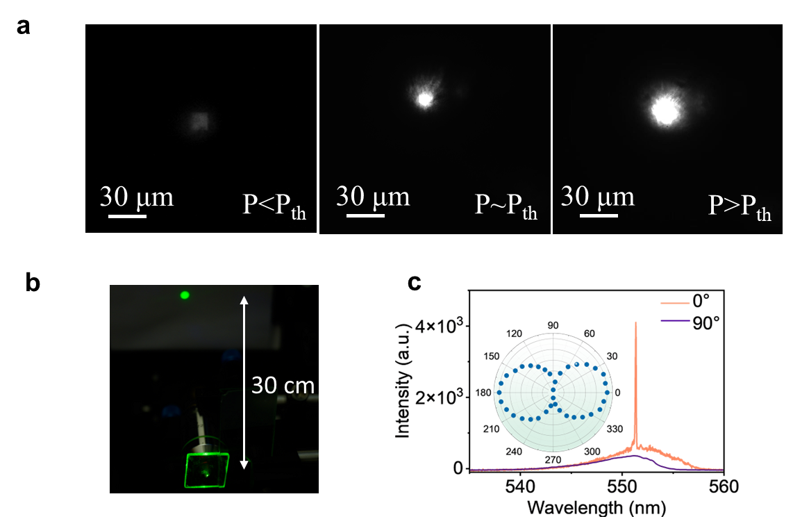
Extended Data Fig. 8 | a, Near-field images of a triplet-harvesting laser with pump energy densities below and above the threshold. b, Photograph of the far-field pattern of the triplet-harvesting laser. The distance between the triplet-harvesting laser and the white paper is 30 cm. c, Polarization characteristics of the CW lasing output. Measured lasing output intensity at polarizer angles of 0° and 90°. Polar plot of the laser emission above the threshold.
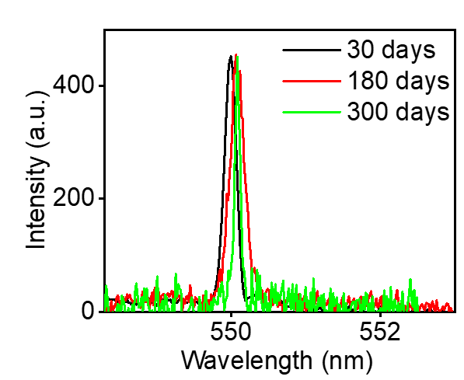
Extended Data Fig. 9 | Long-term storage stability of the polariton-enhanced triplet-harvesting laser. CW emission spectra measured after storage in air for 30, 180 and 300 days at a pump density of 1.2P_{th} (P_{th} = 0.45 W cm⁻²).

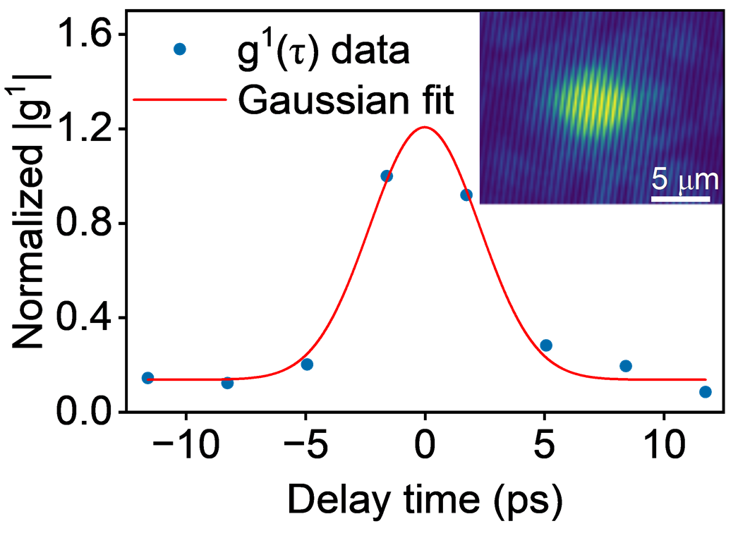
Extended Data Fig. 10 | Temporal coherence. The first-order coherence g¹(τ) above the threshold was measured using a Michelson interferometer. The red solid line represents a Gaussian fit to the data. The inset shows the Michelson interference pattern at zero-time delay. Scale bar, 5 μm.
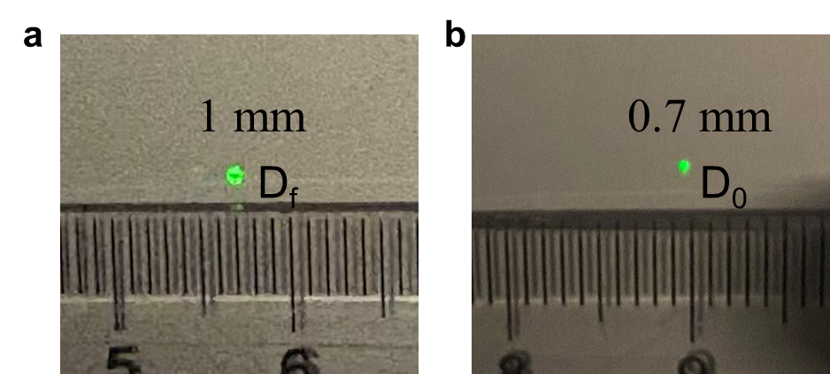
Extended Data Fig. 11 | Photos of the polariton-enhanced triplet harvester laser.
Extended Data Table 4 | Fitting parameters quantifying polariton-enhanced triplet depopulation. Decay times of P2F8 in vacuum, P2F8 in O₂, P2F8 in the Ag-mirror FP cavity (weak coupling), and P2F8 in the Ag-mirror FP cavity (strong coupling).
 | A₁ (%) | τ₁ (ns) | A₂ (%) | τ₂ (ns) | A₃ (%) | τ₃ (ns)
P2F8 in vacuum | 51.1 | 2.60 ± 0.24 | 37.7 | 44 ± 3 | 11.2 | 1312 ± 135
P2F8 in O₂ | 50.6 | 16.6 ± 3 | 39.0 | 95 ± 7 | 10.4 | 686 ± 10
P2F8 in Ag-FP  (weak-coupling) | 49.6 | 1.98 ± 0.08 | 40.1 | 67 ± 2 | 10.3 | 1193 ± 95
P2F8 in Ag-FP  (strong-coupling) | 40.1 | 0.89 ± 0.09 | 54.2 | 5 ± 0.2 | 5.7 | 75 ± 8
Extended Data Table 5 | Pump fluence-dependent pump probe measurements of strongly coupled P2F8 in a Ag FP cavity (Ω = 168 meV) and corresponding vacuum bare film samples. Pump fluence-dependent pump probe kinetics at 380 nm (1 kHz) for P2F8 in a Ag FP cavity (Ω = 168 meV) and P2F8 in vacuum. The average lifetimes at different pump fluences obtained from the three-exponential fit to the experimental decays.
 | pulse fluence  (μJ cm⁻²) |  | A₁ (%) |  | τ₁ (ns) | A₂ (%) |  |  | τ₂ (ns) | A₃ (%) |  | τ₃ (ns)
P2F8 in vacuum | 5.38 | 50.9 |  | 3.11 ± 0.09 |  | 36.0 |  | 45.5 ± 2 |  | 13.1 | 1470 ± 148
P2F8 in vacuum | 7.28 | 51.1 |  | 2.60 ± 0.24 |  | 37.7 |  | 44 ± 3 |  | 11.2 | 1312 ± 135
P2F8 in vacuum | 16.97 | 54.0 |  | 1.73 ± 0.15 |  | 35.3 |  | 46.2 ± 3 |  | 10.7 | 1186 ± 133
P2F8 in Ag-FP (strong-coupling) | 5.38 | 44.9 |  | 0.90 ± 0.03 |  | 46.8 | 7.3 ± 0.6 |  |  | 8.3 | 84 ± 6
P2F8 in Ag-FP (strong-coupling) | 7.28 | 40.1 |  | 0.89 ± 0.09 |  | 54.2 | 5 ± 0.2 |  |  | 5.7 | 75 ± 8
P2F8 in Ag-FP (strong-coupling) | 16.97 | 43.9 |  | 0.79 ± 0.02 |  | 51.0 | 4.6 ± 0.2 |  |  | 5.1 | 46 ± 4

Extended Data Table 6 | Pump fluence-dependent pump probe measurements of CsPbBr₃ and CsFAMA-IBr (Cs_{0.05}(FA_{0.95}MA_{0.05})_{0.95}Pb(I_{0.95}Br_{0.05})₃) samples. Pump fluence-dependent pump probe kinetics at 380 nm (1 kHz). Extracted triplet exciton lifetimes for the CsPbBr₃/CsFAMA-IBr film in vacuum, CsPbBr₃/CsFAMA-IBr in oxygen, and CsPbBr3/CsFAMA-IBr in the Ag-mirror FP cavity (strong coupling).
Material | Pump fluence (μJ cm⁻²) | PVK in vacuum (ns) | PVK in O₂ (ns) | PVK in Ag-mirror FP cavity (strong-coupling) (ns)
CsPbBr₃ | 2.36 | 5400 ± 791 | 3668 ± 863 | 365 ± 53
CsPbBr₃ | 5.38 | 4347 ± 203 | 3353 ± 667 | 340 ± 36
CsPbBr₃ | 8.58 | 4178 ± 298 | 2559 ± 824 | 278 ± 32
CsFAMA-IBr | 2.36 | 10961 ± 606 | 4886 ± 761 | 473 ± 71
CsFAMA-IBr | 5.38 | 8415 ± 480 | 3914 ± 274 | 441 ± 41
CsFAMA-IBr | 8.58 | 6044 ± 259 | 3521 ± 821 | 217 ± 13

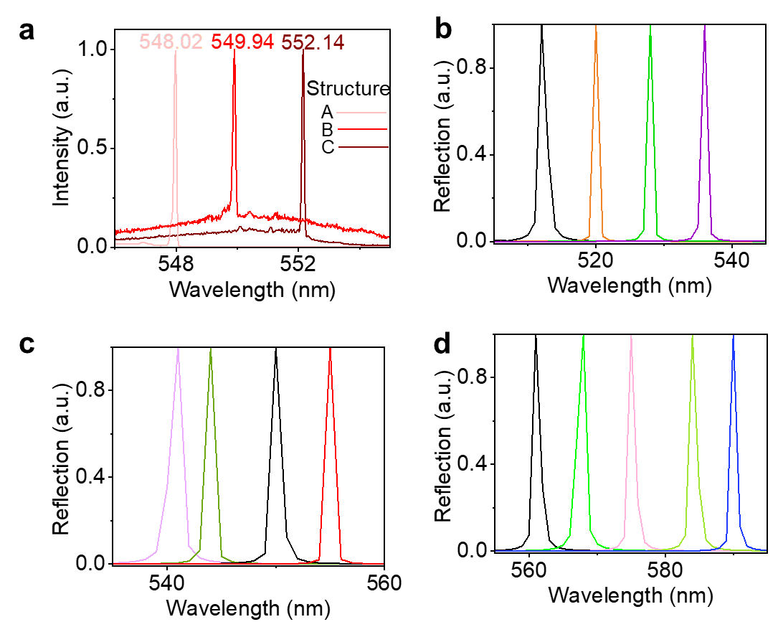
Extended Data Fig. 12 | Tunability of the polariton-enhanced triplet harvester laser. a, Emission spectra of pure phase lasers with three sets of structure parameters (marked in A, B and C). b–d, COMSOL is used to simulate the resonance wavelengths under different cavity lengths. This tuning range is constrained primarily by the gain bandwidth of the P2F8 perovskite and is achieved by controlling the cavity length via the PMMA concentration (Extended Data Table 7).
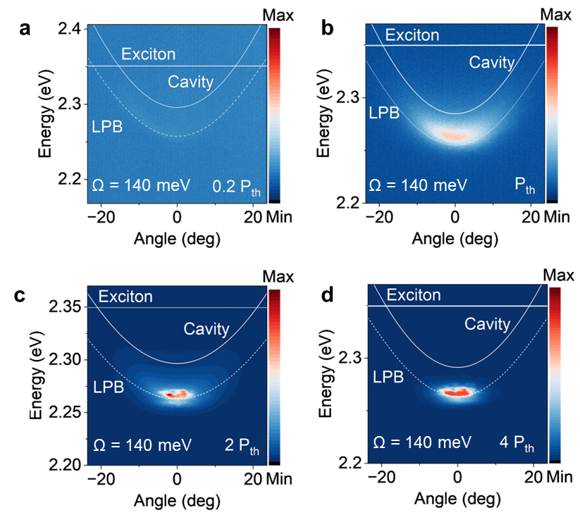
Extended Data Fig. 13 | Signature of strong coupling in microcavities. Pump-fluence-dependent angle-resolved emission of the triplet-harvesting laser under pulse (343 nm, 60 kHz) excitation: (a) P = 0.2 P_{th}, (b) P = P_{th}, (c) P = 2 P_{th}, and (d) P = 4 P_{th}.
Extended Data Table 7 | Implementing cavity length control using PMMA.
Concentration of PMMA (mg/mL) | Resonant Wavelength (nm) | PMMA (nm)
5 | 541 | 71.39
6 | 544 | 71.94
7 | 549 | 73.21
8 | 554 | 74.38
9 | 561 | 75.96
10 | 567 | 77.20
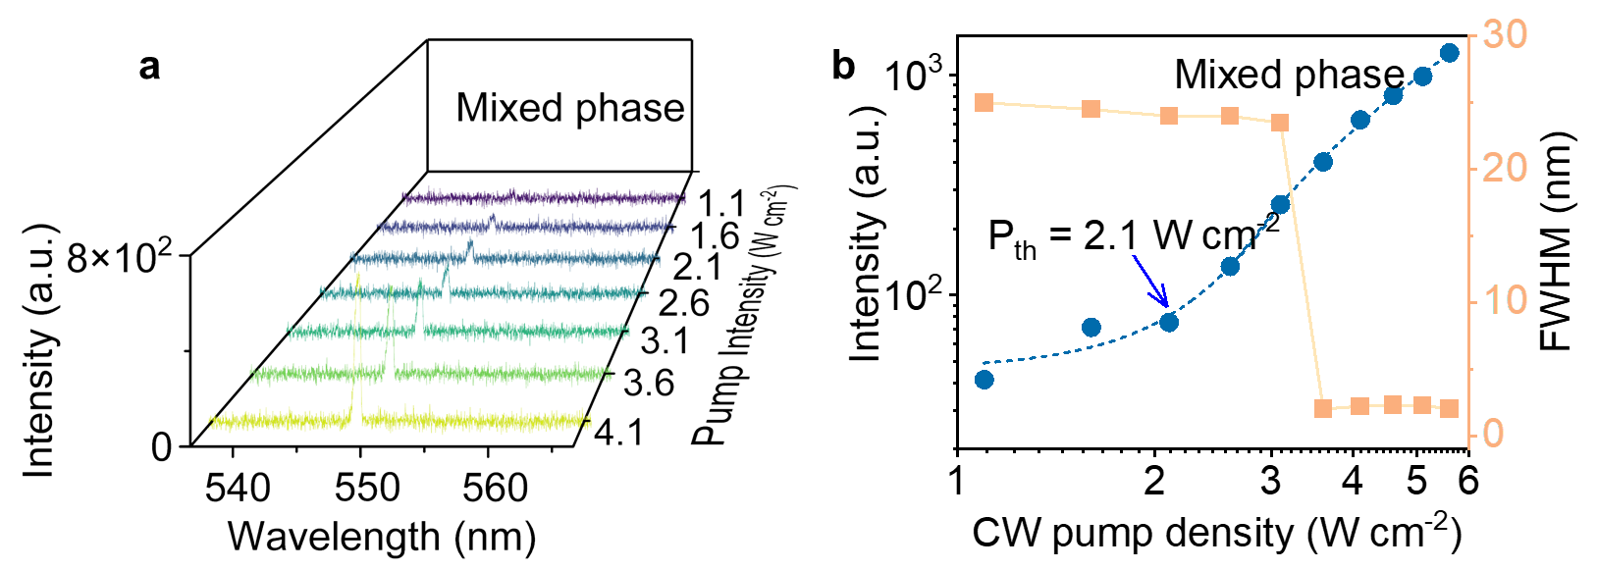
Extended Data Fig. 14 | Continuous-wave spectral characteristics of the mixed-phase laser. a, Evolution of the emission spectra under CW excitation at different pump intensities of the mixed-phase device. b, Emission intensity and FWHM as a function of the pump density of the mixed-phase device, yielding a threshold power density of 2.1 W cm⁻².
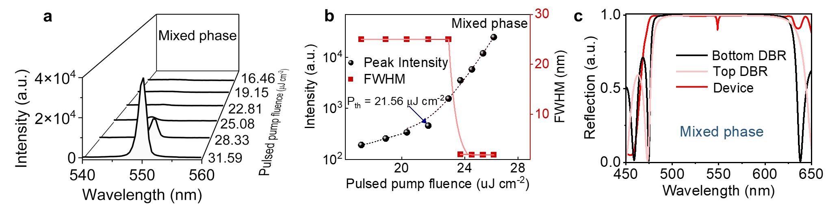
Extended Data Fig. 15 | Pulsed spectral characteristics of the mixed-phase laser. a, Evolution of the emission spectra under pulsed excitation at different pump fluences of the mixed-phase device. b, Emission intensity and FWHM as a function of the pump fluence of the mixed-phase device, yielding a threshold pump fluence of 21.56 μJ cm⁻². c, Reflectance spectra of DBRs with a mixed-phase film (COMSOL).
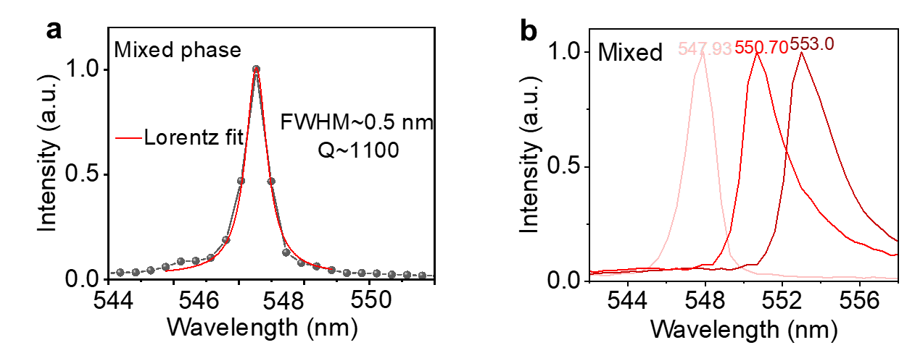
Extended Data Fig. 16 | Characteristics of the mixed-phase laser. a, Lasing spectrum of the mixed-phase laser at P = 28.33 μJ cm⁻² (above the threshold), showing an FWHM of 0.5 nm with a Lorentzian fit, corresponding to a Q factor of 1100. b, Tunability of the DBR laser. The upper figure shows the characterized emission spectra of a mixed-phase laser with three sets of structural parameters (marked as A, B, and C).
Extended Data Table 8 | CW lasing characteristics of perovskite semiconductors.
Material | Cavity | Pump  (CW) | Q | Threshold  (W cm⁻²) | Duration  (min) | Temp | Atmosphere |  | Year
CsPbBr₃ | DBR | 405 nm | - | 6000 | - | 77K | not specified | 2020⁷
(NMA)FAPbBr₃ | DFB | 325 nm | 1222 | 45 | 30 | RT | air | 2020⁸
(PEA)₂PbI₄ | DBR | 488 nm | 1194 | 5.7 | 5 | RT | air | 2021⁹
MAPbBr₃ | DBR | 488 nm | 1140 | 55.2 | - | 80K | not specified | 2021¹⁰
NMA₂FA₄Pb₅Br₁₆ | DBR | 355 nm | 568 | 1.4 | - | RT | air | 2023²
CsPb(Cl_{1-x}Brₓ)₃ | - | 405 nm |  | 0.0526 | - | 83K | not specified | 2026¹¹
CsPbBr₃ PQDs | DBR | 405 nm | 2590 | 152 | 7.5 | RT | air | 2026¹²
(S/Rac-X-MBA)₂FA Pb₂Br₇(X=F, Cl, Br) | DBR-Ag | 405 nm | 1800 | 1.57 | 30 | RT | air | 2026¹³
Type-(I+II) QDs | DFB | 345 nm | 800 | 3.6k | - | RT | air | 2026¹⁴
This work | DBR | 325 nm | 4583 | 0.45 | 60 | RT | vacuum | 2026

References
1 Mukherjee, A., Feist, J. & Börjesson, K. Quantitative Investigation of the Rate of Intersystem Crossing in the Strong Exciton–Photon Coupling Regime. J. Am. Chem. Soc. 145, 5155-5162 (2023).
2 Gao, X. et al. Room-Temperature Continuous-Wave Microcavity Lasers from Solution-Processed Smooth Quasi-2D Perovskite Films with Low Thresholds. J. Phys. Chem. Lett. 14, 2493-2500 (2023).
3 Mhibik, O. et al. An ultranarrow linewidth solution-processed organic laser. Light Sci. Appl. 5, e16026-e16026 (2016).
4 Xu, D. et al. Polariton lasing in a ZnO microwire above 450 K. Appl. Phys. Lett. 104, 082101 (2014).
5 Shi, Y. et al. Coherent optical spin Hall transport for polaritonics at room temperature. Nat. Mater. 24, 56-62 (2025).
6 Tahir, Z. et al. Strong exciton-photon coupling in self-hybridized organic–inorganic lead halide perovskite microcavities. Nanophotonics 12, 4297-4306 (2023).
7 Shang, Q. et al. Role of the Exciton–Polariton in a Continuous-Wave Optically Pumped CsPbBr3 Perovskite Laser. Nano Letters 20, 6636-6643 (2020).
8 Qin, C. et al. Stable room-temperature continuous-wave lasing in quasi-2D perovskite films. Nature 585, 53-57 (2020).
9 Zhang, H. et al. Room-temperature continuous-wave vertical-cavity surface-emitting lasers based on 2D layered organic–inorganic hybrid perovskites. APL Mater. 9, 071106 (2021).
10 Zhang, H. et al. Continuous-Wave Vertical Cavity Surface-Emitting Lasers based on Single Crystalline Lead Halide Perovskites. Adv. Opt. Mater. 9, 2001982 (2021).
11 Li, X. et al. Perovskite nanocrystals-in-glass hierarchical structures enable stable continuous-wave random lasers. Sci. Adv. 12, eadz8460 (2026).
12 Tiwari, S. et al. Narrow Linewidth Spontaneous and Lasing Emissions from Open-Access Microcavity-Embedded Perovskite Quantum Dots. Adv. Opt. Mater. 14, e01918 (2026).
13 Li, Z. et al. Abnormal Chiral Coupling for Efficient and Stable Reduced-Dimensional Perovskite Emitters. ACS Nano 20, 9192-9204 (2026).
14 Hahm, D. et al. Low-threshold lasing from colloidal quantum dots under quasi-continuous-wave excitation. Nat. Photon. 20, 208-215 (2026).

