SUPPLEMENTARY INFORMATION
Development of Schiff Base Chemosensors for Visual Detection of Cu²⁺, Fe²⁺, and Pb²⁺ Ions: Experimental Validation and Theoretical Support.
Swathi Harithas¹, Chaitanya Lakshmi²
¹Department of chemistry, Presidency university, Bengaluru, INDIA
Corresponding Author Mail Id: ………………..

A1. | ¹H NMR spectrum of Schiff base ligands.
A2 | ¹³C NMR Spectrum of Schiff base ligands.
A3 | FT-IR Spectrum of Schiff base ligands.
A4 | Mass Spectrometry of Schiff base ligands.

A1 : ¹H NMR spectrum of Schiff base ligands.
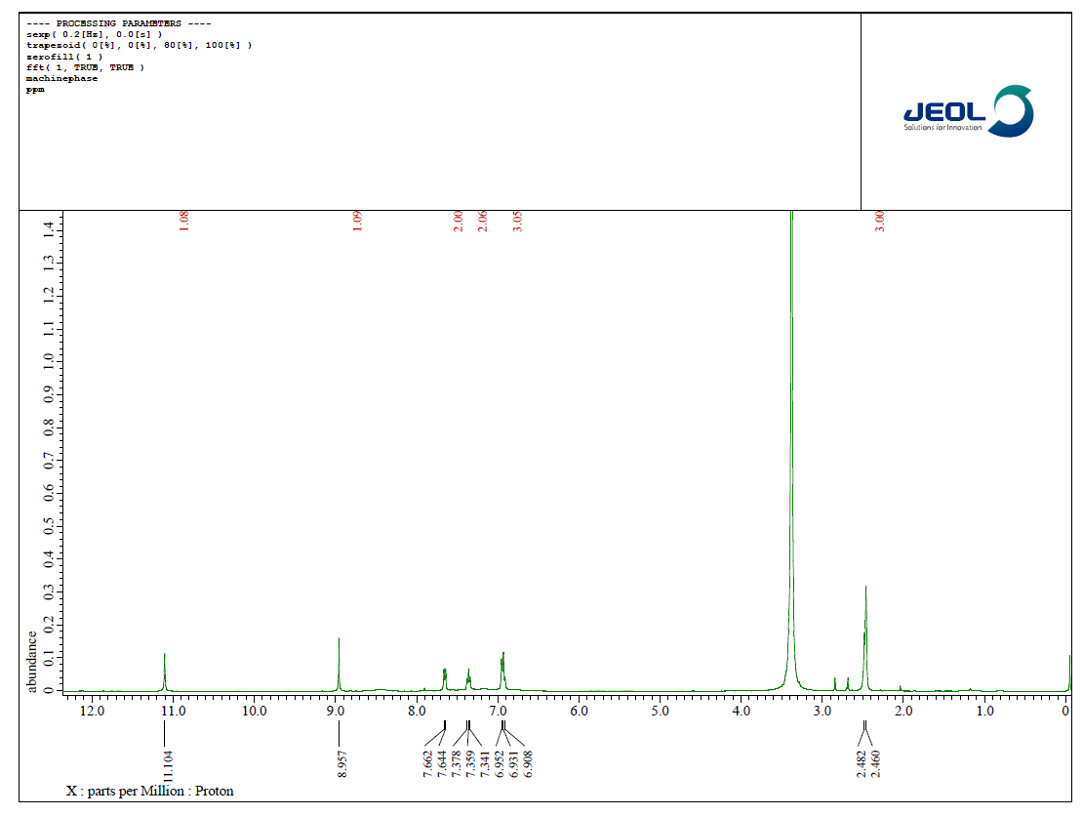
TC-¹H
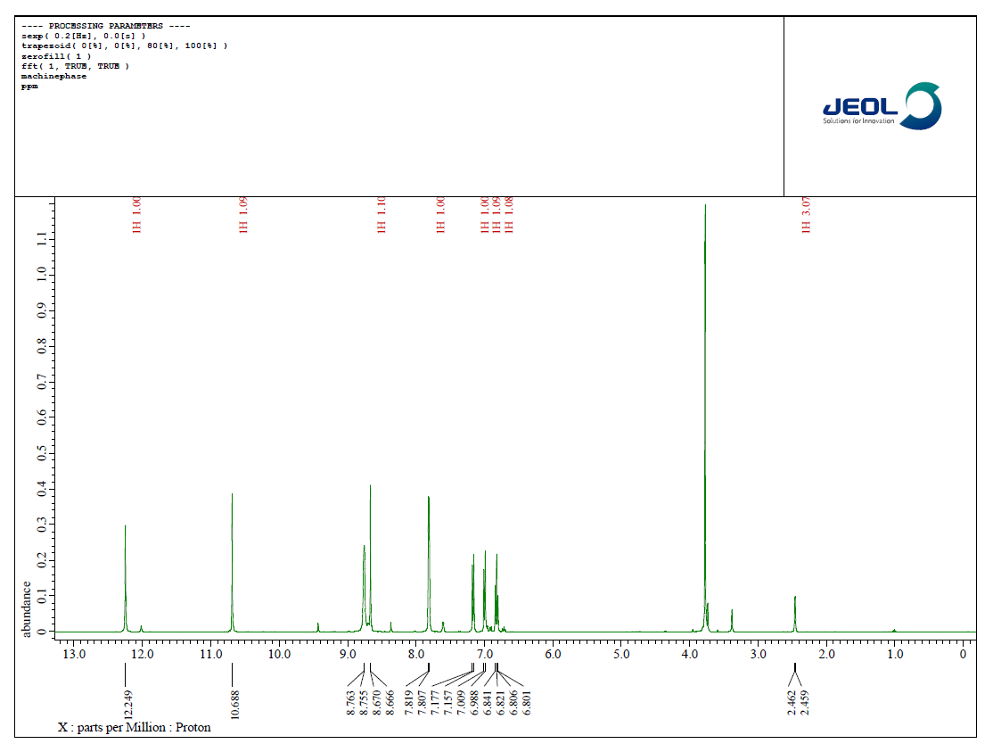
TS -¹H
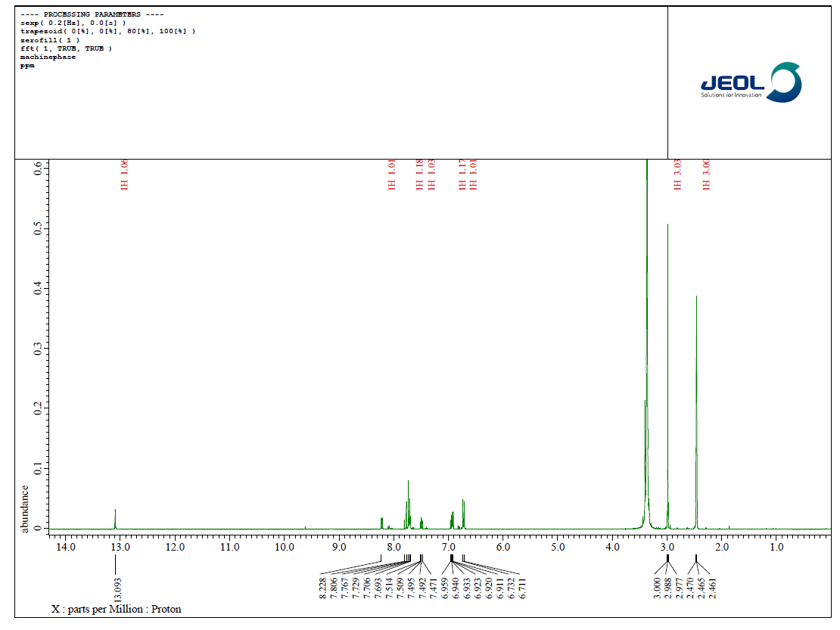
TV -¹H

A2: ¹³C-NMR spectrum of Schiff base Ligands.
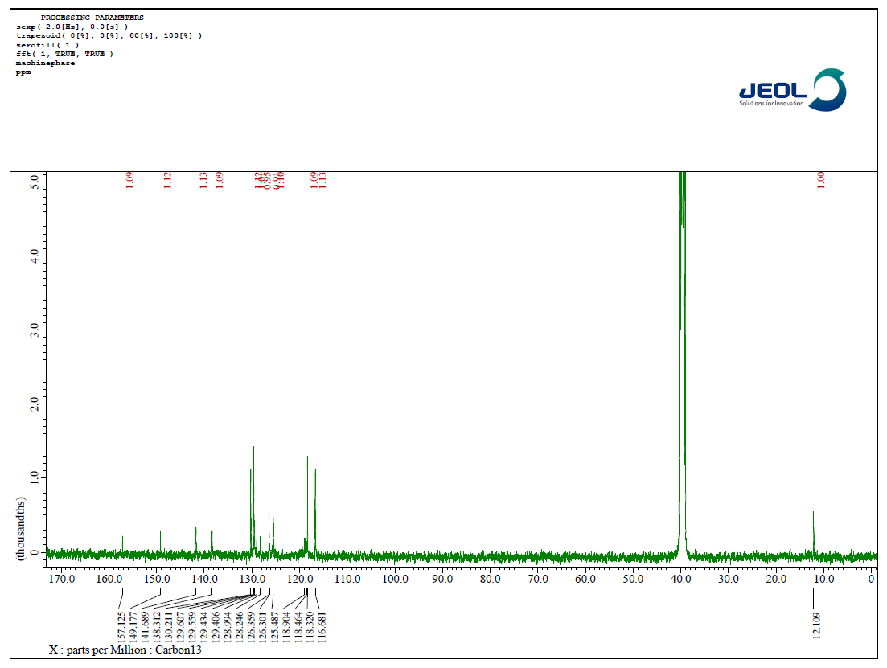
TC -¹³C
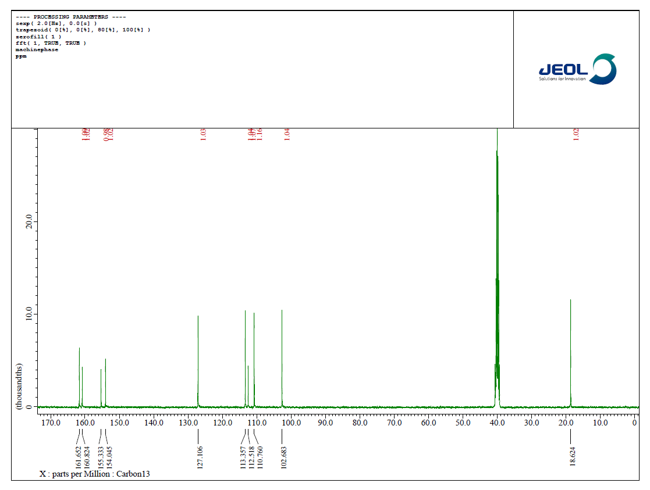
TS -¹³C

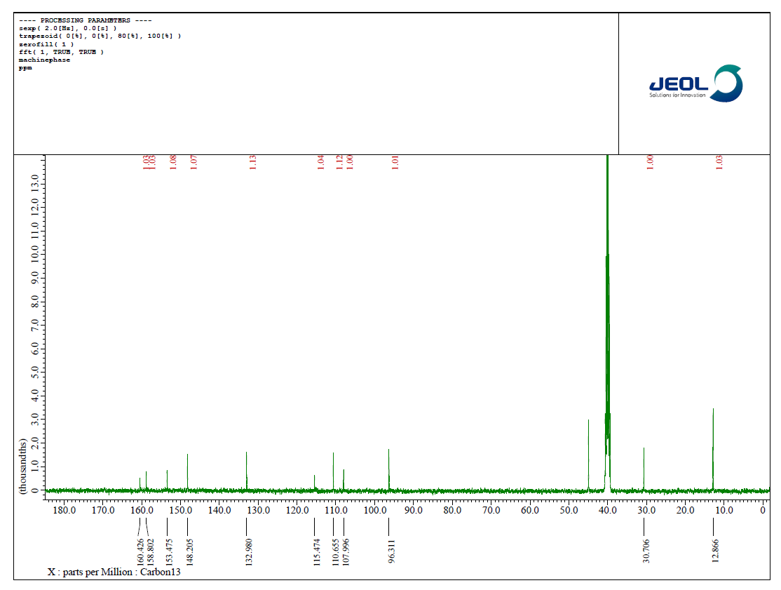
TV -¹³C
Fig-S3: FT-IR spectrum of Schiff base ligands.

Fig-S4: LCMS spectrum of Schiff base ligands.
