Flame Retardancy and Mechanical Properties of Chitosan and DOPO with Different Mass Ratios in Epoxy Resin
Junjie Wang ª, Xinyu Wang ª, Chenyu Zhou ª, Zhiquan Pan ª, Qingrong Cheng ª, Hong Zhou ^{a,*}
a College of Chemistry and Environmental Technology, Wuhan Institute of Technology, Wuhan, China.
* Corresponding author, E-mail: hzhouh@126.com

Contents:
Fig. S1
Fig. S2
Fig. S3

Table S1
Table S2
Table S3

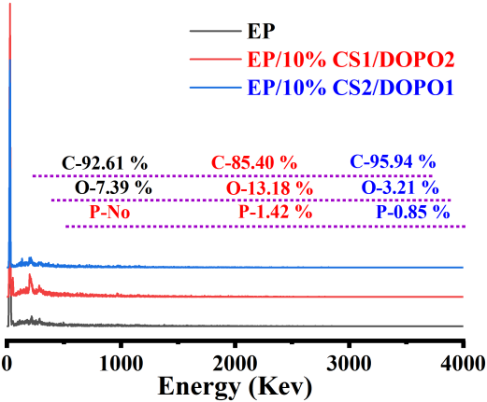
Fig. S1. Element Composition of the surface of the char residues

EP  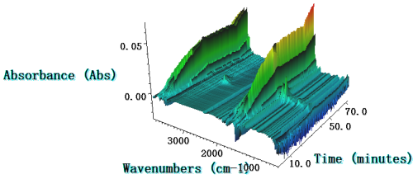 | EP/10% CS  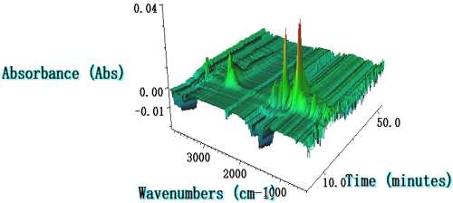
EP/10% CS1/DOPO2  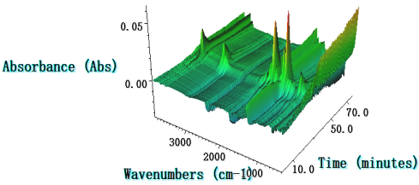 | EP/10% CS2/DOPO1  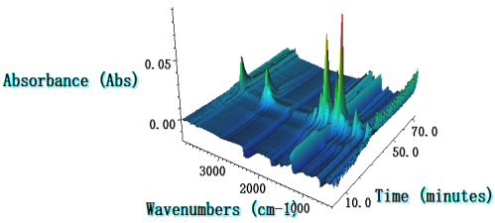

Fig.S2. The 3D TG-FTIR images of EP, EP/10% CS1/DOPO2 and EP/10% CS2/DOPO1 at various temperatures

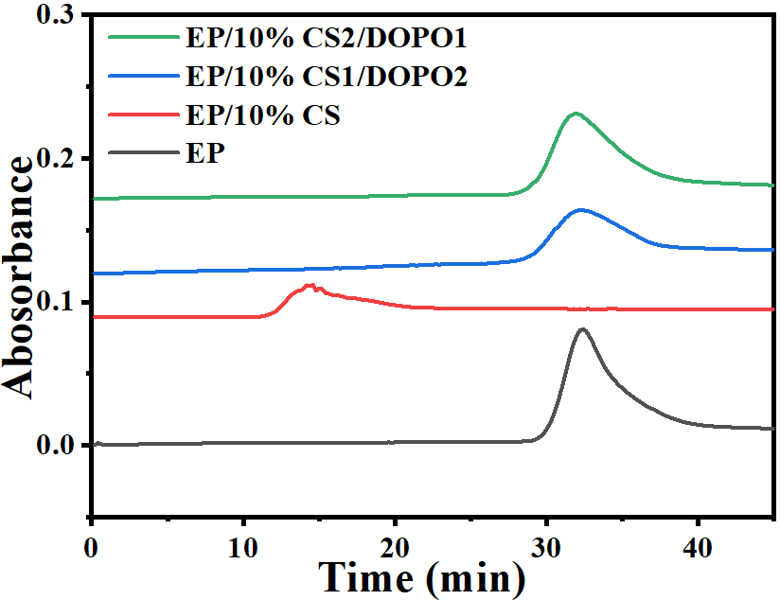 | 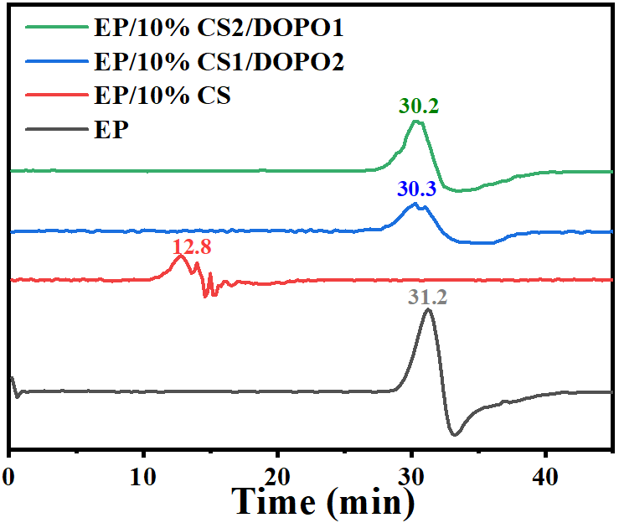
Fig. S3. Time curves of EP, EP/10% CS1/DOPO2 and EP/10% CS2/DOPO1 starting to decompose into gases

Table S1 Thermal decomposition parameters of EP and EP/CS/DOPO samples under air atmosphere
 | Air
Sample | T_{max1%} (°C) | α_{max1} (%/℃) | T_{max2%} (°C) | α_{max2} (%/℃) | Residue at 750 °C (%)
EP | 380.4 | 9.7 | 576.5 | 2.9 | 0.8
EP/10% CS | 311.1 | 8.5 | 532.3 | 11.5 | 0.2
EP/10% DOPO | 309.0 | 7.6 | 537.4 | 11.5 | 1.3
EP/10% CS1/DOPO2 | 309.9 | 7.7 | 536.6 | 11.6 | 1.1
EP/10% CS2/DOPO1 | 309.7 | 7.7 | 532.6 | 11.7 | 0.6

Table S2 The flame retardancy effects of flame inhibition, charring, and formation of a protective barrier layer for EP/10% CS1/DOPO2 and EP/10% CS2/DOPO1samples
sample | Flame-inhibition effect | Charring effect | Barrier and protective effect
EP/10% CS1/DOPO2 | 27.60% | 8.23% | 20.36%
EP/10%CS2/DOPO1 | 0.68% | 4.06% | 36.52%

Table S3 XPS data of different chemical bonds for EP, EP/10% CS1/DOPO2 and EP/10% CS2/DOPO1
Samples | C_{1s} (area (%)) |  |  | N_{1s}  (Area (%)) |  | O_{1s}  (Area (%)) |  | P_{2s}  (Area (%))
Samples | - H  C-C | C-OHC-N  C-O-P | C=CC=O | C-N | C=N | C-O-CC-OH  C-O-P | C=OP=O | C-O-P | P=O
EP | 54 | 25 | 21 | 22 | 78 | 69 | 31 | 0 | 0
EP/10% CS1/DOPO2 | 59 | 28 | 13 | 24 | 76 | 73 | 27 | 68 | 32
EP/10% CS2/DOPO1 | 62 | 14 | 24 | 19 | 81 | 66 | 34 | 56 | 44

