Flame Retardancy and Mechanical Properties of Chitosan and DOPO with Different Mass Ratios in Epoxy Resin
Junjie Wang ª, Xinyu Wang ª, Chenyu Zhou ª, Zhiquan Pan ª, Hong Zhou ^{a,}*

Supporting information

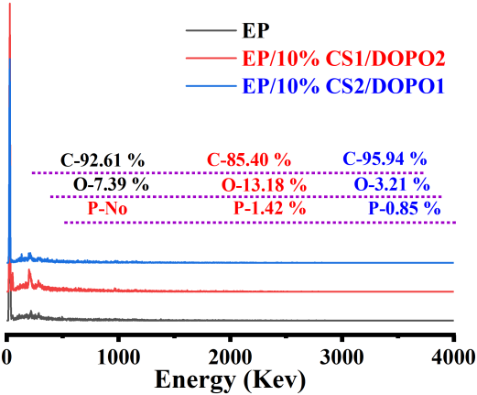
Fig. S1. Element Composition of the surface of the char residues

EP  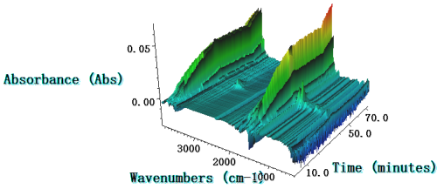 | EP/10% CS  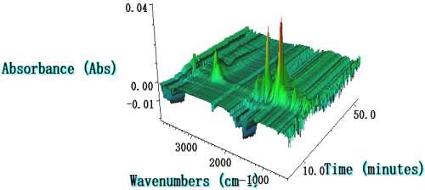
EP/10% CS1/DOPO2  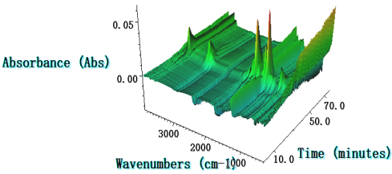 | EP/10% CS2/DOPO1  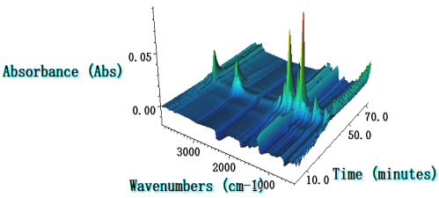

Fig.S2. The 3D TG-FTIR images of EP, EP/10% CS1/DOPO2 and EP/10% CS2/DOPO1 at various temperatures

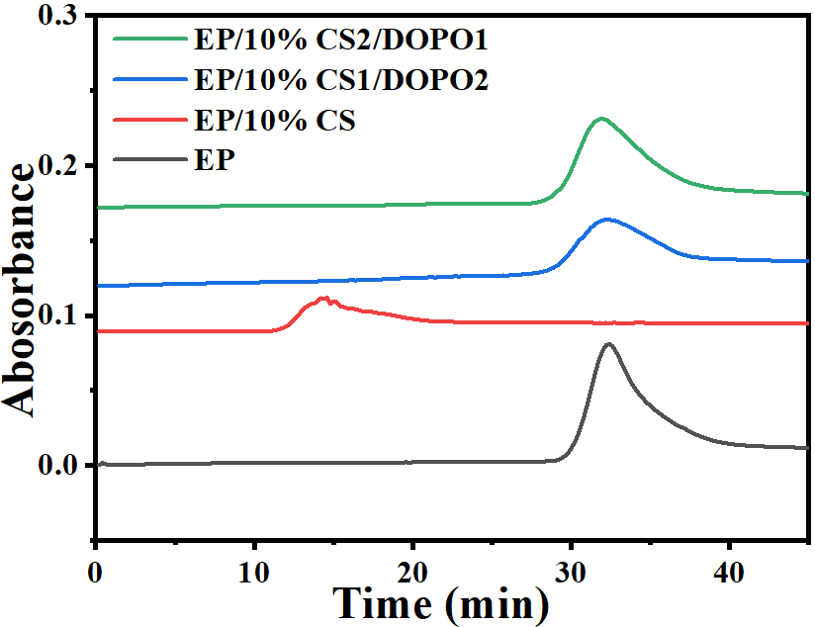 | 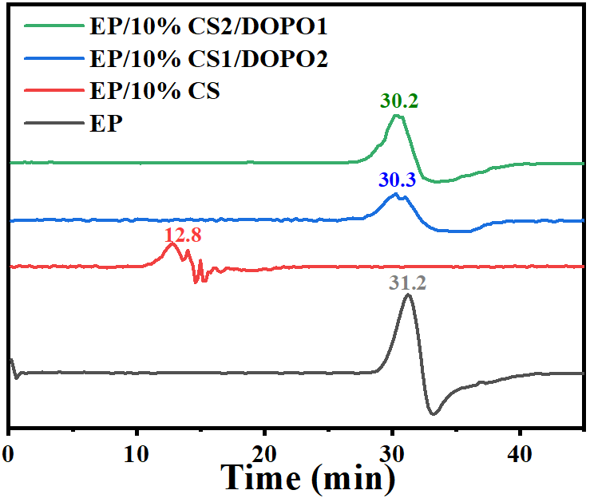
Fig. S3. Time curves of EP, EP/10% CS1/DOPO2 and EP/10% CS2/DOPO1 starting to decompose into gases

Table S1 The flame retardancy effects of flame inhibition, charring, and formation of a protective barrier layer for EP/10% CS1/DOPO2 and EP/10% CS2/DOPO1samples
sample | Flame-inhibition effect | Charring effect | Barrier and protective effect
EP/10% CS1/DOPO2 | 27.60% | 8.23% | 20.36%
EP/10%CS2/DOPO1 | 0.68% | 4.06% | 36.52%

Table S2 XPS data of different chemical bonds for EP, EP/10% CS1/DOPO2 and EP/10% CS2/DOPO1
Samples | C_{1s} (area (%)) |  |  | N_{1s}  (Area (%)) |  | O_{1s}  (Area (%)) |  | P_{2s}  (Area (%))
Samples | - H  C-C | C-OHC-N  C-O-P | C=CC=O | C-N | C=N | C-O-CC-OH  C-O-P | C=OP=O | C-O-P | P=O
EP | 54 | 25 | 21 | 22 | 78 | 69 | 31 | 0 | 0
EP/10% CS1/DOPO2 | 59 | 28 | 13 | 24 | 76 | 73 | 27 | 68 | 32
EP/10% CS2/DOPO1 | 62 | 14 | 24 | 19 | 81 | 66 | 34 | 56 | 44

