Additional file 1. Supplementary appendix
Employment-type inequalities in healthy and unhealthy working life expectancy in China: evidence from CHARLS and implications for retirement-age reform
This supplementary appendix contains sample-flow tables, subgroup sample sizes, state counts and theta sensitivity analysis based on the corrected employment-type definition.
Table S1. Analytic sample flow
Step | Person-wave observations | Unique respondents
All possible respondent-wave records from four harmonized waves | 102344 | 25586
Interviewed in the corresponding wave | 77233 | 25586
After excluding missing sex | 77225 | 25578
After restricting to age 50-100 years | 62084 | 21697
After excluding missing/non-positive respondent weight | 60528 | 21253
After requiring complete functional-health variables | 59903 | 21122
After requiring non-missing work status | 59052 | 20934
Final analytic sample with classifiable wave-3 employment type | 34644 | 11626
The final analytic sample retained 34,644 person-wave observations from 11,626 respondents after applying age, weight, health, work-status and employment-type restrictions.
Table S2. Final analytic sample by wave
Wave | Person-wave observations | Unique respondents
2011 | 6341 | 6341
2013 | 7660 | 7660
2015 | 10035 | 10035
2018 | 10608 | 10608
Table S3. Final analytic sample by sex and employment type
Sex | Employment type | Unique respondents | Person-wave observations
Male | Agricultural | 4432 | 14015
Male | Employee/other | 1322 | 3352
Male | Self-employed/family | 582 | 1532
Female | Agricultural | 4193 | 13063
Female | Employee/other | 704 | 1695
Female | Self-employed/family | 393 | 987
Table S4. Observed joint-state counts by sex and employment type
Sex | Employment type | State | Person-wave observations
Male | Agricultural | HN | 1063
Male | Agricultural | HW | 10709
Male | Agricultural | UN | 390
Male | Agricultural | UW | 1853
Male | Employee/other | HN | 334
Male | Employee/other | HW | 2815
Male | Employee/other | UN | 39
Male | Employee/other | UW | 164
Male | Self-employed/family | HN | 168
Male | Self-employed/family | HW | 1226
Male | Self-employed/family | UN | 23
Male | Self-employed/family | UW | 115
Female | Agricultural | HN | 1420
Female | Agricultural | HW | 7921
Female | Agricultural | UN | 710
Female | Agricultural | UW | 3012
Female | Employee/other | HN | 334
Female | Employee/other | HW | 1150
Female | Employee/other | UN | 52
Female | Employee/other | UW | 159
Female | Self-employed/family | HN | 181
Female | Self-employed/family | HW | 665
Female | Self-employed/family | UN | 40
Female | Self-employed/family | UW | 101
HN = healthy-not working; HW = healthy-working; UN = unhealthy-not working; UW = unhealthy-working.
Table S5. Pooled welfare-maximising retirement age by theta
Sex | theta | Pooled optimal retirement age | Pooled maximum welfare
Male | 0.00 | 50 | 21.972
Male | 0.05 | 50 | 21.972
Male | 0.10 | 60 | 22.206
Male | 0.15 | 65 | 22.656
Male | 0.20 | 70 | 23.365
Male | 0.25 | 75 | 24.225
Male | 0.30 | 75 | 25.161
Female | 0.00 | 50 | 21.017
Female | 0.05 | 50 | 21.017
Female | 0.10 | 50 | 21.017
Female | 0.15 | 53 | 21.080
Female | 0.20 | 58 | 21.364
Female | 0.25 | 61 | 21.740
Female | 0.30 | 65 | 22.211
Figure S1. Sensitivity of pooled welfare-maximising retirement age to theta
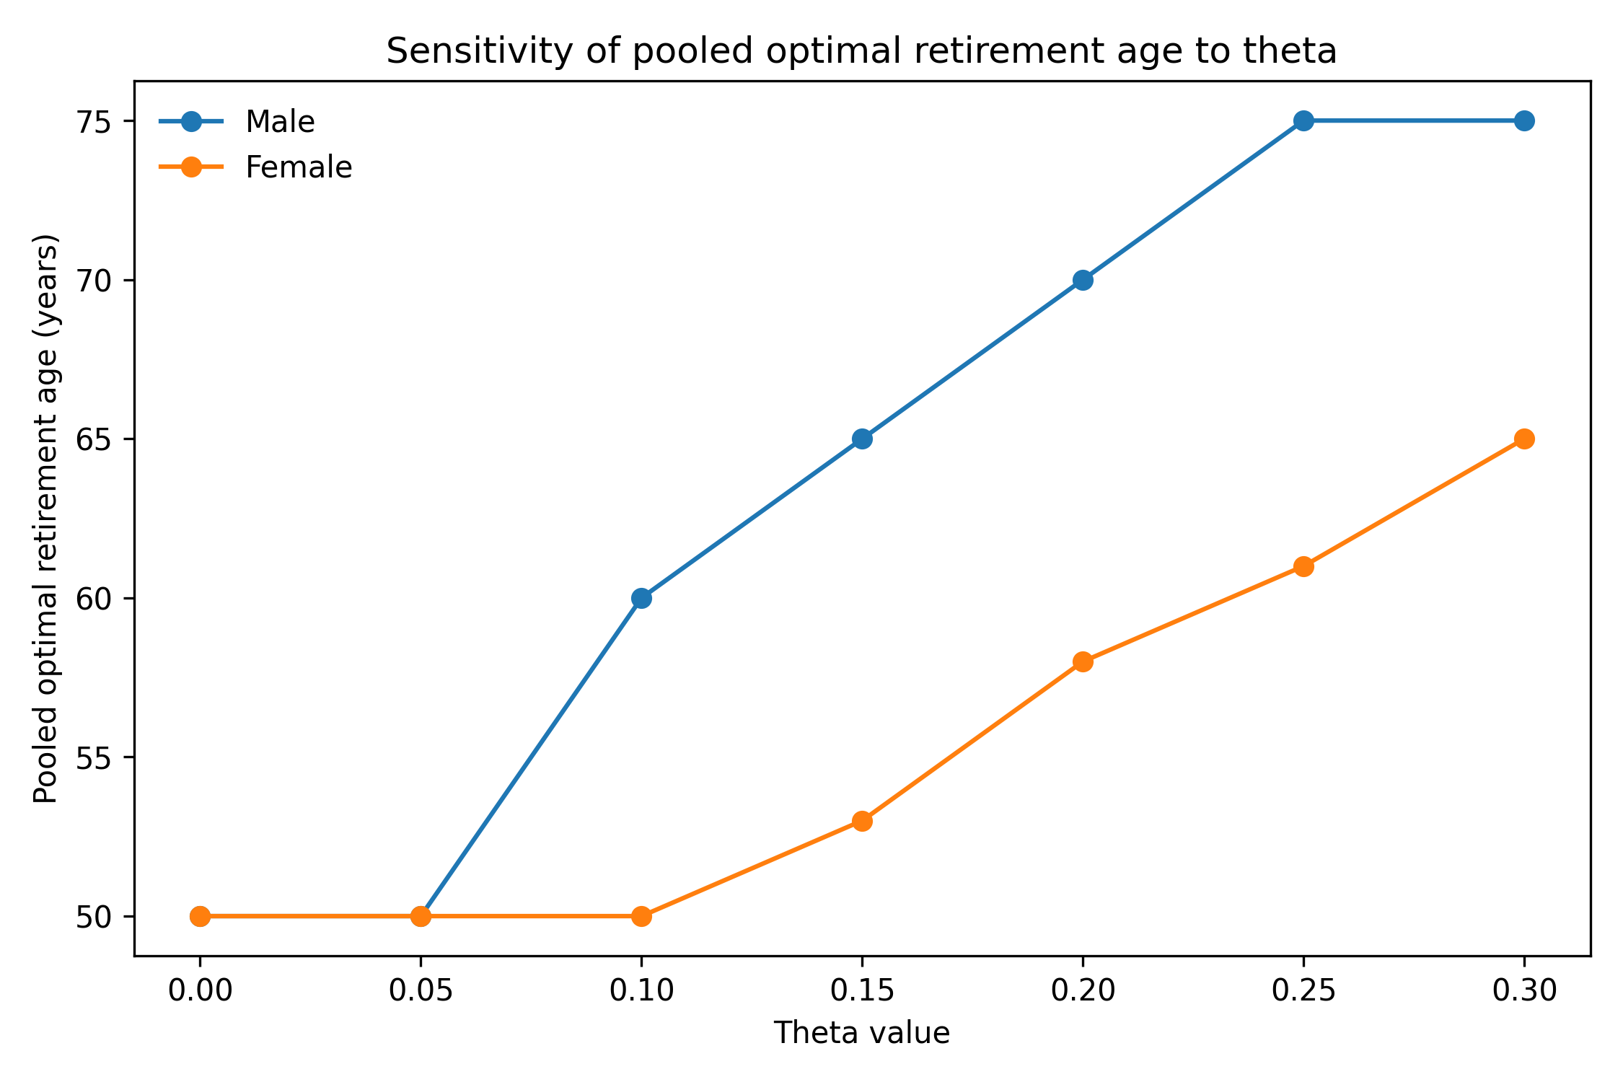
Figure S1. Pooled welfare curves and optimal retirement ages across theta values from 0.00 to 0.30.

