From sampling to sequencing: An optimized workflow for microbial community analysis in hydrogen storage environments
Kristýna Fadrhonc^{1*}, Jakub Říha¹; Arnaud Belcour^{2,3}, Delphine Ropers^{2,3}, Herman K.C. de Vries⁴, Marc van Bemmel⁴, Nicole Dopffel⁵, Kyle Mayers⁵, Larissa Compassi⁶, Kateřina Černá^{1*}
1 Institute for Nanomaterials, Advanced Technologies and Innovation, Technical University of Liberec, Studentská 1402/2, 461 17 Liberec, Czech Republic
2 Univ. Grenoble Alpes, Inria, 655 Avenue de l’Europe, 38334 Montbonnot Cedex, France
3 Univ. Grenoble Alpes, CNRS, LIPhy, 140 rue de la Physique, 38402 Saint-Martin-d’Hères, France
4 MICBUSTERS BV, Zernikepark 12, 9747 AN Groningen, The Netherlands
5 NORCE Research AS, Nygårdsgaten 112, 5008 Bergen, Norway
6 OMV Exploration & Production GmbH, Trabrennstraße 6-8, 1020
* corresponding authors
Corresponding authors: Kristýna Fadrhonc kristyna.fadrhonc@tul.cz, Kateřina Černá katerina.cerna1@tul.cz

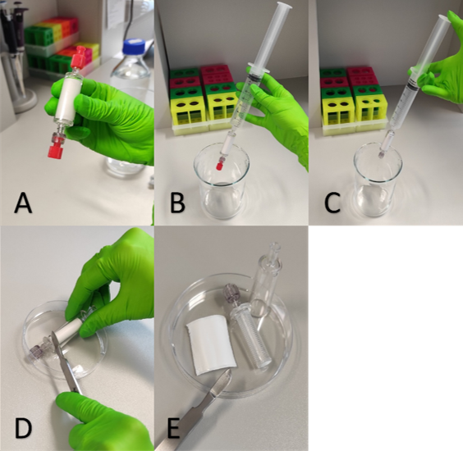
Figure S1: Overview of the Sterivex filter processing workflow. (A) A Sterivex filter containing 70% isopropanol as a preservative was securely sealed with both protective caps. During transport, the filter was kept in a sterile bag within a polystyrene transport box, preferably under refrigerated conditions. (B) The upper protective cap was removed, and an air-filled syringe was attached to the filter. The lower protective cap remained in place to minimize the risk of contamination from the laboratory environment. (C) The lower protective cap was removed, and the preservative (70% isopropanol) was expelled from the filter. The filter was subsequently air-dried by passing air through it twice. For the protocol 2, the filter was additionally dried in a sterile biosafety cabinet for at least 1 hour. (D) The Sterivex filter was opened according to the protocol 1 using a rigid scalpel. The two plastic housing components were carefully separated to allow access to the internal filter membrane. (E) Disassembled Sterivex filter showing the separated membrane designated for DNA isolation. The membrane was handled carefully to avoid contact with the area containing the retained microbial biomass.
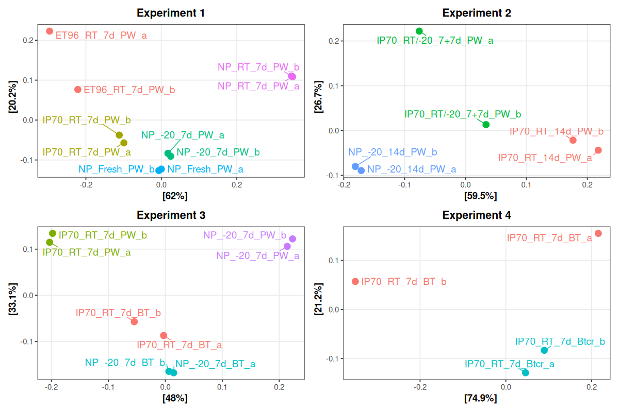
Figure S2: PCoA analysis showing the difference between samples in microbial composition in samples from Experiments 1, 2, 3 and 4. Abbreviations: NP - no preservative; ET96 - 96% ethanol; IP70 - 70% isopropanol; RT - room temperature; PW - DNeasy PowerWater Kit (Qiagen); B&T - DNeasy Blood & Tissue Kit (Qiagen).

Table S1: Negative controls included in each experiment. An extraction blank was included for each DNA extraction batch and kit used. Unused Sterivex filters were processed with both the DNeasy PowerWater (PW) and DNeasy Blood & Tissue (B&T) kits to assess contamination associated with the filter cartridges. Absolute ethanol (pellet from 2mL dried solution) was extracted using the PW kit, whereas absolute isopropanol was extracted using both the PW and B&T kits to evaluate potential contamination originating from the preservation reagents and asses the sensitivity of both kits. All negative controls were free of detectable contamination, and sequencing yielded only a negligible number of reads. PW - DNeasy PowerWater Kit (Qiagen); BT/B&T - DNeasy Blood & Tissue Kit (Qiagen), BDL – DNA concentration below detection limit. The concentration of DNA was determined fluorometrically using a DeNovix QFX Fluorometer (DeNovix Inc., USA) and the Qubit™ dsDNA HS assay.
Name | Experiment | Yield (ng) | Description
CS_BT | Exp3 | 0,3 | Empty sterivex control
CS_PW | Exp1 | 0,4 | Empty sterivex control
C_IP_PW | Exp1 | BDL | Isopropanol control
C_ET_PW | Exp1 | BDL | Ethanol control
C_IP_BT | Exp3 | 0,7 | Isopropanol control
K1_PW | Exp1 | BDL | Extraction blank control
K2_PW | Exp2 | 0,5 | Extraction blank control
K3_BT | Exp3 | 0,45 | Extraction blank control
K3_PW | Exp3 | 0,05 | Extraction blank control
K4_BT | Exp4 | BDL | Extraction blank control

Text S1:

PCR inhibition associated with DNA extraction protocols

Methods
To assess the potential impact of PCR inhibition observed in some samples extracted with the Blood & Tissue (B&T) Kit, we conducted two independent tests comparing it with samples extracted with PowerWater Kit. These tests aimed to determine whether the choice of DNA extraction method influenced PCR performance and to explore strategies to mitigate inhibition effects.

Test 1: Correlation between DNA concentration and 16S rRNA gene quantity
Quantitative PCR (qPCR) was used both to estimate the relative abundance of bacterial 16S rRNA gene copies and to assess potential PCR inhibition in DNA extracts obtained using the PowerWater (PW) and Blood & Tissue (B&T) kits. Analyses were performed on a LightCycler® 480 system (Roche, Switzerland) using the universal bacterial primers PRBA338f (5′-ACTCCTACGGGAGGCAGCAGT-3′) and PRUN518r (5′-ATTACCGCGGCTGCTGGC-3′), targeting the V3 region of the 16S rRNA gene (Ovreås et al., 1997). The reaction setup and cycling conditions followed those of (Shrestha et al., 2022). All samples were analyzed in duplicate, with differences between replicate Cq values consistently below 0.5 cycles. Each qPCR run included both a non-template control and a positive control to verify assay performance and background detection limits.
Because reliable absolute quantification standards are difficult to obtain for complex environmental samples with highly diverse microbial communities, bacterial abundance was expressed as relative quantification (RQ). Relative 16S rRNA gene abundance was calculated using the ΔCq method relative to the corresponding reference samples, which consisted of fresh or frozen controls from the respective experimental series (Lhotský et al., 2021; Shrestha et al., 2021). Amplification efficiency was determined from standard curves generated using serial dilutions of DNA from five internal environmental reference samples.
In parallel with qPCR, bacterial 16S rRNA gene copy numbers were quantified by digital PCR (dPCR) using same primers. The dPCR cycling protocol consisted of an initial denaturation at 95 °C for 2 min, followed by amplification cycles at 95 °C for 15 s, 61 °C for 20 s, and 74 °C for 15 s, with a final hold at 40 °C for 5 min. dPCR is generally less susceptible to PCR inhibition than qPCR (Sidstedt et al., 2020).
For each sample, total DNA concentration, qPCR-derived relative abundance (RQ), and dPCR-derived 16S rRNA gene copy numbers were compared. Disproportionately low qPCR values relative to DNA concentration and dPCR measurements were considered indicative of potential PCR inhibition. Because DNA concentration and 16S rRNA gene abundance are not necessarily proportional in complex microbial communities, suspected inhibition was subsequently verified by serial dilution and PCR Anti-Inhibitor treatment (Test 2).

Test 2: Serial dilution and anti-Inhibitor evaluation
Selected samples from Experiment 3 and additional environmental samples, including frozen and isopropanol-preserved samples extracted using the PW and B&T kits, were subjected to a two-fold serial dilution series from undiluted to 128-fold diluted DNA. Each dilution was analyzed by qPCR with and without PCR Anti-Inhibitor (Qiagen), added at a 1:50 ratio according to the manufacturer’s recommendations.
PCR inhibition was assessed from the relationship between Cq and dilution factor. Amplification efficiency (Ef) was calculated from the slope of the linear regression of Cq against the logarithm of the dilution factor:
Ef = −1 + 10^{(−1/slope)},
Outliers, typically the highest and lowest dilutions, were excluded. Theoretical Cq values for the undiluted sample were extrapolated from the linear portion of the dilution series and compared with the experimentally measured Cq. Higher observed than theoretical Cq values indicated PCR inhibition. A reduction in this difference following PCR Anti-Inhibitor addition indicated mitigation of inhibition, whereas an increased Cq indicated an adverse effect of the reagent on amplification.

Results
PCR inhibition was observed more frequently in samples extracted using the Blood & Tissue (B&T) kit than in those extracted using the PowerWater (PW) kit, as demonstrated by the relationships between DNA concentration and relative 16S rRNA gene abundance measured by qPCR and dPCR (Figures S3 and S4). In the qPCR analysis (Figure S3), RQ values generally increased with DNA concentration in PW extracts, whereas B&T extracts showed disproportionately low RQ values relative to their DNA concentrations, indicating reduced amplification despite their generally higher DNA yields. In contrast, this discrepancy between the extraction methods was substantially reduced in the dPCR analysis (Figure S4), for which samples were diluted 10- to 10,000-fold prior to quantification, thereby substantially reducing the concentration of co-extracted inhibitors. Together, these results indicate that the B&T protocol provides higher DNA recovery, particularly from IP70-preserved samples, but also co-extracts more PCR-inhibitory compounds. The PW protocol, in contrast, provides lower DNA yields from IP70-preserved samples but more effectively removes inhibitors.
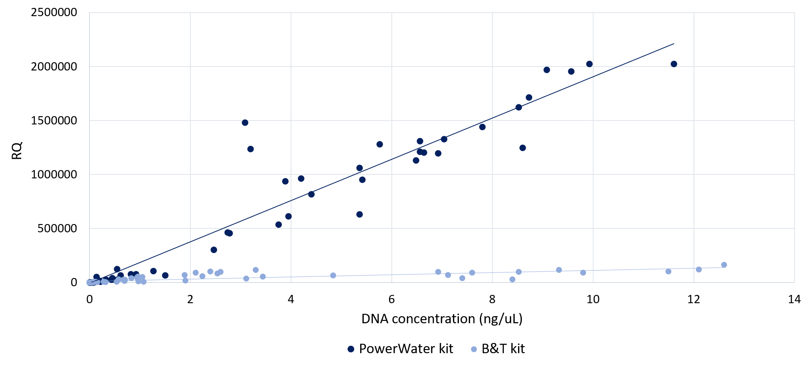

Figure S3: Relationship between qPCR relative quantification (RQ) values and DNA concentration for samples extracted using the two DNA extraction kits. If both extraction methods provided comparable recovery of amplifiable DNA, a similar relationship between DNA concentration and RQ would be expected. Samples extracted using the B&T kit consistently showed lower RQ values relative to their DNA concentrations, indicating a lower proportion of amplifiable target DNA and suggesting greater PCR inhibition in B&T extracts.

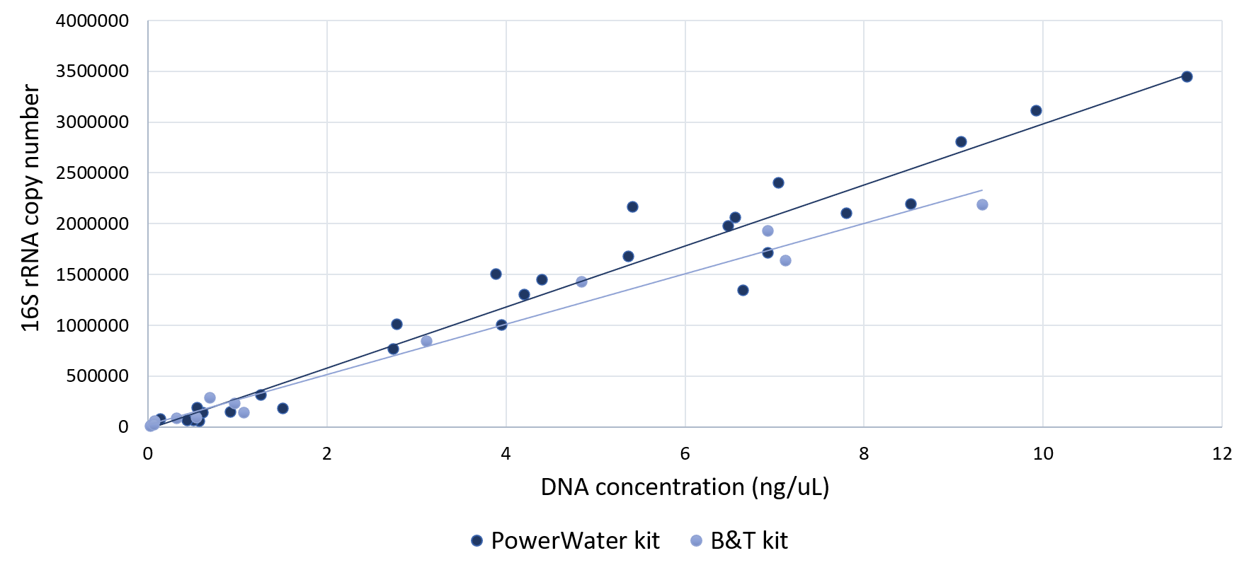
Figure S4: Relationship between 16S rRNA gene copy numbers determined by dPCR and DNA concentration for individual samples. In contrast to qPCR, samples were diluted 10- to 10,000-fold prior to dPCR analysis, substantially reducing the concentration and potential effect of PCR inhibitors. The relationship between DNA concentration and 16S rRNA gene copy number was therefore less affected by inhibition associated with the extraction method.

In the Test 2, two approaches were evaluated to mitigate inhibition: sample dilution and addition of PCR Anti-Inhibitor (Qiagen). The tests included frozen and IP70-preserved samples used for comparison of the two DNA extraction protocols (see Experiment 3 of the main text), as well as other environmental samples showing inhibition following B&T extraction. Samples were analyzed by qPCR across a serial dilution series, both with and without PCR Anti-Inhibitor added at a final 1:50 dilution. Complete results are provided in Table S2.
Serial dilution progressively reduced the apparent inhibition and effectively restored amplification in inhibited samples. PCR Anti-Inhibitor also improved amplification in some inhibited samples, particularly in undiluted or weakly diluted (2- to 4-fold) extracts, as indicated by decreased Cq values (Table S2). However, its effectiveness was strongly sample- and dilution-dependent. At higher dilution factors, where endogenous inhibitors had already been sufficiently diluted, addition of PCR Anti-Inhibitor resulted in increased Cq values and thus reduction of qPCR signal as visible for PW extracts (Table S2). A similar negative effect was observed in samples without apparent inhibition, indicating that the reagent itself can adversely affect amplification when inhibitory compounds are absent or present at low concentrations.
Sample dilution should therefore be preferred for mitigating PCR inhibition whenever sufficient target DNA is available. PCR Anti-Inhibitor may be useful for samples with low DNA concentrations that cannot be sufficiently diluted, but its effectiveness should be evaluated for each sample type and it should not be routinely applied to non-inhibited samples.
For dPCR quantification of bacterial 16S rRNA genes, DNA extracts were diluted 10- to 10,000-fold according to their target abundance. At these dilution factors, the effect of co-extracted inhibitors was substantially reduced, and the relationship between DNA concentration and 16S rRNA gene copy numbers was no longer systematically affected by the extraction protocol (Figure S2). Consequently, despite the higher occurrence of PCR inhibition in concentrated B&T extracts, IP70 preservation combined with B&T extraction is suitable for downstream dPCR analysis and provides the advantage of substantially higher DNA recovery compared with the PW protocol.
Table S2. Evaluation of PCR inhibition in samples extracted using the B&T and PowerWater (PW) kits by serial dilution. Cq values are shown for a two-fold dilution series (undiluted to 128-fold dilution), together with the theoretical Cq value of the undiluted sample recalculated independently from each dilution. The results indicate more pronounced PCR inhibition in B&T extracts compared with PW extracts and its progressive reduction upon sample dilution.
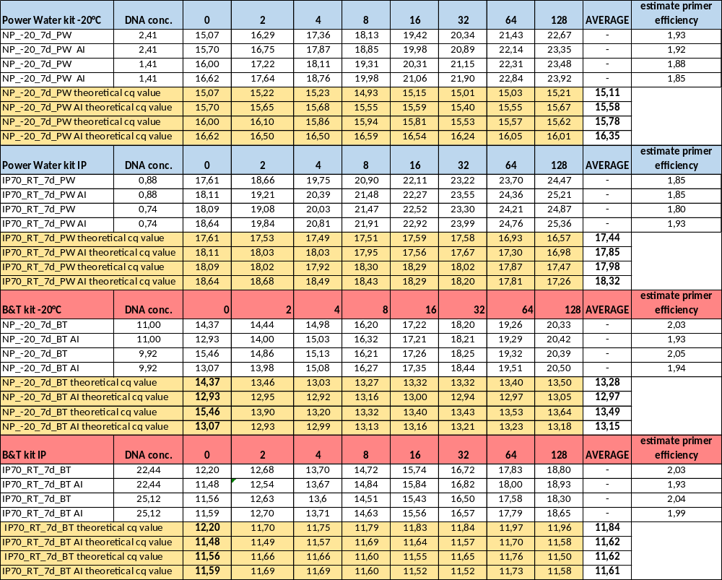

Reference:
Lhotský, O., Kukačka, J., Slunský, J., Marková, K., Němeček, J., Knytl, V., Cajthaml, T., 2021. The effects of hydraulic/pneumatic fracturing-enhanced remediation (FRAC-IN) at a site contaminated by chlorinated ethenes: A case study. Journal of Hazardous Materials 417, 125883. https://doi.org/10.1016/j.jhazmat.2021.125883
Ovreås, L., Forney, L., Daae, F.L., Torsvik, V., 1997. Distribution of bacterioplankton in meromictic Lake Saelenvannet, as determined by denaturing gradient gel electrophoresis of PCR-amplified gene fragments coding for 16S rRNA. Appl Environ Microbiol 63, 3367–3373. https://doi.org/10.1128/aem.63.9.3367-3373.1997
Shrestha, R., Cerna, K., Spanek, R., Bartak, D., Cernousek, T., Sevcu, A., 2022. The effect of low-pH concrete on microbial community development in bentonite suspensions as a model for microbial activity prediction in future nuclear waste repository. Science of The Total Environment 808, 151861. https://doi.org/10.1016/j.scitotenv.2021.151861
Shrestha, R., Černoušek, T., Stoulil, J., Kovářová, H., Sihelská, K., Špánek, R., Ševců, A., Steinová, J., 2021. Anaerobic microbial corrosion of carbon steel under conditions relevant for deep geological repository of nuclear waste. Science of The Total Environment 800, 149539. https://doi.org/10.1016/j.scitotenv.2021.149539
Sidstedt, M., Rådström, P., Hedman, J., 2020. PCR inhibition in qPCR, dPCR and MPS—mechanisms and solutions. Anal Bioanal Chem 412, 2009–2023. https://doi.org/10.1007/s00216-020-02490-2

