Temporal dynamics of the oral microbiome after oral care in ventilated ICU patients and associations with outcomes: an exploratory 16S rRNA sequencing study
Song Cui, MD ^{1#}; Taiyang Jin^{2#}; Jiayang Zuo^{5#}; Yanli Zhang, MD^{3*}; Ning Zheng, MD ^{4*};
1 Department of Critical Care Medicine, Central Hospital of Dalian University of Technology, Dalian, China.
2 Shenzhen Bao’an Chinese Medicine Hospital, Guangzhou University of Chinese Medicine, Shenzhen, China
3 Department of Anatomy, College of Basic Medical Sciences, Dalian Medical University, Dalian, China.
4 Nanjing Hospital Affiliated to Nanjing University of Chinese Medicine, Nanjing, China.
5 School of Chemistry, Chemical Engineering and Life Science, Hubei Key Laboratory of Nanomedicine for Neurodegenerative Disease, Wuhan University of Technology, Wuhan 430070, China.

# Corresponding author: Ning Zheng (zhengning2016@163.com), Yanli Zhang (yanlizhang@dmu.edu.cn)
* These authors have contributed equally to this work.

Abstract
Objectives
To evaluate oral microbiome alterations in ventilator-associated pneumonia (VAP) patients compared to healthy controls, and explore correlations between dynamic microbiome changes after oral care and clinical outcomes.
Methods
Fourteen VAP patients and seven healthy controls were enrolled. Oral samples were collected and analyzed using 16S rRNA gene sequencing. Eight VAP patients underwent serial oral swab sampling every 4 hours within 24 hours after oral care.
Results
VAP patients showed significantly reduced microbial diversity, with lower abundance of oral commensals such as Streptococcus, Neisseria, Prevotella and with higher abundance of Klebsiella and Acinetobacter, aligning with sputum culture findings. After oral care, microbiota diversity transiently increased at 0–4 hours, then declined. Dynamic changes of oral microbiota related to VAP outcomes. fatal cases displayed severe microbial dysbiosis, dominated by pulmonary pathogens.
Conclusions
Oral microbiota diversity in VAP patients is markedly reduced, with dynamic fluctuations after oral care. Microbial diversity is associated with clinical outcomes, highlighting the role of oral microbiota dysbiosis in VAP pathogenesis.
Implications for Clinical Practice
Oral microbiota composition and dynamics is related to VAP. Monitoring oral microbiota may help predict VAP risk and prognosis. Standardized oral care procedure may stabilize microbial composition, reduce pathogen overgrowth, and support improved outcomes in ventilated patients.
Keyword: oral microbiome, 16S rRNA gene sequencing, ventilator-associated pneumonia

Introduction
Ventilator-associated pneumonia (VAP) remains the most prevalent nosocomial infection in intensive care units (ICUs), substantially elevating patient morbidity and mortality while prolonging ICU stays and driving up healthcare expenditures. [1]. Given that the oral cavity harbors the second largest microbial ecosystem in the human body—comprising bacteria, fungi, viruses, and archaea—the translocation of these resident pathogens serves as a primary driver in the multifactorial pathogenesis of ventilator-associated pneumonia (VAP). [2]. While a stable and diverse oral microbiota confers essential colonization resistance against exogenous pathogens, microbial dysbiosis disrupts this ecological equilibrium and is increasingly implicated in both local oral pathologies and systemic disorders, including inflammatory bowel disease and Alzheimer’s disease[3]. The association between the oral microbiota and respiratory diseases has garnered substantial research interest, with mounting evidence demonstrating that inadequate oral hygiene significantly increases susceptibility to hospital-acquired pneumonia. [4, 5], Hospital-acquired pneumonia is predominantly driven by exogenous pathogens that transiently colonize the oropharynx rather than residing there as commensal flora. Key etiological agents include Gram-negative bacilli—such as Pseudomonas aeruginosa, Klebsiella pneumoniae, Escherichia coli, Serratia spp., and Enterobacter spp.—alongside Staphylococcus aureus. In the context of ventilator-associated pneumonia (VAP), endotracheal intubation bypasses natural upper airway defenses, thereby facilitating the microaspiration and direct translocation of these oropharyngeal organisms into the lower respiratory tract. [6]. Compounding this issue, biofilm formation on the endotracheal tube surface confers marked resistance to host defenses and antimicrobial therapy, thereby establishing a persistent pathogenic reservoir that exacerbates infection risk and complicates clinical management. [7]. Within dual-species biofilm models, recent in vitro evidence demonstrates that the opportunistic oral pathogen Candida albicans significantly enhances the bacterial load of key ventilator-associated pneumonia (VAP) pathogens, including Escherichia coli, Staphylococcus aureus, and methicillin-resistant S. aureus (MRSA)[8]. Inadequate oral hygiene has also been consistently associated with an elevated risk of community-acquired pneumonia, as substantiated by accumulating epidemiological evidence [9, 10]. Critically ill patients admitted to the intensive care unit constitute a highly susceptible cohort, particularly those requiring mechanical ventilation due to unconsciousness or pharmacological sedation—an intervention that substantially elevates the risk of ventilator-associated pneumonia (VAP) [11]. A rapid and marked deterioration in oral health status is consistently observed following admission to the intensive care unit [12]. Among critically ill patients, rapid dental plaque accumulation is associated with a pronounced dysbiosis of the oral microbiome; in those requiring mechanical ventilation, this microbial shift frequently encompasses colonization by potential ventilator-associated pneumonia (VAP) pathogens[13, 14]. In mechanically ventilated patients, accumulating evidence indicates that lower respiratory tract pathogens are frequently genetically indistinguishable from oral isolates of the same species[15]. The absence of adequate oral care, compounded by xerostomia secondary to prolonged mouth opening, exacerbates dental plaque accumulation and precipitates severe soft tissue inflammation. Pre-admission poor oral health is consequently recognized as a specific risk factor for VAP development. Moreover, recent case-control evidence indicates that periodontitis is independently associated with heightened risks of ICU admission, mechanical ventilation requirement, and mortality during the COVID-19 pandemic[16]. Advances in high-throughput microbial DNA sequencing have enabled comprehensive characterization of oral microbiota composition and function. Nevertheless, the specific microbial signatures associated with ventilator-associated pneumonia (VAP) and the optimal timing for initiating oral care in intubated patients remain poorly defined. To address these gaps, we investigated post-intubation microbial alterations by comparing oral specimens from 14 intubated patients and 7 healthy controls. Utilizing 16S rRNA gene sequencing and downstream bioinformatic analyses, we assessed microbial diversity, taxonomic composition, and functional profiles to evaluate the association between oral care interventions and VAP-related clinical outcomes.
Methods
Participant grouping and sample collection
This study received approval from the ethics committee of Dalian Central Hospital, and written informed consent was obtained from each participant. The methods were carried out in accordance with the approved guidelines (for detailed information, see “Ethics approval and consent to participate”). The experimental group included patients who underwent hematoma removal surgery due to acute cerebral hemorrhage and were transferred to the ICU for rescue and were diagnosed with ventilator-associated pneumonia. Subjects were excluded if they had chronic oral infectious diseases such as chronic periodontal disease and chronic oral ulcers; if they were pregnant with oral care solution or disinfectant for more than six months before the onset of illness; if they experienced acute suppurative oral infection within three months; if they used antibiotics or probiotics within one month; if they were diagnosed with diabetes, coronary heart disease, chronic kidney disease or other systemic diseases, rupture or bleeding of the oral mucosa, or if aspiration occurred during the onset of cerebral hemorrhage, if they experienced aspiration pneumonia or obvious accumulation pneumonia; or if they were diagnosed, with hematogenous infection , chronic bronchitis, bronchiectasis, COPD or other chronic pulmonary infectious diseases. The control group volunteers were instructed to brush their teeth carefully in the morning (for no less than 2 minutes), and then eat normally. They should not brush their teeth at night on the same day. The next morning, oral and lingual swabs were collected on an empty stomach before brushing. All samples were stored in a -80°C medical ultralow temperature freezer within 10 minutes. Eight patients in the oral care group received oral care using the same method, and two oral swabs were taken at seven time points: 0 h, 4 h, 8 h, 12 h, 16 h, 20 h, and 24 h. The sample preservation method was the same as before.
DNA preparation and sequencing
Oral swab genomic DNA was extracted using the Oral Swab Genomic DNA Extraction Kit (TIANGEN, DP322). The V3-V4 hypervariable region of the 16S rRNA gene was analyzed to quantify the bacterial community, and 16SrRNA V3-V4 amplification was performed using Phanta ® Flash Master Mix (2×) (Novozan, China). The reaction mixture was as follows: 1 µl of genomic template (20 ng/µl), 1 µl of the front and back primers (10 µM each), 2×Phanta ® Flash Master Mix (12.5 µl), and 9.5 µl of double distilled water, (25 µl). Amplification was performed using an Applied Biosystems 2720 thermal cycler, (1 cycle at 95°C for 3 minutes); 25 cycles at 95°C for 30 seconds, 55°C for 30 seconds, and 72°C for 30 seconds; 72°C for 10 minutes; and maintenance at 4°C. The amplified product was recovered with a GeneJET gel recovery kit (Thermo Scientific).
Bioinformatic analyses
DADA214R language software and the Vsearch tool were used to perform sequence quality control, remove chimeras, and denoise, connect, and cluster the data to obtain amplicon sequence variants (ASVs) and operational taxonomic units (OTUs). Species classification level annotation was performed on ASVs, and OTUs were used for cluster analysis. Based on the abundance distribution of OTUs in different samples, the abundance and diversity indices of OTUs were analyzed, and whether the sequencing depth met the standard was determined through sparse curves. Community structure statistical analysis was performed on each sample (group) at different classification levels, and significant differences between groups were tested. Finally, based on the above analysis, cluster analysis based on OTUs and species composition, as well as statistical comparative analysis using PCoA, PCA, and UPGMA clustering, was conducted to explore the differences in species composition between samples. An interaction correlation network was constructed based on the composition and distribution of species in each sample. Based on the 16S rRNA gene sequencing results, it was also possible to predict the microbial metabolic function of each sample.
Results
Participant characteristics and sequencing coverage
This study involved 14 patients who were diagnosed with ventilator-associated pneumonia due to intracerebral hemorrhage and tracheal intubation and 7 healthy controls. The basic characteristics of all participants are summarized in Table1, we obtained a high-quality overlapping group. 699409, with a minimum length of 271 bp and a maximum length of 434 bp. The overlapping group with a length of 430 bp was the most common, accounting for 62.6% of the total sequence. By using Vsearch to perform sequence quality control on overlapping groups, connecting and de embedding, clustering was performed to obtain 7043 operational taxonomic units (OTUs).
Considerable changes in oral microbial diversity and community structure between the VAP patients and healthy controls
To investigate whether the oral microbial diversity and structure are altered in the VAP group compared with the non-pneumonia control group, we first assessed the microbial (alpha) diversity within each individual. The Chao1 index and the Observed for characterizing richness_Specifications index, representing Faith's index based on evolutionary diversity_ The PD index was P<0.05, indicating a significant difference between the two groups in terms of species richness and diversity. The VAP group had lower species richness and diversity than did the control group; Pielou's evenness index (P>0.05, indicates) indicated that there was no statistically significant difference in species evenness between the two groups. (Figure 1a); Beta Diversity analysis: Using QIIME2 (2019) software, a two-dimensional scatter plot was drawn using unweighted UniFrac or unweighted Jaccard principal coordinate analysis (PCoA). It was found that the distance between the experimental group samples was farther and the difference was greater, while the distance between the control group samples was closer and the difference was smaller. The 95% confidence ellipses of the two groups did not overlap or overlapped less, indicating a significant difference in bacterial diversity between the two groups. (Figure 1b). Taken together, these findings revealed considerable changes in oral microbial diversity and structure in the VAP group.
Phylogenetic alteration of the oral microbiota
Krona software was used to create a species composition map and interactively display the community taxonomic composition. In the control group, the proportion of Firmicutes (58%) exceeded half (mainly Streptococcus accounted for 43%), followed by Proteobacteria (25%, Neisseria accounted for 13%, and Haemophilus accounted for 6%) and Bacteroidetes (12%), with the least being Actinobacteria (3%), Clostridium (2%), and Spirochetes (0.6%), which is similar to the results reported in the literature (Figure 2a). In the experimental group, Proteobacteria (41%) was the most abundant (Acinetobacter accounted for 14%, Pseudomonas accounted for 11%, and Klebsiella accounted for 11%), Firmicutes (27%, Enterococcus 9%, Streptococcus 4%, Gemella and Vibrio all accounted for 3%) was the second placemost abundant phylum, followed by Bacteroidetes (24%), while Spirochetes (4%), Actinobacteria (3%), and Clostridium (0.9%) were the least abundant. (Figure 2b). A Venn diagram was created for two groups of ASV/OTU abundance tables, revealing a total of 467 ASV/OTUs shared by the two groups, accounting for only 9.61% (Figure 2c). At the phylum level, the two common species were mainly Firmicutes, Proteobacteria, and Bacteroidetes, while at the genus level, they were mainly Streptococcus, Acinetobacter, Alloprevotella, Pseudomonas, and Neisseria. (Figure 2d). Heatmap showed that the VAP group had significant differences in microbial distribution compared to the control group. The abundance of Klebsiella, Escherichia, Eiknella, Bacteroidales_[G-2], Selenomonas, and Pseudomonas in the VAP group was significantly higher than that in the control group, while the abundance of Prevotella, Cupriavidus, and Aggregatibacter in the experimental group was relatively lower than that in the non-pneumonia control group. (Figure 2e). The Manhattan plot suggests that the control group significantly upregulated Actinobacteria, Firmicutes, Clostridium, and Proteobacteria at the phylum level, with Firmicutes having the highest abundance; At the order level, Actinobacteria, Bacillus, Lactobacillus, Vibrio, Clostridium, Neisseria, and Pasteurella are significantly upregulated. The experimental group also observed a significant upregulation of Actinobacteria and Firmicutes, but at the order level, they were significantly upregulated in the order of Actinobacteria and Mycoplasma, respectively. (Figure 2f).
Oral microbial dynamics after oral care
Microbiome analysis of the oral swabs taken every 4 hours from 8 patients in the VAP oral care group, we found that oral microbiome composition changes drastically after oral care. In genus level, microbiome composition changes, but with different with patterns. In VAP survival cases (case1, 3, 4, 8), two dynamic change patterns observed. In case 1 and 3, community diversity decreased after oral care, and the relative abundance of prevotella and Alloprovotella increased, Alloprovotella became the dominance taxa in oral microbiome, followed by prevotella, streptococcus, and other oral anaerobic commensals. In case 4 and 8 another pattern observed, community structure had dynamic changes, but with a relative higher community diversity. In case 4 and 8, oral microbial diversity changes, but microbial community was not dominated by single genus. The community have relative high abundance of streptococcus, Alloprovotella and other commensals (Figure 3a-d). In VAP dead cases (case2, 5, 6, 7), the oral microbial diversity decreases 4hours after oral care, and the relative abundance of pathogens and pathobionts increased. In case 2, the relative abundance of Klebsiella and Acinetobacter gradually increased after oral care, and oral microbiota is dominated by Klebsiella, Acinetobacter and Alloprovotella. In case 5, the abundance of oral anaerobic commensal increased after 4 hours, then the abundance of Acinetobacter and enterococcus increases. In case 6, the abundance of oral commensal microbiota rapidly decreased after oral care, and enterococcus became the dominant genus of oral microbiota. In case 7, the oral microbiota is dominated by alloprevotella and Acinetobacter. (Figure 3 e-h)
Principal component analysis (PCA) and Principal coordinate analysis (PCoA) was used to assess the composition change after oral care, showed the first turning point at the 4th hour after oral care, and then microbiota underwent compositional change. 24 hours after oral care, the microbiota underwent a drastic change again (Figure 3i-k)
Characteristics of the oral microbiota and clinical prognosis in patients with VAP
A comparative analysis was conducted on the top 20 bacterial genera in the 24-hour oral swab samples of 14 patients in the experimental group and 7 patients in the non-pneumonia control group. The relative abundance of each bacterial genus is represented by the height of the bar chart, indicating that Streptococcus, Neisseria, Prevotella, Vibrio and Haemophilus were the dominant bacterial genera in the non-pneumonia control, and the diversity of the oral microbiota was relatively high; The diversity of the oral microbiota in the VAP patients was significantly reduced, with a significant decrease in the relative abundance of the aforementioned genera. The abundance of opportunistic pathogenic bacteria such as Prevotella, Klebsiella, Acinetobacter, and Pseudomonas increased significantly, consistent with the findings for pathogenic bacteria cultured in the lungs. In dead cases (case2,5,6,7,10,12,13,14), Severe damage to the diversity of the oral microbiota was observed and pulmonary pathogenic bacteria became the absolute dominant bacterial genus in the oral cavity. In the oral care group, the diversity of the oral microbiota in deceased patients was severely disrupted, and the diversity of the oral microbiota gradually decreased within 24 hours after oral care (Figure 4).
Functional metabolic analysis
The core of the KEGG database is the Biological Metabolic Pathway Analysis Database (KEGG Pathway Database), http://www.genome.jp/kegg/pathway.html). Among these pathways, metabolic pathways are divided into six categories: metabolism, genetic information processing, environmental information processing, cellular processes, organic systems, and human diseases. Each category of metabolic pathways was further divided into multiple levels. At present, the second level includes a total of 45 subfunctions of metabolic pathways. We calculated the abundance of secondary functional pathways in the KEGG database, and no significant differences were found between the two groups. (Figure 5a-b).
Discussion
Existing evidence shows that poor oral hygiene and dysbiosis of the oral microbiota contribute to healthcare-associated infections and impact clinical outcomes [17, 18]. We confirmed that the oral microbiome in patients with VAP significantly differs from non-pneumonia healthy controls. This distinction could have implications for clinical outcomes. To confirm the relationship between oral microbiota dysbiosis and the onset of pneumonia, we discovered that, in addition to the significant impact pneumonia has on the microbiota of stroke patients, various interventions, such as antibiotic treatment, invasive airway manipulation, oral hygiene maintenance, and time spent in the ICU, can also influence the microbial composition. Therefore, it is probable that this dysbiosis occurs due to stress caused by factors related to illness, invasive treatments, and pharmacological interventions. In our study, oral microbiota characteristics were significantly correlated with VAP. Compared with those in the non-pneumonia control group, the abundances of Streptococcus oralis and Neisseria in the VAP group decreased, suggesting that they were healthy core flora, which was consistent with previous reports [19]. In previous studies, oral Streptococcus was considered a normal commensal microorganism in stroke patients. Patients in the intraoral streptococcal enrichment group had greater species diversity and fewer systemic infections, and Streptococcus salivarius considered to be probiotic that can maintain the balance of oral flora by producing bacteriocin[20].The oral cavity is the organ with the greatest diversity of Prevotella [21]. In previous studies, Prevolella was thought to be associated with poor oral hygiene and involved in oral diseases such as gingivitis and periodontitis [22, 23]. Prevotella forms a Streptococcus-like filamentous chain that promotes the formation of biofilms by Actinomycetes through interspecific molecular regulation [24] and is therefore considered a risk factor for poststroke pneumonia However, in our study, a decreased abundance of Prevotella was associated with one of the hallmarks of poor prognosis in patients with VAP. Veillonella and Streptococcus are important early oral colonizing bacteria, that establish a stable symbiotic relationship through glucose metabolism, signal exchange, gene regulation and other pathways. Streptococcus colonizes through binding to the acquired pellicle receptor that covers the tooth surface by binding to adhesin, and copolymerizes with other early and late colonizing bacteria, especially Veillonella, which acts as a "bridge" [25, 26]. We found that Veillonella, in combination with Streptococcus, can be used as a risk factor for predicting the prognosis of patients with VAP. In critically ill patients, the combined effects of invasive mechanical ventilation, broad-spectrum antimicrobial exposure, and hyperoxia drive a niche transition in the oral and upper airway microbiota from communities dominated by obligate-anaerobic commensals (e.g., Prevotella, Veillonella, Fusobacterium) toward pathogen-enriched assemblages composed of facultative aerobes and classical respiratory pathogens (e.g., members of Proteobacteria, Staphylococcus aureus, Pseudomonas spp.). The accompanying loss of alpha diversity and “colonization resistance” implies attenuation of acidification, bacteriocin activity, and metabolite-mediated buffering within the upper airway–lung axis, culminating in a low-diversity, pathogen-enriched dysbiosis that is plausibly linked to adverse outcomes[27-29].
At the population level, a multicenter, large Invasive mechanical ventilation cohort with longitudinal, multi-compartment profiling (oral–lung–gut) demonstrated time-dependent declines in obligate-anaerobic commensals and concomitant increases in potential pathogens in both oral and pulmonary sites. Notably, low-diversity, pathogen-enriched clusters in the lower respiratory tract independently predicted survival beyond conventional clinical risk factors, while synchronous depletion of oral anaerobic commensals was observed at the mouth niche [27]. In a nested case–control study of IMV-associated pneumonia, low-diversity clusters were enriched for facultative anaerobes and classical pathogens and were associated with worse 60-day survival, whereas assignment to high-diversity clusters in oropharyngeal swabs correlated with improved survival—consistent with preservation of oral commensal anaerobes aligning with better prognosis [2]. Earlier work likewise linked combined dysbiosis across oral and tracheal sites—characterized by low diversity and reduced abundance of protective oral taxa—to worse 30-day survival and delayed liberation from mechanical ventilation after multivariable adjustment [30]. Collectively, these data support that depletion of oral commensal anaerobes is not merely a marker of dysbiosis but is robustly associated with clinically important outcomes.
From an immunological and functional perspective, commensal oral obligate anaerobes (e.g., Prevotella, Veillonella) have been associated with more favorable outcomes in lower respiratory infections and can engage multiple mucosal defense pathways (including epithelial barrier homeostasis, innate immune modulation, and metabolite signaling). Their depletion may therefore weaken local immunoregulation and facilitate pathogen colonization and ascension[28, 29]. These considerations suggest that preserving indigenous oral anaerobic commensals is clinically important for VAP prevention. Chlorhexidine (CHX) is an antiseptic used for oral care in intubated patients in many ICUs and has been demonstrated to reduce the incidence of VAP [31, 32]. On the other hand, similar to antibiotics, CHX induces bacterial resistance and hypersensitivity [33, 34]. Our dynamic microbiota monitoring found obvious turning points of oral microbial composition at 4 h and 24 h after oral care. The relatively stable microbial structure between the two time windows indicates that the timing of CHX-based oral care can be optimized focusing on the 4-hour and 24-hour nodes. This finding provides a theoretical basis to rethink the conventional oral nursing schedule performed every 6–8 h in routine ICU practice, implying that the frequency and intervention window of chlorhexidine wiping may need individualized adjustment to match the rhythm of oral microbiota fluctuation.
The optimal timing and frequency of oral care for patients who undergo endotracheal intubation remain controversial. Through sequencing technology, we detected changes in the oral microbiota of the experimental group over time. We found that the composition of the oral microbiota after oral care showed the first turning point at the 4th hour and again at the 24th hour; however, the structure of the microbiota in between, these two hours is relatively stable, and the optimal timing of oral care can be presumed to be within 4 hours after intubation and at 24 hours, For the frequency of traditional care [35], labor costs can be reduced, but the optimal frequency of oral care still needs to be confirmed by case‒control studies with large samples in the later stage. This was a longitudinal prospective study in which the impact of initial treatment on microorganisms; decreased in patients in the inclusion group. For the first time, the correlation between dynamic changes in oral microecology and the prognosis of VAP patients was explored in detail, and it was proposed that the oral microbiota could be used as a potential marker for the early identification of VAP and guidance for treatment.
Limitations
There were several limitations to our study. First, this is a single-center exploratory study without an external validation cohort, which only preliminarily verified the dynamic alterations of oral microbiota. Second, subjects enrolled were poststroke ICU patients; these patients cannot take regular oral feeding, receive intensive antibiotic therapy and mechanical ventilation. Such ICU treatment and inpatient environment can inherently cause drastic shifts in indigenous microbiota independent of VAP occurrence, which may interfere with result interpretation. Besides, urgent clinical treatment also precluded standardized professional oral score assessment in enrolled individuals. Third, the sample size was relatively small, and we did not recruit intubated ICU patients without VAP as the optimal control group. Further multicenter, large-cohort studies incorporating this reasonable control group are required to validate our findings in future.
Conclusion
The diversity of the oral microbiota in VAP patients significantly reduced, and Proteobacteria is the primary dominant taxa, indicating that the oral microbiota composition and diversity are related to VAP. Within 4-8 hours after oral care, the diversity and abundance of the oral microbiota briefly increase, followed by rapid growth of dominant bacteria and a decrease in microbial diversity. Approximately 24 hours after oral care, the composition of the microbiota undergoes drastic changes again. In dead VAP cases, diversity of the oral microbiota deceased severely, and the abundance of anaerobic bacteria such as Prevotella and Vibrio reduced. The diversity of the oral microbiota and the proportion of anaerobic bacteria are related to the prognosis and outcome of VAP patients. Impaired microbial diversity and high abundance of pathogenic bacteria is related to poor prognosis.
Abbreviations
ICU: intensive care unit; VAP: ventilator-associated pneumonia; ASVs: amplicon sequence variants; OTUs: operational taxonomic units; PCA: Principal component analysis; PCoA: Principal coordinate analysis; CHX: Chlorhexidine;
Declarations
Ethics approval and consent to participate
The clinical protocols involving the patients and the informed consent form were approved by the Ethics Committee of Dalian Central Hospital (No. YN2017-030-01). All participants provided written informed consent. All methods were performed in accordance with the relevant guidelines and regulations in ethics approval and consent to participate.
Clinical Trail
The observational clinical trial was registered on September 21, 2018, at the Chinese Clinical Trail Registry (ChiCTR) (https://www.chictr.org.cn/), registration number: ChiCTR1800018502.
Consent for publication
Not applicable.
Availability of data and material
Raw sequencing data of this study were deposited in the NCBI SRA database with BioProject accession PRJNA1529941. The data are currently embargoed and will be made publicly available after manuscript publication. Researchers may contact the corresponding authors for access to the data upon reasonable request before public release.
Competing interests
All authors declare no competing interests.
Funding
This work was supported by grants from by the Natural Science Foundation of Liaoning Province of China (20180550075).
Authors’ contribution
Conceptualization: S.C., Y.Z.; analysis and interpretation of data: S.C., T.J. Y.Z.; project administration: N.Z.; methodology: S.C., T.J.; writing—original draft preparation: T.J., N.Z., J.Z; writing—review and editing: T.J., N.Z., J.Z.; visualization: T.J., J.Z; supervision: N.Z.; data curation: T.J., N.Z.; funding acquisition: S.C. All authors have read and agreed to the published version of the manuscript.
Acknowledgments
The authors gratefully thank the patients and volunteers for their contributions to sample collection.

References
1. Kollef MH, Hamilton CW, Ernst FR: Economic impact of ventilator-associated pneumonia in a large matched cohort. Infect Control Hosp Epidemiol 2012, 33(3):250-256.
2. Lockhart PB, Brennan MT, Thornhill M, Michalowicz BS, Noll J, Bahrani-Mougeot FK, Sasser HC: Poor oral hygiene as a risk factor for infective endocarditis-related bacteremia. J Am Dent Assoc 2009, 140(10):1238-1244.
3. Gao L, Xu T, Huang G, Jiang S, Gu Y, Chen F: Oral microbiomes: more and more importance in oral cavity and whole body. Protein Cell 2018, 9(5):488-500.
4. Linden GJ, Lyons A, Scannapieco FA: Periodontal systemic associations: review of the evidence. J Periodontol 2013, 84(4 Suppl):S8-s19.
5. Scannapieco FA, Bush RB, Paju S: Associations between periodontal disease and risk for nosocomial bacterial pneumonia and chronic obstructive pulmonary disease. A systematic review. Ann Periodontol 2003, 8(1):54-69.
6. Safdar N, Crnich CJ, Maki DG: The pathogenesis of ventilator-associated pneumonia: its relevance to developing effective strategies for prevention. Respiratory care 2005, 50(6):725-741.
7. Feldman C, Kassel M, Cantrell J, Kaka S, Morar R, Goolam Mahomed A, Philips JI: The presence and sequence of endotracheal tube colonization in patients undergoing mechanical ventilation. Eur Respir J 1999, 13(3):546-551.
8. Luo Y, McAuley DF, Fulton CR, J SP, McMullan R, Lundy FT: Targeting Candida albicans in dual-species biofilms with antifungal treatment reduces Staphylococcus aureus and MRSA in vitro. PLoS One 2021, 16(4):e0249547.
9. van der Maarel-Wierink CD, Vanobbergen JN, Bronkhorst EM, Schols JM, de Baat C: Oral health care and aspiration pneumonia in frail older people: a systematic literature review. Gerodontology 2013, 30(1):3-9.
10. Kaneoka A, Pisegna JM, Miloro KV, Lo M, Saito H, Riquelme LF, LaValley MP, Langmore SE: Prevention of Healthcare-Associated Pneumonia with Oral Care in Individuals Without Mechanical Ventilation: A Systematic Review and Meta-Analysis of Randomized Controlled Trials. Infect Control Hosp Epidemiol 2015, 36(8):899-906.
11. Zimlichman E, Henderson D, Tamir O, Franz C, Song P, Yamin CK, Keohane C, Denham CR, Bates DW: Health care–associated infections: a meta-analysis of costs and financial impact on the US health care system. JAMA internal medicine 2013, 173(22):2039-2046.
12. Terezakis E, Needleman I, Kumar N, Moles D, Agudo E: The impact of hospitalization on oral health: a systematic review. J Clin Periodontol 2011, 38(7):628-636.
13. Sands KM, Twigg JA, Lewis MAO, Wise MP, Marchesi JR, Smith A, Wilson MJ, Williams DW: Microbial profiling of dental plaque from mechanically ventilated patients. J Med Microbiol 2016, 65(2):147-159.
14. Heo SM, Haase EM, Lesse AJ, Gill SR, Scannapieco FA: Genetic relationships between respiratory pathogens isolated from dental plaque and bronchoalveolar lavage fluid from patients in the intensive care unit undergoing mechanical ventilation. Clin Infect Dis 2008, 47(12):1562-1570.
15. Takahama A, Jr., de Sousa VI, Tanaka EE, Ono E, Ito FAN, Costa PP, Pedriali M, de Lima HG, Fornazieri MA, Correia LS et al: Analysis of oral risk factors for ventilator-associated pneumonia in critically ill patients. Clin Oral Investig 2021, 25(3):1217-1222.
16. Marouf N, Cai W, Said KN, Daas H, Diab H, Chinta VR, Hssain AA, Nicolau B, Sanz M, Tamimi F: Association between periodontitis and severity of COVID-19 infection: A case-control study. J Clin Periodontol 2021, 48(4):483-491.
17. Emonet S, Lazarevic V, Leemann Refondini C, Gaïa N, Leo S, Girard M, Nocquet Boyer V, Wozniak H, Després L, Renzi G et al: Identification of respiratory microbiota markers in ventilator-associated pneumonia. Intensive Care Med 2019, 45(8):1082-1092.
18. Liu C, Wu K, Sun T, Chen B, Yi Y, Ren R, Xie L, Xiao K: Effect of invasive mechanical ventilation on the diversity of the pulmonary microbiota. Crit Care 2022, 26(1):252.
19. Zaura E, Keijser BJ, Huse SM, Crielaard W: Defining the healthy "core microbiome" of oral microbial communities. BMC Microbiol 2009, 9:259.
20. Abranches J, Zeng L, Kajfasz JK, Palmer SR, Chakraborty B, Wen ZT, Richards VP, Brady LJ, Lemos JA: Biology of Oral Streptococci. Microbiol Spectr 2018, 6(5).
21. Tett A, Pasolli E, Masetti G, Ercolini D, Segata N: Prevotella diversity, niches and interactions with the human host. Nat Rev Microbiol 2021, 19(9):585-599.
22. Larsen JM: The immune response to Prevotella bacteria in chronic inflammatory disease. Immunology 2017, 151(4):363-374.
23. Teles FR, Teles RP, Uzel NG, Song XQ, Torresyap G, Socransky SS, Haffajee AD: Early microbial succession in redeveloping dental biofilms in periodontal health and disease. J Periodontal Res 2012, 47(1):95-104.
24. Fine DH, Markowitz K, Furgang D, Fairlie K, Ferrandiz J, Nasri C, McKiernan M, Gunsolley J: Aggregatibacter actinomycetemcomitans and its relationship to initiation of localized aggressive periodontitis: longitudinal cohort study of initially healthy adolescents. J Clin Microbiol 2007, 45(12):3859-3869.
25. Periasamy S, Kolenbrander PE: Central role of the early colonizer Veillonella sp. in establishing multispecies biofilm communities with initial, middle, and late colonizers of enamel. J Bacteriol 2010, 192(12):2965-2972.
26. Cavalcanti IM, Del Bel Cury A, Jenkinson HF, Nobbs AH: Interactions between Streptococcus oralis, Actinomyces oris, and Candida albicans in the development of multispecies oral microbial biofilms on salivary pellicle. Molecular oral microbiology 2017, 32(1):60-73.
27. Kitsios GD, Sayed K, Fitch A, Yang H, Britton N, Shah F, Bain W, Evankovich JW, Qin S, Wang X et al: Longitudinal multicompartment characterization of host-microbiota interactions in patients with acute respiratory failure. Nat Commun 2024, 15(1):4708.
28. Drigot ZG, Clark SE: Insights into the role of the respiratory tract microbiome in defense against bacterial pneumonia. Curr Opin Microbiol 2024, 77:102428.
29. Li R, Li J, Zhou X: Lung microbiome: new insights into the pathogenesis of respiratory diseases. Signal Transduct Target Ther 2024, 9(1):19.
30. Kitsios GD, Yang H, Yang L, Qin S, Fitch A, Wang XH, Fair K, Evankovich J, Bain W, Shah F et al: Respiratory Tract Dysbiosis Is Associated with Worse Outcomes in Mechanically Ventilated Patients. Am J Respir Crit Care Med 2020, 202(12):1666-1677.
31. Zhao T, Wu X, Zhang Q, Li C, Worthington HV, Hua F: Oral hygiene care for critically ill patients to prevent ventilator-associated pneumonia. Cochrane Database Syst Rev 2020, 12(12):Cd008367.
32. Hughes C, Ferguson J: Phenotypic chlorhexidine and triclosan susceptibility in clinical Staphylococcus aureus isolates in Australia. Pathology 2017, 49(6):633-637.
33. Opstrup MS, Johansen JD, Garvey LH: Chlorhexidine allergy: sources of exposure in the health-care setting. Br J Anaesth 2015, 114(4):704-705.
34. Sharp G, Green S, Rose M: Chlorhexidine-induced anaphylaxis in surgical patients: a review of the literature. ANZ J Surg 2016, 86(4):237-243.
35. Rello J, Koulenti D, Blot S, Sierra R, Diaz E, De Waele JJ, Macor A, Agbaht K, Rodriguez A: Oral care practices in intensive care units: a survey of 59 European ICUs. Intensive Care Med 2007, 33(6):1066-1070.

Table 1. Characteristics of participants.
number |  | shock | Sputum Culture |  | antibiotics |  | outcome
1 | klebsiella pneumoniae |  |  | Piperacillin tazobactam sodium |  | Dead
2 | none |  |  | cefazolin sodium pentahydrate |  | Discontinues
3 | Acinetobacter baumannii |  |  | Piperacillin tazobactam sodium |  | Dead
4 | Klebsiella pneumoniae |  |  | Piperacillin tazobactam sodium |  | Dead
5 | Klebsiella pneumoniae |  |  | Piperacillin tazobactam sodium |  | Healing
6 | none |  |  | Ceftriaxone |  | Dead
7 | Klebsiella pneumoniae |  |  | Piperacillin tazobactam sodium |  | Healing
8 | Staphylococcus aureus, Klebsiella pneumoniae |  |  | Mezlocillin |  | Healing
9 | Klebsiella pneumoniae |  |  | Tigecycline, Piperacillin tazobactam sodium |  | Healing
10 | Klebsiella pneumoniae, Acinetobacter baumanni Pseudomonas aeruginosa |  |  | Tigecycline, Ceftriaxone |  | Dead
11 | Klebsiella pneumoniae |  |  | Tigecycline, cefoperazone sulbactam |  | Discontinues
12 | Klebsiella pneumoniae, Candida albicans, Serratia marcescens |  |  | Vancomycin, Meropenem |  | Dead
13 | Acinetobacter baumannii, Staphylococcus aureus |  |  | Vancomycin, Meropenem |  | Dead
14 | Pseudomonas aeruginosa, Serratia marcescens |  |  | Tazobactam, Tigecycline |  | Dead

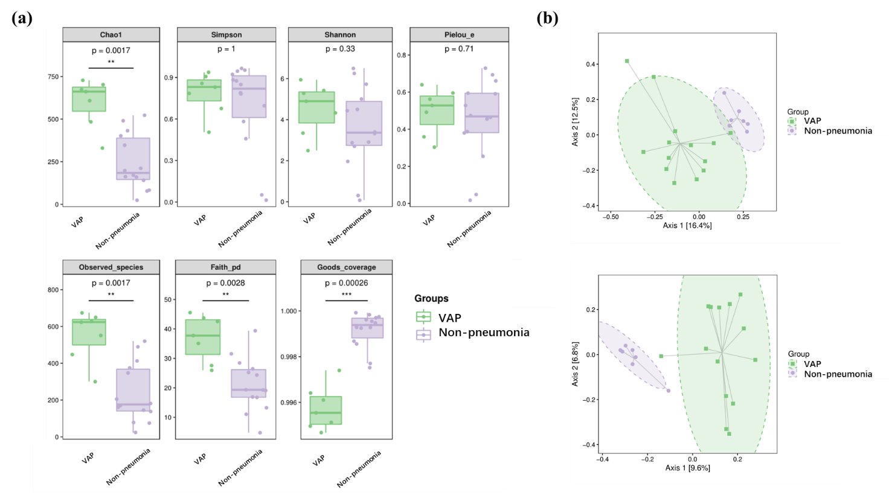
Figure 1. Oral microbial diversity and structure changes between VAP group and non- pneumonia healthy control. Oral microbiota of VAP patients significantly differs from healthy controls. (a)alpha-diversity index in non- pneumonia non-pneumonia and VAP group, including Chao1 index, Simpson index, Shannon diversity index, Pielou's evenness index, observed species richness, Faith's PD index and Goods coverage index, (b)beta-diversity differs between non-pneumonia group and experiment group. Unweighted UniFrac principal coordinate analysis (up panel) and unweighted Jaccard principal coordinate analysis (down panel) showed that oral microbiota of VAP patients differs from non-pneumonia.

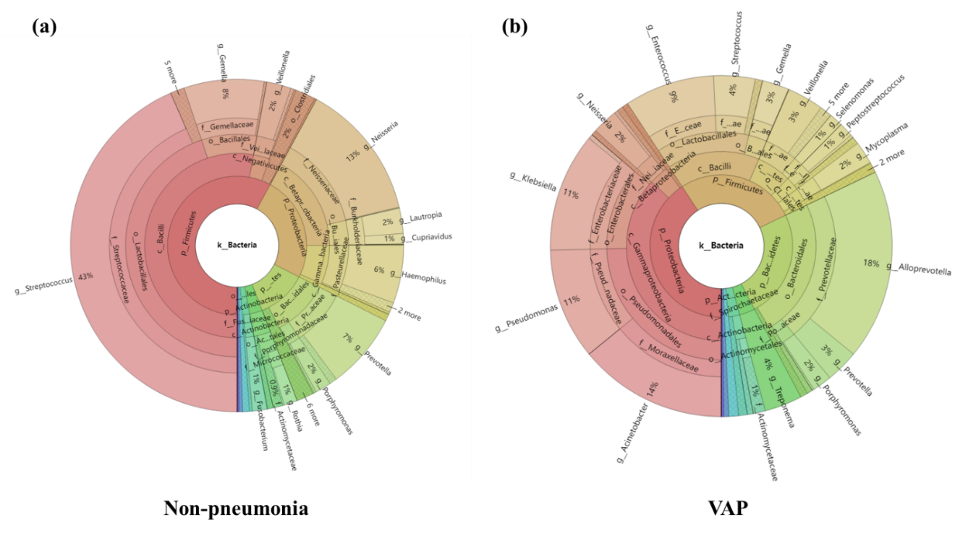

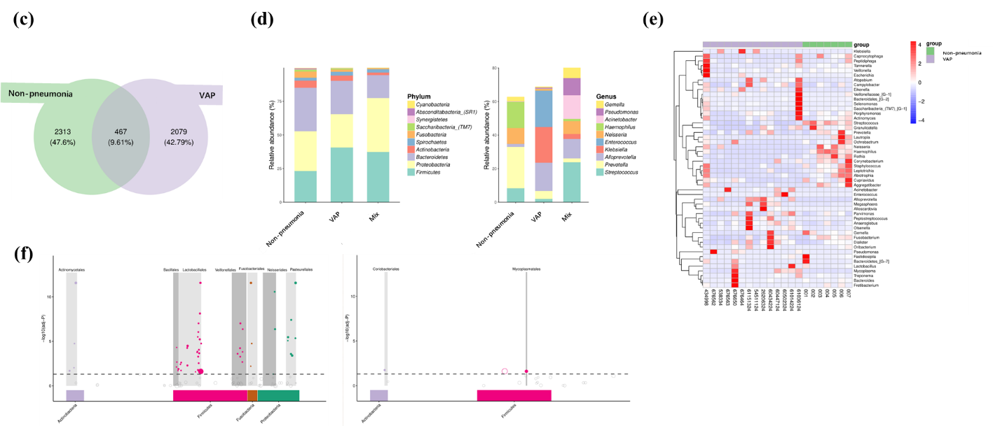
Figure 2. Phylogenetic alteration of the oral microbiota
Figure 2(a)-(f) shows of oral microbiota phylogenetic alterations between VAP patients and healthy controls. (a) Krona plot of healthy oral microbiome (non-pneumonia healthy control), (b) Krona plot of VAP patient’s oral microbiome (VAP group), (c)Venn diagram shows unique and shared ASV/OTUs between VAP patients and non-pneumonia control, (d)relative sequence abundance percentage of 10 most abundant taxa at phylum and genus level, non-pneumonia control group in X axis represents taxa that only exist in non-pneumonia group, VAP group in X axis represents taxa that only exist in VAP group, non-pneumonia group-VAP group represents taxa that exist in both group, (e)heatmap analysis shows the relative abundance between VAP group and non-pneumonia group, (f) Manhattan plot shows the upregulated taxa in non-pneumonia control group (left panel) and VAP group (right panel).

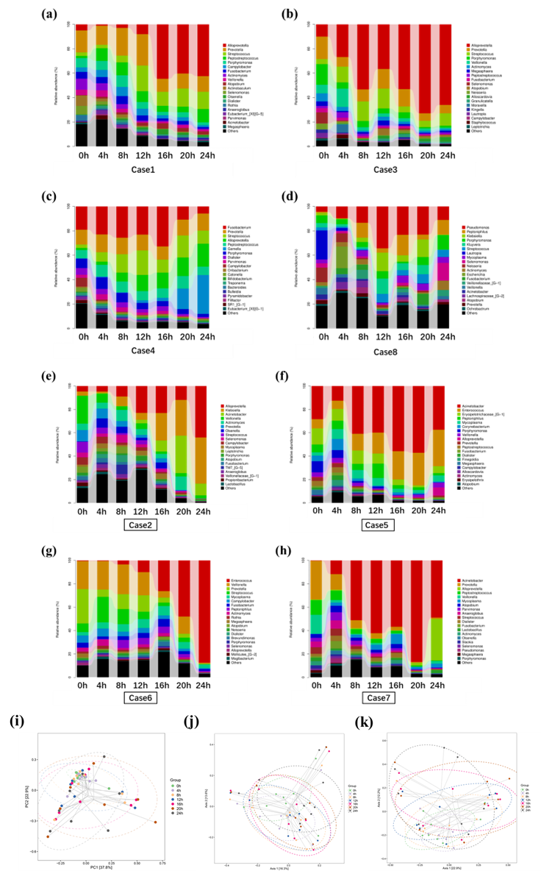
Figure 3. compositional differences in oral microbiota at different timepoint after oral care.
(a)-(h) shows the effect of oral care on oral microbiota in 8 VAP patients. Oral swabs took at 0, 4, 8, 12, 16, 20 and 24h, (i) principal component analysis of oral microbiota composition at different timepoints. (j)weighted and (k)unweighted uniFrac principal coordinates analysis of microbial compositional changes at different timepoints.

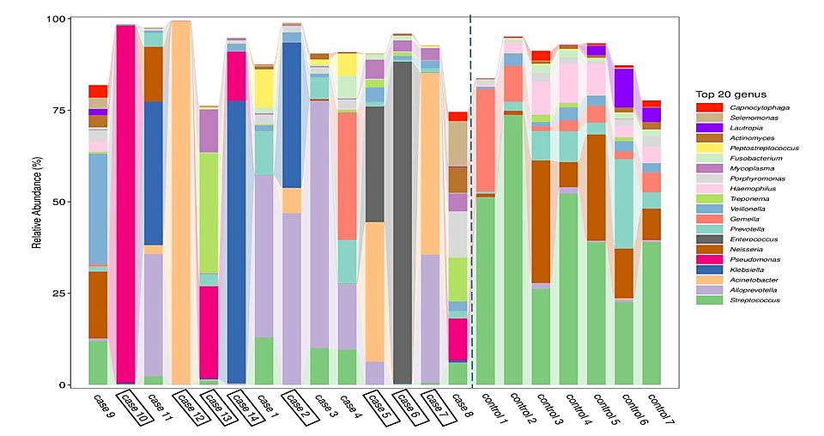
Figure 4. Top 20 bacterial genera in the 24-hour oral swab samples
most abundant 20 genera in oral swab samples. Control 1- 7 belongs to non- pneumonia control, case 1- 14 columns belong to VAP patients. Case 2, 5, 6, 7, 10, 12, 13, 14were dead cases.

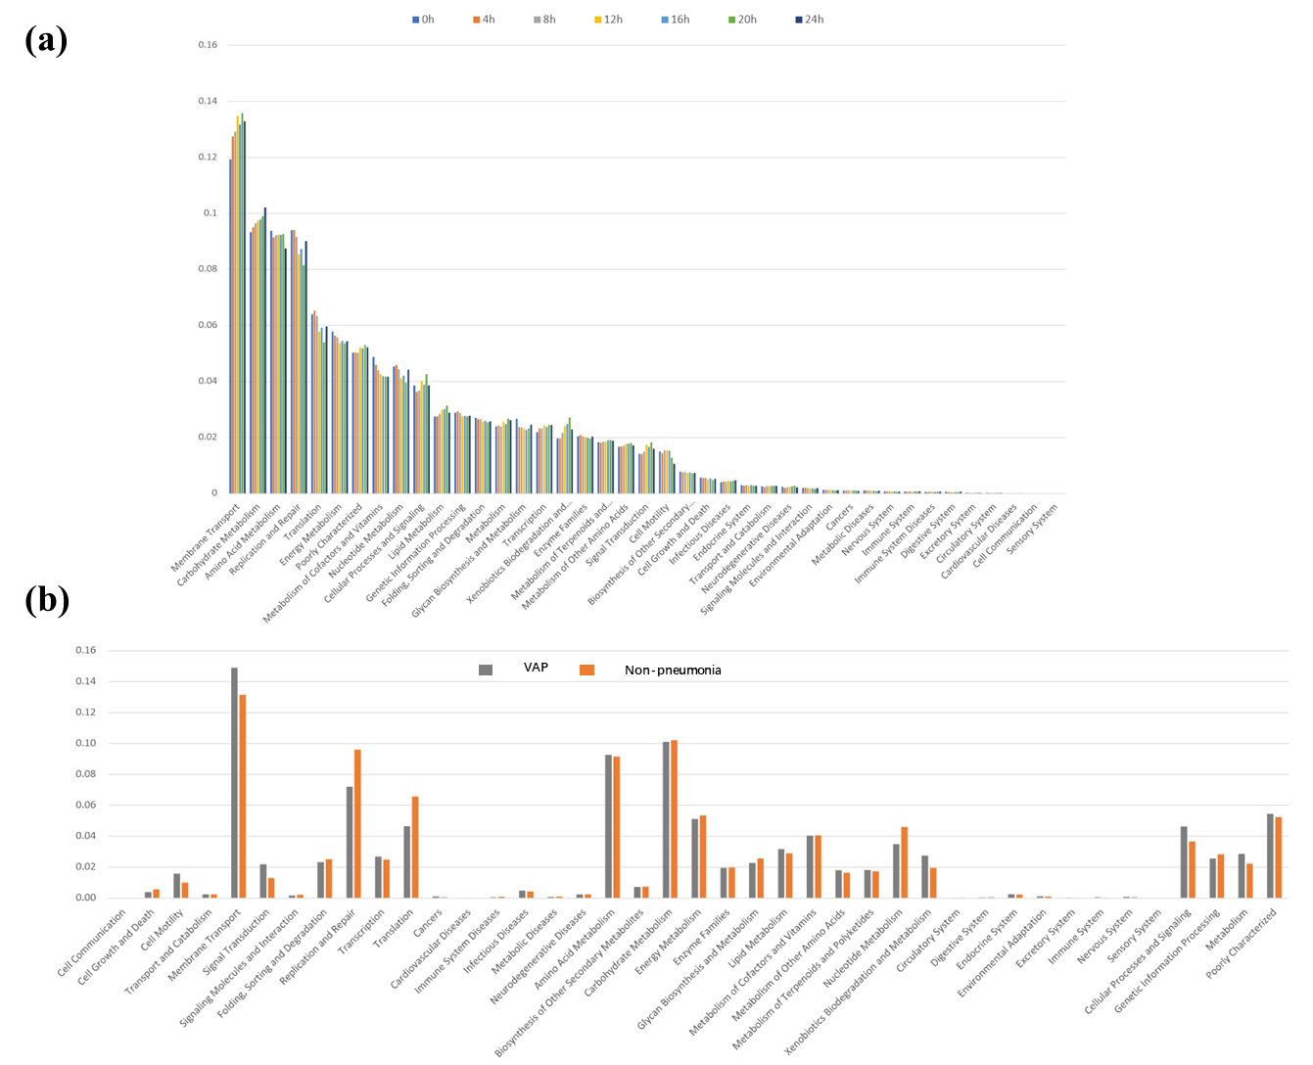
Figure 5. KEGG functional metabolic analysis
Figure 5(a)-(b) shows the KEGG functional metabolic analysis result. (a) time-related changes in community functional metabolism after oral care, (b) KEGG annotation result of VAP and non- pneumonia healthy control, no significant changes observed.

