Supporting information
Surface and pore co-functionalized ceramic membrane with Zr doped Co₃O₄ for SMX degradation through coupling peroxymonosulfate activation
Hang Zhang*, Wenyao Ge, Yinqiu Zhen, Cong Geng, Weichun Gao, Yang Wu*
School of Environmental and Chemical Engineering, Shenyang University of Technology, Shenyang 110870, China
*Corresponding author E-mail: zhanghang@sut.edu.cn and yangwu46@outlook.com

Text S1 Chemicals
Cobalt nitrate (Co(NO₃)₂·6H₂O), zirconyl nitrate (ZrO(NO₃)₂·xH₂O), citric acid, tert-butyl alcohol (TBA), methanol (MeOH), PMS (2KHSO₅·KHSO₄·K₂SO₄), 5,5-Dimethyl-1-pyrroline N-Oxide (DMPO), 2,2,6,6-Tetramethylpiperidine (TEMP), p-benzoquinone (p-BQ) and peroxymonosulfate (2KHSO₅·KHSO₄·K₂SO₄), were purchased from Aladdin Industrial Corporation. Sulfameth oxazole (SMX), Rhodamine B (RHB), Methylene Blue (MB), Bisphenol A (BPA) and phenol was provided by Tianjin Damao Chemical Reagent Co. The porous ceramic Al₂O₃ support was obtained from Guizhou More Advanced Materials Co., Ltd. NaCl, NaH₂PO₄, NaHCO₃, NaNO₃, humic acid (HA) and L-histidine were obtained from Tianjin Damao Chemical Reagent Co. All solutions are prepared with ultrapure water (resistivity > 18 MΩ cm), all chemicals are reagent grade and no further purification is required.
Text S2 Instrumental analysis
The morphologies and structures of catalytic membrane were observed by scanning electron microscope (SEM, JSM-IT800SHL). Powder X-ray diffraction (XRD, D/Max-2400) was used for crystal structure analysis with a Cu Kα X-ray source. The element composition and electronic structure was characterized by X-ray photoelectron spectroscopy (XPS, K-Alpha) and the C1s at 284.8 eV was used as the reference for calibrating peak positions. Active species was identified by electron spin resonance (EPR, Bruker A200) at room temperature. The leaching metal ions during the reaction were determined by ICP-AES spectrometer (Optima 200 DV, Perkinelmer). The pore size distributions of CoZr-CM and Al₂O₃ support were determined with a Capillary Flow Porometer (Porolux 1000, IB-FT GmbH). The intermediates of SMX were identified by a LC/MS (Agilent 1200SL/6410B) in the positive electrospray ionization mode (ESI⁺) and negative electrospray ionization mode (ESI⁻) with a scan range of m/z 80-500.
Test S3. Calculation of membrane porosity
The porosity is calculated from the dry weight and wet weight of the membrane. Firstly, the weight of the dry membrane (W₂/g) was determined. The membrane was then immersed into the ultrapure water until it was fully saturated. After wiping off the surface water, the weight of wet membrane (W₁/g) was determined. The membrane porosity was calculated using the following equation (eq. S1):
$ε=\frac{ω_{1}-ω_{2}}{A×l×d_{w}}$×100% (S1)
Where A, l, d_{w}, ω₁ and ω₂ refer to the valid membrane area (m²), the membrane thickness (m), the water density (0.998 g cm⁻³), the wet membrane weight (g), and the dry membrane weight (g), respectively.
Test S4 The preparation method of Co₃O₄ and Zr-Co₃O₄
Typical, 10 mmol Co(NO₃)₂·6H₂O was dissolved in water. Then, citric acid was added into the above solution where molar ratio of citric acid to all the metal ions was kept at 1.2. The mixed solution was evaporated at 80 ℃ under stirring until the gel was formed. The resulting gel was dried in an oven at 150 ℃ for 12 h to get a sponge-like materials, which was calcined in a muffle furnace at 200 ℃ for 2 h, and then at 500 ℃ for 2 h with a rate of 2 ℃ min⁻¹ to obtain Co3O4. Zr-Co3O4 was prepared by the same method except that 0.8 mmol of Co(NO₃)₂·6H₂O was replaced by ZrO(NO₃)₂·xH₂O.

Figure S1 Lab-scale membrane filtration system

Table S1. Detection methods of organic compounds by HPLC
compoud | mobile phase (v/v) | flow rate (mL min⁻¹) |  |  | wavelength (nm)
SMX | acetonitrile/water: 0.4/0.6 |  | 1.0 | 270
BPA | methanol/water: 0.7/0.3 |  | 1.0 | 280
phenol | methanol /water: 0.7/0.3 |  | 1.0 | 280

The concentrations of Rhodamine B and Methylene blue were measured using a UV-Vis spectrophotometer, with characteristic absorption wavelengths at 552 nm and 664 nm, respectively.

Test S5
20 mg catalyst was added to 100 mL pollutant solution under 500 rpm magnetic stirring. Afterwards, 10 mg PMS was added to initiate the catalytic oxidation. At certain time intervals, 1 mL solution was collected by disposable syringe, quenched by methanol and filtered by a cellulose acetate membrane (0.22 μm pore size) and then analyzed by high-performance liquid chromatography (HPLC) to determine the concentration of pollutants. The reaction rate constant (k) was calculated as follows:
$$\text{Ln}(C_{0}/C_{t})=k_{\text{obs}}t$$
where C₀ is the initial concentration of pollutant, C_{t} is the pollutant concentration at certain time (t) during reaction, k_{obs} is the apparent reaction constant obtained by calculating the slope of the plot of ln(C₀/C_{t}) versus time.
The removal efficiency R (%) of pollutants was calculated as follows:
$$R=\frac{C_{0}-C_{t}}{C_{0}}×100\%$$

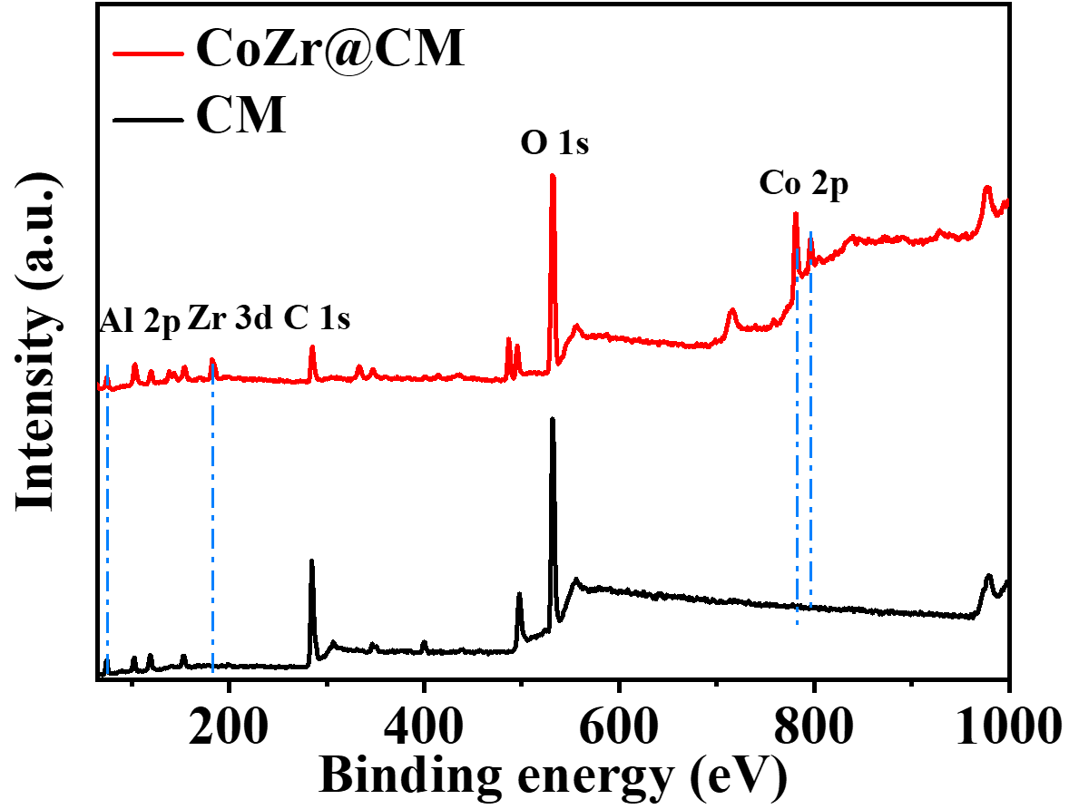
Figure S2 Survey XPS scan of CoZr@CM and CM

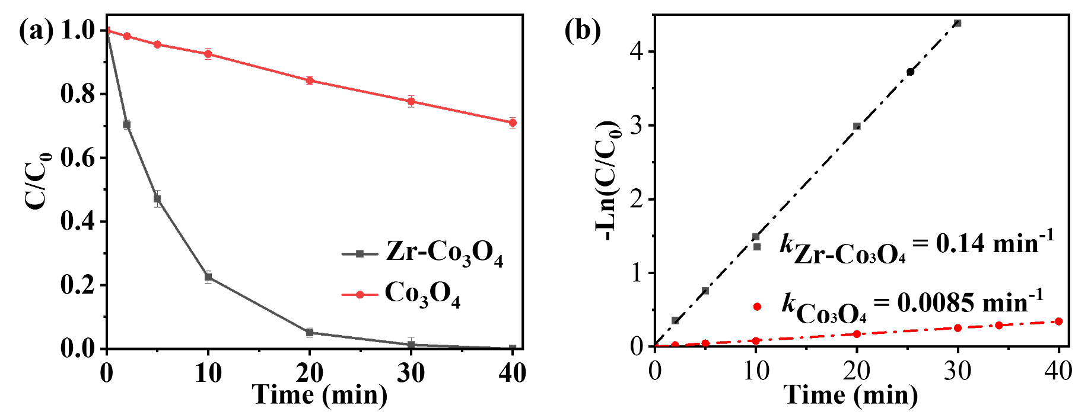
Figure S3 SMX degradation in Zr-Co₃O₄/PMS and Co₃O₄/PMS system

Table S2 The comparison of different catalytic membranes for SMX removal
Catalytic membrane | Permeability  (L m⁻² h⁻¹ bar⁻¹) | Retention time  (s) | PMS addition  (g L⁻¹) | SMX  (mg L⁻¹) | SMX removal (%) | Ref.
CoFCM | 3024 | 17.0 | 0.09 | 10 | 90.0 | [1]
Co₃O₄@Al₂O₃ | 7902 | 16.8 | 0.25 | 20 | 59.0 | [2]
CoFe₂O₄@Al₂O₃ | 3000 | / | 0.09 | 10 | 40.0 | [3]
FeCo@GCTs | 487 | / | 0.22 | 10 | 98.5 | [4]
FeCoS@N-rGO | 632 | / | 0.22 | 30 | 99.4 | [5]
ZTM-450 | 1895 | / | 0.09 | 10 | 96.3 | [6]
CoZr-CM | 2912 | 19.9 | 0.25 | 10 | 97.1 | This work

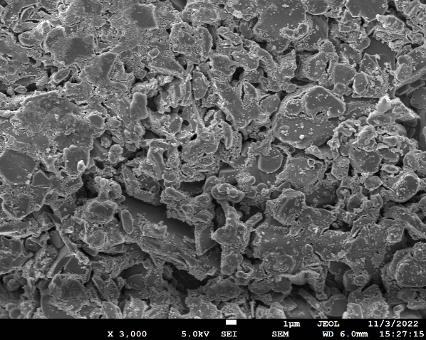
Figure S4 The SEM of used CoZr@CM

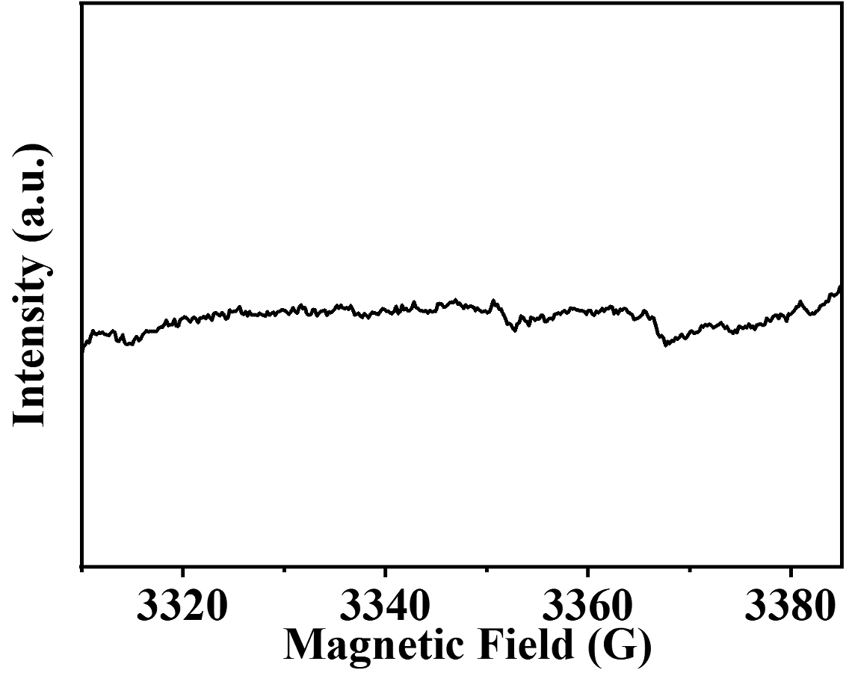
Figure S5 EPR spectra of O₂^{•-}

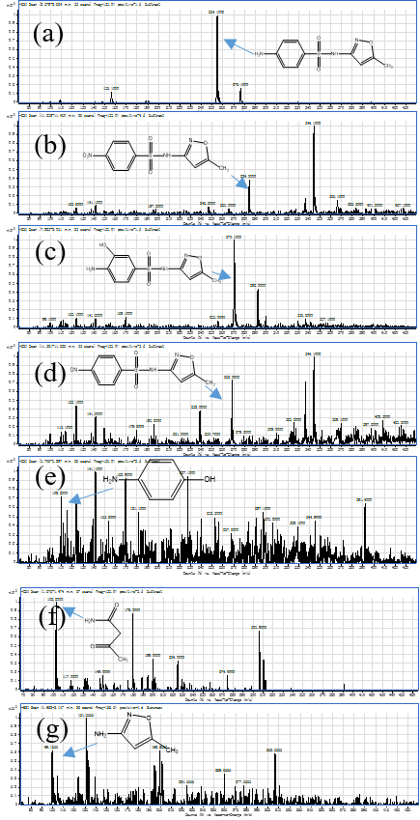
Figure S6 MS spectra of SMX degradation intermediates

Table S3 SMX and it degradation products
Compound | Formula | Chemical name | MW (g mol⁻¹) | Molecular structure
SMX | C₁₀H₁₁N₃O₃S | sulfamethoxazole | 253.05 | 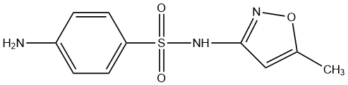
P1 | C₁₀H₉N₃O₄S | N-(5-methylisoxazol-3-yl)-4-nitrosobenzenesulfonamide | 267.03 | 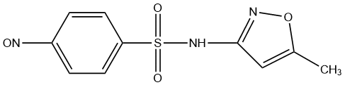
P2 | C₆H₄O₂ | benzoquinone | 108.02 | 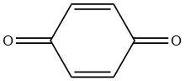
P3 | C₁₀H₁₁N₃O₄S | 4-amino-3-hydroxy-N-(5-methylisoxazol-3-yl)benzenesulfonamide | 269.05 | 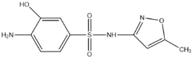
P4 | C₁₀H₉N₃O₅S | N-(5-methylisoxazol-3-yl)-4-nitrobenzenesulfonamide | 283.0 | 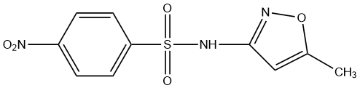
P5 | C₄H₆N₂O | 5-methylisoxazol-3-amine | 98.05 | 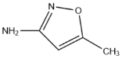
P6 | C₄H₇NO₂ | 3-oxobutanamide | 101.05 | 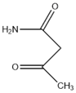

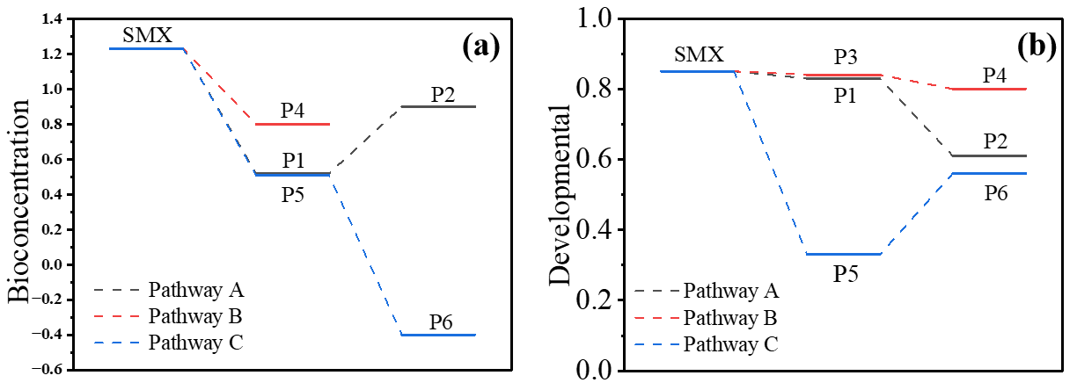
Figure S7 The toxicity of intermediates during SMX degradation. (a) Bioconcentration, (b) Development

Reference
[1] Y. Bao, W.-D. Oh, T.-T. Lim, R. Wang, R.D. Webster, X. Hu, Surface-nucleated heterogeneous growth of zeolitic imidazolate framework – A unique precursor towards catalytic ceramic membranes: Synthesis, characterization and organics degradation, Chemical Engineering Journal, 353 (2018) 69-79.
[2] Y. Bao, W.J. Lee, T.-T. Lim, R. Wang, X. Hu, Pore-functionalized ceramic membrane with isotropically impregnated cobalt oxide for sulfamethoxazole degradation and membrane fouling elimination: Synergistic effect between catalytic oxidation and membrane separation, Applied Catalysis B: Environmental, 254 (2019) 37-46.
[3] Y. Bao, T.-T. Lim, R. Wang, R.D. Webster, X. Hu, Urea-assisted one-step synthesis of cobalt ferrite impregnated ceramic membrane for sulfamethoxazole degradation via peroxymonosulfate activation, Chemical Engineering Journal, 343 (2018) 737-747.
[4] J. Ye, Y. Wang, Z. Li, D. Yang, C. Li, Y. Yan, J. Dai, 2D confinement freestanding graphene oxide composite membranes with enriched oxygen vacancies for enhanced organic contaminants removal via peroxymonosulfate activation, Journal of Hazardous Materials, 417 (2021) 126028.
[5] J. Ye, J. Dai, D. Yang, C. Li, Y. Yan, Y. Wang, 2D/2D confinement graphene-supported bimetallic Sulfides/g-C3N4 composites with abundant sulfur vacancies as highly active catalytic self-cleaning membranes for organic contaminants degradation, Chemical Engineering Journal, 418 (2021) 129383.
[6] H. Ma, X. Li, Z. Pan, R. Xu, P. Wang, H. Li, Y. Shi, X. Fan, C. Song, MOF derivative functionalized titanium-based catalytic membrane for efficient sulfamethoxazole removal via peroxymonosulfate activation, Journal of Membrane Science, 661 (2022) 120924.

