Suppl. Figure

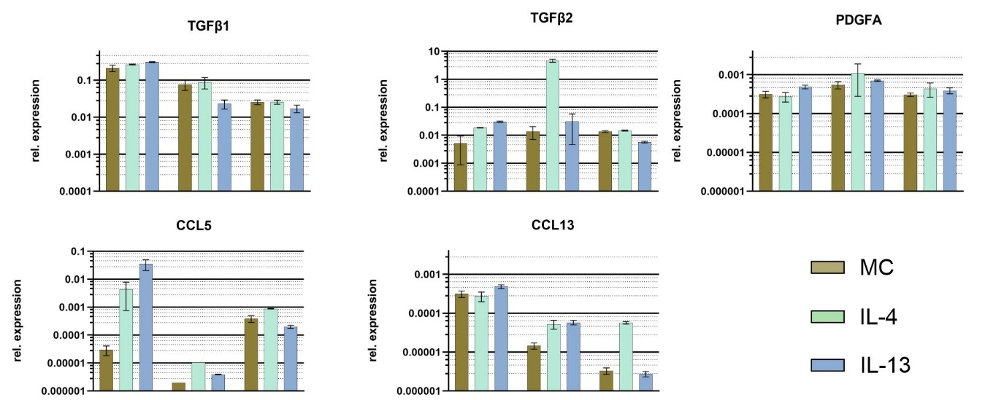
Suppl. Figure 1: Relative gene expression analysis of fibroblast (SPDF) after treatment with 50 ng/ml IL-4 or IL-13. The figure illustrates the differential response of SPDFs to cytokine stimulation. TGFβ1, TGFβ2, PDGFA-A, CCL5 and CCL13. These PAFs showed no reproducible results. Significance is marked: * (p<0.05), **(p<0.01). Data are presented as mean ± SD (n = 3).

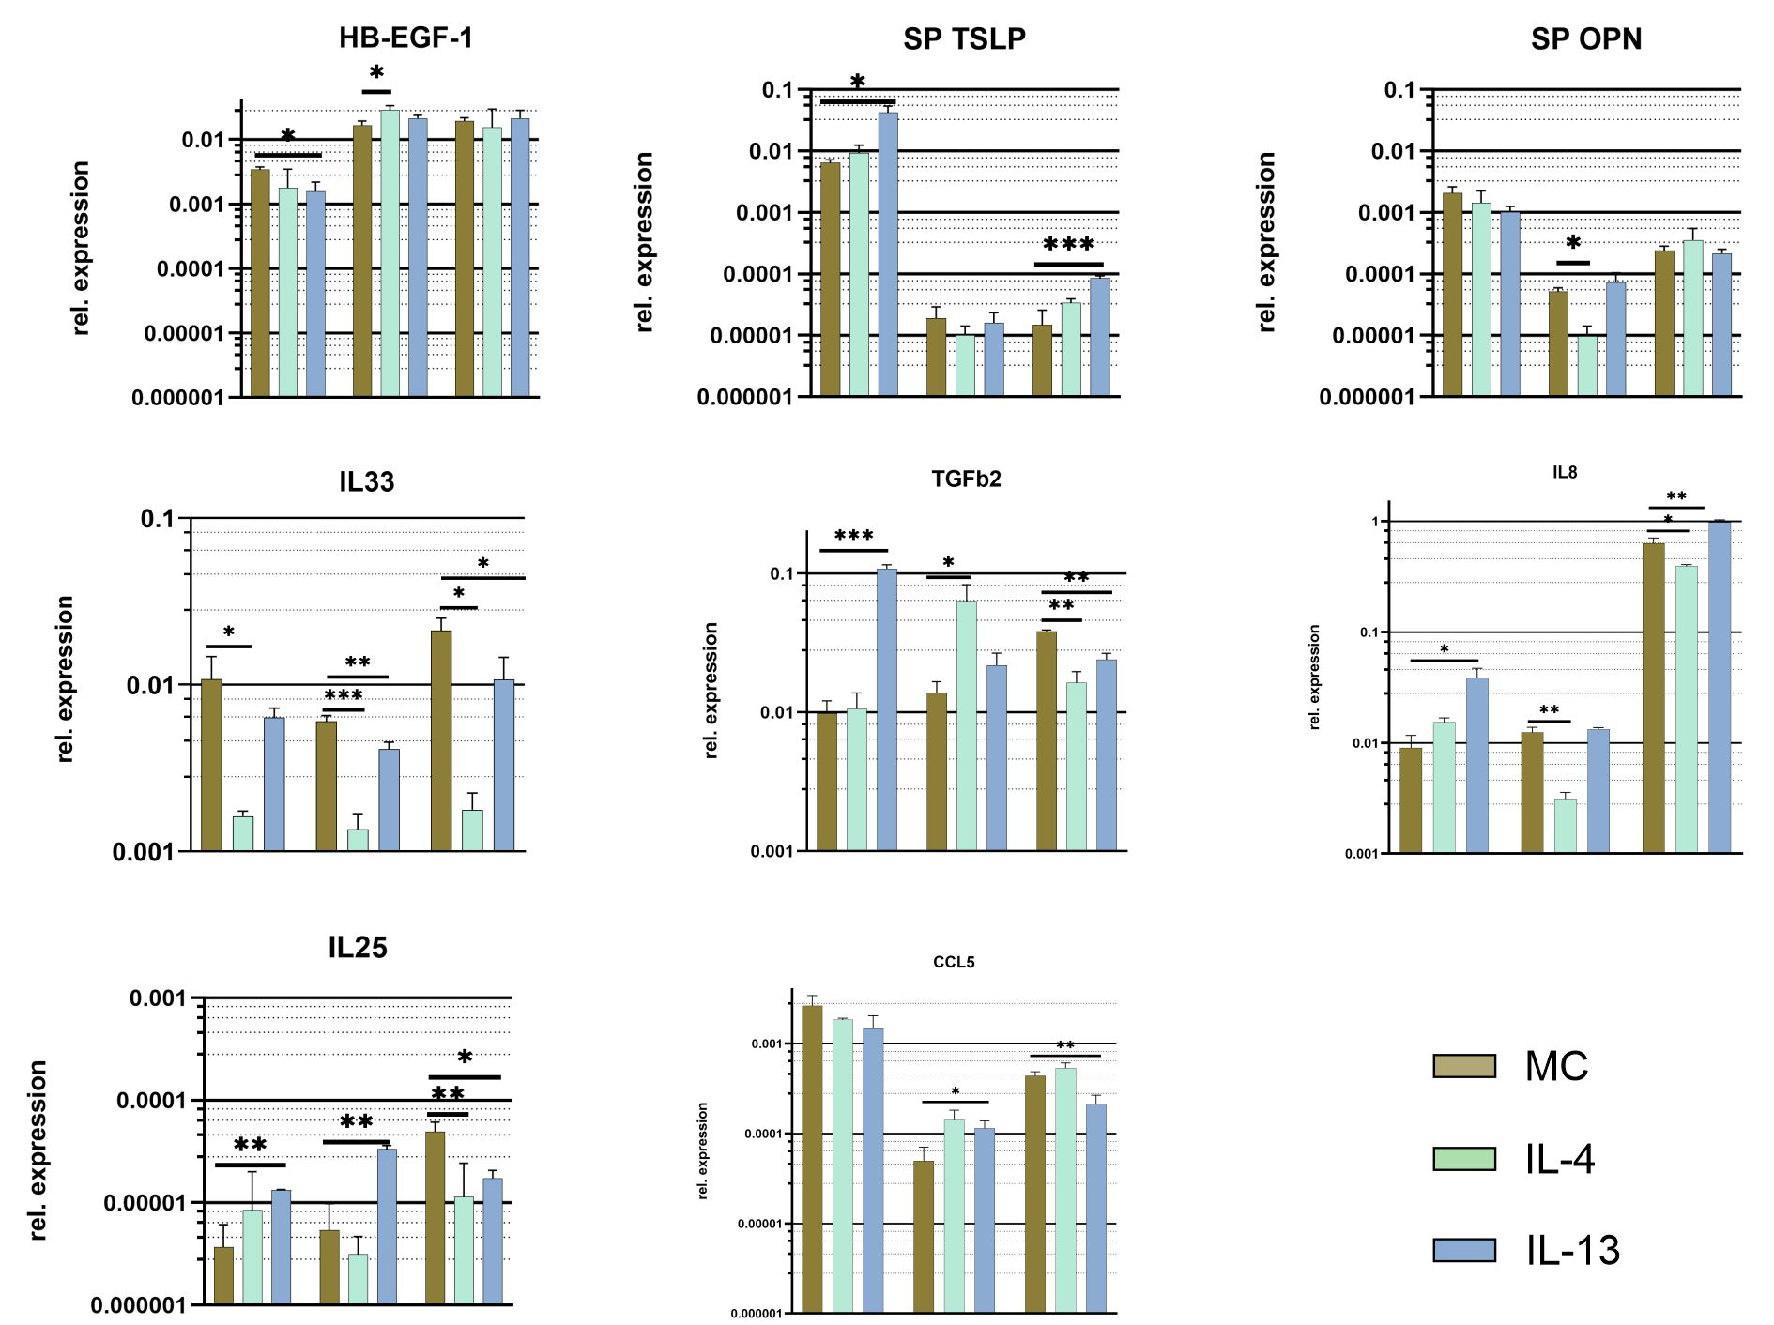
Suppl. Figure 2: Relative gene expression analysis of epithelial cells (SP) cultured under ALI conditions after treatment with 100 ng/ml IL-4 or IL-13. The figure illustrates the differential response of SPs to cytokine stimulation. Of IL-8, IL-25, IL-33, TGFb2, CCL5 and, HB-EGF. These PAFs showed no reproducible results.

