Additional file 1
Table S1. All focal cross-lagged paths in M1-M4
Model | Path | B | SE | β | 95% CI for B | p
M1 | POS T0 → CCSAS T1 | .000 | — | — | — | Fixed
M1 | POS T1 → CCSAS T2 | .000 | — | — | — | Fixed
M1 | NEG T0 → CCSAS T1 | .000 | — | — | — | Fixed
M1 | NEG T1 → CCSAS T2 | .000 | — | — | — | Fixed
M1 | GSES T0 → CCSAS T1 | .000 | — | — | — | Fixed
M1 | GSES T1 → CCSAS T2 | .000 | — | — | — | Fixed
M1 | CCSAS T0 → POS T1 | .000 | — | — | — | Fixed
M1 | CCSAS T1 → POS T2 | .000 | — | — | — | Fixed
M1 | CCSAS T0 → NEG T1 | .000 | — | — | — | Fixed
M1 | CCSAS T1 → NEG T2 | .000 | — | — | — | Fixed
M1 | CCSAS T0 → GSES T1 | .000 | — | — | — | Fixed
M1 | CCSAS T1 → GSES T2 | .000 | — | — | — | Fixed
M2 | POS T0 → CCSAS T1 | 5.184 | 1.987 | .097 | [1.290, 9.078] | .009
M2 | POS T1 → CCSAS T2 | 6.205 | 1.836 | .135 | [2.606, 9.803] | .001
M2 | NEG T0 → CCSAS T1 | -2.337 | 1.818 | -.039 | [-5.900, 1.226] | .199
M2 | NEG T1 → CCSAS T2 | -2.073 | 1.849 | -.039 | [-5.696, 1.550] | .262
M2 | GSES T0 → CCSAS T1 | 6.353 | 1.808 | .122 | [2.810, 9.896] | < .001
M2 | GSES T1 → CCSAS T2 | 1.911 | 2.178 | .040 | [-2.358, 6.180] | .380
M2 | CCSAS T0 → POS T1 | .000 | — | — | — | Fixed
M2 | CCSAS T1 → POS T2 | .000 | — | — | — | Fixed
M2 | CCSAS T0 → NEG T1 | .000 | — | — | — | Fixed
M2 | CCSAS T1 → NEG T2 | .000 | — | — | — | Fixed
M2 | CCSAS T0 → GSES T1 | .000 | — | — | — | Fixed
M2 | CCSAS T1 → GSES T2 | .000 | — | — | — | Fixed
M3 | POS T0 → CCSAS T1 | .000 | — | — | — | Fixed
M3 | POS T1 → CCSAS T2 | .000 | — | — | — | Fixed
M3 | NEG T0 → CCSAS T1 | .000 | — | — | — | Fixed
M3 | NEG T1 → CCSAS T2 | .000 | — | — | — | Fixed
M3 | GSES T0 → CCSAS T1 | .000 | — | — | — | Fixed
M3 | GSES T1 → CCSAS T2 | .000 | — | — | — | Fixed
M3 | CCSAS T0 → POS T1 | .006 | .001 | .275 | [.004, .007] | < .001
M3 | CCSAS T1 → POS T2 | .006 | .001 | .320 | [.005, .008] | < .001
M3 | CCSAS T0 → NEG T1 | .000 | .001 | -.020 | [-.002, .001] | .598
M3 | CCSAS T1 → NEG T2 | .001 | .001 | .045 | [-.001, .002] | .338
M3 | CCSAS T0 → GSES T1 | .005 | .001 | .233 | [.003, .006] | < .001
M3 | CCSAS T1 → GSES T2 | .006 | .001 | .304 | [.004, .008] | < .001
M4 | POS T0 → CCSAS T1 | 2.763 | 1.958 | .048 | [-1.075, 6.601] | .158
M4 | POS T1 → CCSAS T2 | 3.562 | 1.906 | .071 | [-.173, 7.297] | .062
M4 | NEG T0 → CCSAS T1 | -2.074 | 1.820 | -.033 | [-5.640, 1.492] | .254
M4 | NEG T1 → CCSAS T2 | -1.782 | 1.867 | -.029 | [-5.442, 1.877] | .340
M4 | GSES T0 → CCSAS T1 | 5.086 | 1.776 | .091 | [1.604, 8.568] | .004
M4 | GSES T1 → CCSAS T2 | .287 | 2.236 | .005 | [-4.097, 4.670] | .898
M4 | CCSAS T0 → POS T1 | .005 | .001 | .260 | [.004, .007] | < .001
M4 | CCSAS T1 → POS T2 | .006 | .001 | .298 | [.004, .008] | < .001
M4 | CCSAS T0 → NEG T1 | .000 | .001 | -.018 | [-.002, .001] | .618
M4 | CCSAS T1 → NEG T2 | .001 | .001 | .046 | [-.001, .002] | .331
M4 | CCSAS T0 → GSES T1 | .004 | .001 | .210 | [.003, .006] | < .001
M4 | CCSAS T1 → GSES T2 | .006 | .001 | .299 | [.004, .008] | < .001
Note. N = 766 in each model; MLR estimation with FIML for missing repeated measures. M1 = stability-only; M2 = individual variables to adaptation; M3 = adaptation to individual variables; M4 = bidirectional. All four models adjust for sex, age, and residence. CCSAS = college adaptation; POS = positive coping; NEG = negative coping; GSES = general self-efficacy. B, SE, and 95% CI are unstandardized; beta is STDYX standardized. p values refer to tests of B. All estimated paths are reported, including nonsignificant paths. Mplus prints three decimals; near-zero B values can round to .000. T0-T1 and T1-T2 span 1 and 2 months, respectively. Fixed denotes a path constrained to zero or omitted by model specification; its SE, standardized estimate, CI, and p value were not estimated. A fixed path is not an estimated nonsignificant effect.

Figure S1 Final adaptation-to-individual-variables cross-lagged panel model (M3).
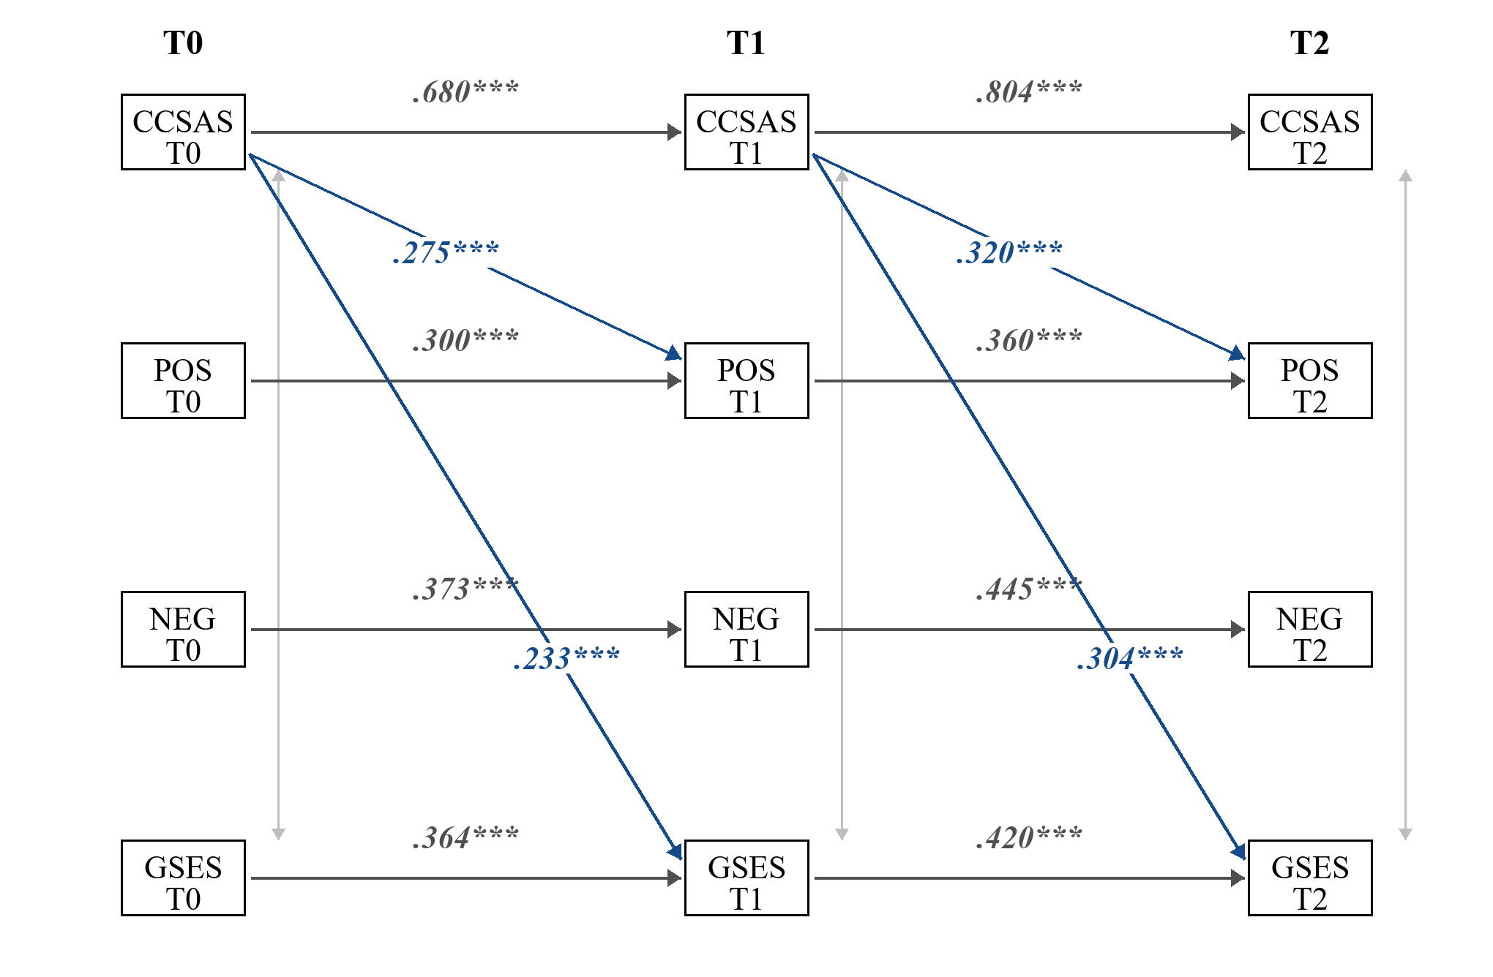
Note. Standardized coefficients are shown. Only significant focal cross-lagged paths involving CCSAS are displayed; all autoregressive paths were estimated and shown in gray. Non-significant focal cross-lagged paths were omitted for clarity. POS = positive coping; NEG = negative coping; GSES = general self-efficacy. The model adjusted for sex, age, and residence. **p < .01; ***p < .001.

Table S2 Measurement invariance results for negative coping and general self-efficacy
Construct | Model | CFI | TLI | RMSEA | SRMR | ΔCFI | ΔRMSEA | ΔSRMR | Decision
Negative coping | Configural | .917 | .899 | .043 | .061 | — | — | — | Baseline fit
Negative coping | Metric | .913 | .899 | .043 | .064 | −.004 | .000 | .003 | Supported
Negative coping | Scalar | .893 | .884 | .047 | .067 | −.020 | .004 | .003 | Not supported
GSES | Configural | .928 | .916 | .055 | .038 | — | — | — | Baseline fit
GSES | Metric | .927 | .919 | .054 | .040 | −.001 | −.001 | .002 | Supported
GSES | Scalar | .914 | .908 | .058 | .043 | −.013 | .004 | .003 | Not supported
Note. N = 766. Changes in fit indices are relative to the preceding model. Strict invariance was not tested after scalar invariance failed.

Table S3 Diagnostic unconditional growth models for negative coping and self-efficacy
Variable | χ² (df) | RMSEA | CFI | SRMR | Intercept M (SE) | Slope M (SE) | Var(I) | Var(S)
Negative coping | 1.507 (1) | .026 | .997 | .012 | 2.22 (0.02)*** | 0.00 (0.01) | .10*** | .010
Self-efficacy | 4.521 (1) | .068 | .984 | .017 | 2.36 (0.02)*** | 0.03 (0.01)** | .20*** | .017

Table S4. Covariate paths in the M2 exploratory parallel-process growth model
Path | B | SE | β | 95% CI for B | p
Sex → Positive coping intercept | .130 | .046 | .131 | [.039, .221] | .005
Age → Positive coping intercept | .018 | .028 | .032 | [−.036, .073] | .510
Residence → Positive coping intercept | −.084 | .041 | −.096 | [−.165, −.003] | .043
Sex → Positive coping slope | −.045 | .023 | −.139 | [−.090, .000] | .050
Age → Positive coping slope | −.017 | .017 | −.089 | [−.049, .016] | .325
Residence → Positive coping slope | .007 | .018 | .023 | [−.029, .042] | .720
Sex → CCSAS intercept | -3.832 | 2.047 | −.062 | [-7.844, .180] | .061
Age → CCSAS intercept | .976 | 1.262 | .028 | [-1.498, 3.450] | .439
Residence → CCSAS intercept | 1.913 | 1.883 | .036 | [-1.778, 5.603] | .310
Sex → CCSAS slope | .689 | .974 | .073 | [-1.220, 2.599] | .479
Age → CCSAS slope | −.582 | .603 | −.107 | [-1.764, .600] | .335
Residence → CCSAS slope | .744 | .700 | .090 | [−.629, 2.117] | .288
Note. N = 766. These estimates refer to PP-M2, not the original or zero-boundary PP model. Sex: 1 = male, 2 = female; residence: 1 = urban, 2 = rural. B, SE, and 95% CI are unstandardized; β is STDYX standardized. p values test B. Sex, age, and residence predict all four growth factors. Time scores are 0, 1, and 3; MLR estimation uses FIML for missing repeated measurements.

Table S5. Residual-structure sensitivity analyses of the parallel-process growth model
Model | χ² (df) | p | CFI | TLI | RMSEA [90% CI] | SRMR | AIC | BIC | Negative variance / admissibility
PP-M1 | 13.783 (11) | .245 | .998 | .995 | .018 [.000, .044] | .018 | 20392.868 | 20550.668 | Negative CCSAS T2 residual variance: −247.564. Inadmissible.
PP-M2 | 56.588 (13) | < .001 | .971 | .927 | .066 [.049, .084] | .056 | 20441.637 | 20590.154 | No negative variances or non-positive-definite warnings. Admissible.
PP-M3a | 31.146 (13) | .003 | .988 | .970 | .043 [.024, .062] | .075 | 20408.502 | 20557.020 | Negative CCSAS T2 residual (−118.782) and adaptation-slope disturbance (−2.263). Inadmissible; see note.
PP-M4 | 62.981 (15) | < .001 | .968 | .931 | .065 [.049, .082] | .085 | 20446.416 | 20585.651 | No negative variances or non-positive-definite warnings. Admissible; SRMR = .085.
Note. N = 766 in all models. PP-M1: both constructs' three residual variances freely estimated; PP-M2: adaptation residual variances equal across waves, coping residual variances free; PP-M3: coping residual variances equal, adaptation residual variances free; PP-M4: residual variances equal within each construct, with different variance parameters for the two constructs. All models freely estimate the three same-wave cross-construct residual covariances and both within-process intercept–slope disturbance covariances, and adjust all four growth factors for sex, age, and residence. No residual variance is fixed to zero.

