Supplementary Data
Anastomotic leakage and long-term survival after minimally invasive esophagectomy: a retrospective cohort study

Supplementary Table S1. Standardized mean differences (SMD) of baseline covariates before and after IPTW weighting.
Variable | SMD_before_IPTW | SMD_after_IPTW
Age | 0.194 | 0.028
Male sex | 0.106 | 0.031
Smoking history | 0.143 | 0.028
T stage 3-4 | 0.252 | 0.014
N+ stage | 0.023 | 0.026
Lymphovascular invasion | 0.147 | 0.014
Perineural invasion | 0.25 | 0.008
Note: SMD < 0.10 indicates good balance. IPTW, inverse probability of treatment weighting; AL, anastomotic leakage; LVI, lymphovascular invasion; PNI, perineural invasion; CEA, carcinoembryonic antigen; BMI, body mass index.
Abbreviations: AL, anastomotic leakage; BMI, body mass index; CEA, carcinoembryonic antigen; IPTW, inverse probability of treatment weighting; LVI, lymphovascular invasion; N, nodal stage; PNI, perineural invasion; SMD, standardized mean difference; T, tumour stage

Supplementary Table S2. Baseline characteristics stratified by sex in the full survival-analysis cohort (n=618).
Variable | Overall (n=618) | Male (n=461) | Female (n=157) | P-value
Age, years | 60.0 (54.0-64.0) | 59.0 (54.0-63.0) | 62.0 (56.0-68.0) | <0.001
BMI, kg/m² | 22.0 (20.2-24.2) | 22.0 (20.2-24.2) | 22.2 (19.9-24.0) | 0.797
Pack-years | 15.0 (0.0-40.0) | 30.0 (0.0-40.0) | 0.0 (0.0-0.0) | <0.001
Operative time, min | 290.0 (250.0-330.0) | 300.0 (258.2-345.0) | 273.0 (240.0-313.0) | <0.001
Blood loss, ml | 100.0 (100.0-150.0) | 100.0 (100.0-150.0) | 100.0 (60.0-162.5) | 0.407
Tumor length, cm | 4.5 (3.3-5.5) | 4.4 (3.5-5.2) | 4.7 (2.8-5.9) | 0.835
Lymph nodes harvested, n | 30.0 (23.0-39.0) | 30.0 (24.0-39.0) | 29.0 (23.0-39.2) | 0.589
Positive lymph nodes, n | 0.0 (0.0-2.0) | 1.0 (0.0-2.0) | 0.0 (0.0-1.0) | <0.001
CEA, ng/ml | 2.3 (1.5-3.4) | 2.6 (1.7-3.7) | 1.7 (1.1-2.4) | <0.001
Hospital stay, days | 20.0 (17.0-26.0) | 20.0 (17.0-26.0) | 19.0 (17.0-25.0) | 0.484
OS, months | 37.4 (24.4-59.1) | 37.2 (23.9-60.4) | 40.1 (26.2-55.6) | 0.938
Anastomotic site |  |  |  | 0.671
Cervical | 457 (90.5) | 351 (90.9) | 106 (89.1)
Intrathoracic | 48 (9.5) | 35 (9.1) | 13 (10.9)
LVI, n (%) | 113 (18.3) | 96 (20.8) | 17 (10.8) | 0.007
PNI, n (%) | 94 (15.2) | 75 (16.3) | 19 (12.1) | 0.260
Differentiation |  |  |  | 0.755
Well | 217 (35.1) | 165 (35.8) | 52 (33.1)
Moderately | 305 (49.4) | 228 (49.5) | 77 (49.0)
Poorly | 40 (6.5) | 32 (6.9) | 8 (5.1)
TNM stage |  |  |  | 0.034
I | 163 (26.4) | 115 (24.9) | 48 (30.6)
II | 110 (17.8) | 76 (16.5) | 34 (21.7)
III | 115 (18.6) | 95 (20.6) | 20 (12.7)
Anastomotic leakage, n (%) | 96 (15.5) | 75 (16.3) | 21 (13.4) | 0.461
Pulmonary infection, n (%) | 199 (32.2) | 162 (35.1) | 37 (23.6) | 0.010
Chylothorax, n (%) | 9 (1.5) | 6 (1.3) | 3 (1.9) | 0.869
Gastroparesis, n (%) | 20 (3.2) | 18 (3.9) | 2 (1.3) | 0.178
Anastomotic stenosis, n (%) | 21 (3.4) | 19 (4.1) | 2 (1.3) | 0.148
Vocal cord palsy, n (%) | 11 (1.8) | 9 (2.0) | 2 (1.3) | 0.837
Death, n (%) | 165 (26.7) | 132 (28.6) | 33 (21.0) | 0.079
Note: Data are presented as median (interquartile range) or n (%). P-values compare male versus female patients. AL, anastomotic leakage; BMI, body mass index; CEA, carcinoembryonic antigen; LVI, lymphovascular invasion; OS, overall survival; PNI, perineural invasion; TNM, tumour-node-metastasis.
Abbreviations: AL, anastomotic leakage; BMI, body mass index; CEA, carcinoembryonic antigen; LVI, lymphovascular invasion; N, nodal stage; OS, overall survival; PNI, perineural invasion; T, tumour stage; TNM, tumour-node-metastasis
Supplementary Table S3. Perioperative outcomes in the full cohort (n=633): AL group vs non-AL group.
Variable | AL+ | AL- | p | n_AL | n_non
Hospital stay (days) | 37.1±14.9 | 20.4±7.7 | <0.001 | 99 | 534
Total cost (CNY×10⁴) | 109586.9±42892.6 | 83866.2±24135.6 | <0.001 | 91 | 496
Operative time (min) | 308.4±69.6 | 296.5±61.9 | 0.1698 | 99 | 531
Blood loss (mL) | 134.5±73.0 | 124.6±70.5 | 0.1124 | 96 | 523
Pulmonary infection | 62 (62.6%) | 144 (27.0%) | <0.001 | 99 | 534
Chylothorax | 3 (3.1%) | 7 (1.3%) | 0.4031 | 98 | 534
Gastroparesis | 1 (1.0%) | 19 (3.6%) | 0.3112 | 98 | 531
Anastomotic stenosis | 4 (7.1%) | 18 (5.8%) | 0.9303 | 56 | 311
Vocal cord palsy | 2 (2.0%) | 9 (1.7%) | 1.0000 | 99 | 529
Reoperation | 0 (0.0%) | 0 (0.0%) | 1.0000 | 16 | 321
Note: Continuous variables presented as mean ± standard deviation; categorical variables as n (%). p-values from Mann-Whitney U test (continuous) or chi-square/Fisher exact test (categorical). CNY, Chinese Yuan.
Abbreviations: AL, anastomotic leakage; CNY, Chinese Yuan

Supplementary Table S4. Sequential covariate adjustment for the AL effect on overall survival.
Model | Covariates adjusted | n | HR | 95% CI | p-value
Model 1 (Unadjusted) | Unadjusted | 592 | 1.969 | 1.377-2.815 | <0.001
Model 2 (+ age, sex) | Age, Sex | 592 | 1.901 | 1.327-2.723 | <0.001
Model 3 (+ T, N stage) | Age, Sex, T stage, N stage | 592 | 1.956 | 1.362-2.810 | <0.001
Model 4 (+ LVI, PNI) | Age, Sex, T, N, LVI, PNI | 592 | 1.925 | 1.339-2.766 | <0.001
Model 5 (+ smoking) | Age, Sex, T, N, LVI, PNI, Smoking | 592 | 1.926 | 1.340-2.770 | <0.001
Note: Sequential adjustment was performed to assess the stability of the AL effect after incrementally adding covariate groups. HR, hazard ratio; CI, confidence interval; AL, anastomotic leakage; LVI, lymphovascular invasion; PNI, perineural invasion.
Abbreviations: AL, anastomotic leakage; CI, confidence interval; HR, hazard ratio; LVI, lymphovascular invasion; N, nodal stage; PNI, perineural invasion; T, tumour stage
Supplementary Table S5. Subgroup analysis of the association between anastomotic leakage and overall survival.
Subgroup | HR | CI_lower | CI_upper | p | n | n_AL
Age ≤60 | 2.081 | 1.266 | 3.422 | 0.004 | 331 | 45
Age >60 | 1.868 | 1.084 | 3.219 | 0.024 | 261 | 46
Male | 1.944 | 1.303 | 2.901 | 0.001 | 446 | 72
Female | 1.590 | 0.604 | 4.188 | 0.348 | 146 | 19
T1-2 | 2.026 | 0.909 | 4.514 | 0.084 | 270 | 32
T3-4 | 1.927 | 1.277 | 2.910 | 0.002 | 322 | 59
N0 | 1.023 | 0.475 | 2.205 | 0.954 | 313 | 49
N+ | 2.442 | 1.604 | 3.717 | <0.001 | 279 | 42
LVI- | 1.624 | 1.016 | 2.594 | 0.043 | 479 | 69
LVI+ | 2.558 | 1.404 | 4.662 | 0.002 | 113 | 22
PNI- | 1.462 | 0.926 | 2.308 | 0.103 | 498 | 69
PNI+ | 4.801 | 2.270 | 10.153 | <0.001 | 94 | 22
Non-smoker | 1.164 | 0.604 | 2.242 | 0.650 | 263 | 35
Smoker | 2.638 | 1.681 | 4.139 | <0.001 | 329 | 56
CEA ≤5 | 1.820 | 1.237 | 2.677 | 0.002 | 539 | 80
CEA >5 | 4.879 | 1.341 | 17.756 | 0.016 | 53 | 11
BMI <24 | 2.150 | 1.418 | 3.260 | <0.001 | 428 | 63
BMI ≥24 | 1.178 | 0.522 | 2.656 | 0.694 | 150 | 27
Note: HR, hazard ratio; CI, confidence interval; Bonferroni-corrected significance threshold α = 0.0028 (18 comparisons). p-values between 0.0028 and 0.05 are nominally significant but do not survive correction.
Abbreviations: AL, anastomotic leakage; BMI, body mass index; CEA, carcinoembryonic antigen; CI, confidence interval; HR, hazard ratio; LVI, lymphovascular invasion; N, nodal stage; PNI, perineural invasion; T, tumour stage

Supplementary Table S6. Risk stratification by nomogram-predicted 5-year overall survival in the 617 patients with complete model variables (8-variable nomogram: AL, age, sex, smoking history, T stage, N stage, LVI, PNI; C-index 0.715). Hazard ratios are referenced to the low-risk group.
Risk group | n | 5-year OS (%) | Median OS (months) | HR (95% CI) | p-value
Low risk | 204 | 86.4 | Not reached | 1 (reference) | -
Intermediate risk | 206 | 72.3 | Not reached | 2.23 (1.35-3.68) | 0.002
High risk | 207 | 47.5 | 49.8 | 5.27 (3.31-8.39) | <0.001
Note: Patients were divided into low-, intermediate-, and high-risk groups based on tertiles of the nomogram-predicted 5-year survival probability. OS, overall survival; CI, confidence interval.
Abbreviations: CI, confidence interval; HR, hazard ratio; OS, overall survival

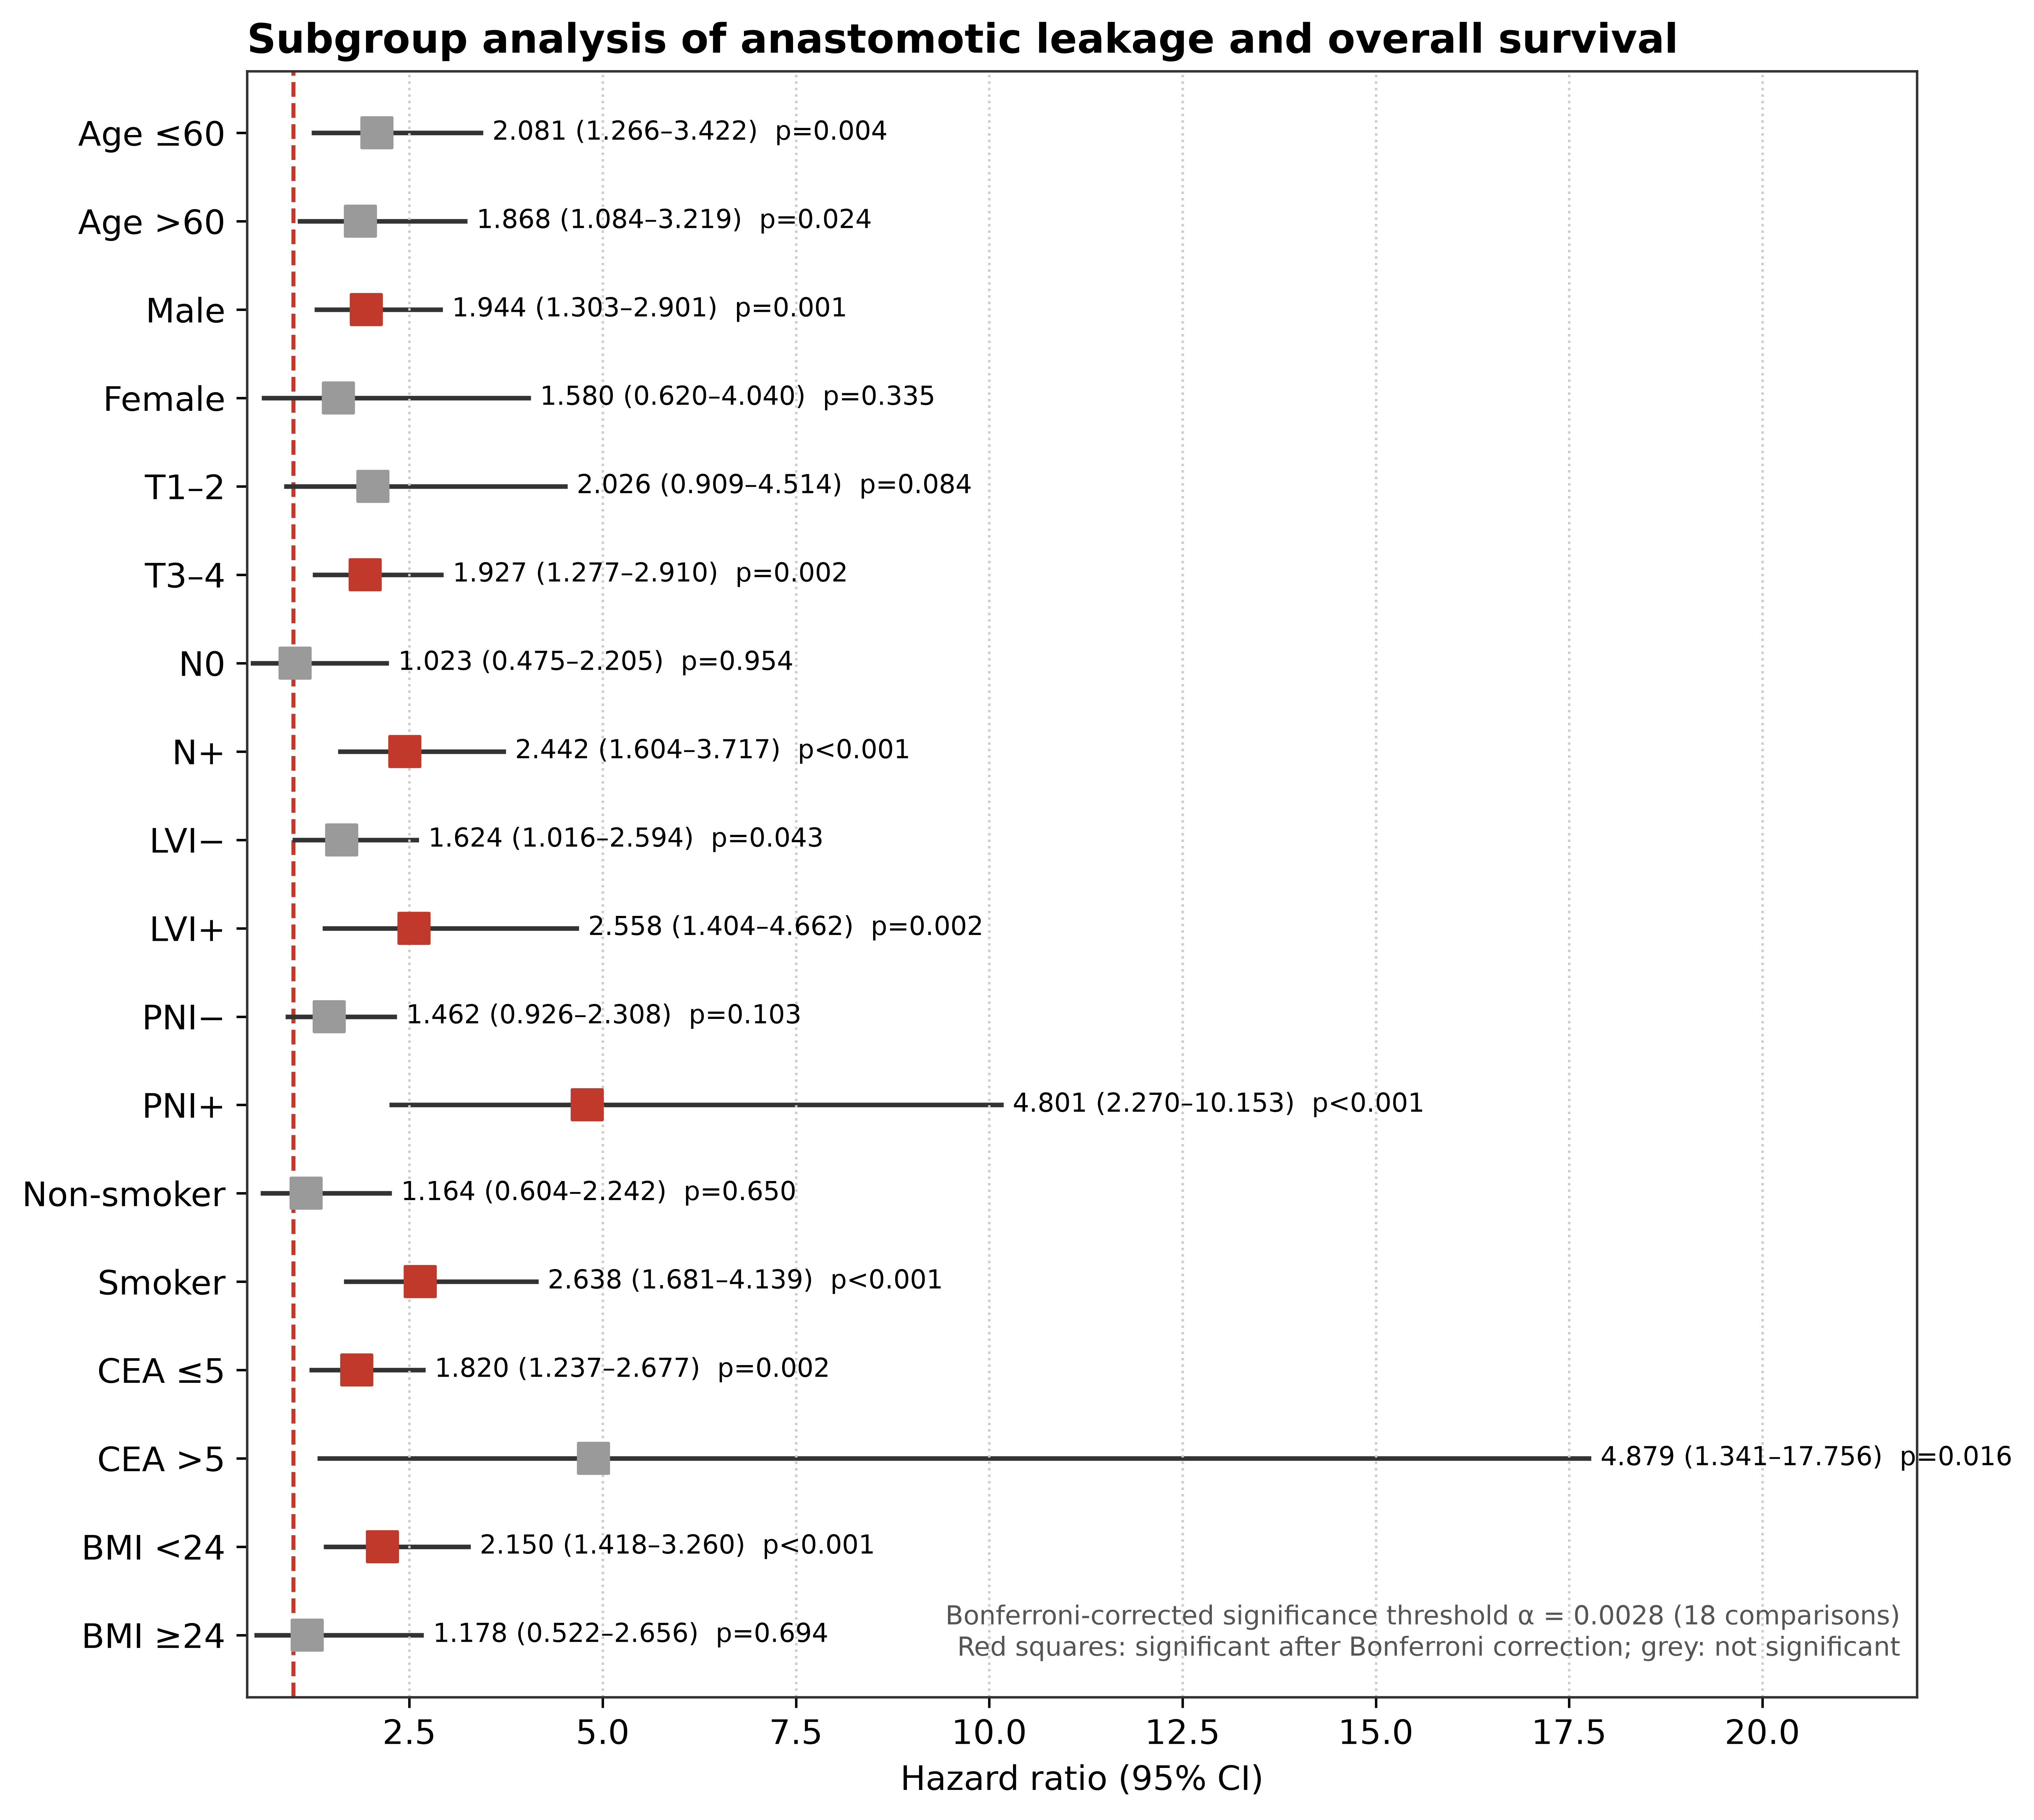
Supplementary Figure S1. Forest plot of subgroup analyses evaluating the association between anastomotic leakage (AL) and overall survival.
Note: Hazard ratios (HR) and 95% confidence intervals (CI) are shown for each subgroup. The vertical dashed line represents HR = 1 (no effect). Blue squares indicate nominally significant results (p < 0.05); red squares indicate results that did not survive Bonferroni correction (α = 0.0028). LVI, lymphovascular invasion; PNI, perineural invasion; CEA, carcinoembryonic antigen; BMI, body mass index.

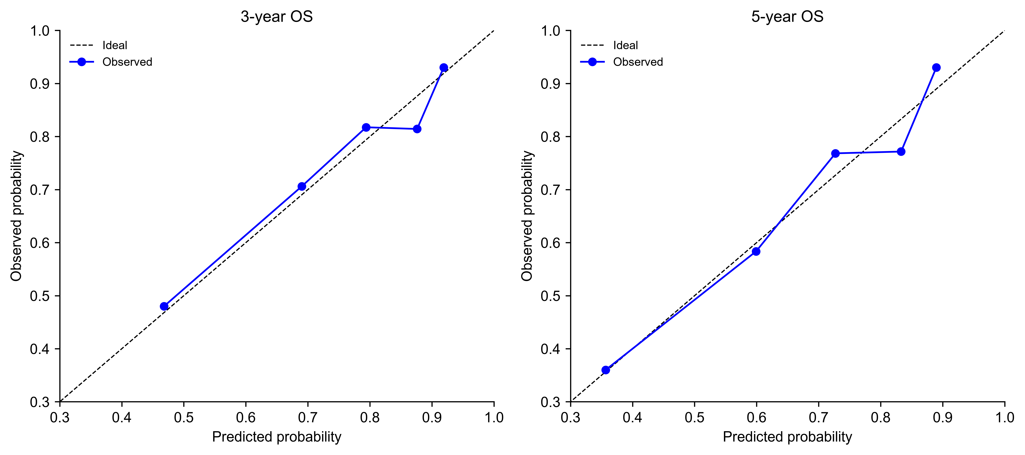
Supplementary Figure S2. Calibration curve of the nomogram for predicting 3-year and 5-year overall survival.
Note: The x-axis represents the nomogram-predicted survival probability, and the y-axis represents the observed survival probability estimated by Kaplan-Meier method. The dashed line represents ideal calibration (predicted = observed). The solid line represents the bootstrap-corrected calibration curve (1000 resamples). Closer alignment to the dashed line indicates better calibration.

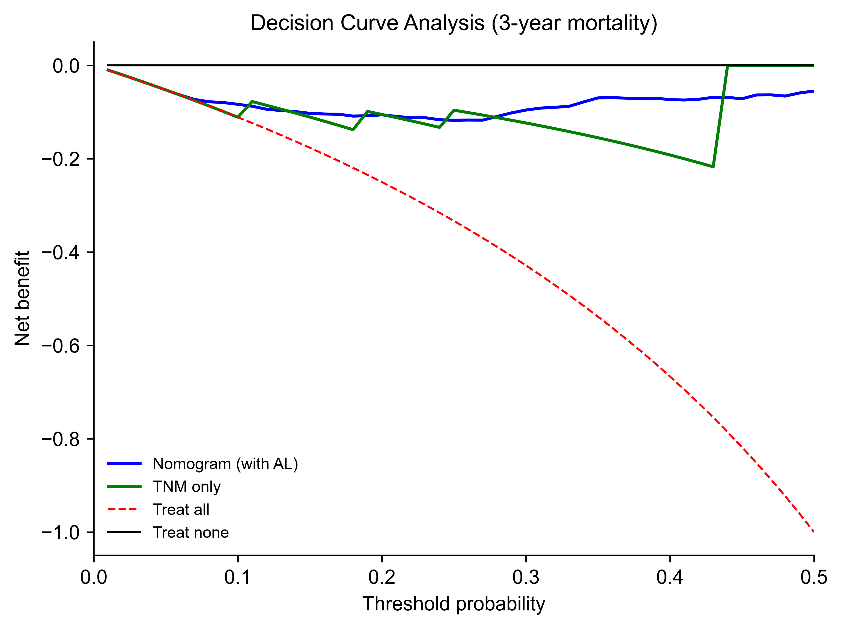
Supplementary Figure S3. Decision curve analysis (DCA) of the nomogram for predicting overall survival.
Note: The x-axis represents the threshold probability, and the y-axis represents the net benefit. The nomogram model (incorporating AL, age, T stage, N stage, LVI, and PNI) is compared with the TNM-only model and the treat-all/treat-none strategies. The nomogram shows greater net benefit than TNM staging alone across threshold probabilities of 0.1–0.5, suggesting potential utility as a complementary tool to TNM staging, pending external validation.

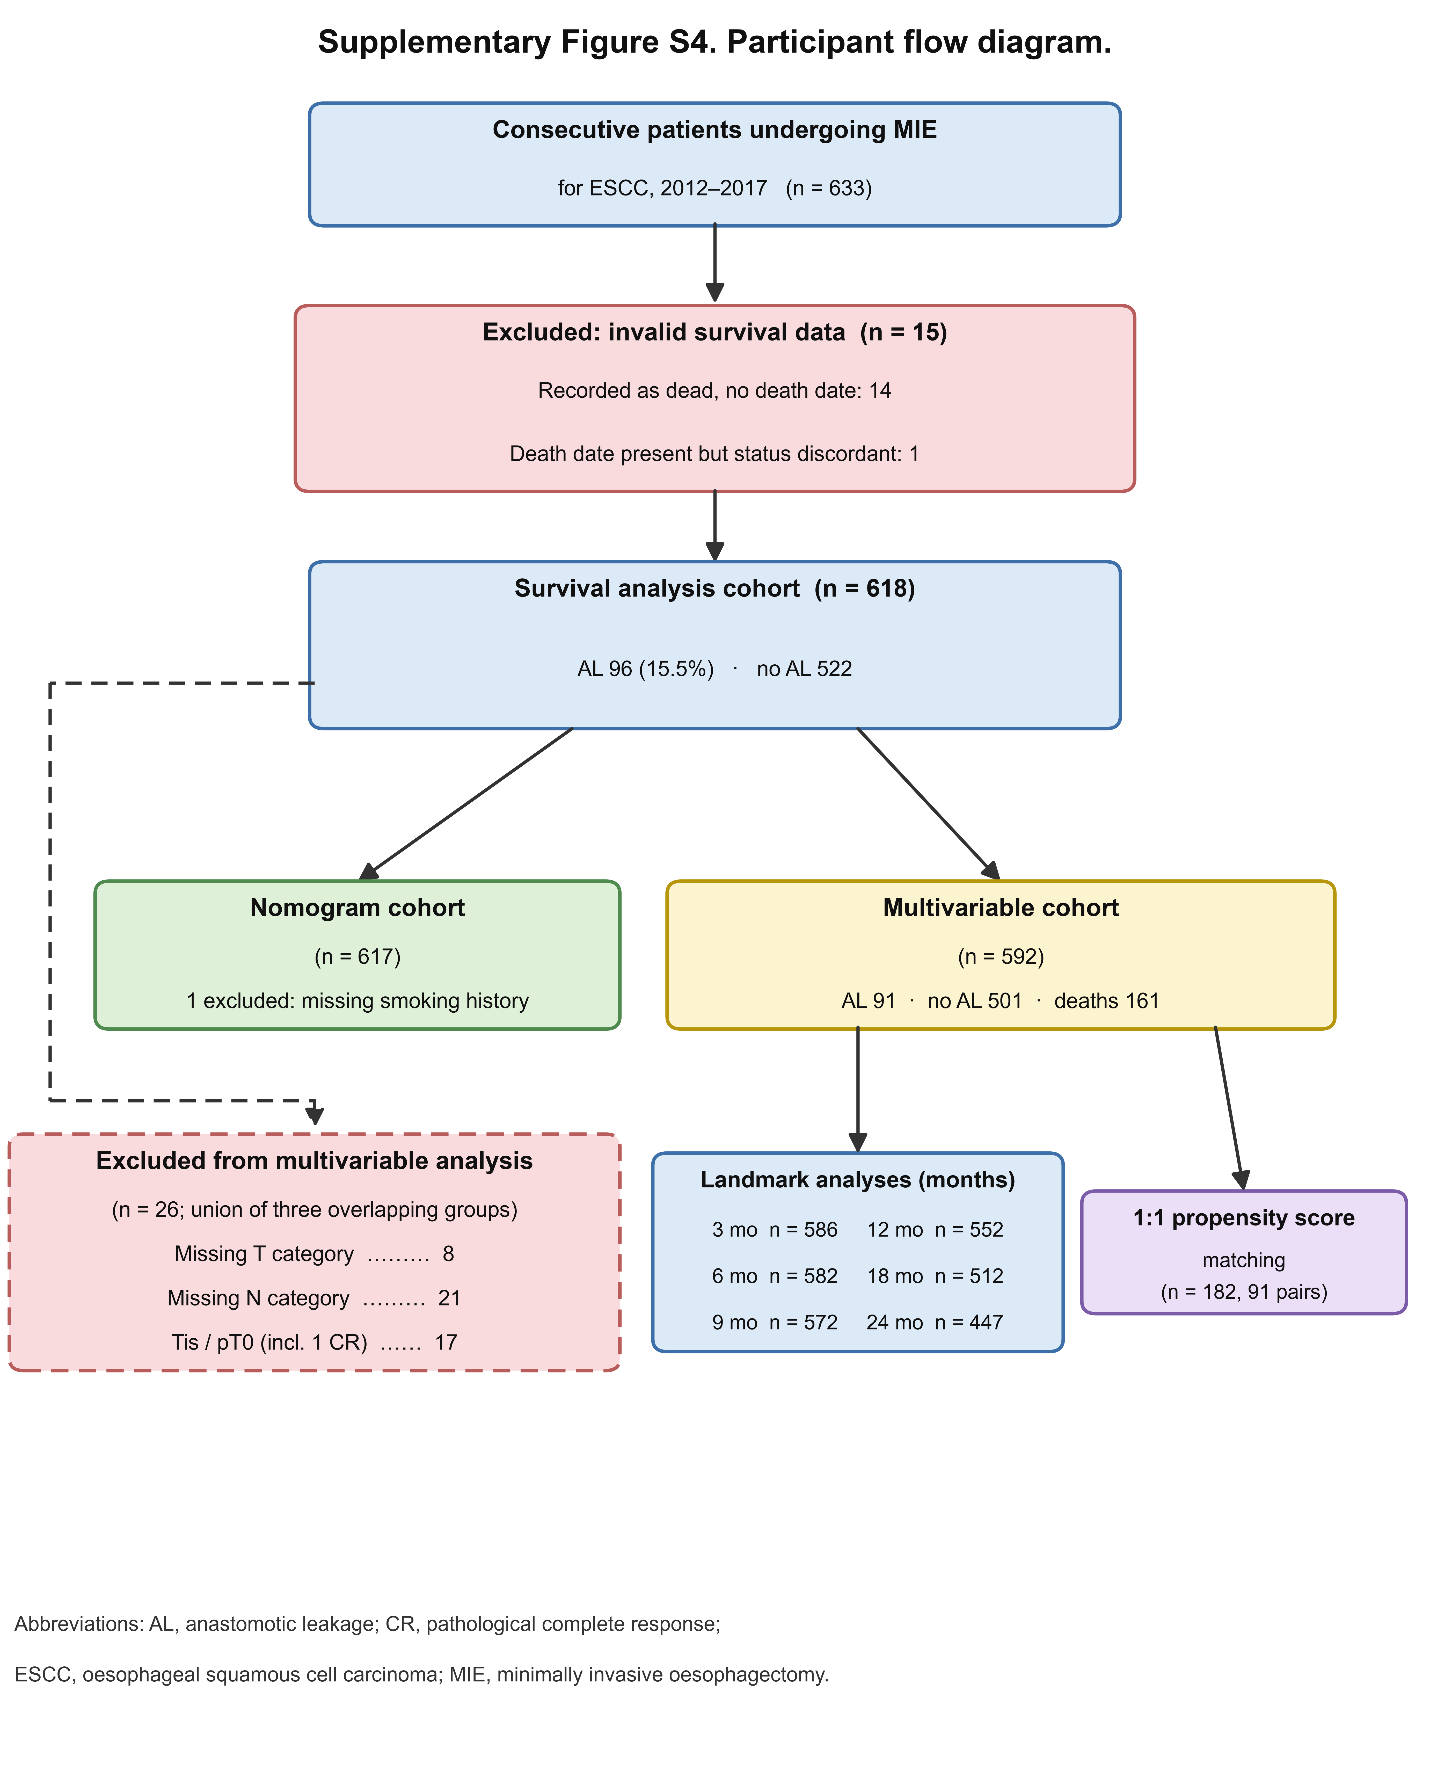
Supplementary Figure S4. Participant flow diagram.
Note: Numbers shown are those available at each analytical step. The 26 patients excluded from multivariable analysis represent the union of three overlapping groups (missing T category, missing N category, and Tis or pT0 disease), so the individual counts do not sum to 26. AL, anastomotic leakage; CR, pathological complete response.

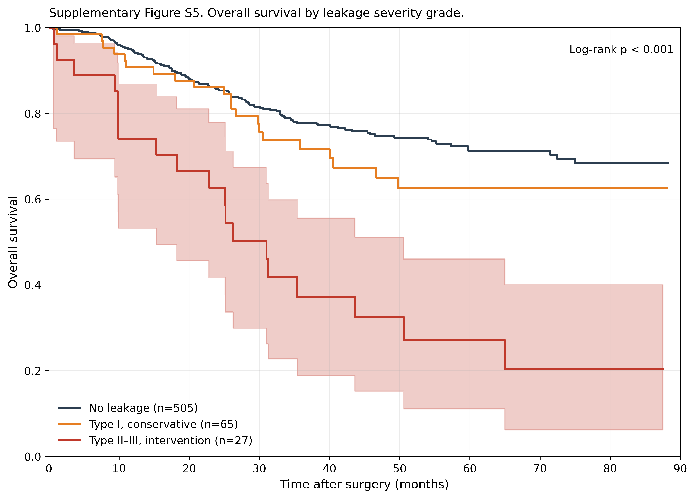
Supplementary Figure S5. Overall survival by leakage severity grade.
Note: Severity was graded retrospectively from recorded reinterventions following the structure of the Esophageal Complications Consensus Group classification: type I, conservative management or no intervention; type II, interventional drainage without thoracotomy; type III, surgical reintervention. Twenty-nine leaks had no recorded reintervention and were classified as type I. Curves are shown for the 592 patients with complete covariate data; log-rank p < 0.001.

