Supplementary Information
Authors: Jinsong Shao (ORCID: 0000-0001-5883-1016)1; XiongJie Wang (ORCID: 0009-0004-5633-2183)2; Weichen Liu (ORCID: 0009-0002-7399-6219)1; Lingshuai Kong (ORCID: 0009-0000-9583-0100)1; Sanjeevi Pandiyan (ORCID: 0000-0002-1377-0456)2; Gautam Sethi (ORCID: 0000-0002-8677-8475)3,*; Li Wang (ORCID: 0000-0003-2838-9807)2,*
Affiliations: 1, School of Information Science and Technology, Nantong University, 9 Seyuan Road, Nantong 226019, Jiangsu, China; 2, School of Artificial Intelligence and Computer Science, Nantong University, 9 Seyuan Road, Nantong 226019, Jiangsu, China; 3, Department of Pharmacology, Yong Loo Lin School of Medicine, National University of Singapore, Blk MD3, 16 Medical Drive, Singapore 117600
Correspondence: Li Wang, School of Artificial Intelligence and Computer Science, Nantong University, 9 Seyuan Road, Nantong 226019, Jiangsu, China; wangli@ntu.edu.cn; primary corresponding author
Gautam Sethi, Department of Pharmacology, Yong Loo Lin School of Medicine, National University of Singapore, Blk MD3, 16 Medical Drive, Singapore 117600; phcgs@nus.edu.sg; corresponding author

MolGlueBench reveals heterogeneous transfer of context gains across molecular-glue DC50 domains

Supplementary Methods
The Supplementary Methods describe the analysis classifications, split and deletion rules, model selection, bootstrap estimands and central processing unit (CPU) reconstruction checks.

Evidence identities
- Frozen scaffold- and compound-disjoint core validation: protocol-frozen primary.
- Frozen held-source and held exact-target-label validation: protocol-frozen primary.
- Same-learner context-only comparison: formal matched extension.
- Strict scaffold deletion, calibration, leave-one-domain-out (LODO), canonical aggregation, HistGradientBoosting, molecular-graph learner and internal learning-curve checks: post-hoc or exploratory as labelled.
- Matched-estimand comparison, held-axis-portable context, fit-weight perturbations, generic Murcko grouping, training-source deletion, chemical-novelty profiles, conditional label randomization and endpoint-censoring summaries: post-hoc robustness, diagnostic or descriptive evidence as labelled.
Supplementary Table S1 | Analysis classification and inferential role.
Analysis | Status | Primary role
Repeated nested scaffold-disjoint ExtraTrees | Protocol-frozen primary | Internal scaffold generalization and feature-block comparison
Compound-disjoint ExtraTrees | Protocol-frozen secondary | Less stringent internal sensitivity
Held-source and held exact-target-label ExtraTrees | Protocol-frozen primary | Transfer across the 4 and 8 fixed domains
Matched-estimand comparison | Post-hoc | Align rows, weights and scaffold resamples across regimes
Strict scaffold purging and canonical aggregation | Post-hoc sensitivity | Test residual scaffold and repeated-compound dependence
HistGradientBoosting and molecular graph | Post-hoc sensitivity with configurations frozen before formal runs | Test learner and representation dependence
Grouped context, portable encoding, fit weights, source deletion and similarity strata | Post-hoc sensitivity or diagnostic | Probe candidate explanations without causal interpretation
Conditional randomization | Post-hoc negative control | Compare observed signal with source–target-stratified label disruption
Calibration, per-domain and leave-one-domain-out summaries | Exploratory/descriptive | Bound absolute use and expose fixed-domain heterogeneity
Endpoint-selection audit and learning curve | Descriptive/post-hoc | Document data selection and observed training-size trajectory

Data construction and categorical encoding
The deterministic builder parsed 3,117 source observations and retained 1,758 observations with an exact equality DC50 in nanomolar units, a valid canonical SMILES and known recruiter and target. Records were aggregated by canonical SMILES, recruiting protein, target protein and cell line. DC50 was combined by the median on the nanomolar scale before conversion to pDC50, while count, minimum and maximum were preserved. Joined source labels and identifiers retained composite provenance; assay and activity time were annotations rather than aggregation keys. The final quality-controlled table contained 1,560 rows. Because publication identifiers were incomplete, this key does not guarantee removal of every literature-level duplicate across databases.
Categorical encoders were fitted only on each training partition with handle_unknown="ignore" and min_frequency=2. A category unseen during fitting therefore produced zeros for all indicators of its field, and unseen interaction categories were handled in the same way. This behavior was identical for internal, held-domain and strict fits. The grouped-context analyses separated provenance, biological/assay fields and missingness for interpretation, but those blocks remain correlated and are not causal components.

Feature and learner equations
For observation i, the chemistry-plus-context vector was
zichem+context = [xichem ∥ xicontext].
where \(\mathbf{x}^{\mathrm{chem}}_i\) and \(\mathbf{x}^{\mathrm{context}}_i\) are the fold-fitted chemistry and context vectors, \(\Vert\) denotes concatenation and \(\mathbf{z}^{\mathrm{chem+context}}_i\) is the combined model input. For the ExtraTrees ensemble,
ŷiET = (1/B) Σb=1B fb(zi; θb), B = 600.
where \(\widehat{y}^{\mathrm{ET}}_i\) is predicted pDC50, \(B\) is the number of trees, \(b\) indexes a tree, \(f_b\) is its prediction and \(\theta_b\) denotes its fitted parameters.
For graph atom \(v\) at message-passing layer \(\ell\), bond-channel-specific messages and the residual update were
mv(ℓ) = Σr Σu∈Nᵣ(v) Wr(ℓ)hu(ℓ),
hv(ℓ+1) = LN(hv(ℓ) + Dropout[GELU(W0(ℓ)hv(ℓ) + mv(ℓ))]).
Here, \(u\) is a neighbouring atom, \(r\) indexes a bond channel, \(\mathcal{N}_r(v)\) is the set of neighbours joined to \(v\) by that channel, \(\mathbf{h}\) is an atom state, \(\mathbf{m}\) is the aggregated message and \(\mathbf{W}_r\) and \(\mathbf{W}_0\) are neighbour and self-state transformations. LN, GELU and Dropout denote layer normalization, the Gaussian error linear unit and dropout.

Independent molecular-graph sensitivity
The molecular-graph experiment was executed as a separate post-hoc learner and representation sensitivity. Chemistry-only and chemistry-plus-context graph models used the same 25 internal scaffold-disjoint outer splits, 4 held-source and 8 held exact-target-label splits, and their 12 strict scaffold-purged counterparts. Every outer training partition received a deterministic scaffold-disjoint early-stopping split, and its context encoder and response standardization were fitted without validation or test rows.
The formal run comprised 98 paired model fits on one NVIDIA GeForce RTX 3080 Ti GPU. No architecture, hyperparameter, seed, ensemble or model-family search followed inspection of the formal output. Its 26,840 saved predictions, paired seeds, split counts, inner and outer leakage checks, repeat averaging, domain-macro metrics and 10,000-resample intervals were independently recalculated; all prespecified checks passed. These computational counts are workflow records, not independent sample sizes.

Post-hoc internal learning-curve sensitivity
The learning-curve analysis reused the 25 outer scaffold-disjoint splits and held their evaluation rows fixed. A deterministic, outcome-blind scaffold ordering selected nested 25%, 50%, 75% and 100% prefixes of every outer-training set. The chemistry-only and chemistry-plus-context ExtraTrees configurations were fixed at 600 trees, min_samples_leaf=1 and max_features="sqrt"; neither tuning nor model selection was repeated. Across both models and four fractions, the formal run comprised 200 fits and 62,400 saved prediction rows. All 20 independent checks passed, including nested-prefix reconstruction, zero train–test scaffold overlap, fixed model identity, prediction completeness, metric recalculation and 10,000 paired global-scaffold bootstrap resamples.
This sensitivity describes the observed internal learning trajectory only. The 25 outer splits, five repeats and bootstrap draws are computational devices rather than independent sample sizes. The curve was specified post-hoc and was not used to infer a saturation point, statistical power or a required future sample size.

Implementation checks
An independent implementation audit identified a response-array dtype mismatch in initial post-hoc ExtraTrees refits. The affected analyses were recomputed with a NumPy float32 response, matching the primary-analysis runner. The data, split rules, features, hyperparameters, seeds, tree counts and estimands were unchanged.
A second audit concerned only the OOD applicability domain-macro intervals. If a small represented domain was absent from a bootstrap replicate, the initial implementation averaged over the remaining domains, thereby changing the macro estimand between replicates. The corrected procedure fixed the represented and metric-eligible domain sets before resampling.
For each OOD regime, protocol, similarity bin and metric, the analysis freezes the represented-domain set and then the metric-specific eligible subset: represented domains whose observed paired contrast is finite. The observed macro is the equal-weight mean over exactly this eligible set. A bootstrap metric replicate is valid only if every fixed eligible domain is present and has a finite paired contrast. An absent eligible domain is retained as NA with reason missing_fixed_eligible_domain; when all domains are present but an eligible-domain contrast is non-finite, the replicate is NA with reason fixed_eligible_domain_metric_nonestimable. The eligible set is never reduced inside a replicate.
Before resampling, each eligible domain must contain at least two unique global scaffold clusters. If any eligible domain contains one scaffold, the descriptive point estimate remains visible, all domain-macro replicates for that metric are structurally not attempted, and the interval is NA. No domain-stratified fallback is used because independent within-domain resampling would break the joint treatment of a global scaffold shared across domains. For non-structural cases, a formal 10,000-replicate interval requires at least 5,000 complete replicates; valid, missing-domain, metric-nonestimable and structural-not-attempted counts must reconcile to the requested total.
The fixed-domain correction left the saved predictions and observed point estimates unchanged and affected only the corresponding OOD domain-macro intervals.
A third audit showed that exact reconstruction of the held exact-target-label no-deletion reference could depend on the native numerical-library thread state. The generic-scaffold and source-deletion analyses were therefore recomputed under the same fixed thread configuration as the primary analysis. This correction changed neither the estimands nor the data, split, feature, model, selection, seed, metric or bootstrap rules. Independent checks confirmed the expected prediction, split, tuning and feature identities.

Independent units and uncertainty
Rows sharing chemistry or context are not treated as independent samples. Internal uncertainty is estimated by paired resampling of the 667 global scaffold clusters after repeat-averaging row-level outer predictions. Out-of-domain (OOD) uncertainty is estimated by paired global-scaffold resampling over the combined fixed test universe within each axis. Domain metrics are calculated before equal-domain averaging. These intervals are conditional on the frozen domains and do not estimate uncertainty over all future databases or protein families.

Post-hoc matched-estimand analysis
The internal and held-domain context contrasts were compared again under an identical estimand. Repeat-averaged scaffold-disjoint internal predictions were restricted to exactly the rows used by the corresponding source- or target-axis OOD analysis. The four source domains and eight exact target-label domains were fixed by the primary protocol, and the within-domain context Spearman increments were assigned equal weight. Internal and OOD contrasts therefore used the same rows, the same domain identities and the same domain weights.
For each axis, 10,000 global Bemis–Murcko-scaffold bootstrap samples were drawn from the combined test universe. All rows belonging to a sampled scaffold were retained, including occurrences across domains, and each sample was applied jointly to the internal and OOD predictions. The paired validation-regime change was the OOD context contrast minus the internal context contrast within a bootstrap sample. Domain-level intervals used the same clustering principle within each fixed domain. The comparison and its domain-level intervals were post-hoc; no multiplicity-adjusted per-domain hypothesis test was performed.

Grouped-context ablation
Three post-hoc models combined the frozen chemistry representation with one context group. Provenance comprised source and source–target internally; it was not fitted for held-source evaluation, and only source was retained for held exact-target-label evaluation. Biological/assay context comprised recruiter, target, cell line, assay, exposure time and mode together with recruiter–target, target–cell and assay–target interactions internally. The target and every target-containing interaction were excluded in held exact-target-label evaluation. Missingness was represented by six binary observed-versus-unspecified indicators for recruiter, target, cell line, assay, exposure time and mode. These indicators were derived from the unfilled input fields rather than from the sanitized categorical labels.
Every model used the same six-point ExtraTrees grid as the original chemistry-plus-context model, four-fold scaffold-disjoint inner selection, 600 trees and NumPy float32 responses. The 25 internal outer splits and the 12 frozen OOD domain splits were unchanged. The source-axis provenance result is intentionally absent because a held source cannot be encoded as portable provenance. Grouped effects are matched contrasts against chemistry on identical rows, with equal-domain weighting and 10,000 paired global-scaffold resamples.

Held-axis portability and representation-weight sensitivities
For held-source evaluation, the held-axis-portable chemistry-plus-context model removed the source main effect and the source–target interaction while retaining recruiter, target, cell line, assay method, activity time, mode of action and interactions not containing source. For held exact-target-label evaluation, it removed the target main effect and every target-containing interaction. The frozen test rows, compound-deletion rules, inner scaffold-disjoint selection and the original chemistry-plus-context and chemistry-only predictions were retained.
The compound-equal fit assigned every canonical compound total fit-fold weight one and then normalized row weights to mean one. The source–target-domain- balanced fit began with inverse source–target-domain frequency weights, normalized them, clipped values above ten times the normalized mean and renormalized. These weights affected fitting only; inner selection and outer evaluation retained the original unweighted estimand. Clipping fractions and effective sample sizes were recorded for every fit.

Scaffold definition and training-source deletion
Generic Murcko groups were obtained by replacing scaffold atom types with carbon and bond types with single bonds. Acyclic compounds retained a canonical-compound-specific fallback. The complete 5 × 5 outer and four-fold inner design was rerun, and every inner and outer train–test generic-scaffold overlap was required to be zero. Its paired 10,000-resample intervals sampled generic Murcko groups rather than the original Bemis–Murcko groups.
For each frozen held exact-target-label domain, training-source deletion removed every training row whose plus-delimited provenance contained one specified source token. The held target, test compounds and test rows were unchanged. Chemistry- only and chemistry-plus-context ExtraTrees models were independently retuned inside each remaining training set. Estimates were averaged across the same eight fixed target domains; infeasible strata, if any, were retained explicitly.

Chemical novelty and repeated negative controls
Existing repeat-averaged internal, frozen OOD and strict OOD predictions were stratified by maximum train-set Morgan Tanimoto similarity using the fixed intervals [0, 0.4), [0.4, 0.6), [0.6, 0.8) and [0.8, 1.000001]. No bin was merged after inspection. OOD point estimates and paired intervals used equal-domain macro metrics, with expected, represented and finite domain counts retained. For OOD macro uncertainty, the represented-domain identity and metric-specific eligible-domain identity were frozen before resampling. A replicate missing any eligible domain was NA rather than averaged over a smaller set. A finite point estimate could therefore coexist with a structurally non-estimable interval when an eligible domain contained only one global scaffold.
For each of 100 deterministic seeds, training pDC50 labels were permuted within exact source–target strata inside every one of the 25 frozen outer fit folds. The test labels, split assignments and originally selected hyperparameters were fixed. Chemistry-only and chemistry-plus-context ExtraTrees models were refitted with 600 trees, and predictions were averaged across the five outer repeats. Directional empirical tail probabilities used the finite-permutation correction defined in the main-text Methods, with 100 permutations. This was a conditional repeated negative control, not a full retuning randomization test.

Endpoint-censoring and selection audit
The parsed public-source table contained 3,117 record rows but 3,082 unique record_id values. It comprised 1,825 equality rows, 535 range rows, 731 one-sided rows and 26 missing/unparsed rows. Two identifiers occurred on both an equality row and a one-sided row, illustrating why relation-row counts and unique-identifier counts are different views of the compilation. Censored records were not imputed, converted to point labels or used for model fitting; identifier reuse does not imply that a censored value entered a model.
The complete selection audit reports the following sequence and preserves the unit at every stage (Supplementary Table S2):
Supplementary Table S2 | Endpoint selection and aggregation counts.
Stage | Count | Unit
All parsed records | 3117 | parsed record rows
Finite numeric endpoint records | 3091 | parsed record rows
Equality-relation records | 1825 | parsed record rows
Equality identifiers | 1793 | unique record_id values
Core component-record occurrences | 1730 | component-identifier occurrences after splitting aggregated provenance
Core component identifiers | 1727 | unique component record_id values represented in the core
Final exact-point core | 1560 | aggregated modelling rows
The 1,727 component identifiers are neither 1,727 unique parsed rows nor 1,727 modelling observations. Because aggregation and identifier deduplication change the unit, adjacent stage ratios are descriptive representation summaries and are not row-wise attrition rates, inclusion probabilities or evidence that the exact-point subset is unbiased. Counts and fractions were also summarized by source and target, together with compound/scaffold overlap with the exact-point core.

Supplementary Results

Matched-estimand validation-regime comparison
After matching the internal and OOD estimands, the equal-domain-macro context Spearman increment changed from +0.037 (95% interval, +0.010 to +0.066) internally to −0.086 (−0.153 to −0.010) across the four source domains. The paired OOD-minus-internal change was −0.123 (−0.180 to −0.056). Across the eight exact target-label domains, the contrast changed from +0.036 (−0.018 to +0.074) to −0.066 (−0.131 to −0.005), with a paired change of −0.102 (−0.169 to −0.023). Thus, the apparent attenuation was not explained by comparing a pooled internal statistic with an equal-domain OOD statistic.
The fixed-domain estimates were heterogeneous (Supplementary Table S3 and Fig. 4b,c). In held-source evaluation, TPDdb had a contrast of −0.443, whereas MGTbind, MGDB and MolGlueDB had contrasts from +0.014 to +0.044. In held exact-target-label evaluation, the largest adverse contrasts occurred for GSPT1 (−0.401) and CDK2 (−0.189), while WIZ had a positive but imprecise estimate (+0.164). These estimates are conditional descriptions of the available domains, not evidence of a common population-domain effect. A descriptive matched leave-one-domain calculation gave a source-axis paired attenuation of −0.002 after omitting TPDdb, compared with −0.123 over all four sources. Omitting GSPT1 changed the target-axis value from −0.102 to −0.054. No population-domain interval was assigned to these fixed-domain influence summaries.
Supplementary Table S3 | Domain-level matched context Spearman increments.
Axis | Domain | n / C / S | Internal contrast (95% interval) | OOD contrast (95% interval)
Source | MGTbind | 755 / 664 / 394 | +0.049 (+0.003 to +0.112) | +0.039 (−0.018 to +0.113)
Source | MGDB | 357 / 340 / 205 | +0.017 (−0.005 to +0.044) | +0.014 (−0.035 to +0.063)
Source | MolGlueDB | 289 / 247 / 144 | +0.038 (−0.005 to +0.083) | +0.044 (−0.079 to +0.156)
Source | TPDdb | 119 / 118 / 58 | +0.042 (−0.022 to +0.116) | −0.443 (−0.681 to −0.174)
Target | VAV1 | 455 / 404 / 230 | +0.029 (−0.002 to +0.065) | +0.017 (−0.017 to +0.054)
Target | CSNK1A1 | 159 / 139 / 68 | +0.094 (−0.045 to +0.235) | −0.015 (−0.058 to +0.046)
Target | GSPT1 | 154 / 106 / 74 | +0.034 (−0.027 to +0.114) | −0.401 (−0.533 to −0.247)
Target | WIZ | 150 / 123 / 47 | +0.000 (−0.048 to +0.040) | +0.164 (−0.235 to +0.486)
Target | CDK2 | 145 / 145 / 102 | +0.007 (−0.017 to +0.031) | −0.189 (−0.321 to −0.066)
Target | CCNK+CDK12 | 86 / 73 / 52 | −0.016 (−0.089 to +0.056) | +0.031 (−0.083 to +0.134)
Target | IKZF2 | 76 / 65 / 32 | +0.142 (−0.292 to +0.420) | −0.106 (−0.363 to +0.149)
Target | IKZF1 | 65 / 60 / 34 | −0.002 (−0.138 to +0.131) | −0.028 (−0.094 to +0.031)
Internal and held-domain estimates use identical domain rows. Values in parentheses are 95% percentile intervals from 10,000 scaffold-cluster bootstrap resamples. n is the number of rows, C the number of canonical compounds and S the number of global Bemis–Murcko scaffolds.

Grouped-context decomposition
The grouped ablations separated recorded provenance, biological/assay fields and missingness indicators while retaining the matched chemistry baseline, test rows, equal-domain estimand and global-scaffold resamples. On source-axis internal rows, provenance and biological/assay context each had a positive increment whose interval excluded zero, whereas missingness alone was near zero. In held-source evaluation, provenance was not portable by definition and the portable biological/assay block was adverse. On the target axis, all three internal grouped estimates were imprecise; under held exact-target-label evaluation, missingness had an adverse increment whose interval excluded zero. No portable group restored a positive chemistry-plus-context transfer increment. Because the context groups are correlated and their models were independently selected and fitted, Supplementary Table S4 is not an additive variance decomposition and does not identify causal pathways.
Supplementary Table S4 | Matched grouped-context increments over chemistry-only ExtraTrees.
Axis | Validation regime | Context group | n / S | Contrast (95% interval)
Source | Internal | Provenance | 1520 / 667 | +0.024 (+0.004 to +0.047)
Source | Internal | Biological/assay | 1520 / 667 | +0.030 (+0.005 to +0.058)
Source | Internal | Missingness | 1520 / 667 | +0.001 (−0.014 to +0.016)
Source | Internal | All recorded context | 1520 / 667 | +0.037 (+0.010 to +0.066)
Source | Held source | Provenance | 1520 / 667 | Not estimated: held source unavailable
Source | Held source | Biological/assay | 1520 / 667 | −0.079 (−0.155 to −0.010)
Source | Held source | Missingness | 1520 / 667 | +0.025 (−0.014 to +0.065)
Source | Held source | All recorded context | 1520 / 667 | −0.086 (−0.153 to −0.010)
Target | Internal | Provenance | 1290 / 601 | +0.023 (−0.029 to +0.057)
Target | Internal | Biological/assay | 1290 / 601 | +0.030 (−0.022 to +0.067)
Target | Internal | Missingness | 1290 / 601 | −0.013 (−0.035 to +0.009)
Target | Internal | All recorded context | 1290 / 601 | +0.036 (−0.018 to +0.074)
Target | Held exact target label | Provenance | 1290 / 601 | −0.020 (−0.059 to +0.016)
Target | Held exact target label | Biological/assay | 1290 / 601 | −0.048 (−0.115 to +0.017)
Target | Held exact target label | Missingness | 1290 / 601 | −0.054 (−0.092 to −0.011)
Target | Held exact target label | All recorded context | 1290 / 601 | −0.066 (−0.131 to −0.005)
Values are equal-domain-macro Spearman contrasts with 95% percentile intervals from 10,000 paired global Bemis–Murcko scaffold resamples. n is the number of rows and S the number of global scaffolds. For held exact-target-label evaluation, provenance contains source only, and biological/assay context excludes the held target and target-containing interactions.
Supplementary Table S5 | Composition of the fixed source and exact-target-label domains.
Axis / domain | Rows / compounds / scaffolds | pDC50 median (IQR) | Missing time / assay; unspecified cell (%) | Dominant assay
Source: MGTbind | 755 / 664 / 394 | 7.39 (6.54–7.98) | 100.0 / 0.0 / 14.2 | dc50_assay
Source: MGDB | 357 / 340 / 205 | 7.48 (7.05–7.85) | 46.8 / 14.0 / 8.1 | NanoBRET
Source: MolGlueDB | 289 / 247 / 144 | 7.55 (6.59–8.09) | 100.0 / 0.0 / 74.4 | target_degradation_text
Source: TPDdb | 119 / 118 / 58 | 7.40 (6.80–8.10) | 100.0 / 0.0 / 50.4 | activity_table
Target label: VAV1 | 455 / 404 / 230 | 7.47 (6.64–7.96) | 100.0 / 0.0 / 11.2 | dc50_assay
Target label: CSNK1A1 | 159 / 139 / 68 | 7.85 (6.84–8.32) | 88.7 / 10.1 / 77.4 | target_degradation_text
Target label: GSPT1 | 154 / 106 / 74 | 7.30 (6.66–8.34) | 87.7 / 6.5 / 31.2 | dc50_assay
Target label: WIZ | 150 / 123 / 47 | 7.49 (7.18–7.80) | 24.0 / 2.7 / 6.7 | HiBiT
Target label: CDK2 | 145 / 145 / 102 | 7.50 (7.17–7.84) | 100.0 / 0.0 / 0.0 | NanoBRET
Target label: CCNK+CDK12 | 86 / 73 / 52 | 6.39 (6.00–7.05) | 100.0 / 0.0 / 0.0 | dc50_assay
Target label: IKZF2 | 76 / 65 / 32 | 7.99 (7.55–8.42) | 96.1 / 1.3 / 76.3 | dc50_assay
Target label: IKZF1 | 65 / 60 / 34 | 7.28 (6.56–7.79) | 96.9 / 4.6 / 86.2 | target_degradation_text
IQR, interquartile range. Counts are rows / compounds / scaffolds; percentages are missing exposure time / missing assay / unspecified cell, in that order. Missingness and unspecified fractions are calculated within each fixed domain. Dominant assay labels partly reflect database-level reporting conventions and should not be interpreted as harmonized experimental protocols.
Supplementary Table S6 | Biological scope of the eight exact target labels.
Exact label | Descriptive biological scope | Interpretation boundary
VAV1 | Guanine nucleotide exchange factor | Exact-label holdout only
CSNK1A1 | Casein kinase family protein | Exact-label holdout only
GSPT1 | Translation termination GTPase | Exact-label holdout only
WIZ | Zinc-finger protein | Exact-label holdout only
CDK2 | Cyclin-dependent kinase | Exact-label holdout only
CCNK+CDK12 | Composite cyclin K–CDK12 label | Complex label; not a single-protein embedding
IKZF2 | Ikaros zinc-finger family protein | Related to IKZF1 but held by exact label
IKZF1 | Ikaros zinc-finger family protein | Related to IKZF2 but held by exact label
Annotations describe the categorical labels used for the benchmark; they were not sequence- or structure-derived features.
Supplementary Table S7 | Evaluation-only sensitivity to the six unresolved target rows.
Evaluation rows (n) | Metric | Chemistry-only | Chemistry + context | Contrast
All prespecified internal rows (1560) | Spearman | 0.5661 | 0.6210 | 0.0549
All prespecified internal rows (1560) | RMSE | 0.8319 | 0.7917 | 0.0402
Excluding NA_INVALID_TARGET (1554) | Spearman | 0.5695 | 0.6243 | 0.0548
Excluding NA_INVALID_TARGET (1554) | RMSE | 0.8308 | 0.7905 | 0.0403
Models were not refitted. Spearman contrasts are chemistry-plus-context minus chemistry-only. RMSE contrasts are chemistry-only minus chemistry-plus-context, so positive values favour the latter.
Supplementary Table S8 | Held-domain test and effective training sizes.
Axis / domain | Test rows | Primary train: rows / compounds / scaffolds | Strict train: rows / compounds / scaffolds
Source: MGTbind | 755 | 528 / 468 / 280 | 511 / 458 / 273
Source: MGDB | 357 | 1119 / 797 / 471 | 1082 / 770 / 462
Source: MolGlueDB | 289 | 1022 / 885 / 539 | 957 / 850 / 523
Source: TPDdb | 119 | 1360 / 1019 / 621 | 1268 / 943 / 609
Target label: VAV1 | 455 | 1105 / 733 / 437 | 1105 / 733 / 437
Target label: CSNK1A1 | 159 | 1270 / 998 / 603 | 1253 / 988 / 599
Target label: GSPT1 | 154 | 1357 / 1031 / 596 | 1330 / 1021 / 593
Target label: WIZ | 150 | 1409 / 1014 / 620 | 1409 / 1014 / 620
Target label: CDK2 | 145 | 1415 / 992 / 565 | 1415 / 992 / 565
Target label: CCNK+CDK12 | 86 | 1472 / 1063 / 614 | 1472 / 1063 / 614
Target label: IKZF2 | 76 | 1369 / 1072 / 635 | 1369 / 1072 / 635
Target label: IKZF1 | 65 | 1392 / 1077 / 643 | 1355 / 1050 / 633
Primary training sets exclude held-domain tokens and test compounds. Strict training sets additionally exclude every scaffold observed in the test domain.

Additional post-hoc robustness analyses
The portable-context and alternative-weight analyses used the same frozen splits, estimands and paired global-scaffold bootstrap as the corresponding primary analyses. Portable encoding retained an adverse context Spearman increment under both held axes, whereas equal-compound and source–target-balanced fitting retained a positive internal contrast. Generic Murcko grouping likewise retained the internal increment. These results are reported in Supplementary Fig. S6.
In held exact-target-label evaluation, deleting MGTbind from training gave a domain-macro context Spearman increment of −0.033 (95% interval, −0.088 to +0.027); deleting MGDB gave −0.032 (−0.069 to +0.014); deleting MolGlueDB gave −0.089 (−0.139 to −0.033); and deleting TPDdb gave −0.052 (−0.095 to −0.001). Because the direction and interval relation varied across these fixed deletions, they do not identify a causal source effect.
Fixed chemical-similarity bins were retained without merging or selective omission. Every source-OOD bin represented all four fixed source domains and used all four as Spearman-eligible domains. In the lowest source-OOD bin (0.0–0.4), the observed contrasts were +0.062 for the frozen analysis and +0.015 after strict scaffold removal, but their intervals were non-estimable because only 4,011 and 3,948 complete fixed-domain bootstrap replicates, respectively, met the metric requirements. For the lowest target-OOD bin, seven fixed target domains were represented and six were Spearman eligible; IKZF2 had only one scaffold. The observed frozen and strict contrasts were −0.037 and +0.013, respectively, but both intervals were therefore structurally non-estimable. In the remaining frozen target-OOD bins, the represented/eligible domain counts were seven/seven, five/five and four/four from lower to higher similarity; after strict scaffold removal they were seven/seven, five/five and three/three. Missing fixed-domain repeats were retained as invalid rather than silently averaging over the domains that remained. Across the estimable bins, directions varied rather than following a monotonic trend. The strata are heterogeneous descriptive evidence, not a calibrated applicability or acceptance domain.
In the repeated conditional label-randomization control, chemistry-only Spearman was 0.566 (empirical one-sided p=0.010; conditional-null 95% range, 0.361–0.412), and chemistry-plus-context Spearman was 0.621 (p=0.010; null range, 0.403–0.452). The context rank increment was 0.055 (p=0.059; null range, 0.027–0.057). Thus the individual ranking signals lay beyond the restricted null distributions, whereas the observed ranking increment was less distinctly separated from its conditional null. These empirical probabilities are repeated negative-control summaries and are not multiplicity-adjusted primary tests.

Internal learning curve
Median outer-training sizes were 134, 267, 401 and 534 scaffolds at the 25%, 50%, 75% and 100% prefixes. Chemistry-only Spearman estimates were 0.506 (0.412–0.595), 0.563 (0.474–0.641), 0.575 (0.485–0.653) and 0.574 (0.483–0.655), respectively. Chemistry-plus-context estimates were 0.552 (0.470–0.629), 0.603 (0.523–0.674), 0.618 (0.539–0.687) and 0.621 (0.542–0.691). The paired context Spearman interval remained above zero at every fraction.
For the prespecified descriptive 75%-to-100% contrast, the Spearman change was −0.001 (−0.013 to 0.012) for chemistry-only and 0.003 (−0.008 to 0.015) for the chemistry-plus-context model. RMSE improvements were 0.002 (−0.007 to 0.011) and 0.003 (−0.007 to 0.013) pDC50 units, respectively. These intervals leave the last observed increment unresolved and do not demonstrate an asymptote.

Source database access
Supplementary Table S9 | Public source databases used for local reconstruction.
Database | Snapshot information | Official download page | Dataset article
MGTbind | Unversioned study snapshot; database article describes launch version 1.0 | Official download page [S2] | 10.1093/nar/gkaf1075
MGDB | Version 1.0; database reports creation in June 2025 | Official download page [S3] | 10.1093/nar/gkaf1131
MolGlueDB | Unversioned official download snapshot | Official download page [S4] | 10.1093/nar/gkaf811
TPDdb | Unversioned official download snapshot | Official download page [S5] | 10.1093/nar/gkaf996
The study snapshot was acquired on 31 May 2026. The authors do not redistribute source records or row-level derivatives; users should obtain the databases from the owners' official download pages and apply the public reconstruction code subject to the source owners' conditions.

Supplementary figure interpretation rules
- Positive Spearman contrasts favour the first named model.
- Root mean squared error (RMSE) contrasts are oriented so that positive values also favour the first named model.
- Undefined Spearman correlations from constant predictions remain missing and are not replaced with zero.
- Per-domain, LODO, calibration, canonical aggregation and learner-family results are descriptive or post-hoc and are not multiplicity-controlled.
- Supplementary Fig. S1 uses pooled contrasts only for internal validation and equal-domain macro contrasts over frozen metric-specific eligible domains for OOD panels. A missing fixed eligible domain makes that bootstrap repeat NA; an eligible domain represented by one global scaffold makes the macro interval structurally non-estimable. Points, empty sets and non-estimable intervals remain visible.
- Supplementary Fig. S2 shows all 100 conditional permutations without downsampling. Its empirical probabilities have minimum resolution 1/101.
- Supplementary Fig. S3 is a descriptive endpoint-selection audit and does not imply that censored observations were modelled.
- Supplementary Fig. S4 is a post-hoc internal sensitivity. Its 75%-to-100% contrast does not establish saturation, power or a required sample size.
- Supplementary Fig. S5 reports absolute OOD performance, strict scaffold purging and learner-family sensitivities.
- Supplementary Fig. S6 collects post-hoc robustness analyses. Its source-deletion panel describes fixed deletions and is not a causal source analysis.
- Folds, repeats, random seeds and bootstrap draws are computational devices, not independent sample sizes.

Supplementary figure legends
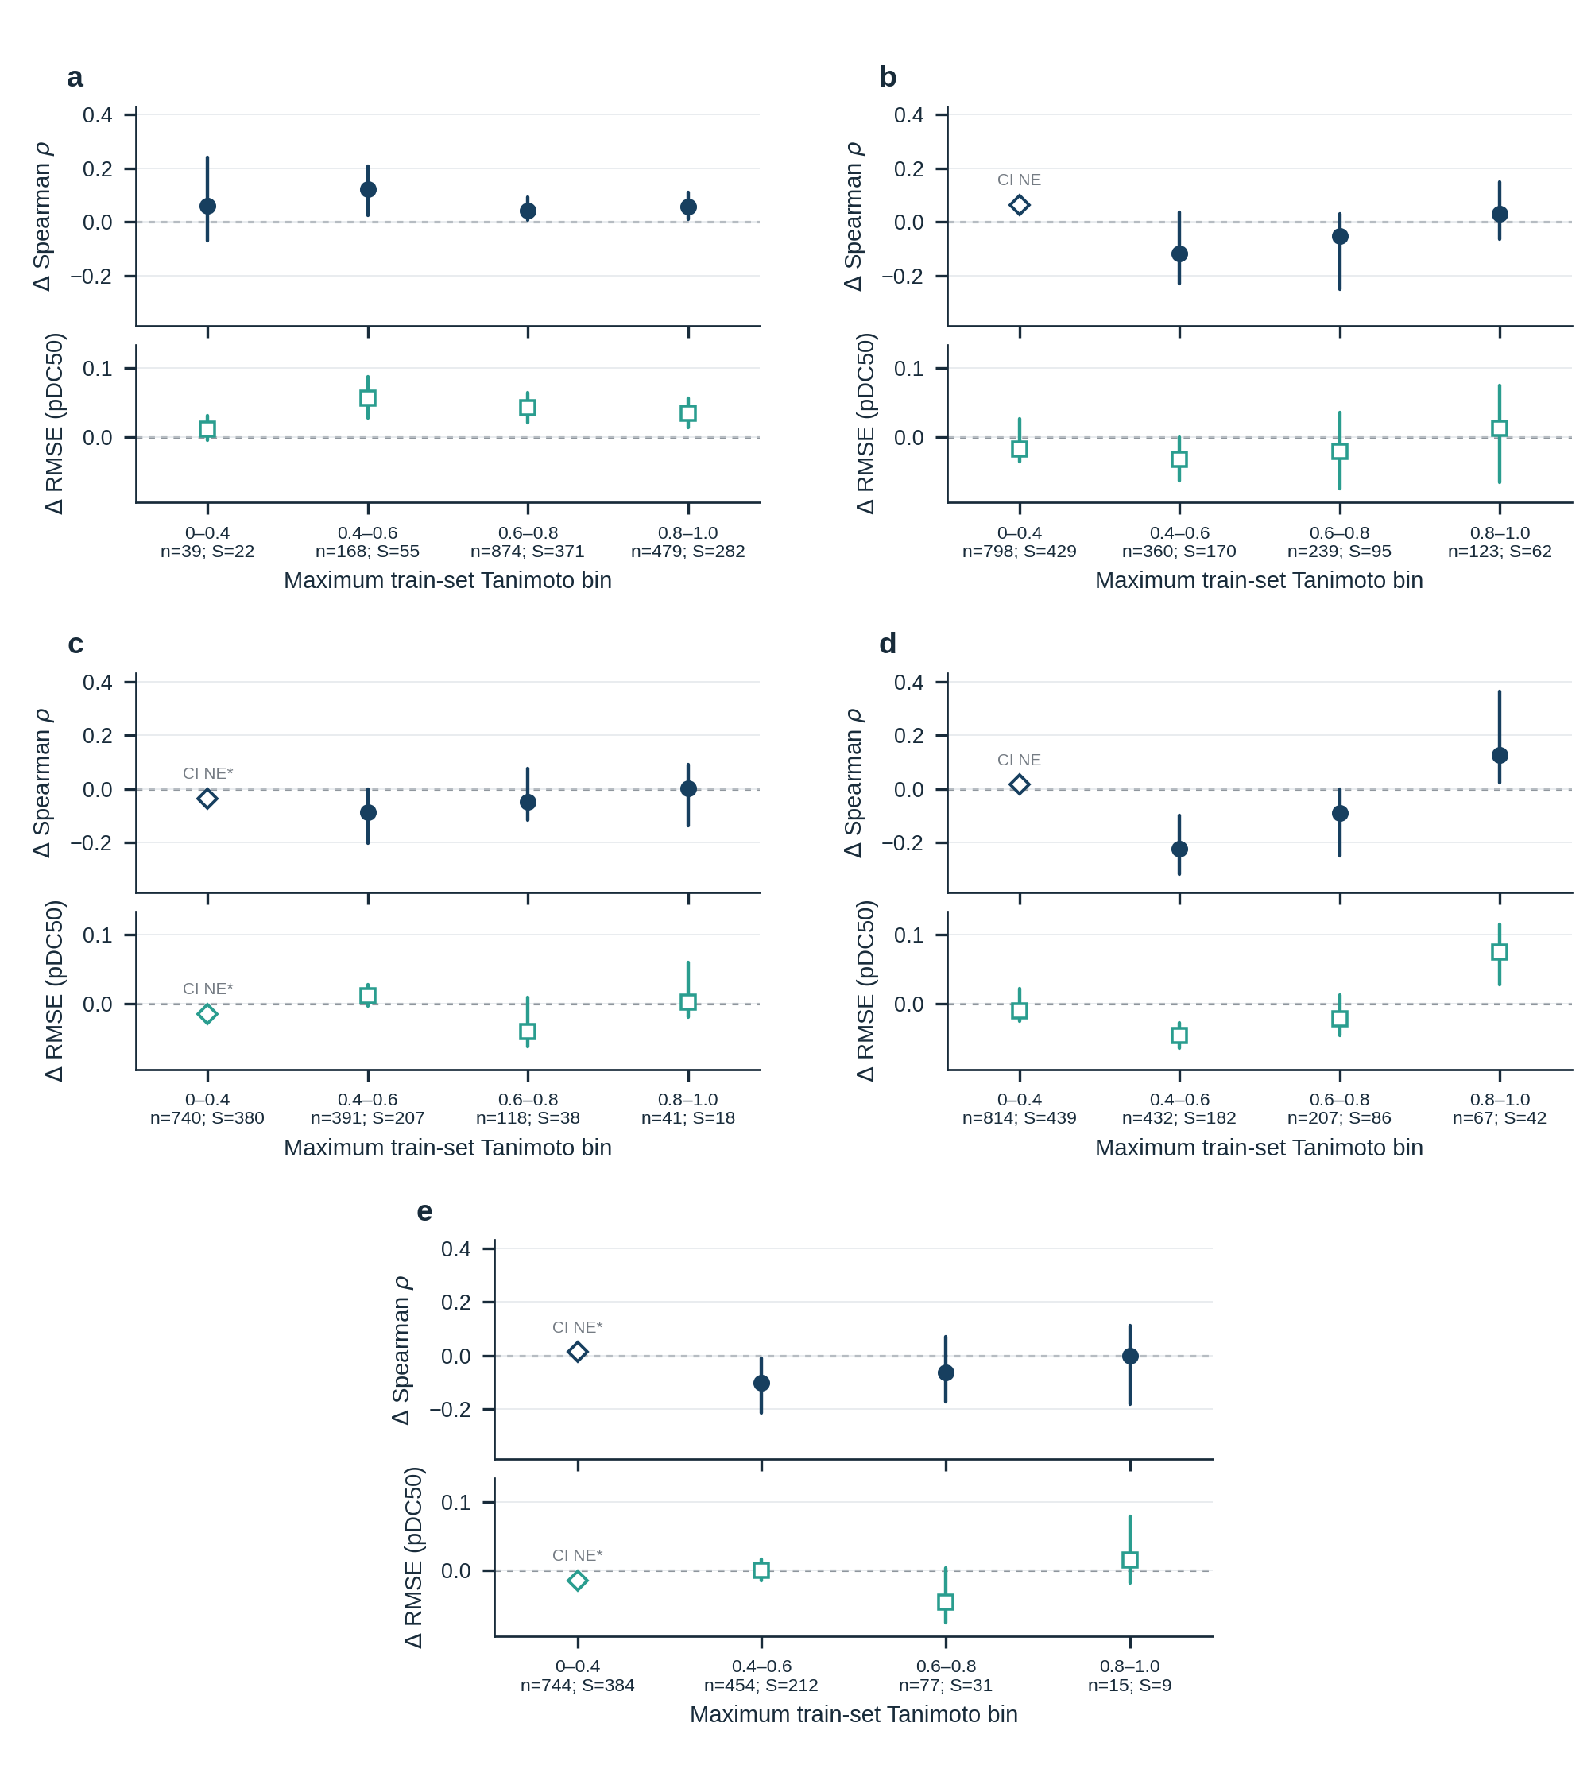

Supplementary Fig. S1 Chemical-novelty applicability profile
Context increments in Spearman and RMSE improvement from adding context across four prespecified maximum train-set Morgan Tanimoto bins. a, Internal scaffold-disjoint validation. b,c, Frozen held-source and held exact-target-label evaluation, respectively. d,e, Strict domain-plus-scaffold held-source and held exact-target-label sensitivities, respectively. Positive values favour the chemistry-plus-context model. Points are observed estimates and lines are paired 95% global-scaffold bootstrap intervals from 10,000 resamples. Internal estimates are pooled; OOD points are equal-domain macro values over the frozen metric-specific eligible domains. An OOD line is shown only when the corrected fixed-domain bootstrap met the complete-replicate threshold and every eligible domain contained at least two global scaffolds. n denotes rows and S global scaffolds. Non-estimable intervals and their reasons are retained.
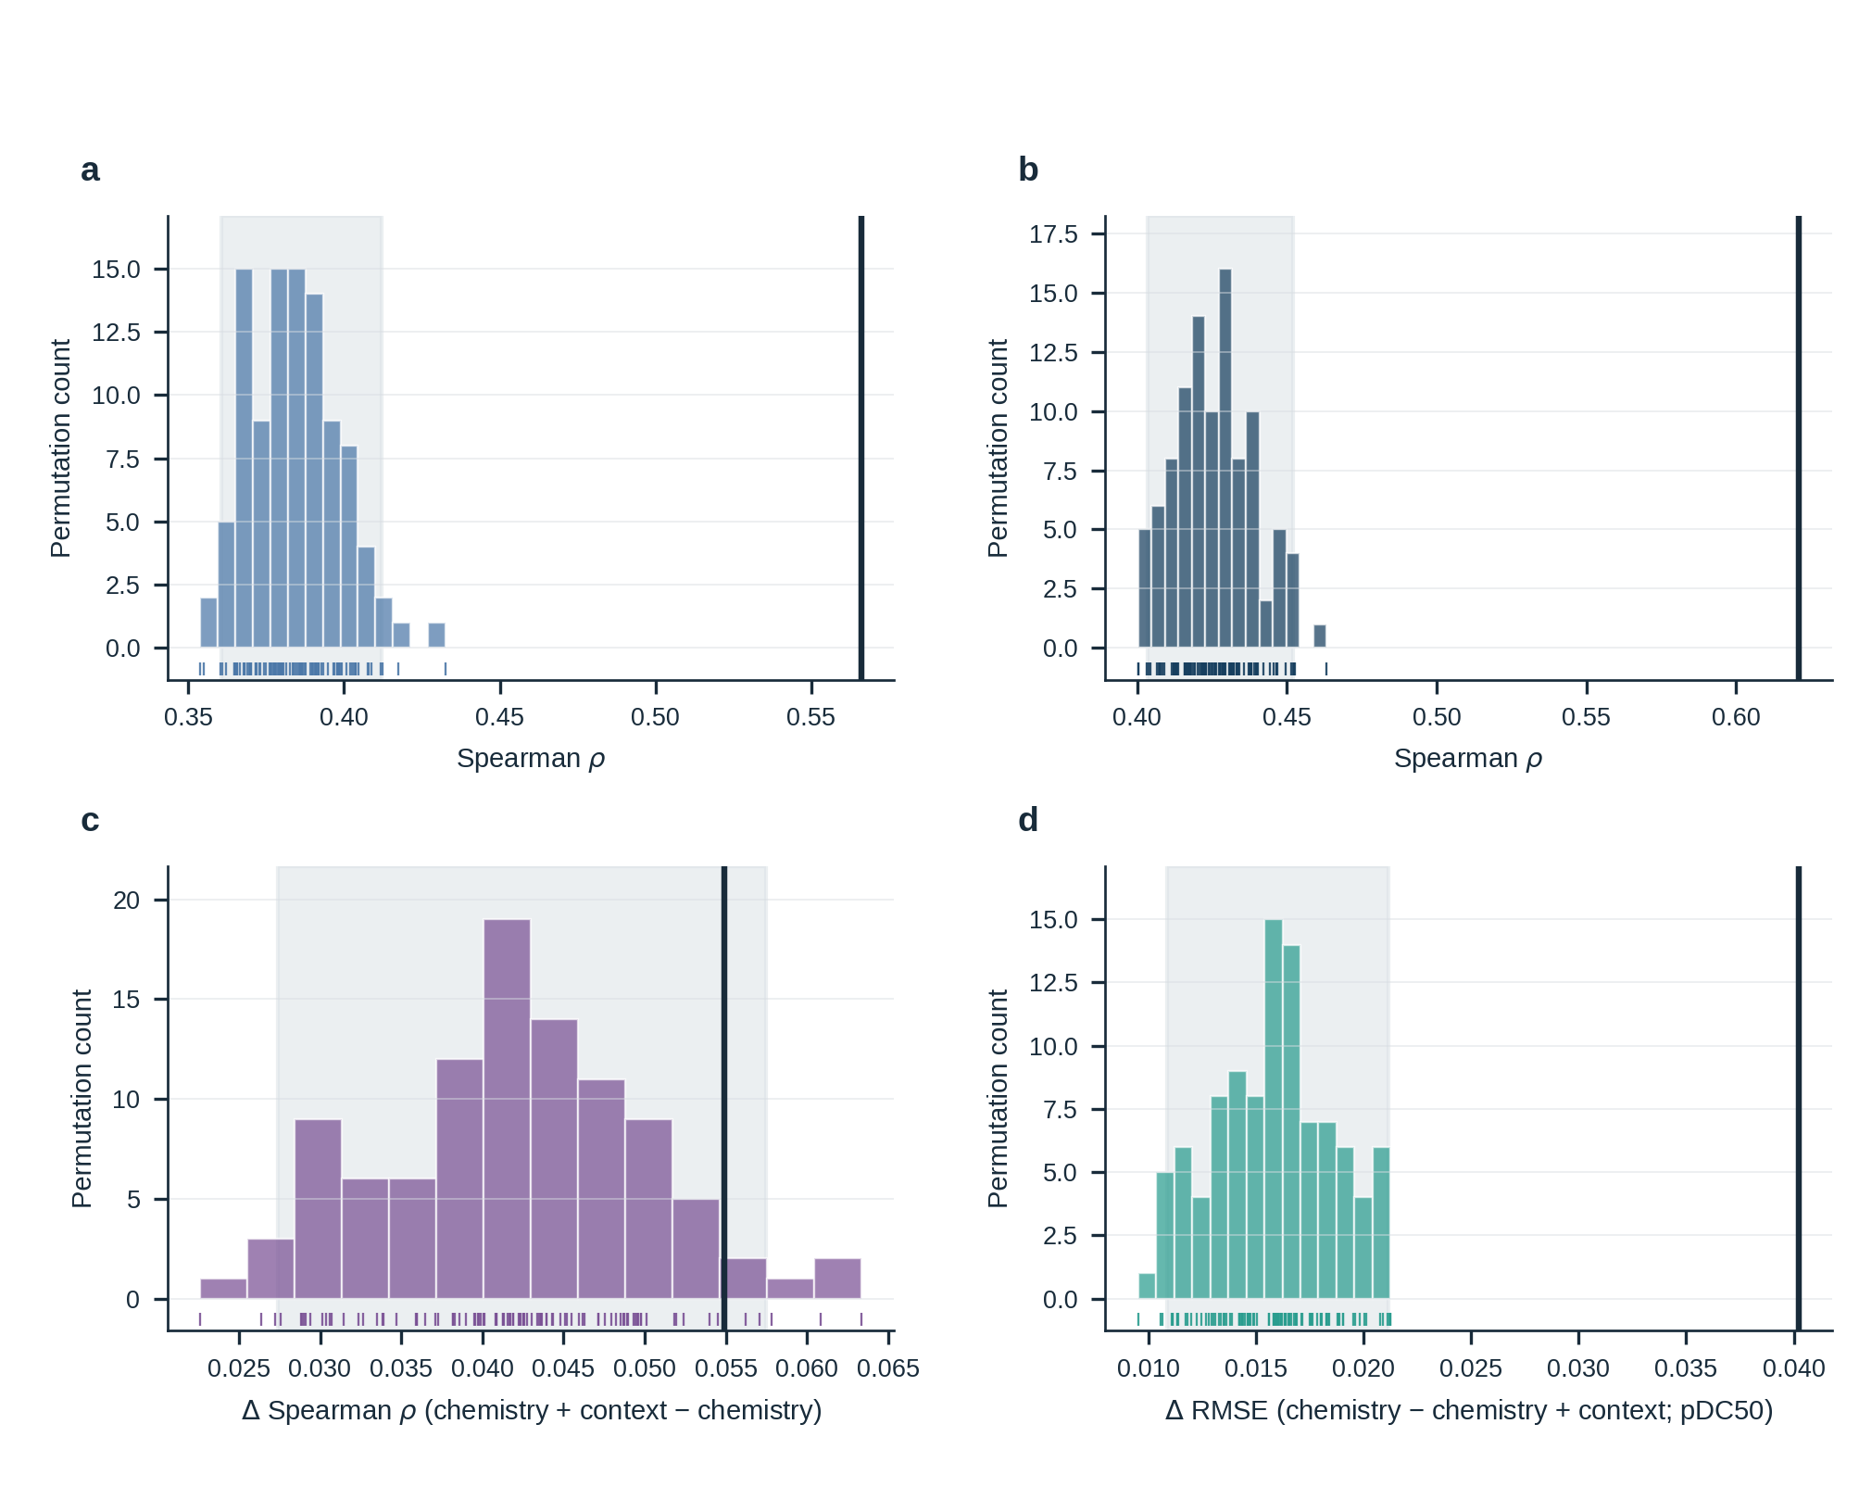

Supplementary Fig. S2 Repeated conditional label-randomization controls
Conditional null distributions for a, chemistry-only Spearman; b, chemistry-plus-context Spearman; c, the context Spearman increment; and d, RMSE improvement from adding context. All 100 within-source–target training-label permutations are shown as histograms and rugs. Dark vertical lines indicate the observed unpermuted estimates and shaded regions the 2.5th–97.5th null percentiles. Empirical one-sided tail probabilities include the finite-permutation correction. For a–d, the observed estimates, null 2.5th–97.5th percentiles and empirical probabilities were respectively 0.566, 0.361–0.412 and 0.010; 0.621, 0.403–0.452 and 0.010; 0.055, 0.027–0.057 and 0.059; and 0.040, 0.011–0.021 and 0.010.
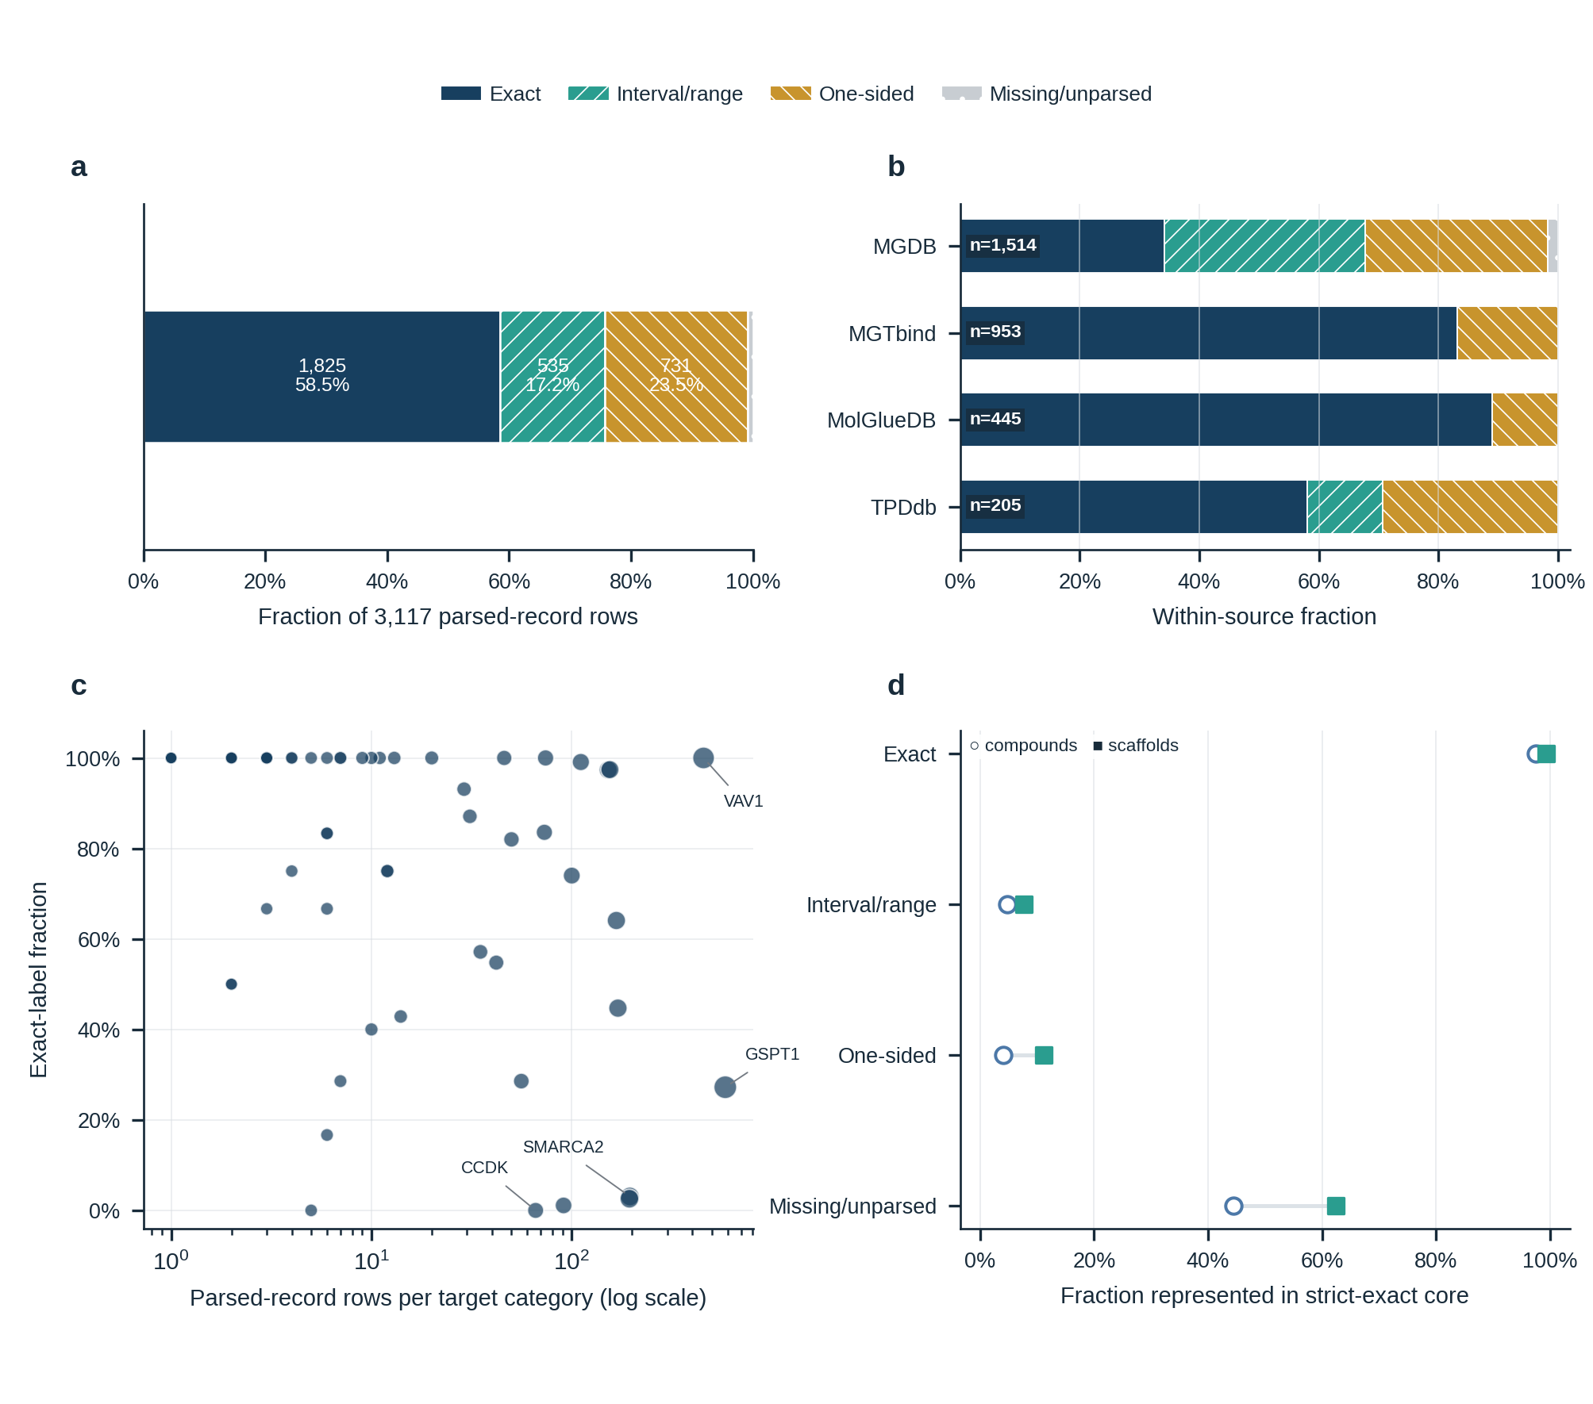

Supplementary Fig. S3 Endpoint selection and censoring boundary
a, Relation-type composition across all parsed DC50 records. b, Relation-type composition by source. c, Exact-label fraction for every declared target category. d, Compound and scaffold overlap between each endpoint-relation class and the exact-point modelling core. All target categories are plotted; only the three largest and the lowest exact-fraction category with at least eight records are labelled. Counts denote record-table rows rather than unique record identifiers. This is a descriptive audit; interval, one-sided and missing records were not converted to point labels or used for model fitting.
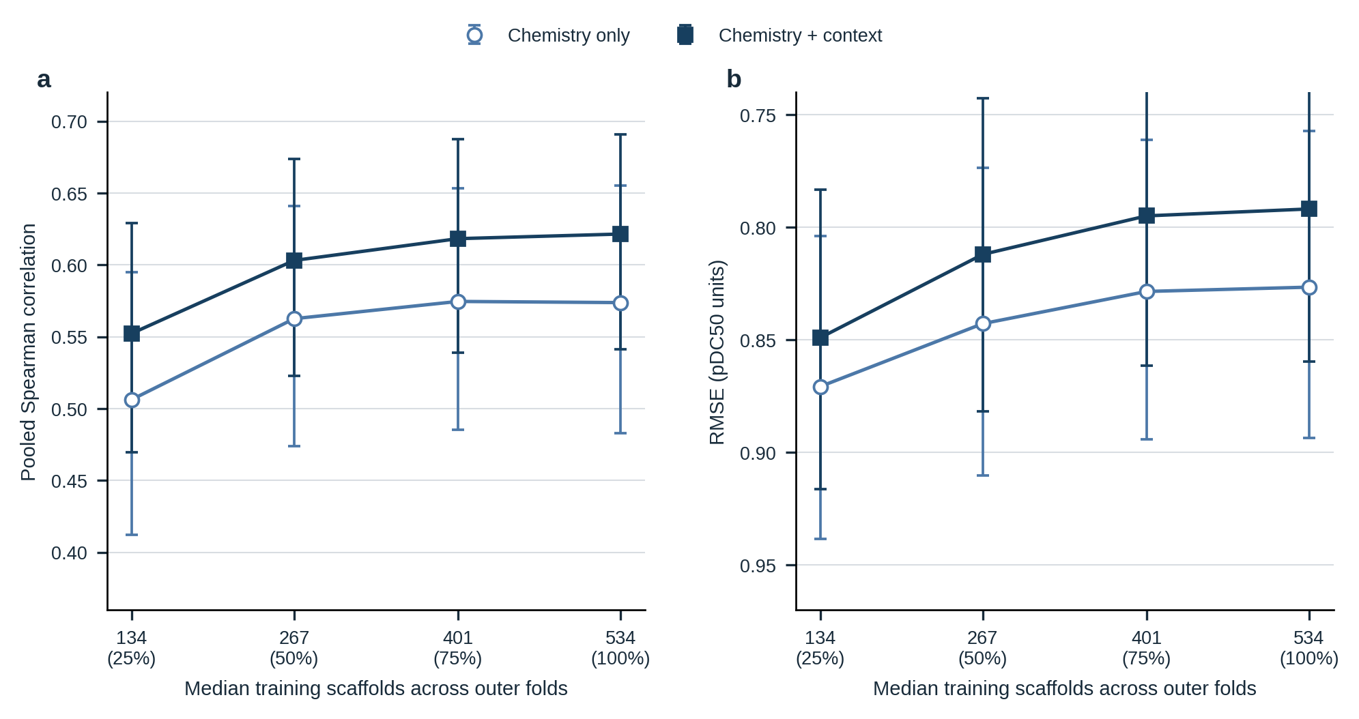

Supplementary Fig. S4 Internal scaffold learning curve
Pooled Spearman correlation and root mean squared error (RMSE) for fixed chemistry-only and chemistry-plus-context ExtraTrees models as nested prefixes retained 25%, 50%, 75% or 100% of the available outer-training scaffolds. Points use repeat-averaged predictions; error bars are paired 95% intervals from 10,000 scaffold-cluster bootstrap resamples. Values below each x-axis count give the prespecified scaffold fraction. From 75% to 100% of training scaffolds, the observed Spearman change was −0.001 (95% interval, −0.013 to +0.012) for chemistry only and +0.003 (−0.008 to +0.015) for chemistry plus context. This post-hoc contrast does not establish an asymptote or required sample size.
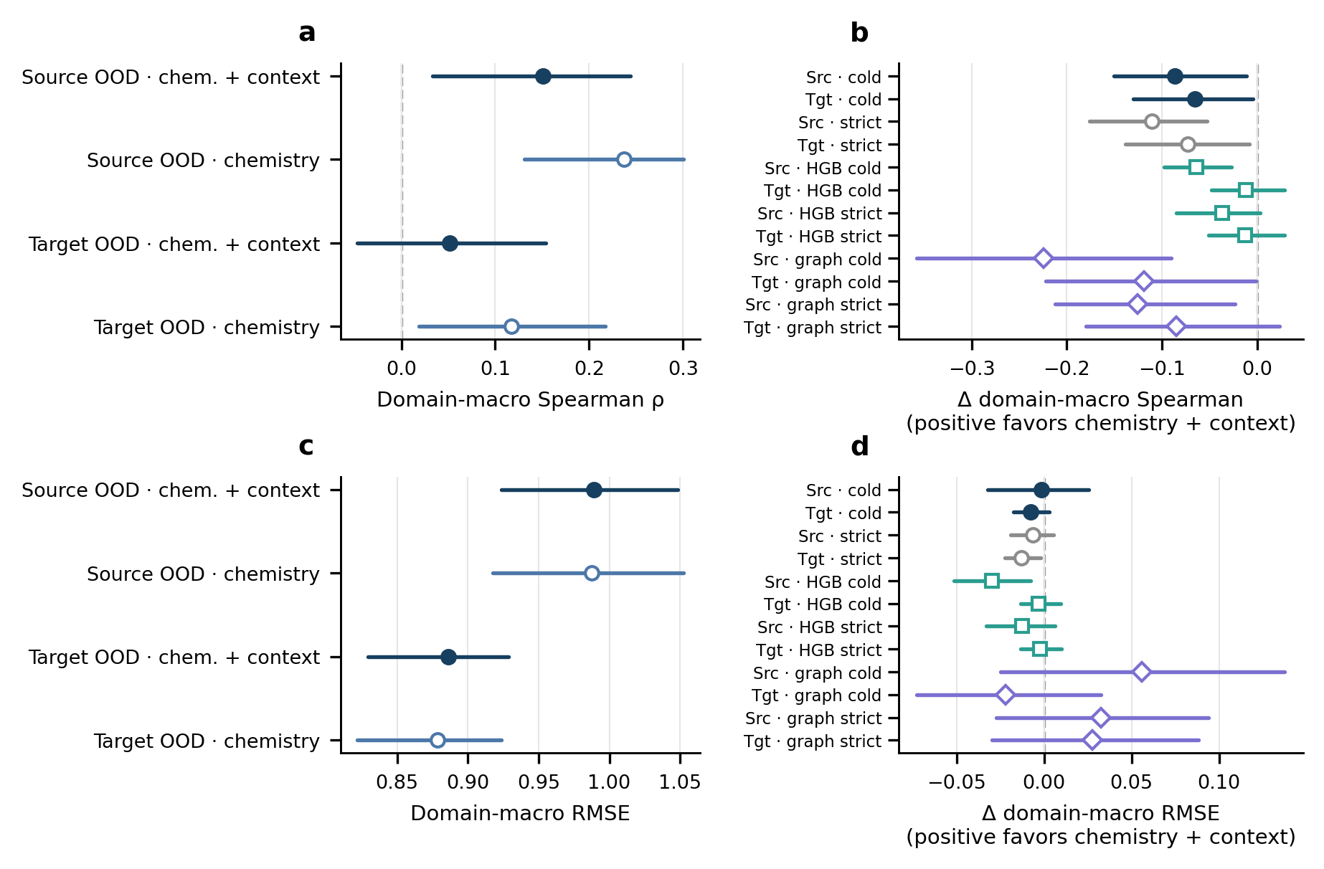

Supplementary Fig. S5 Held-domain performance and learner sensitivities
a,c, Equal-domain-weight Spearman correlation and root mean squared error (RMSE) for chemistry-only and chemistry-plus-context ExtraTrees in four held-source and eight held exact-target-label domains. b,d, Paired context increments under the protocol-frozen domain-plus-compound-cold design, strict post-hoc scaffold purging, and post-hoc HistGradientBoosting and molecular-graph sensitivities. Positive contrasts favour the chemistry-plus-context model. Points show estimates and lines show 95% percentile intervals from 10,000 paired global-scaffold bootstrap resamples. Absolute performance is modest and this figure does not establish prospective utility or protein-family zero-shot prediction.
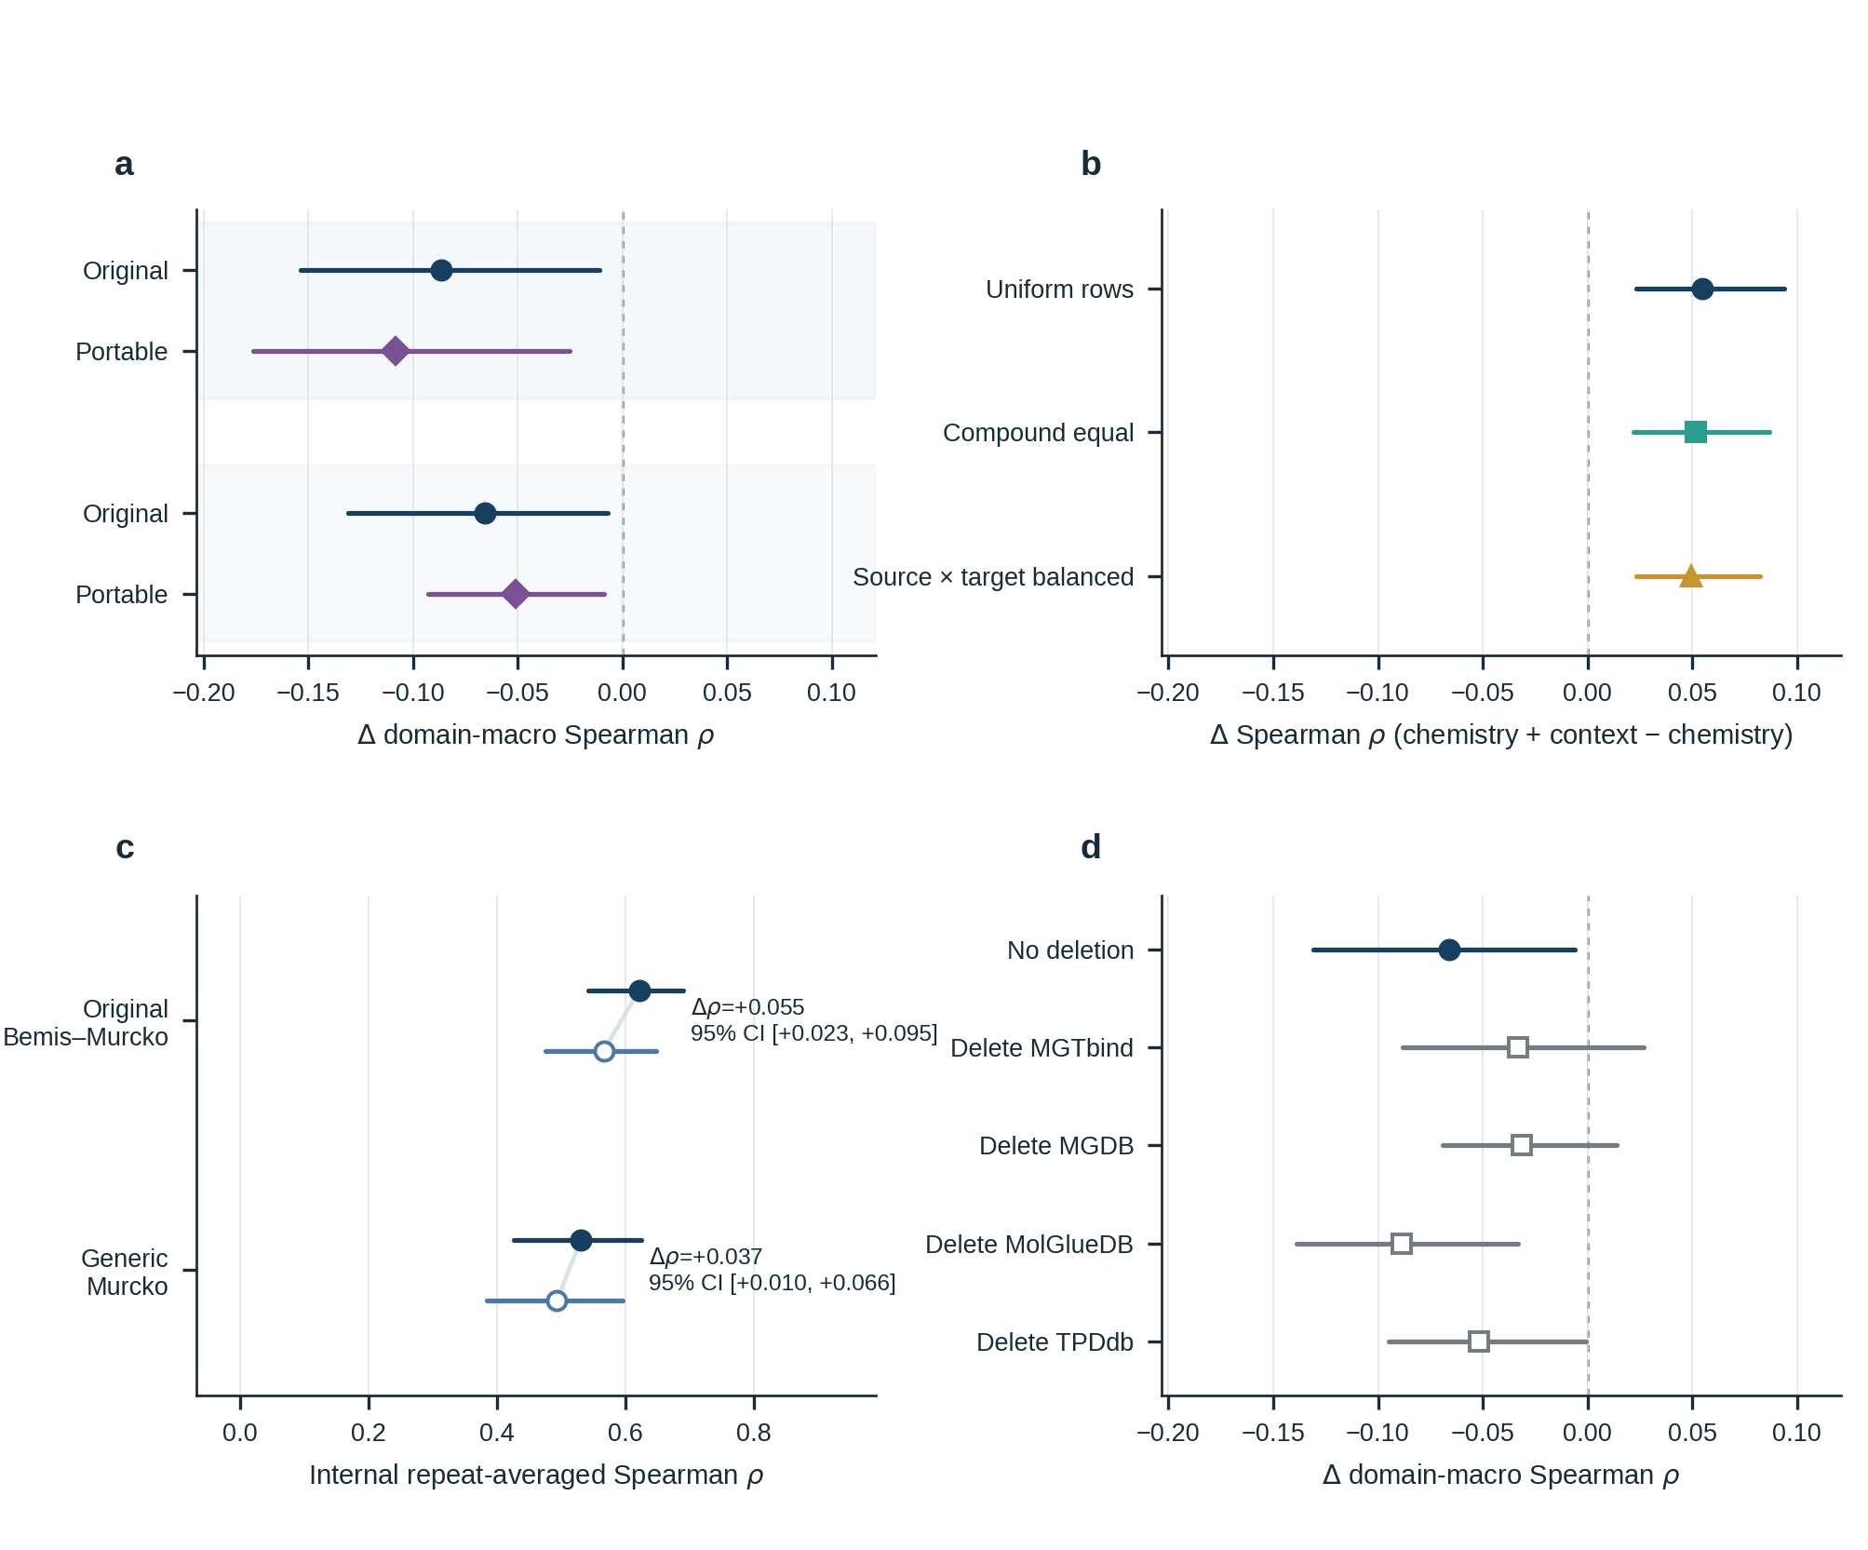

Supplementary Fig. S6 Robustness map across validation and representation sensitivities
a, Held-source and held exact-target-label context domain-macro Spearman contrasts for the original chemistry-plus-context (circles) and held-axis-portable chemistry-plus-context models (diamonds). b, Internal context increments under uniform-row, compound-equal and source–target-domain-balanced fitting; evaluation remains unweighted. c, Chemistry-only (open circles) and chemistry-plus-context (filled circles) Spearman correlations under the original Bemis–Murcko and generic Murcko scaffold definitions. d, Held exact-target-label context increments after deleting no source or one source token from every training set, evaluated on the same eight held targets. Points are estimates and lines show paired 95% scaffold-cluster percentile intervals from 10,000 resamples. All panels are post-hoc sensitivities; positive contrasts favour the chemistry-plus-context model.

Supplementary reproducibility statement
No prospective validation data were available or used. Reconstruction and analysis code is available from the MolGlueBench repository [S1] under the MIT License. Third-party raw exports, harmonized row-level tables, split assignments and row-level predictions are not redistributed. They can be reconstructed locally from the owners' official downloads, subject to each source owner's access conditions.

Supplementary references
S1. MolGlueBench: molecular-glue DC50 benchmark. GitHub. https://github.com/NTU-MedAILab/molglue-dc50-benchmark. Accessed 2 Sept 2026.
S2. MGTbind data download. Peking University Molecular Design Laboratory. https://mgtbind.pkumdl.cn/download. Accessed 31 May 2026.
S3. MGDB data download. iDrugLab. http://mgdb.idruglab.cn/download. Accessed 31 May 2026.
S4. MolGlueDB data download. MolGlueDB. https://www.molgluedb.com/download. Accessed 31 May 2026.
S5. TPDdb data download. TPDdb. https://tpddb.idrblab.net/download. Accessed 31 May 2026.

