Supplementary Information
Harnessing a transient liquid-metal flux for the ultrafast photoforging of compositionally complex oxide nanoarchitectures
Taehee Kim‡, Yeon-Ju Ryu‡, Sehyeon Seok, Jiheong Kang, Seon Joon Kim, Albert S. Lee,
Ji–Soo Jang*, Taegon Oh*
Contact: taegon.oh@kist.re.kr, wkdwltn92@skku.edu

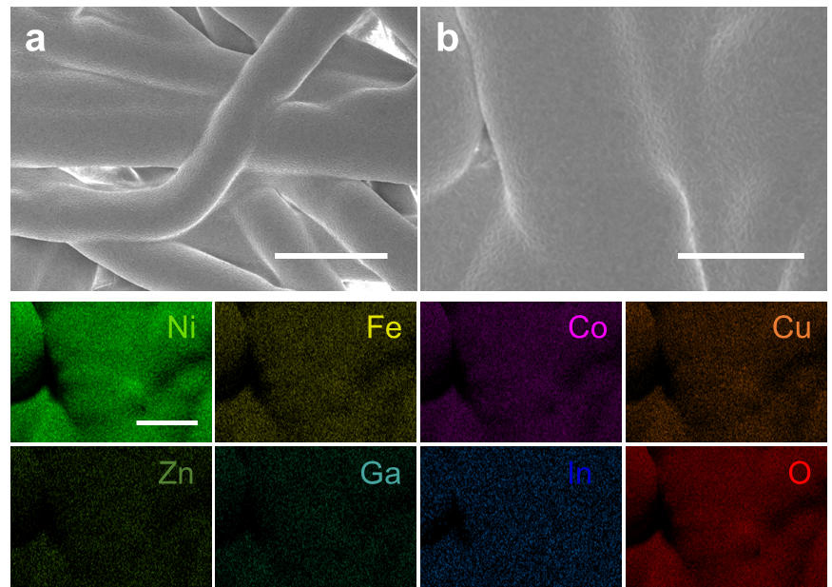
Supplementary Fig. 1 Morphology and elemental distribution of the furnace-treated control sample. (a) Low-magnification SEM image of LM@TM-coated NFP after furnace annealing at 900 °C for 1 h. (b) Higher-magnification SEM image and corresponding EDS elemental maps of Ni, Fe, Co, Cu, Zn, Ga, In, and O. Scale bars: 50 μm (a) and 25 μm (b and EDS maps).

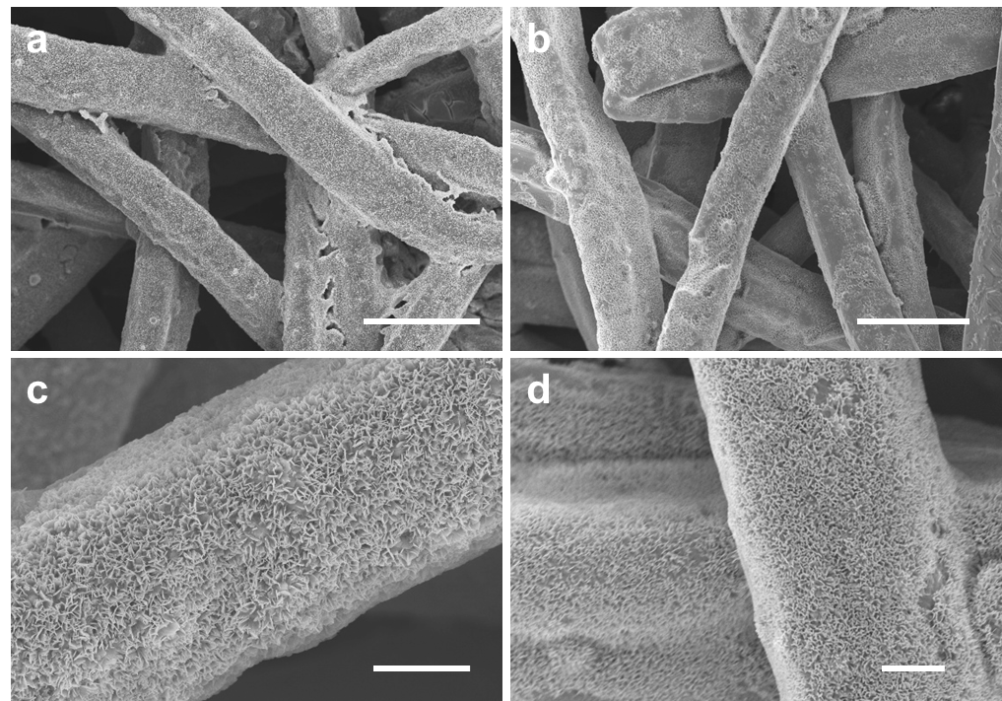
Supplementary Fig. 2. SEM images of TM@LM-coated NFP after IPL photoforging. (a,b) Low-magnification and (c,d) high-magnification images acquired from different regions of the electrode prepared using a single 20 ms pulse at 400 V. Vertically oriented nanosheets are observed across the Ni fibers. Scale bars: 30 μm (a,b) and 5 μm (c,d).

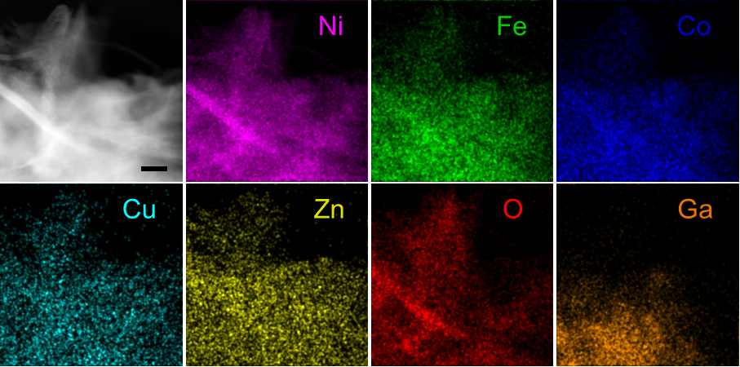
Supplementary Fig. 3. HAADF-STEM image and corresponding EDS elemental maps acquired from an SCCO nanosheet attached to NFP, including the SCCO and the NFP interface. Fe, Co, Ni, Cu, Zn, and O are distributed throughout the nanosheet, whereas Ga is preferentially enriched in the substrate-adjacent lower region, consistent with interfacial Ni–Ga alloying. The Ni signal includes contributions from both the SCCO and the underlying NFP. Scale bar: 50 nm.

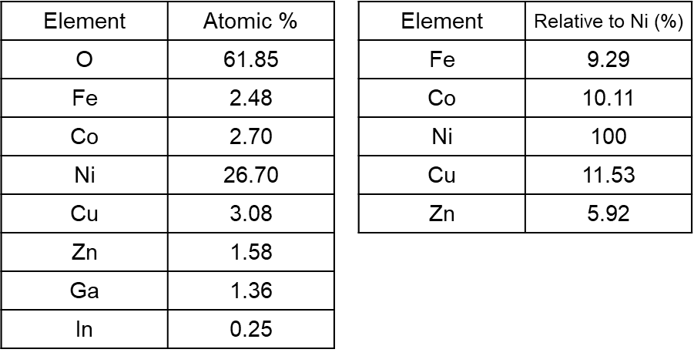
Supplementary Table 1. Elemental composition determined by EDS analysis of the mapped region shown in Figure S3. The measured atomic percentages are listed together with the transition-metal atomic ratios relative to Ni.
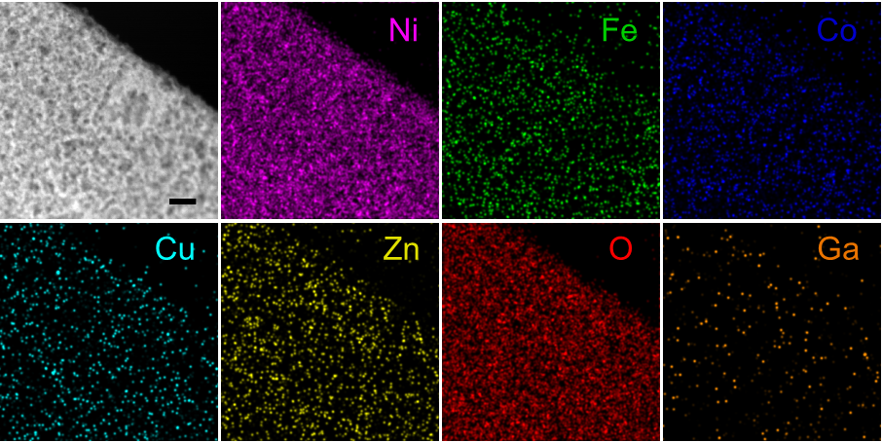
Supplementary Fig. 4. HAADF-STEM image and corresponding EDS elemental maps of Ni, Fe, Co, Cu, Zn, O, and Ga acquired from a single SCCO nanosheet, detached from the NFP substrate. Ni, Fe, Co, Cu, Zn, and O are distributed throughout the nanosheet, whereas only a weak and spatially sparse Ga signal is detected. Scale bar: 10 nm.

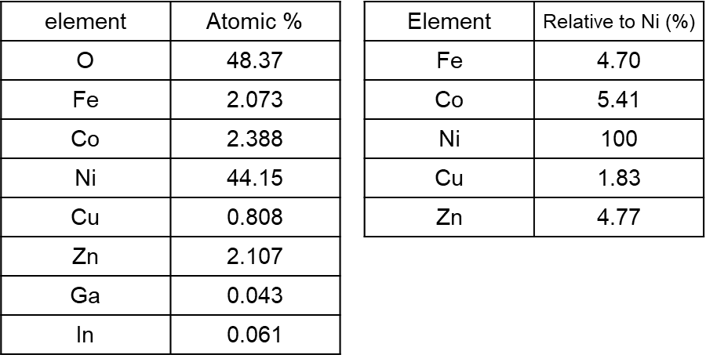
Supplementary Table 2. Elemental composition determined by EDS analysis of the mapped region shown in Figure S4. The measured atomic percentages are listed together with the transition-metal atomic ratios relative to Ni.

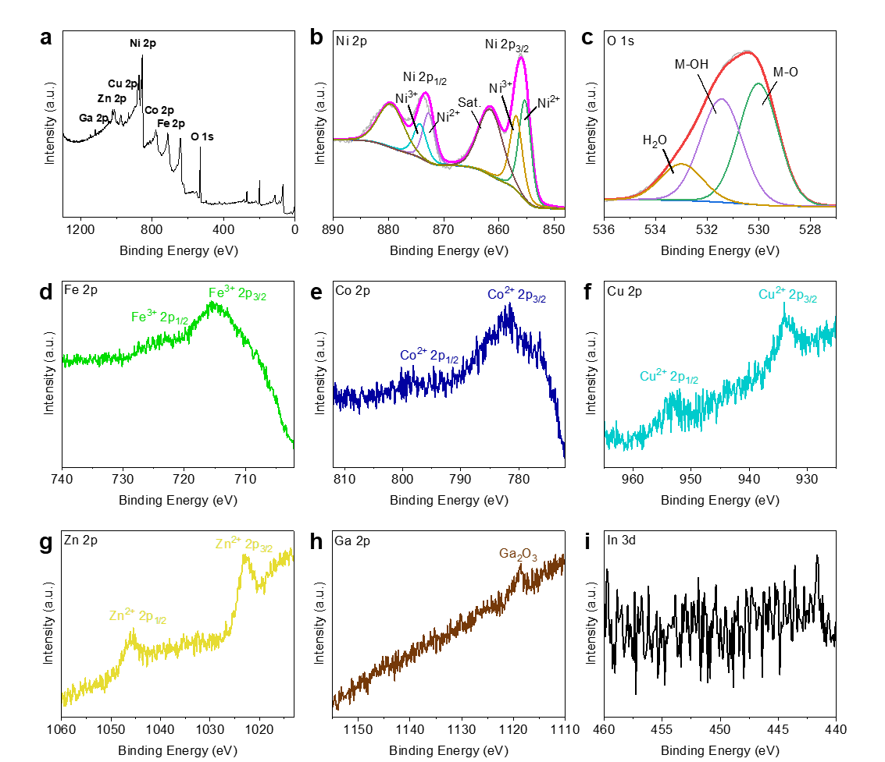
Supplementary Fig. 5. X-ray photoelectron spectra of SCCO. (a) Survey spectrum and high-resolution spectra of (b) Ni 2p, (c) O 1s, (d) Fe 2p, (e) Co 2p, (f) Cu 2p, (g) Zn 2p, (h) Ga 2p, and (i) In 3d. The Ni 2p spectrum was deconvoluted into Ni²⁺, Ni³⁺, and satellite components, while the O 1s spectrum was deconvoluted into metal-oxygen (M-O), metal-hydroxyl (M-OH), and adsorbed H₂O. The dominant Fe 2p, Co 2p, Cu 2p, and Zn 2p features were assigned to Fe³⁺, Co²⁺, Cu²⁺, and Zn²⁺ species, respectively.

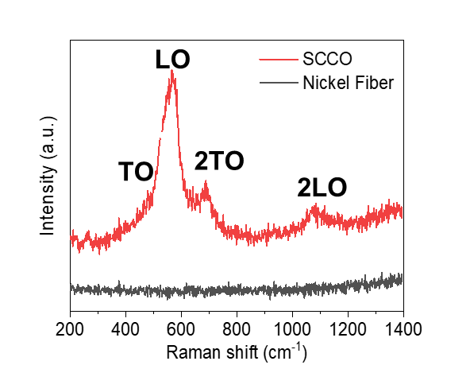
Supplementary Fig. 6. Raman spectra of SCCO and bare NFP. The bands labeled transverse optical (TO), longitudinal optical (LO), 2TO, and 2LO are assigned to the transverse-optical, longitudinal-optical, and corresponding second-order phonon modes of the nanosized NiO-derived rock-salt lattice.

Supplementary Table 3. Comparison of thermal processing conditions for LM-IPL and reported synthesis routes for compositionally complex or high-entropy oxides and alloys. The maximum processing temperature and reported heating and cooling characteristics are summarized. HEO and HEA denote high-entropy oxide and high-entropy alloy, respectively. A dash indicates that the corresponding value was not reported in the original reference.¹⁻¹⁰
Method | T (max) | heating rate (K/s) | cooling rate (K/s) | Materials | Ref.
LM-IPL | 1000 °C | 5$×$10⁴ | 10⁴ | SCCO | This work
IPL | 1800 °C | > 10⁵ | >6.7$×$10⁴ | HEA | 1
Hydrothermal | 400 °C  (Ga assisted) | 3$×$10⁻² | - | HEO | 2
Hydrothermal | 170 °C (active H) | - | - | HEA | 3
Joule heating | 1000 °C | 10⁵ | Few seconds | HEO | 4
Joule heating | 2000 °C | 10⁵ | - | HEA | 5
Joule heating | 1700 °C | 10⁵ | 10⁵ | HEA | 6
Microwave | 1550 °C | > 10³ | > 10³ | HEA | 7
Flame | 1900 °C | - | - | HEO | 8
Flame | 2700 °C | 2.9$×$10⁷ | 10⁶ | HEA | 9
Colloidal | 220 °C | injection | water bath | HEO | 10

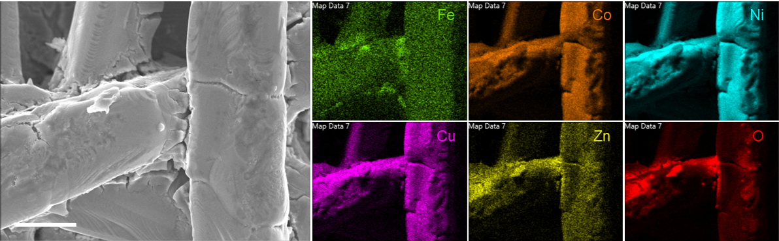
Supplementary Fig. 7. Morphology and elemental distribution of the liquid-metal-free control after IPL irradiation. SEM image and corresponding EDS elemental maps of Fe, Co, Ni, Cu, Zn, and O for NFP coated with the mixed transition-metal chloride precursor without EGaIn and irradiated with a single 20 ms IPL pulse at 400 V. The elemental maps reveal spatially nonuniform distributions across the coated Ni fibers. Scale bar: 10 μm.

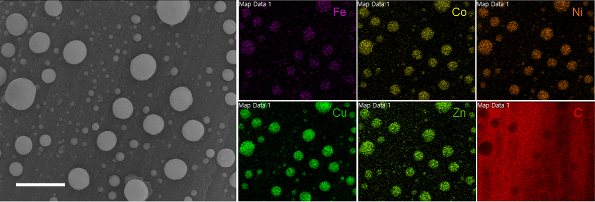
Supplementary Fig. 8. Morphology and elemental distribution of TM@LM particles after IPL irradiation on carbon fiber paper. SEM image and corresponding EDS elemental maps of Fe, Co, Ni, Cu, Zn, and C acquired after irradiation with a single 20 ms IPL pulse at 400 V. Multimetallic spherical particles are observed on the carbon substrate without the formation of vertically oriented nanosheets. Scale bar: 10 μm.
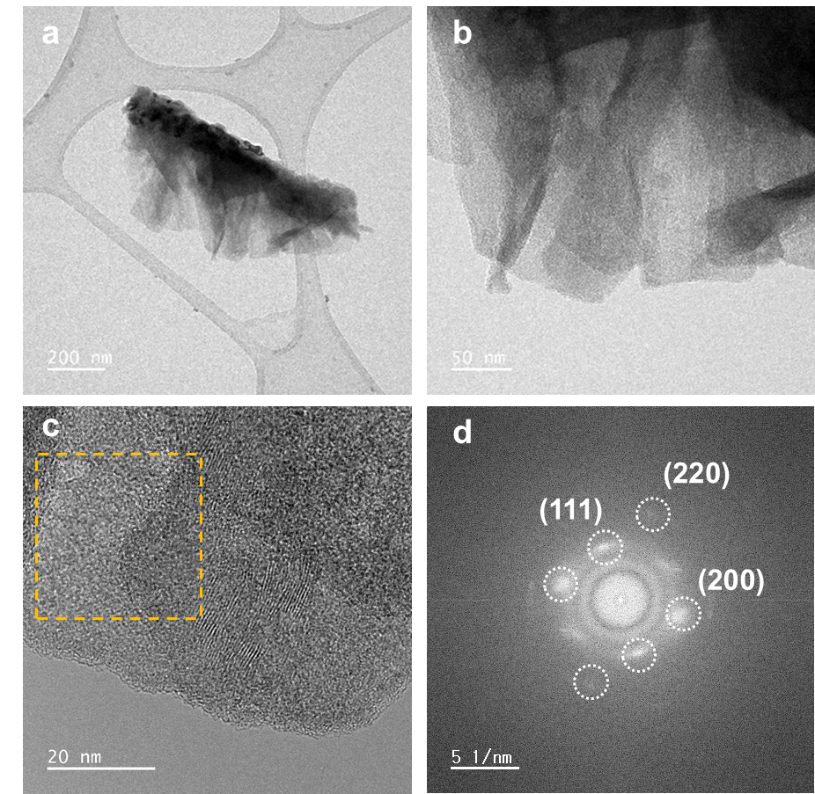
Supplementary Fig. 9. TEM and FFT analyses of SCCO nanosheets. (a,b) TEM images of an SCCO nanosheet at increasing magnifications. (c) HRTEM image of the nanosheet, with the yellow dashed box indicating the region used for FFT analysis. (d) Corresponding FFT pattern indexed to the (111), (200), and (220) reflections of the NiO-type rock-salt lattice. Scale bars: 200 nm (a), 50 nm (b), 20 nm (c), and 5 nm⁻¹ (d).

Supplementary Table 4. Compositional screening of SCCO formation by LM-IPL. The matrix summarizes the formation of the characteristic vertically oriented SCCO nanosheet morphology for unary, binary, ternary, quaternary, and quinary combinations of Fe, Co, Ni, Cu, and Zn, together with the denary MgAlKCrMnFeCoNiCuZn composition. Circles (O) and crosses (X) denote successful and unsuccessful formation of the nanosheet architecture, respectively.
Unary | Fe | Co | Ni | Cu | Zn
Unary | x | o | o | o | x
Binary | FeCo | FeNi | FeCu | FeZn | CoNi | CoCu | CoZn | NiCu | NiZn | CuZn
Binary | x | x | x | x | o | o | x | o | x | o
Ternary | FeCoNi | FeCoCu | FeCoZn | FeNiCu | FeNiZn | FeCuZn | CoNiCu | CoNiZn | CoCuZn | NiCuZn
Ternary | x | x | x | x | x | x | o | o | x | x
Quaternary | FeCoNiCu | FeCoNiZn | FeCoCuZn | FeNiCuZn | CoNiCuZn
Quaternary | x | x | x | x | o
Quinary | FeCoNiCuZn |  |  |  |  | Denary | MgAlKCrMnFeCoNiCuZn
Quinary | o |  |  |  |  | Denary | o

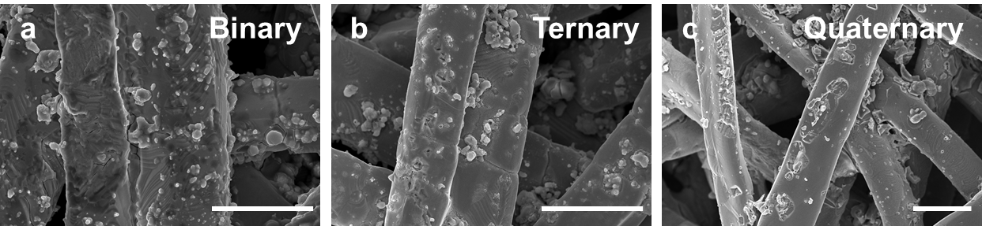
Supplementary Fig. 10. Representative non-nanosheet morphologies of Fe-containing compositions identified as unsuccessful in the LM–IPL compositional screening. SEM images of (a) FeCo, (b) FeCoNi, and (c) FeCoNiZn after irradiation with a single 20 ms IPL pulse at 400 V. These compositions exhibit irregular particulate or aggregated deposits rather than the characteristic vertically oriented SCCO nanosheets. Scale bars: 20 μm
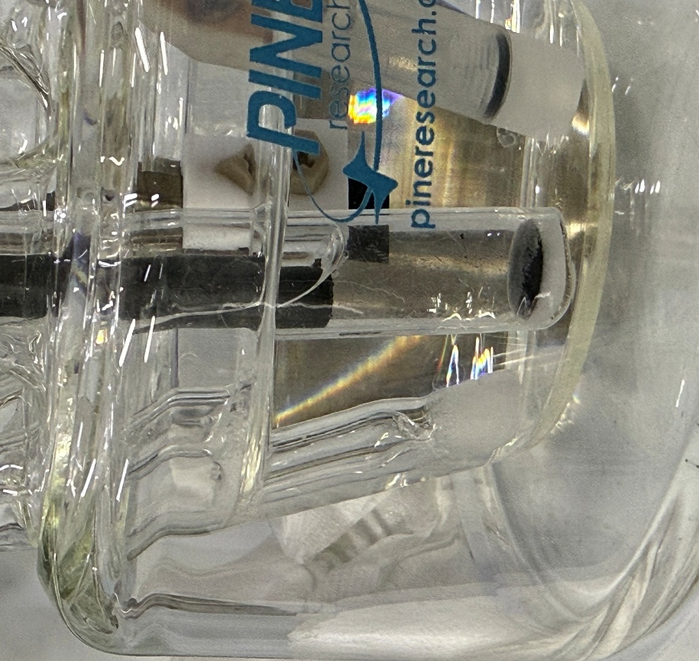
Supplementary Fig. 11. Graphite fragments released during long-term HER durability testing. Photograph showing graphite fragments detached from the counter electrode and accumulated at the bottom of the electrochemical cell during 50 h of chronopotentiometric operation at −100 mA cm⁻² in 1.0 M KOH.

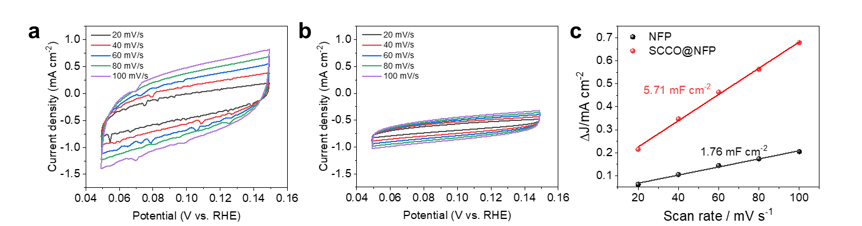
Supplementary Fig. 12. Electrochemical double-layer capacitance analysis of SCCO@NFP and bare NFP. Cyclic voltammograms recorded in the non-Faradaic potential region from 0.05 to 0.15 V vs RHE at scan rates of 20, 40, 60, 80, and 100 mV s⁻¹ for (a) SCCO@NFP and (b) bare NFP. (c) Capacitive current density, Δj = (j_{a} − j_{b})/2, plotted as a function of scan rate. Linear fitting yielded C_{dl} values of 5.71 and 1.76 mF cm⁻² for SCCO@NFP and bare NFP, respectively.

References
1. Cha, J.-H. et al. Flash-Thermal Shock Synthesis of High-Entropy Alloys Toward High-Performance Water Splitting. Adv. Mater. 35, 2305222 (2023).
2. Luo, Z. & Zhou, X.-P. Liquid metal–induced low-temperature synthesis of tunable high-entropy oxides. Sci. Adv. 11, eadw1461 (2025).
3. Zhang, Z. et al. Off-Equilibrium Hydrothermal Synthesis of High-Entropy Alloy Nanoparticles. J. Am. Chem. Soc. 147, 9640-9652 (2025).
4. Su, W. et al. Joule-Heating Synthesis of High-Entropy Oxide Nanoparticles as Sulfion Oxidation Catalysts for Efficient and Durable Hybrid Seawater Electrolysis. Adv. Funct. Mater. 35, 2506415 (2025).
5. Xie, P. et al. Highly efficient decomposition of ammonia using high-entropy alloy catalysts. Nat. Commun. 10, 4011 (2019).
6. Yao, Y. et al. Carbothermal shock synthesis of high-entropy-alloy nanoparticles. Science 359, 1489-1494 (2018).
7. Qiao, H. et al. Scalable Synthesis of High Entropy Alloy Nanoparticles by Microwave Heating. ACS Nano 15, 14928-14937 (2021).
8. Phakatkar, A.H. et al. Ultrafast Synthesis of High Entropy Oxide Nanoparticles by Flame Spray Pyrolysis. Langmuir 37, 9059-9068 (2021).
9. Dai, Y. et al. Flame Spray Pyrolysis Synthesis of Ultra-Small High-Entropy Alloy-Supported Oxide Nanoparticles for CO2 Hydrogenation Catalysts. Small Methods 8, 2301768 (2024).
10. Rowell, J.L. et al. Colloidal Synthesis of Monodisperse High-Entropy Spinel Oxide Nanocrystals. J. Am. Chem. Soc. 146, 17613-17617 (2024).

