Supplementary Data

Extracellular DNA of slow growers of mycobacteria and its contribution to biofilm formation and drug tolerance

Aleksandr Ilinov, Akihito Nishiyama, Hiroki Namba, Yukari Fukushima, Hayato Takihara, Chie Nakajima, Anna Savitskaya, Shaban A. Kaboso, Yuri S. Vinnik, Gebremichal Gebretsadik, Mariko Hakamata, Yuriko Ozeki, Yoshitaka Tateishi, Shujiro Okuda, Yasuhiko Suzuki, and Sohkichi Matsumoto.



Supplementary Figure S1. Differential effect of DNase I treatment on drug susceptibility of M. intracellulare and M. avium.

M. intracellulare and M. avium were – untreated (-DNase I) or – treated (+DNase I) at 37 °C for 72 hours and further incubated with AMK, CLA or not, for 6 and 24 hours. CFU/ml was determined and normalized with that of control samples. The average viability ratio of each sample (mean ± SD, n = 3) is indicated. *, p<0.05.

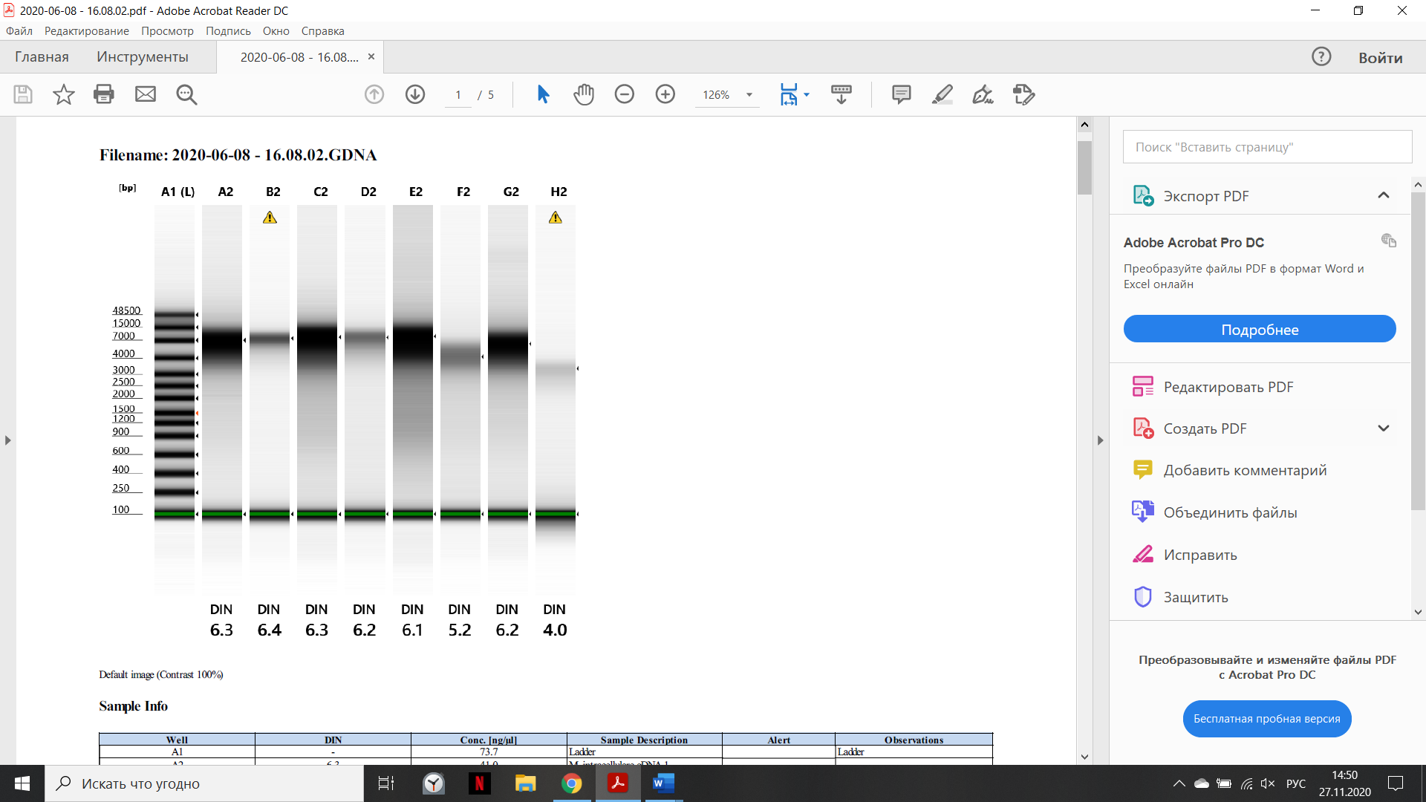
Supplementary Figure S2. Gel electrophoresis of genomic DNA (gDNA) and eDNA of mycobacteria.
gDNA and eDNA extracted from M. intracellulare (line A2 and B2, respectively), BCG (line C2 and D2, respectively), Mtb (line E2 and F2, respectively), and M. avium (line G2 and H2, respectively) and fractionated were visualized by Agilent 2200 TapeStation gel electrophoresis.

