Supporting Information

Drought to Flood Abrupt Alternation Events Across Monsoon Region in China: Characteristics, Mechanisms, and Crop Exposure
Jun Liu¹, Yingxiao Sun^{2,3}, Chunxuan Zhao³, Tong Jin⁴, Xuehua An³, Jiayi Mu³, Qianrong Ma^{2,3,6*}, Shanlei Sun³, Hao Wu^{5,6}

- Hubei Meteorological Observatory, Hubei Meteorological Service, Wuhan, 430074, China;
- Jiangsu Key Laboratory of Severe Storm Disaster Risk, Nanjing Innovation Institute for Atmospheric Sciences, Nanjing, 210041, China;
- State Key Laboratory of Climate System Prediction and Risk Management, CIC-FEMD/KLME, School of Atmospheric Sciences, Nanjing University of Information Science and Technology, Nanjing, 210044, China;
- Wuhan Leiguang Digital Technology Co., Ltd, Wuhan, 430074, China;
- Hunan Climate Center, China Meteorological Administration, Changsha 410118, China;
- Dongting-lake National Climatic Observatory, China Meteorological Administration, Yueyang 414000, China.

*Corresponding author: Qianrong Ma, maqianron_g@163.com

Contents of this file
Figure S1

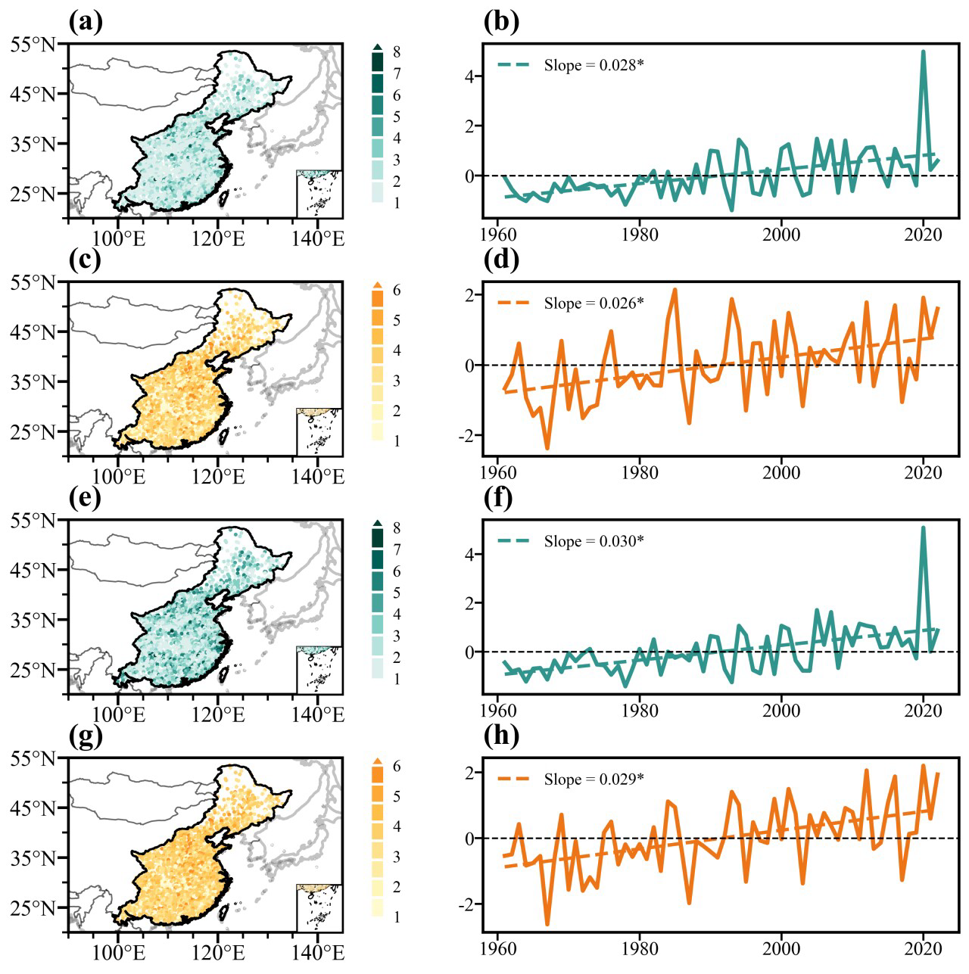
Fig S1. Spatiotemporal distributions of DTFAA events across the MRC from May to September during 1961–2023 under different transition period settings. Panels (a-d) correspond to transition durations of 6 days and (e-h) 10 days, respectively, while both drought and flood durations are fixed at 10 days. In each panel, the left column shows event spatial distribution of frequency (green) and intensity (yellow). The right column shows related time series. The asterisk (*) denotes a statistically significant trend according to the Student’s t-test at the 95% confidence level.

