Supplementary Information
System dynamics model driven by process parameter for carbon emission prediction and mitigation scenario evaluation in open-pit metal mines
This supplementary file provides reproducibility materials for the model development described in Section 2, including the complete indicator system, subsystem stock-flow diagrams, detailed calculation equations and model assumptions. The main text retains the system boundary, core model structure and key equations, whereas this file supports inspection and reproduction of the model details.
Contents
This file includes:
1. Complete indicator system: Production and technical variables; carbon-emission indicators and emission factors.
2. Model indicator system: Variable system for carbon-emission prediction in an open-pit metal mine.
3. Subsystem stock-flow diagrams: Drilling, blasting, shoveling, haulage, crushing, beneficiation and tailings-handling, land-disturbance carbon sink loss, and potential carbon cost subsystems.
4. Model assumptions: Boundary assumptions, parameter treatment, scenario assumptions, and model-use limitations.
5. Model system settings: Vensim time settings, table-function inputs, carbon-price settings, and unit-consistency check.
6. Model parameterization and mitigation-scenario analysis tables: Parameterization table, scenario settings, annual and monthly scenario results, carbon-emission intensity, potential carbon cost, and haulage electrification results.

1. Complete indicator system
Model variables were divided into production-technology variables and carbon-emission variables. Production-technology variables describe process parameters and activity data used to calculate energy and material consumption, whereas carbon-emission variables describe process-level emissions, cumulative emissions, carbon emission intensity, emission factors and potential carbon cost.
Table S1. Production and technical variables for carbon emission prediction in an open-pit metal mine.
Variable | Symbol | Unit | Variable | Symbol | Unit
Mining-stripping quantity | P | m³/month | Rated load capacity of small diesel trucks | V_{stc_fuel} | m³
Blasting volume | V | m³ | Rated load capacity of electric trucks | V_{tc_elec} | m³
Pitch | a | m | Ore haulage volume by small diesel trucks | Q_{sto_fuel} | m³
Array pitch | b | m | Waste-rock haulage volume by small diesel trucks | Q_{stw_fuel} | m³
Bench height | H | m | Number of ore-haulage trips by small diesel trucks | N_{sto_fuel} | /
Extra depth | ΔH | m | Number of waste-rock-haulage trips by small diesel trucks | N_{stw_fuel} | /
Blast-hole depth | h | m | Total ore haulage distance by large diesel trucks | L_{lto_fuel} | km
Total blast-hole length | L_{dr} | m | Total waste-rock haulage distance by large diesel trucks | L_{ltw_fuel} | km
Number of blast holes | N | / | Total ore haulage distance by small diesel trucks | L_{sto_fuel} | km
Single hole blasting volume | v | m³ | Total waste-rock haulage distance by small diesel trucks | L_{stw_fuel} | km
Explosive unit consumption | q | kg·m⁻³ | Total ore haulage distance by electric trucks | L_{to_elec} | km
Unit drilling electricity consumption | D_{dr} | kWh·m⁻¹ | Total waste-rock haulage distance by electric trucks | L_{tw_elec} | km
Drilling electricity consumption | F_{dr_elec} | kWh | Unit electricity consumption of electric trucks | T_{elec} | kWh·km⁻¹
Explosive consumption | F_{ex_epe} | t | Unit fuel consumption of large diesel trucks | T_{l_fuel} | L·km⁻¹
Unit electricity consumption of electric | S_{elec} | kWh·m⁻³ | Unit fuel consumption of small diesel trucks | T_{s_fuel} | L·km⁻¹
Unit diesel consumption of hydraulic | S_{hy} | L·m⁻³ | Ore volume transported by belt conveyor | Q_{bc} | m³
Total shoveling volume | Q_{sl} | m³ | Unit electricity consumption of belt conveyor | T_{bc_elec} | kWh·m⁻³
Total shoveling volume of electric shovel | Q_{sl_elec} | m³ | Belt-conveyor electricity consumption | F_{bc_elec} | kWh
Total shoveling volume of hydraulic shovel | Q_{sl_hy} | m³ | Crushed ore volume | Q_{cr} | m³
Shoveling electricity consumption | F_{sl_elec} | kWh | Unit electricity consumption of crushers | C_{elec} | kWh·m⁻³
Shoveling diesel consumption | F_{sl_fuel} | L | Crushing electricity consumption | F_{cr_elec} | kWh
Haulage electricity consumption | F_{tc_elec} | kWh | Ore grade | g_{h} | %
Haulage diesel consumption | F_{tc_fuel} | L | Beneficiation feed | Q_{h} | t
Total electric-truck haulage volume | Q_{elec} | m³ | Concentrate output | M_{c} | t
Ore haulage volume by electric trucks | Q_{to_elec} | m³ | Concentrate output by stage | M_{c_i} | t
Waste-rock haulage volume by electric trucks | Q_{tw_elec} | m³ | Concentrate production rate | M′_{c} | t
Total diesel-truck haulage volume | Q_{fuel} | m³ | Unit electricity consumption for beneficiation | M_{m_elec} | kWh·t⁻¹
Ore haulage volume by diesel trucks | Q_{to_fuel} | m³ | Beneficiation electricity consumption | F_{m_elec} | kWh
Waste-rock haulage volume by diesel trucks | Q_{tw_fuel} | m³ | Tailings volume | Q_{t} | t
Number of ore-haulage trips by electric trucks | N_{to_elec} | / | Unit electricity consumption for tailings disposal | M_{t_elec} | kWh·t⁻¹
Number of waste-rock-haulage trips by electric trucks | N_{tw_elec} | / | Tailings disposal electricity consumption | F_{t_elec} | kWh
Number of ore-haulage trips by large diesel trucks | N_{lto_fuel} | / | Land area disturbed by open-pit mining | S_{m} | m²
Number of waste-rock-haulage trips by large diesel trucks | N_{ltw_fuel} | / | Land area disturbed by tailings storage | S_{t} | m²
Ore haulage volume by large diesel trucks | Q_{lto_fuel} | m³ | Land area disturbed by waste dump | S_{w} | m²
Waste-rock haulage volume by large diesel trucks | Q_{ltw_fuel} | m³ | Land area disturbed by other activities | S_{o} | m²
Average one-way haulage distance for waste rock | l_{tw} | km | Unit-area vegetation carbon sequestration capacity | V_{cs} | gCO₂ eq·m⁻²·a⁻¹
Average one-way haulage distance for ore | l_{to} | km | Unit-area soil carbon storage | S_{cs} | kgCO₂ eq·m⁻²
Rated load capacity of large diesel trucks | V_{ltc_fuel} | m³ | Final pit area | S_{u} | m²

Table S2. Carbon-emission indicators and emission factors.
Variable | Symbol | Unit | Variable | Symbol | Unit
Total carbon emissions | EM | t CO₂ eq | Carbon emission rate of drilling process | F′_{dr} | t CO₂ eq/month
Carbon emissions at different time stages | EM_{i} | t CO₂ eq | Carbon emission rate of blasting process | F′_{ex} | t CO₂ eq/month
Carbon emission intensity at different time stages | CI_{ni} | t CO₂ eq·t⁻¹ | Carbon emission rate of shoveling process | F′_{sl} | t CO₂ eq/month
Total carbon emission intensity | CI_{n} | t CO₂ eq·t⁻¹ | Carbon emission rate of haulage process | F′_{tc} | t CO₂ eq/month
Carbon emissions from drilling | F_{dr} | t CO₂ eq | Carbon emission rate of beneficiation process | F′_{m} | t CO₂ eq/month
Carbon emissions from blasting | F_{ex} | t CO₂ eq | Carbon emission rate of crushing process | F′_{cr} | t CO₂ eq/month
Carbon emissions from shoveling | F_{sl} | t CO₂ eq | Carbon emission rate of tailings disposal process | F′_{td} | t CO₂ eq/month
Carbon emissions from haulage | F_{tc} | t CO₂ eq | Carbon emission rate of carbon sink loss | F′_{cs} | t CO₂ eq/month
Carbon emissions from beneficiation | F_{m} | t CO₂ eq | Carbon emission factors of diesel | EF_{dsl} | t CO₂ eq·t⁻¹
Carbon emissions from crushing | F_{cr} | t CO₂ eq | Carbon emission factors of electricity | EF_{elec} | t CO₂ eq·MWh⁻¹
Carbon emissions from tailings handling | F_{t} | t CO₂ eq | Gasoline emission factor | EF_{gas} | t CO₂ eq·t⁻¹
Carbon sink loss | F_{cs} | t CO₂ eq | Explosive emission factor | EF_{epe} | t CO₂ eq·t⁻¹
Potential carbon cost | C_{pc} | CNY | Carbon price | P_{ct} | CNY/t CO₂ eq

2. Model indicator system
Fig. S1. Variable system for carbon-emission prediction in an open-pit metal mine.

3. Subsystem stock-flow diagrams
The stock-flow diagrams of the subsystems show the calculation relationships among activity data, energy or material consumption, emission factors and carbon-emission results in the model.
Fig. S2. Stock-flow diagram of the drilling subsystem.
Fig. S3. Stock-flow diagram of the blasting subsystem.
Fig. S4. Stock-flow diagram of the shoveling subsystem.
Fig. S5. Stock-flow diagram of the haulage subsystem.

Fig. S6. Stock-flow diagram of the crushing subsystem.

Fig. S7. Stock-flow diagram of the beneficiation and tailings-handling subsystem.

Fig. S8. Stock-flow diagram of the land-disturbance carbon sink loss subsystem.

Fig. S9. Stock-flow diagram of the potential carbon cost subsystem.

4. Model assumptions
- The system boundary covers open-pit extraction, concentrate production and tailings handling, and excludes smelting, refining, downstream manufacturing, transportation outside the mine production system and end-use stages.
- The production process is divided into drilling, blasting, Shoveling, haulage, crushing, beneficiation and tailings handling.
- Land-disturbance carbon sink loss is included as an independent module to represent the reduction in vegetation carbon uptake capacity and soil carbon storage caused by newly disturbed land.
- The model does not currently consider reclamation recovery, vegetation succession or long-term dynamic recovery of soil carbon pools.
- Energy and material consumption are calculated from production plans, equipment parameters and process activity data, rather than being fully specified as external inputs at each time step.
- Emission factors for electricity, diesel, gasoline and explosives are treated as model parameters and can be adjusted for scenario analysis.
- Carbon price is treated as a scenario parameter, and potential carbon cost represents cost exposure under a given carbon-price scenario.
- Carbon allowances, free allocation, offset mechanisms and specific compliance rules are not included; therefore, potential carbon cost is not equivalent to the actual carbon-market compliance cost of the enterprise.
- The model is intended for dynamic prediction and scenario comparison, not as a substitute for measured enterprise greenhouse gas accounting or statutory reporting.
- When production organization, equipment configuration or energy structure changes, the model should be updated iteratively using on-site production data and energy-consumption records.

5. Model system settings

Fig. S10. Three-dimensional view of the mine's final pit limit.
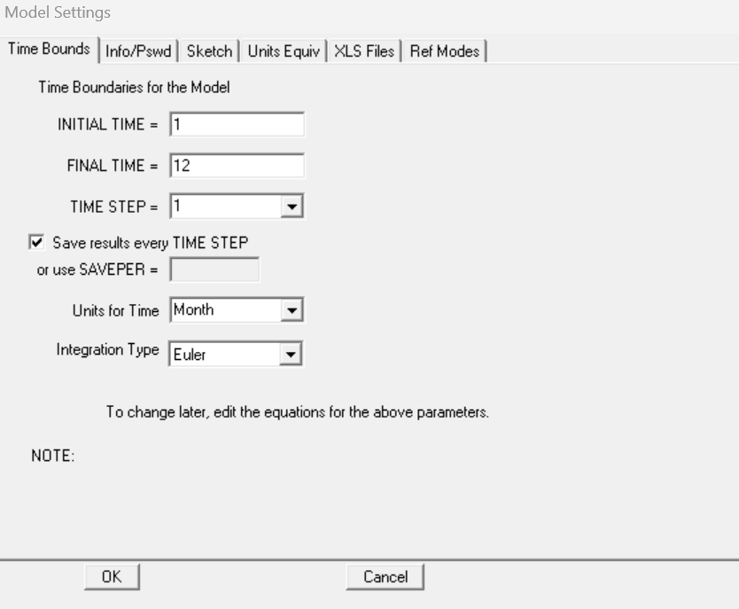
Fig. S11. Basic model settings.
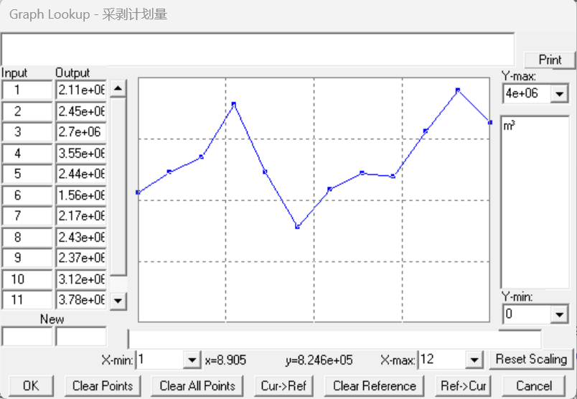
Fig. S12. Table function design of monthly mining-stripping quantities.
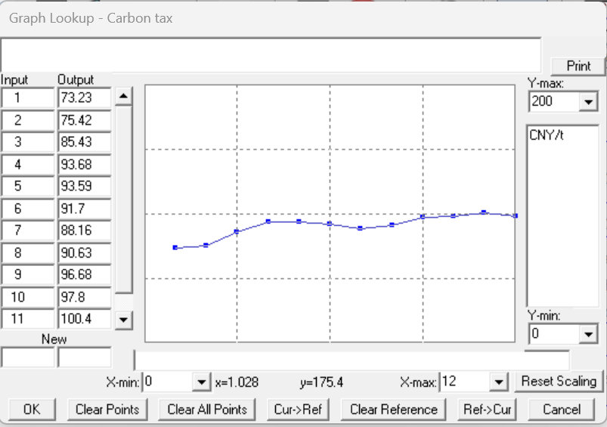
Fig. S13. Table function design of carbon price.

Fig. S14. Units consistency check results.

6. Model parameterization and mitigation-scenario analysis tables
This supplementary note lists the main parameters, data sources, and model applications of the system dynamics model, together with the key settings and results used for the mitigation-scenario analysis presented in Section 4.5 of the main manuscript. To improve readability, the original scenario-analysis workbook was split into separate supplementary tables for carbon emission intensity and potential carbon cost.
Table S3. Input forms, data sources and model uses for model parameterization.
Parameter category | Main parameter | Symbol | Unit | Input form/scenario setting | Data source | Model use
Mining-stripping plan | Monthly mining-stripping quantity | P(t) | m³/month | Monthly time series | Annual/monthly mining-stripping plan | Determine operation volumes for production processes
Mining-stripping plan | Monthly ore volume | Q_{o}(t) | m³/month or t/month | Monthly time series | Production plan and mine design documents | Calculate haulage, crushing and beneficiation operation volumes
Mining-stripping plan | Monthly waste-rock volume | Q_{w}(t) | m³/month or t/month | Monthly time series | Production plan and mine design documents | Calculate waste-rock haulage volume and land disturbance
Drilling parameter | Hole spacing | a | m | Fixed value | Blasting design documents | Calculate rock volume broken per hole and number of blast holes
Drilling parameter | Burden | b | m | Fixed value | Blasting design documents | Calculate rock volume broken per hole and number of blast holes
Drilling parameter | Bench height | H | m | Fixed value | Mine design documents | Calculate blast-hole depth and blasting volume
Drilling parameter | Subdrilling depth | ΔH | m | Fixed value | Blasting design documents | Correct blast-hole depth
Drilling parameter | Unit drilling electricity consumption | D_{dr} | kWh·m⁻¹ | Fixed value | Equipment manuals and operating records | Calculate drilling electricity consumption
Blasting parameter | Specific explosive consumption | q | kg·m⁻³ | Fixed value | Blasting design documents and material-consumption records | Calculate explosive consumption
Blasting parameter | Explosive emission factor | EF_{epe} | t CO₂ eq·t⁻¹ | Emission-factor parameter | Greenhouse gas accounting guidelines, literature or enterprise data | Calculate carbon emissions from blasting
Shoveling parameter | Unit electricity consumption of electric shovels | S_{elec} | kWh·m⁻³ | Fixed value | Equipment records and operating records | Calculate electricity consumption for electric-shovel Shoveling
Shoveling parameter | Unit fuel consumption of hydraulic shovels | S_{hy} | L·m⁻³ | Fixed value | Equipment records and operating records | Calculate fuel consumption for loading
Haulage parameter | Average ore haulage distance | l_{to}(t) | km | Monthly time series | Haulage-system design and dispatching records | Calculate ore haulage energy consumption
Haulage parameter | Average waste-rock haulage distance | l_{tw}(t) | km | Monthly time series | Haulage-system design and dispatching records | Calculate waste-rock haulage energy consumption
Haulage parameter | Unit fuel consumption of large diesel trucks | T_{l_fuel} | L·km⁻¹ | Fixed value | Equipment manuals and operating records | Calculate diesel haulage energy consumption
Haulage parameter | Unit fuel consumption of small diesel trucks | T_{s_fuel} | L·km⁻¹ | Fixed value | Equipment manuals and operating records | Calculate diesel haulage energy consumption
Haulage parameter | Unit electricity consumption of electric trucks | T_{elec} | kWh·km⁻¹ | Fixed value | Equipment manuals and operating records | Calculate electric haulage energy consumption
Haulage parameter | Unit electricity consumption of belt conveyor | T_{bc_elec} | kWh·m⁻³ | Fixed value | Equipment data and operating records | Calculate belt-conveyor energy consumption
Crushing parameter | Monthly crushed ore volume | Q_{cr}(t) | t/month or  m³/month | Monthly time series | Production plan and crushing-station records | Calculate crushing electricity consumption
Crushing parameter | Unit electricity consumption of crushers | C_{elec} | kWh·m⁻³ | Fixed value | Equipment manuals and operating records | Calculate carbon emissions from crushing
Beneficiation parameter | Monthly beneficiation feed | Q_{h}(t) | t/month | Monthly time series | Beneficiation production records | Calculate beneficiation electricity consumption and derive concentrate and tailings outputs
Beneficiation parameter | Unit electricity consumption for beneficiation | M_{m_elec} | kWh·t⁻¹ | Fixed value | Beneficiation operating records | Calculate carbon emissions from beneficiation
Beneficiation parameter | Monthly concentrate output | M_{c}(t) | t/month | Monthly time series | Beneficiation production records | Calculate carbon emission intensity
Tailings-handling parameter | Monthly tailings volume | Q_{t}(t) | t/month | Monthly time series | Beneficiation-plant and tailings-storage operating records | Calculate tailings-handling electricity consumption and carbon emissions
Tailings-handling parameter | Unit electricity consumption for tailings handling | M_{t_elec} | kWh·t⁻¹ | Fixed value | Equipment data and operating records | Calculate carbon emissions from tailings handling
Land-disturbance parameter | Newly disturbed area of the open pit | ΔS_{m}(t) | m² | Monthly time series | Mine surveying, design documents and remote-sensing interpretation | Calculate land-disturbance carbon loss
Land-disturbance parameter | Newly disturbed area of the waste dump | ΔS_{w}(t) | m² | Monthly time series | Mine surveying, design documents and remote-sensing interpretation | Calculate land-disturbance carbon loss
Land-disturbance parameter | Newly disturbed area of the tailings storage facility | ΔS_{t}(t) | m² | Monthly time series | Mine surveying, design documents and remote-sensing interpretation | Calculate land-disturbance carbon loss
Land-disturbance parameter | Unit-area vegetation carbon sequestration capacity | V_{cs} | g CO₂ eq·m⁻²·a⁻¹ | Fixed value | Regional ecological data, literature or measured data | Calculate vegetation carbon sink loss
Land-disturbance parameter | Unit-area soil carbon storage | S_{cs} | kg CO₂ eq·m⁻² | Fixed value | Soil survey, literature or measured data | Calculate soil carbon pool loss
Emission factor | Electricity emission factor | EF_{elec} | t CO₂ eq·MWh⁻¹ | Emission-factor parameter | Regional grid emission factor or accounting guidelines | Calculate electricity-related carbon emissions
Emission factor | Diesel emission factor | EF_{fuel} | t CO₂ eq /L 或 t CO₂ eq /t | Emission-factor parameter | Greenhouse gas accounting guidelines | Calculate fuel-related carbon emissions
Carbon-price parameter | Low carbon-price scenario | P_{cL}(t) | CNY/t CO₂ eq | Monthly carbon-price scenario series | Carbon-market prices and policy scenario settings | Estimate potential carbon cost
Carbon-price parameter | Medium carbon-price scenario | P_{cM}(t) | CNY/t CO₂ eq | Monthly carbon-price scenario series | Carbon-market prices and policy scenario settings | Estimate potential carbon cost
Carbon-price parameter | High carbon-price scenario | P_{cH}(t) | CNY/t CO₂ eq | Monthly carbon-price scenario series | Carbon-market prices and policy scenario settings | Estimate potential carbon cost
Note: The input form/scenario setting column describes how each parameter is entered into the model. Complete monthly time series were determined from the production plan, design documents, equipment operating records and relevant accounting guidelines for the case-study mine.

Table S4. Mitigation scenario settings.
Scenario | Scenario meaning | Key parameter adjustment | Variables adjusted in the model | Setting | Notes
S0 | Baseline scenario | Keep the 2027 production plan, energy intensity, haulage allocation and emission factors unchanged | All baseline variables | Baseline | S0 data are from the validated 2027 simulation results.
S1 | Beneficiation energy-saving scenario | Reduce unit electricity consumption for beneficiation | M_{m_elec} | -10% | The corresponding adjustment value is entered after scenario setting.
S2 | Power decarbonization scenario | Reduce the purchased-electricity emission factor | EF_{elec} | -15% | Represents regional grid decarbonization or green electricity procurement.
S3 | Haulage electrification scenario | Shift part of diesel-truck haulage volume to electric trucks | Q_{fuel}, Q_{elec}, F_{tc_fuel}, F_{tc_elec} | 30% haulage-volume substitution | The substitution is based on haulage volume rather than vehicle number.
S4 | Combined mitigation scenario | Implement S1, S2 and S3 simultaneously | Multiple variables | S1+S2+S3 | Used to evaluate integrated mitigation potential.
Note: S0 is the baseline scenario, S1 is the beneficiation energy-saving scenario, S2 is the power decarbonization scenario, S3 is the haulage electrification scenario and S4 is the combined mitigation scenario.
Table S5. Annual carbon emissions, carbon emission intensity and potential carbon cost under different scenarios.
Scenario | Annual total emissions  (kt CO₂ eq) | Emission reduction vs S0 (kt CO₂ eq) | Reduction rate vs S0 (%) | Mean carbon emission intensity (t CO₂ eq/t) | Annual potential carbon cost  (million CNY) | Cost reduction vs S0 (million CNY) | Peak month | Peak monthly emissions  (kt CO₂ eq)
S0 | 1762.53 | 0 | 0 | 8.49 | 176.67 | 0 | 9 | 189.78
S1 | 1624.5 | 138.03 | 7.83 | 7.82 | 162.83 | 13.84 | 9 | 174.92
S2 | 1514.64 | 247.89 | 14.06 | 7.29 | 151.82 | 24.85 | 9 | 163.08
S3 | 1747.53 | 15.00 | 0.85 | 8.41 | 175.12 | 1.55 | 9 | 188.13
S4 | 1381.05 | 381.48 | 21.64 | 6.65 | 138.42 | 38.25 | 9 | 148.65
Note: CO₂ eq denotes carbon dioxide equivalent. Potential carbon cost is a scenario-based estimate and does not represent actual compliance cost.

Table S6. Annual process-level carbon emissions and mitigation effects under different scenarios.
Scenario | Process | Annual emissions  (kt CO₂ eq) | Contribution  (%) | Emission reduction vs S0 (kt CO₂ eq) | Reduction rate vs S0 (%)
S0 | Drilling | 15.57 | 0.88 | 0 | 0
S0 | Blasting | 13.07 | 0.74 | 0 | 0
S0 | Shoveling | 24.04 | 1.36 | 0 | 0
S0 | Haulage | 80.41 | 4.56 | 0 | 0
S0 | Crushing | 8.14 | 0.46 | 0 | 0
S0 | Beneficiation | 1381.09 | 78.36 | 0 | 0
S0 | Tailings handling | 222.25 | 12.61 | 0 | 0
S0 | Land-disturbance carbon sink loss | 17.95 | 1.02 | 0 | 0
S1 | Drilling | 15.57 | 0.96 | 0 | 0
S1 | Blasting | 13.07 | 0.8 | 0 | 0
S1 | Shoveling | 24.04 | 1.48 | 0 | 0
S1 | Haulage | 80.41 | 4.95 | 0 | 0
S1 | Crushing | 8.14 | 0.5 | 0 | 0
S1 | Beneficiation | 1242.98 | 76.52 | 138.11 | 10
S1 | Tailings handling | 222.25 | 13.68 | 0 | 0
S1 | Land-disturbance carbon sink loss | 17.95 | 1.11 | 0 | 0
S2 | Drilling | 13.24 | 0.87 | 2.33 | 14.96
S2 | Blasting | 13.07 | 0.86 | 0 | 0
S2 | Shoveling | 21.69 | 1.43 | 2.35 | 9.78
S2 | Haulage | 78.85 | 5.21 | 1.56 | 1.94
S2 | Crushing | 6.92 | 0.46 | 1.22 | 14.99
S2 | Beneficiation | 1173.93 | 77.51 | 207.16 | 15
S2 | Tailings handling | 188.91 | 12.47 | 33.34 | 15
S2 | Land-disturbance carbon sink loss | 17.95 | 1.19 | 0 | 0
S3 | Drilling | 15.57 | 0.89 | 0 | 0
S3 | Blasting | 13.07 | 0.75 | 0 | 0
S3 | Shoveling | 24.04 | 1.38 | 0 | 0
S3 | Haulage | 65.34 | 3.74 | 15.07 | 18.74
S3 | Crushing | 8.14 | 0.47 | 0 | 0
S3 | Beneficiation | 1381.09 | 79.03 | 0 | 0
S3 | Tailings handling | 222.25 | 12.72 | 0 | 0
S3 | Land-disturbance carbon sink loss | 17.95 | 1.03 | 0 | 0
S4 | Drilling | 13.24 | 0.96 | 2.33 | 14.96
S4 | Blasting | 13.07 | 0.95 | 0 | 0
S4 | Shoveling | 21.69 | 1.57 | 2.35 | 9.78
S4 | Haulage | 62.89 | 4.55 | 17.52 | 21.79
S4 | Crushing | 6.92 | 0.5 | 1.22 | 14.99
S4 | Beneficiation | 1056.3 | 76.49 | 324.79 | 23.52
S4 | Tailings handling | 188.91 | 13.68 | 33.34 | 15
S4 | Land-disturbance carbon sink loss | 17.95 | 1.3 | 0 | 0

Table S7. Monthly whole-mine carbon emissions under different scenarios.
Month | S0 total emissions  (kt CO₂ eq) | S1 total emissions  (kt CO₂ eq) | S2 total emissions  (kt CO₂ eq) | S3 total emissions  (kt CO₂ eq) | S4 total emissions  (kt CO₂ eq)
1 | 106.94 | 98.51 | 91.81 | 106.2 | 83.85
2 | 131.04 | 120.71 | 112.51 | 130.07 | 102.69
3 | 128.8 | 118.65 | 110.59 | 127.86 | 100.95
4 | 144.36 | 132.99 | 123.95 | 143.28 | 113.12
5 | 145.13 | 133.76 | 124.71 | 143.91 | 113.72
6 | 182.9 | 168.56 | 157.14 | 181.35 | 143.27
7 | 145.11 | 133.74 | 124.69 | 143.89 | 113.71
8 | 155.92 | 143.86 | 134.22 | 154.24 | 122.15
9 | 189.78 | 174.92 | 163.08 | 188.13 | 148.65
10 | 153.85 | 141.78 | 132.18 | 152.57 | 120.54
11 | 134.01 | 123.52 | 115.17 | 132.89 | 105.03
12 | 144.68 | 133.5 | 124.56 | 143.13 | 113.37
Total | 1762.52 | 1624.5 | 1514.64 | 1747.53 | 1381.05
Note: The total row gives annual cumulative emissions in kt CO2 eq.

Table S8. Monthly carbon emission intensity under different scenarios.
Month | S0 carbon emission intensity (t CO₂ eq/t) | S1 carbon emission intensity (t CO₂ eq/t) | S2 carbon emission intensity (t CO₂ eq/t) | S3 carbon emission intensity (t CO₂ eq/t) | S4 carbon emission intensity (t CO₂ eq/t)
1 | 8.432 | 7.767 | 7.239 | 8.374 | 6.612
2 | 8.44 | 7.775 | 7.247 | 8.378 | 6.616
3 | 8.439 | 7.774 | 7.246 | 8.378 | 6.615
4 | 8.44 | 7.775 | 7.247 | 8.377 | 6.615
5 | 8.485 | 7.82 | 7.291 | 8.414 | 6.65
6 | 8.477 | 7.812 | 7.283 | 8.405 | 6.641
7 | 8.484 | 7.819 | 7.29 | 8.413 | 6.649
8 | 8.588 | 7.923 | 7.392 | 8.495 | 6.729
9 | 8.485 | 7.82 | 7.291 | 8.411 | 6.647
10 | 8.474 | 7.808 | 7.28 | 8.403 | 6.64
11 | 8.488 | 7.823 | 7.294 | 8.417 | 6.653
12 | 8.592 | 7.926 | 7.396 | 8.499 | 6.732
Note: Carbon emission intensity is expressed as CO₂ eq emissions per unit metal product.

Table S9. Monthly potential carbon cost under different scenarios.
Month | S0 potential carbon cost  (million CNY) | S1 potential carbon cost  (million CNY) | S2 potential carbon cost  (million CNY) | S3 potential carbon cost  (million CNY) | S4 potential carbon cost  (million CNY)
1 | 10.11 | 9.31 | 8.68 | 10.03 | 7.92
2 | 12.51 | 11.53 | 10.74 | 12.42 | 9.81
3 | 12.43 | 11.45 | 10.67 | 12.34 | 9.74
4 | 14.07 | 12.97 | 12.08 | 13.97 | 11.03
5 | 14.3 | 13.17 | 12.28 | 14.17 | 11.2
6 | 18.2 | 16.77 | 15.64 | 18.04 | 14.25
7 | 14.58 | 13.44 | 12.53 | 14.46 | 11.43
8 | 15.83 | 14.6 | 13.62 | 15.65 | 12.4
9 | 19.45 | 17.93 | 16.71 | 19.28 | 15.24
10 | 15.92 | 14.67 | 13.68 | 15.79 | 12.47
11 | 14 | 12.91 | 12.03 | 13.88 | 10.97
12 | 15.26 | 14.08 | 13.14 | 15.1 | 11.96
Note: Potential carbon cost was estimated under the specified carbon-price scenario and is used only to compare carbon cost across scenarios.
Table S10. Haulage energy consumption, emissions and mitigation effects under different scenarios.
Scenario | Diesel Truck Haulage Volume (m³) | Electric Truck Haulage Volume (m³) | Diesel Consumption (t) | Electricity Consumption (MWh) | Haulage GHG Emissions (kt CO₂ eq) | Emission Reduction (%)
S0 | 27,622,000 | 11,838,000 | 22,269.08 | 11,730.58 | 80.41 | 0
S1 | 27,622,000 | 11,838,000 | 22,269.08 | 11,730.58 | 80.41 | 0
S2 | 27,622,000 | 11,838,000 | 22,269.08 | 11,730.58 | 78.85 | 1.94
S3 | 19,335,400 | 20,124,600 | 15,588.37 | 18,451.66 | 65.34 | 18.74
S4 | 19,335,400 | 20,124,600 | 15,588.37 | 18,451.66 | 62.89 | 21.79
Note: The haulage electrification scenario was evaluated using haulage-volume substitution as the accounting basis.

