SUPPLEMENTARY FIGURES
Transcriptome changes of disinhibited somatostatin neurons in the medial prefrontal cortex mediating male-specific stress resilience

Meiyu Shao ^{1,3,5}, Deepro Banerjee ^{2,3}, Anirban Paul ⁴, Santhosh Girirajan ^{2,3}, and Bernhard Lüscher^{1,2 3}

¹ Department of Biology, The Pennsylvania State University, University Park, PA
² Department of Biochemistry and Molecular Biology, The Pennsylvania State University, University Park, PA
³ The Huck Institutes of the Life Sciences, The Pennsylvania State University, University Park, PA
⁴ Department of Neuroscience and Experimental Therapeutics, Penn State College of Medicine, Hershey, PA
⁵ Current address: Department of Stem Cell Biology and Regenerative Medicine, Keck School of Medicine, University of Southern California, Los Angeles, CA

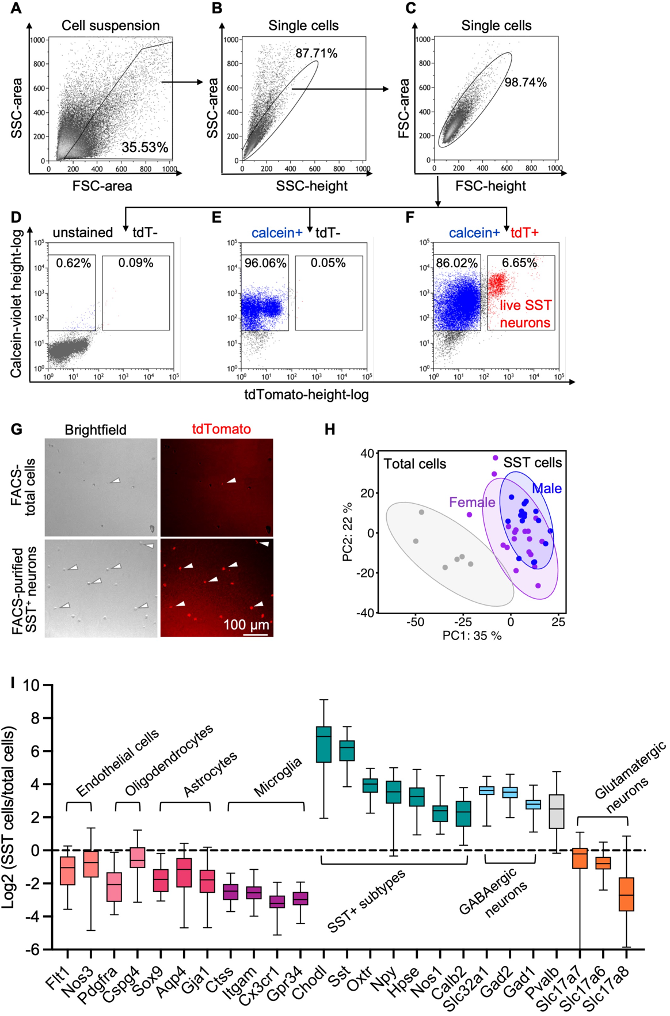
Figure S1. Enrichment of SST neurons purified by FACS from dissociated brain tissue of SSTCre:tdT transgenic mice. A–C) FACS strategy for purification of singlets from dissociated mPFC with a representative FSC-area x SSC-area plot in (A), followed by the sequential singlet gate purification by SSC-area x SSC-height (B) and FSC-area x FSC-height plots (C). D–F) Sorting of live SST neurons using calcein and tdT epifluorescence markers. Blue indicates live cells, and red indicates live SST neurons. Note the clear separation from separate samples of unstained/tdT⁻ cells (D), tdT⁻/calcein⁺ cells (E), and calcein⁺/tdT⁺ cells (F). G) Brightfield (left) and epifluorescent (right) micrographs of total tissue cells (top) and FACS-sorted SST neurons (bottom row) illustrating enrichment of tdT⁺ SST cells. H) PCA analysis of RNA-Seq data indicates overt separation of FACS-purified SST neurons from total mixed cell samples, with co-clustering of SST⁺ neurons from male and female mice. Circles indicate 95% CI. I) Box-and whisker plots of RNA-Seq data of known cell-type-specific markers show that purified SST neurons are depleted of non-neural cell types and glutamatergic neurons and enriched for markers of GABAergic interneurons including, especially markers expressed in SST neurons. Pvalb is modestly enriched, consistent with low expression in SST neurons (n = 31 mice).

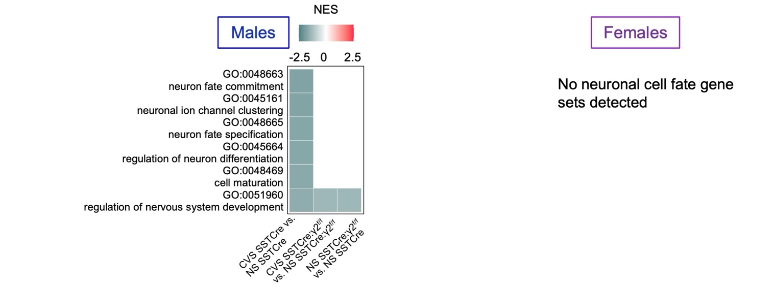
Figure S2A. GO terms related to neuronal cell fate. Comparison of heat maps for NES values of GO terms related to neuronal cell fate between CVS effects on stress-vulnerable mice, CVS effects on stress resilient mice, and genotype effects on NS mice. Note the selective downregulation by CVS of GO terms in stress-vulnerable male mice. None of these GO terms were enriched in the same contrasts of female mice. p_{adj} < 0.05, adjusted using the Benjamini-Hochberg (BH) procedure (n = 4).
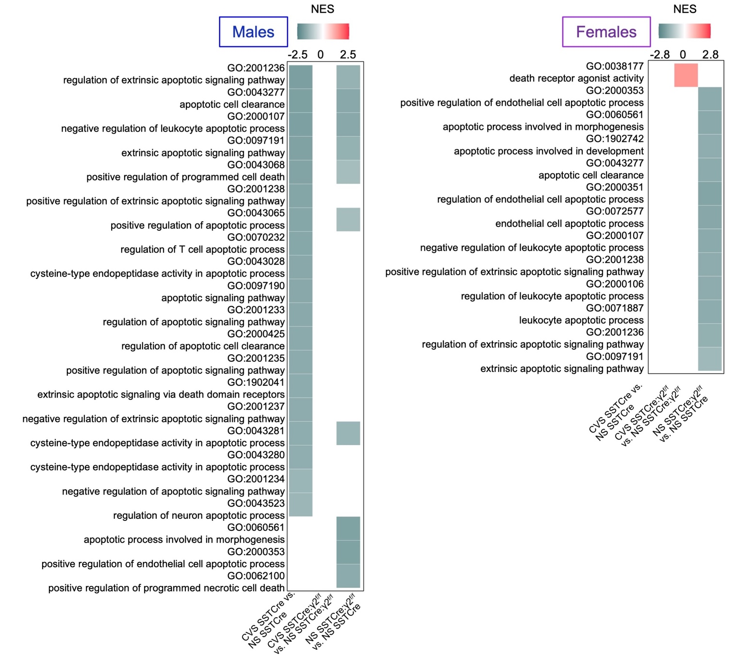

Figure S2B. GO terms related to apoptosis and programmed cell death. Comparison of heat maps for NES values related to apoptosis and programmed cell death across the three contrasts indicated. Note the downregulation by CVS of GO terms in stress-vulnerable but not stress-resilient male mice. These same effects are absent in female mice. Some of the same gene sets are also downregulated in NS stress-resilient vs. stress-vulnerable mice, in both sexes.

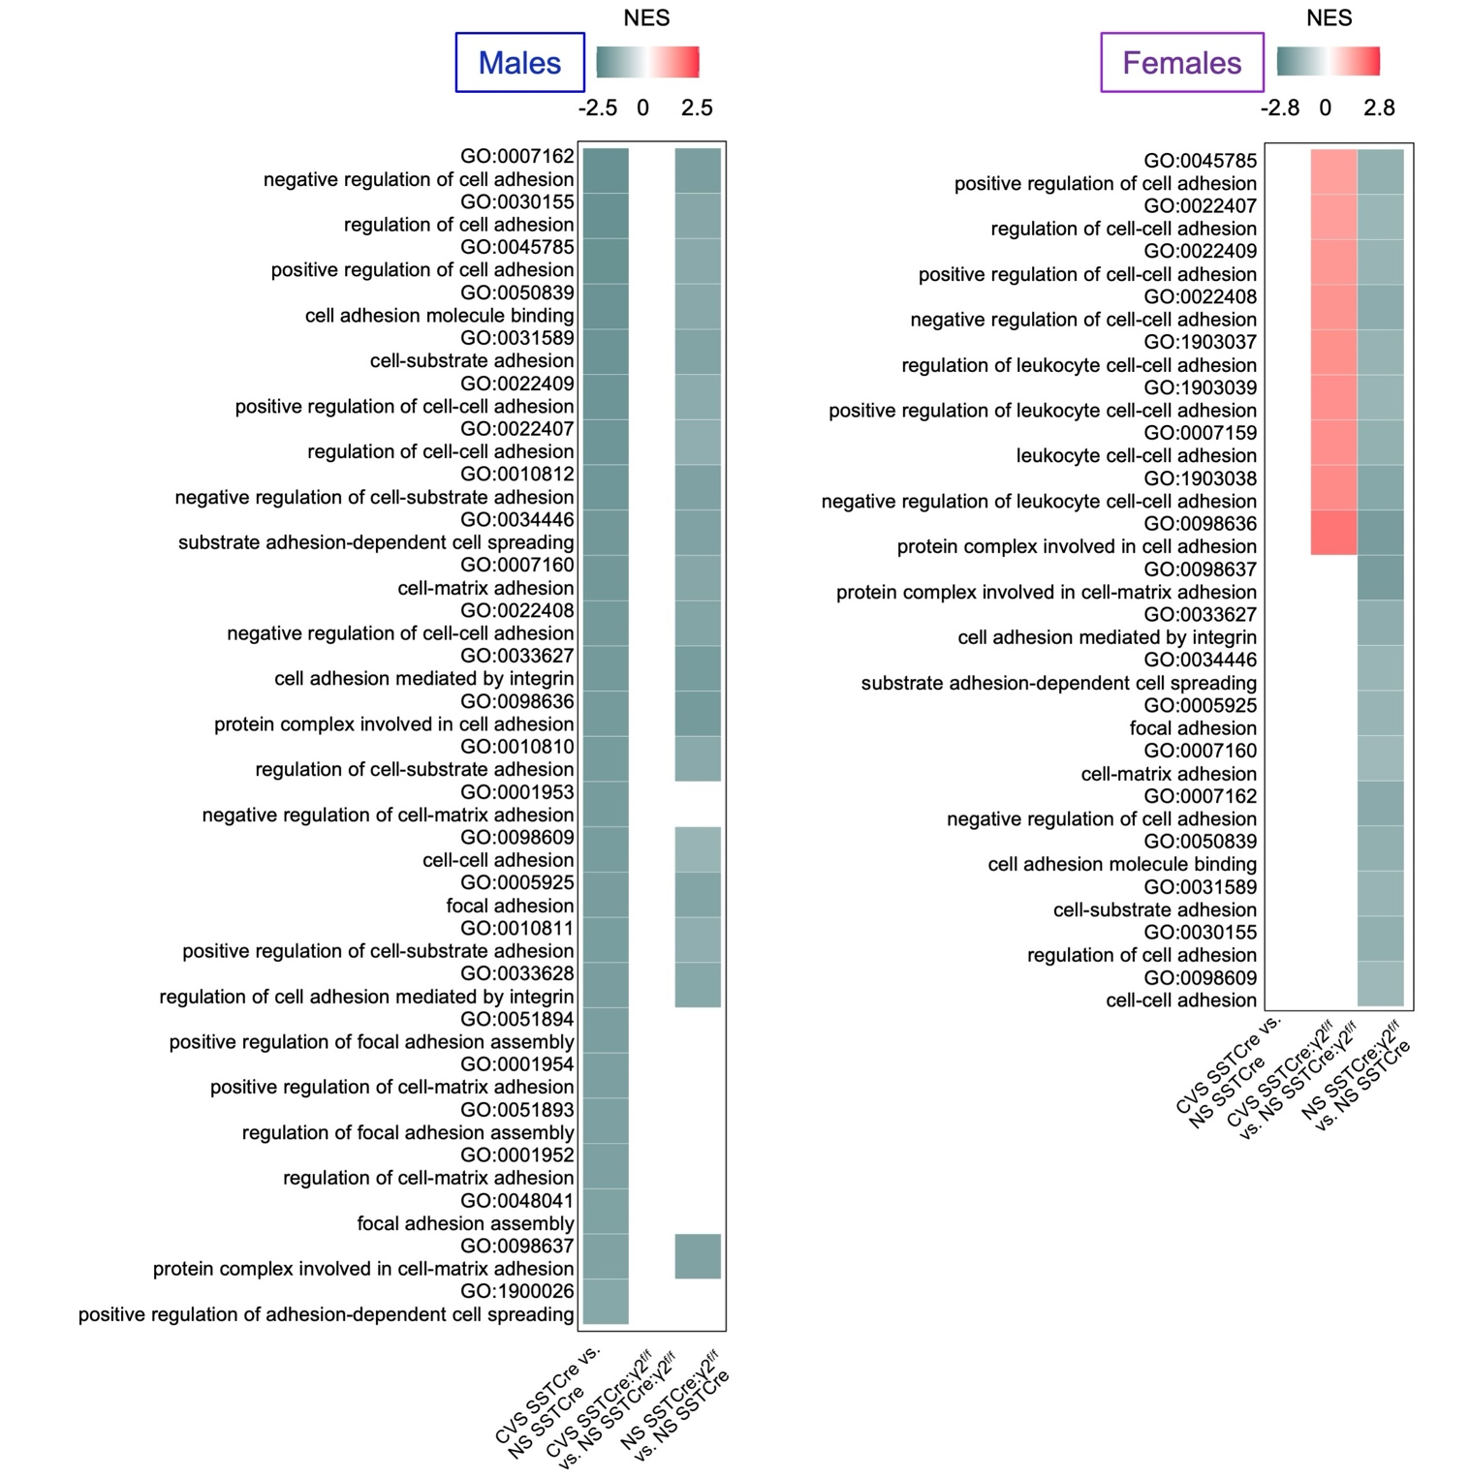
Figure S2C. GO terms related to adhesion. Comparison of heat maps for NES values related to adhesion across the three contrasts indicated. Note the downregulation by CVS of GO terms in stress-vulnerable but not stress-resilient male mice. These same effects are absent in female mice. Some of the same gene sets are also downregulated in NS stress-resilient vs. stress-vulnerable mice, in both sexes. In addition, some of the adhesion-related GO terms were uniquely upregulated by CVS in stress-resilient female mice.

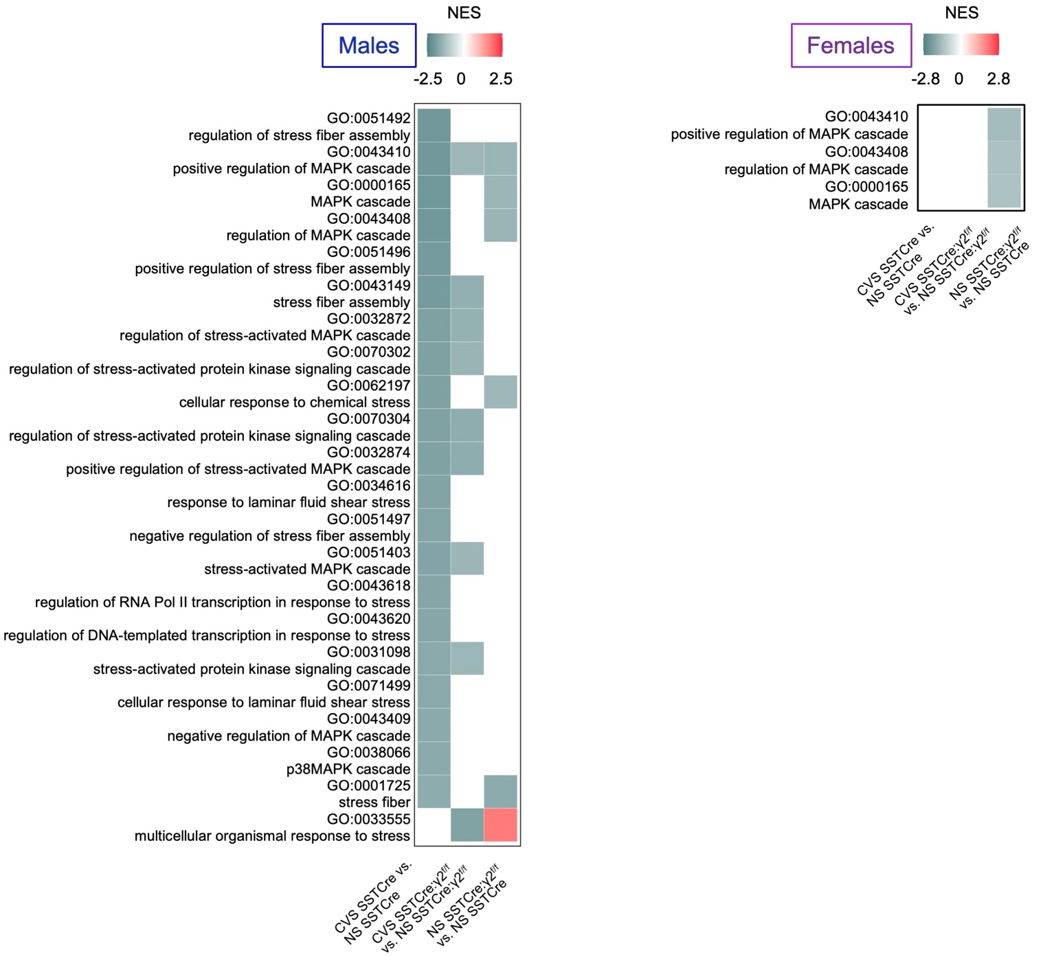

Figure S2D. GO terms related to the MAPK pathway. Comparison of heat maps for NES values related to mitogen-activated protein kinase (MAPK) pathways across the three contrasts indicated. Note the CVS-induced downregulation of GO terms in stress-vulnerable and, to a lesser extent, in stress-resilient male mice. These same effects are absent in female mice. A few of the same gene sets are also downregulated in NS stress-resilient vs. stress-vulnerable mice, in both sexes.

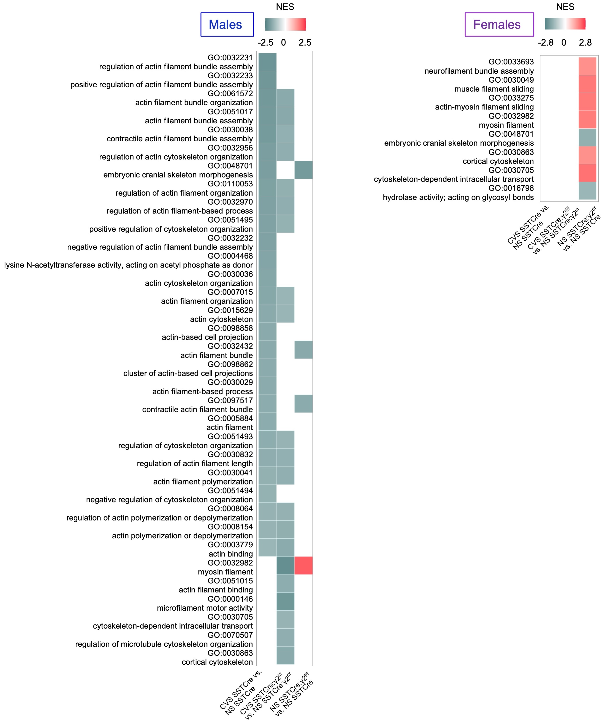Figure S2E. GO terms related to the cytoskeleton. Comparison of heat maps for NES values related to the actin cytoskeleton across the three contrasts indicated. Note the CVS-induced downregulation of GO terms in stress-vulnerable and, to a somewhat lesser extent, in stress-resilient male mice. These same effects are absent in female mice. Some of the same terms were uniquely upregulated in NS stress-vulnerable vs. stress-resilient female mice.

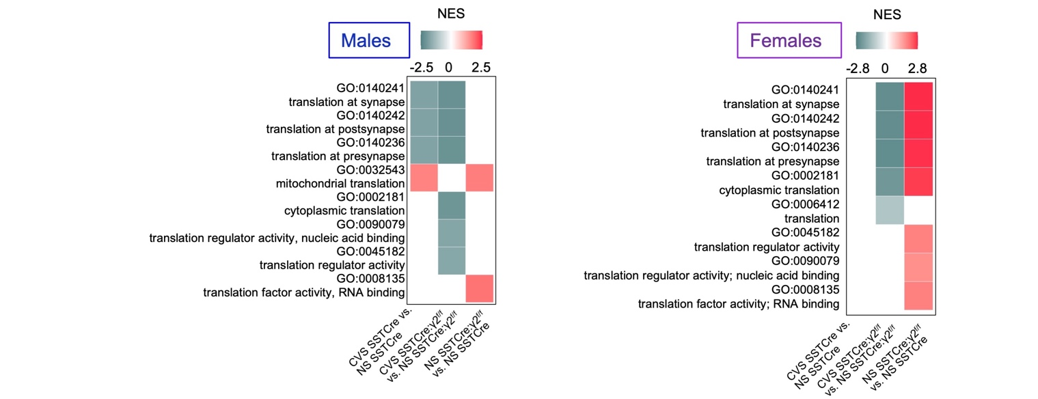
Figure S2F. GO terms related to translation. Comparison of heat maps for NES values related to mRNA translation across the three contrasts indicated. Note the CVS-induced downregulation of corresponding GO terms in both stress-vulnerable and stress-resilient male mice. CVS did not affect these terms in stress-vulnerable female mice. However, translation-related terms were uniquely and prominently upregulated in NS stress-vulnerable vs. stress-resilient female mice.

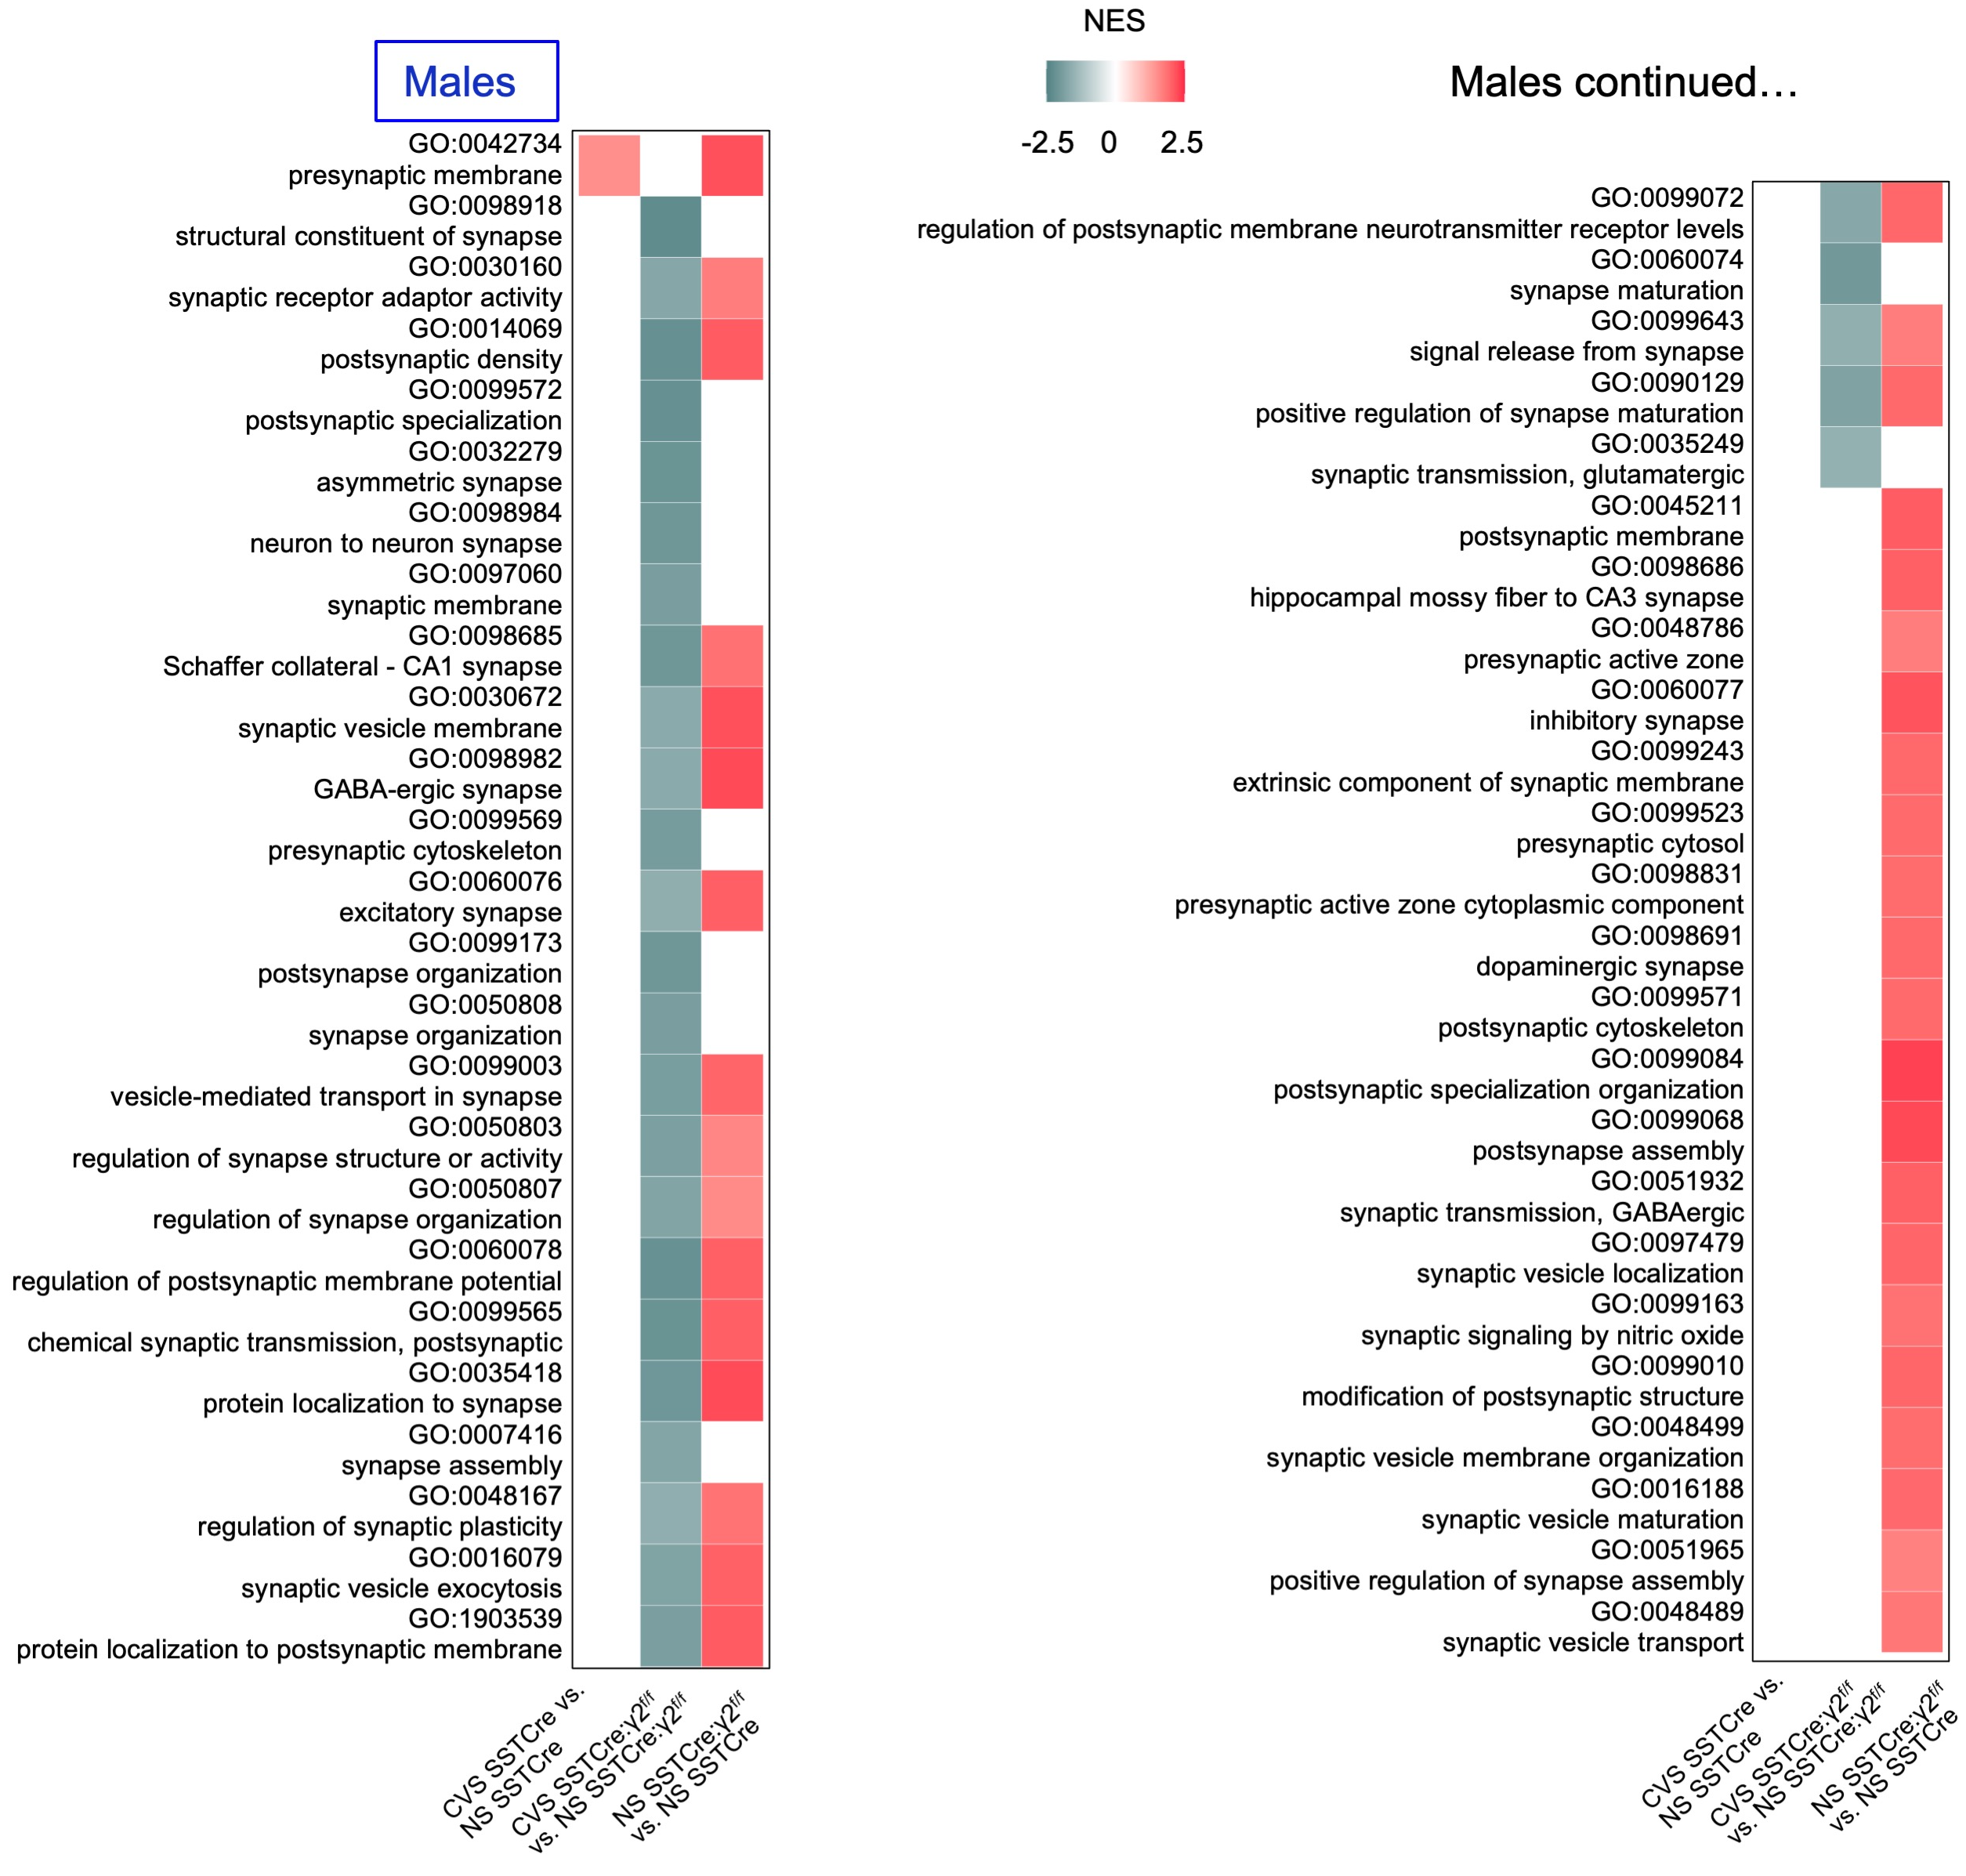

Figure S2G part 1. GO terms related to synapses in males. Comparison of heat maps for NES related to synapse function across the three contrasts indicated. CVS did not affect synapse-related NES in vulnerable mice but downregulated these scores in the resilient strain. CVS resulted in negative NES scores in the stress-resilient mice, suggesting partial normalization of genotype-induced NES values in NS resilient mice. Comparable changes in synapse-related NES were observed in both sexes, indicating they were not specific to stress resilience brain substrate of male mice. All evidence suggests that the increased expression of synapse-related transcripts in SSTCre:γ2^{f/f} mice is a compensatory response to the genetic ablation of GABA_{A} receptors in SST neurons of these mice that is not reflected in increased synapse function (see Discussion). Data from females mice are depicted in Figure S3G part 2.

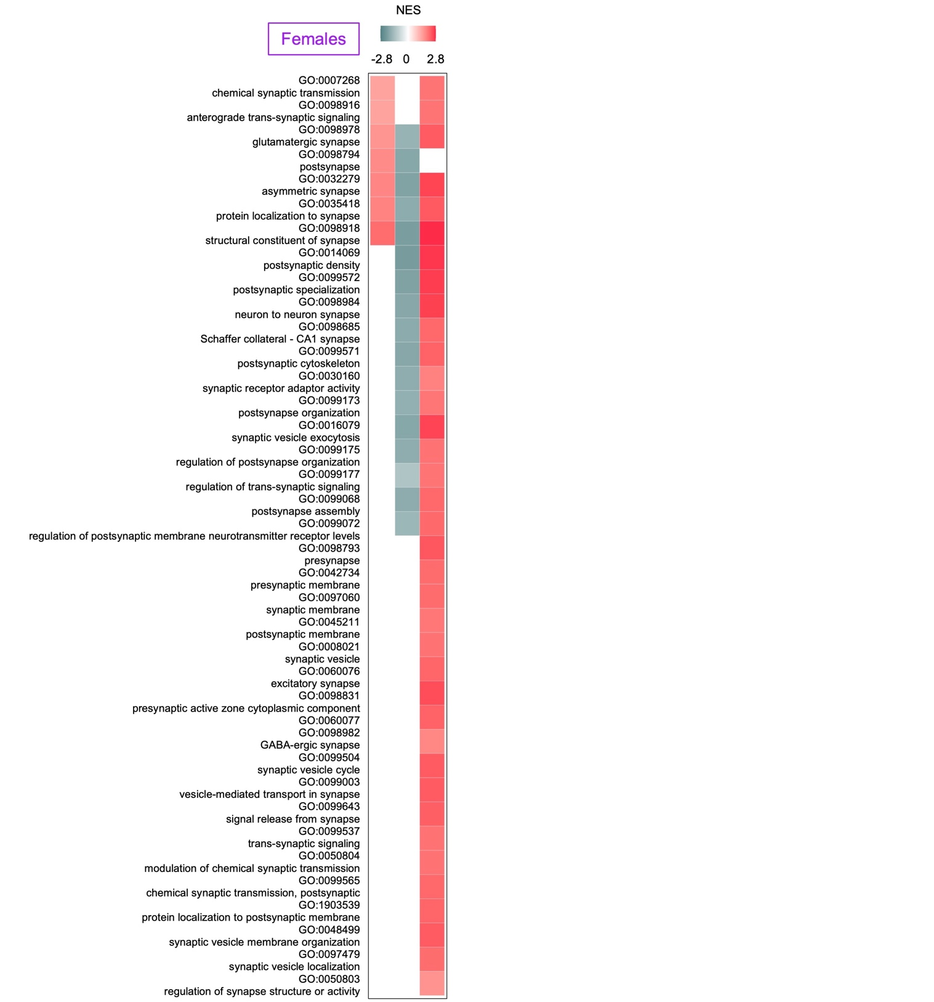
Figure S2G part 2. GO terms related to synapses in females
For a description, see the legend for Figure S3G part 1.

 |  | Male  CVS vs. NS SSTCre |  | Male  CVS vs. NS SSTCre:γ2^{f/f} |  | Female  CVS vs. NS SSTCre |  | Female  CVS vs. NS SSTCre:γ2^{f/f}
ID | Description | NES | p_{adj} | NES | p_{adj} | NES | p_{adj} | NES | p_{adj}
GO:0034605 | Cellular response to heat *) | -1.75 | 0.015 | -1.13 | 0.74 | -0.98 | 1 | 1.12 | 0.98
GO:0009408 | Response to heat *) | -1.76 | 0.009 | -1.22 | 0.43 | -1.05 | 1 | 1.16 | 0.91
GO:0030433 | Ubiquitin-dependent ERAD pathway | -0.92 | 0.94 | -1.07 | 0.88 | -1.00 | 1 | 0.52 | 1
GO:0036503 | ERAD pathway | -0.85 | 1 | -0.95 | 1 | -0.96 | 1 | 0.50 | 1
GO:0061077 | Chaperone-mediated protein folding | -1.30 | 0.33 | 0.51 | 1 | -0.71 | 1 | -0.60 | 1
GO:0051085 | Chaperone cofactor-dependent protein refolding | -1.15 | 0.60 | 0.65 | 1 | 0.65 | 1 | 0.66 | 1
GO:0006458 | 'De novo' protein folding | -1.02 | 0.80 | 0.61 | 1 | 0.58 | 1 | 0.57 | 1
GO:0051084 | 'De novo' post-translational protein folding | -1.03 | 0.79 | 0.61 | 1 | 0.61 | 1 | 0.59 | 1
GO:0031072 | Heat shock protein binding | -1.04 | 0.75 | -1.06 | 0.86 | 0.57 | 1 | 0.68 | 1
GO:0036498 | IRE1-mediated UPR | 0.50 | 1 | -0.86 | 1 | 0.78 | 1 | -0.65 | 1
GO:0036500 | ATF6-mediated UPR | 0.59 | 1 | -0.96 | 1 | 0.87 | 1 | -1.01 | 1
GO:0030968 | ER UPR | -1.02 | 0.78 | -1.02 | 0.78 | -0.89 | 1 | 0.41 | 1
GO:1903894 | Regulation of IRE1-mediated UPR | -0.97 | 0.83 | -0.97 | 0.83 | -1.31 | 1 | 1.09 | 1
GO:1900102 | Negative regulation of ER UPR | -0.73 | 1 | -0.73 | 1 | 0.55 | 1 | -0.61 | 1
GO:1903891 | Regulation of ATF6-mediated UPR | 0.59 | 1 | 0.59 | 1 | 0.87 | 1 | -1.01 | 1
GO:1900101 | Regulation of ER UPR | -0.54 | 1 | -0.54 | 1 | 0.78 | 1 | -0.48 | 1
GO:1900103 | Positive regulation of endoplasmic UPR | 0.47 | 1 | 0.47 | 1 | 1.12 | 1 | 0.62 | 1
GO:1903898 | Negative regulation of PERK-mediated UPR | -1.23 | 0.57 | 0.96 | 1 | 1.19 | 1 | -1.01 | 1

Figure S2H. GO terms related to ER stress and the UPR. None of the ER Stress- and UPR-related GSEA values were significantly affected by stress in SSTCre mice, except those related to cellular response to heat. Terms are from Tomoda et al (2022), Mol Psychiatry. 27:2304-2314. *) significantly affected GO terms.
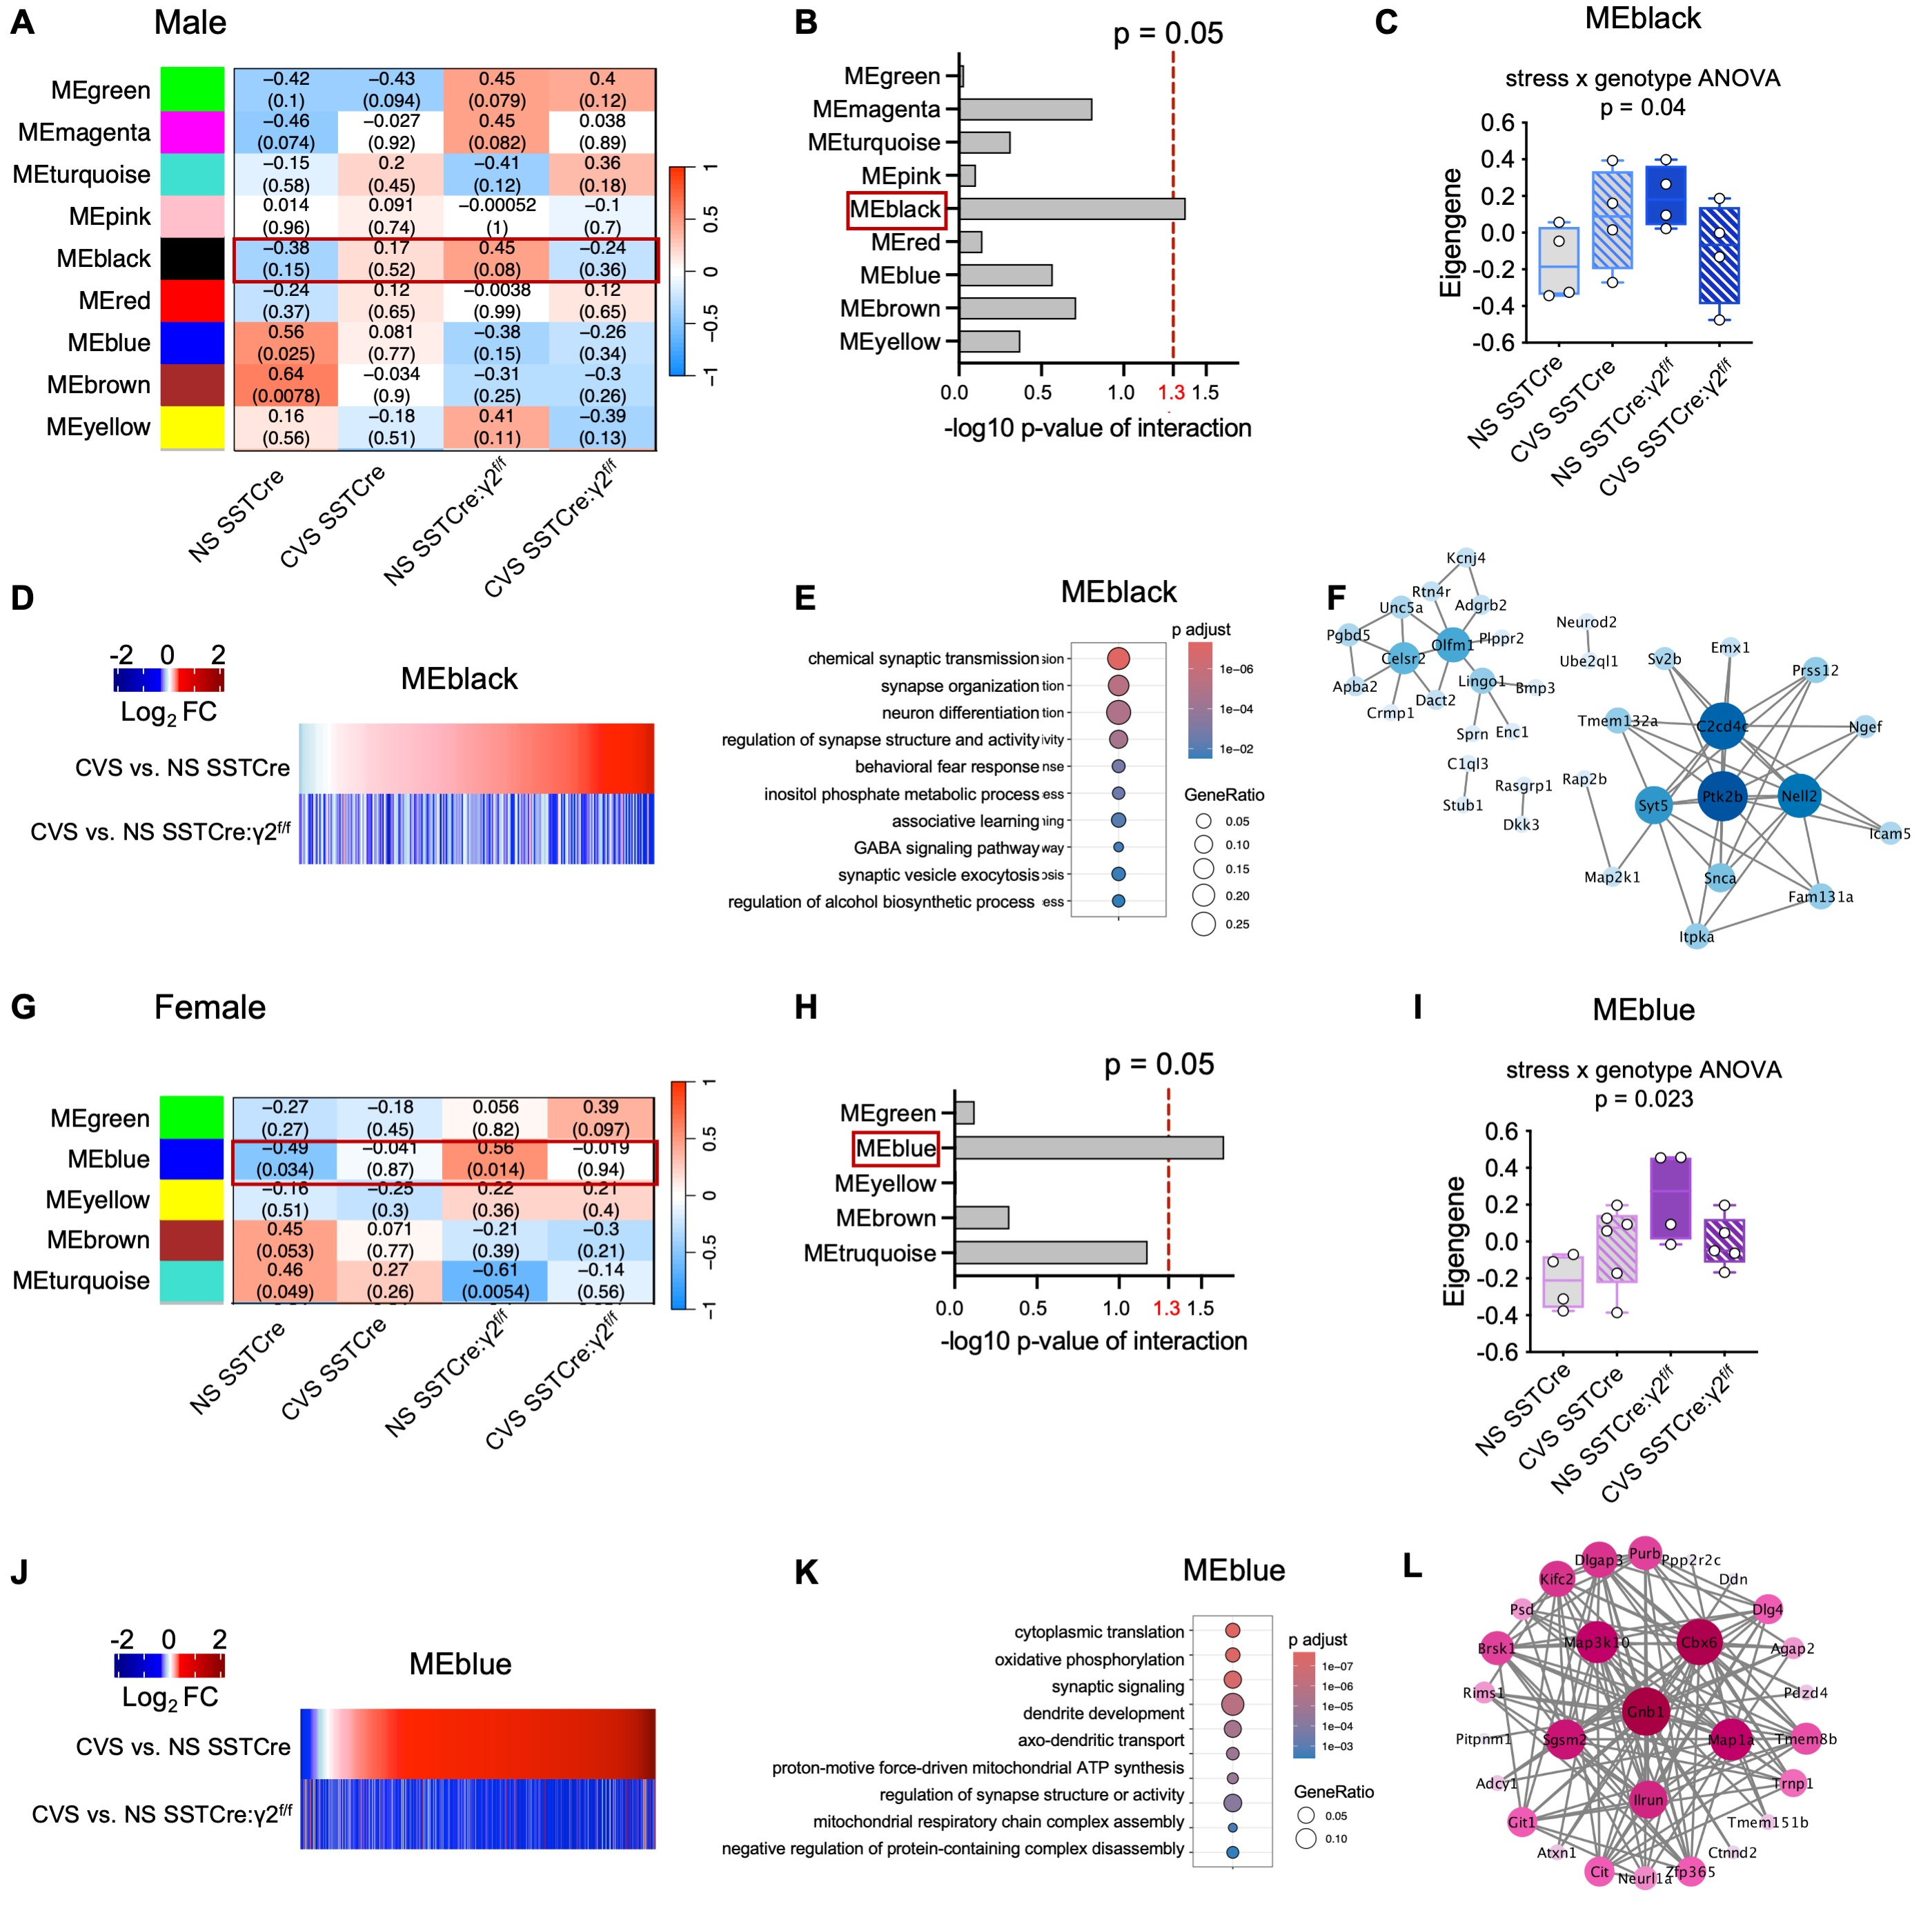

Figure S3. Weighted Gene Correlation Network Analysis. A) Heat maps of modules identified by signed WGCNA of SST neuron-derived RNAseq data from male mice. The top numbers for each module indicate the correlation coefficient of eigengene values for traits (NS SSTCre, CVS SSTCre, NS SSTCre:γ2^{f/f}, CVS, SSTCre:γ2^{f/f}); the bottom numbers indicate the corresponding p-values. B) ‑Log10 (p-values of stress*genotype interaction effects) for all identified modules. C) Summary data of eigengene values for MEblack showing a stress*genotype interaction. D) Heat maps depicting the relationship between mouse strains of CVS-induced gene expression fold changes for MEblack. E) Top ten GO terms associated with MEblack. F) Network relationship of genes in MEblack. G–L) Data analogous to (A–F) but from female mice. As in males, WGCNA of female mice identified a single module (MEblue) with a significant stress*genotype interaction (G–I). Heatmaps for MEblue (J) show CVS-induced fold changes in SSTCre vs. SSTCre:γ2^{f/f} mice very similar to MEblack. The top ten GO terms associated with MEblue (K) map to synaptic signaling and related GO terms as the most robustly altered biological functions. Network relationship of genes in MEblue (L).

