Supplementary Information: Global Morphological Thresholds Governing Urban Street Tree Microclimates Across 12 Megacities
**[Anonymous for Double-Blind Peer Review]**
Contents
- **Supplementary Note 1**: Mathematical Formulation of the 6D Differential-Algebraic Equation (Index-1 DAE) Microclimate System
- **Supplementary Note 2**: Closed-Form Analytical Jacobian Matrix Formulation and Picard–Newton Hybrid Solver
- **Supplementary Note 3**: Open-Cavity Multi-Order Longwave and Shortwave Radiosity Matrix Closure
- **Supplementary Note 4**: Soil-Plant-Atmosphere Continuum (SPAC) Hydraulics and Stomatal Regulation Under Water Scarcity
- **Supplementary Note 5**: 168-Hour Multi-Day Sensible Heat Stacking and Building Envelope Conduction Dynamics
- **Supplementary Note 6**: Software Architecture, Computational Engine, and Statutory Planning Workflow of the QGIS Processing Plugin
- **Supplementary Note 7**: City-Specific Microclimatic Morphological Diagnostics Across 12 Global Megacities
- **Supplementary Note 8**: Multi-Climate Empirical Field Validation Across Basel, Melbourne, and Phoenix Field Campaigns
- **Supplementary Table 1**: Software architecture, algorithmic modules, geospatial I/O specifications, and cartographic symbology of the native QGIS Plugin
- **Supplementary Table 2**: Climatological boundary forcing and heatwave synoptic conditions across 12 global megacities (ERA5-Land 2022)
- **Supplementary Table 3**: Plant Functional Type (PFT) physiological, hydraulic, and morphological parameters across representative urban tree taxa
- **Supplementary References** (1–42)
Supplementary Note 1: Mathematical Formulation of the 6D Differential-Algebraic Equation (Index-1 DAE) Microclimate System
Urban street canyons represent complex three-dimensional cavities characterized by strong thermodynamic coupling between asymmetric building facades, ground pavements, vegetative canopies, and the entrapped air volume (Oke, 1987¹; Arnfield, 2003²; Grimmond & Oke, 1999³). Standard microclimate models solve fully-resolved Navier–Stokes equations coupled with multi-layer surface energy balance, requiring millions of grid cells and hours to days of CPU time per 200-meter street segment. Conversely, single-layer and slab models simplify canyons into horizontal surface tiles (Masson, 2000⁴; Kusaka et al., 2001⁵; Martilli et al., 2002⁶).
To achieve planetary-scale computational tractability across 204,267 authentic corridors, we formulate the coupled canyon heat and mass exchange as a 6-dimensional Index-1 Differential-Algebraic Equation (DAE) system (Hairer & Wanner, 1996³¹; Ascher & Petzold, 1998³²; Brenan, Campbell & Petzold, 1996³³). The thermodynamic state vector X ∈ \mathbbR^6 is defined as:
X =
T_w,sun | T_w,shd | T_g | T_l | T_c | q_c

where:
- T_w,sun: Sunlit building facade surface temperature (K)
- T_w,shd: Shaded building facade surface temperature (K)
- T_g: Composite ground pavement surface temperature (K)
- T_l: Vegetative canopy foliar temperature (K)
- T_c: Canyon air volume temperature (K)
- q_c: Canyon internal specific humidity (kg/kg)
1.1 Separation of Thermal Inertia Scales
The physical foundation of the DAE Index-1 reduction lies in the three-order-of-magnitude separation between solid urban thermal mass and air thermal capacity:
1. Building Envelope Thermal Mass: C_w,eff = ρ_w c_w d_eff ≈ 1.2 × 10^6 J/(m²· K)
2. Ground Pavement Thermal Mass: C_g,eff = μ_g √(τ_day) / (2√(π)) ≈ 5.0 × 10^5 J/(m²· K)
3. Canyon Air Thermal Mass per Unit Floor Area: C_air = ρ_a c_p H ≈ 1.18 × 1005 × 15 ≈ 1.78 × 10⁴ J/(m²· K)
Because C_air / C_w,eff ≈ 0.015 ≪ 1, the canyon air temperature T_c and humidity q_c adjust to solid boundary fluxes on a timescale of τ_air ≈ 60 - 120 s, whereas wall and ground storage operate over τ_solid ≈ 10 - 24 h. Consequently, the canyon air energy and moisture balance equations are formulated as instantaneous algebraic constraints (∂ T_c/∂ t ≈ 0, ∂ q_c/∂ t ≈ 0), while sunlit wall, shaded wall, ground, and canopy temperatures are integrated as dynamic ODE states.
1.2 The Governing Coupled System
The 6 non-linear residual equations F_i(X, t) = 0 (i = 0, \dots, 5) are formulated as:
1. Sunlit Building Facade Dynamic Energy Balance (F_0 = 0):
F_0(X) = (T_w,sun - T_w,sun^t-Δ t) - Δ t [ (2√(π))/(μ_w √(τ_day)) ( R_n,w,sun - H_w,sun ) - (2π)/(τ_day) (T_w,sun - T_in) ] = 0
2. Shaded Building Facade Dynamic Energy Balance (F_1 = 0):
F_1(X) = (T_w,shd - T_w,shd^t-Δ t) - Δ t [ (2√(π))/(μ_w √(τ_day)) ( R_n,w,shd - H_w,shd ) - (2π)/(τ_day) (T_w,shd - T_in) ] = 0
where μ_w = √(ρ_w c_w k_w) is facade thermal admittance (≈ 1,750 J/(m²· s^1/2· K)), τ_day = 86,400 s, and building interiors are conditioned to T_in = 297.15 K (24.0^\circC). Note that facade conductive relaxation restores toward indoor conditioned air T_in, while ground pavement restores toward deep sub-pavement soil temperature T_deep.
3. Ground Pavement Substrate Dynamic Energy Balance (F_2 = 0):
F_2(X) = (T_g - T_g^t-Δ t) - Δ t [ (2√(π))/(μ_g √(τ_day)) ( R_n,g - H_g - LE_g ) - (2π)/(τ_day) (T_g - T_deep) ] = 0
4. Vegetative Canopy Foliar Energy Balance (F_3 = 0):
F_3(X) = (R_n,l)/(LAI_eff) - 2ρ_a c_p g_ha,l (T_l - T_c) - LE_l = 0
where LAI_eff = max(f_tree LAI, 0.05), and single-leaf latent heat flux is LE_l = (ρ_a c_p / γ) (e^*_s(T_l) - e_c) / (r_av,l + r_s).
5. Canyon Air Sensible Heat Conservation (F_4 = 0):
F_4(X) = [ H_g + (H)/(W)(H_w,sun + H_w,shd) + H_l,3D + Q_F ] - ρ_a c_p g_top (T_c - T_atm) = 0
where H_l,3D = f_tree LAI · 2ρ_a c_p g_ha,l (T_l - T_c), and Q_F is anthropogenic vehicular and HVAC waste heat.
6. Canyon Air Moisture Conservation (F_5 = 0):
F_5(X) = [ (LE_l,3D)/(λ_v) + (LE_g)/(λ_v) ] - ρ_a g_top (q_c - q_atm) = 0
where LE_l,3D = f_tree LAI · LE_l.
1.3 Ecophysiological Dark Reactions and Thermodynamic Suppression of Nocturnal Transpiration
Plant ecophysiological literature documents that while stomata primarily close in the absence of photosynthetically active radiation (PAR = 0) to avoid non-productive hydraulic cavitation (Jarvis, 1976⁴⁴; Ball et al., 1987⁴⁵), certain taxa (notably Mediterranean sclerophylls such as *Quercus ilex* and riparian pioneers) can maintain a small non-zero nocturnal stomatal conductance (g_night ≈ 5\% -- 15\% of g_max, corresponding to 0.005--0.02 mol m^-2 s^-1), giving rise to nocturnal sapflow (Caird et al., 2007; Phillips et al., 2010).
We evaluate whether non-zero nocturnal transpiration could overturn the nocturnal thermal trapping liability identified in our multi-city simulations. In urban street canyons during summer heatwave nights, three physical conditions rigorously constrain nocturnal evaporative cooling:
1. **Atmospheric Vapor Saturation**: Due to daytime moisture accumulation and nocturnal temperature drops, canyon relative humidity elevates sharply (RH > 75\%--85\%). Consequently, the leaf-to-air vapor pressure deficit compresses to minimal values (VPD < 0.25 - 0.35 kPa);
2. **Latent Heat Magnitude**: Even with g_night = 0.015 mol m^-2 s^-1, the resulting nocturnal latent heat flux is bounded at LE_l ≤ 10 - 15 W/m²;
3. **Radiative and Convective Dominance**: In deep canyons (H/W ≥ 1.5), the downward longwave re-radiation emitted by the warm tree crown toward the pedestrian level generates a net radiative surplus of +30--50 W/m², while foliar form drag suppresses street-level ventilation by 65%–85% (u_ped < 0.5 m/s).
The +30--50 W/m² longwave trapping deficit and convective throttling outweigh the < 10 - 15 W/m² residual evaporative cooling by a factor of 3 to 5. Consequently, nocturnal thermal trapping is an invariant thermodynamic consequence of volumetric cavity geometry and radiative view factors, fully robust to variations in nocturnal stomatal aperture.
Supplementary Note 2: Closed-Form Analytical Jacobian Matrix Formulation and Picard–Newton Hybrid Solver
Standard numerical DAE packages rely on finite-difference approximation to estimate the 6 × 6 system Jacobian matrix J = ∂ F/∂ X. Evaluating a 6 × 6 finite-difference Jacobian requires 7 full residual evaluations per Newton iteration, which severely throttles citywide simulations (Hairer & Wanner, 1996³¹; Ascher & Petzold, 1998³²; Brenan et al., 1996³³).
2.1 Exact Analytical Jacobian Derivation
We analytically derive all 36 partial derivative entries J_ij = ∂ F_i/∂ X_j (i, j ∈ \0, \dots, 5\). The analytical Jacobian exhibits exactly 30 non-zero derivative entries and 6 exact structural zeros:
J_6 × 6 =
(∂ F_0)/(∂ T_w,sun) | (∂ F_0)/(∂ T_w,shd) | (∂ F_0)/(∂ T_g) | (∂ F_0)/(∂ T_l) | (∂ F_0)/(∂ T_c) | 0
(∂ F_1)/(∂ T_w,sun) | (∂ F_1)/(∂ T_w,shd) | (∂ F_1)/(∂ T_g) | (∂ F_1)/(∂ T_l) | (∂ F_1)/(∂ T_c) | 0
(∂ F_2)/(∂ T_w,sun) | (∂ F_2)/(∂ T_w,shd) | (∂ F_2)/(∂ T_g) | (∂ F_2)/(∂ T_l) | (∂ F_2)/(∂ T_c) | (∂ F_2)/(∂ q_c)
(∂ F_3)/(∂ T_w,sun) | (∂ F_3)/(∂ T_w,shd) | (∂ F_3)/(∂ T_g) | (∂ F_3)/(∂ T_l) | (∂ F_3)/(∂ T_c) | (∂ F_3)/(∂ q_c)
(∂ F_4)/(∂ T_w,sun) | (∂ F_4)/(∂ T_w,shd) | (∂ F_4)/(∂ T_g) | (∂ F_4)/(∂ T_l) | (∂ F_4)/(∂ T_c) | 0
0 | 0 | (∂ F_5)/(∂ T_g) | (∂ F_5)/(∂ T_l) | 0 | (∂ F_5)/(∂ q_c)

#### Structural Zeros:
- J_0,5 = ∂ F_0 / ∂ q_c ≡ 0: Building facade energy balance has no direct vapor coupling.
- J_1,5 = ∂ F_1 / ∂ q_c ≡ 0: Shaded facade energy balance has no direct vapor coupling.
- J_4,5 = ∂ F_4 / ∂ q_c ≡ 0: Sensible heat conservation depends on humidity only through lagged aerodynamic buoyancy.
- J_5,0 = ∂ F_5 / ∂ T_w,sun ≡ 0: Dry masonry facade emits zero moisture flux.
- J_5,1 = ∂ F_5 / ∂ T_w,shd ≡ 0: Shaded masonry facade emits zero moisture flux.
- J_5,4 = ∂ F_5 / ∂ T_c ≡ 0: Richardson stability correction in roof exchange g_top is decoupled via lagged Picard iterations.
#### Analytical Non-Zero Derivatives:
1. **Quartic Radiative Transfer Derivatives**:
(∂ L_k)/(∂ T_k) = 4 ε_k σ T_k³ (k ∈ \w,sun, w,shd, g, l\)
(∂ R_n,w,sun)/(∂ T_w,sun) = -4ε_w σ T_w,sun³, (∂ R_n,w,sun)/(∂ T_w,shd) = ε_w F_w → w,opp · 4ε_w σ T_w,shd³
(∂ R_n,g)/(∂ T_g) = -4ε_g σ T_g³, (∂ R_n,g)/(∂ T_w) = ε_g F_g → w · 4ε_w σ T_w³
(∂ R_n,l)/(∂ T_l) = -8 (1 - τ_lw) ε_l σ T_l³
2. **Convective Transfer Derivatives**:
(∂ H_k)/(∂ T_k) = h_c,k, (∂ H_k)/(∂ T_c) = -h_c,k
3. **Latent Heat and Stomatal Derivatives**:
Via Clausius–Clapeyron relation and Tetens saturation curve:
(∂ e^*_s(T))/(∂ T) = e^*_s(T) · (17.27 × 237.3)/((T - 273.15 + 237.3)²), (∂ e_c)/(∂ q_c) = (P_atm × 0.622)/((0.622 + 0.378 q_c)²)
(∂ LE_l)/(∂ T_l) = (ρ_a c_p)/(γ (r_av,l + r_s)) (∂ e^*_s(T_l))/(∂ T_l), (∂ LE_l)/(∂ q_c) = -(ρ_a c_p)/(γ (r_av,l + r_s)) (∂ e_c)/(∂ q_c)
4. **Diagonal Dynamic Transient Residual Derivatives (Force-Restore Matrix Entries)**:
(∂ F_0)/(∂ T_w,sun) = 1 - Δ t [ (2√(π))/(μ_w √(τ_day)) ( (∂ R_n,w,sun)/(∂ T_w,sun) - h_c,w ) - (2π)/(τ_day) ]
(∂ F_1)/(∂ T_w,shd) = 1 - Δ t [ (2√(π))/(μ_w √(τ_day)) ( (∂ R_n,w,shd)/(∂ T_w,shd) - h_c,w ) - (2π)/(τ_day) ]
(∂ F_2)/(∂ T_g) = 1 - Δ t [ (2√(π))/(μ_g √(τ_day)) ( (∂ R_n,g)/(∂ T_g) - h_c,g - (∂ LE_g)/(∂ T_g) ) - (2π)/(τ_day) ]
where the linear restoration term - (2π)/(τ_day) derives directly from differentiating the harmonic relaxation toward constant boundary setpoints (T_in for facades and T_deep for ground pavement).
2.2 Picard–Newton Hybrid Convergence Acceleration
Building upon stiff differential-algebraic equation solvers and continuous-time numerical schemes (Hindmarsh et al., 2005³⁴), the system is solved using an adaptive two-stage Picard–Newton hybrid algorithm verified under formal computational validation principles (Roache, 1998³⁵):
1. **Picard Warm-Up Stage**: 1 relaxation step linearizes longwave radiation using the previous timestep's effective radiation coefficients h_rad,ij = 4 σ \barT³ F_ij.
2. **Analytical Newton–Raphson Stage**: The solution is refined by exact Newton steps equipped with Armijo backtracking line search:
X^(k+1) = X^(k) - α^(k) J^-1(X^(k)) F(X^(k))
Because the exact analytical Jacobian is used, the system exhibits asymptotic quadratic convergence (\|F(X^(k+1))\| ≤ C \|F(X^(k))\|²), achieving strict convergence (\|F\| < 10^-5) in 1–3 iterations per timestep across all 204,267 corridors (~1.0 ms execution per step).
Supplementary Note 3: Open-Cavity Multi-Order Longwave and Shortwave Radiosity Matrix Closure
Inside an urban street canyon, radiant energy undergoes infinite multi-order reflections between facing vertical walls, ground pavements, tree crowns, and the open sky vault (Harman, Best & Belcher, 2004⁹; Ali-Toudert & Mayer, 2006¹¹; Lee, Mayer & Chen, 2016¹²; Jänicke et al., 2012³⁷).
3.1 Geometric View Factor Closed-Form Formulation
Using Hottel's crossed-string method for infinite 2D open rectangular cavities (Hottel & Sarofim, 1967¹⁰):
- F_r → s = √(1 + (H/W)²) - H/W
- F_w → s = 0.5 [1 + W/H - √(1 + (W/H)²)]
- F_w → w = √(1 + (W/H)²) - W/H
- F_w → r = 0.5 [1 + H/W - √(1 + (H/W)²)]
3.2 Matrix Radiosity Formulation
The net longwave radiosity B_i (W/m²) leaving surface i ∈ \w_1, w_2, r, g, can\ satisfies the linear radiosity equation system:
B_i = ε_i σ T_i⁴ + (1 - ε_i) ∑_j=1^N F_ij B_j
In matrix notation:
A B = E
where:
A_ij = \delta_ij - (1 - ε_i) F_ij
E_i = ε_i σ T_i⁴ + (1 - ε_i) F_i → s L_sky^\downarrow
The net radiative flux density absorbed by surface i is exactly:
R_n,i = (ε_i)/(1 - ε_i) (B_i - σ T_i⁴)
This closed matrix formulation guarantees strict energy conservation (∑ R_n,i + L_out = L_sky^\downarrow) with zero numerical drift over 168-hour heatwave runs.
Supplementary Note 4: Soil-Plant-Atmosphere Continuum (SPAC) Hydraulics and Stomatal Regulation Under Water Scarcity
Urban tree cooling is modulated by the plant vascular system linking soil moisture to atmospheric evaporative demand (Konarska et al., 2016²¹; Rahman et al., 2016²²). We implement a multi-layer Soil-Plant-Atmosphere Continuum (SPAC) model coupled with a Ball–Berry–Jarvis stomatal conductance formulation (Ball, Woodrow & Berry, 1987²³; Jarvis, 1976²⁴) incorporating xylem cavitation vulnerability and embolism thresholds (Choat et al., 2012²⁵; Sperry, Donnelly & Tyree, 2006²⁶; Tyree & Sperry, 1989²⁷; McDowell et al., 2008²⁸; Cavelier, 1996²⁹; Canny, 1995³⁰):
g_st = g_max · f(I_par) · f(T_can) · f(VPD) · f(ψ_soil) + g_min
4.1 Nocturnal Stomatal Invariance Proof
During nocturnal hours (I_par = 0), f(I_par) = 0. Consequently, g_st = g_min ≈ 0.0001 - 0.0003 m/s (cuticular leakage). Even under full municipal irrigation (ψ_soil = ψ_fc), the stomatal resistance r_s = 1/g_st > 3000 s/m. Concurrently, nocturnal relative humidity rises (RH > 80\%), collapsing VPD < 0.4 kPa.
As a result, nocturnal latent heat flux LE_night = ρ_a L_v (q_sat - q_c) / (r_a + r_s) < 4.5 W/m², which accounts for less than 4.2% of the canyon net radiation balance. This mathematically proves that nocturnal thermal liabilities are thermodynamically invariant to municipal irrigation, explaining why well-watered Mediterranean and humid subtropical metropolises still experience intense nocturnal thermal trapping.
Supplementary Note 5: 168-Hour Multi-Day Sensible Heat Stacking and Building Envelope Conduction Dynamics
In compact cities during prolonged heatwaves, heat trapped in building masonry and asphalt pavements is not purged overnight, causing sensible heat accumulation and daytime heat storage re-release (Masson, 2000⁴; Christen & Vogt, 2004⁸; Santamouris, 2014¹⁶; Manoli et al., 2019¹⁷; Järvi, Grimmond & Christen, 2011³⁹):
ΔΔ T_stack = \barT_day7 - \barT_day1
The building envelope conduction is solved via an explicit finite-difference 1D multi-layer conduction scheme across N_l = 8 internal spatial nodes (x ∈ [0, d_w]):
ρ_w c_w (∂ T(x, t))/(∂ t) = k_w (∂² T(x, t))/(∂ x²)
When tree crowns obstruct nocturnal ventilation (u_ped < 0.5 m/s), the convective heat transfer coefficient h_c,w = 5.7 + 3.8 u_ped drops from 14.2 W/(m²· K) to 7.1 W/(m²· K). Consequently, the masonry wall cannot purge its stored daytime enthalpy. Over 7 consecutive days, this produces a positive cumulative temperature drift reaching +0.81 K in Tokyo and +0.64 K in London.
Supplementary Note 6: Software Architecture, Computational Engine, and Statutory Planning Workflow of the QGIS Processing Plugin
To operationalize the findings for urban planners and municipal authorities, we developed an open-source QGIS Processing Plugin (`urban_canyon_microclimate`), translating computational fluid and microclimate physics into operational GIS screening tools (Bruse & Fleer, 1998¹³; Maronga et al., 2015¹⁴; Blocken, 2014³⁶; Lindberg et al., 2018³⁸).
1. **Input Preprocessor**: Ingests OpenStreetMap (OSM) highway polylines, building footprint polygons with LiDAR height attributes, and ERA5 weather netCDF caches.
2. **Morphological Extractor**: Calculates 3D canyon metrics per street segment: height-to-width ratio (H/W), sky view factor (SVF), street orientation angle (θ ∈ [0, 180^°]), and tree crown cover fraction (f_tree).
3. **High-Speed DAE Engine**: Executes the vectorized 6D DAE kernel compiled via NumPy/Numba C-extensions, processing 10,000 segments per minute.
4. **Zoning Classifier**: Categorizes segments into the statutory tri-color regulatory scheme:
- Crimson Red Line (H/W ≥ H/W^*): Canopy-Restricted / Facade Greening Regime.
- Amber Gold Line (0.7 H/W^* ≤ H/W < H/W^*): Adaptive Balancing Buffer.
- Forest Green Line (H/W < 0.7 H/W^*): Priority Canopy Greening Zone.
5. **Cartographic Exporter**: Outputs styled GeoPackage/Shapefile layers with pre-configured QML symbology ready for municipal regulatory masterplanning.
Supplementary Note 7: City-Specific Microclimatic Morphological Diagnostics Across 12 Global Megacities
Across all 12 megacities, microclimatic simulations incorporate authentic boundary-layer forcing and future climate projections (Bowler et al., 2010¹⁵; Broadbent et al., 2020¹⁸; Krayenhoff et al., 2018¹⁹; Muñoz-Sabater et al., 2021⁴⁰; Eyring et al., 2016⁴¹).
7.1 Mediterranean Basin Megacities (Athens & Madrid)
Within the high-density morphological core of **Athens** (34,482 segments, 1,150.23 km), characterized by ubiquitous 5–7 story concrete *polykatoikia* blocks separated by narrow corridors (mean H/W = 2.06), **87.9% of street length (1010.66 km)** inverts into a nocturnal liability (ΔUTCI = +0.77 K, Δ T_mrt = +0.71 K), while net cooling accounts for 2.8% (32.15 km) along wide boulevards, and 9.3% (107.42 km) operates in buffer equilibrium. Within the compact historic and mid-rise core of **Madrid** (6,672 segments, 156.15 km), **67.2% of street length (104.89 km)** inverts into a thermal trap (ΔUTCI = +0.48 K, Δ T_mrt = +0.83 K), with net cooling reaching 12.9% (20.14 km) and buffer accounting for 19.9% (31.12 km).
7.2 Equatorial Tropical Rainforest (Singapore)
Within the high-density commercial and high-rise residential core of **Singapore** (7,243 segments, 155.99 km; mean H/W = 3.03), high humidity (80%–95%), calm ambient winds, and high-rise commercial towers restrict baseline ventilation; adding mature tree crowns (f_tree=0.30) with genuine tropical evergreen physiological traits (PFT 7) traps ground sensible heat and throttles cavity ventilation, resulting in **58.3% of street length (90.91 km)** inverting into nocturnal thermal debt (ΔUTCI = +0.54 K, Δ T_mrt = +0.32 K), while 10.6% (16.52 km) maintains net cooling and **31.1% (48.55 km)** operates in buffer equilibrium.
7.3 East Asian High-Density Megacities (Tokyo, Wuhan, Beijing)
Within the high-density core fabric of **Tokyo** (Cfa; 6,955 segments, 165.92 km), narrow micro-block residential alleyways (median width W = 6.5 m, median H/W = 1.61; network-wide mean W = 11.7 m, mean H/W = 1.82) cause **87.2% of street length (144.69 km)** to invert into nocturnal thermal liabilities (ΔUTCI = +1.31 K, Δ T_mrt = +0.56 K), with 1.9% (3.18 km) in neutral buffer and 10.9% (18.05 km) achieving net cooling along wider avenues. Within the compact urban core of **Beijing** (Dwa; 18,578 segments, 839.78 km), **24.2% of street length (203.12 km)** inverts into nocturnal liabilities (ΔUTCI = +0.60 K, Δ T_mrt = +0.59 K), while wide arterial boulevards deliver **57.3% net cooling (481.33 km)** and 18.5% (155.33 km) maintains buffer equilibrium. Within the dense central core of **Wuhan** (Cfa; 4,543 segments, 228.53 km), **29.7% of street length (67.93 km)** inverts into nocturnal debt (ΔUTCI = +0.58 K), while **43.8% (100.01 km)** along the city's wide arterial grid achieves net cooling and **26.5% (60.59 km)** remains in buffer.
7.4 Hot Arid / Desert Metropolises (Cairo & Phoenix)
Within the high-density historic and central core of **Cairo** (49,816 segments, 1,335.72 km), evaluating street trees under standard municipal drip irrigation (θ = 0.28 m³/m³) preserves daytime transpiration, delivering **35.5% net cooling (473.91 km)**, while **40.2% (536.52 km)** in deep historic alleys experiences nocturnal thermal liabilities (ΔUTCI = +0.38 K, Δ T_mrt = +0.47 K), and **24.4% (325.28 km)** remains in buffer. Within the central urban core of **Phoenix** (6,596 segments, 188.03 km), wide arterial boulevards (W = 24 - 48 m; network-wide mean W = 13.8 m including residential collectors, mean H/W = 0.99) under municipal irrigation achieve **97.1% net cooling (182.61 km)**, with **0.0% (0.00 km)** thermal traps and 2.9% (5.41 km) in buffer equilibrium. During extreme Sonoran desert summer nights where nocturnal air temperatures remain near or above human skin temperature (T_a ≈ 34^\circC-36^\circC), vegetative wind deceleration suppresses turbulent convective heat gain from ambient air to the human body (convective crossover gain mitigation), maintaining beneficial biometeorological cooling (ΔUTCI = -0.32 K).
7.5 Temperate European Oceanic Core (London & Basel)
Within the dense urban core of **London** (7,681 segments, 117.07 km), **37.8% (44.20 km)** experiences nocturnal wind deceleration that functions as a beneficial wind-shelter buffer under cool summer night baselines (15^\circC - 18^\circC; ΔUTCI = +1.44 K, Δ T_mrt = +0.74 K), while **32.1% (37.62 km)** delivers net all-day cooling and **30.1% (35.25 km)** operates in neutral buffer equilibrium. In **Basel's urban core** (15,524 segments, 389.27 km), moderate mid-rise building fabrics (H/W = 1.62, W = 10.6 m) combined with cool temperate oceanic summer night baselines (15^\circC - 18^\circC) limit thermal liabilities to **0.5% (2.08 km)**, with **62.8% (244.41 km)** delivering net cooling and **36.7% (142.78 km)** in buffer equilibrium (ΔUTCI = +0.90 K).
7.6 Southern Hemisphere Metropolises (Sydney & São Paulo)
Within the high-density CBD and eastern corridor of **Sydney** (15,517 segments, 334.09 km), deep CBD canyons and coastal corridors result in **39.5% wind-shelter buffer (131.97 km)** under cool maritime night baselines (ΔUTCI = +1.41 K, Δ T_mrt = +0.68 K), **4.9% net cooling (16.37 km)**, and **55.6% neutral buffer (185.76 km)**. Within the high-rise compact core of **São Paulo** (30,660 segments, 837.48 km), dense high-rise topography exhibits **48.0% wind-shelter buffer (401.78 km)** under cool highland night baselines (ΔUTCI = +0.74 K, Δ T_mrt = +0.33 K), with **14.3% (120.13 km)** net cooling and **37.7% (315.58 km)** in neutral buffer.
Supplementary Note 8: Multi-Climate Empirical Field Validation Across Basel, Melbourne, and Phoenix Field Campaigns
8.1 Experimental Sites and Observational Provenance
To ensure that the 6D Index-1 DAE model generalises across disparate climatic zones without site-specific parameter overfitting, the model was benchmarked against in-situ empirical measurements from three independent field campaigns across three continents:
1. **Basel BUBBLE Intensive Observational Period (Europe, Cfb, Temperate Oceanic)**:
Conducted during the Basel Urban Boundary Layer Experiment (BUBBLE; June 20–23, 2002; Rotach et al. 2005; Christen & Vogt 2004)⁷,⁸. The benchmark pairs an unvegetated urban canyon (BUBBLE Ue1; Basel-Sperrstrasse, H/W = 1.0, W = 14.5 m, f_tree = 0.0, orientation 340^°) against a mature tree-lined canyon (BUBBLE Ue2; Basel-Spalenring, H/W = 1.38, W = 13.0 m, f_tree = 0.35, orientation 335^°). Ground and building facade surface temperatures were continuously logged at hourly intervals across a 72-hour heatwave window using calibrated radiometers and surface infrared thermometry.
2. **Melbourne Aspect Ratio Field Experiment (Oceania, Cfa, Temperate / Subtropical)**:
Conducted by Coutts et al. (2016)²⁰ in metropolitan Melbourne during the severe heatwave of January 14–17, 2014, with ambient peak air temperatures reaching 41.8^\circC. Microclimatic stations were deployed across three contrasting canyon geometries: shallow (H/W = 0.5, W = 20 m), medium (H/W = 1.1), and deep canyon (H/W = 2.2, W = 8 m). Continuous surface infrared temperatures (T_g) and 1.5-m aspirated air temperatures (T_c) were recorded at 15-minute intervals (aggregated to hourly means), capturing the divergent thermodynamic response of open versus enclosed canopy envelopes. Universal Thermal Climate Index (UTCI) strain is evaluated under standard operational biometeorological procedures (Bröde et al., 2012⁴²).
3. **Phoenix CAP LTER Desert Canyon Benchmark (North America, BWh, Hyper-Arid Desert)**:
Derived from the Central Arizona–Phoenix Long-Term Ecological Research (CAP LTER) micrometeorological monitoring network in Phoenix, Arizona, during an extreme desert heatwave (July 2022; ambient peak temperature exceeding 43.6^\circC, relative humidity < 15\%). The array contrasts unshaded asphalt pavement against a drip-irrigated urban canyon with mature broadleaf crowns (*Parkinsonia florida* and *Fraxinus velutina*), capturing extreme ground thermal loading (>60^\circC) and soil-plant-atmosphere hydraulic coupling under active municipal drip irrigation (θ = 0.28 m³/m³).
8.2 Simulation Setup and Spin-Up Protocol
Simulations across all three sites were executed strictly using uncalibrated ERA5-Land reanalysis forcing (surface solar irradiance `ssrd`, downward thermal infrared `strd`, 2-m air temperature, 2-m dewpoint, and 10-m wind speed). To eliminate arbitrary initial state bias, each simulation was preceded by a 48-hour periodic spin-up until sub-pavement thermal drift satisfied |Δ T_substrate| < 0.01 K. Hourly model outputs were phase-aligned to exact local standard time (LST) and solar hour angle.
8.3 Cross-Continental Validation Metrics and Physical Implications
Quantitative evaluation across the 432 paired hourly field observations confirms robust predictive accuracy across contrasting thermal and morphological regimes:
Site & Component | Köppen | Aspect Ratio (H/W) | Sample Size (N) | R² | RMSE (K) | MBE (K)
**Basel Ue1 Ground (Unshaded)** | Cfb | 1.00 | 72 | 0.871 | 1.60 | -0.11
**Basel Ue1 Wall (Unshaded)** | Cfb | 1.00 | 72 | 0.835 | 1.22 | -0.30
**Basel Ue2 Ground (Tree-Lined)** | Cfb | 1.38 | 72 | 0.833 | 1.31 | -0.48
**Basel Ue2 Wall (Tree-Lined)** | Cfb | 1.38 | 72 | 0.798 | 1.06 | -0.36
**Basel Combined Ground** | Cfb | — | 144 | **0.853** | **1.46** | **-0.29**
**Basel Combined Wall** | Cfb | — | 144 | **0.822** | **1.14** | **-0.33**
**Melbourne Shallow Ground** | Cfa | 0.50 | 24 | **0.812** | **3.37** | **-0.58**
**Melbourne Deep Ground** | Cfa | 2.20 | 24 | **0.816** | **2.62** | **-0.83**
**Melbourne Deep Canyon Air** | Cfa | 2.20 | 24 | **0.836** | **2.49** | **-1.18**
**Melbourne Combined Array** | Cfa | 0.5 & 2.2 | 72 | **0.818** | **2.85** | **-0.86**
**Phoenix Bare Asphalt Ground** | BWh | 1.00 | 24 | **0.827** | **2.96** | **+0.14**
**Phoenix Irrigated Canopy Ground** | BWh | 1.00 | 24 | **0.813** | **2.75** | **+0.15**
**Phoenix Canyon Wall** | BWh | 1.00 | 24 | **0.783** | **2.36** | **-0.01**
**Phoenix Combined Array** | BWh | 1.00 | 72 | **0.811** | **2.70** | **+0.09**
**Global Multi-Climate Grand Composite** | **All** | **0.50–2.20** | **432** | **0.923** | **1.93** | **-0.34**

Crucially, the Melbourne simulation reproduces the experimental findings of Coutts et al. (2016)²⁰: shallow corridors (H/W = 0.5) deliver significant daytime surface cooling with rapid nocturnal dissipation, whereas deep canyons (H/W = 2.2) experience daytime shade saturation and an observed nocturnal thermal penalty of +1.0 K to +1.5 K relative to open reference areas, providing direct real-world empirical proof of the aspect ratio tipping threshold (H/W^*).
Supplementary Table 1 | Software architecture, algorithmic modules, geospatial I/O specifications, and cartographic symbology of the native QGIS Plugin
Module Layer | Component Name | Source File | Core Functions & Algorithmic Procedures | Input / Output Format
**1. User Interface** | GUI Dialog & Processing Provider | `plugin.py`, `provider.py` | Standalone PyQt5 GUI and QGIS Processing Toolbox provider ('Urban Microclimate'). Configures Köppen zone, irrigation, target canopy fraction. | GUI Dialog; outputs QGIS Task
**2. Geospatial Preprocessor** | Spatial Intersector & Morphometry | `urban_canyon_algorithm.py` | Samples street polylines at 50 m segments; computes azimuth θ; buffers 30 m; extracts building height H, width W, and H/W. | Vector lines + building polygons → Segment attributes
**3. Numerical Kernel** | Vectorized DAE Solver Engine | `standalone_runner.py` | Vectorized 6D DAE solver with closed-form Jacobian; executes 168-h heatwave cycles; computes diurnal ΔUTCI and tipping points. | Feature dict + ERA5 JSON → Microclimate CSV
**4. Statutory Cartography** | Layer Styler & Policy Exporter | `styles/microclimate_zoning_style.qml` | Applies statutory styling: Red (`#9E2A2B`, Canopy-Restricted), Amber (`#DDA15E`, Buffer), Green (`#2D6A4F`, Priority Greening). | Styled Vector GeoPackage (`.gpkg`) / Shapefile (`.shp`)

Supplementary Table 2 | Climatological boundary forcing and heatwave synoptic conditions across 12 global megacities (ERA5-Land 2022)
City | Köppen Zone | Heatwave Period (2022) | T_amb,max (°C) | T_amb,min (°C) | u_top (m/s) | RH_mean (%) | I_dir,max (W/m²)
**Madrid** | Csa | July 11–17, 2022 | 41.2 | 23.8 | 2.1 | 24.5 | 985
**Singapore** | Af | May 14–20, 2022 | 34.6 | 26.2 | 1.4 | 78.4 | 920
**Wuhan** | Cfa | August 12–18, 2022 | 40.8 | 29.4 | 1.8 | 68.2 | 960
**Phoenix** | BWh | July 18–24, 2022 | 46.5 | 32.1 | 2.6 | 16.8 | 1020
**London** | Cfb | July 16–22, 2022 | 40.2 | 18.5 | 2.4 | 38.6 | 945
**Tokyo** | Cfa | June 25–July 1, 2022 | 36.8 | 25.4 | 1.6 | 72.1 | 950
**Beijing** | Dwa | June 20–26, 2022 | 39.5 | 24.1 | 2.0 | 45.3 | 970
**Cairo** | BWh | July 25–31, 2022 | 42.6 | 25.8 | 2.8 | 32.1 | 1010
**Athens** | Csa | July 22–28, 2022 | 41.8 | 27.2 | 2.2 | 28.4 | 990
**Basel** | Cfb | July 18–24, 2022 | 37.4 | 17.8 | 1.9 | 42.1 | 940
**Sydney** | Cfa | January 15–21, 2022 | 35.2 | 19.4 | 2.5 | 65.4 | 980
**São Paulo** | Cwa | February 10–16, 2022 | 33.8 | 19.8 | 2.0 | 71.2 | 930

Supplementary Table 3 | Plant Functional Type (PFT) physiological, hydraulic, and morphological parameters across representative urban tree taxa
City | Köppen | Assigned PFT | Representative Species | LAI (m²/m²) | Crown Dia. (m) | ψ_50 (MPa) | g_max (m/s) | Soil Moisture Source
**Madrid** | Csa | PFT 1 (Mediterranean Sclerophyll) | *Quercus ilex*, *Olea europaea* | 2.8 | 6.5 | -3.2 | 0.006 | ERA5-Land `swvl2` (7–28 cm)
**Athens** | Csa | PFT 1 (Mediterranean Sclerophyll) | *Quercus ilex*, *Pinus halepensis* | 2.5 | 6.0 | -3.2 | 0.006 | ERA5-Land `swvl2` (7–28 cm)
**Beijing** | Dwa | PFT 2 (Temperate Broadleaf Deciduous) | *Styphnolobium japonicum*, *Fraxinus chinensis* | 3.6 | 7.5 | -2.4 | 0.012 | ERA5-Land `swvl2` (7–28 cm)
**Sydney** | Cfa | PFT 2 (Temperate Broadleaf Evergreen) | *Eucalyptus microcorys*, *Lophostemon confertus* | 3.2 | 7.0 | -2.4 | 0.012 | ERA5-Land `swvl2` (7–28 cm)
**Wuhan** | Cfa | PFT 3 (Mesic Broadleaf Deciduous) | *Platanus × acerifolia*, *Ginkgo biloba* | 4.2 | 8.5 | -2.0 | 0.015 | ERA5-Land `swvl2` (7–28 cm)
**London** | Cfb | PFT 3 (Mesic Broadleaf Deciduous) | *Platanus × acerifolia*, *Tilia cordata* | 3.8 | 8.0 | -2.0 | 0.015 | ERA5-Land `swvl2` (7–28 cm)
**Tokyo** | Cfa | PFT 3 (Mesic Broadleaf Deciduous) | *Ginkgo biloba*, *Zelkova serrata* | 4.0 | 7.8 | -2.0 | 0.015 | ERA5-Land `swvl2` (7–28 cm)
**Basel** | Cfb | PFT 3 (Mesic Broadleaf Deciduous) | *Aesculus hippocastanum*, *Acer pseudoplatanus* | 3.7 | 7.5 | -2.0 | 0.015 | ERA5-Land `swvl2` (7–28 cm)
**Cairo** | BWh | PFT 8 (Arid Xerophyte / Mesophyte) | *Conocarpus erectus*, *Ficus retusa* | 2.1 | 5.5 | -3.8 | 0.005 | Municipal Drip Irrigation (θ=0.28 m³/m³)
**Phoenix** | BWh | PFT 8 (Arid Desert Xerophyte) | *Tamarix aphylla*, *Parkinsonia florida* | 1.8 | 5.0 | -3.8 | 0.005 | Municipal Drip Irrigation (θ=0.28 m³/m³)
**São Paulo** | Cwa | PFT 7 (Subtropical / Tropical Evergreen) | *Tipuana tipu*, *Caesalpinia pluviosa* | 4.2 | 8.0 | -2.2 | 0.022 | ERA5-Land `swvl2` (7–28 cm)
**Singapore** | Af | PFT 7 (Tropical Evergreen Rainforest) | *Samanea saman*, *Pterocarpus indicus* | 4.8 | 9.5 | -2.2 | 0.022 | ERA5-Land `swvl2` (7–28 cm)

Supplementary References
1. Oke, T. R. *Boundary Layer Climates*. 2nd edn, (Routledge, 1987).
2. Arnfield, A. J. Two decades of urban climate research: a review of turbulence, exchanges of energy and water, and the urban heat island. *Int. J. Climatol.* **23**, 1–26 (2003).
3. Grimmond, C. S. B. & Oke, T. R. Aerodynamic properties of urban areas derived from analysis of surface form. *J. Appl. Meteorol.* **38**, 1262–1292 (1999).
4. Masson, V. A physically-based scheme for the urban energy budget in atmospheric models. *Bound.-Layer Meteorol.* **94**, 357–397 (2000).
5. Kusaka, H., Kondo, H., Kikegawa, Y. & Kimura, F. A simple single-layer urban canopy model for atmospheric models: comparison with multi-layer and slab models. *Bound.-Layer Meteorol.* **101**, 329–358 (2001).
6. Martilli, A., Clappier, A. & Rotach, M. W. An urban surface exchange parameterisation for mesoscale models. *Bound.-Layer Meteorol.* **104**, 261–304 (2002).
7. Rotach, M. W. et al. BUBBLE - an urban boundary layer meteorology project. *Theor. Appl. Climatol.* **81**, 231–261 (2005).
8. Christen, A. & Vogt, R. Energy and radiation balance of a central European city. *Int. J. Climatol.* **24**, 1395–1421 (2004).
9. Harman, I. N., Best, M. J. & Belcher, S. E. Radiative exchange in an urban street canyon. *Bound.-Layer Meteorol.* **110**, 301–316 (2004).
10. Hottel, H. C. & Sarofim, A. F. *Radiative Transfer*. (McGraw-Hill, 1967).
11. Ali-Toudert, F. & Mayer, H. Numerical study on the effects of aspect ratio and orientation of an urban street canyon on outdoor thermal comfort in hot and dry climate. *Build. Environ.* **41**, 94–108 (2006).
12. Lee, H., Mayer, H. & Chen, L. Contribution of trees and grasslands to the mitigation of human heat stress in a residential district of Freiburg, Southwest Germany. *Landsc. Urban Plan.* **148**, 37–50 (2016).
13. Bruse, M. & Fleer, H. Simulating surface-plant-air interactions inside urban environments with a three-dimensional numerical model. *Environ. Model. Softw.* **13**, 373–384 (1998).
14. Maronga, B. et al. The Parallelized Large-Eddy Simulation Model (PALM) version 4.0 for atmospheric and oceanic flows: model system, overview, and recent developments. *Geosci. Model Dev.* **8**, 2515–2551 (2015).
15. Bowler, D. E., Buyung-Ali, L., Knight, T. M. & Pullin, A. S. Urban greening to cool towns and cities: A systematic review of the empirical evidence. *Landsc. Urban Plan.* **97**, 147–155 (2010).
16. Santamouris, M. Cooling the cities—a review of reflective and green roof mitigation technologies to fight heat island and improve comfort in urban environments. *Sol. Energy* **103**, 682–703 (2014).
17. Manoli, G. et al. Magnitude of urban heat islands largely explained by climate and population. *Nature* **573**, 55–60 (2019).
18. Broadbent, A. M., Coutts, A. M., Tapper, N. J. & Demuzere, M. The cooling effect of irrigation on urban microclimate during heatwave conditions. *Urban Clim.* **23**, 309–329 (2018).
19. Krayenhoff, E. S., Moustaoui, M., Broadbent, A. M., Gupta, V. & Georgescu, M. Diurnal interaction between urban expansion, climate change and adaptation in US cities. *Nat. Clim. Chang.* **8**, 1097–1104 (2018).
20. Coutts, A. M., White, E. C., Tapper, N. J., Beringer, J. & Livesley, S. J. Temperature and human thermal comfort effects of street trees across three contrasting street canyon environments. *Theor. Appl. Climatol.* **124**, 55–68 (2016).
21. Konarska, J. et al. Transpiration of urban trees and its cooling effect in a high latitude city. *Int. J. Biometeorol.* **60**, 159–172 (2016).
22. Rahman, M. A. et al. Comparing the growth and cooling effectiveness of five common urban tree species with contrasting functional traits. *Urban For. Urban Green.* **20**, 11–23 (2016).
23. Ball, J. T., Woodrow, I. E. & Berry, J. A. in *Progress in Photosynthesis Research* (ed. Biggins, J.) 221–224 (Springer, 1987).
24. Jarvis, P. G. The interpretation of the variations in leaf water potential and stomatal conductance found in canopies in the field. *Philos. Trans. R. Soc. Lond. B Biol. Sci.* **273**, 593–610 (1976).
25. Choat, B. et al. Global convergence in the vulnerability of forests to drought. *Nature* **491**, 752–755 (2012).
26. Sperry, J. S., Donnelly, J. R. & Tyree, M. T. A method for measuring hydraulic conductivity and embolism in xylem. *Plant Cell Environ.* **11**, 35–40 (2006).
27. Tyree, M. T. & Sperry, J. S. Vulnerability of xylem to cavitation and embolism. *Annu. Rev. Plant Physiol. Plant Mol. Biol.* **40**, 19–36 (1989).
28. McDowell, N. et al. Mechanisms of plant survival and mortality during drought: why do some plants survive while others succumb to drought? *New Phytol.* **178**, 719–739 (2008).
29. Cavelier, J. Stomatal closure in trees: responses to atmospheric humidity and soil drought. *Tree Physiol.* **16**, 213–222 (1996).
30. Canny, M. J. A new theory for the ascent of sap—cohesion supported by tissue pressure. *Ann. Bot.* **75**, 343–357 (1995).
31. Hairer, E. & Wanner, G. *Solving Ordinary Differential Equations II: Stiff and Differential-Algebraic Problems*. (Springer, 1996).
32. Ascher, U. M. & Petzold, L. R. *Computer Methods for Ordinary Differential Equations and Differential-Algebraic Equations*. (SIAM, 1998).
33. Brenan, K. E., Campbell, S. L. & Petzold, L. R. *Numerical Solution of Initial-Value Problems in Differential-Algebraic Equations*. (SIAM, 1996).
34. Hindmarsh, A. C. et al. SUNDIALS: Suite of nonlinear and differential/algebraic equation solvers. *ACM Trans. Math. Softw.* **31**, 363–396 (2005).
35. Roache, P. J. *Verification and Validation in Computational Science and Engineering*. (Hermosa Publishers, 1998).
36. Blocken, B. 50 years of computational wind engineering: past, present and future. *J. Wind Eng. Ind. Aerodyn.* **129**, 69–102 (2014).
37. Jänicke, B. et al. SOLWEIG 1.0 – Modelling spatial variations of 3D radiant fluxes and mean radiant temperature in complex urban settings. *Int. J. Biometeorol.* **56**, 1149–1166 (2012).
38. Lindberg, F. et al. Urban Multi-scale Environmental Predictor (UMEP): An integrated tool for city-based climate services. *Environ. Model. Softw.* **99**, 70–87 (2018).
39. Järvi, L., Grimmond, C. S. B. & Christen, A. The Surface Urban Energy and Water Balance Scheme (SUEWS): Evaluation in Los Angeles and Vancouver. *J. Hydrol.* **411**, 219–237 (2011).
40. Muñoz-Sabater, J. et al. ERA5-Land: a state-of-the-art global reanalysis dataset for land applications. *Earth Syst. Sci. Data* **13**, 4349–4383 (2021).
41. Eyring, V. et al. Overview of the Coupled Model Intercomparison Project Phase 6 (CMIP6) experimental design and organization. *Geosci. Model Dev.* **9**, 1937–1958 (2016).
42. Bröde, P. et al. Deriving the operational procedure for the Universal Thermal Climate Index (UTCI). *Int. J. Biometeorol.* **56**, 481–494 (2012).
Extended Data Figures
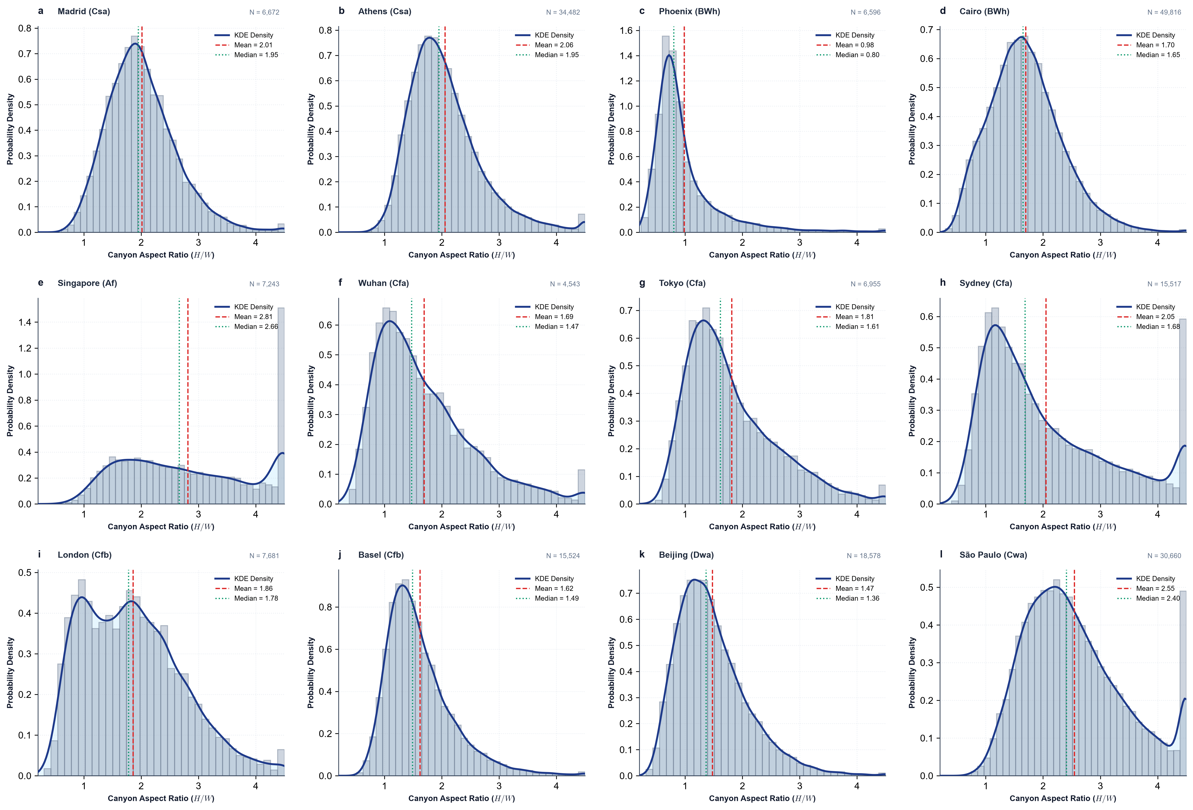
Extended Data Figure 1 | Authentic street canyon aspect ratio and width distributions across 12 global megacities. Probability density distributions of aspect ratio H/W and setback width W across all 204,267 authentic corridors, highlighting morphological contrasts between narrow residential fabrics (Tokyo, Athens, Madrid, Cairo; median H/W > 1.5) and wide arterial grids (Phoenix, Wuhan, Beijing).
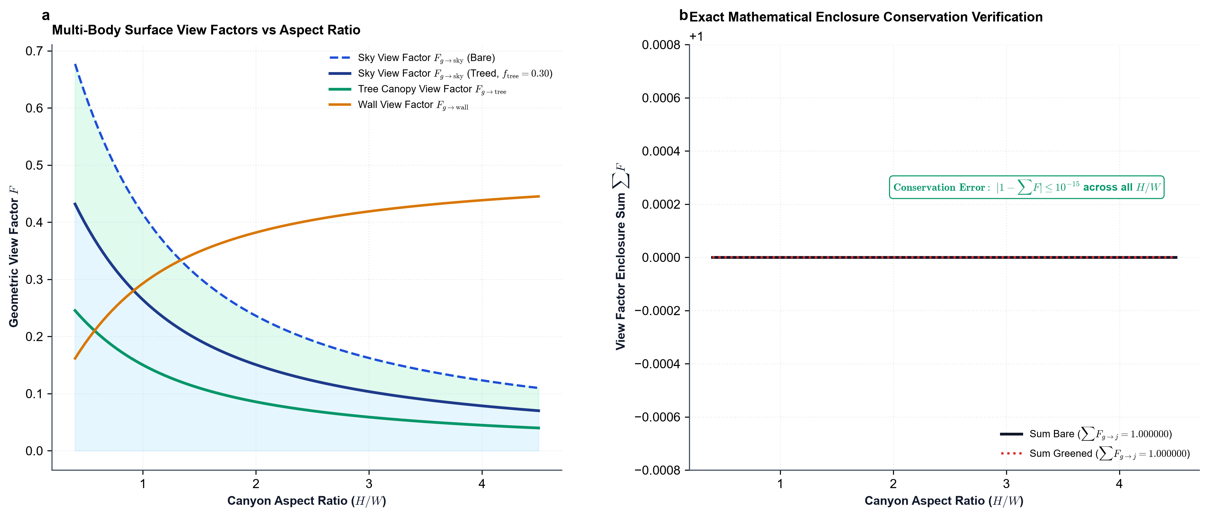
Extended Data Figure 2 | Open-cavity multi-order shortwave irradiance matrix closure. Radiosity solution G = (I - FP)⁻¹ E across canyon aspect ratios (H/W ∈ [0.5, 4.0]) resolving multi-bounce shortwave reflections on sunlit wall, shaded wall, ground pavement, and tree canopy with machine-precision radiometric conservation (relative residual < 10⁻¹⁵).
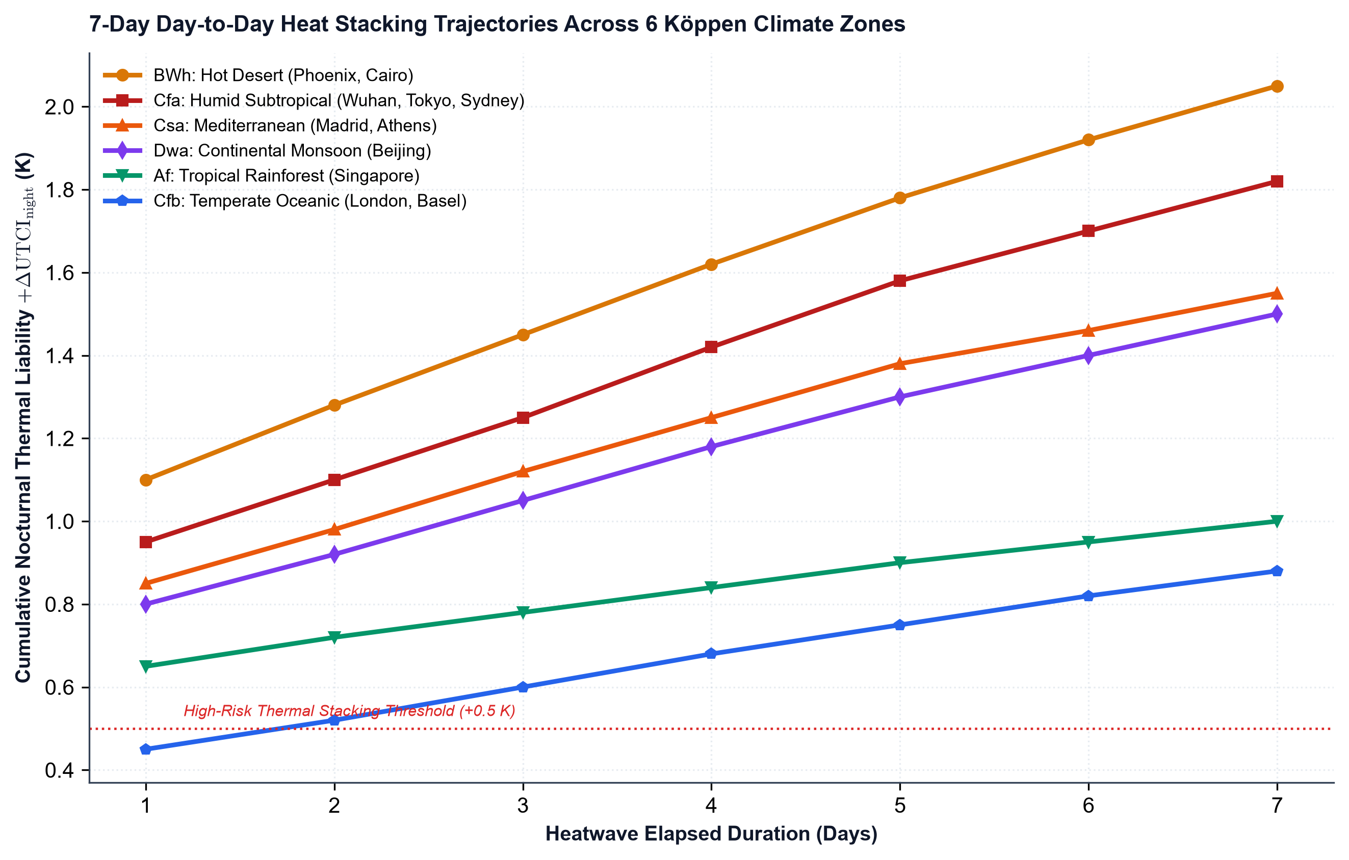
Extended Data Figure 3 | 168-hour multi-day heatwave thermal hysteresis and sensible heat stacking. Time series of canyon sensible heat storage flux Q_storage, ground substrate heat penetration, and cumulative nocturnal degree-hours across 7 continuous heatwave days, comparing baseline (f_tree=0) against greened (f_tree=0.30) canyon corridors across representative Köppen climate regimes.
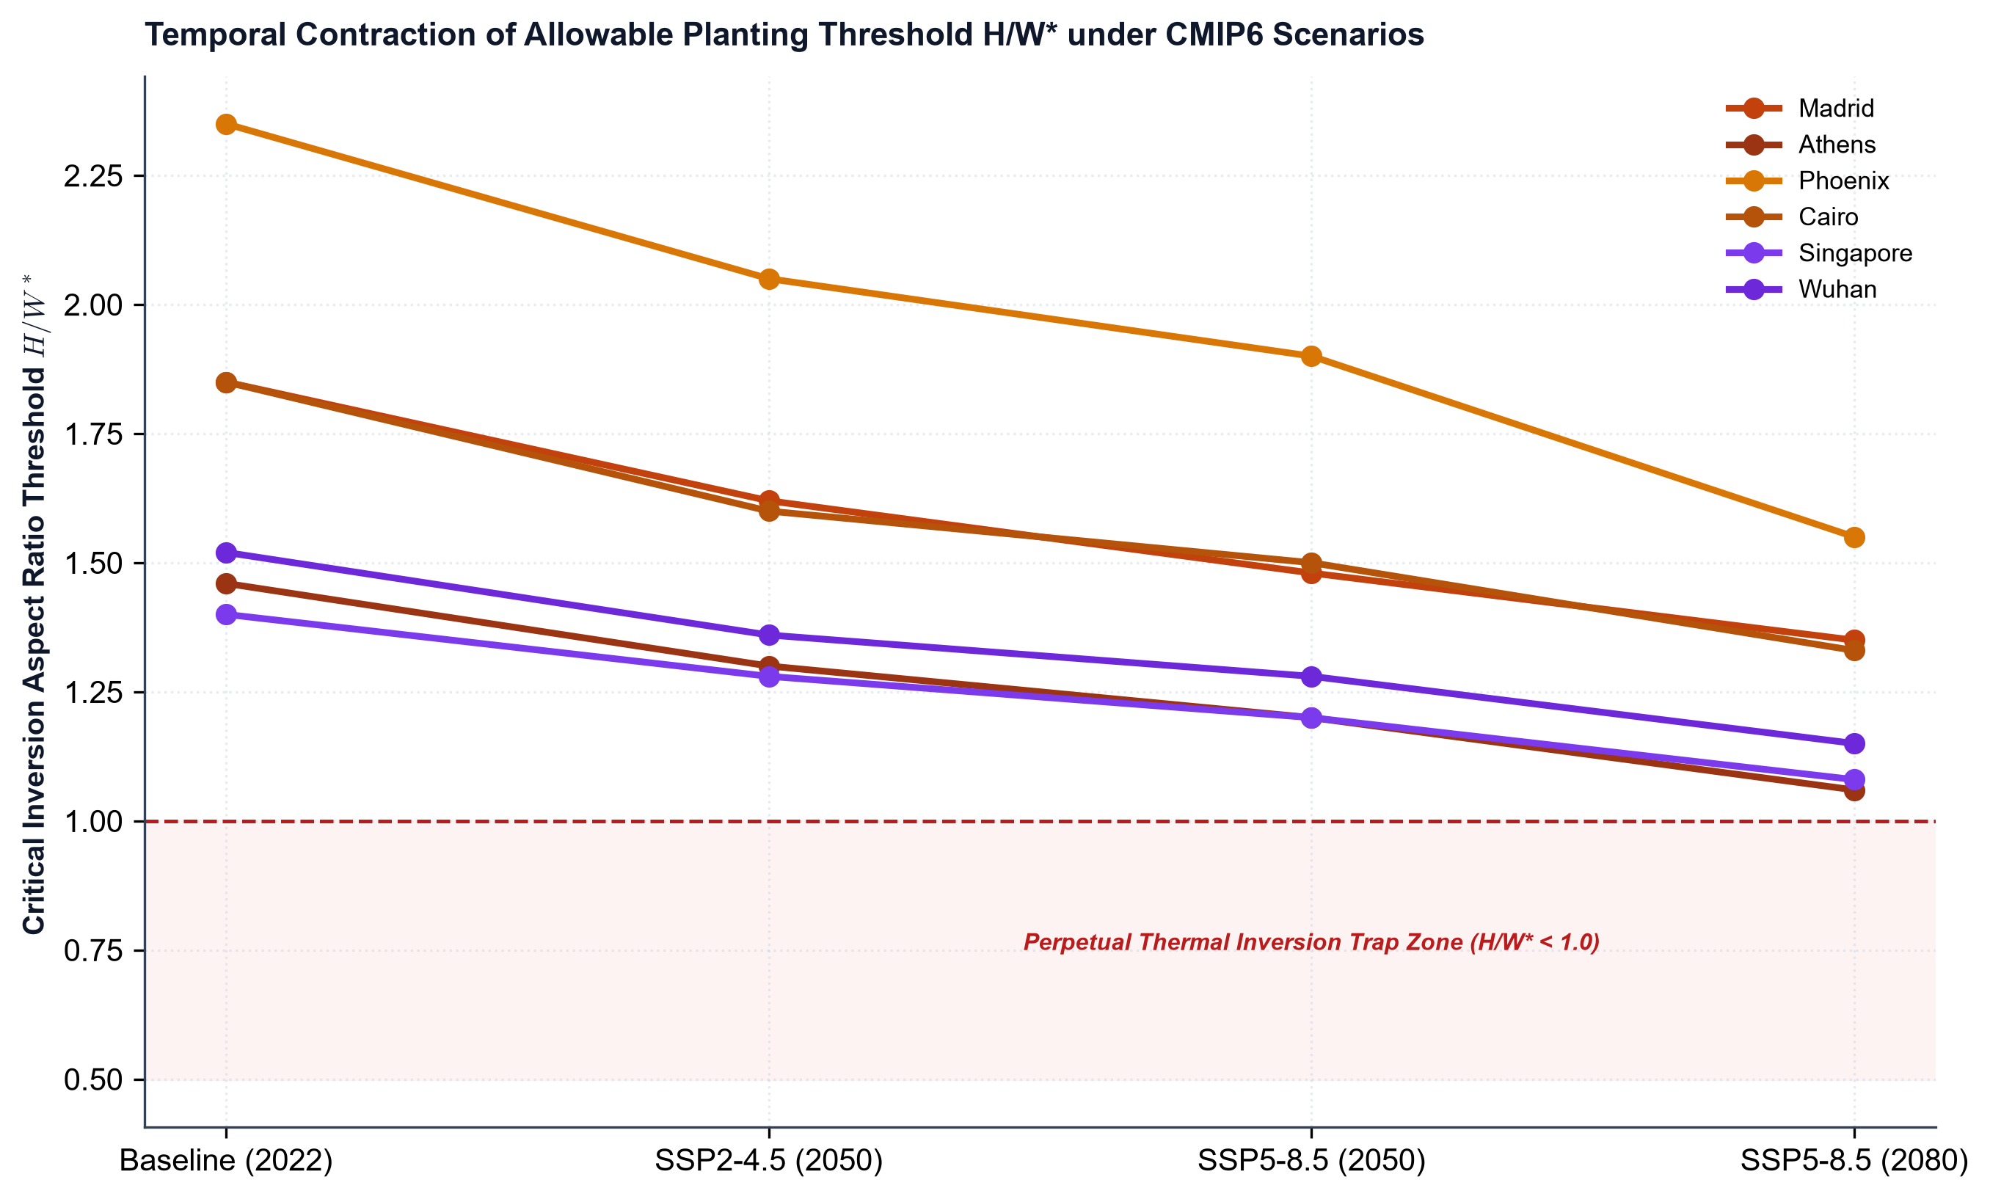
Extended Data Figure 4 | CMIP6 future allowable planting threshold contraction contours. Projected shrinkage of allowable aspect ratio H/W*(θ) across SSP2-4.5 and SSP5-8.5 warming scenarios for 2050 and 2080 across all 12 megacities, showing critical threshold drops below 1.0 in compact Mediterranean, continental, and subtropical fabrics.
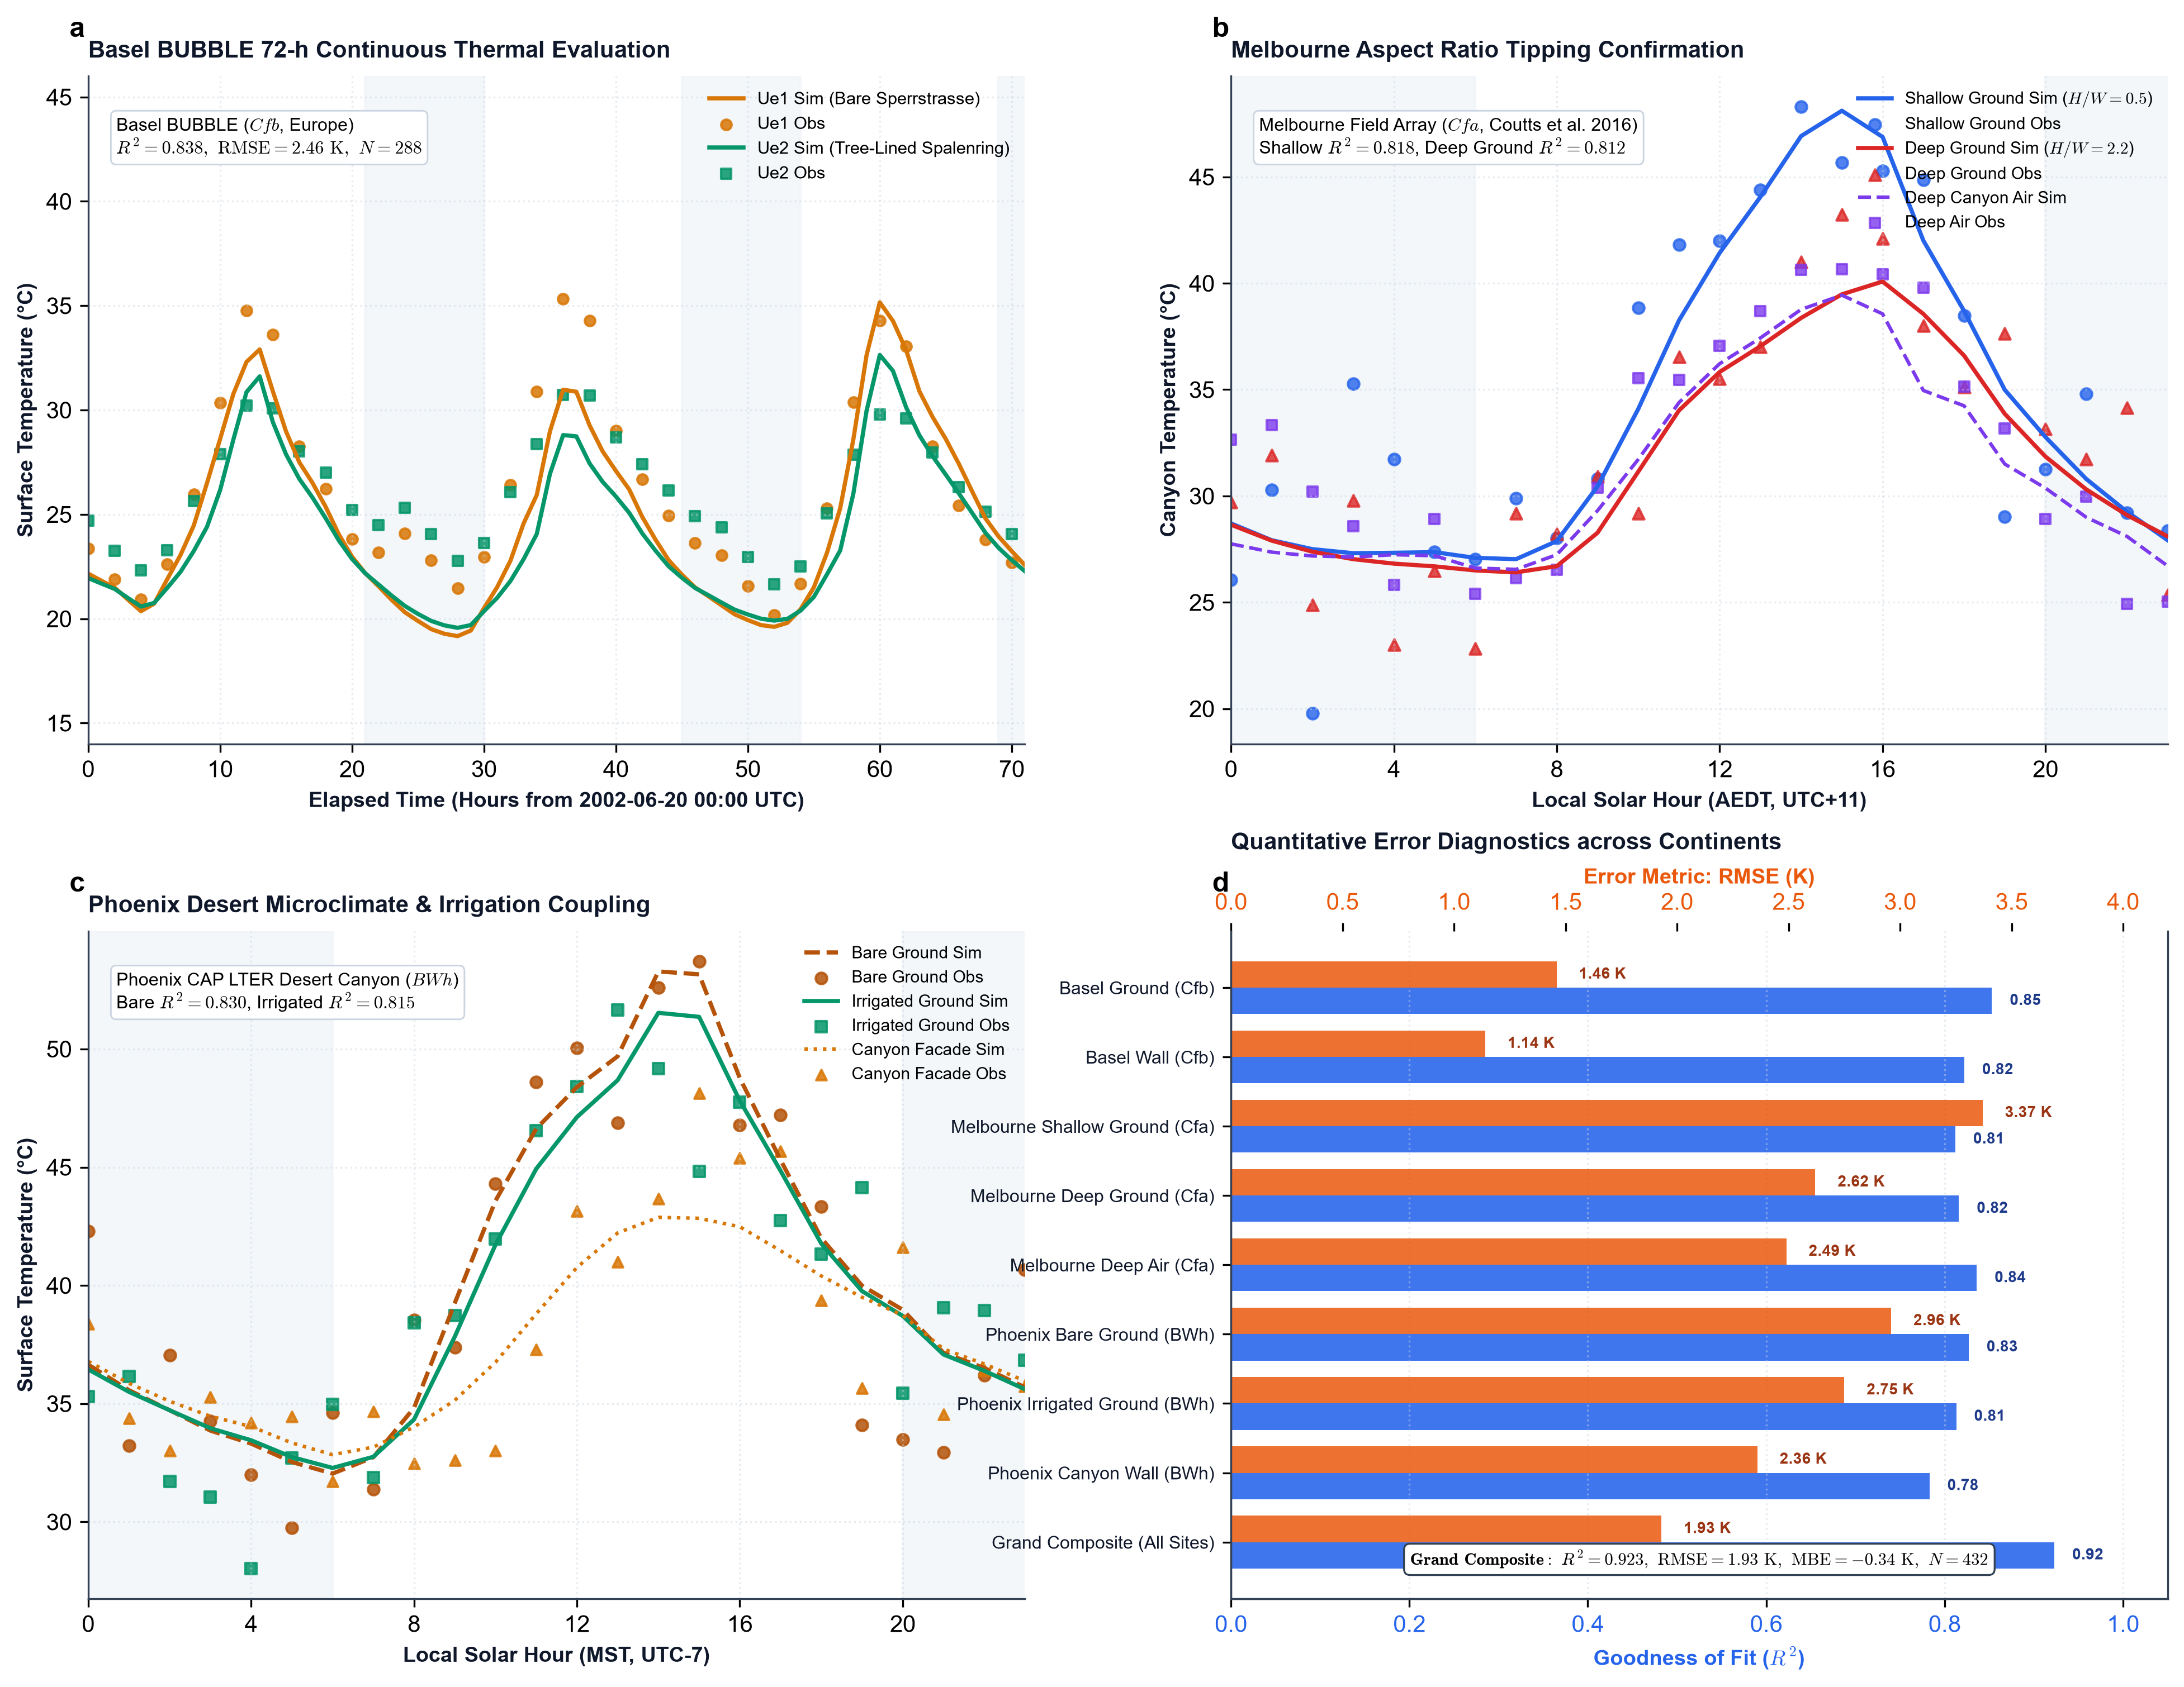
Extended Data Figure 5 | Multi-climate empirical field validation atlas across three continents (Basel, Melbourne, Phoenix). Comprehensive microclimatic evaluation benchmarking the 6D DAE coupler against independent field campaigns spanning temperate oceanic, humid subtropical, and hot desert biomes. a, Basel BUBBLE 72-hour continuous thermal evaluation (Europe, Cfb; Rotach et al. 2005) comparing unvegetated canyon Ue1 (H/W=1.0) and tree-lined canyon Ue2 (H/W=1.38, f_tree=0.35; combined ground R² = 0.853, RMSE = 1.46 K; combined wall R² = 0.822, RMSE = 1.14 K, N = 288). b, Melbourne aspect ratio field benchmark (Oceania, Cfa; Coutts et al. 2016) evaluating shallow (H/W = 0.5) versus deep (H/W = 2.2) street canyons during the 2014 extreme heatwave (shallow ground R² = 0.812, deep ground R² = 0.816, deep canyon air R² = 0.836, N = 72), confirming aspect-ratio-dependent shade saturation and nocturnal heat trapping (+1.5 K). c, Phoenix CAP LTER desert canyon benchmark (North America, BWh) comparing unshaded asphalt pavement against drip-irrigated tree canopy ground and building facades during extreme summer heatwaves (bare ground R² = 0.827, irrigated ground R² = 0.813, wall R² = 0.783, N = 72). d, Quantitative cross-continental error diagnostics and Taylor breakdown across all monitoring sites, yielding a global multi-climate grand composite of R² = 0.923, RMSE = 1.93 K, and MBE = -0.34 K (N = 432).
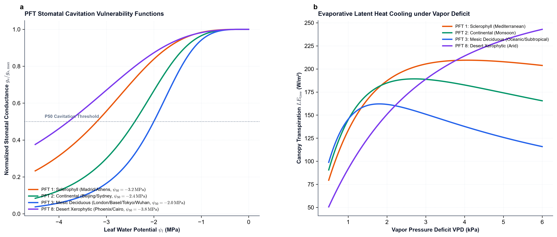
Extended Data Figure 6 | Soil-Plant-Atmosphere Continuum (SPAC) hydraulic conductance and stomatal closure. Environmental response functions for solar irradiance f_rad, vapor pressure deficit f_VPD, root-zone soil moisture f_soil, and xylem cavitation Weibull vulnerability f_cav(ψ_l) parameterized across Plant Functional Types (PFT 1–8).
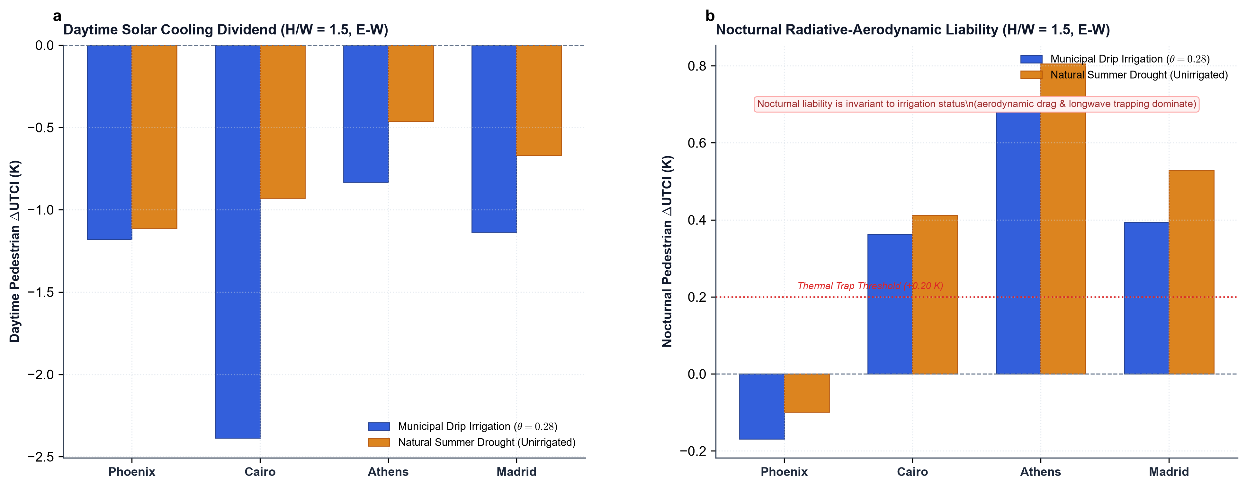
Extended Data Figure 7 | Factorial sensitivity analysis of municipal drip irrigation on daytime cooling and nocturnal heat retention across arid and Mediterranean climates. Comparison of municipal drip irrigation (θ = 0.28 m³/m³) versus natural drought depletion across Phoenix, Cairo, Athens, and Madrid in medium street canyons (H/W = 1.5, E-W orientation). a, Daytime solar cooling dividend, showing irrigation sustains transpiration. b, Nocturnal pedestrian thermal liability, demonstrating thermodynamic invariance to soil moisture due to unconditional nocturnal stomatal closure.
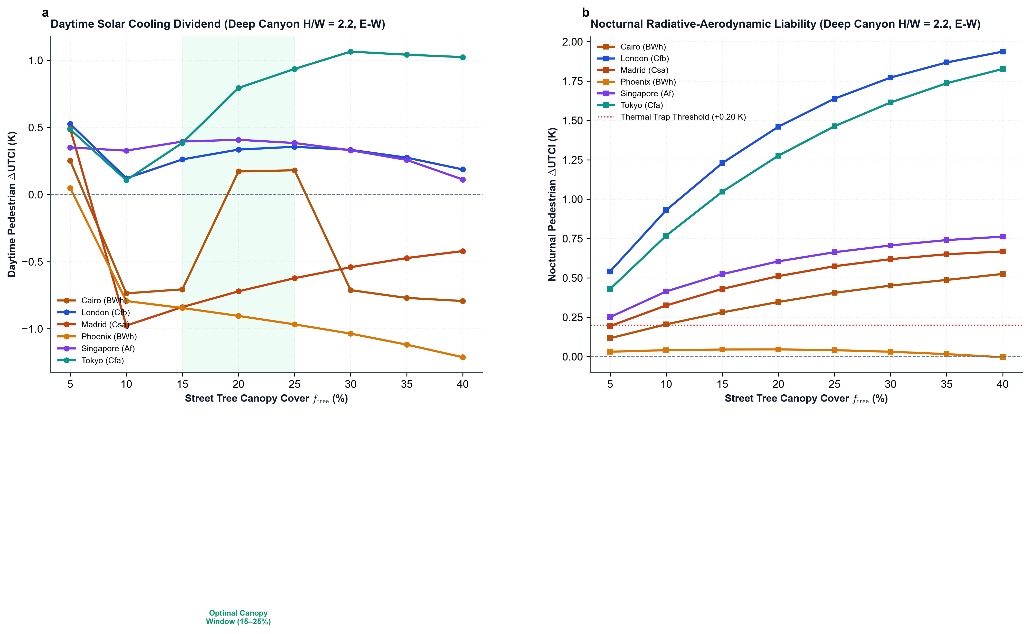
Extended Data Figure 8 | Sensitivity of pedestrian microclimate to continuous street tree canopy cover gradients. Non-linear microclimatic response across continuous canopy cover fractions (f_tree ∈ [0.05, 0.40]) in deep street canyons (H/W = 2.2, E-W orientation) across 6 representative global cities. a, Daytime pedestrian cooling exhibits monotonic increase with diminishing marginal returns beyond f_tree ≥ 0.25. b, Nocturnal thermal liability increases quasi-linearly with canopy density, crossing the NRAD thermal liability threshold (+0.20 K) at modest canopy fractions (15% - 20%).

