Supplementary Material 1

Supplementary Methods and Results
Associated manuscript: Intersectional Inequalities in Multimorbidity Burden Among Older Adults: A Population-Based Multilevel Analysis of Individual Heterogeneity and Discriminatory Accuracy (MAIHDA)
This supplementary material provides the extended cohort-construction and outcome-ascertainment procedures, the complete coding of candidate social dimensions, the full Variable Importance and Variable Interaction (VIVI) and MAIHDA specifications, complete model-ranking and variance diagnostics, dimension-specific proportional changes in variance, and additional stratum-level prediction figures. It is designed to be read independently of the companion repository, while the repository provides the complete analytical scripts and disclosure-controlled output files that are too extensive for a static Word attachment.
Companion repository: MAIHDA-of-MM-burden GitHub repository

Contents
- S1. Cohort construction
- S2. Outcome and candidate social dimensions
- S3. VIVI screening and configuration of 15 MAIHDA models
- S4. MAIHDA model specification, estimands and predictions
- S5. Complete model ranking and variance diagnostics
- S6. Dimension-specific PCV estimates in the five leading models
- S7. Additional stratum-level results for Models 3–5
- S8. Repository-hosted analytical resources
- S9. Reproducibility record
This document is the principal supplementary methods and results resource (Supplementary Material 1). Tables S6–S20, comprising the complete parameter tabulations for all 15 configurations, are supplied separately as Supplementary Material 5 in the companion repository and should be interpreted using the coding and reference categories in Table S2 of this document.

S1. Cohort construction
The analytical cohort was assembled within the Secure Anonymised Information Linkage (SAIL) Databank by linking population, household, area and health records through anonymised identifiers. The 2011 Census person and household files formed the population spine and provided demographic, educational, family, housing and household-resource measures together with 2011 lower-layer super output area identifiers. The census extract contained 3,264,772 people living in 1,421,337 households (Table S1).
Area-level deprivation information was added through the Wales Demographic Service Dataset and external Office for National Statistics classifications, including 2011 Welsh Index of Multiple Deprivation (WIMD) quintile and rural–urban category. Primary-care diagnoses and related prescribing or laboratory information were obtained from the Welsh Longitudinal General Practice dataset, while hospital inpatient diagnoses were obtained from the Patient Episode Database for Wales.
The multiple long-term condition measures developed by MacRae et al. (2023) were available for 2,472,944 SAIL-registered patients. Inner linkage to the census- and area-enriched population file yielded 2,075,591 people. Eligibility was then restricted to people aged at least 65 years who were registered with a Welsh general practice on the census date, 27 March 2011, and had complete information for LTC count and all 14 candidate social dimensions. The final analytical cohort contained 375,070 older adults (Table S1).

Table S1. Cohort-construction stages
Cohort stage | Records in the linked-data workflow | Role in cohort construction
2011 Census person and household records | 3,264,772 people in 1,421,337 households | Population spine and personal, family, household and dwelling characteristics
Wales Demographic Service Dataset | 3,092,046 people in the dataset | Area-based deprivation attributes linked through area identifiers
SAIL-registered patients with LTC measures | 2,472,944 | LTC measures derived from primary-care and hospital-inpatient records
Census, area and health linked cohort | 2,075,591 | People retained after inner linkage
Age ≥65 years with complete outcome and 14 dimensions | 375,070 | Final analytical cohort

S2. Outcome and candidate social dimensions

S2.1 Outcome ascertainment
The response was the number of long-term conditions recorded at the index date, with a theoretical range from 0 to 47. The 47-condition set and phenotype rules followed MacRae et al. (2023), who adapted Delphi-consensus recommendations and combined primary-care and hospital-inpatient records. The outcome therefore represents recorded multimorbidity burden as a count rather than the prevalence of a binary threshold.
Condition-specific look-back periods reflected the expected clinical course of each condition. Lifelong or life-threatening anaemias, for example, were identified from any prior record, whereas iron-, vitamin B12- or folate-deficiency anaemia required a record within the preceding 12 months. Unless a shorter period was explicitly stipulated, eligible diagnostic codes recorded from 1 January 2000 through 27 March 2011 were considered. Conditions requiring evidence of current activity, including asthma and epilepsy, were qualified using available prescribing or laboratory information from primary care. The cohort median was 3 LTCs (Q1 2; Q3 5).

S2.2 Dimensions, codes and reference categories
All 14 candidate dimensions (Table S2) were selected a priori because prior evidence and substantive reasoning indicated relevance to multimorbidity inequality. The empirical VIVI screen compared their relative predictive salience for constructing alternative five-way intersections; it was not used to determine whether any dimension was theoretically legitimate or socially meaningful.

Table S2. Candidate dimensions and fixed-effect coding
Dimension | Raw code prefix | Categories | Fixed-effect reference | Analytical level
Age group | age_10yr_grp | 65–74; 75–84; ≥85 years | 65–74 | Personal/demographic
Highest qualification | HLQPUK11 | No qualifications; Level 1; Level 2; apprenticeship; Level 3; Level 4 or above; other; not applicable (administrative/structural category; see interpretation below) | No qualifications | Personal socioeconomic
Dwelling tenure | TENDUK11 | Owned/shared ownership; private rented; social rented; living rent free | Owned/shared ownership | Household/residential
Cars/vans in household | CARSNO | None; one; two or more | None | Household material resource
Employed adults in household | ADEMHUK11 | One; two; three or more | One | Household economic/compositional
Accommodation type | TYPACCOM | Detached; semi-detached; terraced; flat/maisonette/apartment; mobile/temporary structure | Detached | Household/residential
Provision of unpaid care | CARER | 0; 1–19; 20–49; ≥50 hours | 0 | Personal/household role
Sex | GNDR_CD | Female; male | Female | Personal/demographic
WIMD 2011 quintile | WIMD_qntl | 5 least deprived; 4; 3; 2; 1 most deprived | 5 least deprived | Area socioeconomic
Household size | SIZHUK11 | One; two; three or more | One | Household composition
NS-SEC of household reference person | NSSHUK11 | Higher managerial/administrative/professional; intermediate; lower supervisory/technical; never worked/long-term unemployed; routine/semi-routine; small employer/own-account | Higher managerial/administrative/professional | Household socioeconomic
Ethnic group | AGGETHPUK111 | White; mixed/multiple; Asian/Asian British; Black/African/Caribbean/Black British; other | White | Personal/social position
Family status | FMSPUK11 | Couple family; lone-parent family; students, short-term migrants and others not in a family | Couple family | Household/family
Rural–urban classification | RUC11 | Urban city/town; rural town/fringe; rural village/dispersed | Urban city/town | Area context
The categories require several interpretive qualifications. `HLQPUK11Not applicable` contained 385 people (0.10%) and contributed to several extreme low-count predictions. The number of employed adults in the household may reflect co-residence with working-age adults, household income and household composition, but may also be affected by illness or care needs. Sex was available only as female/male and cannot represent gender diversity or the full operation of gendered institutions. The cohort was 99.02% White, which limits the precision and scope of contrasts involving broad ethnic categories. WIMD and rural–urban classifications were area attributes attached to individuals; they did not constitute a separately modelled geographical level.
The category labels are derived from the 2011 UK Census and some do not map directly onto education, housing or social-class classifications used elsewhere. The notes below provide the interpretation used in this study and direct readers to authoritative sources for fuller category definitions.

Highest qualification (HLQPUK11)
The substantive attainment categories describe the highest qualification reported rather than years of schooling. In broad terms, Level 1 covers lower secondary or foundation qualifications (for example, one to four GCSEs or equivalent); Level 2 covers five or more GCSE passes at the former A*–C standard or equivalent intermediate vocational qualifications; apprenticeship identifies a recognised apprenticeship; Level 3 covers advanced secondary qualifications such as two or more A levels or equivalent; and Level 4 or above covers degree-level, higher-degree and professional qualifications. ‘Other’ includes vocational or work-related qualifications and qualifications gained outside the UK whose level was not stated or could not be assigned to the standard hierarchy. These categories are UK-specific equivalence groupings and should not be read as direct international schooling-year equivalents. Detailed mappings are available from the Office for National Statistics (ONS).
For the official UK-harmonised 2011 Census highest-level-of-qualification variable—identified as HLQPUK in the harmonised metadata—the statistical universe is people aged 16–74. Its Not applicable category is a structural, out-of-universe code comprising people aged 15 or younger and people aged 75 or older; it does not describe educational attainment. The official UK-harmonised definition is available from Scotland's Census.
The analytical field used in this study is labelled HLQPUK11, but its observed coding does not reproduce that strict 16–74 universe: the cohort contains 183,175 people aged 75 years or older, whereas only 385 records are labelled Not applicable, and the England-and-Wales-specific apprenticeship and other categories are retained. The field therefore behaves as a country-specific or recoded England-and-Wales qualification derivation despite its mnemonic. In this analysis, Not applicable is retained as a small administrative/structural category and is not interpreted as an educational level. Any coefficient or stratum estimate involving it should be understood as reflecting the coding status and the characteristics of the people assigned to it, rather than the health effect of a particular level of educational attainment.
This distinction explains why the age restriction can otherwise appear confusing. Standard published England-and-Wales qualification tables classify usual residents aged 16 and over without an upper age limit, so qualification information can be available for people aged 75 or older in country-specific Census outputs even though the official UK-harmonised variable treats that age group as out of universe. See the official Nomis table QS501EW.

Dwelling tenure (TENDUK11)
Tenure describes the legal or rental basis on which a household occupies its accommodation, not the physical type or condition of the dwelling. Owned or shared ownership combines accommodation owned outright, owned with a mortgage or loan, and part-owned/part-rented through a shared-ownership scheme. Social rented includes renting from a local authority, housing association or another registered social landlord. Private rented includes renting from a private landlord or letting agency and other private arrangements, such as renting from an employer, relative or friend. Living rent free identifies households occupying accommodation without paying rent and is retained separately here rather than combined with private renting. The ONS 2011 Census tenure definitions and distributions are described in the 2011 Census key statistics for England and Wales.

NS-SEC of household reference person (NSSHUK11)
The National Statistics Socio-economic Classification (NS-SEC) is an occupational measure of socio-economic position. It is derived from occupation together with employment status, self-employment and supervisory responsibility. The household reference person (HRP) is the individual selected by Census rules to provide a consistent reference point for characterising the household; in a one-person household, that person is the HRP, whereas in multi-person households selection prioritises economic activity and then age. Consequently, NSSHUK11 assigns all members of a household the NS-SEC of its HRP and should not be interpreted as each older adult's own current or former occupation.
The study uses an aggregated classification comprising higher managerial, administrative and professional occupations; intermediate occupations; small employers and own-account workers; lower supervisory and technical occupations; routine and semi-routine occupations; and never worked and long-term unemployed. The category labels denote employment relations and occupational conditions rather than a simple income ranking, and the ordering should therefore not be treated as a perfectly linear social-class scale. Authoritative information is available from Nomis table QS609EW, while the ONS discussion of how the HRP is selected is provided in its 2011 Census family and household analysis.

Rural–urban classification (RUC11)
The 2011 Rural–Urban Classification is a settlement-based area typology rather than a measure of remoteness, service accessibility or neighbourhood deprivation. At Output Area level, places are classified as urban when they fall within a built-up area containing at least 10,000 people; remaining areas are rural. The standard classification further distinguishes settlement form and whether the wider setting is sparse. For this study, the six small-area categories were collapsed into three settlement-form groups by combining sparse and non-sparse versions: urban city and town, rural town and fringe, and rural village and dispersed. At LSOA level, classification follows the category applying to the majority of constituent Output Areas. Full methodology and lookup resources are available from the ONS 2011 Rural–Urban Classification.
Several further qualifications apply across the candidate dimensions. The number of employed adults in the household may capture co-residence with working-age adults, pooled economic resources and household composition, but may also be affected by illness or caring responsibilities. Sex was available only as female/male and cannot represent gender diversity or the full operation of gendered institutions. The cohort was 99.02% White, limiting the precision and scope of contrasts involving broad ethnic categories. WIMD and rural–urban classifications were area attributes attached to individuals; they were not fitted as a separate geographical level in these MAIHDA models.

S3. VIVI screening and configuration of 15 MAIHDA models

S3.1 Gradient-boosting and VIVI specification
A gradient-boosting model was fitted with gbm() using LTC count as the response and all 14 candidate dimensions as predictors. The model used a Poisson loss, train.fraction = 0.8, fivefold cross-validation and parallel processing on all but one detected core. The analytical specification used 100 trees, interaction.depth = 5, minimum terminal-node size 10, learning rate 0.1 and bag fraction 0.5, with model data retained and verbose output disabled. An interaction depth of five allowed each tree to represent interaction structures involving up to five predictors, consistent with the five-way configurations subsequently examined. The first 80% of rows were used for model fitting and the remaining rows for the package's out-of-sample loss calculation. Fivefold cross-validation error was generated within the fitted object as the predictive-performance statistic; it informed assessment of the learner but was not used as a variable-inclusion threshold.
The fitted model was passed to vivid::vivi() with the complete analytical cohort and ltc_all_count identified as the response. The specification used model-agnostic permutation importance with four permutations, Friedman's unnormalised pairwise H-statistic, a maximum sample of 500 observations for partial-dependence calculations, a grid size of 50 and matrix reordering enabled. Seed 2211 was set immediately before VIVI computation. Variable importance quantified the increase in prediction error after a predictor was permuted, whereas the H-statistic quantified the extent to which the joint partial-dependence function for a variable pair departed from the sum of its marginal functions. The VIVI network retained all variables and displayed interaction edges with values of at least 0.001.
The resulting matrix was used comparatively: diagonal values informed the ordering of relative variable importance and off-diagonal values represented pairwise interaction strength. Because the learner permitted interactions up to depth five, both components were used to organise the high-, low- and mixed-VIVI configurations. The VIVI screen remained subordinate to substantive reasoning; it did not determine whether any candidate dimension was theoretically meaningful.

S3.2 Configuration strategy
Three families of five-dimensional intersections were constructed while holding the number of dimensions constant (Table S3):
- High VIVI configurations: five models progressively combining dimensions from the upper end of the VIVI ordering.
- Low VIVI configurations: five models progressively combining dimensions from the lower end.
- Mixed configurations: five manually specified models combining higher- and lower-ranked dimensions on substantive grounds.
The mixed family served two purposes. It prevented empirical rank from becoming the sole basis of model construction, and it ensured that area context was examined despite lower relative importance. WIMD was retained in mixed Models 4, 9 and 11, while rural–urban classification was retained in mixed Models 2, 5 and 11. Every observed combination of categories across the selected five dimensions defined an intersectional stratum.

Table S3. Fifteen VIVI-informed null MAIHDA configurations, ranked by discriminatory accuracy
Model | Analytical label | Configuration class | Null model DA* | Null model Variance (τ₀₀) | Five stratum-defining factors
1 | Max VIVI 1 | High VIVI | 12.40% | 0.1431 | Age group; Highest qualification; Dwelling tenure; Cars/vans in household; Employed adults in household
2 | mnl strta 3 | Mixed VIVI | 9.78% | 0.1020 | Highest qualification; Cars/vans in household; Dwelling tenure; Ethnic group; Rural–urban classification
3 | Max VIVI 2 | High VIVI | 6.70% | 0.0683 | Highest qualification; Dwelling tenure; Cars/vans in household; Employed adults in household; Accommodation type
4 | mnl strta 2 | Mixed VIVI | 3.82% | 0.0365 | Highest qualification; Accommodation type; Dwelling tenure; Sex; WIMD quintile
5 | mnl strta 1 | Mixed VIVI | 3.54% | 0.0340 | Employed adults in household; Accommodation type; Cars/vans in household; Dwelling tenure; Rural–urban classification
6 | Max VIVI 3 | High VIVI | 3.32% | 0.0320 | Dwelling tenure; Cars/vans in household; Employed adults in household; Accommodation type; Unpaid care
7 | Max VIVI 4 | High VIVI | 3.04% | 0.0294 | Cars/vans in household; Employed adults in household; Accommodation type; Unpaid care; Sex
8 | Max VIVI 5 | High VIVI | 2.79% | 0.0264 | Employed adults in household; Accommodation type; Unpaid care; Sex; WIMD quintile
9 | mnl strta 4 | Mixed VIVI | 2.56% | 0.0241 | Ethnic group; Cars/vans in household; Accommodation type; Sex; WIMD quintile
10 | Min VIVI 5 | Low VIVI | 1.86% | 0.0172 | Household size; WIMD quintile; Sex; Unpaid care; Accommodation type
11 | mnl strta 5 | Mixed VIVI | 1.83% | 0.0166 | Dwelling tenure; Sex; Ethnic group; Rural–urban classification; WIMD quintile
12 | Min VIVI 4 | Low VIVI | 1.80% | 0.0167 | NS-SEC of household reference person; Household size; WIMD quintile; Sex; Unpaid care
13 | Min VIVI 2 | Low VIVI | 1.68% | 0.0153 | Family status; Ethnic group; NS-SEC of household reference person; Household size; WIMD quintile
14 | Min VIVI 1 | Low VIVI | 1.67% | 0.0153 | Rural–urban classification; Family status; Ethnic group; NS-SEC of household reference person; Household size
15 | Min VIVI 3 | Low VIVI | 1.30% | 0.0118 | Ethnic group; NS-SEC of household reference person; Household size; WIMD quintile; Sex
DA percentages use the unrounded null model ICC. Configuration classes describe the construction procedure, not the substantive importance of every included dimension.

S4. MAIHDA model specification, estimands and predictions
For each configuration, individuals $i$ were nested within intersectional strata $j$. All null, partially adjusted and fully adjusted models were fitted with glmmTMB() using family = nbinom1. The default log link was therefore applied, with conditional variance
$$Var\left(Y_{ij}|u_{j}\right)=μ_{ij}\left(1+ϕ\right),$$
where $μ_{ij}$ is the expected count and $ϕ$ is the dispersion parameter. No zero-inflation component was specified (ziformula = ~0), and dispersion was constant (dispformula = ~1). Because REML was not enabled, models were estimated by maximum likelihood. Gaussian random effects were integrated through the Laplace approximation implemented by Template Model Builder, using the default nlminb optimiser. Parallel evaluation used all but one detected processor core.
The retained model tabulations contained finite fixed-effect, variance and likelihood-based fit statistics and did not display a failed fit. For reproducible refitting, convergence assessment should include the optimiser convergence code, the optimiser message, finite parameter estimates and a positive-definite Hessian (model$sdr$pdHess). The complete analysis workflow is accompanied in Supplementary Material 2 by a convergence-audit helper so that any model failing these checks can be identified before final export; convergence diagnostics are methodological checks rather than substantive selection criteria.

S4.1 Null model: total between-stratum differentiation
The null model was
$$log\{E\left(Y_{ij}|u_{j}\right)\}=β_{0}+u_{j},u_{j}∼N\left(0,τ_{00}\right),$$
where $τ_{00}$ is the random-intercept variance. Adjusted ICCs were extracted with performance::icc(model)$ICC_adjusted. For the non-Gaussian negative-binomial models, the function's default lognormal approximation was used to obtain the distribution-specific residual variance. Between-stratum variance was extracted with insight::get_variance(model)$var.random.
In an intercept-only model containing one random effect, the adjusted ICC is equivalent to the conditional $R^{2}$. Unrounded conditional $R^{2}$ values were expressed as percentages for discriminatory accuracy (DA), whereas the raw parameter tables print ICCs rounded to two decimal places. A large null-model ICC indicates that the selected categorisation differentiates strata with different average LTC counts. It does not by itself demonstrate synergistic or causal interaction.

S4.2 Partially adjusted models: dimension-specific PCV
Each of the five stratum-defining dimensions was entered separately as fixed effects while the same composite-stratum random intercept was retained:
$$log\{E\left(Y_{ij}|u_{j}\right)\}=β_{0}+β_{k}X_{kj}+u_{j}.$$
For dimension $k$, the proportional change in variance was calculated as
$${PCV}_{k}=100×\frac{τ_{00}^{\left(0\right)}-τ_{00}^{\left(k\right)}}{τ_{00}^{\left(0\right)}}.$$
These PCVs are overlapping, configuration-dependent reductions from separate models and should not be summed as a unique variance partition. Negative PCV denotes a small increase in estimated random-intercept variance after the relevant fixed effect was entered.

S4.3 Fully adjusted models: residual departure from additivity
All five dimensions were then entered simultaneously as fixed main effects while retaining the composite-stratum random intercept:
$$log\{E\left(Y_{ij}|u_{j}\right)\}=β_{0}+β_{1}X_{1j}+⋯+β_{5}X_{5j}+u_{j}.$$
Exponentiated fixed effects are reported as incidence rate ratios. The remaining $τ_{00}$ and adjusted ICC represents residual deviation of stratum means from the additive pattern implied by the five main effects. They are therefore the principal fitted-scale indicators of non-additivity. In the leading models, full-model variance was 0.01 or rounded to 0.00, showing that most null-model stratification was represented by additive or compositional contrasts.

S4.4 Stratum-level predictions and disclosure control
Random intercepts were obtained with modelbased::estimate_grouplevel(). Expected counts and 95% confidence intervals on the response scale were generated with modelbased::estimate_relation(model, by = dimensions), and corresponding link-scale estimates with modelbased::estimate_link(). These estimates incorporate partial pooling, so small-stratum predictions are shrunk towards the overall mean.
The complete rankings include structurally possible, empty and sparsely populated combinations. Figures show the upper and lower 5% of ranked predicted counts and report the population size associated with each stratum. Bold type font identifies strata containing at least 0.5% of the cohort; this was a presentation criterion, not a significance threshold. Population counts below 10 and their percentages were masked under SAIL statistical disclosure-control requirements.

S5. Complete model ranking and variance diagnostics
The complete model ranking and variance diagnostics are shown in Table S4 below.

Table S4. Null and fully adjusted variance diagnostics for all 15 configurations
Model | Analytical label | Configuration Class | Null model DA* | Full model ICC | Null model variance (τ₀₀) | Full model variance (τ₀₀) | Marginal R² | Conditional R² | Null model AIC | Full model AIC
1 | Max VIVI 1 | High-VIVI | 12.40% | 1.31% | 0.1431 | 0.0134 | 0.059 | 0.072 | 1632004.662 | 1630968.191
2 | mnl strta 3 | Mixed-VIVI | 9.78% | 0.24% | 0.1020 | 0.0023 | 0.037 | 0.039 | 1654165.416 | 1653060.764
3 | Max VIVI 2 | High-VIVI | 6.70% | 0.39% | 0.0683 | 0.0037 | 0.041 | 0.044 | 1652669.422 | 1650944.663
4 | mnl strta 2 | Mixed-VIVI | 3.82% | 0.21% | 0.0365 | 0.0019 | 0.029 | 0.031 | 1660725.706 | 1658579.591
5 | mnl strta 1 | Mixed-VIVI | 3.54% | 0.34% | 0.0340 | 0.0031 | 0.024 | 0.027 | 1657252.405 | 1656749.908
6 | Max VIVI 3 | High-VIVI | 3.32% | 0.33% | 0.0320 | 0.0031 | 0.023 | 0.026 | 1656185.095 | 1655718.208
7 | Max VIVI 4 | High-VIVI | 3.04% | 0.36% | 0.0294 | 0.0034 | 0.021 | 0.024 | 1656800.680 | 1656425.282
8 | Max VIVI 5 | High-VIVI | 2.79% | 0.25% | 0.0264 | 0.0023 | 0.018 | 0.020 | 1662917.931 | 1662276.849
9 | mnl strta 4 | Mixed-VIVI | 2.56% | 0.18% | 0.0241 | 0.0017 | 0.021 | 0.023 | 1659378.224 | 1659059.886
10 | Min VIVI 5 | Low-VIVI | 1.86% | 0.32% | 0.0172 | 0.0029 | 0.011 | 0.014 | 1664833.971 | 1664366.718
11 | mnl strta 5 | Mixed-VIVI | 1.83% | 0.16% | 0.0166 | 0.0014 | 0.011 | 0.013 | 1667621.038 | 1667384.532
12 | Min VIVI 4 | Low-VIVI | 1.80% | 0.35% | 0.0167 | 0.0032 | 0.011 | 0.014 | 1665376.285 | 1664812.944
13 | Min VIVI 2 | Low-VIVI | 1.68% | 0.48% | 0.0153 | 0.0043 | 0.012 | 0.017 | 1665575.234 | 1665401.038
14 | Min VIVI 1 | Low-VIVI | 1.67% | 0.56% | 0.0153 | 0.0051 | 0.011 | 0.017 | 1666376.034 | 1666274.354
15 | Min VIVI 3 | Low-VIVI | 1.30% | 0.18% | 0.0118 | 0.0016 | 0.011 | 0.013 | 1666612.554 | 1666319.896
Null DA is the null ICC expressed as a percentage. Full model ICC is the random-intercept ICC after all five constituent factors were entered as fixed main effects. AIC values are comparable only among models fitted to the same outcome and observations, but differences also reflect distinct fixed-effect parameter counts and stratum structures.
The diagnostics show two distinct findings. First, null-model differentiation varied considerably across configurations, from 12.4% in Model 1 to 1.3% in Model 15. Second, the ICC after all five main effects were included was less than 0.5% in 13 configurations, 1.31% in Model 1 and 0.56% in Model 14.

S6. Additional stratum-level results for Models 3–5

Figure S1. Upper and lower 5% of predicted LTC counts in Model 3 (Max VIVI 2)
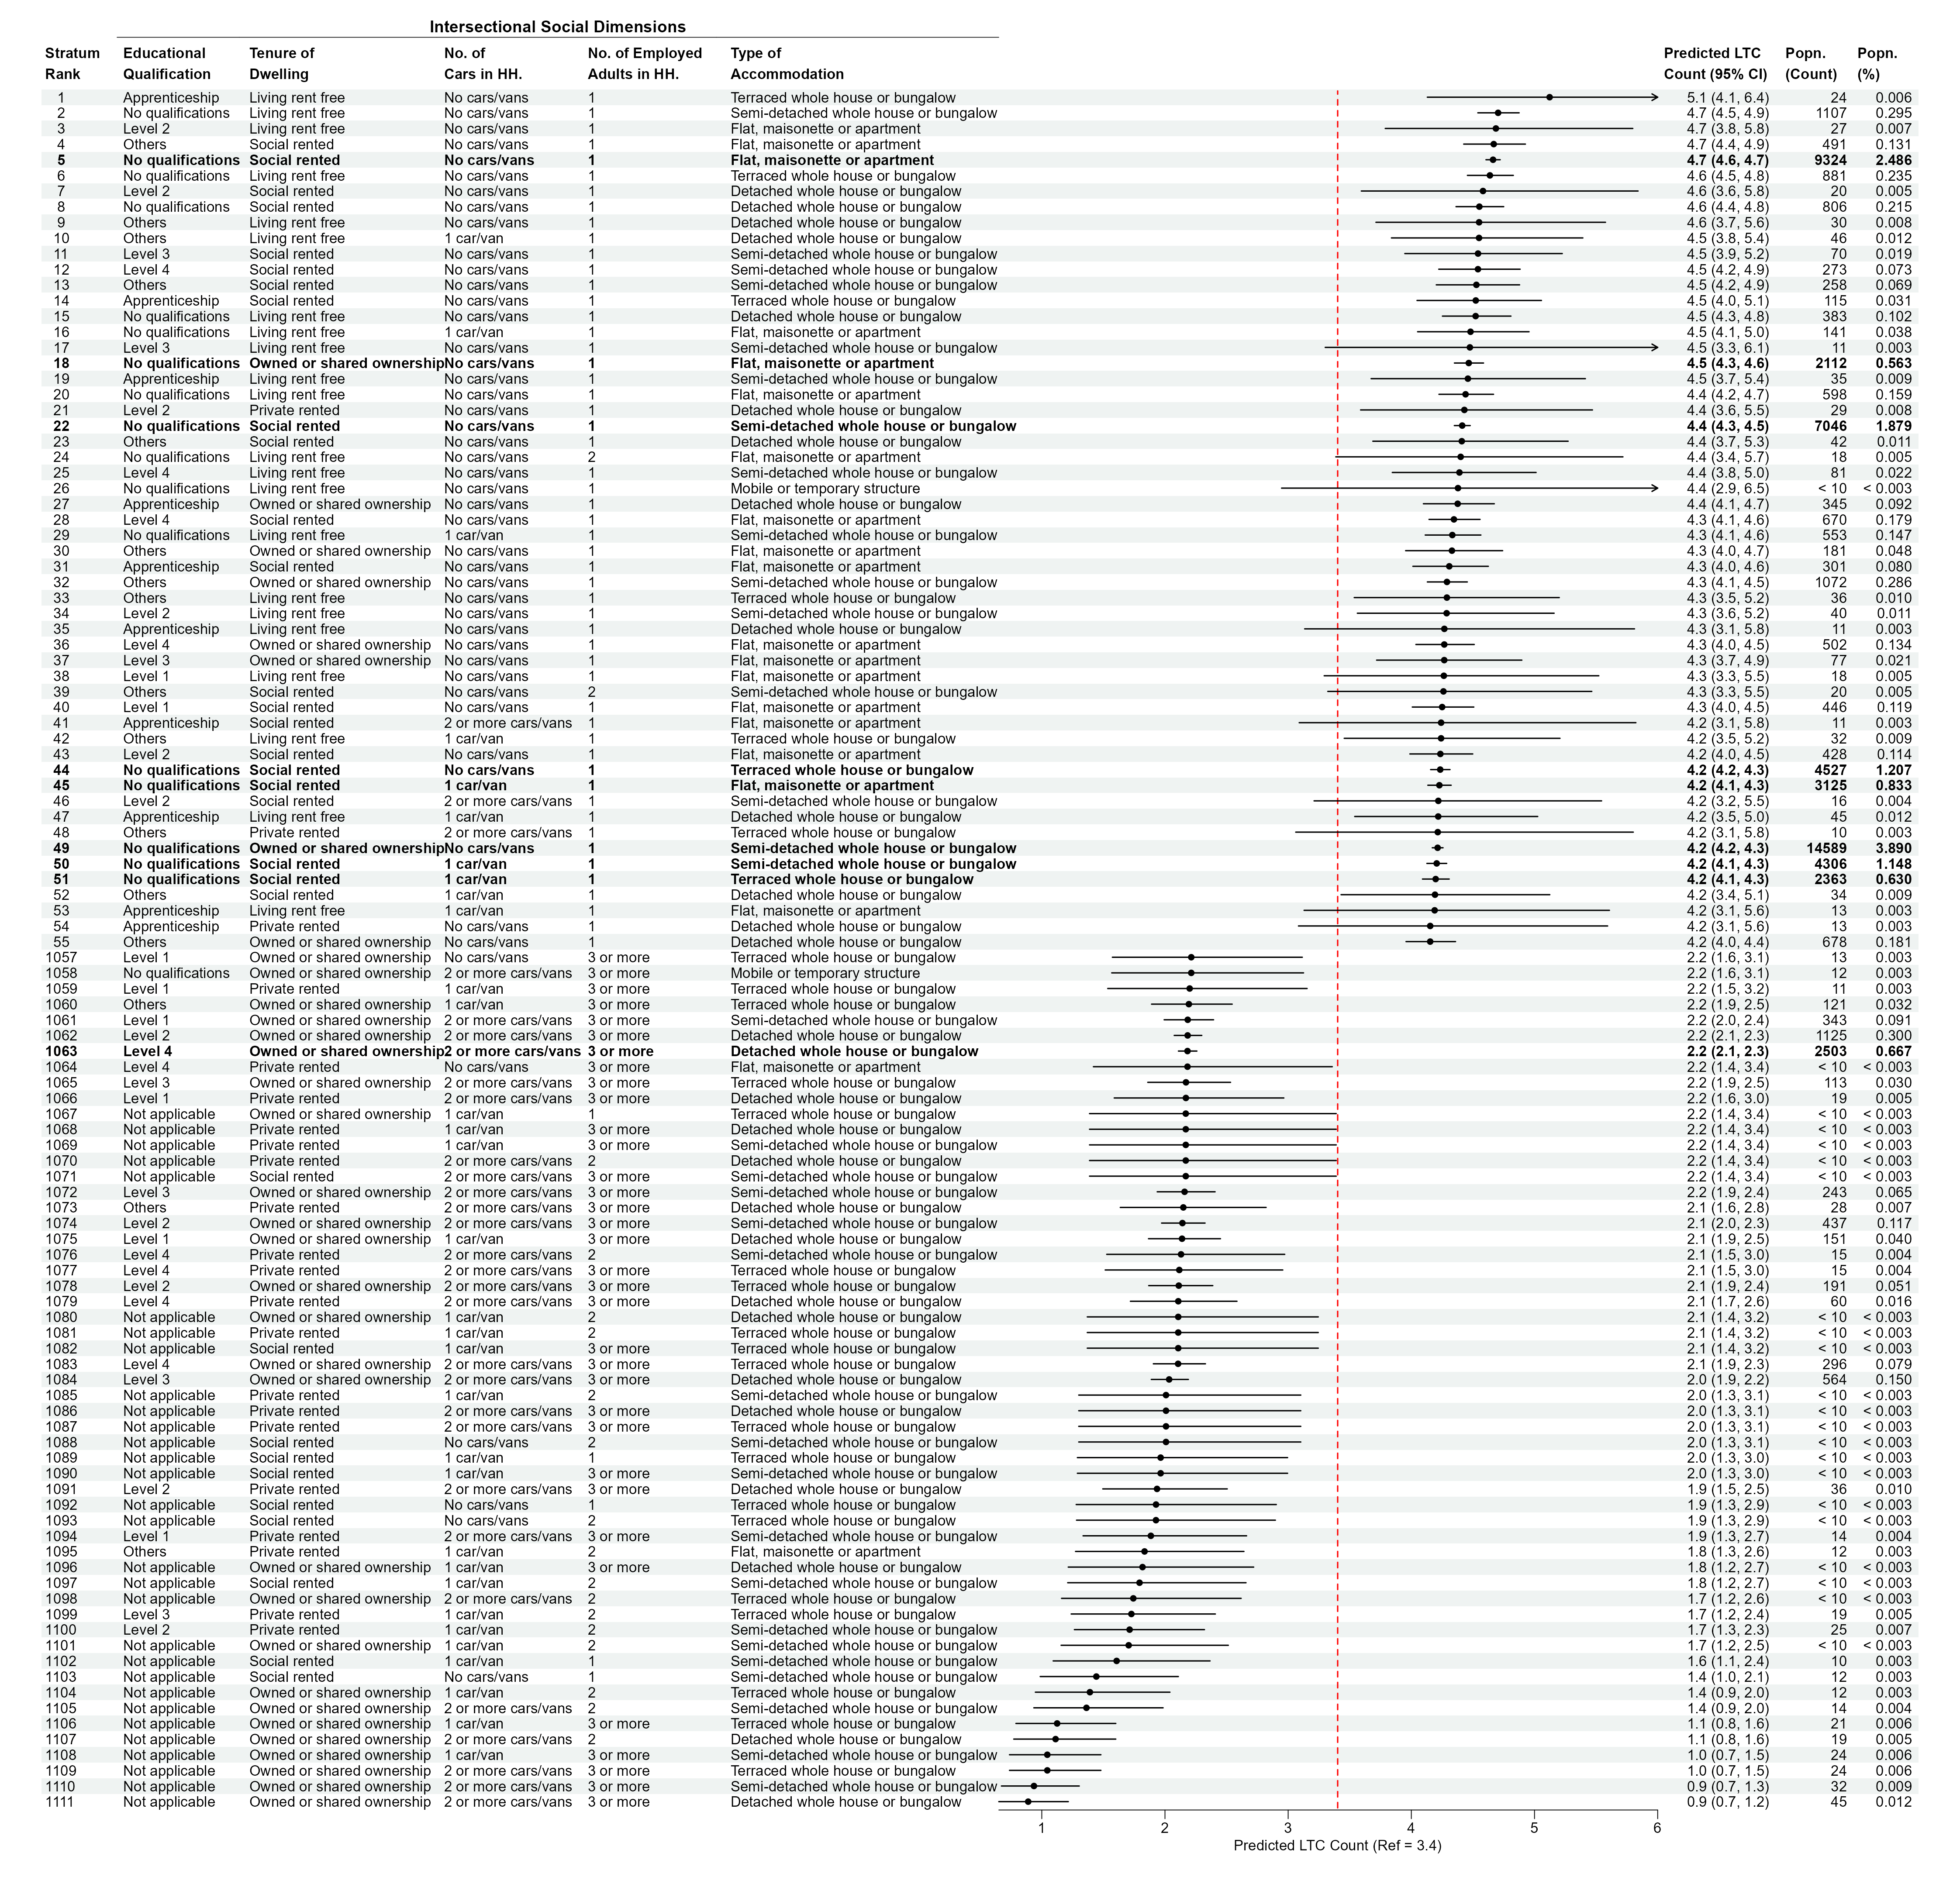
Model 3 predictions ranged from 0.89 to 5.09 across the complete set of modelled strata. Among strata containing at least 0.5% of the cohort, a prominent high-burden group comprised people with no qualifications who lived in socially rented flats, had no car or van and lived in a household with one employed adult; their predicted count was 4.66 LTCs (95% CI 4.61–4.72; n=9,324; 2.49%). The configuration's PCVs were 51.1% for qualification, 46.0% for household employment, 26.0% for vehicle access, 23.1% for tenure and 3.0% for accommodation type.

Figure S2. Upper and lower 5% of predicted LTC counts in Model 4 (mnl strta 2)
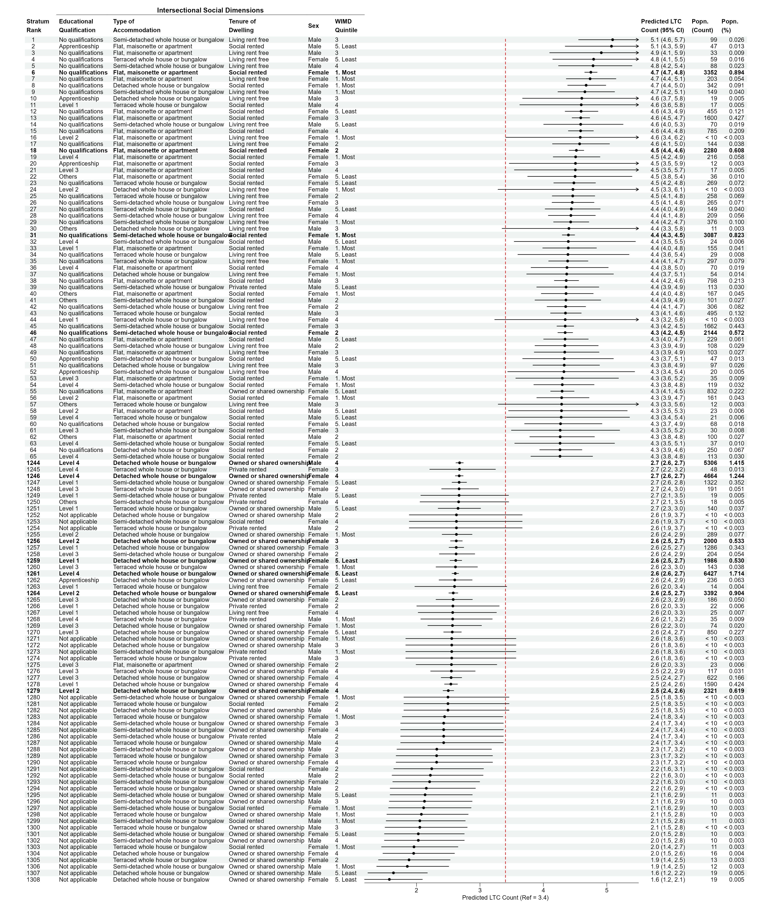
Model 4 predictions ranged from 1.57 to 5.09, a difference of 3.52 LTCs. Among strata containing at least 0.5% of the cohort, the highest predicted count was 4.75 for women with no qualifications who lived in socially rented flats in the most deprived WIMD quintile (n=3,352; 0.89%). The lowest was 2.50 for women with Level 2 qualifications who lived in owned detached accommodation in WIMD quintile 4 (n=2,321; 0.62%). Qualification and tenure had PCVs of 60.3% and 50.8%, whereas WIMD and sex had PCVs of 2.2% and 0.0%, respectively.

Figure S3. Upper and lower 5% of predicted LTC counts in Model 5 (mnl strta 1)
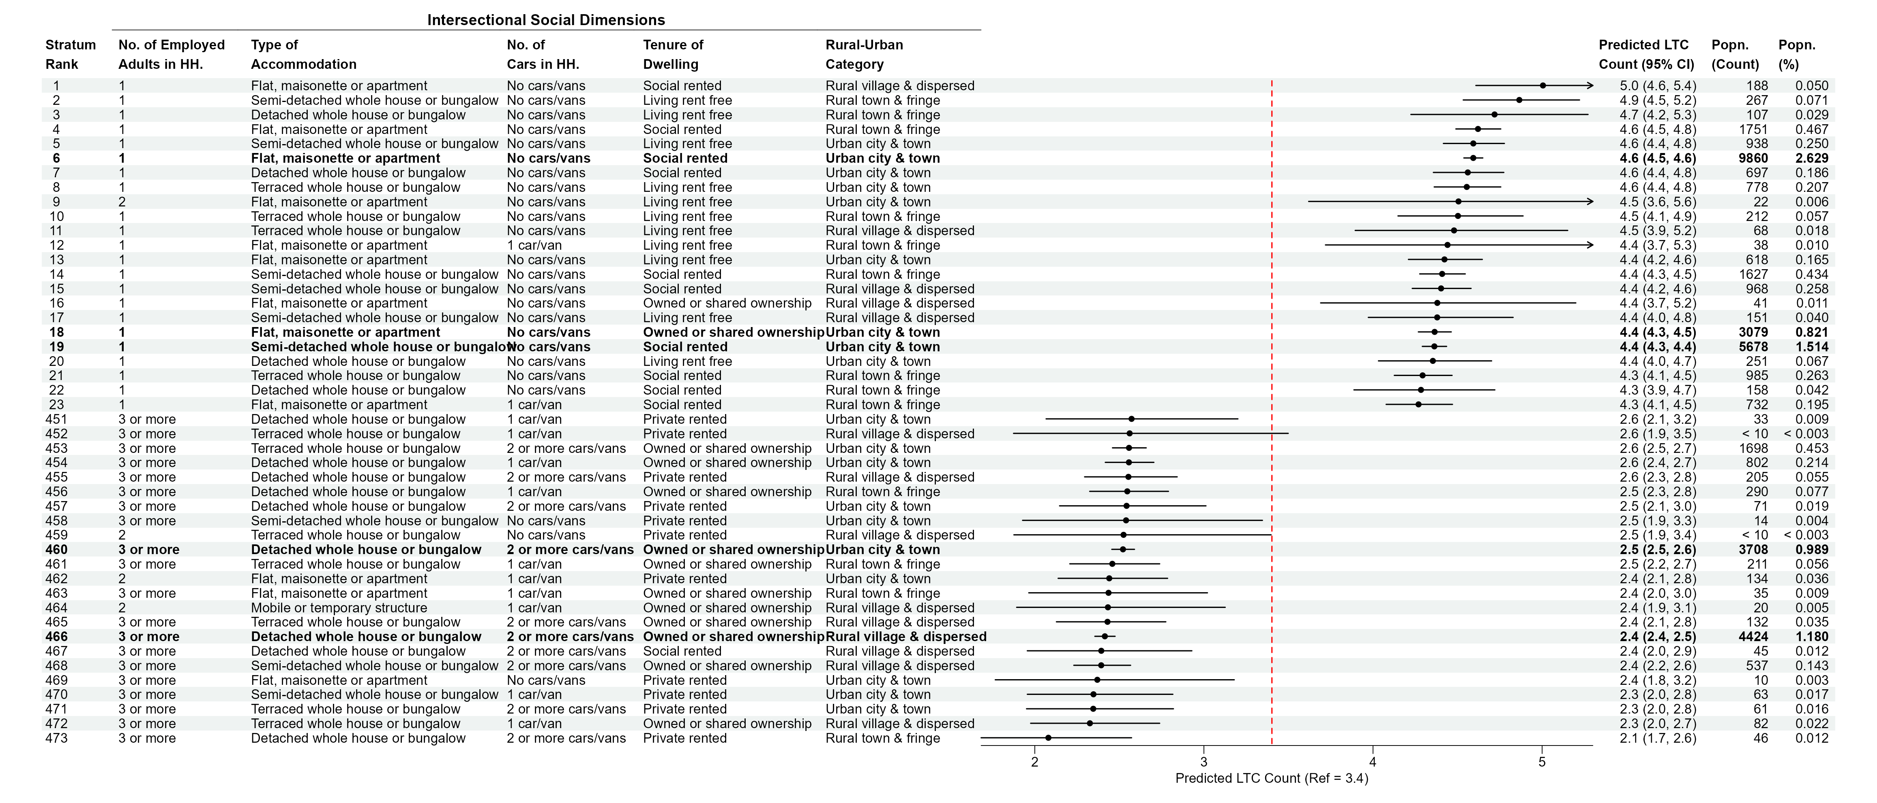
Model 5 predictions ranged from 2.08 to 5.00, a difference of 2.92 LTCs. Among strata containing at least 0.5% of the cohort, the highest predicted count was 4.59 for people in households with one employed adult who lived in socially rented flats, had no vehicle and resided in an urban city or town (n=9,860; 2.63%). The lowest was 2.41 for people in households with at least three employed adults who lived in owned detached accommodation, had at least two vehicles and resided in a rural village or dispersed setting (n=4,424; 1.18%). Household employment, vehicle access and tenure had PCVs of 52.4%, 30.3% and 28.6%, compared with 3.0% for accommodation and 1.4% for rural–urban classification.

S7. Repository-hosted analytical resources
The companion GitHub repository contains the following disclosure-controlled resources. These files complement, but are not required to understand, the methods and principal results reported in the manuscript and this supplementary document.

Supplementary Material 2. R Markdown analytical workflow
Supplementary Material 2 comprises two scripts representing the deliberately separated secure and downstream stages of the workflow:
- maida_of_mm_analysis_script.Rmd is the authoritative secure-stage script used within the SAIL Trusted Research Environment to prepare the analytical cohort, undertake VIVI screening and fit the MAIHDA models.
- maihda_of_mm_2025.Rmd reads approved, disclosure-controlled outputs and prepares downstream publication figures and tabulations using repository-relative paths.
The confidential individual-level records required by the secure-stage script are not included in the repository.

Supplementary Material 3. Null-model stratum predictions
MAIDA_nll_mhda_all_ranef_rspns.xlsx contains one worksheet for each of the 15 null MAIHDA configurations. Columns identify the composite stratum and constituent categories, population count and percentage, precision-weighted predicted LTC count, lower and upper 95% confidence limits, and random-effect information. Worksheets are ordered by predicted count. These are the complete values underlying Figures 4 and 5 in the manuscript and Figures S1–S3 in this document.

Supplementary Material 4. Fully adjusted stratum predictions
MAIDA_fll_mhda_all_ranef_rspns.xlsx contains the corresponding response-scale predictions from the fully adjusted models. Because all five constituent dimensions are included as fixed main effects, the stratum random effect describes residual departure from the fitted additive structure. These estimates support examination of unusually positive or negative residual intersections, although residual variance was very small in the leading configurations.

Supplementary Material 5. Complete MAIHDA parameter tables
supplementary_materials/complete_maihda_parameter_tables.md contains Tables S6–S20: the seven-column parameter tabulations for the null model, five partially adjusted models and fully adjusted model for each of the 15 five-way configurations. The raw variable codes and reference categories are defined in Table S2 of this document, and Tables S4–S5 provide the concise variance and PCV summaries needed for substantive interpretation.
Although the retained workbook filenames use MAIDA, the analytical method is MAIHDA. The filenames are kept unchanged to preserve continuity with the completed workflow. All public files must continue to comply with SAIL disclosure-control requirements.

S8. Reproducibility record
The analysis was specified as follows:
- R and package versions assumed for this record: R 4.6.1; gbm 2.3.1; vivid 0.3.0; glmmTMB 1.1.14; performance 0.17.1; insight 1.5.2; modelbased 0.16.0; sjPlot 2.9.0; gtsummary 2.5.1; and ggplot2 4.0.3.
- GBM screen: Poisson loss; 80% training fraction; fivefold cross-validation; 100 trees; interaction depth 5; minimum terminal-node size 10; shrinkage 0.1; bag fraction 0.5; retained data; parallel processing on all but one detected core. The depth setting permits interaction structures involving up to five predictors.
- VIVI: model-agnostic permutation importance; four permutations; unnormalised H-statistic; maximum partial-dependence sample 500; grid size 50; reordering enabled; seed 2211 immediately before VIVI computation; network threshold 0.001.
- Configuration design: five high-VIVI, five low-VIVI and five substantively specified mixed intersections, each containing five dimensions; WIMD and rural–urban category deliberately retained in selected mixed models.
- MAIHDA: glmmTMB negative-binomial type 1 models with log link, constant dispersion, no zero inflation, maximum-likelihood estimation, Laplace integration and default nlminb optimisation. Reproducible convergence checks comprise optimiser code/message, finite estimates and a positive-definite Hessian.
- Variance measures: adjusted ICC from performance::icc() using the default lognormal residual approximation; random-intercept variance from insight::get_variance(); PCV calculated from the change in random-intercept variance.
- Predictions: group-level coefficients from estimate_grouplevel(); response-scale counts and intervals from estimate_relation(); link-scale estimates from estimate_link(); population counts below 10 masked.
- Governance: SAIL Information Governance Review Panel approval under Project 1350.
- Reproducible code: the two R Markdown scripts are provided as Supplementary Material 2 in the companion GitHub repository. Seed 2211 is used for the VIVI procedure; for exact refitting of the stochastic GBM, a seed should also be set immediately before gbm(). The secure-stage script records interaction.depth = 5 explicitly and includes a convergence-audit helper.
The repository also contains a README.md study overview and a REPRODUCIBILITY.md guide documenting the secure-data boundary, required approved inputs and the separation between Trusted Research Environment analysis and downstream publication processing. Supplementary Materials 3–5 provide the disclosure-controlled numerical outputs needed to audit the manuscript's reported estimates without releasing individual-level records.

References cited in Supplementary Material 1
Brooks, M. E., Kristensen, K., van Benthem, K. J., Magnusson, A., Berg, C. W., Nielsen, A., Skaug, H. J., Mächler, M., & Bolker, B. M. (2017). glmmTMB balances speed and flexibility among packages for zero-inflated generalized linear mixed modeling. The R Journal, 9(2), 378–400. https://doi.org/10.32614/RJ-2017-066
Evans, C. R. (2024). Overcoming combination fatigue: Addressing high-dimensional effect measure modification and interaction in clinical, biomedical, and epidemiologic research using multilevel analysis of individual heterogeneity and discriminatory accuracy (MAIHDA). Social Science & Medicine, 340, 116493. https://doi.org/10.1016/j.socscimed.2023.116493
Evans, C. R., Leckie, G., Subramanian, S. V., Bell, A., & Merlo, J. (2024). A tutorial for conducting intersectional multilevel analysis of individual heterogeneity and discriminatory accuracy (MAIHDA). SSM - Population Health, 26, 101664. https://doi.org/10.1016/j.ssmph.2024.101664
Humbert, A. L. (2024). Methodological insights into multilevel analysis of individual heterogeneity and discriminatory accuracy: An empirical examination of the effects of strata configurations on between-stratum variance and of fixed effects across hierarchical levels. PLOS ONE, 19(3), e0297561. https://doi.org/10.1371/journal.pone.0297561
Inglis, A., Parnell, A., & Hurley, C. B. (2022). Visualizing variable importance and variable interaction effects in machine learning models. Journal of Computational and Graphical Statistics, 31(3), 766–778. https://doi.org/10.1080/10618600.2021.2007935
Kristensen, K., Nielsen, A., Berg, C. W., Skaug, H., & Bell, B. M. (2016). TMB: Automatic differentiation and Laplace approximation. Journal of Statistical Software, 70(5), 1–21. https://doi.org/10.18637/jss.v070.i05
Lüdecke, D., Ben-Shachar, M. S., Patil, I., Waggoner, P., & Makowski, D. (2021). performance: An R package for assessment, comparison and testing of statistical models. Journal of Open Source Software, 6(60), 3139. https://doi.org/10.21105/joss.03139
Lyons, R. A., Jones, K. H., John, G., Brooks, C. J., Verplancke, J.-P., Ford, D. V., Brown, G., & Leake, K. (2009). The SAIL databank: Linking multiple health and social care datasets. BMC Medical Informatics and Decision Making, 9, 3. https://doi.org/10.1186/1472-6947-9-3
MacRae, C., Morales, D., Mercer, S. W., Lone, N., Lawson, A., Jefferson, E., McAllister, D., van den Akker, M., Marshall, A., Seth, S., Rawlings, A., Lyons, J., Lyons, R. A., Mizen, A., Abubakar, E., Dibben, C., & Guthrie, B. (2023). Impact of data source choice on multimorbidity measurement: A comparison study of 2.3 million individuals in the Welsh National Health Service. BMC Medicine, 21, 309. https://doi.org/10.1186/s12916-023-02970-z
Nakagawa, S., Johnson, P. C. D., & Schielzeth, H. (2017). The coefficient of determination $R^{2}$ and intra-class correlation coefficient from generalized linear mixed-effects models revisited and expanded. Journal of the Royal Society Interface, 14(134), 20170213. https://doi.org/10.1098/rsif.2017.0213
R Core Team. (2026). R: A language and environment for statistical computing (Version 4.6.1). R Foundation for Statistical Computing.

