The influence of the oxygen vacancies on the Pt/TiO2 single-atom catalyst – a DFT study

Yongkang Zhang, Yuhang Wang, and Fengping Wang*

School of Mathematics and Physics, University of Science and Technology Beijing, Beijing 100083, P.R. China

*Corresponding authors: Fengping Wang (fpwang@ustb.edu.cn).
Picture 1. All computational model after structural relaxation. All models are perfect surfaces and do not contain oxygen vacancies.
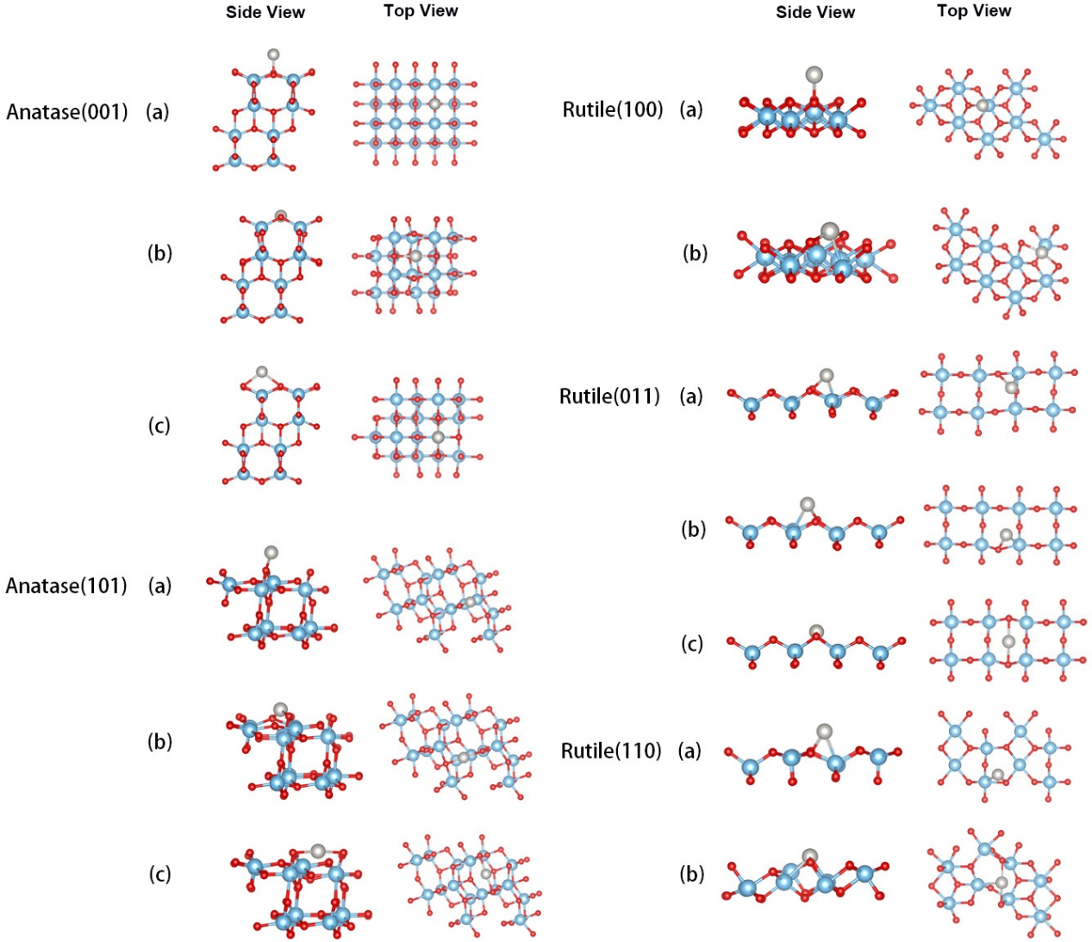
Picture 2. All computational model after structural relaxation, which contain oxygen vacancies.
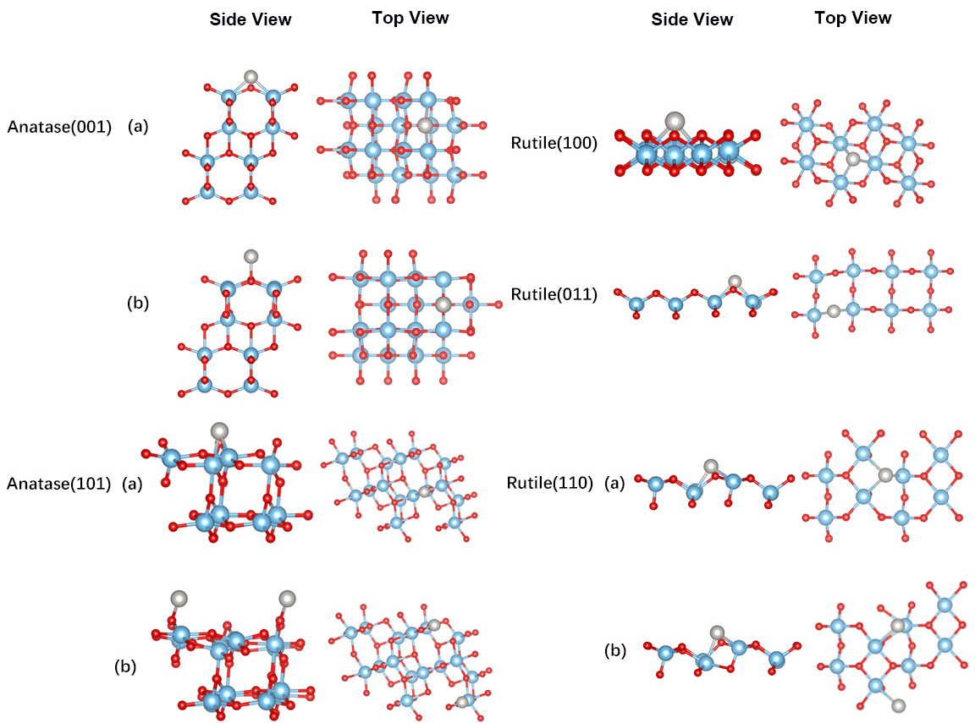

Table S1. The adsorption energy of all TiO₂ surface loaded Pt atom models in the article, E(ads) = E(Pt+TiO₂)-E(TiO₂)-E(Pt). The red value indicates the model with the largest adsorption energy. Unit is eV.

Model | E(TiO2+Pt) | E(TiO2) | E(Pt) | E(ads)
Anatase(001) (a) | -421.803 | -420.065 | -0.617 | -1.12
Anatase(001) (b) | -423.363 | -420.065 | -0.617 | -2.68
Anatase(001) (c) | -421.569 | -420.065 | -0.617 | -0.87
Anatase(001)+Vo (a) | -415.638 | -409.602 | -0.617 | -5.42
Anatase(001)+Vo (b) | -411.704 | -409.602 | -0.617 | -1.89
Anatase(101) (a) | -422.481 | -420.255 | -0.617 | -1.61
Anatase(101) (b) | -422.706 | -420.255 | -0.617 | -1.83
Anatase(101) (c) | -423.554 | -420.255 | -0.617 | -2.68
Anatase(101)+Vo (a) | -412.991 | -410.487 | -0.617 | -1.89
Anatase(101)+Vo (b) | -416.189 | -410.487 | -0.617 | -5.08
Rutile(100) (a) | -211.182 | -208.902 | -0.617 | -1.66
Rutile(100) (b) | -211.543 | -208.902 | -0.617 | -2.02
Rutile(100)+Vo (a) | -205.342 | -199.436 | -0.617 | -5.29
Rutile(011) (a) | -209.237 | -206.513 | -0.617 | -2.11
Rutile(011) (b) | -208.920 | -206.513 | -0.617 | -1.79
Rutile(011) (c) | -210.226 | -206.513 | -0.617 | -3.09
Rutile(011)+Vo (a) | -202.649 | -195.896 | -0.617 | -6.14
Rutile(110) (a) | -206.551 | -204.181 | -0.617 | -1.75
Rutile(110) (b) | -210.163 | -204.181 | -0.617 | -5.36
Rutile(110)+Vo (a) | -200.432 | -193.188 | -0.617 | -6.63
Rutile(110)+Vo (b) | -200.856 | -193.188 | -0.617 | -7.05

Table S2. D-band center energy of different adsorption model. Surfaces containing oxygen vacancies are represented by Vo. Unit is eV. The energy has subtracted the Fermi level.

Model | E(ads)/eV | d-band center/eV | Model | E(ads)/eV | d-band center/eV
Anatase(001) (a) | -1.12 | -1.02 | Rutile(100) (a) | -1.66 | -1.21
Anatase(001) (b) | -2.68 | -1.43 | Rutile(100) (b) | -2.02 | -1.52
Anatase(001) (c) | -0.87 | -1.15 | Rutile(100)+Vo (a) | -5.29 | -0.87
Anatase(001)+Vo (a) | -5.42 | -1.17 | Rutile(011) (a) | -2.11 | -1.59
Anatase(001)+Vo (b) | -1.89 | -2.07 | Rutile(011) (b) | -1.79 | -1.20
Anatase(101) (a) | -1.61 | -0.86 | Rutile(011) (c) | -3.09 | -1.93
Anatase(101) (b) | -1.83 | -2.01 | Rutile(011)+Vo (a) | -6.14 | -1.40
Anatase(101) (c) | -2.68 | -1.41 | Rutile(110) (a) | -1.75 | -1.12
Anatase(101)+Vo (a) | -1.89 | -2.20 | Rutile(110) (b) | -5.36 | -1.84
Anatase(101)+Vo (b) | -5.08 | -1.17 | Rutile(110)+Vo (a) | -6.63 | -0.77
 |  |  | Rutile(110)+Vo (b) | -7.05 | -0.68
Table S3. Cohesive energy of Pt. E(coh)=(E(bulk)-N(E(Pt)))/N. Unit is eV.
E(bulk) | E(Pt) | N | E(coh)
-24.457 | -0.617 | 4 | -5.48

