Supplementary Methods
fMRI data preprocessing
Preprocessing of the functional images involved the following steps: (1) discarding the first 10 time points of functional images to account for magnetic stabilization; (2) slice timing correction to compensate for temporal shifts of different slices; (3) within-subject fMRI image realignment to estimate and spatially correct for head motions of different volumes; (4) rigid-body T1 image registration to the functional mean image and functional image normalization to the Montreal Neurological Institute (MNI) standard space using the T1 images; (5) functional image resampling to 3×3×3 mm³ voxel size followed by regressing out confounding signals, including linear trends, white matter (WM), cerebrospinal fluid (CSF), and Friston’s 24 head motion parameters; (6) bandpass filtering (0.01–0.1 Hz) to suppress low-frequency drift and physiological noises (breathing and heartbeat); and (7) functional image spatial smoothing using a 6 mm full-width at half-maximum (FWHM) Gaussian kernel. All data preprocessing was performed on AFNI,FSL and ANTs, MATLAB toolbox for batch fMRI data preprocessing.

Supplementary Figures

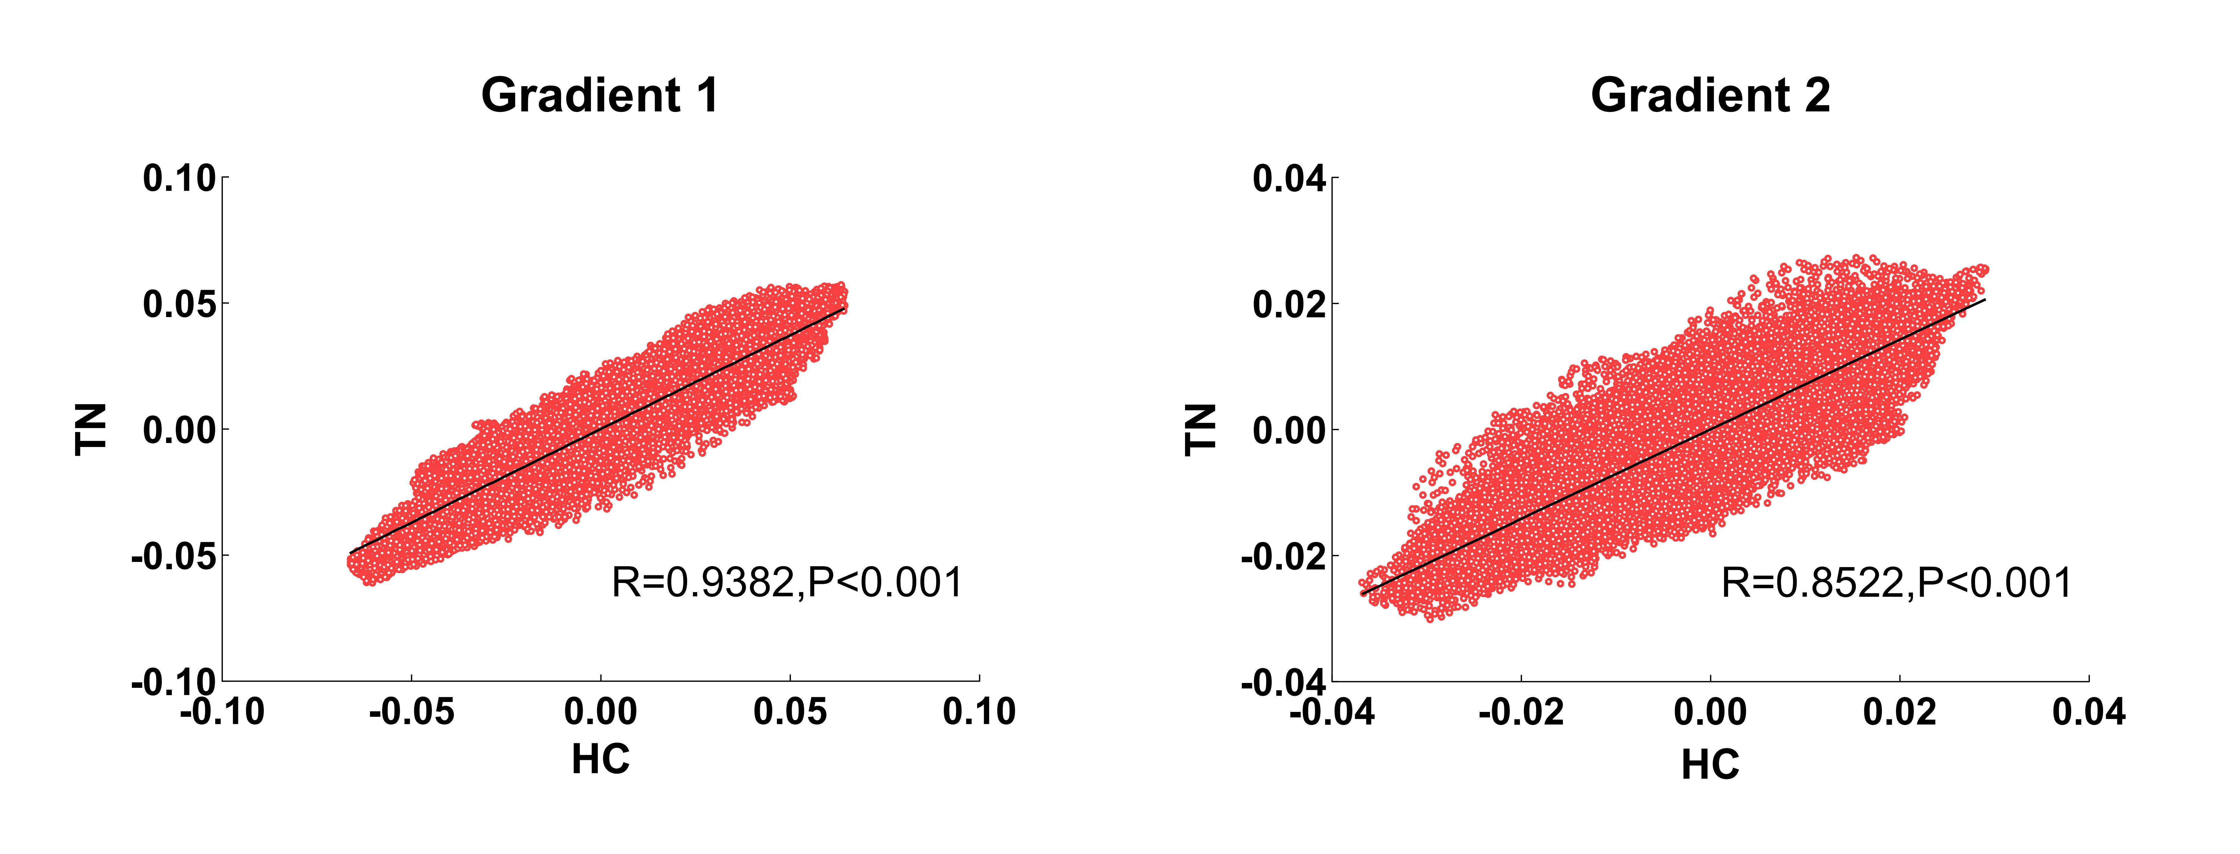
Supplementary Figure 1 Correlations of the group-averaged gradient maps between the TN and HC. These correlations were corrected for spatial autocorrelations by using a permutation test (N = 10,000). TN, Trigeminal Neuralgia; HC, healthy control.
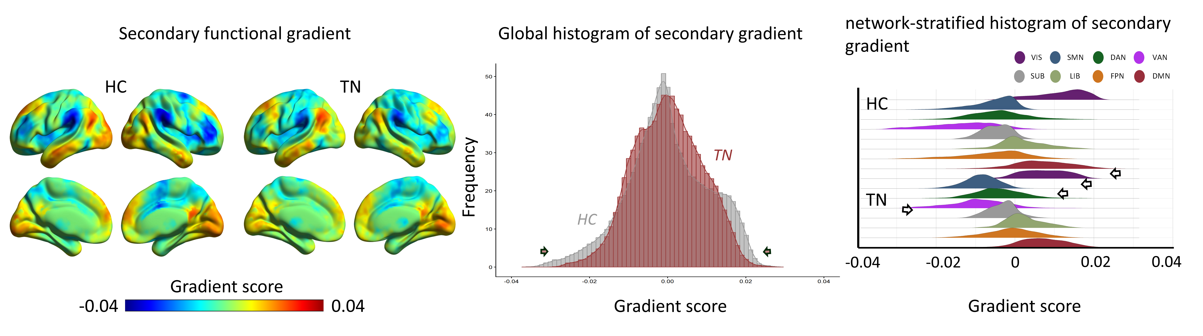
Supplementary Figure 2 Secondary connectome gradient. The group-level connectome gradient mapping of both TN (n = 35) and HC (n = 64) were calculated from group mean functional connectivity matrix. Secondary gradient mapping in patients with TN and HC (left). The global (middle) and network-stratified histogram(right) show that the extreme values in the patients with TN were contracted relative to those in the HC in the secondary gradient. The system-based differences of secondary gradient distribution between TN and HC were evaluated using two-sample t test with age and sex as covariates. A two-tailed P < 0.05 after FDR correction for multiple comparisons was considered significant. VIS, visual network; SMN, sensorimotor network; DAN, dorsal attention network; VAN, ventral attention network; SUB, subcortical regions; LIB, limbic network; FPN, frontoparietal network; DMN, default mode network. TN, Trigeminal Neuralgia; HC, healthy control.
Supplementary Figure 3 Spatial correlations between secondary gradient and gray matter volume. (A) Spatial correlation between global secondary gradient and gray matter volume. (B) Network-stratified spatial correlations between secondary gradient and gray matter volume. (C) Global and network-stratified associations between gradient and gray matter volume at the individual level and their group differences between TN and HC were measured by a two-sample t test and corrected by FDR. *, P < 0.05.

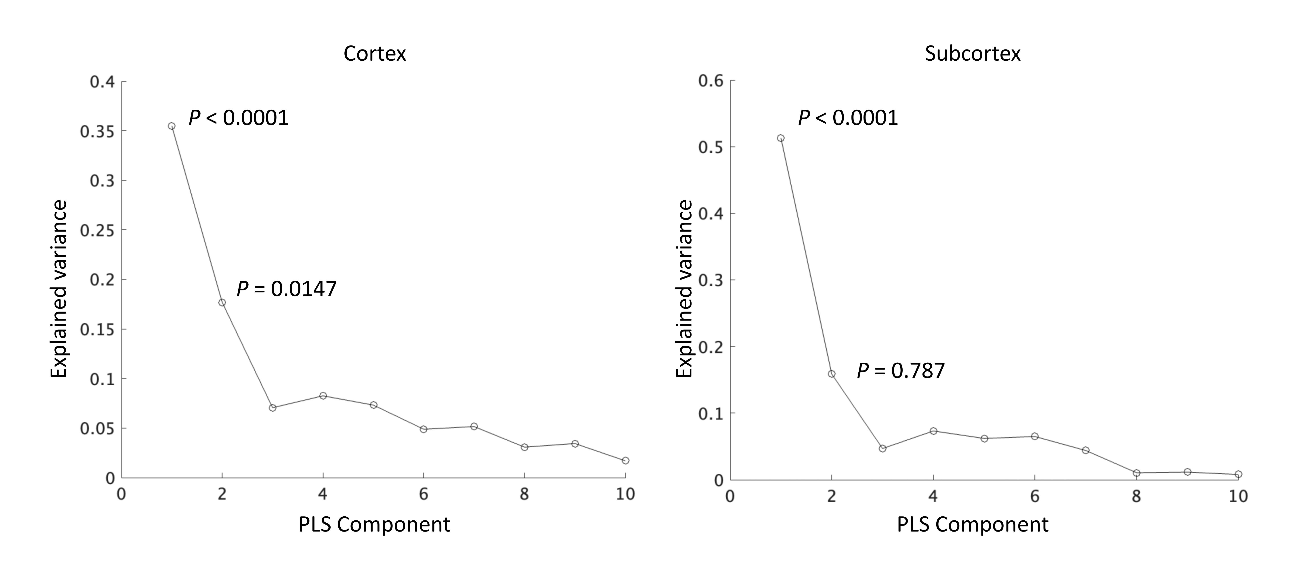
Supplementary Figure 4 The percentage of variance in the response variables explained by the components in the partial least square regression analysis. The significance level was determined by a permutation test (N = 10,000) with spatial autocorrelation corrected. PLS, partial least squares.

Supplementary Table
Supplementary Table 1 Between-group differences in the principal gradient scores of the network-stratified in the mean maps

network-stratified | t | Cohen’s d | P | FDR q
Visual network | 47.90 | 0.82 | <0.0001 | <0.0001
Sensorimotor network | 56.74 | 0.97 | <0.0001 | <0.0001
Dorsal attention network | 26.57 | 0.45 | <0.0001 | <0.0001
Ventral attention network | 0.7573 | 0.13 | =0.4489 | =0.4489
Subcortical network | 59.75 | 1.02 | <0.0001 | <0.0001
Limbic network | 47.22 | 0.81 | <0.0001 | <0.0001
Frontoparietal network | 4.062 | 0.69 | <0.0001 | <0.0001
Default mode network | 56.47 | 0.96 | <0.0001 | <0.0001
Abbreviations: FDR, false discovery rate.

