Enhancing Toughness of 3D Printed Poly (l-lactic acid) Parts by Utilizing Long-chain Branching
Rui Zhang ¹*, Rene Sattler ^{2,3}, Paul-Maximilian Runge ⁴, Mengxue Du ¹, Bao Wang ⁵, Xintong Zhao ⁶, Katalee Jariyavidyanont ¹, Holm Altenbach ⁴, Mario Beiner ^{2,3}, Christoph Schick ⁷, René Androsch ¹
¹ Interdisciplinary Center for Transfer-Oriented Research in Natural Sciences, Martin Luther University Halle-Wittenberg, Hoher Weg. 7A, D-06120 Halle (Saale), Germany. ² Fraunhofer-Institute for Microstructure of Materials and Systems IMWS, Walter-Hülse-Str. 1, D-06120 Halle (Saale), Germany. ³ Faculty of Natural Sciences II, Martin Luther University Halle-Wittenberg, Kurt-Mothes-Str. 2, D-06120 Halle (Saale), Germany. ⁴ Institute for Materials, Technologies and Mechanics, Otto von Guericke University Magdeburg, Universitätsplatz 2, D-39106 Magdeburg, Germany. ⁵ Institute of Zhejiang University-Quzhou, Zheda Road No. 99, 324000 Quzhou, China. ⁶ State Key Laboratory of Polymer Science and Technology, Changchun Institute of Applied Chemistry, Chinese Academy of Sciences, Renmin Street 5625, D-130022 Changchun, China ⁷ Institute of Physics & Competence Center CALOR, University of Rostock, Albert-Einstein-Str. 23−24, 25, D-18059 Rostock, Germany. ✉ e-mail: rui.zhang@iwetfn.uni-halle.de.

S1. Crystallization kinetics measured using Flash DSC and DSC
The crystallization kinetics of all PLLA samples were re-examined using commercial fast scanning calorimetry (Flash DSC 2+) and conventional differential scanning calorimetry, with results presented in Figure S1 and Figure S2, respectively. The Flash DSC 2+ instrument (Mettler Toledo, Greifensee, Switzerland) was coupled to a Huber TC100 intracooler (Huber, Offenburg, Germany), with the supporting system maintained at approximately 173 K. Measurements were performed on a USF1 chip sensor. The same PLLA grades as those used in the main text were tested following the temperature-time protocol shown in Figure S1A, with multiple repeat measurements conducted to further ensure reproducibility.
The half-times of crystallization are plotted in Figure S1B. The results are in good agreement with the experimental data acquired on a half-commercial FSC from Funktionale Materialien Rockst e.V..

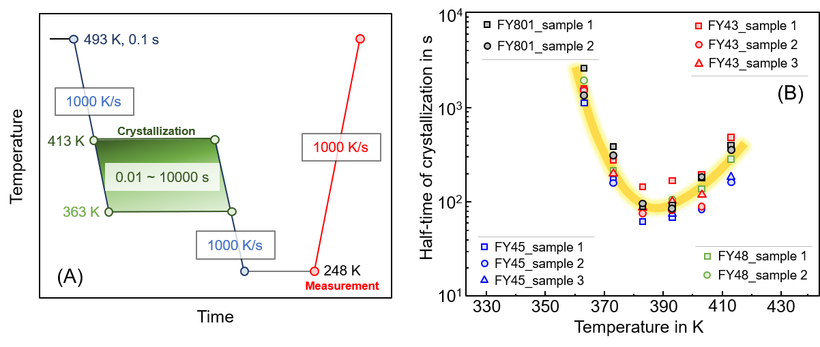
Figure S1. (A) Temperature-time protocol for investigating isothermal crystallization kinetics by Flash DSC. (B) Half-time of crystallization as a function of temperature.
Isothermal crystallization kinetics were further investigated through DSC using the temperature-time protocol shown in Figure S2A. The difference from the FSC tests lies in the cooling rate from the melt to the target crystallization temperature: DSC uses ~0.83 K/s, which is significantly lower than the 5,000 K/s for the Rostock FSC and 1,000 K/s for the Flash DSC used in this work.
As shown in Figure S2B, crystallization rates measured by DSC in the temperature range of 363–413 K increase systematically with increasing branch point number. This observation is consistent with the references (Ind. Eng. Chem. Res. 2011, 50, 13789–13798; Ind. Eng. Chem. Res. 2012, 51, 13670–13679; Cryst. Eng. Commun. 2014, 16, 2452–2461), which also used DSC for characterization.
We propose that the slow cooling rate of DSC suppresses crystal growth during cooling, but does not suppress nucleation. As branch point content increases, more nucleation occurs during the cooling process because the critical cooling rate for nucleation increases. The excess nuclei formed during cooling subsequently accelerate the overall isothermal crystallization process, leading to a different result compared to FSC measurements.

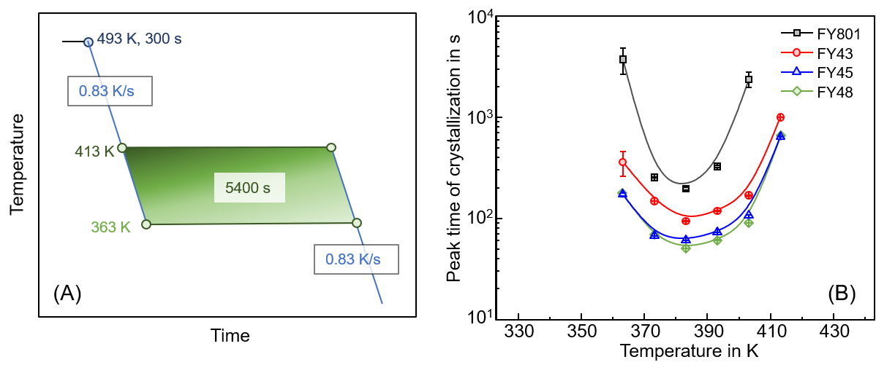
Figure S2. (A) Temperature-time protocol for investigating isothermal crystallization kinetics. (B) Peak-time of crystallization as a function of temperature.

