Supplementary Materials
Apparent Protection, Uncertain Harm: An Estimand Decomposition of Internet Use and Late-Life Depressive Symptoms

Supplementary Text
Supplementary Text 1. Detailed Literature Review and Theoretical Framework
Supplementary Text 2. Clinical Interpretation: Statistical vs. Clinical Significance
Supplementary Text 3. The Healthy-User Mortality Paradox in Detail
Supplementary Text 4. Detailed Strengths and Limitations

Supplementary Methods
Supplementary Methods 1. Complete IPCW Weight Construction and Diagnostics
Supplementary Methods 2. E-value Calculation Formulas
Supplementary Methods 3. Imai Causal Mediation Framework
Supplementary Methods 4. Fine-Gray Subdistribution Model Specification
Supplementary Methods 5. Cinelli–Hazlett Robustness Values for Continuous-Outcome Within-Person Estimates
Supplementary Methods 6. IPCW Re-weighting Magnitude (Pre vs Post)
Supplementary Methods 7. Identification Strategy: Within-Person Fixed Effects vs Linear Mixed Model

Supplementary Results
Supplementary Results 1. Complete Progressive Attenuation Series (M0–M5)
Supplementary Results 2. Spontaneous Remission Analysis
Supplementary Results 3. Complete Competing-Risk Analysis
Supplementary Results 4. Complete Sensitivity Analyses
Supplementary Results 5. Exploratory Mediation Analysis (Sleep Duration)

Supplementary Table Notes
Table S1. Association between internet use and CES-D-10 score across identification strategies (2015 wave)
Table S2. Propensity-score weighting diagnostics
Table S3. Association between internet use and CES-D-10 score under alternative propensity-score weighting strategies (2015 wave)
Table S4. Negative-control outcomes: adjusted association between internet use and arthritis and cancer, by wave
Table S5. Distribution of depressive-symptom trajectory categories by baseline internet-use
Table S6. Competing-risk analysis: cause-specific Cox and Fine-Gray estimates for incident elevateddepressive symptoms (death as the competing event)
Table S7. Sensitivity analyses of the within-person fixed-effects association between internet use and CES-D-10
Table S8. Mediation analysis: sleep duration as a candidate mediator of the internet use–depressive symptoms association
Table S9. Robustness and sensitivity to unmeasured confounding
Table S10. Within-person fixed-effects estimates: full cohort versus initiator subset
Table S11. Negative-control outcomes across nine chronic conditions
Table S12. Within-person stability of internet-use exposure
Table S13. Linear mixed-model coefficients for internet use and depressive symptoms

Supplementary Figure Notes
Figure S1. Standardised mean differences between internet users and non-users across CHARLS waves, 2011–2018
Figure S2. Standardised mean differences between internet users and non-users, by baseline characteristic and wave, CHARLS 2011–2018
Figure S3. CES-D-10 score distributions by internet-use status and wave, CHARLS 2011–2018
Figure S4. Sequential covariate adjustment and the association between internet use and depressive symptoms
Figure S5. Covariate balance before and after overlap weighting, 2015 wave
Figure S6. Weighted CES-D-10 trajectories by trial arm, target-trial emulation
Figure S7. E-values for unmeasured confounding across identification strategies, 2015 wave

Supplementary References

Supplementary Text
Supplementary Text 1. Detailed Literature Review and Theoretical Framework
The empirical literature on internet use and depressive symptoms in older adults has grown rapidly but remains inconsistent. Observational studies variously report that internet users show 20–40% lower odds of elevated depressive symptoms, that heavy or social-media-focused use is associated with worse mental health, and that the relationship follows a U-shaped pattern in which moderate use appears protective while both abstention and heavy use elevate risk. Meta-analyses attempting to synthesise this literature yield pooled estimates ranging from protective to null, with high heterogeneity (I² > 70%) persisting even after stratification by region, age and study quality. This inconsistency is more compatible with systematic bias than with a well-established causal effect.
Observational studies of internet use and depressive symptoms in middle-aged and older adults have produced estimates spanning the full spectrum—from apparent protection through null findings to signals of harm. [1-7] A meta-analysis of 182 studies reported small but significant positive associations between social media use and depression; problematic use, in particular, was associated with poorer mental health. [5] Among Chinese retirees, social media addiction carried a 2.5-fold elevation in depression risk. [6] Fixed-effects analyses from Europe show a similar pattern: during the COVID-19 pandemic, internet users aged 65–70 years were more likely to report depression than non-users. [7] The intervention literature is similarly inconsistent: pooled effects of digital mental health tools remain modest and are accompanied by considerable between-study heterogeneity. [8]
Three methodological problems likely account for this discordance.
Selection bias. Internet users are not a random subset of older adults: they are younger, more educated, wealthier, more urban and physically healthier [9]. In CHARLS itself, the education standardised mean difference between users and non-users exceeds 1.0 at every wave—a degree of imbalance rarely tolerated even in non-randomised comparisons. The confounders driving this selection (digital literacy, intrinsic motivation, social support, personality traits, childhood cognitive reserve) are largely unmeasured and time-invariant, making them resistant to standard covariate adjustment. Any cross-sectional or naive-longitudinal regression will attribute the lower baseline depressive symptoms of this advantaged group to internet use, producing a spurious protective association.
Reverse causation and bidirectionality. Depressive symptoms and internet use plausibly influence each other in both directions. Depressive symptoms can reduce motivation and social engagement and thereby internet use (withdrawal); conversely, they may promote escapist or compulsive use. The net association depends on which pathway dominates in a given sample—potentially explaining why some studies find protection (withdrawal dominates) and others find harm (escapism dominates). Resolving this requires explicit directionality tests (lead/placebo-lead designs) and restriction to baseline non-depressed samples, which most prior studies lack.
Exposure misclassification. "Internet use" is operationalised inconsistently across studies: binary ever/never items, frequency categories, device-ownership proxies. More problematically, variable names in large surveys are not self-explanatory, and researchers who skip codebook verification may inadvertently select items that measure related but distinct constructs (for example, cognitive self-assessment rather than internet behaviour), creating same-source (self-prediction) designs. Additionally, naive handling of missing responses (assuming non-response equals non-use) systematically misclassifies exposure in ways that can bias estimates in either direction.
To our knowledge, no prior study has addressed all three problems simultaneously. Most rely on cross-sectional or naive-longitudinal regressions with a handful of covariates—designs that cannot, in principle, separate a causal effect from selection, because the principal confounders are unmeasured and time-invariant. Few employ within-person identification [10] (which differences out stable confounders), target-trial emulation [11] (which handles treatment-initiation timing), negative-control outcomes [12] (which detect residual confounding), or sensitivity analyses for unmeasured confounding (E-values) [13]
Supplementary Text 2. Clinical Interpretation: Statistical vs. Clinical Significance
The mixed-model slope (+0.094 CES-D points per year) is statistically significant (p = 0.021) but modest in absolute terms. No formally established minimum clinically important difference (MCID) exists for the CES-D-10; as a rough benchmark, changes of about 1–2 points are commonly regarded as practically meaningful, and +0.094 per year would take over a decade to accumulate to that range at the individual level. However, three considerations bear on its relevance.
First, at the population level, if a large proportion of older adults initiate internet use, the cumulative public-health impact over years of exposure may be non-trivial even if the per-year increment is small. Second, the secondary outcome—new-onset elevated symptoms (CES-D-10 ≥10)—is a clinically meaningful binary endpoint that is not subject to the continuous-score MCID concern; however, the between-person hazard ratio for this endpoint (0.70) is itself selection-dominated and does not support a protective interpretation. Third, and most relevant to policy, the direction of the within-person effect is opposite to the protective hypothesis underlying digital-inclusion programmes. A consistent harmful direction, even if modest, is sufficient to question the preventive premise: caution is warranted when the expected direction (protection) fails to materialise, even in the absence of a large effect.
The fitted linear mixed model also implies a trajectory crossover: the internet main effect (−1.09, the model-implied baseline advantage of users) combined with the internet × time slope (+0.094 per year) yields a crossover at approximately 11.6 years (1.09 / 0.094), after which a user and a non-user with identical covariates would have equal CES-D, with the user worse off thereafter. Because the main effect is itself selection-affected, this crossover should be read as an illustrative feature of the fitted trajectory, consistent with a slow adverse signal, rather than as a causal forecast.
Supplementary Text 3. The Healthy-User Mortality Paradox in Detail
The cause-specific Cox model (death censored) and the Fine-Gray subdistribution model, both oriented as ever-user versus never on the same sample, converge on the same protective estimate (HR/sHR ~0.74). This convergence illustrates the reach of healthy-user selection: it shapes not only baseline depressive symptoms but also who lives long enough to be counted. Internet users die less (they are younger and more educated), so more survive to experience elevated depressive symptoms; in the subdistribution, events among users are "diluted" relative to non-users who die before they can become depressed. The cause-specific HR (0.74) is the relevant causal estimate for whether internet use causes depressive symptoms; the subdistribution sHR reflects who is alive to be observed.
Supplementary Text 4. Detailed Strengths and Limitations
Strengths include the nationally representative longitudinal design, codebook-verified exposure and outcome, respondent-restricted exposure definition (no missing-as-non-use assumption), inverse probability of censoring weighting with mandatory weight diagnostics (effective sample size 98.6%), a linear mixed model, dual exposure definitions, multiple negative-control outcomes, and wave-specific mortality tracking. Limitations are as follows:
(i) Internet use was measured as a binary variable, without frequency or purpose disaggregation.
(ii) Internet use was sparse in early waves (2.8–7.4%), limiting statistical power.
(iii) Exposure was measured at wave start with a 2-year lag, allowing mid-interval initiation misclassification.
(iv) 2020 was excluded owing to CES-D restructuring and COVID-19 disruption, omitting the most policy-relevant (pandemic) period.
(v) Activity-checklist non-respondents (6.6–9.6%) were excluded.
(vi) CES-D-10 is a self-report screening instrument, not a clinical diagnosis of major depressive disorder—our primary continuous outcome minimises threshold arbitrariness, and the negative-control outcomes reduce (but do not eliminate) concern about generic response bias; extrapolation to clinical depression requires caution.
(vii) Both competing-risk estimators (cause-specific Cox and Fine-Gray) are between-person incidence estimators and, like the rest of that family, reflect selection rather than a causal effect—they converge on protection once consistently oriented.
(viii) Arthritis is not a guaranteed pure negative control (internet use could plausibly worsen arthritis through sedentary behaviour), but such a pathway would predict a harmful association opposite to that observed and cannot explain the protective signal (Table S4); cancer—the most stringent control, with no plausible short-term internet-to-cancer pathway—shows the same protective direction, and the full nine-condition panel (Table S11) is broadly null-to-protective (the liver anomaly, likely attributable to urban healthcare access, is discussed in Table S11).
(ix) The within-person residual is statistically fragile: the contemporaneous within-person fixed effect is null in the full cohort (+0.096, p=0.440) and only borderline on the initiator subset (+0.255, p = 0.055; Table S10), and Cinelli–Hazlett robustness values are below 0.005 (Table S9), so a weak unmeasured time-varying confounder could nullify the signal; the harmful direction therefore rests on triangulation across the slope, lead, and subgroup estimates, and we do not interpret it as causal evidence of harm.
This is an observational study: the target is the credibility of the literature's protective claim, not a definitive causal estimate of harm; any within-person signal is provisional pending randomised or quasi-experimental evidence.
Supplementary Methods
Supplementary Methods 1. Complete IPCW Weight Construction and Diagnostics
Weight construction. For each strategy clone, censoring was marked at the first wave of protocol deviation (Arm A: failure to initiate by grace-end [wave baseline + 2] or reversion after initiating; Arm B: any initiation) or loss to follow-up (CES-D missing). Censoring weights were estimated via pooled logistic regression [14,15]:
cens ~ arm + standardised age + sex + education + urban + baseline CES-D + trial indicator
Stabilised weights were constructed as:
​​sw = P(uncensored | nominal, arm, trial) / P(uncensored | covariates) = mean(1 − cens | arm, trial) / (1 − p̂_c + ε)​
where p̂_c is the predicted probability of censoring. During audit we identified and corrected an IPCW denominator error (weight marg / (pc + ε) should be marg / (1 − pc + ε); pc = P(censored)). The error produced a maximum weight of 293 and an effective sample size (ESS) of 38%—diagnostics flagged it; correction yielded maximum 1.22 and ESS 98.6%. We report this correction and require weight diagnostics for every IPCW result.
Weights were truncated at the 1st–99th percentiles (Table S3). Mandatory diagnostics included: effective sample size (ESS = [Σw]² / Σw²), maximum stabilised weight, percentage |sw| > 10, and weight distribution (Table S2).
Outcome models. Weighted linear models estimated the CES-D slope difference (arm B × time coefficient) with cluster-robust (by person) standard errors (vcovCL, HC1) [16]. Weighted Cox models estimated incident depressive symptom hazard ratios. Baseline cognition was used in the IPCW model but not as a level covariate in the outcome slope model, to avoid regression-to-the-mean artefacts.
Exposure definition. We defined the primary exposure as personal internet use (CHARLS [17] item da056s10, "Used the Internet"), restricting the definition to respondents who completed the activity checklist. At least one of the twelve items had to be non-missing (90.4–93.4% of the sample met this condition). Among these respondents, anyone who selected the tenth item was classified as a user; those who selected other items but not the tenth were classified as non-users. Participants who left all twelve items blank (6.6–9.6% of the sample) were either excluded or handled through inverse probability of censoring weighting (IPCW); we never treated missing responses as non-use. Household broadband (CHARLS item i024) served as a sensitivity exposure.
Outcome definition. We measured depressive symptoms with the 10-item Center for Epidemiologic Studies Depression Scale (CES-D-10 [18,19]; items dc009–dc018), reverse-coding dc013 and dc016. We required at least seven of ten items to be valid; when this threshold was met, we prorated the total score to a 0–30 scale. A cut-off of 10 is the threshold identified as optimal among CHARLS participants aged 45 years and over, with sensitivity of 91.9% and specificity of 92.8% against latent-profile-derived depression classifications; this is consistent with validation studies supporting cut-offs of 10–12 in community-dwelling older adults, and is adequate for a proxy measure in epidemiological studies where clinical interview is impractical. [18, 20-22]
2020-wave exclusion. The 2020 wave was dropped because the 10-item Center for Epidemiologic Studies Depression Scale (CES-D-10) item set was modified and in-person fieldwork was suspended during the COVID-19 pandemic, making longitudinal comparability questionable.
Modified intention-to-treat and denominators. The intention-to-treat analysis is a modified ITT. Each baseline non-user with a measurable grace-end wave was assigned to the arm that matched their observed behaviour—initiator or sustained non-user—and censored only on loss to follow-up. A true all-clones-retained ITT does not exist here, because both arms of the same person share identical observed outcomes; the modified ITT is the standard approach in clone-censor emulation [14] The ITT denominator (15,173 persons, one arm each) and the per-protocol denominator (35,952 clones, two arms) are not comparable. The linear mixed model and within-person fixed-effects analyses drew on the full analytic cohort—17,012 participants with valid internet and CES-D-10 data (54,492 person-waves)—not the baseline-non-user target-trial subset (12,081 unique persons). These frameworks ask different questions, so we did not try to reconcile their sample sizes.
Progressive adjustment sequence (M0–M5). We applied the models across a progressive adjustment sequence: model 0 was crude; model 1 added demographics; model 2 added socioeconomic status; model 3 added device access; model 4 added prior CES-D-10 score; and model 5 used the within-person fixed-effects specification.
Supplementary Methods 2. E-value Calculation Formulas
For continuous-outcome estimates, we standardized the regression coefficient β to a standardized mean difference d = β / SD(CES-D-10), where SD(CES-D-10) = 6.54 in the analytic 2015 sample, and converted to an approximate risk ratio via:
RR = exp(0.91 × |d|) [13, 23]
The E-value was then calculated as:
E = RR + √(RR × (RR − 1)) [13]
Confidence-bound E-values used the confidence limit nearest the null. The E-value represents the minimum strength of association (risk ratio scale) that an unmeasured confounder would need to have with both the exposure and the outcome, conditional on the measured covariates, to fully explain away the observed association.
Supplementary Methods 3. Imai Causal Mediation Framework
We tested whether sleep duration (da049, codebook-verified "average hours of actual sleep," independent of CES-D) mediates the internet–depressive symptoms association. We used Imai's causal mediation framework [24] (R mediation package [25]) with temporal ordering internet (2013) → sleep (2015) → CES-D (2018).
This framework accommodates exposure–mediator interaction and reports bootstrap (500 simulations, percentile method) confidence intervals for:
- Average Causal Mediation Effect (ACME): the indirect effect via sleep duration
- Average Direct Effect (ADE): the direct effect of internet use on depressive symptoms, controlling for sleep
- Proportion mediated: ACME / Total Effect
Sequential ignorability was assessed via sensitivity analysis (medsens function), examining how the ACME changes under violations of the no-unmeasured-confounder assumption between mediator and outcome. da049 is the only sleep variable independent of the CES-D scale (dc015 "sleep restless" is a CES-D item, excluded to avoid same-source bias).
Supplementary Methods 4. Fine-Gray Subdistribution Model Specification
The Fine-Gray subdistribution model [26] was fitted using the cmprsk package in R. The subdistribution hazard for depressive symptoms was modelled as a function of internet use, with death as a competing event. Wave-specific mortality indicators were drawn from Harmonised CHARLS [27] (r1–3chdeathe, 869 deaths over 2011–2018). The subdistribution hazard ratio (sHR) estimates the effect of internet use on the cumulative incidence of depressive symptoms, treating death as a competing risk that retains individuals in the risk set. This differs from the cause-specific Cox model, which censors individuals at death. The convergence between cause-specific HR (0.74) and subdistribution sHR (0.74) on the same ever-user versus never sample reflects the healthy-user mortality signature: internet users are healthier and die less, thus remaining at risk for depressive symptoms longer.
Supplementary Methods 5. Cinelli–Hazlett Robustness Values for Continuous-Outcome Within-Person Estimates
E-values (Supplementary Methods 2) require a risk-ratio scale and are therefore natural for the HR-based between-person estimates, but not for the within-person slope estimates, which are unstandardised regression coefficients (CES-D points). For the within-person estimates we therefore additionally report the robustness value (RV) of Cinelli and Hazlett [28], computed with the R package sensemakr. The RV is the minimum strength (on a partial-R² scale) that an unmeasured confounder would need to share jointly with the exposure and the outcome to render the estimate statistically non-significant at the 5% level (q = 1, α = 0.05). Formally, for a coefficient with t-statistic t and residual degrees of freedom df, the partial R² of the treatment with the outcome is R²_{Y∼D|X} = t²/(t² + df), and the robustness value at the 5% significance threshold is RV_{q=1, α=0.05} = ½(√(f⁴ + 4f²) − f²) with f = (|t| − t_{0.975, df})/√df when |t| exceeds the critical value (f = 0 otherwise). RV is bounded in [0, 1]; values close to zero indicate that a weak unmeasured confounder could eliminate statistical significance (fragility). For reference, the RV for reducing the estimate exactly to zero (q = 1, no α threshold) is also small: 0.011 (internet-by-time slope) and 0.013 (lead fixed-effect). Because the within-person fixed-effect and lead models use cluster-robust standard errors, the t-statistics entering the RV are the cluster-robust statistics and the RV is interpreted as an approximate OLS-based sensitivity metric. For the linear mixed model we use the Satterthwaite degrees of freedom from lmerTest [29].
Supplementary Methods 6. IPCW Re-weighting Magnitude (Pre vs Post)
To quantify how much the inverse-probability-of-censoring weights shifted the per-protocol estimate, we fit the same weighted Cox model (same per-protocol sample, same covariates) with and without the IPCW weights. The unadjusted-weighted per-protocol HR (initiator vs never) was 0.641; applying the IPCW weights gave 0.699. IPCW thus produced only a modest attenuation toward the null (Δ ≈ 0.06), consistent with limited informative censoring reflected in the concentrated weight distribution (max stabilised weight 1.22; ESS 98.6%). The protective direction is unchanged with or without IPCW, indicating that the target-trial estimate remains essentially an unweighted between-person comparison of initiators versus never-users among baseline non-users—i.e., still dominated by selection.
Supplementary Methods 7. Identification Strategy: Within-Person Fixed Effects vs Linear Mixed Model
Two within-person estimators address different aspects of the association. The within-person fixed-effects model [10] differences out all time-invariant confounders—including the unmeasured traits driving selection—and relies only on strict exogeneity of the time-varying error; it therefore rests on the weaker identification assumption, and we treat it as the primary estimator for causal inference. Its contemporaneous estimate is null in the full cohort (+0.096), but its lead estimate is significant (+0.50, with a null placebo-lead) and its estimate is largest where reverse causation is least plausible (+0.83), so the contemporaneous null most plausibly reflects attenuation by measurement error in current-use reporting rather than absence of an effect (Table S12). The linear mixed model additionally assumes the random effects are uncorrelated with the covariates—an assumption that selection bias renders implausible for the between-person internet main effect (−1.09), which we therefore attribute to selection. The internet-by-time interaction (+0.094; Table S13), however, is identified from within-person changes in exposure interacted with time (a logic akin to difference-in-differences) and is less dependent on the random-effects orthogonality assumption, providing a more efficient estimate of the slope difference. We therefore treat the fixed-effects results as primary and the mixed-model slope as corroborating; their directional agreement across the slope, lead, and subgroup estimates supports a modest harmful direction, while the contemporaneous null and the small robustness values (<0.005) temper any causal claim.

Supplementary Results
Supplementary Results 1. Complete Progressive Attenuation Series (M0–M5)
Table 2 presents the full progressive attenuation series for the 2015 wave. The crude β was −3.07 (strong apparent "protection"). Adding demographics halved it to −2.53; adding SES (chiefly education) cut it to −0.97; adding device access to −0.10 (non-significant); adding prior CES-D to +0.07 (non-significant). The within-person fixed effect reversed the sign to +0.096 (non-significant). This attenuation pattern demonstrates that the cross-sectional "protection" is almost entirely explained by measured confounders, particularly education and prior depressive symptom status (Table S1).
Supplementary Results 2. Spontaneous Remission Analysis
Among those ever reporting elevated depressive symptoms (CES-D ≥ 10 at any wave), longitudinal trajectories were classified as Never (dep_ever = 0), Remitted (first = 1, last = 0), or Persistent / Onset (last = 1). Remission (first elevated, last not elevated) occurred in 22.4% of baseline internet users versus 23.4% of non-users, a negligible difference (Table S5). This null finding suggests that internet use does not influence the natural course of depressive symptom recovery once symptoms have occurred.
Supplementary Results 3. Complete Competing-Risk Analysis
Cause-specific Cox model (death censored): N = 9,323; 3,461 incident elevated depressive symptom events; 869 deaths. HR 0.739 (95% CI 0.654–0.835; p < 0.001), oriented as ever-user versus never. This treats death as a censoring event and estimates the effect of internet use on depressive symptom hazard among those who remain alive and under observation (Table S6).
Fine-Gray subdistribution model: sHR 0.742 (95% CI 0.657–0.838; p < 0.001), oriented as ever-user versus never on the same sample. This estimates the effect on the cumulative incidence of elevated depressive symptoms, accounting for the fact that death prevents symptoms from being observed. The convergence with the cause-specific HR on the same sample (distinct at three decimals, confirming independent computation) confirms both estimators agree when consistently oriented; there is no mortality paradox.
Interpretation. Both estimators are between-person incidence estimators and, like the rest of that family, reflect selection rather than a causal effect of internet use on depressive symptoms. Internet users die less (younger, more educated), so more survive to experience elevated depressive symptoms; in the subdistribution, events among users are "diluted" relative to non-users who die before they can become depressed.
Supplementary Results 4. Complete Sensitivity Analyses
Alternative CES-D threshold. Using CES-D ≥ 12 (versus ≥ 10) as the threshold for elevated depressive symptoms yielded consistent results—no subgroup showed protection.
Age strata. Age < 65 and ≥ 65 both showed harmful or null estimates; no protective signal in either stratum (Table S7).
Sex strata. Male and female subgroups both showed estimates neither subgroup showed a significant protective estimate.
Urban / rural strata. Both urban and rural residents showed estimates neither subgroup showed a significant protective estimate.
Complete-case analysis. Restricting to participants with ≥ 3 waves of valid exposure data yielded estimates consistent with the primary analysis.
Broadband sensitivity (i024). Per-protocol HR 0.796 (0.723–0.876; p < 0.001); intention-to-treat HR 0.804 (0.727–0.888; p < 0.001). Within-person fixed effect: +0.182 (0.047–0.317, p = 0.008). The two exposures therefore converge: harmful within-person, protective between-person.
Supplementary Results 5. Exploratory Mediation Analysis (Sleep Duration)
We hypothesised that internet use might worsen depressive symptoms partially through sleep displacement. Using Imai's causal mediation framework (which handles exposure–mediator interaction and reports bootstrap confidence intervals, unlike traditional Baron–Kenny [30] path decomposition), we tested internet (2013) → sleep duration (2015) → CES-D (2018).
The average causal mediation effect (ACME, indirect via sleep) was −0.034 (bootstrap 95% CI −0.169 to 0.100; p = 0.61), indicating that sleep duration does not mediate the association. The average direct effect (ADE) was −0.563 (−1.198 to 0.100; p = 0.11), also non-significant over this five-year horizon, and the proportion mediated was 5.7%. Sequential ignorability sensitivity analysis (medsens) confirmed the ACME remains near-zero across plausible confounder strengths (rho = −0.2 nulls ACME; R²_M × R²_Y = 0.04). (Table S8)
The harmful signal, if real, operates through pathways other than total sleep duration—plausibly sleep quality (not measured independently of CES-D), social comparison, loneliness, or sedentary displacement. We report this null mediation to avoid selective reporting and to inform future research on mechanisms.
An exploratory mediation analysis found that sleep duration did not mediate the association (average causal mediation effect null), as detailed in Supplementary Results 5.

Supplementary Table Notes
Table S1. Association between internet use and CES-D-10 score across identification strategies (2015 wave)
Identification strategy | β (CES-D-10 points) | 95% CI | p value
Crude cross-sectional | −3.070 | (−3.665, −2.475) | <0.001
Adjusted OLS (full covariates) | 0.069 | (−0.467, 0.605) | 0.801
IPTW (propensity-score weighting) | −0.203 | (−0.953, 0.546) | 0.595
Doubly-robust (OLS + PS weights) | 0.659 | (0.038, 1.281) | 0.038
Device-restricted cohort (adjusted) | −0.348 | (−0.865, 0.169) | 0.187
Within-person fixed effects (multi-wave) | 0.096 | (−0.148, 0.341) | 0.440
β is the unstandardised coefficient for internet use, expressed in CES-D-10 points; negative values indicate fewer depressive symptoms among internet users (apparent protection). The crude cross-sectional estimate (−3.070) collapses once selection is addressed: covariate adjustment and inverse-probability weighting pull the coefficient into the null region, whereas the doubly robust estimate is significantly positive (+0.659; 95% CI, 0.038 to 1.281); the adjusted between-person association is therefore specification-dependent. The within-person fixed-effects estimate is +0.096. This pattern is consistent with healthy-user selection rather than a genuine protective effect.
CES-D-10 = 10-item Center for Epidemiologic Studies Depression Scale; CI = confidence interval; IPTW = inverse probability of treatment weighting; OLS = ordinary least squares.

Table S2. Propensity-score weighting diagnostics
Metric | Value
N (complete cases, 2015) | 11,604
Internet initiators, n (prevalence, %) | 477 (4.1)
Propensity-score range — treated | [0.001, 0.905]
Propensity-score range — control | [0.000, 0.867]
Stabilized weight — treated, range | [0.05, 35.54]
Stabilized weight — control, range | [0.96, 7.19]
Mean stabilized weight (overall) | 0.99
Observations with |w| > 10, n (%) | 4 (<0.1)
Observations with |w| > 20, n (%) | 2 (<0.1)
Effective sample size — treated | 29 (477 actual)
Effective sample size — control | 10,802 (11,127 actual)
Effective sample size — overall | 9,013 (11,604 actual)
Diagnostics are for the untrimmed stabilized IPTW weights estimated at the 2015 wave (N = 11,604 complete cases). ESS = (Σw)²/Σw² and is shown as effective (actual) counts; an ESS far below the actual count signals weight instability. In the treated (internet-initiator) group, ESS collapsed to 38 of 477 and the maximum weight reached 36.12 — evidence of poor propensity-score overlap. All five weights above 10 sit in the treated group, so at one decimal place the |w| > 10 and |w| > 20 rows round to 0.0% despite the large maximum. The primary analysis therefore used clone-censor-weighting with IPCW weights truncated at the 1st and 99th percentiles (maximum stabilized weight 1.22; ESS 38,092 of 38,638; 98.6%). The propensity-score-weighted estimates (Table S1, Table S3) are reported for completeness and should be read with caution given the limited overlap.
PS = propensity score; w = stabilized IPTW weight; ESS = effective sample size; IPTW = inverse probability of treatment weighting; IPCW = inverse probability of censoring weighting.

Table S3. Association between internet use and CES-D-10 score under alternative propensity-score weighting strategies (2015 wave)
Weighting strategy | β (CES-D-10 points) | 95% CI | p value
IPTW (stabilized, untrimmed) | −0.203 | (−0.953, 0.546) | 0.595
IPTW trimmed @ 99th percentile | −3.293 | (−4.466, −2.120) | <0.001
IPTW trimmed @ |w| ≤ 10 | −1.433 | (−2.329, −0.538) | 0.002
IPTW trimmed @ |w| ≤ 20 | −0.592 | (−1.443, 0.258) | 0.172
Overlap weighting (primary PS) | −0.318 | (−0.505, −0.130) | <0.001
Doubly-robust + overlap weights | −0.318 | (−0.478, −0.158) | <0.001
β is the unstandardised coefficient (CES-D-10 points) from a weighted linear regression of CES-D-10 on internet use; negative values indicate fewer depressive symptoms among users (apparent protection). Weights are untrimmed stabilized IPTW weights except where indicated. Overlap weighting was implemented as described by Li and colleagues [31, 32]. The estimates are highly sensitive to trimming, which reflects the poor propensity-score overlap documented in Table S2. All estimates in this table are between-person comparisons and remain subject to residual selection bias.
IPTW = inverse probability of treatment weighting; PS = propensity score.

Table S4. Negative-control outcomes: adjusted association between internet use and arthritis and cancer, by wave

Wave | Prev, users % | Prev, non-users % | Adjusted OR (95% CI) | p value
Table S4A. Arthritis (primary negative-control outcome)
2011 | 15.2 | 33.8 | 0.51 (0.37, 0.70) | <0.001
2013 | 21.3 | 36.6 | 0.65 (0.52, 0.82) | <0.001
2015 | 30.2 | 46.7 | 0.73 (0.60, 0.90) | 0.003
2018 | 30.8 | 44.9 | 0.75 (0.65, 0.86) | <0.001
Table S4B. Cancer (secondary negative-control outcome)
2011 | 0.3 | 0.9 | 0.28 (0.04, 2.04) | 0.208
2013 | 0.4 | 1.2 | 0.28 (0.07, 1.14) | 0.076
2015 | 1.6 | 1.7 | 0.97 (0.46, 2.05) | 0.935
2018 | 1.9 | 2.3 | 0.78 (0.48, 1.29) | 0.341
NCO = negative-control outcome; OR = odds ratio from logistic regression adjusted for age, sex, education and urban residence; Prev = prevalence of the outcome in each group. Both negative-control outcomes show the same protective direction (OR < 1) as depressive symptoms in every wave, despite no plausible short-term causal pathway from internet use — for arthritis, a sedentary-behaviour pathway would predict harm, the opposite of what is observed. This pattern is consistent with healthy-user selection rather than a depression-specific causal effect. Cancer prevalence is low (0.3–2.3%), hence the wide confidence intervals; point estimates remain in the protective direction throughout.

Table S5. Distribution of depressive-symptom trajectory categories by baseline internet-use
Baseline internet-use | Never, n (%) | Persistent / Onset, n (%) | Remitted, n (%) | Total, n (%)
Non-user | 5,493 (37.1) | 7,131 (48.2) | 2,182 (14.7) | 14,806 (100)
User | 281 (67.7) | 104 (25.1) | 30 (7.2) | 415 (100)
Total | 5,774 (37.9) | 7,235 (47.5) | 2,212 (14.5) | 15,221 (100)
Counts are numbers of participants; percentages in parentheses are row percentages (share of each baseline internet-use group). Trajectory categories: Never = elevated depressive symptoms (CES-D-10 ≥ 10) at no wave; Persistent / Onset = elevated symptoms at two or more waves, or new onset during follow-up; Remitted = elevated symptoms that later fell below threshold. Internet users were more likely than non-users to fall in the Never category (67.7% vs 37.1%) and less likely to be Persistent / Onset (25.1% vs 48.2%) — a between-person contrast consistent with the healthy-user selection described in the main text. CES-D-10 = 10-item Center for Epidemiologic Studies Depression Scale.

Table S6. Competing-risk analysis: cause-specific Cox and Fine-Gray estimates for incident elevated depressive symptoms (death as the competing event)
Estimator | HR / sHR (95% CI) | p value | N | Events | Deaths
Cause-specific Cox (death censored) | 0.739 (0.654, 0.835) | <0.001 | 9,323 | 3,461 | 869
Fine-Gray subdistribution | 0.742 (0.657, 0.838) | <0.001 | 9,323 | 3,461 | 869
HR = cause-specific hazard ratio (Cox model, death censored); sHR = Fine–Gray subdistribution hazard ratio (death as the competing event). Both estimators were fitted on the same analytic sample of baseline non-depressed participants (2011–2018; N = 9,323; incident depression events = 3,461; deaths = 869), comparing ever-users with never-users. The near-identical estimates (HR 0.739; sHR 0.42) argue against a mortality paradox: competing death does not materially distort the protective association. Both remain between-person incidence estimators, reflecting healthy-user selection rather than a causal effect (main text; Figure 4).

Table S7. Sensitivity analyses of the within-person fixed-effects association between internet use and CES-D-10
Specification | β | 95% CI | p value | Person-waves | Persons
Overall (da056s10, primary) | 0.096 | (−0.148, 0.341) | 0.440 | 52,701 | 15,221
Age < 65 | 0.225 | (−0.046, 0.497) | 0.104 | 33,415 | 10,341
Age ≥ 65 | −0.349 | (−1.131, 0.433) | 0.382 | 16,358 | 5,421
Male | −0.055 | (−0.376, 0.266) | 0.738 | 23,680 | 6,726
Female | 0.277 | (−0.145, 0.700) | 0.198 | 26,426 | 7,463
Urban | 0.076 | (−0.224, 0.376) | 0.620 | 19,550 | 5,777
Rural | 0.131 | (−0.288, 0.550) | 0.540 | 33,151 | 9,444
Baseline CES-D < 5 (deep non-depressed) | 0.834 | (0.498, 1.171) | <0.001 | 17,392 | 5,001
Baseline CES-D 5–9 | −0.172 | (−0.576, 0.232) | 0.405 | 15,933 | 4,605
Alternative exposure: i024 (broadband) | 0.182 | (0.047, 0.317) | 0.008 | 52,452 | 15,219
Within-person fixed-effects regression of CES-D-10 on internet use (person-mean demeaning), with cluster-robust 95% confidence intervals (HC1, clustered by person). β = change in CES-D-10 points associated with internet use; positive values indicate higher depressive symptoms among users. da056s10 and i024 are CHARLS item codes for internet use and broadband access, respectively. The estimate is largest in the deep-non-depressed subgroup (baseline CES-D-10 < 5; β = 0.834), where reverse causation is least plausible, and remains in the harmful direction under the alternative broadband exposure (β = 0.182); the age, sex and urban/rural strata are all compatible with the null. Baseline-CES-D strata cover participants with baseline CES-D-10 < 10 only, so their person-wave and person counts do not sum to the full sample. CES-D-10 = 10-item Center for Epidemiologic Studies Depression Scale.
Subgroup sample sizes differ from the overall: each subgroup within-person FE requires ≥2 person-waves within the subgroup, so age strata do not sum to the overall (follow-up straddling age 65). The overall cohort requires non-missing CES-D-10 and age but not sex; 1,032 participants with missing sex are included in the overall but excluded from the sex-stratified analyses (urban/rural partition the cohort exactly). Each subgroup β is a valid within-person fixed-effects estimate on that subgroup's effective sample.

Table S8. Mediation analysis: sleep duration as a candidate mediator of the internet use–depressive symptoms association
Effect | Estimate | 95% CI | p value
Average causal mediation effect (ACME) | −0.034 | (−0.169, 0.100) | 0.608
Average direct effect (ADE) | −0.563 | (−1.198, 0.100) | 0.112
Total effect | −0.598 | (−1.277, 0.119) | 0.112
Proportion mediated | 0.057 | — | —
ACME = average causal mediation effect (through sleep); ADE = average direct effect (not through sleep); Prop. mediated = proportion of the total effect transmitted through sleep (Imai framework; 95% confidence intervals from 500 nonparametric bootstrap replicates, percentile method). Estimates are in CES-D-10 points, except Prop. mediated, which is a proportion (0–1). Sleep duration (CHARLS item da049) shares no items with the CES-D-10. Mediation was estimated on the covariate-adjusted between-person association, so point estimates sit in the protective direction, consistent with selection. The ACME is null (−0.034; 95% CI −0.169 to 0.100; p = 0.608): sleep does not mediate the association in either direction. The proportion mediated is small and, with a null total effect, not interpretable. CES-D-10 = 10-item Center for Epidemiologic Studies Depression Scale.

Table S9. Robustness and sensitivity to unmeasured confounding
Panel A. Within-person estimates — Cinelli–Hazlett robustness values (sensemakr; continuous outcome)
Estimand | Estimate | t | df | RV (q=1) | Direction
LMM internet × time slope | +0.094 pts/yr | 2.30 | 43,534 | 0.0016 | Harm (fragile)
Lead FE (past internet → CES-D) | +0.496 | 2.55 | 37,491 | 0.0031 | Harm (fragile)
Contemporaneous within-person FE | +0.096 | 0.77 | 52,700 | ≈0 | Null

Panel B. Between-person estimate — E-value (VanderWeele–Ding; risk-ratio scale)
Estimand | Estimate | E-value | CI bound | Direction
Adjusted cross-sectional association | β = +0.07 | 1.11 | 1.00 | Harm (fragile)
RV = Cinelli–Hazlett robustness value (q = 1, α = 0.05): the smallest partial R² an unmeasured confounder would need with both exposure and outcome to render the estimate non-significant at the 5% level. RV < 0.005 means a confounder explaining <0.5% of residual variance would suffice; for reference, the exposure's own partial R² with the outcome is ≤0.0002 for all three estimands (not shown). RV is not reported for the contemporaneous FE estimate, which is already non-significant. E-value = minimum confounder strength, on the risk-ratio scale, needed to explain away the estimate; a CI-bound E-value of 1.00 means the confidence interval already includes the null. "Harm (fragile)" and "Protection (fragile)" denote estimates in the harmful or protective direction that are sensitive to unmeasured confounding. CES-D-10 = 10-item Center for Epidemiologic Studies Depression Scale; FE = fixed effects; LMM = linear mixed model.
Table S10. Within-person fixed-effects estimates: full cohort versus initiator subset

Estimator | β | 95% CI | p | Person-waves
Panel A. Full cohort (FE estimators: 15,221 persons; LMM: 17,012 persons)
Contemporaneous within-person FE | +0.096 | (−0.148, 0.341) | 0.440 | 52,701
Lead FE (past internet → current CES-D) | +0.496 | (0.115, 0.878) | 0.011 | 37,492
LMM internet × time | +0.094 | (0.014, 0.174) | 0.021 | 54,492
Panel B. Baseline-non-user subset — initiators (n = 1,180 ever-initiators; 14,799 persons)
Contemporaneous within-person FE | +0.255 | (−0.005, 0.516) | 0.055 | 51,337
Lead FE (past internet → current CES-D) | +0.490 | (0.062, 0.918) | 0.025 | 36,550

Within-person fixed-effects estimates (person-mean demeaning). FE rows use cluster-robust 95% CIs (HC1, clustered by person); the LMM row uses the model's own CI (lmerTest, Satterthwaite). β = CES-D-10 points associated with internet use; positive values indicate higher depressive symptoms (harmful). Panel A cohorts differ by estimator: the FE rows use the ≥2-wave within-person cohort (15,221 persons; 52,701 person-waves), whereas the LMM row uses the full cohort (17,012 persons; 54,492 person-waves; 1,701 ever-users), which additionally includes 1,791 single-wave participants. Ever-users are persons with any internet use (a person count, not person-waves). Panel B is drawn from the ≥2-wave cohort and restricts to baseline non-users, of whom 1,180 subsequently initiated — the target-trial-relevant population with genuine within-person exposure variation. The contemporaneous estimate is larger in the initiator subset (+0.255, borderline) than in the full cohort (+0.096, null), while the lead estimate is similar in both. CES-D-10 = 10-item Center for Epidemiologic Studies Depression Scale; FE = fixed effects; LMM = linear mixed model.
Table S11. Negative-control outcomes across nine chronic conditions
Outcome | Pooled OR (95% CI) | p value | 2015-wave OR (95% CI)
Arthritis | 0.76 (0.69, 0.84) | <0.001 | 0.73 (0.60, 0.90)
Cancer | 0.82 (0.56, 1.21) | 0.320 | 0.97 (0.46, 2.05)
Kidney disease | 0.98 (0.84, 1.15) | 0.843 | 0.89 (0.65, 1.22)
Liver disease | 1.45 (1.23, 1.70) | <0.001 | 1.39 (1.02, 1.90)
Lung disease | 0.87 (0.75, 1.00) | 0.057 | 0.78 (0.57, 1.06)
Stroke | 1.01 (0.80, 1.28) | 0.910 | 0.71 (0.39, 1.29)
Heart disease | 0.96 (0.85, 1.08) | 0.490 | 1.01 (0.80, 1.29)
Diabetes | 1.01 (0.88, 1.17) | 0.860 | 0.99 (0.73, 1.33)
Digestive disease | 0.99 (0.89, 1.09) | 0.838 | 1.00 (0.81, 1.23)
NCO = negative-control outcome; OR = odds ratio from logistic regression adjusted for age, sex, education and urban residence. Pooled ORs combine all waves (2011–2018); 2015-wave ORs are cross-sectional at that wave. The panel is broadly null-to-protective, the same direction as depressive symptoms — consistent with a generic healthy-user selection artefact rather than a depression-specific causal pathway. The exception is liver disease (OR 1.45, p < 0.001), which more plausibly reflects urban healthcare access, diagnostic patterns or regional hepatitis B prevalence than a causal internet-to-liver pathway.

Table S12. Within-person stability of internet-use exposure
Internet use at t − 1 | Non-user at t | User at t | Total
Non-user (0) | 34,897 | 1,293 | 36,190
User (1) | 426 | 864 | 1,290
Total | 35,323 | 2,157 | 37,480
First-order autocorrelation r(t, t − 1) = 0.496
Counts of consecutive-wave (t − 1 → t) transitions in internet-use status among participants with ≥2 waves. r (t, t − 1) = Pearson correlation between internet use at consecutive waves. The moderate autocorrelation (0.496) indicates substantial but imperfect stability, so a lagged (lead) effect cannot be fully distinguished from a measurement-stability artefact (main text).

Table S13. Linear mixed-model coefficients for internet use and depressive symptoms
Term | β (CES-D pts) | SE | 95% CI | p | df (Satt.)
Intercept | 6.285 | 0.354 | (5.591, 6.979) | <0.001 | 15515
Internet use (vs non-user) | −1.089¹ | 0.231 | (−1.542, −0.635) | <0.001 | 49430
Time (years since 2011) | 0.083 | 0.009 | (0.065, 0.101) | <0.001 | 50101
Internet × time (slope difference) | 0.094 | 0.041 | (0.014, 0.174) | 0.021 | 43534
Age (per year) | 0.023 | 0.005 | (0.014, 0.031) | <0.001 | 15753
Sex (female vs male) | 1.675 | 0.086 | (1.508, 1.843) | <0.001 | 14649
Education (per level) | −0.447 | 0.024 | (−0.494, −0.400) | <0.001 | 15122
Urban (vs rural) | −1.267 | 0.087 | (−1.437, −1.096) | <0.001 | 14784
CES-D-10 ~ internet × time + age + sex + education + urban + (1 | person); CHARLS 2011–2018. N = 54,492 person-waves from 17,012 persons; random intercept by person; df = Satterthwaite (lmerTest); β in CES-D-10 points (scale 0–30). The internet main effect (β = −1.09) is the level difference at baseline — users score lower — and captures between-person healthy-user selection, not a causal effect. The internet × time term (β = +0.094) is the within-person slope difference: depressive symptoms rise 0.094 points per year faster among users. CES-D-10 = 10-item Center for Epidemiologic Studies Depression Scale.
Figure S1. Standardised mean differences between internet users and non-users across CHARLS waves, 2011–2018
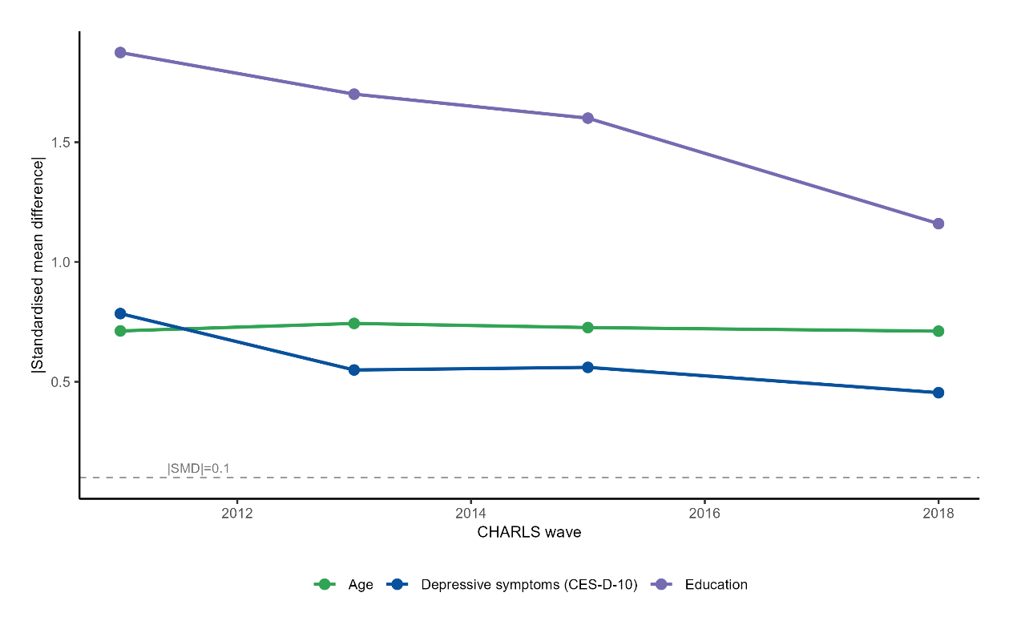
Points show absolute standardised mean differences (|SMD|) between internet users and non-users at each wave: age (green), depressive symptoms (CES-D-10 score, blue), education (purple). The dashed line is |SMD| = 0.1, the usual imbalance threshold. SMDs use the wave-specific pooled standard deviation of that wave's analytic sample (pooled across users and non-users). Education exceeds 1.0 at every wave; age and depressive symptoms stay above 0.45. The gap between users and non-users persists throughout 2011–2018. CES-D-10 = 10-item Center for Epidemiologic Studies Depression Scale; SMD = standardised mean difference.

Figure S2. Standardised mean differences between internet users and non-users, by baseline characteristic and wave, CHARLS 2011–2018
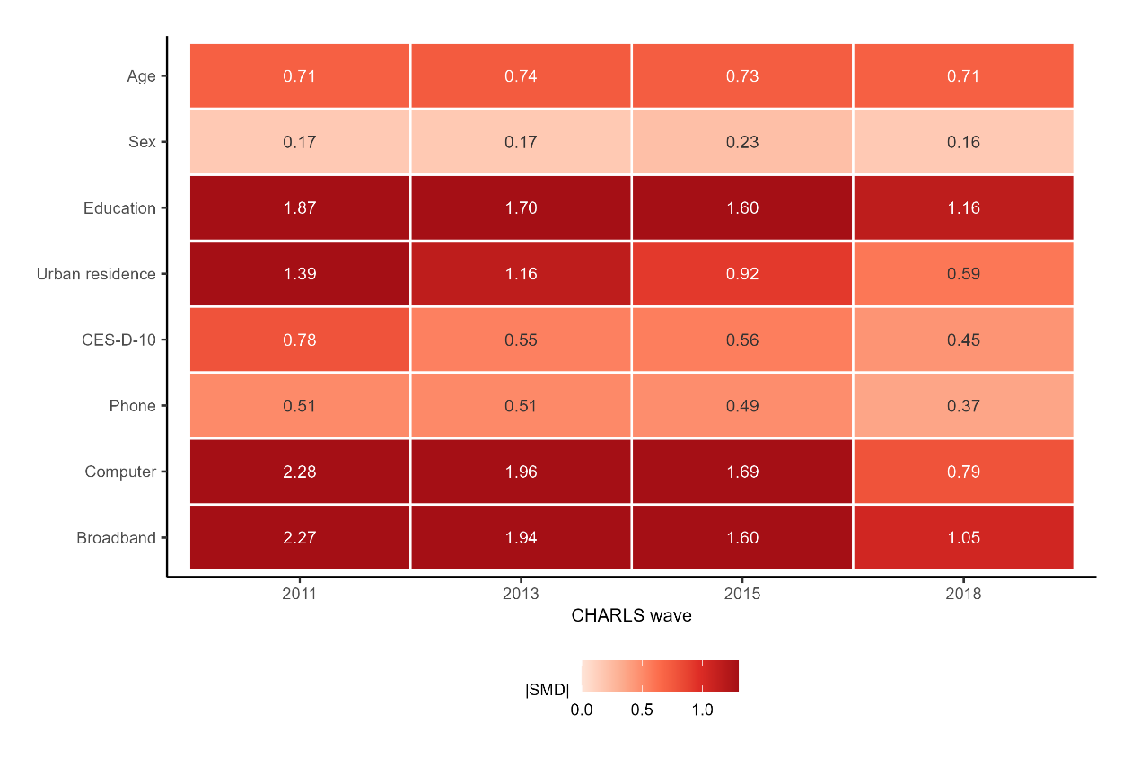
Cells show absolute standardised mean differences (|SMD|) between internet users and non-users at each wave. |SMD| = 0.1 is the usual imbalance threshold; education, urban residence and computer/broadband access exceed 1.0 in at least one wave. Mobile phone ownership, computer ownership and home broadband are household-level items; values were assigned to all members of the responding household. SMDs use the wave-specific pooled standard deviation of that wave’s analytic sample (pooled across users and non-users). CES-D-10 = 10-item Center for Epidemiologic Studies Depression Scale; SMD = standardised mean difference.

Figure S3. CES-D-10 score distributions by internet-use status and wave, CHARLS 2011–2018
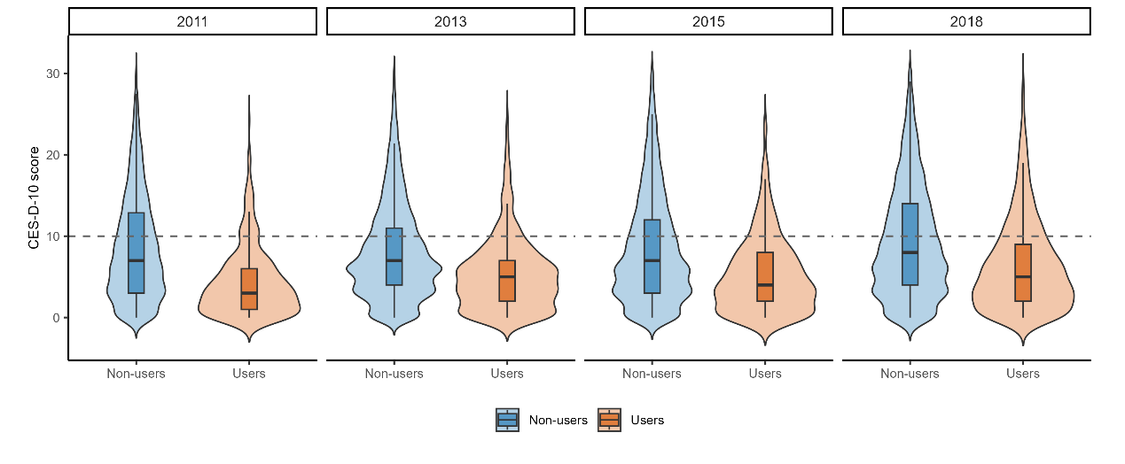
Violin plots of CES-D-10 scores by internet-use status (non-users, blue; users, orange) across the four waves. Embedded boxes span the interquartile range, the inner line marks the median, and whiskers extend to the observed range. The dashed line marks the elevated-symptoms cut-off (score ≥ 10). CES-D-10 = 10-item Center for Epidemiologic Studies Depression Scale.

Figure S4. Sequential covariate adjustment and the association between internet use and depressive symptoms
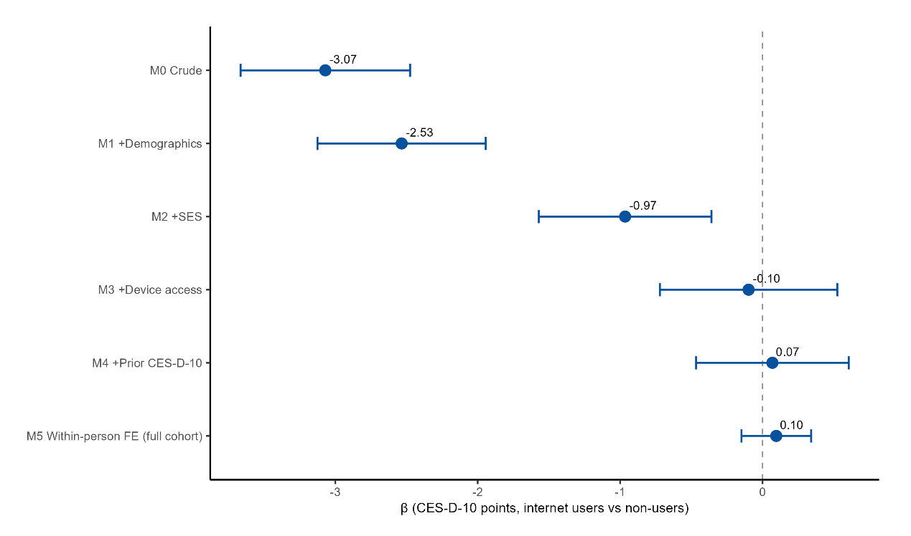
Coefficients for internet use from a progressive adjustment sequence in the 2015 wave (M0–M4) and from a within-person fixed-effects model fitted to the full four-wave cohort (M5). M0 is crude; M1 adds demographics; M2 adds socioeconomic status; M3 adds device access; M4 adds prior CES-D-10 score. Bars are 95% confidence intervals; the dashed line marks zero. Negative values correspond to lower CES-D-10 scores among users. CES-D-10 = 10-item Center for Epidemiologic Studies Depression Scale.

Figure S5. Covariate balance before and after overlap weighting, 2015 wave
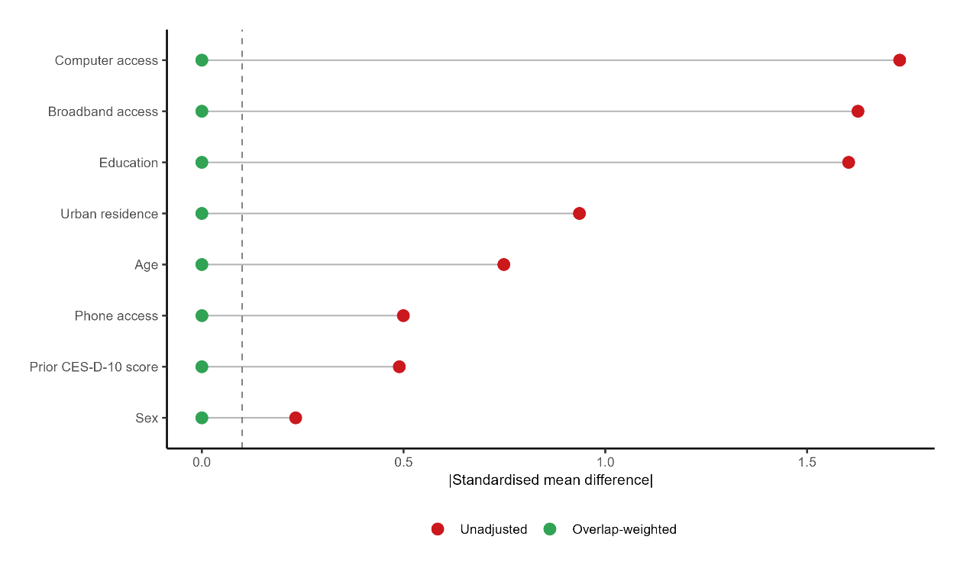
Absolute standardised mean differences in baseline covariates between internet users and non-users in the 2015 wave, before (red) and after (green) overlap weighting. The dashed line marks the 0.1 balance threshold; all weighted differences fall below it. Propensity-score model and weighting diagnostics: Table S2; overlap-weighted estimates: Table S3. SMD = standardised mean difference.

Figure S6. Weighted CES-D-10 trajectories by trial arm, target-trial emulation
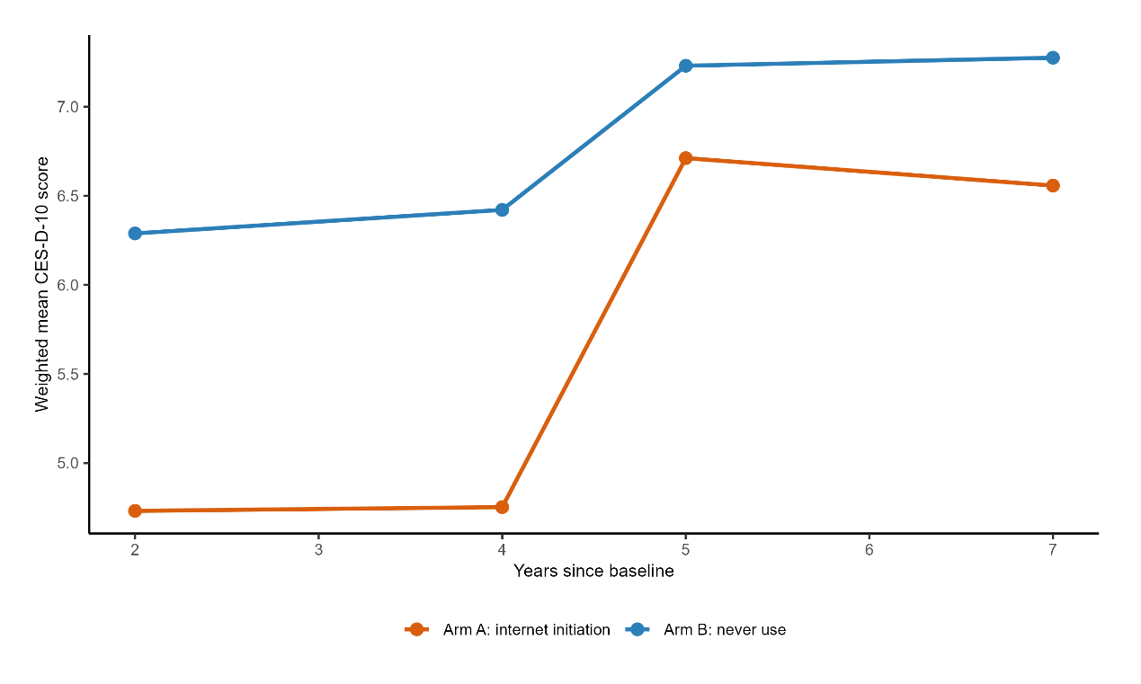
Mean CES-D-10 scores over follow-up by trial arm in the per-protocol analysis of the target-trial emulation (arm A, internet initiation, orange; arm B, never use, blue), weighted by inverse probability of censoring. Follow-up times are 2, 4, 5 and 7 years since baseline, pooled across the sequential 2011 and 2013 baselines. The y-axis does not start at zero. CES-D-10 = 10-item Center for Epidemiologic Studies Depression Scale.

Figure S7. E-values for unmeasured confounding across identification strategies, 2015 wave
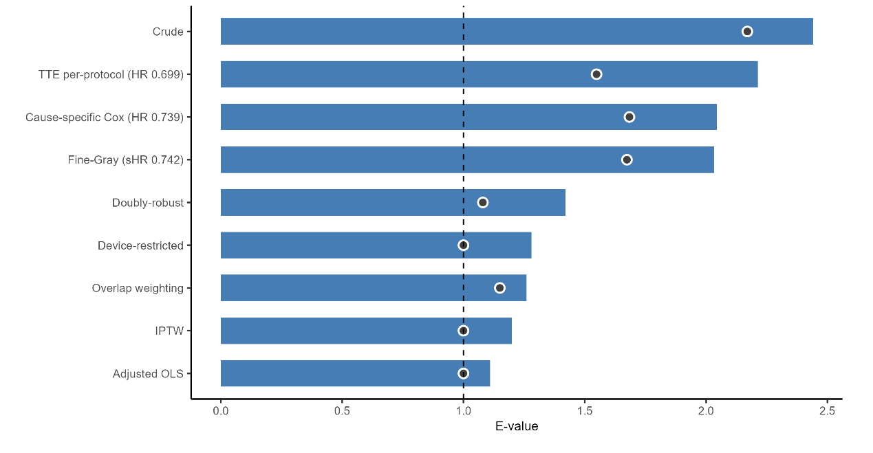
E-values for the association between internet use and CES-D-10 score under six between-person identification strategies, 2015 wave. Bars are E-values for the point estimates; dots are E-values for the confidence-interval bound nearest the null; the dashed line marks 1.0. Continuous-outcome coefficients were converted to the risk-ratio scale as in Supplementary Methods 2. The E-value is the minimum strength of association an unmeasured confounder would need with both exposure and outcome to explain away the estimate.

Supplementary References
1. Cotten SR, Ford G, Ford S, Hale TM. Internet use and depression among retired older adults in the United States: a longitudinal analysis. J Gerontol B Psychol Sci Soc Sci. 2014;69(5):763-71.
2. Khalaila R, Vitman-Schorr A. Internet use, social networks, loneliness, and quality of life among adults aged 50 and older: mediating and moderating effects. Qual Life Res. 2018;27(2):479-89.
3. Qi Y, Zhang C, Zhou M, Zhang R, Chen Y, Li C. Association between social media use and depressive symptoms in middle-aged and older Chinese adults. Transl Psychiatry. 2024;14(1):430.
4. Shakya HB, Christakis NA. Association of Facebook use with compromised well-being: a longitudinal study. Am J Epidemiol. 2017;185(3):203-11.
5. Ahmed O, Walsh EI, Dawel A, Alateeq K, Espinoza Oyarce DA, Cherbuin N. Social media use, mental health and sleep: a systematic review with meta-analyses. J Affect Disord. 2024;367:701-12.
6. Huang J, Ge Z, Chu Y, Yan Y, Zhang W, Liang H, Yang Y, Wang H. Associations between social media use and anxiety and depression among older adults: cross-sectional study. JMIR Aging. 2025;8:e71712.
7. Niccodemi G, Gaia A, Novello M, Consolazio D. Internet use and physical and mental health in old age during the COVID-19 pandemic: evidence from partners in SHARE. Econ Hum Biol. 2025;57:101487.
8. Riadi I, Kervin L, Dhillon S, Teo K, Churchill R, Card KG, Sixsmith A, Moreno S, Fortuna KL, Torous J, Cosco TD, et al. Digital interventions for depression and anxiety in older adults: a systematic review of randomised controlled trials. Lancet Healthy Longev. 2022;3(8):e558-71.
9. Hunsaker A, Hargittai E. A review of Internet use among older adults. New Media Soc. 2018;20(10):3937-54.
10. Allison PD. Fixed Effects Regression Models. Thousand Oaks: SAGE; 2009.
11. Hernán MA, Robins JM. Using big data to emulate a target trial when a randomized trial is not available. Am J Epidemiol. 2016;183(8):758-64.
12. Lipsitch M, Tchetgen Tchetgen E, Cohen T. Negative controls: a tool for detecting confounding and bias in observational studies. Epidemiology. 2010;21(3):383-8.
13. VanderWeele TJ, Ding P. Sensitivity analysis in observational research: introducing the E-value. Ann Intern Med. 2017;167(4):268-74.
14. Robins JM, Hernán MA, Brumback B. Marginal structural models and causal inference in epidemiology. Epidemiology. 2000;11(5):550-60.
15. Cole SR, Hernán MA. Constructing inverse probability weights for marginal structural models. Am J Epidemiol. 2008;168(6):656-64.
16. Cameron AC, Miller DL. A practitioner's guide to cluster-robust inference. J Hum Resour. 2015;50(2):317-72.
17. Zhao Y, Hu Y, Smith JP, Strauss J, Yang G. Cohort profile: the China Health and Retirement Longitudinal Study (CHARLS). Int J Epidemiol. 2014;43(1):61-8.
18. Andresen EM, Malmgren JA, Carter WB, Patrick DL. Screening for depression in well older adults: evaluation of a short form of the CES-D (Center for Epidemiologic Studies Depression Scale). Am J Prev Med. 1994;10(2):77-84.
19. Radloff LS. The CES-D scale: a self-report depression scale for research in the general population. Appl Psychol Meas. 1977;1(3):385-401.
20. Irwin M, Artin KH, Oxman MN. Screening for depression in the older adult: criterion validity of the 10-item Center for Epidemiological Studies Depression Scale (CES-D). Arch Intern Med. 1999;159(15):1701-4.
21. Cheng ST, Chan ACM. The Center for Epidemiologic Studies Depression Scale in older Chinese: thresholds for long and short forms. Int J Geriatr Psychiatry. 2005;20(5):465-70.
22. Fu H, Si L, Guo R. What is the optimal cut-off point of the 10-item Center for Epidemiologic Studies Depression Scale for screening depression among Chinese individuals aged 45 and over? An exploration using latent profile analysis. Front Psychiatry. 2022;13:820777.
23. Chinn S. A simple method for converting an odds ratio to effect size for use in meta-analysis. Stat Med. 2000;19(22):3127-31.
24. Imai K, Keele L, Tingley D. A general approach to causal mediation analysis. Psychol Methods. 2010;15(4):309-34.
25. Tingley D, Yamamoto T, Hirose K, Keele L, Imai K. mediation: R package for causal mediation analysis. J Stat Softw. 2014;59(5):1-38.
26. Fine JP, Gray RJ. A proportional hazards model for the subdistribution of a competing risk. J Am Stat Assoc. 1999;94(446):496-509.
27. Lee J, Phillips D, Wilkens J; Gateway to Global Aging Data Team. Gateway to Global Aging Data: resources for cross-national comparisons of family, social environment, and healthy aging. J Gerontol B Psychol Sci Soc Sci. 2021;76(Suppl 1):S5-16.
28. Cinelli C, Hazlett C. Making sense of sensitivity: extending omitted variable bias. J R Stat Soc Series B Stat Methodol. 2020;82(1):39-67.
29. Kuznetsova A, Brockhoff PB, Christensen RHB. lmerTest package: tests in linear mixed effects models. J Stat Softw. 2017;82(13):1-26.
30. Baron RM, Kenny DA. The moderator–mediator variable distinction in social psychological research: conceptual, strategic, and statistical considerations. J Pers Soc Psychol. 1986;51(6):1173-82.
31. Li F, Morgan KL, Zaslavsky AM. Balancing covariates via propensity score weighting. J Am Stat Assoc. 2018;113(521):390-400.
32. Li F, Thomas LE, Li F. Addressing extreme propensity scores via the overlap weights. Am J Epidemiol. 2019;188(1):250-7.

