Additional file 1
Sathu changal hme and the fermented pork dishes of the Hmar people of Northeast India

Catalogue of documented preparations
Table S1 lists all 21 named preparations compiled for the study [5, 6, 7]. Figures 1–3 in the main manuscript illustrate three selected examples. Figures S1–S3 below contain the remaining 18 photographs. The entries record culinary names and reported ingredients, not a botanical survey or an estimate of consumption frequency.
Local plant names are retained where species identity is uncertain. “Not specified” means that no additional ingredient was recorded in the compiled entry; it does not imply that the recipe excludes all other ingredients. Sahro is dried meat, not a vegetable.
Table S1. Complete catalogue of named preparations.
No. | Name prefix¹ | Principal ingredient | Additional ingredient | Image
1 | Rawtuoi | Rawtuoi (bamboo shoots) | Not specified | Main Fig. 1
2 | Ankhapui | Ankhapui (green milkweed climber) leaves and shoots | Not specified | Fig. S1a
3 | Dohro | Dolhro (dried taro leaves); dish-name spelling requires confirmation | Not specified | Fig. S1b
4 | Papal | Papal (mushroom) | Rawtuoi (bamboo shoots), maihna (pumpkin leaves) | Fig. S1c
5 | Behna | Behna (bean leaves) | Not specified | Fig. S1d
6 | Manta le Singzuor | Brinjal and singzuor (locally described as mezenga leaves; species unresolved) | Not specified | Fig. S1e
7 | Aihretil | Aihretil (reported as galangal root; species and plant part unverified) | Manta (brinjal), Khanghmuk (climbing wattle shoots) | Fig. S1f
8 | Tuoiterek | Tuoiterek (baby bamboo shoots) | Behna (bean leaves), manta (brinjal) | Fig. S2a
9 | Sapthei Hna | Sapthei Hna (passion fruit leaves) | Sahro | Fig. S2b
10 | Mantakha | Mantakha (scarlet eggplant) | Not specified | Fig. S2c
11 | Chengkha | Chengkha (bitter gourd) | Behna (bean leaves) | Fig. S2d
12 | Purunsen par | Onion buds and leaves | Not specified | Fig. S2e
13 | Maikung | Maikung (Pumpkin stalks) | Not specified | Main Fig. 2
14 | Rawtuoi le Khanghmuk | Rawtuoi (bamboo shoots), Khanghmuk (climbing wattle shoots) | Not specified | Fig. S2f
15 | Fanghra | Fanghra (reported as Canavalia gladiata; species and plant part unverified) | Behna (bean leaves) | Fig. S3a
16 | Khanghmuk | Khanghmuk (climbing wattle shoots) | Manta (brinjal) | Main Fig. 3
17 | Bapon | Bapon (dried taro stem) | Not specified | Fig. S3b
18 | Tierhrep | Tierhrep (local plant name; species unresolved) | Sahro | Fig. S3c
19 | Rawtuoi Hro | Rawtuoi Hro (dried bamboo shoots) | Not specified | Fig. S3d
20 | Khumhawi | Khumhawi (local plant name; species unresolved) | Not specified | Fig. S3e
21 | Aithieng Par | Aithieng par (Ginger buds) | Not specified | Fig. S3f
¹ Each prefix is followed by “sathu changal hme”. Local spellings follow the compiled material. Scientific identifications require confirmation against plant specimens.

Sources
5. Lalthanpuii PB, Lalruatfela B, Zoramdinthara, Lalthanzara H. Traditional food processing techniques of the Mizo people of Northeast India. Science Vision. 2015;15(1):39–45.
6. Lalmuanpuii R, Zodinpuii B, Lalbiaknunga J, Zothanpuia. Traditional food preparation of wild edible vegetables among the ethnic groups of Mizoram, North East India. Journal of Ethnic Foods. 2021;8:26. https://doi.org/10.1186/s42779-021-00104-5.
7. Hmar Hme. Sathu—fermented pork. 2019. https://hmarhme.com/2019/02/sathu-fermented-pork/. Accessed 1 June 2024.

Supplementary Figure S1
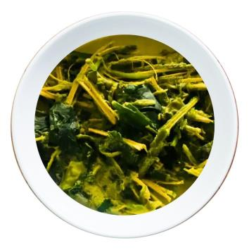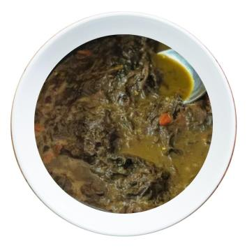
(a) Ankhapui. (b) Dohro.
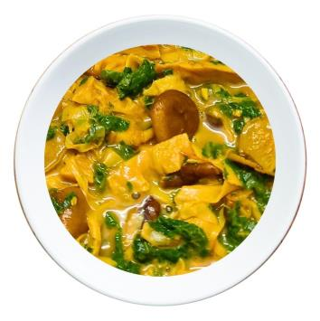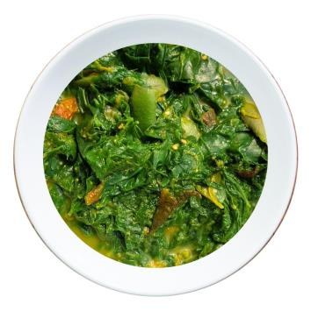
(c) Papal. (d) Behna.
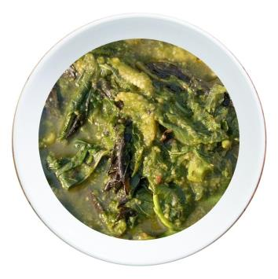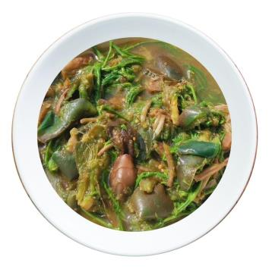
(e) Manta le Singzuor. (f) Aihretil.
Fig. S1. Additional sathu changal hme preparations. Panel names correspond to Table S1. Photographs are drawn from the Hmar Hme and hmarhme.com source collection acknowledged in the main manuscript.

Supplementary Figure S2
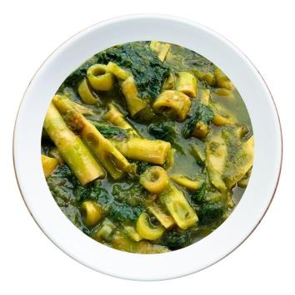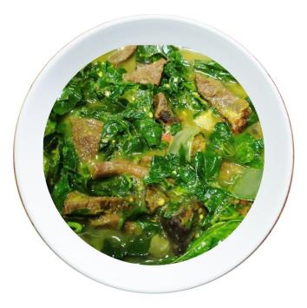
(a) Tuoiterek. (b) Sapthei Hna.
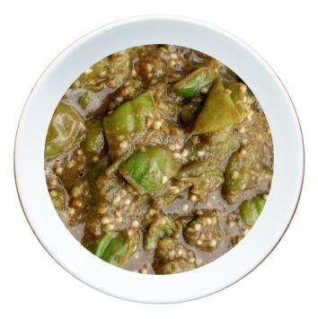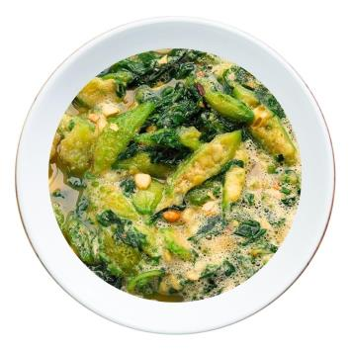
(c) Mantakha. (d) Chengkha.
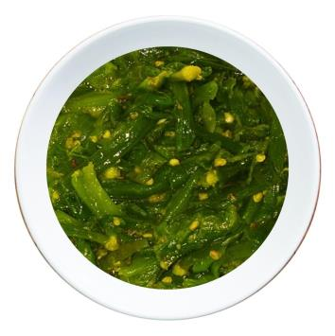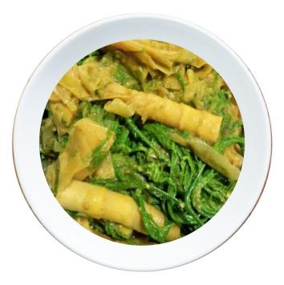
(e) Purunsen par. (f) Rawtuoi le Khanghmuk.
Fig. S2. Additional sathu changal hme preparations. Panel names correspond to Table S1. Photographs are drawn from the Hmar Hme and hmarhme.com source collection acknowledged in the main manuscript.

Supplementary Figure S3
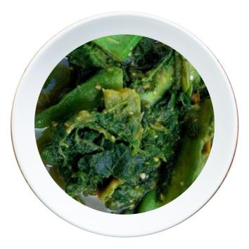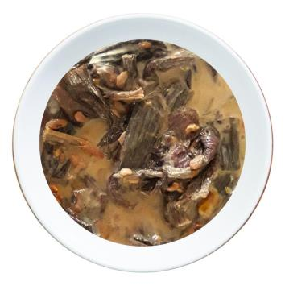
(a) Fanghra. (b) Bapon.
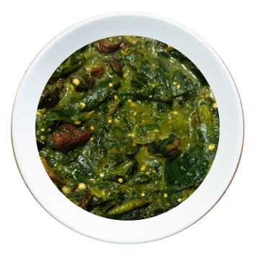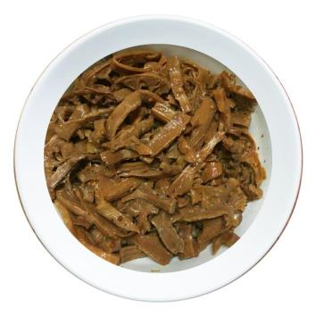
(c) Tierhrep. (d) Rawtuoi Hro.
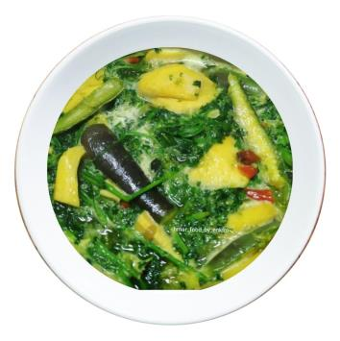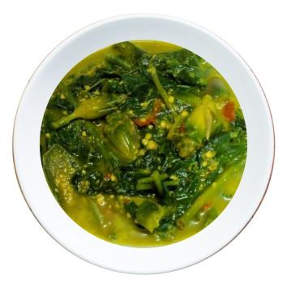
(e) Khumhawi. (f) Aithieng Par.
Fig. S3. Additional sathu changal hme preparations. Panel names correspond to Table S1. Photographs are drawn from the Hmar Hme and hmarhme.com source collection acknowledged in the main manuscript.

