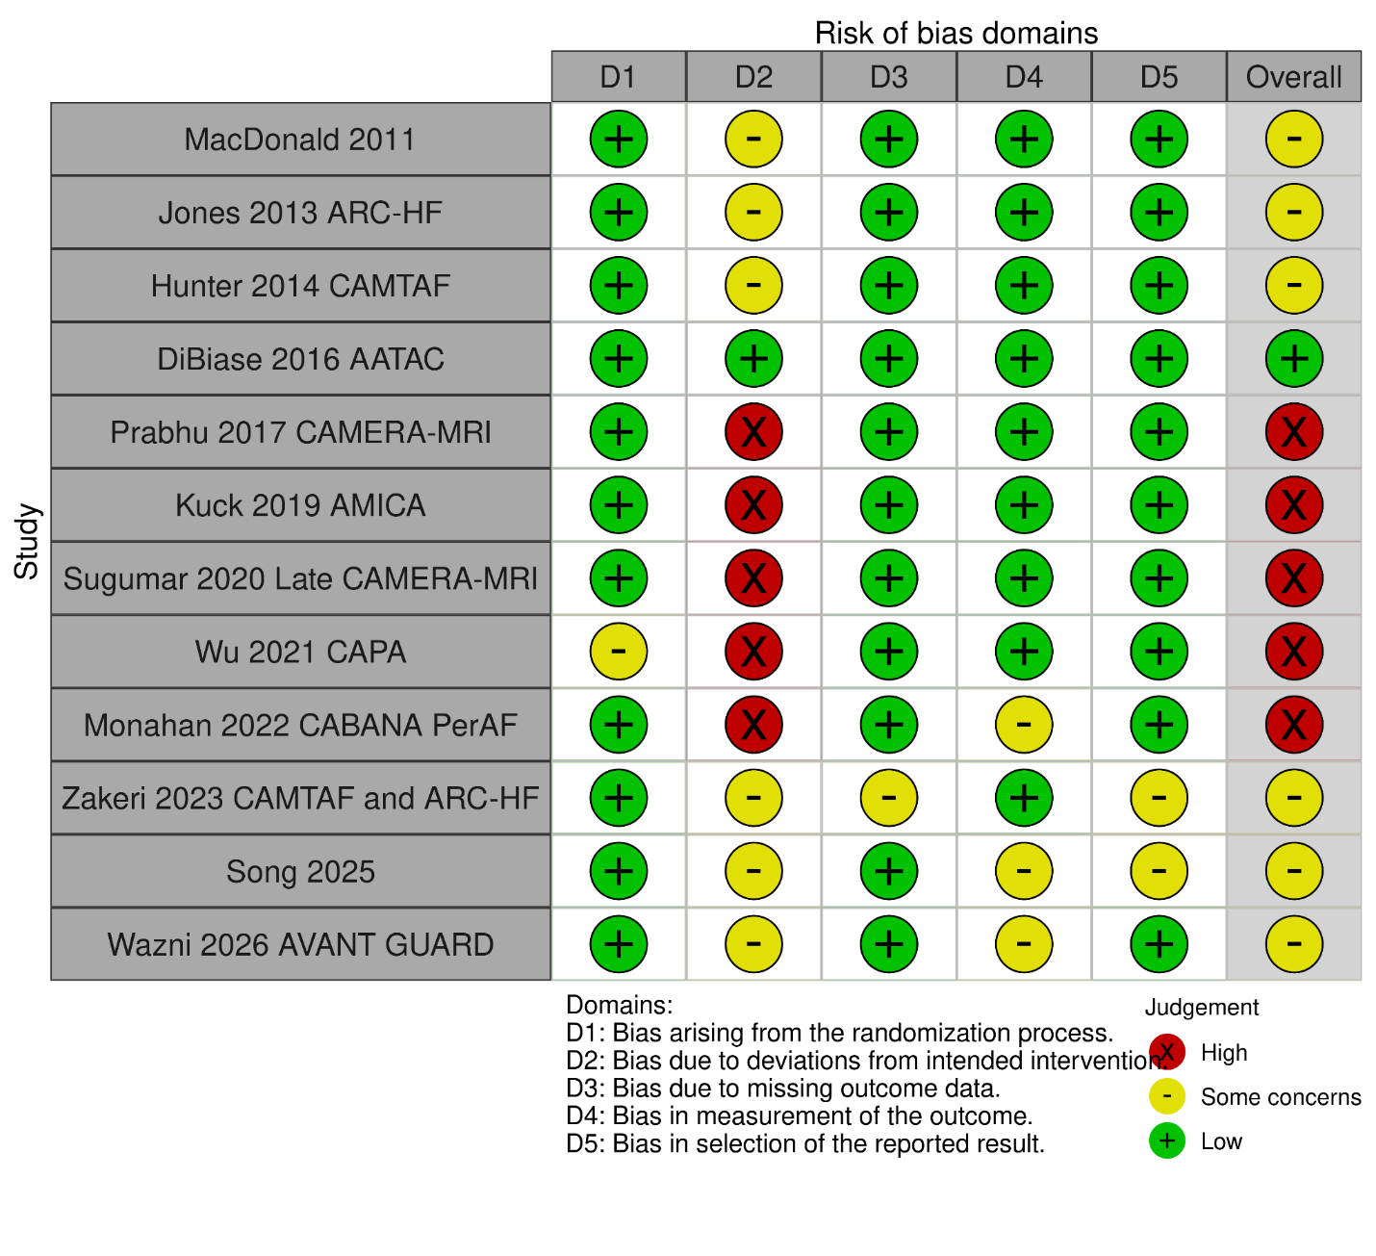

Figure S5. Risk Of Bias

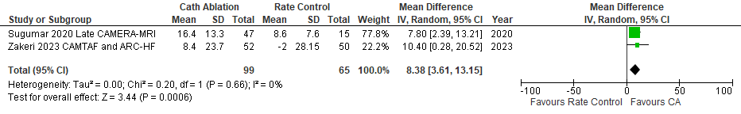

Figure S6. LVEF changes (Follow-up Studies)

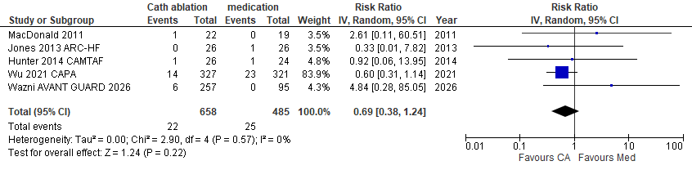
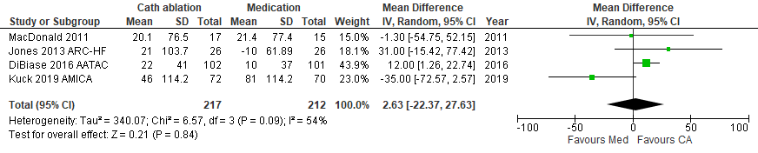

Figure S7. 6MWD changes

Figure S8. Stroke TIA
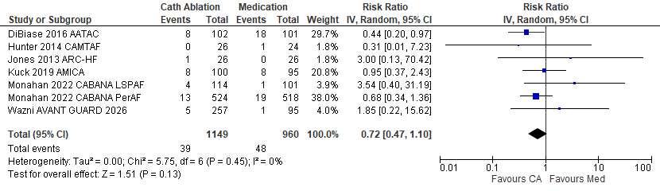

Figure S9. All-Cause Mortality
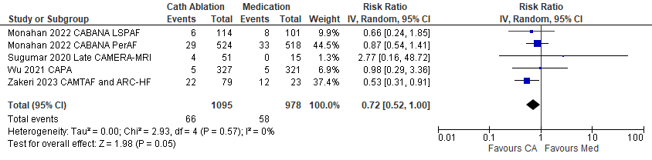

Figure S10. Long-term All Cause Mortality (follow-up)

